**Title:** “Strategic Entrepreneurship in the Context of International Expansion: A Study of Success Factors and Challenges for Indian Startups Pursuing Global Growth”

1. **ABSTRACT**

This paper investigates whether national and entrepreneurial framework conditions positively affect economic growth via its effects on entrepreneurial activity more significantly than via its effects on technological innovation intensity.

The most crucial ones are described as limited and lack access to finance, lack of managerial and labour skills, inability to equip modern technology, incompetent marketing and research & design strategies, increasing cost of labour, inadequate government policies and governance, political instability, and corruption. The background of this study is the upcoming topic social media in combination with entrepreneurship. Social media is offering potential entrepreneurs a lot of opportunities. It can be noticed that in the nowadays generations more and more people seeking to have their own business through social media.

Therefore the research question of this paper should be: How people become entrepreneurs with the help of social media on the example of self-employed companies? The purpose of this study is to crave out the creating process of how to become an entrepreneur with the help of social media focused on self-employed companies. In the theoretical framework the terms entrepreneurship, self-employment, opportunity recognition, creation and discovery theory, digitalism and social media will be defined and detailed examined. For this thesis a qualitative research study was chosen. Therefore qualitative interviews with prepared questions with nine companies who got self-employed through social media have been executed. The chosen companies are dealing with businesses as photography, travelling, music or fashion.

Furthermore the interviewed companies are from four different countries but the main part is from Germany. It was important that the companies are created through social media, self-employed, not bigger than three employees and not older than five years. The researcher decided for a deductive approach. The empirical data from the interviews were analyzed with the help of the theoretical framework to find significant outcomes and conclusions. The conclusion for this thesis is that social media has a huge influence on all interviewed self-employed persons Facebook, Instagram and YouTube are the most popular platforms to start the business with. Self-recognition from followers and the fact that social media is a great and cheap marketing opportunity, influenced people to become self-employed. The interviewed companies saw the opportunities to use their skills and knowledge to discover something new, which has not been there before or to create something that is better than the competitors and brings a new value to the market.

1. **INTRODUCTION**

This paper investigates whether national and entrepreneurial framework conditions positively affect economic growth via its effects on entrepreneurial activity more significantly than via its effects on technological innovation intensity.

The most crucial ones are described as limited and lack access to finance, lack of managerial and labour skills, inability to equip modern technology, incompetent marketing and research & design strategies, increasing cost of labour, inadequate government policies and governance, political instability, and corruption. The background of this study is the upcoming topic social media in combination with entrepreneurship. Social media is offering potential entrepreneurs a lot of opportunities. It can be noticed that in the nowadays generations more and more people seeking to have their own business through social media.

Therefore the research question of this paper should be: How people become entrepreneurs with the help of social media on the example of self-employed companies? The purpose of this study is to crave out the creating process of how to become an entrepreneur with the help of social media focused on self-employed companies. In the theoretical framework the terms entrepreneurship, self-employment, opportunity recognition, creation and discovery theory, digitalism and social media will be defined and detailed examined. For this thesis a qualitative research study was chosen. Therefore qualitative interviews with prepared questions with nine companies who got self-employed through social media have been executed. The chosen companies are dealing with businesses as photography, travelling, music or fashion.

Furthermore the interviewed companies are from four different countries but the main part is from Germany. It was important that the companies are created through social media, self-employed, not bigger than three employees and not older than five years. The researcher decided for a deductive approach. The empirical data from the interviews were analyzed with the help of the theoretical framework to find significant outcomes and conclusions. The conclusion for this thesis is that social media has a huge influence on all interviewed self-employed persons Facebook, Instagram and YouTube are the most popular platforms to start the business with. Self-recognition from followers and the fact that social media is a great and cheap marketing opportunity, influenced people to become self-employed. The interviewed companies saw the opportunities to use their skills and knowledge to discover something new, which has not been there before or to create something that is better than the competitors and brings a new value to the market.

1. **LITERATURE REVIEW**

Research on entrepreneurship and the way the concept has been interpreted by scientists can be categorised into three streams (Stevenson & Jarillo, 1990). The first stream of research focused on the result – the what of entrepreneurship. One of the most compelling examples to mention is the Schumpeterian view of entrepreneurship, where the outcome of an entrepreneur’s activity is analysed (Stevenson & Jarillo, 1990).

In that sense, entrepreneurship is viewed as a process by which the whole of the economy is advancing through disruptions followed by innovative creations (Schumpeter, 1934). The next stream of entrepreneurship research concentrated on the actor – the entrepreneur itself, and thus analyses entrepreneurship from a psychological and sociology point of view.

As such, strong focus lies on individual human beings to answer the question of why in relation to entrepreneurship, by also integrating an entrepreneur’s environment, objectives, motivations, or values into the research (Stevenson & Jarillo, 1990).

Lastly, the third wave of research looks at the entrepreneurial management process, and hence, how entrepreneurship occurs, which will also be the focus of this thesis. Central in this stream of research is finding out how entrepreneurs’ objectives are accomplished (Stevenson & Jarillo, 1990). It explores how to increase innovation in existing firms, investigates start-ups, the firm’s life cycle, as well as prognosticators of entrepreneurial success.

1. **RESEARCH OBJECTIVE**

1. Identifying Key Success Factors: Investigate the factors that contribute to the success of entrepreneurial ventures in international markets, including market selection criteria, competitive strategies, innovation capabilities, and strategic partnerships.

2. Exploring Market Entry Strategies: Analyze different market entry modes employed by entrepreneurs and organizations, such as exporting, licensing, franchising, joint ventures, acquisitions, and greenfield investments. Assess the effectiveness of these strategies in different contexts and industries.

3. Understanding Innovation and Adaptation: Explore how entrepreneurs innovate and adapt their products, services, and business models to meet the diverse needs and preferences of international markets. Examine the role of technological innovation, cultural sensitivity, and market intelligence in driving international growth.

4. Examining Strategic Alliances and Partnerships: Investigate the role of strategic alliances, partnerships, and networks in facilitating international expansion. Assess how entrepreneurs leverage alliances with local firms, suppliers, distributors, and government agencies to overcome market entry barriers and enhance competitiveness.

5. Assessing Risk Management Strategies: Examine the challenges and risks associated with internationalization, including currency fluctuations, political instability, regulatory compliance, and cultural differences. Evaluate how entrepreneurs mitigate these risks through strategic planning, hedging strategies, and organizational resilience.

1. **RESEARCH METHODOLOGY**
   1. **Data Designing:**

* **Basic research:** This study is undertaken only for the advancement of knowledge and has no immediate economic prospects. The study conducted for the wellbeing of humans, animals, and the plant kingdom. It is known as basic, pure, and fundamental research. The primary objective here is to extend human understanding, not to construct or invent something.
* **Applied research:** Applied research is intended to solve actual issues in the current world rather than acquiring information for its own sake. Applied research aims to better the human situation. It focuses on analyzing and addressing social and real-world problems. This study is often undertaken on a huge scale and is costly. As a result, it is frequently carried out with the assistance of a finance body such as the national government, government company, world bank, unicef, ugc, etc.
* **Quantitative research:** The study is based on numerical data. Quantitative research aims to measure a number or amount, compare it to previous data, and forecast for the future. In the humanities and social sciences, "quantitative research alludes to the systematic examination of quantitative features and events and their relationships".
* **Qualitative research:** Qualitative research presents non-quantitative type of analysis. Qualitative research is collecting, analyzing and interpreting data by observing what people do and say. Qualitative research refers to the meanings, definitions, characteristics, symbols, metaphors, and description of things. Qualitative research is much more subjective and uses very different methods of collecting information, mainly individual, in-depth interviews and focus groups.
  1. **Data Collection:**

The data collection method of choice was an online questionnaire survey, which targeted employees currently working in organisations striving for innovation recognition. The type of research was conducted as a cross-sectional study, meaning that data was only collected during a restricted time-period, namely four weeks. The design of the questionnaire primarily consists of closed questions using nominal scales for the demographics and interval scales, namely in the form of a Likert scale, for answering the questions. A neutral option is offered to balance the rating scale. According to Elmore and Beggs (1975), an increase from 5 to 7 or any more points on a rating scale will unlikely improve the reliability. However, due to the use of itemised rating scales the centrality tendency bias must be addressed. The central tendency can be described as the tendency of quantitative data to assemble around a central value.

The questions of the online survey were formed in relation to the frame of references and the proposed new model and the hypotheses that were sought to be tested. Hence the different sections of the questionnaire aimed at investigating the independent variables, namely the attitude toward the behaviour, the subjective norm and the perceived behavioural control. The organisational factors as moderating variables have a strong probable effect on the independent variable–dependent variable relationship (Sekaran, 2003). To measure internal consistency, Cronbach’s alpha was applied to test the dimensionality of the scale.

Whilst developing the online questionnaire survey, the authors fulfilled the six methodological components, which ought to be applied to the success of online surveys. According to Regmi, Waithaka, Paudyal, Simkhada and van Teijlingen (2016), the crucial factors are a user-friendly design, the careful selection of the survey participants, the avoidance of multiple responses, accurate data management, the consideration of ethical issues and the piloting tools.

1. **DATA ANALYSIS**

After presenting all the empirical data in the following analysis chapter these data will be connected with the theoretical background to get information’s. Therefore each of the parts will be firstly analyzed and it will be tried to find an outcome for each part. In a reflection these outcomes will be will valuated. In the following the analysis will be divided into the important subparts regarding the research question of this thesis. The subparts have been already mentioned in the analysis model: -

1. Personal motivation

2. Characteristics

3. Use of social media platforms

4. Influence and importance of social media

5. Timeframe for starting business

6. Opportunity recognition

7. Starting the business without social media?

8. Success factors

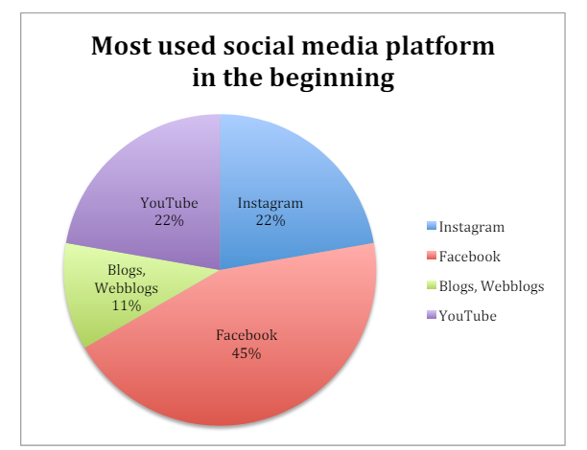

Influence and importance of social media:

• More followers and likes

• Great marketing opportunity

• Inspiration about new trends

• Learning and gaining new knowledge

• Self recognition

• Self confidence

• Use for free

• Getting new contacts/ offers

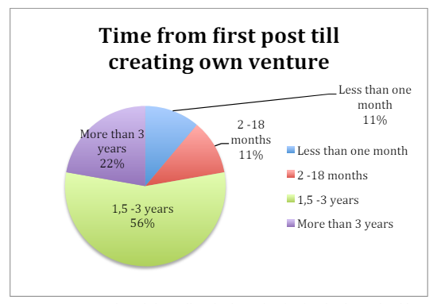

**Perceived barriers to growth**

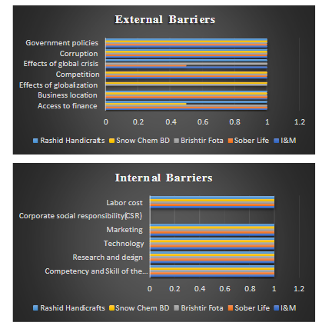

**Leading industries in MSMEs sector with their respective shares**

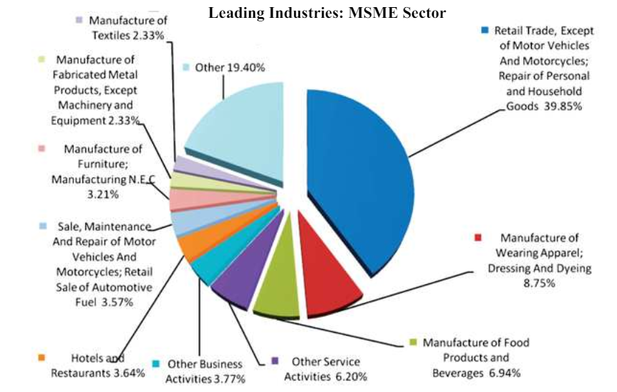

1. **FINDINGS**

The study delves into the critical success factors and challenges faced by Indian startups seeking global expansion. It highlights that strategic entrepreneurship plays a pivotal role in the internationalization process, emphasizing the importance of factors such as idea generation, CEO decisions, business model innovation, effective marketing strategies, building strong teams, securing adequate funding, and timing of market entry.

The research underscores that successful international expansion requires a comprehensive strategy that aligns with the company's goals and resources, emphasizing the significance of managerial capabilities, top management commitment, and entrepreneurial behavior in navigating the complexities of global growth. Moreover, the study identifies challenges such as the lack of vision, fear of failure, structural changes, and the need for corporate social responsibility to sustain long-term value.

Additionally, the findings emphasize the role of human capital in internationalization, highlighting the balance needed to leverage education and expertise without creating organizational constraints. Overall, the research sheds light on the multifaceted nature of strategic entrepreneurship in the context of international expansion for Indian startups, providing insights into both success factors and challenges encountered in pursuing global growth.

1. **LIMITATION**

The authors encountered limitations in terms of limited diversification of data collection. Since the method of distribution included the snowball sampling on social networks, a considerable number of younger employees was ultimately targeted which led to a higher amount of responses collected from a specific age group.

Additionally, due to the cross-sectional character of the research, this study did not measure the actual incentives implemented by the firms to foster intrapreneurial activities. The study could only concentrate on an employee’s perception and his or her intrapreneurial intention. Intention is the key anticipatory indicator for behaviour, but it does not conclude if and to what extent the behaviour will appear in the future. Moreover, since a survey must be designed in a way that respondents are willing to complete the questionnaire, the researchers had only a limited amount of questions that could be included in the research approach. Since the focus of this research was of exploratory nature, questions targeting all involved theories were selected only to test the established hypothesised model.

1. **RECOMMENDATION**

* The research paper should emphasize the importance of a comprehensive approach to strategic entrepreneurship for Indian startups aiming for global expansion. It is crucial to highlight the significance of aligning business strategies with the dynamic international market landscape, focusing on key success factors such as innovative business models, effective marketing strategies, and the utilization of emerging technologies like artificial intelligence and blockchain.
* Additionally, the paper should stress the need for Indian startups to build strong teams, secure adequate funding, and adapt to changing technology landscapes to remain competitive on a global scale. Addressing challenges such as regulatory hurdles, infrastructure limitations, talent scarcity, and intense competition should be a focal point, with recommendations on how startups can navigate these obstacles effectively.
* Moreover, the research paper should advocate for fostering a supportive ecosystem that encourages entrepreneurship, innovation, and collaboration, while also highlighting the role of government initiatives and policies in facilitating the growth of Indian startups in the global arena. By providing actionable recommendations based on the identified success factors and challenges, the research paper can offer valuable insights to guide Indian startups towards sustainable global expansion and success.

1. **CONCLUSION**

This thesis hereby deployed an exploratory research approach by developing a research model that immerses organisational factors – an employee’s perception of the company’s EO, with behavioural attributes as designed by Ajzen’s TPB (1991) for measuring someone’s intrapreneurial intention. The model included five dimensions of a firm’s Entrepreneurial Orientation (EO), namely autonomy, innovativeness, risk-taking, proactiveness, and competitive aggressiveness (Lumpkin & Dess, 1996). Behavioural attributes proposed by Ajzen (1991) consist of a personal attitude towards intrapreneurship, subjective norms, and perceived behavioral control.

The quantitative study, which consisted of a questionnaire with 28 items, generated a sample of 394 respondents working in different organizations, industries, and distinct hierarchical firm levels.

The results concerning the hypothesized model show that an employee’s intrapreneurial intentions are not directly influenced by perceptions of the firm’s EO. However, EO has a positive direct effect on one’s attitude towards intrapreneurship. Respectively, attitude is the only behavioral factor which influences an employee’s intention towards intrapreneurship. As documented by the authors’ analyses, the direct effect of EO on the employee’s intrapreneurial intention is weak to non-existent. The findings contradict common practices in companies these days, which foster intrapreneurial intention with direct incentives, rather than focusing on the employee’s perception and attitude (Deeb, 2016). Thus, the authors propose a higher focus on the determinants of TPB instead of modifying EO’s incentives. As such, the authors suggest a newly designed framework in which intrapreneurial intentions are directly influenced by someone’s attitude towards intrapreneurship and indirectly influenced by an employee’s positive perception of the organizations EO.

1. **REFERENCES**

Ajzen, I. (1991). The theory of planned behavior. Organizational Behavior and Human Decision Processes, 50, 179-211.

Ajzen, I. (2005). Attitudes, Personality and Behavior (2nd ed.). Maidenhead, Berkshire, England: McGraw-Hill Education.

Al Mamun, A., Kumar, N., Ibrahim, M. D., & Bin Yusoff, M. N. (2017). Validating the measurement of entrepreneurial orientation.

Economics and Sociology, 10(4), 51-66. Alpkan, L., Bulut, C., Gunday, G., Ulusoy, G., & Kilic, K. (2010). Organizational support for intrapreneurship and its interaction with human capital to enhance innovative performance. Management Decision, 48(5), 732-755.

Andersén, J. (2017). What about the employees in entrepreneurial firms? A multi-level analysis of the relationship between entrepreneurial orientation, role ambiguity, and social support. International Small Business Journal:

Researching Entrepreneurship, 35(8), 969-990.

Andersén, J., & Samuelsson, J. (2016). How entrepreneurial orientation and management accounting influence the profitability of growing and non-growing SMEs. International Journal of Entrepreneurial Behaviour& Research, 22(4), 466-484. Antoncic, B. (2007).

Intrapreneurship: A comparative structural equation modeling study. Industrial Management & Data Systems, 107(3), 309-325.