**A STUDY ON EMPLOYEE MOTIVATION AND ENGAGEMENT STRATEGIES OF AMAZON**

SAKSHI YADAV

SCHOOL OF BUSINESS

GALGOTIAS UNIVERSITY, GREATER NOIDA

UTTAR PRADESH

ABSTRACT

Employee engagement and motivation are essential, especially in a fast-paced, cutthroat environment like Amazon. This study aims to add to the body of knowledge already available in this sector by examining the several approaches that Amazon uses to improve employee engagement and motivation. This research investigates the theoretical foundations of motivation and engagement through a thorough literature analysis, emphasizing their importance in influencing employee performance and organizational outcomes. As a leader in e-commerce and technology worldwide, Amazon has particular opportunities and problems when it comes to developing a driven and enthusiastic workforce. The company's success is ascribed to both its creative business strategy and its attention on fostering an environment at work that enhances worker happiness and wellbeing. Three fundamental components of Amazon's strategy are its emphasis on the customer, ongoing learning and improvement, and an innovative and risk-taking culture. Furthermore, Amazon has put in place a number of targeted initiatives to raise worker engagement and motivation. These consist of a decentralized decision-making process, a results-driven work atmosphere, and a strong focus on empowerment and autonomy. Employees are further encouraged to give their best work by the company's excellent remuneration packages, extensive benefits, and career progression chances.  
  
Moreover, Amazon prioritizes feedback and acknowledgment, utilizing peer reviews, awards programs, and performance evaluations to recognize and motivate employee accomplishments. In addition, the organization promotes a supportive and cooperative work environment by providing team-building exercises, social gatherings, and volunteer opportunities that cultivate a sense of community and belonging. Despite its achievements, Amazon continues to come under fire and scrutiny for the way it treats its workers, especially when it comes to the labour laws and working conditions in its fulfilment facilities. This emphasizes how crucial it is to strike a balance between the needs of the company and the welfare of the workforce, as well as how crucial it is to continuously assess and enhance motivating and engagement tactics.

INTRODUCTION

Engagement and motivation among employees are essential to the success of a firm. Employees that are engaged and motivated are more creative, dedicated, and productive. Here's a quick rundown of several tactics:

1. Clearly Defined Goals and Expectations: To provide staff members with a feeling of direction and purpose, clearly outline goals and expectations.

2. Recognition and Awards: Give staff members credit for their accomplishments and contributions. This could be achieved through rewards like bonuses or vocal commendation.

3. Professional Development: Offer mentorship programs, training sessions, and workshops as means of fostering personal and professional development. Putting money into a worker's skill development and career progression demonstrates your value to them.

4. Encourage Open Communication: Create an environment where staff members feel free to voice their opinions, issues, and suggestions. Pay attention to what they have to say.

5. Empowerment and Autonomy: Provide workers the freedom to decide for themselves and accept responsibility for their job in order to empower them. This strengthens their sense of commitment and accountability.

OBJECTIVES

For Amazon to stay ahead of the competition and promote an innovative and high-achieving culture, motivation and engagement are essential. Their initiatives in these areas include a variety of goals, all geared toward developing a motivated workforce dedicated to the vision and values of the organization. The following are some main goals:  
  
1. Increasing Output: Increasing worker productivity is one of Amazon's main goals for motivation and engagement initiatives. Amazon maintains the focus, efficiency, and commitment of its workers to accomplishing both individual and organizational goals by providing opportunities for growth and engagement. Higher output levels and better overall performance may come from this.

2. Promoting Innovation: Innovative thinking is a key component of Amazon's success, and inspired staff members are more likely to come up with fresh concepts and think beyond the box. Amazon hopes to establish a work atmosphere where people are empowered to innovate, try new things, and take measured risks by putting incentive and engagement tactics into practice. This aim is consistent with Amazon's mission to continuously push the envelope and spur growth via innovation.  
  
3. Improving Holdout: Any company that experiences high employee turnover may incur significant costs for hiring new staff members as well as for losing out on talent and institutional knowledge. By putting in place motivation and engagement tactics that promote a happy work atmosphere, offer chances for professional growth and development, and acknowledge and reward employee achievements, Amazon hopes to lower turnover rates.

4. Fostering Cooperation and Unity: Amazon needs to collaborate and operate as a team effectively in order to provide outstanding customer service and promote corporate success. Employees that are engaged and motivated are more inclined to help one another out, share knowledge, and work well together. By encouraging a culture of respect, trust, and cooperation among employees in various teams and departments, Amazon's motivation and engagement tactics seek to improve teamwork.  
  
5. Improving Worker Contentment and Health: Amazon understands how critical employee happiness and health are to boosting productivity and achieving company goals. Amazon wants to build a welcoming and inclusive environment where workers feel appreciated, respected, and cared for. To this end, the company is putting in place incentive and engagement techniques that put employee welfare, work-life balance, and job satisfaction first.

In conclusion, increasing productivity, encouraging creativity, increasing retention, encouraging cooperation and teamwork, and boosting employee happiness and well-being are the main goals of Amazon's motivation and engagement initiatives. By fulfilling these goals, Amazon will be able to keep its employees inspired and involved, which fosters success, growth, and innovation.

LITERATURE REVIEW

A survey of the literature on employee engagement and incentive techniques would entail looking at numerous academic publications, novels, and research papers to comprehend the field's current models, theories, and procedures. It probably would encompass things like:

1. Theoretical frameworks for motivation, such as Herzberg's Two-Factor Theory, Maslow's Hierarchy of Needs, and Self-Determination Theory.

The Maslow hierarchy of needs is a psychological theory that places human needs in a hierarchical order, usually depicted as a pyramid. It implies that before higher-level needs become motivators, lower-level demands must be met. Physiological needs, safety needs, love/belongingness needs, esteem needs, and self-actualization requirements are usually included in the hierarchy. It is a framework for comprehending the motivations and behaviours of people.

HERZBERGS TWO FACTOR THEORY: Also referred to as the motivation-hygiene theory, Herzberg's two-factor theory postulates that hygiene factors and motivators are two distinct sets of factors that affect job satisfaction and discontent. Aspects of the workplace, including as pay, policies, and working conditions, are examples of hygiene elements. When they are met, they can reduce unhappiness but do not always result in satisfaction. Conversely, motivators are elements that, when present, promote motivation and job satisfaction. These elements include possibilities for personal development, accountability, and acknowledgment.

SELF-DETERMINATION THEORY: This psychological framework examines how people's personalities evolve and why they act the way they do. According to this theory, humans are motivated by three fundamental psychological needs: relatedness (feeling a sense of connection to others), competence (feeling competent and efficient), and autonomy (feeling in control of one's activities). Satisfying these demands increases intrinsic motivation, well-being, and personal development, according to SDT.

2. Elements (such as job design, corporate culture, incentives, and recognition) that affect employee engagement and motivation.   
The practice of allocating jobs and duties inside a company in a way that maximizes output, effectiveness, and worker happiness is known as "job design." It entails selecting assignments, strategies, connections, and frameworks to satisfy organizational objectives while taking into account the qualifications, propensities, and drives of personnel. Balance between workload, autonomy, variety, and feedback is a goal of effective job design.

ORGANIZATIONAL CULTURE: A company's common values, beliefs, attitudes, and actions are referred to as its organizational culture. It includes how staff members communicate, make choices, and understand the purpose and objectives of the company.

3. Various methods (such as organizational, behavioural, and psychological) for fostering employee engagement.

PHYSIOLOGICAL APPROACH: The impact that an employee's physical health has on their degree of engagement at work is referred to as the physiological components of employee engagement. This can include things like temperature, noise levels, natural light availability, health advantages, ergonomics at work, and general comfort. Employee engagement, productivity, and motivation are higher when they perceive their physical comfort and well-being in the workplace. Employers can improve physiological involvement by establishing a safe and encouraging work environment.

BEHAVIORAL APPROACH: From a behavioural perspective, employee engagement is the degree to which workers show that they are emotionally invested in and dedicated to their work by their actions and behaviours. This can involve traits like a strong work ethic, a determination to go above and beyond, and a commitment to the objectives of the company. High productivity, proactive problem-solving, pleasant interactions with co-workers, and a willingness to support team initiatives are examples of behavioural indications of engagement.

4-Treatments and techniques to improve engagement and motivation (e.g., goal-setting, work-life balance programs, career development, performance feedback)   
Employee engagement is the term used to describe an employee's emotional attachment to their organization and its objectives, which leads to their desire to make extra effort to support the success of the firm. It's essential for organizational creates a relaxing workplace, lowering stress and improving wellbeing. A sense of community and cooperation is fostered by the smooth interaction between team members made possible by collaborative tools and communication platforms. To sustain motivation and engagement in remote teams, firms must set clear boundaries and offer support in the face of obstacles like isolation and the difficulties of separating work from personal life.

5- Cross-cultural viewpoints on involvement and motivation.   
Cross-cultural viewpoints on motivation and engagement recognize that, when it comes to inspiring and involving people, various cultures may place varying values on certain elements. For instance, whereas one culture may place more value on individual accomplishment and acknowledgment, another may place more value on group unity and shared objectives.

SWOT ANALYSIS

Strengths:

1. Market leader: With a strong brand presence and devoted client base, Amazon is the biggest online retailer in the world.

2. Diverse product and service offerings: In addition to a large selection of books, gadgets, and food, Amazon also provides a number of services like Prime Video, Kindle, and AWS (Amazon Web Services).

3. Effective logistics and distribution network: Customers can expect prompt and dependable delivery thanks to Amazon's vast network of fulfilment centres and warehouses.

4. Innovation: With projects like drone deliveries, Amazon Go stores, and Alexa, among other cutting-edge products and services, the company is well-known for its inventiveness.

5. Data-driven strategy: To enhance customer experiences and streamline processes, Amazon makes use of data analytics.

Weakness:

1. Dependency on online sales: Due to its significant reliance on online sales, Amazon is susceptible to e-commerce disruptions from factors including cybersecurity risks and technological advancements.

2. Regulatory challenges: Amazon is under investigation by authorities for labour violations, tax evasion, and antitrust violations.

3. Counterfeit goods: Because of Amazon's huge marketplace, there are worries about counterfeit items, which can harm the company's reputation and undermine customer confidence.  
4. Labour relations: Amazon has come under fire for how it treats warehouse employees, raising issues with pay and working conditions.

5. Environmental impact: There are worries over Amazon's carbon footprint and environmental sustainability due to its rapid expansion and large operations.

Opportunities:

1. Growth into new markets: Amazon can keep growing its footprint throughout the world and look into new product categories and market niches.

2. The expansion of cloud computing: As more companies use cloud services for their computing requirements, Amazon offers enormous potential for income development.

3. Integration of offline and online retail: Through programs like Whole Foods Market and Amazon Go locations, Amazon may further combine its offline and online retail operations.

4. Subscription services: In order to draw and keep users, Amazon may decide to grow its line-up of membership-based services, which currently include Twitch, Audible, and Prime.

5. Emerging technologies: To improve its services and boost productivity, Amazon may take advantage of cutting-edge technologies like blockchain, AI, and machine learning.

Threats:

1. Competition: Amazon is up against fierce competition from traditional shops growing their online presence, as well as rival e-commerce behemoths like Alibaba and Walmart.

2. Regulatory risks: Amazon's business operations and growth strategies may be impacted by heightened regulatory scrutiny and possible antitrust actions.

3. Disruptions to the supply chain: Natural disasters and geopolitical unrest can cause supply chain disruptions that make it more difficult for Amazon to fulfil orders from customers and keep inventory levels stable.

4. Economic downturns: Recessions or downturns in the economy may result in lower consumer spending, which would affect Amazon's earnings.

5. Technology risks: In order to stay competitive, quickly advancing technologies may necessitate large investments in research and development. Failure to adapt could result in a loss of market share.

DATA ANALYSIS

Studying data from a variety of sources, such as employee surveys, performance measurements, and organizational behaviour studies, is usually required for analyzing the information on employee motivation and motivation tactics at Amazon.

1. Staff Surveys: To determine staff motivation and happiness, it's likely that Amazon often conducts employee surveys. interpretation of the data based on these performance measures. Metrics like absenteeism, staff turnover, productivity, and performance reviews can give important information on how well motivational techniques are working. For instance, high productivity and low turnover rates might point to ineffective motivational techniques, whereas poor productivity and high turnover rates might point to areas that need to be improved.

2. Qualitative Feedback: Employee impressions of motivational techniques can be better understood by qualitative feedback from focus groups, exit interviews, and employee interviews, which goes beyond quantitative data.

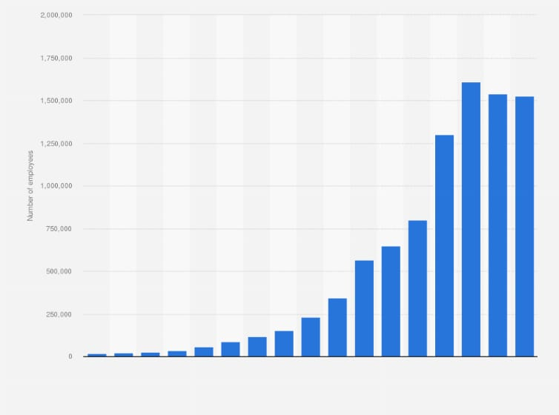

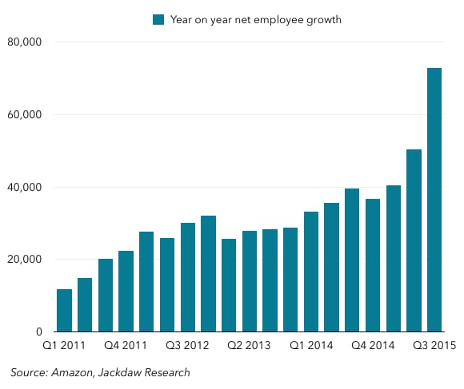

LIMITATIONS

1. Tailored Recognition Programs: Establishing a program to recognize employees for their efforts in keeping with Amazon's leadership tenets. Peer-to-peer recognition, management spot awards, and team-based recognition activities are a few examples of this.

2. Continuous Feedback Loops: Putting in place routine feedback systems to give staff members helpful criticism on their work and room for improvement. This could include pulse surveys to find out how employees are feeling, 360-degree feedback questionnaires, or quarterly check-ins.

3. Professional Development Opportunities: Providing training courses, mentorship programs, or financial aid for postsecondary education to enable individuals to enhance their skills and grow in their careers.

4. Flexible Work Arrangements: To help employees achieve work-life balance, employers should offer flexible work arrangements including reduced workweeks, flexible hours, or remote work choices

5. Wellness Initiatives: Putting in place wellness initiatives to assist staff members' emotional, mental, and emotional well-being.

6. Community Engagement: To provide a feeling of purpose and connection outside of the workplace, encouraging staff members to take part in volunteer or community service projects.

7. Transparent Communication: Encouraging openness and transparency in communication to make sure staff members are informed and participate in decision-making. Town hall gatherings, frequent email updates, or intranet platforms for disseminating corporate news might all be part of this.

CONCLUSION

In order to guarantee a motivated and contented staff, Amazon employs a variety of tactics for employee engagement and motivation. Competitive pay packages, chances for career progression, a focus on creativity and autonomy, generous employee perks including healthcare and paid time off, and an inclusive, diverse, and learning-oriented culture are some examples of these tactics. Nonetheless, complaints about labour laws and working conditions have been made, indicating the necessity for continual assessment and development in these fields. All things considered, Amazon's approach to employee motivation and engagement blends traditional awards with a commitment to innovation and customer-centricity.   
Amazon is introducing features including competitive pay packages, chances for professional growth, a focus on innovation, and a customer-focused culture. To guarantee that these tactics successfully promote worker happiness and well-being, it is necessary to continuously assess and modify them in light of concerns expressed about working conditions and employee burnout.

BIBLIOGRAPHY

1https://www.academia.edu/36524249/A_STUDY_ON_EMPLOYEE_SATISFACTION_AT_AMAZON_DEVELOPMENT_CENTRE_INDIA_PRIVATE_LIMITED_In_partial_fulfillment_of_the_requirement_for_the_award_of_MASTER_OF_BUSINESS_ADMINISTRATION

2-https://www.ukessays.com/essays/employment/motivation-in-the-workplace-amazon-case-study.php

3- https://www.scribd.com/document/551913506/Amazon-Case-Study

4-https://www.cliffsnotes.com/study-notes/4605271

5- https://www.newassignmenthelp.co.uk/analyse-the-effectiveness-of-pay-and-reward-strategies-at-amazon-fulfilment-assignment-sample-14543

6-https://www.totalassignmenthelp.com/free-sample/amazon-case-study-impact-of-employee-training-on-organisational-performance