**Master’s Thesis On**

**Revolutionizing Pharmaceutical Marketing Through Digital Transformation**

**FOR THE PARTIAL FULFILLMENT OF THE REQUIREMENT**

**FOR THE AWARD OF**

**MASTER OF BUSINESS ADMINISTRATION**

**UNDER THE GUIDANCE OF**

**Dr. Surinder**

**Submitted By**

**Rishab Srivastava**

**22GSOB2010508**



**SCHOOL OF BUSINESS**

**GALGOTIAS UNIVERSITY**

**Certificate**

This is to certify that the Master’s Thesis “Impact of Social Media on Students” has been prepared by Mr. Rishab Srivastava under my supervision and guidance. The project report is submitted towards the partial fulfillment of 2 year, Full time Master of Business Administration.

Name & Signature of Faculty

**Dr. surinder**

Date

**Declaration**

I, **Rishab Srivastava** Roll No. **22GSOB2010508, s**tudent of School of Business, Galgotias University, Greater Noida, hereby declare that the Master’s Thesis on “How can social media impact the buying choices of shoppers” is an original and authenticated work done by me.

I further declare that it has not been submitted elsewhere by any other person in any of the institutes for the award of any degree or diploma.

Name and Signature of the Student **Rishab srivastava**

Date

**ACKNOWLEDGEMENT**

I have benefited a lot from project during the of our course MBA 4th Semester project has been a rewarding knowledge.

I take this opportunity to acknowledge the invaluable assistance of those people who helped me in successful completion of this Dissertation thesis report.

I also thank my college and my mentor for steering my confidence and capability for giving me insight into training by giving me exposure to the area of competitive and real world.

Last but not the least, I express my thanks to all the person and friends who always encourage me and provided me support at all times. I am thankful to my friend who always helped & guided me.

(Rishab srivastava)

(MBA 4thsem)

**TABLE OF CONTENTS**

|  |
| --- |
| **TITLE** |
| Abstract |
| Objectives |
| Introduction   1. DIGITAL MARKETING 2. HISTORY 3. INDIA'S DIGITAL MARKETING SCENARIO 4. DIGITAL MARKETING IN INDIAN PHARMACEUTICAL INDUSTRY |
| Literature Review |
| Research Methodology |
| Data Analysis |
| Limitation |
| Appendix |
| Conclusion |
| References |

**ABSTRACT**

"Integration into the digital realm has become indispensable for everyday life, prompting industries across the board to swiftly adapt. However, the pharmaceutical sector has been relatively slow in fully embracing digital marketing, aside from maintaining a website. This industry confronts numerous hurdles in its marketing endeavors. Nevertheless, there is a notable shift towards utilizing social media and e-commerce platforms for digital marketing among pharmaceutical companies, catering to the preferences of today's consumers who increasingly favor online purchases. While some businesses are still in the process of fully unlocking the potential of digital marketing, others have seamlessly integrated it into their overarching marketing strategies. In an effort to enhance brand visibility, pharmaceutical companies are now forging partnerships with celebrities.

The indispensability of digital devices in daily life has spurred rapid adoption of online marketing by all industries. Yet, the pharmaceutical sector, save for website presence, has been slow to fully embrace digital marketing.

Digital marketing has facilitated the online sale of pharmaceutical and healthcare products through various Indian e-commerce platforms such as Netmeds.com, Img.com, Medidart.com, Medplusmart.com, and Apollo Pharmacy.in.

Exploring the factors driving consumers towards online purchases of pharmaceuticals and healthcare products amidst the existence of physical pharmacies, the study examines the impact of digital marketing on these sales. The findings suggest that digital marketing, employing strategies such as direct marketing, discounts, and promotional offers, can sway consumers towards online medication purchases, hinting at a promising future for digital marketing in the current market landscape.

Globally, an increasing number of businesses are leveraging social media platforms to harness their viral potential. However, pharmaceutical digital marketing offers diverse avenues for all companies to effectively promote their products and brands to pertinent audiences, including physicians and patients. It is imperative for pharmaceutical marketing strategies and advertising campaigns to adhere to the industry's stringent regulations. Already, businesses are leveraging emerging technologies to expand their reach and engage with a broader customer base."

**OBJECTIVE**

* The main objective of this article is to pinpoint the traits that incentivize customers to buy medications and healthcare items via online channels.
* The aim of this study is to examine the impact of digital marketing on consumers who make purchases of medications and healthcare products through online platforms.
* The objective is to recognize the proper implementation of digital marketing within the pharmaceutical sector.

**INTRODUCTION**

Digital marketing entails the exchange of data, goods, and services through computer networks or the internet, reshaping various aspects of the economy, including supply chains, customer interactions, revenue streams, and organizational structures. In the healthcare realm, the primary goals of innovation have traditionally centered on enhancing patient outcomes, promoting preventive care, and alleviating physicians' burdens. Projections suggest a significant growth in the digital healthcare market in the US by 2028, reaching $295.4 billion, up from $110.2 billion.

Digital marketing serves as a vital tool for businesses to engage with customers online and promote their offerings. It encompasses both traditional marketing methods and internet-based platforms, facilitating diverse digital media formats such as display advertising, mobile marketing, social media campaigns, and search engine marketing.

Despite the presence of technically proficient companies, the application of digitalization in the pharmaceutical sector remains limited, largely due to a dearth of credible case studies and the industry's conservative practices and regulatory complexities. However, digital marketing strategies, including social media engagement, hold promise for enhancing brand perception among pharmaceutical companies.

The pharmaceutical industry's future appears promising due to its adaptability and the availability of technologies fostering innovation. Recent technological advancements aid companies in expanding their customer base, raising awareness, promoting engagement, gathering insightful data, and making meaningful contributions.

Navigating pharmaceutical marketing campaigns and maintaining market leadership pose challenges amidst stringent regulations. Nonetheless, pharmaceutical digital marketing offers significant opportunities for healthcare organizations to market their products and brands effectively to relevant audiences, including patients, businesses, and healthcare professionals.

1. DIGITAL MARKETING

The most significant advancements of the twenty-first century will arise from the convergence of healthcare and technology, marking the onset of a new era, as articulated by Steve Jobs. The promotion of products and services through online channels, including mobile devices, display ads, and digital television platforms, is the domain of digital marketing professionals. The emergence of electronic marketing in the 1990s and 2000s has transformed how companies and brands leverage technology for promotional purposes. Internet marketing initiatives are gaining traction and effectiveness, fueled by the widespread adoption of digital platforms in daily life and marketing strategies, alongside the increasing preference for digital devices over traditional brick-and-mortar stores.

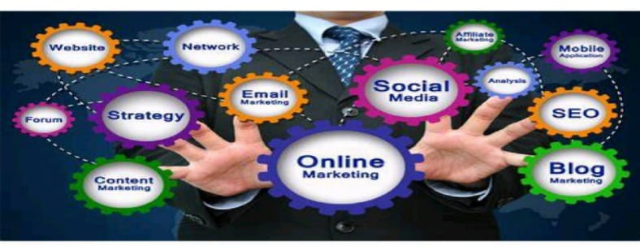

1. HISTORY

The evolution of technology is closely intertwined with the expansion of internet marketing. A pivotal moment in email history occurred in 1971 when Ray Tomlinson introduced the capability for users to exchange files across different devices. The development of Archie's search engine in 1990 provided a directory for FTP sites, marking a significant milestone in the emergence of internet marketing. By the 1980s, computers had sufficient storage capacity to handle large volumes of client data, prompting businesses to transition from traditional list brokers to online strategies like database marketing. This transition enabled companies to track customer information more efficiently, reshaping the dynamics between buyers and sellers. However, manual processes remained inefficient. The term "Internet advertisement" emerged in the 1990s alongside the rise of CRM software, which became essential for promotional activities with the advent of site/client architectures and the widespread use of personal computers. In response to intense competition, software vendors began offering additional services such as sales, service, and marketing applications to meet evolving demands.

The introduction of eCRM software facilitated the acquisition of vast amounts of online customer data, enabling marketers to prioritize customer experience and update information about client preferences. Notably, AT&T's "You Will" campaign launched the first clickable banner advertisement in 1994, with 44% of viewers engaging with it within the first four months.

The rise of the internet and the iPhone in the 2000s prompted consumers to conduct product research and make purchases online before contacting salespersons, posing challenges for companies without an online presence. This spurred marketers to explore digital avenues for market expansion. Marketing automation emerged in 2007 as a solution to these challenges, enabling companies to launch marketing campaigns, segment their consumer base, and provide personalized information. However, its adaptation to consumer electronics was slow. The 2000s and 2010s witnessed a significant increase in devices with access to digital media, leading to advancements in internet marketing. Statistics from 2012 and 2013 indicated sustained growth in this field. The emergence of social media platforms like LinkedIn, Facebook, YouTube, and Twitter further intensified consumers' reliance on the latest electronic devices, fueling expectations for a seamless product search experience across multiple platforms. This shift in consumer behavior bolstered the diversification of marketing technologies.

1. INDIA'S DIGITAL MARKETING SCENARIO

India boasts the world's third-largest population of internet users. Since the inception of the internet, marketing strategies have undergone significant evolution to engage with the public, with digital marketing emerging as a dominant force. In India, the internet serves various functions in people's daily lives beyond mere awareness, leading to a thriving digital marketing industry. Social media platforms play a key role in driving the adoption of digital marketing in the country.

The retail sector in India, both online and offline, is experiencing rapid growth. Although India entered the online shopping arena later than many other countries, it is quickly catching up. Projections indicate a 55% annual increase in online sales in the coming years, driven by the country's large internet user base, which is expected to surpass 330 million by 2015, largely due to the rapid adoption of mobile commerce.

Social media platforms are instrumental in advancing digital marketing, particularly among young, affluent consumers who spend significant time and money online, influencing purchasing trends. Popular online products range from consumer electronics to clothing and cosmetics, with major metropolitan areas such as Mumbai, Delhi, and Kolkata serving as hubs for online shopping. Platforms like Snapdeal, established in 2012, facilitate a substantial portion of online transactions.

While the internet currently contributes modestly to India's GDP, analysts foresee a forthcoming boom in retail internet sales. Indian youth, known for upholding strong moral and family values while prioritizing education and careers, represent a significant market segment that influences businesses to cater to their preferences. This study assesses the impact of youth marketing and provides valuable insights for marketers to tailor their strategies effectively to target both current and potential adolescent markets.

YOUTH PURCHASING BEHAVIOUR

Consumer behavior plays a significant role in shaping purchasing patterns, particularly among young people. "Behavioral marketing" involves identifying connections between market offerings and specific consumer behavior segments. This discipline entails segmenting the market based on consumer behavior characteristics, positioning products to align with the interests, activities, and attitudes of the target audience, and implementing customized promotional campaigns accordingly.

Pharmaceutical companies are actively responding to the transformative impact of digital technology. In recent years, businesses in this sector have embraced digital marketing as a novel approach to engaging with patients, healthcare professionals, and caregivers. Technologies such as cloud computing, mobile communication, advanced analytics, and the internet are driving profound changes in the healthcare landscape. In India, while most pharmaceutical organizations primarily use digital platforms to disseminate therapy information and offer basic dietary advice, nutrition guidance, and exercise tips, only a limited number are actively involved in marketing over-the-counter (OTC) products. Nutraceutical companies show relatively greater enthusiasm in leveraging digital marketing strategies for their products.

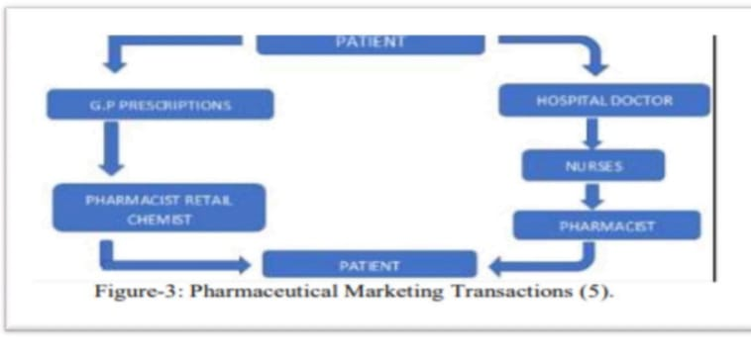

**CONCEPT OF PHARMA**

The roots of the Indian pharmaceutical sector date back to the early 19th century, when it began to take form. Initially, the industry emerged as a result of the British importing medications for their own needs. Over time, as these medications became widely used and traditional medical systems declined, the Indian pharmaceutical industry gradually asserted its dominance over the nation's healthcare landscape. Concurrently, the production of surgical dressings also began during this period.

Today, the Indian pharmaceutical industry has become a major player in the global generics market by supplying high-quality medications on a large scale. By offering essential medications that are both accessible and affordable, the sector has captured a significant market share in developed countries like the United States (where it accounts for one out of every three pills) and the United Kingdom.

**Pharamaceutical Market**

Since its inception in the early 19th century, the Indian pharmaceutical market has undergone consistent evolution, with marketing playing a crucial role, especially given the country's legislative and regulatory environment. Traditional marketing techniques continue to be the primary strategies employed in the pharmaceutical sector, particularly where Registered Medical Practitioners (RMP) and Healthcare Providers (HCP) play a significant role in fulfilling patient needs. Despite ongoing advancements and modernization within the industry, traditional marketing methods persist due to the specific regulatory framework governing pharmaceutical marketing in India.

**PHARMACEUTICAL MARKETING**

Pharmaceutical marketing refers to a management process aimed at identifying and effectively meeting patients' needs for pharmaceutical products. This comprehensive approach encompasses various strategies such as providing free samples, offering detailed product literature, implementing disease management programs, distributing patient support materials, launching internet initiatives, and organizing events or meetings for physicians. The primary objective is to enhance awareness of both new and established pharmaceutical brands among healthcare professionals and the general public.

The product The doctor The Patient

Figurel- Flow pharmaceutical product

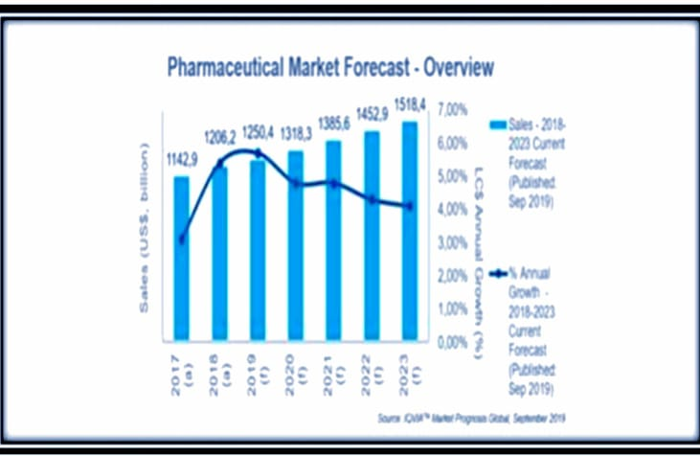

**Pharmaceutical traditional marketing**

Traditional marketing in the pharmaceutical industry differs significantly from other sectors, primarily relying on personal selling as its predominant form. Personal selling, particularly through detailing, is the cornerstone of pharmaceutical marketing, wherein medical professionals are engaged through various promotional activities to establish trust and potentially encourage the prescription or distribution of medications. Detailing involves sales representatives meeting with healthcare professionals to provide them with product information, samples, and other promotional materials. These tactics are primarily executed through sales representatives, who utilize a range of promotional materials such as literature, drug samples, gifts, and pamphlets containing detailed drug information. This personalized approach is crucial for building relationships and influencing prescribing behavior within the pharmaceutical industry.

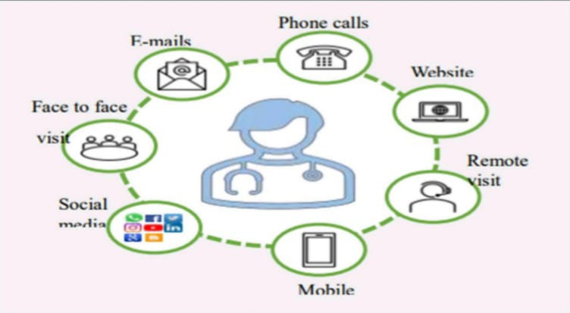

Omnichannel marketing

**Wearable medical equipment**

The market for wearable medical technology is experiencing rapid expansion. Projections suggest that by 2027, it will reach a value of $195.57 billion. Wearables are appealing due to their ability to offer data for preventive healthcare measures. Fitbit, perhaps the most recognizable wearable device for collecting biometric data, highlighted how wearables can contribute to combating the COVID-19 pandemic. Fitbit found that its tools can detect nearly half of all COVID-19 cases one day before participants report symptoms.

**TRADITIONAL+DIGITAL) PHYGITAL**

Based on doctor behavior and research findings, it appears that they are generally not enthusiastic about monthly meetings with medical representatives. Many doctors perceive these meetings as disrupting their daily routines and feel they don't gain sufficient knowledge during the typical 3-5 minute consultations.

This underscores the importance of digital marketing, which is becoming just as essential as traditional marketing for reaching both consumers and healthcare professionals. Digital platforms serve as a common ground for providing better services.

Due to existing norms and regulations, completely transitioning from traditional to digital marketing can be challenging. Therefore, a more effective approach involves blending digital and traditional marketing, known as PHYGITAL.

Implementing the PHYGITAL framework in marketing can bridge the gap between consumer needs and pharmaceutical services. An integrated strategy enhances the overall consumer experience, with studies indicating that robust omnichannel engagement can boost client retention by up to 90%. Selecting the appropriate platform is a critical aspect of digital marketing. Given the advantages and limitations of both traditional and digital marketing, the PHYGITAL model helps address these gaps, recognizing that not all social media platforms are suitable for every pharmaceutical company. Effective strategy and planning are pivotal in PHYGITAL marketing endeavors.

**DIGITAL MARKETING CHANNELS**

1. Search engine optimization
2. Email Newsletters
3. Pay Per Click Ads
4. Social Media Marketing
5. E-Detailing
6. ECMES
7. Content marketing
8. Management of Online Reputation
9. Affiliate marketing
10. Display advertising

**REVIEW LETERATURE**

Pharmaceutical marketing, or pharma marketing, is a specialized field within pharmaceutical management that covers various marketing strategies. It impacts medical practitioners, pharmacists, and general consumers alike. Extensive research has been conducted in this area, prompting this report to examine the current understanding. The authors of the report have segmented their findings into four key areas: Pharmaceutical Marketing Mix, Consumer Behavior Regarding Pharma Products, Green Marketing Strategies, and Execution of Pharma Marketing Initiatives. (https://doi.org/10.31033/ijemr. 12.2.10)(April-2022).

**Paul, 1996**" The fastest-growing type of direct marketing is online marketing," according to Philip Kotler. The internet has dramatically influenced consumer perceptions of convenience, pricing, product information, and service, and modern marketing demands that businesses commit to being customer-focused (Jaworski and Kohli, 1993). As a result, a large digital presence is critically necessary for all businesses nowadays.

Rowley (2001) Internet advertising is a sort of advertising that makes advantage of the Internet to draw customers through the delivery of messages via websites or placing banner ads on other well-known websites that point internet users to a business's website. The website of the business must be reachable. The website should be well-planned, well- designed, and easy to use in order to draw in more of the target audience.

According to Ratchford et al. (2001), consumers may evaluate products between sellers and gather information about products utilising the Internet at a minimal cost. They can also rapidly and effectively examine the available choices to determine the best pricing for a certain commodity.

To achieve profitable consumer acquisition and retention (within a multi-channel buying process and consumer lifecycle) through improving our consumer knowledge (of their profiles, behaviour, value, and trustworthiness), Dave Chaffey (2002) defines eMarketing as the utilisation of digital technologies that create platforms for communication (Web, e-mail, statistics, and databases, as well as mobile/wireless & digital TV).

In Chaffey's definition, which emphasises that the business model, not technology, should drive electronic marketing, the relationship marketing idea is reflected.

(<http://www.wnim.com/archive/issue2904/eMarketing.htm>).

Delone and Reif (2004) found that when clients gain greater understanding of the process, they are more inclined to continue making online purchases. Young individuals have also been found to have a more receptive attitude towards online purchasing.

The creative visual appeal of web-websites that communicate a sense of inventiveness and individuality have been expressed by Lavie and Tractinsky (2004). This style of aesthetics is likely to be relevant while searching for speciality items. Because of their distinct traits, speciality goods benefit from expressive design, which emphasises shopping knowledge.

**According to Foux (2006)** Buyers view social media as a more reliable source of information about goods and services than messages produced by businesses and distributed through conventional elements of a marketing mix.

**Vollmer and Precourt, 2008; Lempert, 2006** A mass media platform for consumer- sponsored communication, the World Wide Web has developed throughout time. It is currently the second most popular media source at home and the most popular media source for customers at work. Traditional advertising channels including radio, television, magazines, and newspapers are losing customers. More control over media consumption is still something that consumers want. They need immediate, on-demand access to information that they may use whenever they choose. Customers are increasingly doing informational searches and making judgements about purchases on numerous social media platforms.

Cavusgil 2008 In this study, the researcher examines the effects on physicians of certain marketing communication acts (advertising and sales force). Medicines for the gastrointestinal tract (GID) are being researched as a single therapeutic group. An economist studies the effects of pharmaceutical marketing campaigns, focusing on the return on investment (ROI). The results of this study can assist managers in maximising the promotional mix during the course of a product's life cycle. The effects of other promotional strategies, including advertisement directly to consumers, journal advertisements, and sales force, are also examined.

**2009, Steltzner** Many practitioners now regard online marketing as the new arena for market communication, with Facebook, blogs, Twitter, YouTube, and LinkedIn at the top of the list of users of the various mediums.

According to **Jerry (2009),** Online marketing has emerged as the most effective and widely used form of global communication. Global idea, concept, and product and service information exchange is a component of web-based advertising communication.

According to a **McKinsey** survey, Companies are making extensive use of wikis and other digital platforms for customer assistance. Digital technologies are used by two thirds of enterprises for online advertising and product creation. Today, the majority of businesses do not combine their offline and online marketing efforts, but in the near future, there will be a growing trend for businesses to use online tools throughout the full spectrum of marketing operations.

Greene, **J.A., and A.S. Kesselheim**, 2010 The main social media Web sites, Facebook and Twitter, have over 350 million users globally. According to research, 60% of Americans seek health-related information on the Internet first. As a result, the pharmaceutical industry is preparing to build a social media presence.

Mckensy's report April 2012 The pharmaceutical business should transition to digital and interactive forms of media, and starting in 2009, the sector has embraced social media or digital media, which enables online conversations with physicians and patients. According to the article "Demystifying the world of social media," chief marketing officers want to increase social media spending from its current level of less than 1% of average marketing expenditures to 5%.

According to **IBM (2012**), Social media may be used by drug manufacturers to track brand reputation and get crucial customer input for better marketing innovation. Therefore, pharmaceutical companies can use social media to enhance their patient relationships. In the pharmaceutical sector, it might be challenging to rely on marketing, but WHO (1998) has not addressed any concerns with regard to commercials that are transmitted on electronic media.

May **2012, Oswal and Deshmukh** The study looks into current pharmaceutical marketing strategies, with a particular emphasis on medical representatives, pharmacies, physicians, and consumer-focused advertising. It gives instances of marketing strategies and the impact they have on patient and customer behaviour. It outlines the negative effects of these behaviours. Around the city of Pune, research is being done on anti-diabetic drugs already on the market.

The majority of the research points to a beneficial effect of digital marketing on the sales of prescription drugs. Digital marketing techniques raise consumer knowledge of pharmaceutical items, which increases the possibility that doctors will recommend them, and eventually raises sales. It is crucial for pharmaceutical companies to adjust their digital marketing plans to the unique demands of the market and track how well it affects both sales and brand awareness.

**RESEARCH METHODOLOGY**

The study draws upon both primary and secondary sources of information.

For primary data, a questionnaire was utilized as the primary tool for data collection, specifically designed for this study.

Secondary sources included research papers, journals, periodicals, and relevant websites.

The sample size consisted of the opinions of 100 customers from various cities in Bihar, India, who currently purchase pharmaceutical and healthcare products online.

Data analysis involved the use of simple charting and tabulation tools, as well as an empirical technique known as a Likert scale, with a maximum of five points ranging from 1 (Strongly Disagree) to 5 (Strongly Agree). Likert scales are commonly used in survey research.

The data analysis process led to the formulation of conclusions based on the findings.

**RESULTS AND DISCUSSION**

The data analysis and discussion of conclusions are pivotal stages in the study. This section will delve into the empirical findings, primarily focusing on the primary information gathered through surveys.

Beginning with demographics, respondents provided data regarding age, gender, income, and education. After completing this initial stage, researchers will proceed to analyze the first part of the questionnaire, focusing on factors driving online purchases and the impact of digital marketing. This part comprises six questions, each representing a distinct module, resulting in a total of six modules, as illustrated in Table 1.

Each module will be independently analyzed and explained using frequency tables, graphs, and Likert scale scores. The researchers employed a five-point Likert scale, where a score of 5 indicates strong agreement and a score of 1 indicates significant disagreement.

For instance, if "Strongly agree" corresponds to "5" and the other terms are "4, 3, 2, 1," the calculation can be demonstrated as follows: (5*37) + (4*43) + (3*112) + (2*7) + (1*2) = 406. This result is then divided by the total number of responses (100), yielding the average score for that module. This process will be repeated for all six modules, with each one examined independently. Subsequently, researchers will compute the average score for each module and then determine the average for each group by combining the averages from all modules. Finally, the average scores will be ranked from highest to lowest.

**Demography:-**

**Online Buyer**

|  |  |  |  |
| --- | --- | --- | --- |
| **Gender** | **Category** | **No. of Respondent** | **Percentage of Respondent (%)** |
| **Male** | **72** | **72** |
| **Female** | **28** | **28** |
| **Total** | **100** | **100** |
| **Age** | **Below 18 years** | **0** | **0** |
| **19-30 years** | **69** | **69** |
| **31-50 years** | **31** | **31** |
| **Above 45 years** | **0** | **0** |
| **Total** | **100** | **100** |
| **Profession** | **Employee** | **33** | **33** |
| **Business** | **19** | **19** |
| **Student** | **27** | **27** |
| **Any Other** | **6** | **6** |
| **Total** | **100** | **100** |
| **Monthly family**  **income** | **Below 10000** | **27** | **27** |
| **10000-40000** | **44** | **44** |
| **Above 40000** | **29** | **29** |
| **Total** | **100** | **100** |
|

**TABLE Frequency findings for participant concurrence with statements are provided. Each statement is treated as its own module.**

|  |  |  |  |  |  |  |  |  |
| --- | --- | --- | --- | --- | --- | --- | --- | --- |
| **Mo Module** | **Strong**  **agree** | **Agree** | **Neutral** | **Disagree** | **Strongly**  **disagree** | **Total**  **weight** | **Avg** | **Rank** |
| **You find it secure while go for ff online marketing** | **27(135)** | **50**  **(200)** | **12**  **(36)** | **8**  **(46)** | **2**  **(2)** | **389** | **3.89** | **IV** |
| **Enhancing the standard of education will enhance the efficiency of digital marketing** | **37(185)** | **43**  **(172)** | **11**  **(33)** | **7**  **(14)** | **2**  **(20** | **406** | **4.06** | **I** |
| **The product & price details are transparent or clear** | **26(130)** | **43**  **(172)** | **19**  **(57)** | **6**  **(12)** | **6**  **(6)** | **377** | **3.77** | **V** |
| **easy way to purchase** | **36(180)** | **44**  **(176)** | **10**  **(30)** | **5**  **(10)** | **4**  **(4)** | **400** | **4** | **III** |
| **D Discount and offer encourage you to make online purchase** | **38(190)** | **42(168)** | **12**  **(36)** | **2**  **(4)** | **4**  **(4)** | **402** | **4.02** | **II** |
| **Digital video advertisement Great influence you** | **25(125)** | **42**  **(168)** | **26**  **(69)** | **6**  **(12)** | **4**  **(4)** | **378** | **3.72** | **VI** |

**Analysis Of Six Modules**

**1) Safety Perception in Digital Marketing:**

**In the first module, "You find it safe while you go for digital marketing," 16% of respondents agreed that they feel safe engaging in digital marketing, while only 5% disagreed. The average score for this module, calculated by dividing the total score by the sample size of 100 and multiplying each frequency by the corresponding Likert scale score, is 4.23. This indicates that online buyers generally feel safe while using digital marketing to shop online.**

**2) Education Level and Digital Marketing Effectiveness:**

**Regarding the statement "Increasing education level will make digital marketing more successful," 43% of respondents strongly agree, while 22% agree. Only 13% disagree with the assertion. The average score for this module is 3.89, suggesting that respondents have a positive attitude towards the idea that increasing their level of education will enhance the effectiveness of digital marketing.**

**3) Transparency of Price and Product Information:**

**For the statement "Price and Product Information Is Transparent," 34% of respondents strongly agree and 41% agree. Only 10% disagree with this assertion. The average score for this module is 3.93, indicating that respondents generally believe that product pricing and information are transparent when purchasing medicine and healthcare products online.**

**4) Influence of Easy Mode of Purchase:**

**Regarding the assertion "Easy mode of purchase influences us," 62% of respondents strongly agree and 22% agree. Only 5% disagree with this statement. The average score for this module is 4.35, showing that respondents have a positive attitude towards the ease of purchasing online, which influences their decision to buy.**

**5) Influence of Discounts and Offers:**

**For the statement "Discounts/Offers Influence Us to Buy Online," 46% of respondents strongly agree and 35% agree. Only 6% disagree with this assertion. The average score for this module is 4.17, indicating that respondents perceive discounts and offers as motivating factors for online purchases.**

**6) Influence of Digital Video Advertising:**

**Regarding the assertion "Digital Video advertising has a large influence on us," 57% of respondents strongly agree and 22% agree. Only 7% disagree with this statement. The average score for this module is 4.27, suggesting that respondents believe digital video advertising significantly influences their decision to purchase medicine and healthcare products online.**

**Awareness" of online shoppers"**

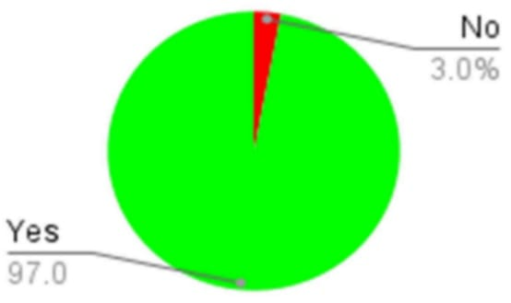

**It is assumed that out of 100 the total 97 respondents are familiar with internet buying and 3 are not aware about it.**

**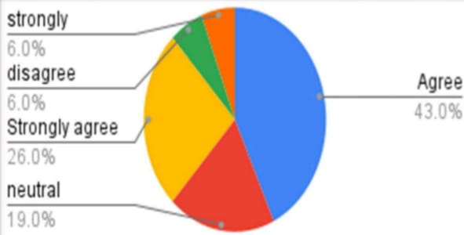  
Consider whether the information provided about the product on the website is sufficient:**

**LIMITATION OF THE STUDY**

**1. Data Reliability and Bias: The reliance on individual opinions for data collection introduces potential bias, posing significant limitations to the study's findings.**

**2. Geographic Limitations: The study's focus on customer preferences in Bihar may limit the generalizability of the conclusions to other regions, presenting a constraint to the study's applicability.**

**3. Constraints on Consumer Views: Factors such as personal bias and limited expressiveness among consumers may restrict the depth and accuracy of the data collected, impacting the study's comprehensiveness.**

**4. Novelty of Internet Marketing in Pharma Industry: The novelty of internet marketing within the pharmaceutical industry may lead to challenges in fully understanding and catering to customer preferences, potentially hindering the effectiveness of digital marketing strategies.**

**5. Sample Representation: There is a possibility that the chosen sample may not accurately reflect the broader population, leading to discrepancies between the study's findings and real-world phenomena, thereby limiting its external validity.**

**Despite these limitations, the study offers valuable insights into how digital marketing influences consumer purchasing behavior and explores opportunities for maximizing marketing advantages. As an exploratory study, it lays the groundwork for further investigation in the field, highlighting areas for future research and development.**

**CONCLUSION**

**In today's business environment, digital marketing holds a bright future. Consumers increasingly favor online shopping, influenced by factors like targeted digital marketing, discounts, various payment methods, and fast delivery. This shift has not only reshaped the economy but also transformed marketing, presenting opportunities and challenges for marketers in competitive fields.**

**Pharmaceutical and healthcare ecommerce industries can greatly benefit from embracing digital marketing and tailoring their strategies to consumer preferences. With many people spending significant time on digital devices, such as smartphones and tablets, the importance of digital marketing in the pharmaceutical sector cannot be overstated.**

**According to available research, digital marketing is vital for the pharmaceutical industry's rapid growth. It has become a cornerstone of marketing efforts, enabling streamlined campaigns. While some digital strategies are well-established, others are still evolving. Nevertheless, all digital marketing methods offer accessibility and significant cost savings in terms of time and effort.**

**Pharmaceutical companies are utilizing these technologies to navigate the modern digital landscape. However, the effectiveness of these strategies is most evident in platforms like blogs and Facebook, indicating ongoing exploration and refinement of digital marketing approaches within the pharmaceutical sector.**

**APPENDIX**

**1. Awareness of online shoppers**

**2. You find it secure while you go for online marketing**

**3. Enhancing the standard of education will enhance the efficiency of digital marketing**

**4. The product price and related details are transparent or clear**

**5. Easy way to purchase**

**6. Discount and offer encourage you to make online purchase**

**7. Digital video advertisement positive influence you**

**8. Reason for choosing online shopping**

**9. Which advertising method do you trust?**

**10. Which advertising sources encourage you to buy a product online?**

**11. 'frequency of online purchase**

**REFERENCES**

**1. International Journal of Pharmaceutical Research and Applications Volume 6, Issue 6 Nov-Dec 2021, pp: 249-266 www.ijprajournal.com**

**2. Richa Mishral, Gaurav Tripathi URL For the publication, "A Study on Impact of Digital Marketing on Online Medicine and Healthcare Products Sales in Uttar Pradesh, India"**

**https://www.ijltemas.in/DigitalLibrary/Vol.7Issue5/65-69.pdf 3. Sivasankaran S., "Digital Marketing and Its Impact on Youth Buying Behaviour," International Journal of Research in Management & Business Studies (URMBS**

**2017), p. 35.**

**4. E-business & e-Commerce Management: Strategy, Implementation, and Practise, Chaffey D. 2009, Paris: Pearson Education, page 16.**

**5. "A Study on Digital Marketing and Its Impact," Journal of Chemical and Pharmaceutical Sciences, Deekshith.D and Kinslin D.**

**6. Parekh Dhara, Shah Ketan, and Kapupara Pankaj URL for the publication "Digital Pharmaceutical Marketing: A Review": https://www.researchgate.net/publication/297726227 Digital Phar maceutical_Marketing_A_Review”**

**7. Madhusudhana, K. (2021). Role of information and promotional strategies for Indian pharmaceutical firms in the age of digital marketing.EPRA International Journal of Research and Development (IJRD), 6(3), 170-172.**

**8. Rejikumar, G., Asokan, A. A.& Kumar, G. V. (2018).Pharmaceutical marketing: Directions for customer orientation. Research Journal of Pharmacy and Technology, 11(8), 3283-3289**

**9. G. R. S. (2017). Mapping of online pharmaceutical marketing practices: Review of literature. IMPACT: International Journal of Research in Humanities, Arts and Literature, 5(11), 15-26**

**10. Bhangale, V. (2008). Pharma marketing in India: opportunities, challenges and the way forward. Journal of Medical Marketing, 8(3), 205-210**