**CROWDFUNDING THROUGH BLOCKCHAIN**

## **Shubham Kirve , Divyesh Patel , Kunal More , Soubiya Mullaji**

## **Prof. Sayali Karmode**

Mahatma Gandhi Mission’s College of Engineering and Technology

(Affiliated to University of Mumbai and Approved by, AICTE, New Delhi.) Plot No. 1, 2, Sion - Panvel Expressway, Sector 18, Kamothe, Navi Mumbai, Maharashtra410209 Website : [www.mgmmumbai.ac.in](http://www.mgmmumbai.ac.in/)

Department of Information Technology

**ABSTRACT**

People's sensitive and important data can be viewed quite differently thanks to blockchain technology. Every transaction is irrevocably logged and time- and date-stamped. Even transactions can be automated using smart contracts, increasing efficiency and accelerating

the procedure even further. The transaction or process advances to the following step when pre-established requirements are satisfied. Smart contracts do away with the need for third parties to confirm that the terms of the contract have been met and the necessity for human intervention. In order to provide a dependable, secure, transparent, and decentralized solution, a blockchain-based crowdfunding web application is developed. Transparency and security are critical issues for any organization, but they are especially so for those that operate crowdfunding platforms.

**INTRODUCTION**

Every transaction is recorded in an uncorruptible digital ledger called the blockchain. Since it's a distributed system, every node in the decentralized network houses every record. Ethereum-approved running apps on the blockchain are called smart contracts. It permits the execution of every smart contract. Using crowdfunding to raise money for creative project ideas is a simple process. The problem with the existing crowdfunding platforms is that they often charge exorbitant fees and engage in dishonest business practices. Avoiding these kinds of problems can be aided by implementing a blockchain crowdfunding process. Smart agreement for crowdfunding removes the usual platform costs and transaction fees associated with other crowdfunding stages, like Kickstarter, by combining Peer to Peer. Blockchain technology is still relatively young. Only a small number of studies and research are available online. A distributed database containing records of every transaction that has been carried out and distributed among interested parties is what blockchain is. The characteristics of blockchain includes auditability, persistency, anonymity, and decentralization of information. The blockchain framework consists of two main components: the transaction and the block. The term "transaction" refers to the action initiated by the member, whereas "block" refers to a grouping of data that documents the transaction as well as additional details linked to it, such as the correct sequence, creation time, and so forth.

**LIETERATURE REVIEW**

The results show that due to their inadequate knowledge of crowdfunding, young entrepreneurs were unable to fully research a range of potential business models, especially the investment-related one. Additionally, they think it makes it simpler to solicit consumer feedback and engage with a wider audience.The two FinTech applications of crowdfunding and blockchain are not well covered in the economics and finance literature, according to Cynthia Weiyi Cai's study[2]. It is based on an evaluation of 402 papers written between 2010 and 2018, which included a detailed analysis of important works in the field. The examination of them shows that the blockchain's trust component reduces the need for middlemen, though not across the board in the financial industries. The two FinTech applications of crowdfunding and blockchain are not well covered in the economics and finance literature, according to Cynthia Weiyi Cai's study. It is based on an evaluation of 402 papers written between 2010 and 2018, which included a detailed analysis of important works in the field. The examination of them shows that the blockchain's trust component reduces the need for middlemen, though not across the board in the financial industries.

**1.2. FEATURES**

1. Smart contracts — automate processes done manually and ensures security.

2. Capped contracts — you set a minimum amount of funds needed for a project to be viable. If this amount is not reached during funding, all funds return to the investors.

3. Time vault contracts — you can set time limits after which a user won’t be able to withdraw the tokens. If an investor would like to withdraw their funds back, they will not be able to do it after a certain deadline.

**1.3. INTENDED AUDIENCE**

i. Entrepreneurs and Startups

ii. Investors

iii. Crypto currency enthusiasts

iv. Non-profit organization

v. Supporters of social cause.

**3. SYSTEM DESIGN**

3.1 Design and Development

Prior to building any application from scratch, it is important to plan the design flow of the application. The user interface design is essential to know how the application is intended to work. Planning an application involves some specific strategies. Many strategic questions come to the mind while designing and planning an application like there might be apps in the app store similar to your idea, what the need of such an application in the market is, what features make your app unique, what will make the people use your app and not the ones designed by others, how much time the application will take to develop, what user requirements either small or big should be considered, what category should the app fall into, etc.

3.2 Proposed System:

The convergence of cryptocurrency and crowdfunding has sparked immense interest online. To address existing challenges in both realms, we propose leveraging blockchain technology. Here’s how our system works:

1.Campaign Creation and Listing:

A fund initiator creates a campaign and lists it on our platform.

All projects are displayed on the portal for potential backers to explore.

2.Backer Classification:

Backers can choose to support a project based on their contribution amount.

If the donation meets or exceeds the minimum set by the fund initiator, the backer becomes either a “backer” or a “normal donor.”

3.Smart Contracts and Approval:

A smart contract manages the funds.When a specified condition is met (e.g., campaign goal achieved), all donated money accumulates in a pool. The fund initiator requests approval from backers. For funds to be released, more than 50% of backers must approve the transaction.

4.Direct Transfer to Initiator:

Once approved, funds are directly transferred to the fund initiator. No intermediaries are involved, ensuring transparency and efficiency.

5.Blockchain and Decentralization:

We utilize Ethereum, a blockchain-based platform, and its cryptocurrency, Ether. Ethereum’s decentralized virtual machine (EVM) enables application execution on public nodes.

6.Mining and Transaction Validation:

In our distributed system, new transactions are added through mining.Miners compete to generate hash values that meet predefined criteria.

Our proposed system combines the security of blockchain, efficient smart contracts, and direct backer approval, revolutionizing crowdfunding for the digital age.

**4.Feasibility Analysis**

4.1. Operational Feasibility

The project is operationally feasible. The platform is easy to use and maintain, and the crowdfunding process is automated as much as possible.

4.2 Economic Feasibility

The project is economically feasible. The cost of developing and maintaining the platform is reasonable and the revenue generated from the platform is sufficient to coverthe costs and generate profits.

4.3 Structured System Requirements Structured system requirements for a crowdfunding project using blockchain may include:

4.3. User Registration And Authentication

• The system shall allow users to register and create a profile using their email address or social media account. • The system shall use two-factor authentication to verify the identity of users.

• The system shall store user data securely using encryption and other security measures

4.3.2 Project Creation:

• The system shall allow project creators to create and submit their crowdfunding projects using a web-based interface.

• The system shall allow project creators to provide details about their project, including the project description, funding goal, and duration of the campaign.

• The system shall require project creators to provide a project video or other media to promote their project.

4.3.3 Payment Processing:

• The system shall allow users to make contributions to projects using cryptocurrency, such as Bitcoin or Ethereum.

• The system shall use a secure and reliable payment processing system to ensure the safe and efficient transfer of funds.

• The system shall provide a receipt or confirmation of payment to the user.

4.4.4 Smart contract execution:

• The system shall execute smart contracts that automate the crowdfunding process, including managing contributions, tracking project funding progress, and distributing rewards to backers.

• The system shall use Ethereum smart contracts or other compatible blockchain technology.

• The system shall automatically transfer funds to the project creator's account when the funding goal is reached.

4.4.5 Security:

• The system shall have robust security features to ensure the safety and security of user data and transactions.

• The system shall use encryption and other security measures to protect user data.

• The system shall use multi-factor authentication to prevent unauthorized access.

4.4.6 Integration with blockchain:

• The system shall be integrated with blockchain technology to ensure the security, transparency, and immutability of transactions.

• The system shall use Ethereum or other compatible blockchain technology.

• The system shall follow best practices for blockchain integration and development.

• By defining structured system requirements, you can ensure that the crowdfunding project using blockchain is developed and implemented in a systematic and organized manner, leading to a successful and effective platform.

**5.IMPLEMENTATION**

Metamask is primarily used for facilitating transactions and interacting with decentralized applications on the Ethereum blockchain. Users can send and receive Ether and ERC-20 tokens, as well as engage in decentralized exchanges (DEXs), lending and borrowing protocols, and yield farming.

A Metamask wallet is a digital wallet provided by the Metamask browser extension, allowing users to securely store, send, and receive Ethereum-based assets. It functions as a decentralized wallet, meaning that users have full control over their private keys and funds, without relying on a centralized authority.

Metamask wallets are compatible with various Ethereum-based tokens and support the creation of multiple accounts within a single interface, offering flexibility and convenience to users managing different assets or engaging in different activities within the Ethereum ecosystem.

By providing a secure and user-friendly solution for interacting with decentralized applications and managing cryptocurrency assets, Metamask has played a significant role in popularizing blockchain technology and fostering the growth of the Ethereum ecosystem.

Certainly! Here’s a concise summary of **Sepolia**:

**Sepolia** is an **Ethereum testnet** designed for developers to test their applications and smart contracts before deploying them on the mainnet. It provides a safe environment for experimentation without risking real funds. Sepolia mimics the Ethereum mainnet, allowing developers to refine their dApps before going live.

SEPOLIA TEST NETWORK ACCOUNT

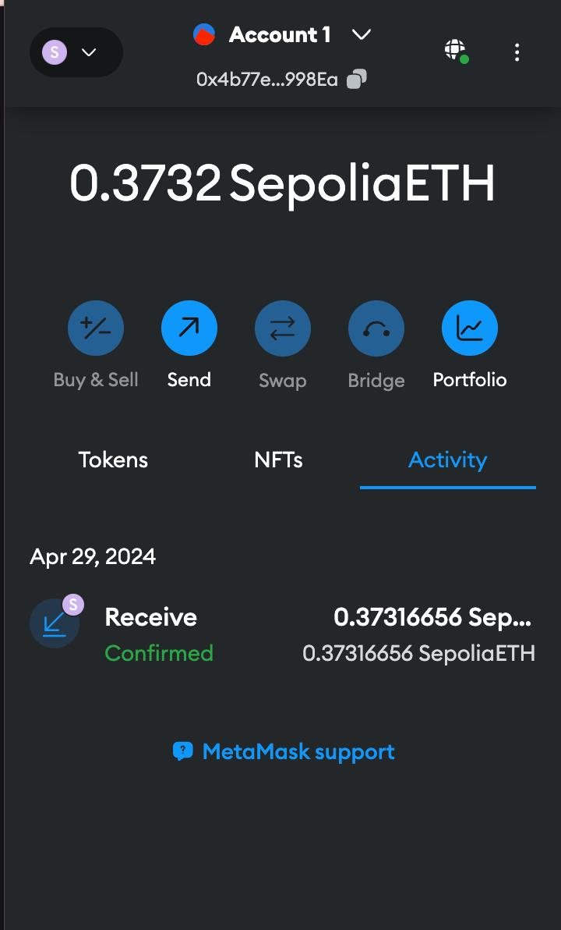

Fig1:Sepolia account

**6.RESULT**

6.1 SYSTEM PREVIEW

STEP 1 (CONNECT WALLET WITH THE APPLICATION):

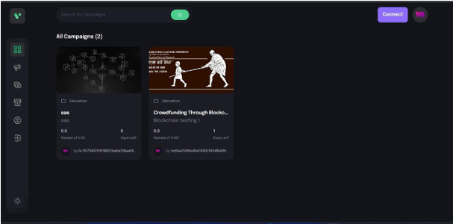

STEP 2 (CREATE CAMPAIGN FOR CROWDFUNDING):

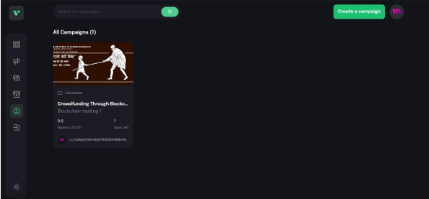

6.2 STEPS FOR DONATING FOR A CAMPAIGN

STEP 3 (BEFORE DONATION THE APP SHOWS 0 BACKERS/DONORS):

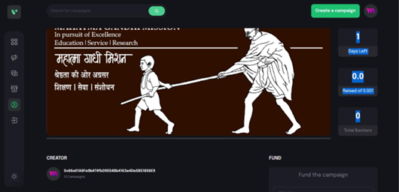

STEP 4 (METAMASK WALLET TRIGGERED WHEN A DONOR WANTS TO FUND FOR A CAMPAIGN):

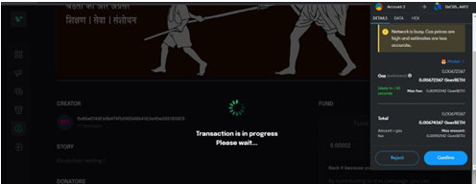

STEP 5 (TOTAL NUMBER OF BACKER INCREASED TO 1 ALONG WITH THE DONORS COMPLETE BLOCKCHAIN ADDRESS AND THE AMOUNT DONATED)

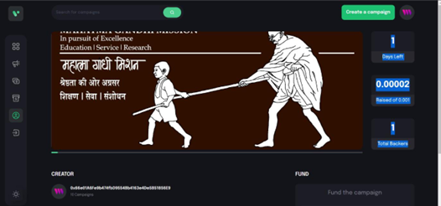

**7.CONCLUSION**

Framework for Crowdfunding using Blockchain allows for decentralisation, which lowers the risk of fraud and makes tampering with the data practically impossible. Additionally, each contributor can track the usage of every dollar they contribute, which enhances confidence.

Blockchain technology has the potential to revolutionize various industries beyond just cryptocurrencies. The technology can help to create a transparent, secure, and decentralized system for various applications. As the technology continues to evolve, we can expect to see more innovative use cases in the future.

**8.REFERENCES**

[1] S. Gore, S. Hamsa, S. Roychowdhury, G. Patil, S. Gore and S. Karmode, "Augmented Intelligence in Machine Learning for Cybersecurity: Enhancing Threat Detection and Human-Machine Collaboration," 2023 Second International Conference on Augmented Intelligence and Sustainable Systems (ICAISS), Trichy, India, 2023, pp. 638-644, doi: 10.1109/ICAISS58487.2023.10250514.

[2] Layth Almahadeen, Renzon Daniel Cosme Pecho, Murugananth Gopal Raj, Nichenametla Rajesh, Zainab Mohammed Imneef, Sayali Karmode Yelpale, “Digital Investigation Forensic Model with P2P Timestamp Blockchain for Monitoring and Analysis” , Journal of Electrical System, Vol. 1, No 1, (2024): 09-17 ( DOI : <https://doi.org/10.52783/jes.656>)

[3] Sayali Karmode, Security Challenges for IoT Based Applications & Solutions Using Fog Computing: A Survey, Journal of Journal of Cybersecurity and Information Management, Vol. 3 , No. 1 , (2020) : 21-28 (Doi : <https://doi.org/10.54216/JCIM.030103>)

[4] Yelpale, M. S. K., & Sayali, K. Y. (2020). Security and privacy challenges in cloud computing: a review. Journal of Cybersecurity and Information Management, 4(1), 36-45.Sayali

Karmode Yelpale, “IOT Technology for Pandemic Situation”, NJITM, vol. 4, no. 2, pp. 25–27, Jan. 2022.

[5] Karmode, S. S., & Bhagat, V. B. (2017). DETECTION AND BLOCKING SOCIAL MEDIA MALICIOUS POSTS. International journal of modern trends in engineering and research, 4(5).

[6] Nikunj Garg, Siddharth Seth, Naincy Rastogi, Rajiv Kumar, Vimal Gupta, Sur Singh Rawat, Crowdfunding using Blockchain Technology: A Review. Glo.Jou.of .Innov .and. Eme.Tech. 2022;1(2):8-14

[7] H.L. Gururaj*, V. Janhavi, Abhishek M. Holla, Ashwin A. Kumar and R. Bhumika Decentralised application for crowdfunding using blockchain technology International Journal of Blockchains and Cryptocurrencies · January 2021

[8] Loan T.Q. Nguyen, Thinh G. Hoang, Linh H. Do , Xuan T. Ngo , Phuong H.T. Nguyen ,Giang D.L. Nguyen , Giang N.T. Nguyen The role of blockchain technology-based social crowdfunding in advancing social value creation [Volume 170](https://www.sciencedirect.com/journal/technological-forecasting-and-social-change/vol/170/suppl/C), September 2021, 120898