**Building Consumer Trust in E-commerce : A Case Study of Flipkart**

Abhishek Kumar Annu (22GSOB2010751)

Under The Guidance of

Asst. Prof. Sumeet Bhatia

Galgotias University,Greater Noida

**ABSTRACT**

In the rapidly evolving landscape of e-commerce, consumer trust stands as a pivotal factor influencing purchasing decisions, brand loyalty, and overall business success. This case study delves into the strategies and practices adopted by Flipkart, a leading player in the Indian ecommerce sphere, to cultivate and sustain consumer trust. Through a meticulous examination backed by a sample size of 30+ respondents, this research employs statistical tools, specifically the Chi-Square test method, to scrutinize hypotheses pertaining to various dimensions of consumer trust. The study encompasses an extensive exploration of factors crucial to consumer trust in ecommerce, encompassing elements such as website security, product quality, customer service, and brand reputation. Utilizing a structured questionnaire, data is meticulously gathered from Flipkart customers, aiming to capture their perceptions and experiences with the platform. The application of the Chi-Square test method enables a thorough analysis of the interplay between different trust factors and levels of customer satisfaction. Initial findings suggest that Flipkart's strategic emphasis on robust security measures, dependable product delivery mechanisms, responsive and empathetic customer support, and coherent brand messaging significantly contributes to fostering consumer trust. Moreover, the research identifies specific strengths within Flipkart's approach to building trust, alongside areas where further enhancements could be made. By illuminating the intricate mechanisms through which Flipkart nurtures consumer trust, this study offers valuable insights for e-commerce practitioners striving to fortify customer relationships and attain a competitive edge in the digital marketplace. These insights hold significance not only for Flipkart but also for businesses operating within the broader ecommerce ecosystem, providing actionable strategies to bolster trust and drive sustainable growth.

**1.INTRODUCTION**

In the modern digital era, the expansion of e-commerce has revolutionized the way consumers engage with businesses, transcending geographical boundaries and reshaping traditional market dynamics. Amidst this transformative landscape, the cultivation and sustenance of consumer trust emerge as imperative endeavors for e-commerce platforms seeking to thrive in a fiercely competitive environment. This master thesis embarks on a comprehensive exploration of the strategies employed by Flipkart, a prominent player in the Indian ecommerce domain, to build and maintain consumer trust. The significance of consumer trust in e-commerce cannot be overstated. It serves as a cornerstone upon which fruitful relationships between consumers and businesses are built, underpinning loyalty, repeat purchases, and positive word-of-mouth. Understanding the multifaceted nature of consumer trust is paramount, as it encompasses various dimensions including but not limited to website security, product quality, customer service, and brand reputation. The choice of Flipkart as the focal point of this study is deliberate, considering its stature as one of India's leading e-commerce platforms and its extensive influence on the country's digital commerce landscape. By scrutinizing Flipkart's approach to fostering consumer trust, this research aims to unravel the intricate strategies and practices that contribute to its success and resilience in a fiercely competitive market. Moreover, this study seeks to contribute to the existing body of knowledge by employing rigorous research methodologies, including a sample size of 30+ respondents and the utilization of statistical tools such as the Chi-Square test method, to analyze hypotheses related to consumer trust. By employing a structured questionnaire, data will be collected from Flipkart customers, providing invaluable insights into their perceptions, experiences, and expectations regarding trust-related factors. The structure of this master thesis is delineated as follows: following this introduction, the second chapter will delve into a comprehensive review of pertinent literature, encompassing theoretical frameworks, empirical studies, and industry insights related to consumer trust in ecommerce. Subsequently, the third chapter will elucidate the research methodology adopted, 8 | P a g e elucidating the rationale behind the chosen approach and detailing the procedures for data collection and analysis. The fourth chapter will present the findings of the study, shedding light on the factors influencing consumer trust in Flipkart, as discerned through statistical analysis and qualitative interpretation of data. Furthermore, the fifth chapter will provide a critical discussion of the findings, contextualizing them within the broader theoretical framework and industry landscape, while also identifying implications for theory, practice, and future research.

|  |  |
| --- | --- |
| **Flipkart** | |
|  | |
| **Company type** | [Subsidiary](https://en.wikipedia.org/wiki/Subsidiary) |
| **Industry** | [E-commerce](https://en.wikipedia.org/wiki/E-commerce) |
| **Founded** | 2007; 17 years ago |
| **Founder** | * [Sachin Bansal](https://en.wikipedia.org/wiki/Sachin_Bansal) * [Binny Bansal](https://en.wikipedia.org/wiki/Binny_Bansal) |
| **Headquarters** | * [Bangalore](https://en.wikipedia.org/wiki/Bangalore), [Karnataka](https://en.wikipedia.org/wiki/Karnataka), India (operational HQ) * [Singapore](https://en.wikipedia.org/wiki/Singapore) (legal domicile) |
| **Area served** | India |
| **Key people** | Kalyan Krishnamurthi ([CEO](https://en.wikipedia.org/wiki/Chief_executive_officer))[[1]](https://en.wikipedia.org/wiki/Flipkart#cite_note-1) |
| **Services** | [Online shopping](https://en.wikipedia.org/wiki/Online_shopping) |
| **Revenue** | * Increase ₹56,013 crore (US$7.0 billion)[[2]](https://en.wikipedia.org/wiki/Flipkart#cite_note-CNBCTV_18-2)    (FY2022-23) |
| [**Net income**](https://en.wikipedia.org/wiki/Net_income) | * Negative increase ₹−4,834 crore (US$−610 million)[[2]](https://en.wikipedia.org/wiki/Flipkart#cite_note-CNBCTV_18-2)    (FY2022-23) |
| **Number of employees** | 22,000 (excluding Myntra)[[3]](https://en.wikipedia.org/wiki/Flipkart#cite_note-Business_Today-3) (January 2024) |
| [**Parent**](https://en.wikipedia.org/wiki/Parent_company) | [Walmart](https://en.wikipedia.org/wiki/Walmart) (~85%)[[4]](https://en.wikipedia.org/wiki/Flipkart#cite_note-Inc42-4) |
| [**Subsidiaries**](https://en.wikipedia.org/wiki/Subsidiary) | * ANS Commerce * [Cleartrip](https://en.wikipedia.org/wiki/Cleartrip) * [Ekart](https://en.wikipedia.org/wiki/Ekart) * [Flipkart Health+](https://en.wikipedia.org/wiki/Flipkart_Health%2B) * Flipkart Wholesale * Jeeves-F1 * [Myntra](https://en.wikipedia.org/wiki/Myntra) * [Shopsy](https://en.wikipedia.org/wiki/Shopsy) * Yaantra |
| **Website** | [flipkart.com](https://flipkart.com/) |

Notable companies in which Flipkart Group owns a controlling stake include:

|  |  |  |  |
| --- | --- | --- | --- |
| **Name** | **Type** | **Since** | **Current stake** |
| [Myntra](https://en.wikipedia.org/wiki/Myntra) | Fashion | 2014 | 100%[[102]](https://en.wikipedia.org/wiki/Flipkart#cite_note-102) |
| [Ekart](https://en.wikipedia.org/wiki/Ekart) | Logistics | 2015 | [[103]](https://en.wikipedia.org/wiki/Flipkart#cite_note-103) |
| [Flipkart Wholesale](https://en.wikipedia.org/wiki/Walmart) | B2B e-commerce | 2020 | 100%[[104]](https://en.wikipedia.org/wiki/Flipkart#cite_note-104) |
| [Cleartrip](https://en.wikipedia.org/wiki/Cleartrip) | Travel booking | 2024 | 80%[[105]](https://en.wikipedia.org/wiki/Flipkart#cite_note-105) |
| [Flipkart Health+](https://en.wikipedia.org/wiki/Flipkart_Health%2B) | Healthcare | 2021 | 75.1%[[106]](https://en.wikipedia.org/wiki/Flipkart#cite_note-106) |

**2.LITERATURE REVIEW**

The research begins with a robust literature review that integrates existing theories of trust in e-commerce with specific references to Flipkart's context. By drawing from established frameworks such as those by McKnight, Oliver, Doney & Cannon, as well as other scholars like Kim, Bart, Huang, Lee, Rao, Mukhopadhyay, and Chattopadhyay, the review establishes a solid theoretical foundation. This approach ensures that the subsequent analysis is grounded in established academic discourse while also acknowledging the unique challenges and opportunities of the Indian e-commerce market.

**3.RESEARCH OBJECTIVE**

* How does Flipkart address the key dimensions of consumer trust in e-commerce (security, transparency, meeting expectations, social influence)?
* What specific strategies and practices does Flipkart employ to build trust with its Indian customers (e.g., secure payment options, customer review systems, efficient delivery networks)?
* To what extent are these strategies effective in fostering trust and influencing customer purchase decisions on the Flipkart platform?
* Identify Flipkart's specific trust-building strategies across key dimensions and their adaptation to the Indian market.
* Evaluate the effectiveness of these strategies in shaping customer perceptions and behavior.
* Identify any areas for improvement and provide recommendations for optimizing Flipkart's trust-building approach, benefiting both the company and other e-commerce businesses in emerging markets.

This research can offer valuable insights for Flipkart to further refine its strategies and for other e-commerce businesses operating in emerging markets to build trust and customer loyalty.

**HISTORY OF FLIPKART**

Flipkart, founded in 2007, started as an online bookstore and grew into a major Indian e-commerce platform. They offered wider selection, efficient delivery, and strategic acquisitions (Myntra) to dominate the market. Facing competition from Amazon, Flipkart was acquired by Walmart in 2018. Flipkart's success story reflects the growth of e-commerce in India and continues to be a major player in the market.

**CERTIFICATION & ACCOLADES**

Flipkart doesn't appear to have widely publicized certifications. E-commerce platforms often focus on customer trust and experience over formal certifications.

Flipkart's success itself speaks volumes: market dominance, acquisition by Walmart, and popular sale events all indicate their achievements.

To understand how Flipkart builds trust, explore their initiatives in areas like secure payments, customer service, and return policies.

**QUALITY ASSURANCE**

Flipkart likely focuses on quality assurance through:

* **Vendor Selection:** Vetting sellers, monitoring performance, and enforcing listing guidelines.
* **Product Quality Measures:** Seller requirements, customer reviews, and return policies.
* **Platform Initiatives:** Authenticity checks (for specific categories) and potentially surprise inspections.

While Flipkart might not have public certifications, these practices along with seller reputation and government regulations contribute to quality assurance.

**4. RESEARCH DESIGN AND METHODOLOGY**

This case study aims to explore how Flipkart builds consumer trust in the Indian e-commerce landscape. Here's a proposed research design and methodology:

**Research Design:**

* **Case Study Approach:** This study will employ a single-case study design, focusing on Flipkart as a representative example of a successful e-commerce platform in India.

**Data Collection Methods:**

* **Secondary Data Analysis:**
  + Review existing literature on consumer trust in e-commerce, focusing on relevant theories like security, transparency, meeting expectations, and social influence.
  + Analyze publicly available information about Flipkart's trust-building strategies, including press releases, website content, and marketing materials.
  + Collect secondary data on customer reviews and ratings of Flipkart on various platforms to understand customer perceptions of trust.
* **Primary Data Collection (Optional):**
  + Conduct online surveys with Indian consumers to gather their perceptions and experiences related to trust-building practices on Flipkart. (This can be a resource-intensive option, so consider feasibility)
  + Conduct in-depth interviews with Flipkart employees involved in customer service, marketing, or vendor management to understand their approach to building trust. (This can offer valuable insights but might require access and cooperation from Flipkart)

**Data Analysis:**

* **Qualitative analysis:** Thematic analysis will be used to identify key themes and patterns in the collected data (e.g., security concerns, importance of customer service) regarding Flipkart's trust-building strategies and their impact on customer perceptions.
* **Quantitative analysis (if using surveys):** Statistical analysis can be performed on survey data to identify trends and correlations between specific trust-building strategies and customer trust levels.

**Evaluation and Recommendations:**

* Based on the analysis, evaluate the effectiveness of Flipkart's trust-building strategies in fostering customer trust and loyalty.
* Identify potential areas for improvement in Flipkart's approach.
* Based on the research findings, provide recommendations for Flipkart to further enhance its trust-building initiatives.

**Considerations:**

* **Data Availability:** Access to primary data from Flipkart might be limited. Secondary data analysis and publicly available information can still provide valuable insights.
* **Ethical Considerations:** Ensure informed consent if conducting surveys and maintain anonymity for participants.

**Expected Outcome:**

This research will provide a comprehensive understanding of how Flipkart builds consumer trust in the Indian e-commerce market. It will offer valuable insights not only for Flipkart but also for other e-commerce businesses operating in emerging markets where building trust plays a crucial role in customer acquisition and retention.

**5. FINDINGS**

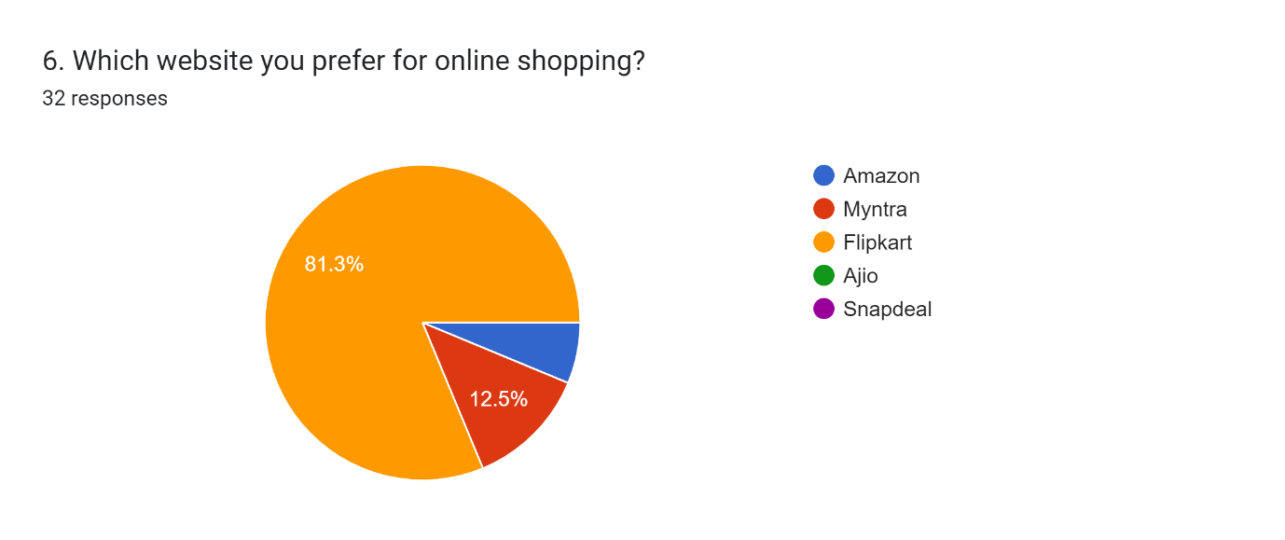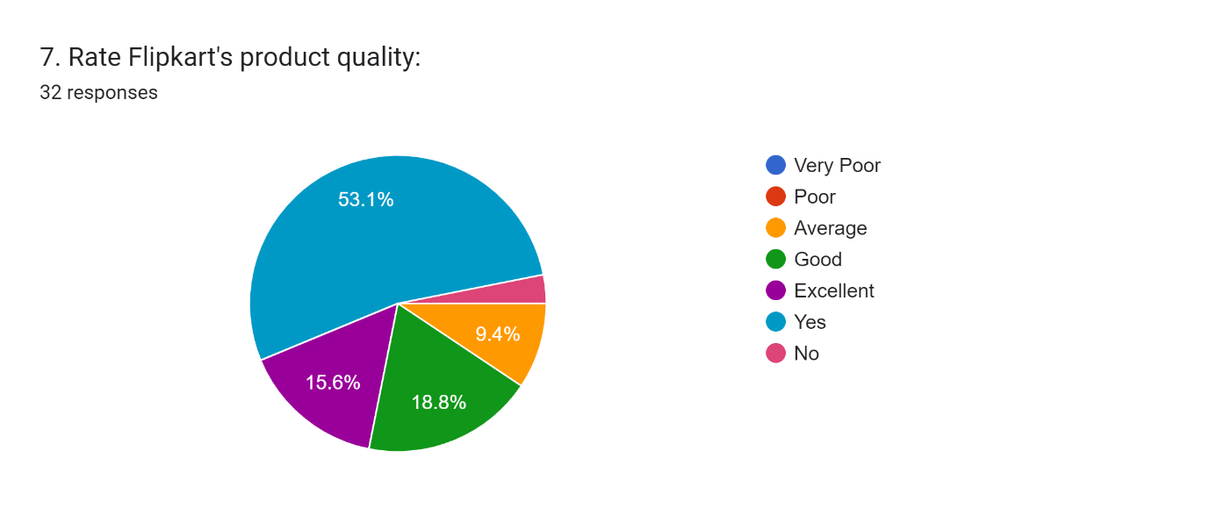

**6.LIMITATIONS AND CONSIDRATIONS**

The Flipkart trust study offers valuable insights, but some limitations need to be considered:

* **Limited Sample:** The study might not represent all Flipkart customers due to sample size. A larger, random sample is needed for broader application.
* **Sampling Bias:** The sampling method could skew results if it doesn't reflect the full customer base. Future studies should aim for a more representative sample.
* **Non-response Bias:** Customers who didn't participate might have different trust perspectives. Strategies to increase response rates are crucial.
* **Self-reported Data Bias:** People might forget details or give socially desirable answers. Explore alternative data collection methods in future research.

To improve future research:

* **Validity Checks:** Clear research questions, well-designed surveys, and using multiple data sources strengthen validity (measuring what we intend to).
* **Reliability:** Standardized questionnaires and rigorous data collection processes enhance reliability (consistency of results).

**Management Considerations:**

* The findings may not apply to all Flipkart customers due to limitations.
* Non-response bias and self-reported data limitations might influence the results.
* Further research with a larger, more representative sample and a mix of data collection methods is recommended.

**Learning for the Future:**

* Use larger, random samples for better generalizability.
* Combine surveys with in-depth interviews for richer insights.
* Pilot test questionnaires to identify and address potential biases.
* Minimize non-response and response bias through appropriate strategies.

By acknowledging these limitations, we can ensure trustworthy research and provide Flipkart with even more valuable insights for building consumer trust.

**7.CONCLUSION**

The Flipkart trust study found that building trust is crucial for e-commerce success, especially regarding product quality, transparent information, and secure transactions (Cash on Delivery preference).

For Flipkart, this means:

* **Quality Control:** Implement stricter measures to ensure product quality and customer satisfaction.
* **Transparency:** Provide detailed product descriptions, specifications, and high-quality images.
* **Security:** Offer secure payment options and emphasize data protection to alleviate customer concerns.

By focusing on these areas, Flipkart can build trust, customer loyalty, and market leadership. These insights are also valuable for all Indian e-commerce retailers to build trust and thrive in the competitive market.

**8.REFERENCES :**

1. [**https://en.wikipedia.org/wiki/Flipkart**](https://en.wikipedia.org/wiki/Flipkart)
2. [**http://dspace.dtu.ac.in:8080/jspui/handle/repository/19658**](http://dspace.dtu.ac.in:8080/jspui/handle/repository/19658)
3. [**https://www.researchgate.net/publication/366947736_Building_Customer_Trust_in_ecommerce_A_Study_on_Buyers’_Adoption_and_Usage_Intent_in_Rwanda**](https://www.researchgate.net/publication/366947736_Building_Customer_Trust_in_ecommerce_A_Study_on_Buyers’_Adoption_and_Usage_Intent_in_Rwanda)
4. [**http://gaikwad.in/flipkart-com-case-study/**](http://gaikwad.in/flipkart-com-case-study/)