RESEARCH ON DOCUMENT VERIFICATION USING BLOCKCHAIN

# Komal Pagare1, Mansi Patankar2, Gitanjali Jadhav3, Vidya Kandekar 4, Prof. P.N.Pathak5

Department of Computer Engineering1,2,3,4,5

Loknete Gopinathji Munde Institute of Engineering Education & Research, Nashik, Maharastra, India

---------------------------------------------------------------------***---------------------------------------------------------------------

**Abstract –** Now-a-days all the user wants to use smart systems to carry on routine activities as well as expecting many intelligent systems to adopt with their daily life. Many smart gadgets and Smartphones are available in market to satisfied their needs. However, the requirement of such systems and its necessity is not even satisfied up to the level of present situations. Each and every organization (both commercial and non-commercial and Government Sector) want to convert all its hardcopy of documents into digital form, because of the sustention of maintenance and complexity. The flaws over here mentioned as the corruption, forgery of document approval and so on. The digital document verification process provides complete security to the users who are all want to maintain the documents in digital format. Document verification using blockchain and QR code scanning is an innovative approach to enhance the security and authenticity of documents. This technology controls the immutability and transparency by using blockchain to ensure the integrity of documents, while QR code scanning provides a convenient to accessing and verifying information. The Blockchain is deployed at the origin of creation of the document itself on the server side and at the client side it gives indication of the document via QR code assigned to each document.

***KeyWords*:** Blockchain Technology, C#.NET Desktop Application, Firebase Integration, SHA-256, AES, Data Integrity, Cryptographic Algorithms

## INTRODUCTION

In the rapidly evolving digital age, the need for secure and tamper-proof document verification has become paramount. Traditional methods of verifying certificates and documents are susceptible to fraud and manipulation, leading to a demand for innovative solutions that leverage cutting-edge technologies. This project aims to address this challenge by combining the power of blockchain, cryptographic algorithms, and QR code technology to create a robust and secure document verification system.

Our system is designed to facilitate tamper-proof detection of certificates through a decentralized and transparent blockchain network. The use of blockchain ensures the immutability of records, providing a reliable and trustworthy source for document verification. The implementation involves three key roles: the admin, authorized employees, and end-users.

The administrative module, built using C#.NET, serves as the control center where administrators can manage and add authorized employees. These authorized employees are

responsible for inputting student information, which is securely stored and validated on Firebase. To enhance the security of the data, the SHA-256 hashing algorithm is applied before creating blocks. Unlike traditional blockchain systems that use smart contracts, we implement block creation directly in C# to tailor the solution to our specific needs.

Furthermore, our system employs the Advanced Encryption Standard (AES) algorithm for encryption and decryption, adding an additional layer of security to the stored information. Each document is enriched with a QR code that encapsulates essential details, allowing for efficient and user-friendly verification.

On the user-facing side, a React.js and HTML-based interface facilitates seamless interaction with the system. A college guide, for instance, can easily scan the QR code on a document using a mobile device. The system then promptly responds, confirming whether the document is genuine and if the holder is valid. This real-time verification process provides a practical and reliable solution for institutions and organizations seeking to streamline their document verification procedures.

## LITERATURE REVIEW

In the realm of document verification, the advent of blockchain technology has offered novel and secure avenues for ensuring the integrity of certificates. This literature review surveys recent advancements in blockchain-based document verification systems, exploring key components such as administrative control, data security, cryptographic measures, and user interfaces.

This section presents a thorough review of related works, referencing studies ([1], [2], [3]]) that contribute valuable insights to the field of document verification using blockchain technology.

A. Gayathiri, J. Jayachitra, and S. Matilda [1] introduce the a blockchain-based system with certificate transparency and revocation transparency. While providing trust, the system faced issues of delayed certificate validation and a false sense of security. The project proposes the use of blockchain technology to store certificates securely. Certificates are converted to digital form, and a chaotic algorithm generates hash codes for validation. The certificates stored in the blockchain can be validated using a mobile application. This provides a more secure and efficient means of certificate validation. The institution registers student details in the application, storing them in the database. - Certificates issued

by the registrar are stored in the application, forming a blockchain. - Employers or verifiers can validate certificates by entering student details. To Verify the document user needs this proposed application.

Venkata Marella, Anoop Vijayan [2] introduce a blockchain- based solution for document verification in the hiring process.

- Hash values of original documents stored on a consortium blockchain for efficient background checks, because difficulty in job market, leading to CV manipulation with fake information. - Current background verification processes by companies are costly, time-consuming, and inefficient. created where universities, companies, police, doctors, and certification authorities have the privilege to write the information on to the blockchain. Educational Institutions will submit the academic details such as the name of the program, list of courses taken, and grades of all their Document Verification using Blockchain for Trusted CV Information Americas Conference on Information Systems 5 students. All the information that you normally find on an academic transcript will be submitted to the blockchain. Companies will submit the work experience details such as years of experience, skillset, and performance ratings of all their employees on to the blockchain. All these documents will be verified by an administrator node before calculating the hash values and saving them to the blockchain. . The hash verifier application will compare the hash value of the uploaded document with the hash value present on the blockchain.

Bejugam Sanjana, Challa Naga Narasimha Reddy, Choppadandi Aravind [3] introduce a blockchain-based solution to Secure academic certificates and prevent forgery. - Convert certificates into digital signatures stored in a Blockchain server for tamper-proof data storage. Ensures tamper-proof data storage. Detects alterations through hash code verification across multiple servers. - Enhances security by storing data in different blocks. The system employs a custom blockchain for dynamic certificate generation. - Students apply online, and a third party authenticates academic documents. - Verified data is stored in the blockchain, generating a unique certificate ID or QR code for the student. For registration Users register to upload files, and login is required for file uploading. After uploading file, the successful file uploads result in a confirmation message will show result. The application converts certificates into digital signatures for secure storage. The system described involves a Blockchain database for storing student details and certificates. Certificate verification is done by uploading certificates to the application, which converts them into digital signatures.

The digital signatures are checked against the Blockchain database for authenticity. If a match is found, all student details associated with the certificate are retrieved and displayed; otherwise, the certificate is considered fake. The project includes a graphical user interface where users can enter student details and save certificates with digital signatures in the Blockchain.

## PROPOSED SYSTEM

In our proposed system for document verification, we aim to provide a robust, secure, and user-friendly solution for tamper- proof detection of certificates. The system comprises distinct user roles – Admin, Authorized Employee, and User (College Guide) – each contributing to a seamless and efficient verification process. The following outlines the key components and functionalities of our proposed system:

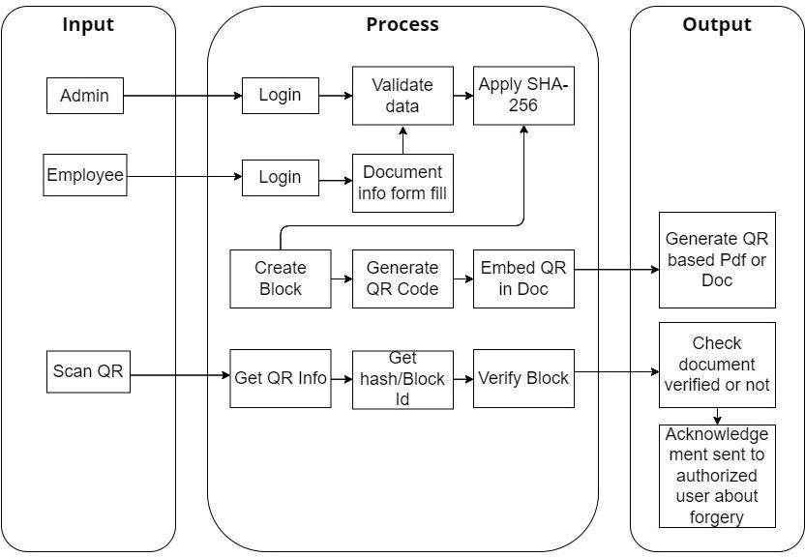

### Administrative Module:

* Desktop Application (C#.NET): An intuitive desktop application will be developed using C#.NET to serve as the administrative control center. This empowers the admin to manage users and oversee the document verification process.
* User Management: The admin has the authority to add authorized employees, who will play a pivotal role in the system. These employees are responsible for inputting and validating student information.

### Data Storage and Validation:

* Firebase Integration: To ensure secure storage and validation of student information, we integrate Firebase as the backend. Firebase provides a reliable platform, enhancing data management and authentication.

### SHA-256 Hashing Algorithm:

* The system employs the SHA-256 hashing algorithm to create a unique fingerprint for each set of information. This cryptographic measure ensures the integrity of stored data, preventing unauthorized tampering.

### Enhanced Security Measures:

* AES Algorithm: For an additional layer of security, the Advanced Encryption Standard (AES) algorithm is applied for encryption and decryption. This ensures the confidentiality of sensitive information throughout the document verification process.

### QR Code Integration:

* Embedding QR Codes: Each document is embedded with a QR code containing essential details. This QR code serves as a quick and efficient method for end- users, such as college guides, to verify the authenticity of the document.

### User Interface with React.js and HTML:

* Responsive Design: The user interface is developed using React.js and HTML, ensuring a responsive and interactive experience for end-users. Real-time Verification: College guides or interviewer, as end-users, can simply scan the QR code on a document using the implemented React.js and HTML interface. The system responds in real-time, providing immediate confirmation of the document's legitimacy and verifying the status of the certificate holder.

In summary, our proposed system leverages blockchain technology, robust encryption algorithms, and user-friendly interfaces to create a secure and efficient document verification solution. The tailored approach to blockchain implementation and the integration of cutting-edge technologies ensure the system's effectiveness in preventing document tampering.

1. 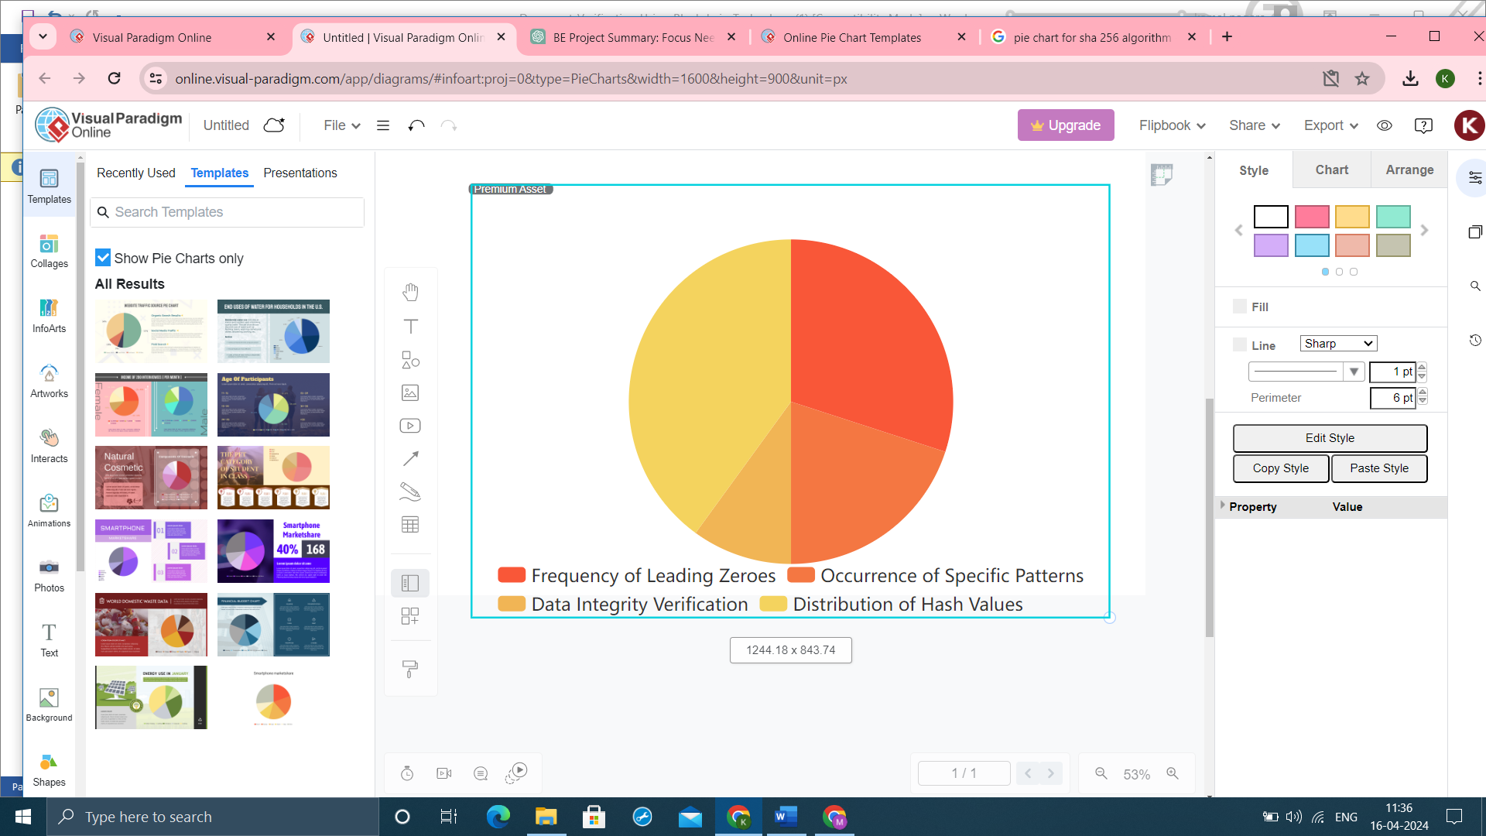**RESULTS – SHA-256**

* **Distribution of Hash Values:** This aspect is crucial as it demonstrates the variability and uniformity of hash outputs.

Percentage: 40%

* **Frequency of Leading Zeroes:** Analyzing the frequency of leading zeroes in hash outputs can indicate the difficulty and randomness of the algorithm.

Percentage: 30%

* **Occurrence of Specific Patterns:** Identifying and analyzing any recurring patterns within hash outputs can provide insights into the algorithm's behavior.

Percentage: 20%

**Data Integrity Verification**: Verifying the integrity of data using SHA-256 hashes is a common application. This includes comparing original and modified data hashes.

Percentage: 10%

## CONCLUSIONS

Our project successfully demonstrated the effectiveness of using blockchain technology and the SHA-256 algorithm for document verification. Through our implementation, we showcased the ability to enhance document authenticity and integrity while mitigating risks of fraud and tampering. Moving forward, further research can focus on optimizing scalability and addressing privacy concerns in blockchain-based document verification systems.

## REFERENCES

[1]A. Gayathiri, J. Jayachitra, and S. Matilda, “Certificate validation using blockchain,” in 2020 7th International Conference on Smart Structures and Systems(ICSSS),pp.1–4, IEEE,2020.

1. V. Marella and A. Vijayan, “Document verification using blockchain for trusted cv information.,” in AMCIS, 2020.
2. Bejugam Sanjana, Challa Naga Narasimha Reddy, Choppadandi Aravind, “BLOCKCHAIN BASED CERTIFICATE VALIDATION,” International Journal of Creative Research Thoughts, vol. 9, no. 6, pp. 714–718, 2021.
3. I. T. Imam, Y. Arafat, K. S. Alam, and S. A. Shahriyar, “Doc-block: Ablockchain based authentication system for digital documents,” in 2021 Third International Conference on Intelligent Communication Technologies and Virtual Mobile Networks (ICICV), pp. 1262–1267, IEEE, 2021.
4. R. S. Lamkoti, D. Maji, A. B. Gondhalekar, and H. Shetty, “Certificate verification using blockchain and generation of transcript,” Int. J. Eng. Res. Technol vol. 10, no.3, 2021. 62 Document Verification Using Blockchain.