**DESIGN,DEVELOPMENT AND SIMULATION OF BRIDGELESS CUK CONVERTER FOR EV CHARGER**

**Prof Dimpal Zade, Aniket Butey, Gaurav Bokde, Chetan Khoke,Prathmesh Kondawar**

*Department of Electrical Engineering*

*Shri Sai College of Engineering and Technology, Bhadrawati (MS), India*

**Abstract**:

A Cuk converter based EV (Electric vehicle) battery charger is designed and developed in this work. It supplies affordable as well as high-power density-based billing service for EV. This charger includes much less variety of tools running over one switching cycle, which minimizes the additional transmission loss incurred by a diode bridge rectifier of conventional battery charger and hence, enhances the charger effectiveness. Throughout constant present and also consistent voltage regions, the commands for battery charging are synchronized by a flyback converter. The included benefit of recommended geography is that the undesirable capacitive combining loophole is eliminated, as well as unwanted conduction via the body diode of non-active button in formerly created BL Cuk converter is prevented. This substantially boosts the charger effectiveness. For the consistent present (CC) and also continuous voltage (Curriculum Vitae) charging, the commands are synchronized by a flyback converter. The suggested charger is examined to demonstrate the improved power quality. Test results validate the better performance of the recommended battery charger.

**Keywords: Electrical vehicle, cuk converter, CC, flyback converter, battery charging.**

**Objectives**:

The objective of this thesis work is to provide an On-Board EV charger (OBC) for level 1 charging purpose. The designed OBC is a two stage charger with Boost PFC converter at the front end for conversion of AC to DC with very high PF whereas the second stage is a Non-Isolated DC-DC converter for battery voltage and current regulation. The high voltage propulsion battery is considered as a Li-Ion type and CC/CV charging algorithm is developed for the battery. An Low-Voltage DC-DC Converter (LDC) is designed with the utilization of the OBC for charging the Auxiliary battery from the propulsion battery.

**Introduction:**

A Bridgeless CUK converter with less conducting components over a single switching cycle is proposed as an improved PQ-based EV charger. Using single voltage feedback power, the proposed PFC CUK converter provides excellent PFC characteristics in DCM mode. As a consequence, the charger's size is decreased. The proposed topology also eliminates the unwanted capacitive coupling loop, as well as unwanted conduction through the body diode of the inactive switch, which was present in the previously established BL CUK converter. This boosts the charger's performance greatly. For the long-term growth of the modern transportation market, battery-powered electric vehicles (BEVs) have surpassed traditional gasoline-powered vehicles. The significant supporting equipment of the electric vehicle is an AC-DC converter based on board or off board charger to allow battery charging in BEVs (EV). Various off-board and on-board topologies of EV battery chargers with unidirectional or bidirectional configuration are discussed in the literature under level 1, level 2, or level 3 categories. To enhance energy utilization during charging, an off-board charger must have improved power quality (PQ) characteristics in addition to high power density and small form factor. Improved PQ-based EV chargers, which draw a sinusoidal input current with high PF and output voltage is controlled stiffly at constant value, have been extensively studied in the literature to address these issues. In the literature for EV chargers, multiple topologies of front end PFC converters are discussed, depending on whether they are off-board or on-board. Various on-board EV chargers have been registered, all of which benefit from high power density and efficiency.

**Block Diagram:**

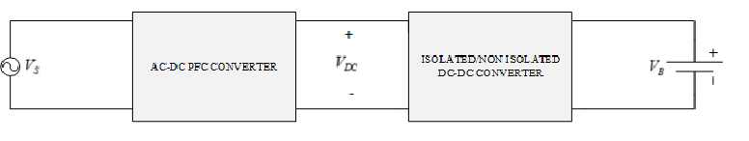

*Figure 1: Block Diagram of EV Charger*

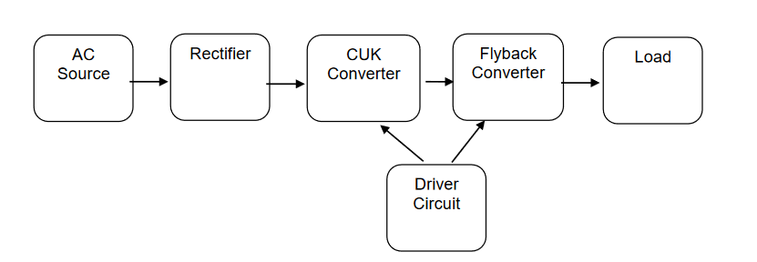

Figure 2: Block Diagram of proposed system

**Methodology**

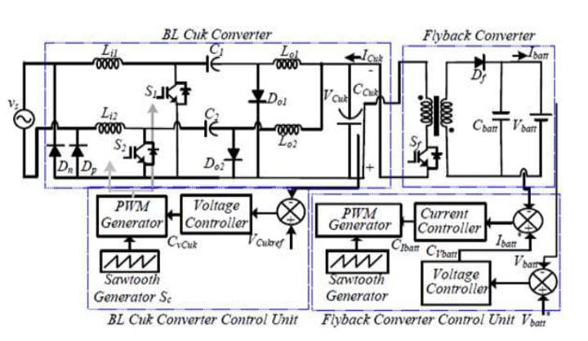

*Fig 3* ***Proposed model for CUK converter for EV charger***

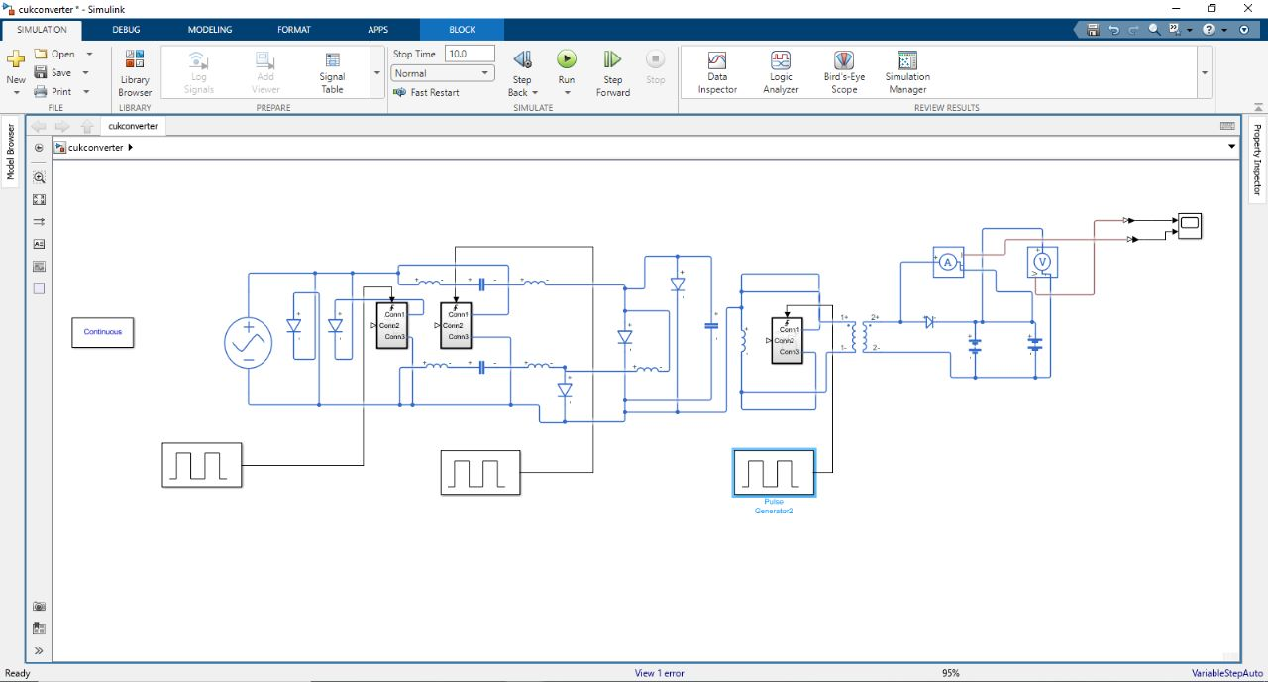

*Fig4* ***Performed model for CUK converter for EV charger***

**Advantages:**

1)Have the ability to decrease the greenhouse emissions.

2)Reduce the use on petroleum.

3)Reduce the health effects from air pollution.

4)Lesser vibration.

5)Lesser noise.

6) The main advantage of this converter is the continuous currents at the input and

output of the converter.

7) There is low ripple current at both input and output.

8) The output is well organized as positive or negative.

9) It is also used in the regulation and control of DC voltage.

10) A device can be driven by bucking or boosting the available voltage. Thus

preventing the damage of the device or breakdown.

11)It offers high efficiency across wide input and output voltage ranges.

**Applications:**

1) Switching converters are prone to noise.

2) They are expensive.

3) The main disadvantage is the high current stress on the switch.

4) The disadvantage is that the switching regulator requires passive components

like capacitors and resistors; semiconductors, such as diodes with an attendant

increase in the number of required parts and complexity in design.

**Results:**

The extensive functions of suggested charger is to

1. decrease above worries are summarized as follows.
2. The intermediate capacitors are performing individually, in both fifty percents;
3. as a result, distributing losses are removed,
4. which ends up into boosted performance of the battery charger.
5. There isn't any return modern-day through the body diode of non-active buttons within the different 1/2 cycle because of used manipulate.
6. For that reason, losses inside the button are reduced.

**Conclusion:**

With a BL CUK converter and less conducting components over a single switching period, an improved PQ-based EV charger is suggested. Using single voltage feedback power, the proposed PFC CUK converter provides excellent PFC characteristics in DCM mode. As a result, the charger's size is decreased. The proposed topology also eliminates the undesirable capacitive coupling loop, as well as unnecessary conduction through the body diode of the inactive switch in the previously formed BL CUK converter. This boosts the charger's performance greatly. During steady state and over 50% grid voltage variance, the proposed charger demonstrated satisfactory charging characteristics. However, the proposed charger's PQ is calculated using guidelines over a broad input voltage range. As a result, the proposed charger provides a viable EV charging option with improved power quality and performance.

**FUTURE SCOPE:**

The designed On-Board Electric Vehicle charger is of two stage type whereas a single stage prototype can be designed which will reduce the losses associated with the components and maximize efficiency. Moreover, the Boost PFC converter is designed with an analogue controller the digital mode of the controller can be designed which can be implemented using

microcontrollers.

A Bi-directional isolated DC-DC converter can be designed for both G2V and V2G modes

and can operate as LDC. To reduce the switching losses a ZVS or ZCS topology of the

designed DC-DC converter can be developed which will reduce the losses associated with

the switches during turn ON or turn OFF.

**REFERENCES:**

[1] X. Yan, and moreover D. Patterson "A High- Efficiency On-Board Battery Charger with Unity Input Power Aspect" Australasian Colleges Power Style Workshop, pp.306-312, September 1999.

[2] S. Kim and F. S. Kang, “Multifunctional onboard battery charger for plug-in electric

vehicles,” IEEE Trans. Ind. Electron., vol. 62, no. 6, pp. 3460–3472, 2015.

[3] M. Morcos, C. R. Mersman, G. G.Sugavanam, and N. G. Dillman, "Battery battery chargers for electric powered lorries," IEEE Power layout Review, Vol. 20, No. Eleven, pp. Eight-eleven, November 2000.

[4] Y. C. Chiang, Y. L. Ke, H. S. Chuang, and moreover H. K. Chen, "Execution and assessment of a superior series loaded powerful dc dc converter walking over resonance for battery chargers," IEEE Industrial and moreover in addition Industrial Power Systems Technical Fulfilling, pp. 1- 8, May 2008.

[5] Y. C. Chuang and furthermore Y. L. Ke, "High-regular not unusual usual overall performance extra to lowstress ZVT-PWM DC- to-DC converter for battery charger," IEEE Trans. Ind. Electron., Vol.Fifty five, No. Eight, pp. 3030-3037, August 2008.

[6] J. J. Chen, F. C. Yang, C. C. Lai, Y. S. Hwang, further to moreover R. G. Lee," An excessive ordinary performance multimode Li-Ion battery charger with variable cutting-edge deliver and handling previousstage provide voltage," IEEE Trans. Ind. Electron., Vol. Fifty six, No. 7, pp. 2469-2478, July 2009.

## [7] S. Y. Tseng, T. C. Shin, S. Y. Fan, similarly to furthermore G. K. Chang, "Style and moreover execution of lithium- ion/lithiumpolymer battery charger with resistance affiliation," IEEE International Meeting on Power Electronics further to Drive Solution, pp. 866-870, November 2009

## [8]. Aruna P, Dr. Vasan Prabhu V “Review On Energy Management System Of Electric Vehicles” IEEE Trans,2nd International Conference On Power And Embedded Drive Control (ICPEDC) ,pg 371-374, March 2019.

## [9]. ue Wang, Atriya Biswa, Romina Rodriguez,Zahra Keshavarz-Motamed,Ali Emadi, “Hybrid electric vehicle specific engines: State-of-the-art review’,Elsevier,pp.832-852,November 2022.

## [10]. J. Kim, G. Choe, H. Jung, B. Lee, Y. Cho,and moreover K. Han. "Layout and Application

## of a High-Efficiency OnBoard Battery Charger for Electric Autos with Frequency Control Strategy" IEEEVehicle Power similarly to Propulsion Seminar, pp. 1-6, September 2010.