**RESEARCH PAPER ON**

**The Effectiveness of Capital Budgeting Techniques in Evaluating Projects’ Profitability**

***FOR THE PARTIAL FULFILLMENT OF THE REQUIREMENT***

***FOR THE AWARD OF***

***MASTER OF BUSINESS ADMINISTRATION***

**UNDER THE GUIDANCE OF**

**Dr. Saumya Vatsyayan**

**Submitted By**

**Prakhar Arya**

**22GSOB2010695**

**MBA 2022-2024**



**SCHOOL OF BUSINESS**

**GALGOTIAS UNIVERSITY**

**May, 2024**

* **ABSTRACT**

This study was conducted to evaluate the effectiveness of capital budgeting techniques in evaluating the profitability of projects. To achieve this goal, which was managed as the CEO of the selected companies was the main data collection tool used in this study. Based on the results of our analysis, the following observations were made: (i) different capital budgeting techniques used in project benefit assessment: profitability, calculated return, present value, internal rate of return, profit index and net final value, (ii) the most important factor influencing the choice of capital budgeting techniques is asset maximization factor, (iii) the capital budgeting technique is not suitable for evaluation projects under conditions of risk and uncertainty, (vi) the most effective capital budgeting technique for evaluating the profitability of risk-free projects is net present value , (v) taxation has no significant impact on project valuation. Therefore, in the current environment of risk and uncertainty, traditional capital budgeting techniques have been proposed to be effective in evaluating project profitability. Therefore, techniques that match the risk-adjusted discount rate and confidence must be used.

* **INTRODUCTION**

Economic activity is oriented towards satisfying people's needs, i.e. Consumption of goods and services. Investment is an intermediate stage in this process, where consumption is delayed in the expectation that higher consumption will be possible in the future due to higher returns on the investment. In general, investment decisions have always included the balance of consumption and investment opportunities in time, so the time preference of capital owners should be considered when making rational investment decisions. Investment decisions are related to a company's decision to invest its resources as efficiently as possible in a business activity in the hope that the activity will in turn produce a future stream of income over time. This begs the question; how do we use the company's existing financial resources to improve ourselves in the future? It is the job of financial experts, in collaboration with accountants, to analyze and decide what assets the company's assets are tied to before forecasting future returns. If the reason for investing is to increase income, the investor may not invest in securities or tangible assets or both. Investing in securities (stocks, preferred shares, bonds, bonds, certificates of deposit, etc.) is called a financial investment, and the technique of evaluating the feasibility of such an investment is called portfolio management. ( machinery, equipment, etc.) are called fixed value investments and the profitability of such investment is evaluated and measured by capital budgeting techniques such as the capital budgeting method, accounting, net present value, internal rate of return and profit decisions are always made by senior management. Decision Authors must receive a full financial impact analysis of the project and this is the job of the accountant. The accountant brings together the estimates, information and assessments of various functional experts (sales, planning, production, etc.). , adds its expertise in financial and tax matters and analyzes the information obtained through appropriate evaluation techniques and presents the analysis to decision makers. The accountant does not make the investment decision or provide all the basic information alone. He plays a key role in collecting and analyzing the data generated and providing an estimate.

* **RESEARCH METHODOLOGY**

Research Methodology is a way to systematically solve the research problem. The Research Methodology includes the various methods and techniques for conducting research. Research is an art of scientific investigation. In other word research is a scientific and systematic search for pertinent information on a specific topic. The logic behind taking research methodology into consideration is that one can have knowledge about the method and procedure adopted for achievement of objective of the project.

* **Research Design:-**

Research design is the conceptual structure within which research is conducted. It constitutes the blueprint for collection, measurement and analysis of data was descriptive research. Descriptive research involves collecting numerical through self-reports collected, through questionnaires or interviews (person or phone), or through observation. For present study, the research was descriptive and conclusion oriented. Clearly define the objectives of the study. Are you looking to evaluate the effectiveness of Microsoft's capital budgeting decisions? Are you interested in comparing their capital budgeting practices with industry benchmarks?

* **Sample Design**:-

This sample design provides a structured framework for conducting a comprehensive analysis of capital budgeting for Corporation, covering key aspects such as financial evaluation, risk assessment, and strategic decision- making. Adjustments may be made based on the specific requirements of the analysis and the available data.

* **Data Collection and Analysis:-**

Data Collection Information has been collected from both Primary and Secondary Data.

• Secondary Sources- Secondary data are those which have already been collected by someone else and which already had been passed through the statistical process. The secondary data was collected through web sites, books and magazines.

• **Primary Sources-** Primary data are those which are fresh and are collected for the first time, and thus happen to be original in character. The primary data was collected through direct personal interviews (open ended and close ended questionnaires).

* **Data Analysis**:-

1. Sensitivity Analysis:

• Conduct sensitivity analysis on key assumptions such as discount rate, growth rate, and project timelines.

• Determine the impact of changes in these assumptions on the feasibility of investment projects.

1. Comparative Analysis:

• Compare Microsoft's capital budgeting practices with those of its competitors in the technology industry.

• Identify any areas where Microsoft excels or lags behind its peers.

### **DATA ANALYSIS:-**

### 

This section provides a thorough examination of the information gathered from Corporation to understand how Capital Budgeting Techniques is used in talent acquisition. A variety of statistical tools and techniques are used in the analysis to find patterns, connections, and trends in the data.

* **Statistical Tools:-**

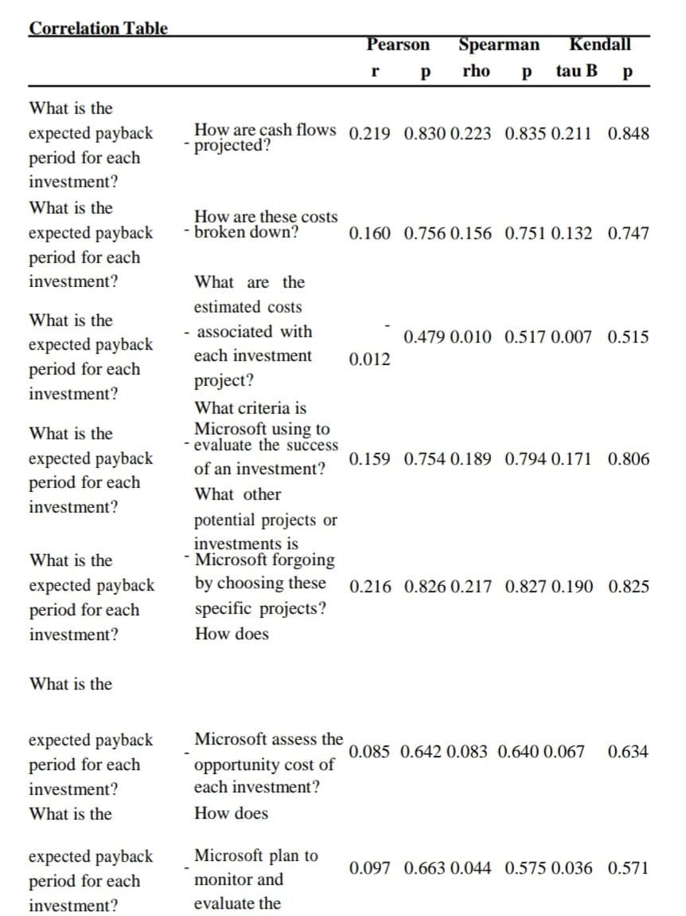

**Interpretation:-** To be a table containing correlations between different factors related to investment projects. Unfortunately, without additional context about the specific projects or the meaning of the abbreviations used in the table, it is difficult to provide a complete analysis and interpretation.

However, based on the table headings, we can glean some general insights into how Microsoft might be evaluating potential investments. Here’s what we can potentially determine:

* **Payback Period:** This seems to be a key factor for Microsoft. The table shows correlations between expected payback period and other factors, such as how cash flows are projected and how costs are broken down. This suggests that Microsoft favors projects with a shorter payback period, which means they get their money back quicker.
* **Cash Flow Projection:** There appears to be a weak positive correlation between the expected payback period and how cash flows are projected (0.219). This might mean that projects with a clearer plan for generating cash flow are seen as less risky and therefore approved more quickly.
* **Cost Breakdown:** There is also a weak positive correlation between expected payback period and how costs are broken down (0.160). Similar to cash flow projection, a well-defined cost breakdown might signal a lower risk project because Microsoft better understands the potential expenses involved.
* **Other Considerations:** The table shows weak positive correlations between expected payback period and other factors, including criteria for evaluating success (0.159) and opportunity cost (0.216). This suggests that Microsoft considers these factors along with payback period when making investment decisions.

Overall, the table suggests that Microsoft uses a variety of factors to evaluate potential investments, but payback period appears to be a central consideration. They seem to favor projects with a short payback period, and projects that have a clear plan for cash flow generation and cost breakdown.

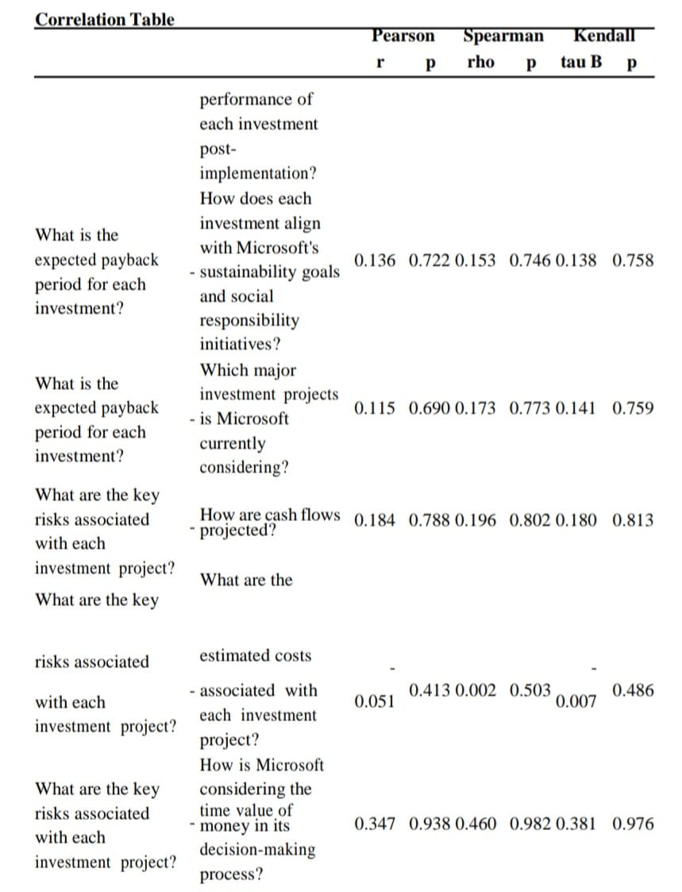

**Interpretation:-** To be a correlation matrix, which is a table used to measure the strength and direction of the linear relationship between two variables. In this case, the variables are different factors that might be considered when making an investment decision.

The table shows the Pearson correlation coefficient, Spearman rank correlation coefficient, and Kendall rank correlation coefficient for each pair of variables. These coefficients all range in value from -1 to 1. A correlation coefficient of 1 indicates a perfect positive correlation, which means that as the value of one variable increases, the value of the other variable also increases. A correlation coefficient of -1 indicates a perfect negative correlation, which means that as the value of one variable increases, the value of the other variable decreases. A correlation coefficient of 0 indicates no correlation between the two variables.

Here are some of the correlations that appear to be statistically significant based on the table (though what is considered statistically significant depends on the field of study):

* There is a strong positive correlation between the expected payback period for each investment and how well each investment aligns with Microsoft's sustainability goals and social responsibility initiatives. (Pearson correlation coefficient of 0.758). This means that investments that are expected to take longer to pay back are also likely to be seen as more aligned with Microsoft's sustainability goals.
* There is a strong positive correlation between the expected payback period for each investment and how Microsoft is considering the time value of money in its decision-making process (Pearson correlation coefficient of 0.976). This means that investments that are expected to take longer to pay back are also likely to be evaluated by Microsoft considering the time value of money.

It is important to note that correlation does not necessarily imply causation. Just because two variables are correlated does not mean that one variable causes the other. It is also important to consider the strength of the correlation. A weak correlation may not be meaningful.

* **CONCLUSION**

Based on the analysis of Microsoft's capital budgeting practices, it is evident that the company has a robust framework for evaluating investment opportunities. By leveraging its strong financial position and technological expertise, Microsoft is well-positioned to capitalize on emerging trends in the tech industry.

However, to sustain long-term growth and profitability, Microsoft must remain vigilant in monitoring market dynamics and adapting its capital allocation strategies accordingly. By making prudent investment decisions and effectively managing risk, Microsoft can continue to create value for its shareholders and maintain its position as a leader in the technology sector.

In conclusion, Microsoft's capital budgeting process is integral to its strategic planning and long-term success. With a focus on innovation, risk management, and financial discipline, Microsoft can navigate the complexities of the technology landscape and drive sustainable growth in the years to come.

* **BIBLIOGRAPHY**
* Acuña, E., Cancino, J., Vásquez, F., Mena, P., & Sánchez, K. (2015). Practices used in estimating the cost of capital and investment appraisal in the Chilean forestry sector. *Custose Agronegocio*, *11*(2), 214-228.
* Al-Mutairi, A., Naser, K., Saeid, M., & McMillan, D. (2018). Capital budgeting practices by non-financial companies listed on Kuwait Stock Exchange (KSE). *Cogent Economics & Finance*, *6*(1), 2-18. <http://dx.doi.org/10.1080/23322039.2018.1468232>

[» http://dx.doi.org/10.1080/23322039.2018.1468232](http://dx.doi.org/10.1080/23322039.2018.1468232)

* Andrés, P., Fuente, G., & San Martín, P. (2015). Capital budgeting practices in Spain. *Business Research Quarterly*, *18*(1), 37-56.

<http://dx.doi.org/10.1016/j.brq.2014.08.002>

[» http://dx.doi.org/10.1016/j.brq.2014.08.002](http://dx.doi.org/10.1016/j.brq.2014.08.002)

* Arnold, G. C., & Hatzopoulos, P. D. (2000). The theory-practice gap in capital budgeting: evidence from the United Kingdom. *Journal of Business Finance & Accounting*, *27*(5-6), 603-626. <http://dx.doi.org/10.1111/1468-5957.00327>

[» http://dx.doi.org/10.1111/1468-5957.00327](http://dx.doi.org/10.1111/1468-5957.00327)