Automated Fire Detection and Suppression Robot Using Proteus

**T. Venkatajalapathi1, P. Kalaiselvi2, P. Mohanraj3, K. Vindhiya4, T. Kiruthik Varshan5,**

**N. Venkatesh6**

1,2,3,4,5&6UG Student, Department of EEE, Sengunthar Engineering College, Tamil Nadu – 637205.

**ABSTRACT**

A fire incident is a catastrophic event that can lead to loss of life, property damage, and permanent disability for those affected. Firefighters are often exposed to significant risks in such situations. With advancements in technology, robots are increasingly being deployed in life-threatening scenarios. Our objective is to develop a robot capable of detecting and suppressing fires. By designing and implementing a firefighting robot equipped to identify and extinguish flames, we aim to mitigate disasters with minimal risk to human life. The implementation of an autonomous firefighting robot involves automatic detection of smoke and fire, followed by the initiation of water pumping to extinguish the flames.

**Keywords:** Firefighting Robot, Arduino UNO, Flame Sensor, Smoke Sensor, Water Pump.

1. **INTRODUCTION**

In fire disasters, preserving life is paramount, often requiring rescue efforts that risk the lives of firefighters. Access to fire sites can be hindered by explosive materials, smoke, and high temperatures, making quick response critical for preventing further tragedy. Fires can occur in both domestic and industrial settings, often sparked by seemingly minor incidents that escalate into major conflagrations. Inadequate fire management systems put lives at risk, affecting not only industrial workers but also residents. Fires can claim numerous lives and cause lifelong injuries, underscoring the importance of implementing effective fire control measures. In the Fire Extinguishing Robot project, our goal is to create a system capable of detecting and extinguishing small flames autonomously. Using flame sensors, the robot will detect the fire and navigate to the location independently. This paper showcases the development of an autonomous firefighting robot equipped to detect smoke and fire, initiating the water pumping process to extinguish the flames automatically. Flame and gas sensors have been integrated into the system to detect both fire and smoke automatically. These sensors enable the robot to identify the location of a fire breakout. Once the fire is detected, the robot navigates towards the source and activates its built-in fire extinguishing system. Three flame sensors are utilized for fire detection: one for the left direction, one for the forward direction, and one for the right direction. When the fire detection system identifies a fire, the fire extinguishing system is triggered. The robot then approaches the fire and initiates the water pumping process to extinguish the flames. The primary objective of this system is to provide surveillance of fire outbreaks, thereby preventing major fire accidents and minimizing the loss of human lives.

1. **PROBLEM IDENTIFICATION**

* Firefighters and humans are more likely to cause injuries while performing their daily duties. In a fire emergency the shortage of time is problematic
* An alternative method to reduce firefighter casualties and enhance firefighter capabilities is the integration of robots.

1. **EXISTING SYSTEM**

The current system utilizes an infrared flame sensor capable of detecting flames or light sources with wavelengths ranging from 760nm to 1100nm. It can detect the flame of a lighter from a distance of 80cm, with the detection distance increasing as the flame size increases. A relay driver is employed to control the activation or deactivation of the relay.

Arduino will send data to the base of transistor. If base of transistor is at zero volts, then transistor is off and relay is in de-energized condition. Therefore, NO contact remains NO.

If base of transistor is at +5 volts then transistor is ON and current flows through transistor as well as relay. Therefore relay is in energized condition. Therefore NO contact will become NC. We are using transistor BC547 as relay driver as well as buzzer driver.

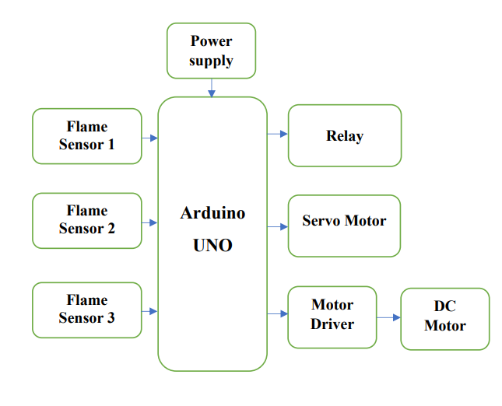

In some other existing systems either uses fans or depend upon an external source to extinguish fire and they uses smoke detectors which are useful but not highly reliable. Mostly in existing fire fighting systems used features like flame detection, gas detection, SMS alert and fire alarm are installed separately.

1. **PROPOSED SYSTEM**

Fires pose significant threats, resulting in human injuries, property damage, and lasting harm to victims. Firefighters often face substantial risks during their heroic efforts. Leveraging technology, robots have emerged as valuable substitutes in life-threatening situations. The primary objective of our project is to engineer an advanced fire-suppression and detection robot. By creating and deploying such a robot, to prevent disasters while minimizing the inherent dangers faced by human responders. Our autonomous firefighting robot possesses the capability to autonomously detect smoke and fire, promptly responding by initiating water dispersion.

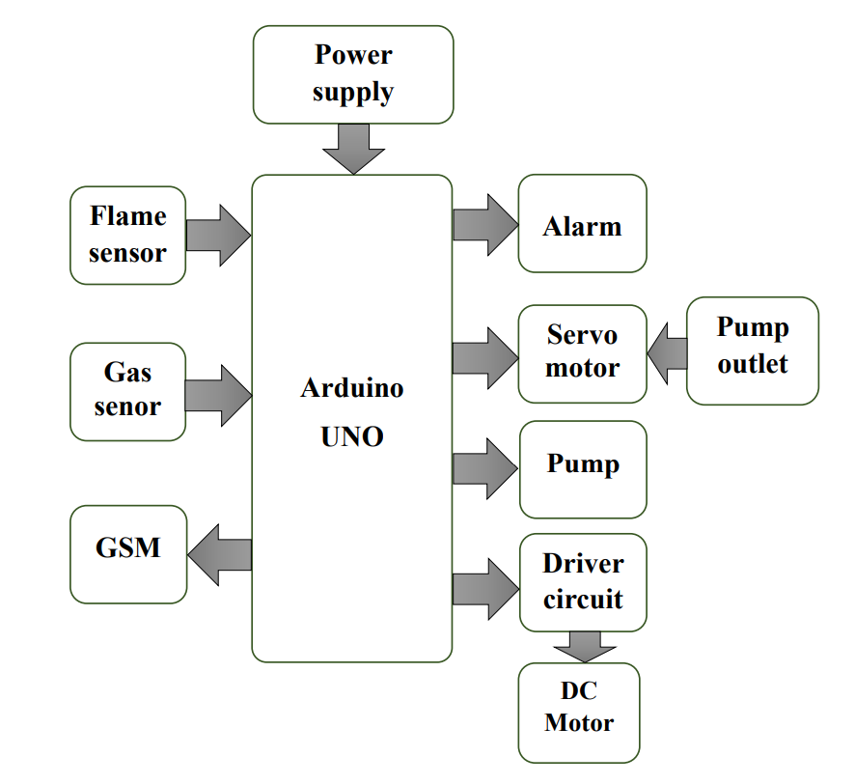

The autonomous firefighting robot which is an integrated system has more features. In this project flame and gas sensors were used for continuous monitoring to detect the fire and smoke. Once the fire/gas detected, the sensors alert the microcontroller and the controller starts alarm sound and an alert message which will be given to the registered mobile number through GSM.

A servo motor is used to spray the water by a pump in a direction. DC motors were used for the movement while the robot is on operation mode to extinguish the fire. In this proposed system, the features like flame detection, gas detection, SMS alert and fire alarm are integrated together.

Firefighters and humans are more likely to cause injuries while performing their daily duties. In fire emergencies the shortage of time is problematic. One alternate method for lowering firefighter casualties and improving firefighter capabilities is the use of robots.

1. **FLOW CHART**

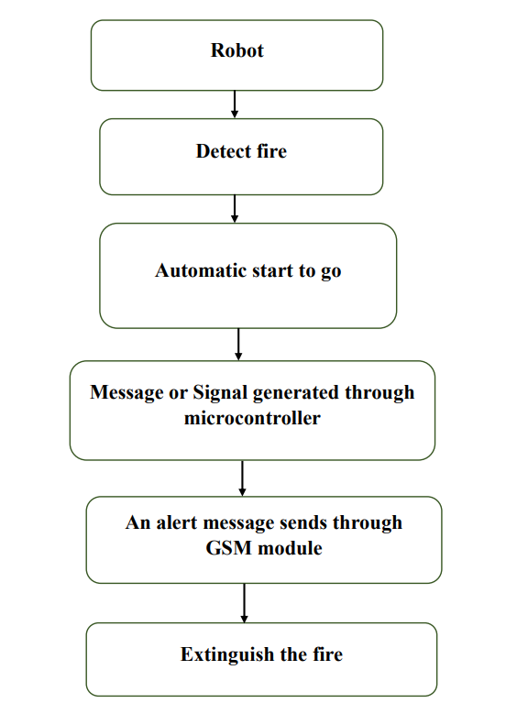

1. **SIMULATION DIAGARM**

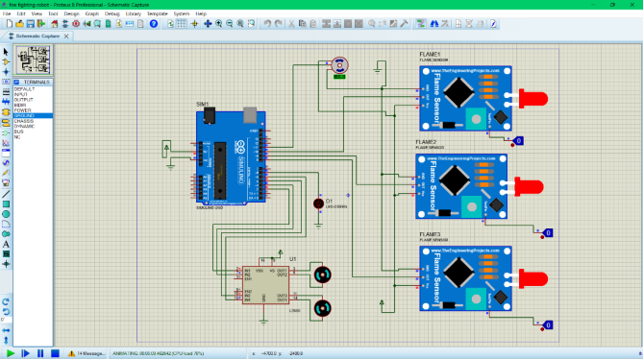

1. **SIMULATION OUTPUT**

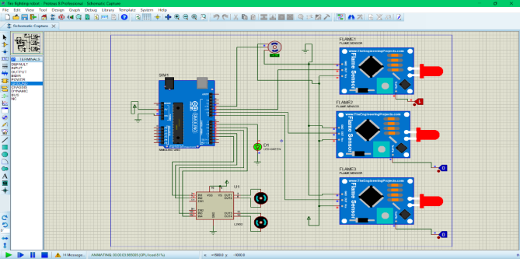

The above figure shows the detection of flame by glowing of the LED, it means the system has started and starts moving to extinguish the fire.

1. **RESULT**

In this project, we have developed an autonomous Firefighting Robot capable of detecting flames and smoke and effectively extinguishing them. The robot is equipped to move forward, as well as left and right, with seamless control facilitated by the motors and Arduino code. In the event of flame or smoke detection by any of the sensors, a buzzer is activated to alert of the hazardous environment. Upon receiving the signal indicating a danger zone, the motors initiate movement towards the affected area, while a servo motor pumps water to extinguish the fire. This process repeats until the fire or smoke is completely extinguished.

1. **CONCLUSION**

It emphasizes the project's role in minimizing risks to human lives and property through the development of a fire-suppression and detection robot. The robot's has a autonomous capability to detect smoke and fire and initiate fire-suppression measures and underscores its importance in enhancing safety in firefighting scenarios.

1. **FUTURE WORK**

In future this project can be extended by advancing the ability of robots to extinguish fires through various means, such as water, foam, or specialized suppression agents. Improving sensor technology for better detection of heat, smoke, gas, and victims, enhancing the robot's ability to locate and assess the fire environment. AI and Machine Learning: Integrating advanced AI and machine learning algorithms for better situational awareness, object recognition, and decision-making in firefighting scenarios. Developing robust communication systems for real-time data exchange between robots and firefighting teams.

1. **REFERENCE**
2. Lokendra Joshi, Pratik Shinde, Vaibhav Khade, Mayur Shinde, Prof. S. S. Kulkarni, “IOT Based Fire Fighting Robot”, International Journal of Advanced Research in Science, Communication and Technology (IJARSCT), Volume 2, Issue 3, May 2022.
3. Durgesh Sharma, Harshala Gaikwad, Kartavya Verma, “Fire extinguishing robot using arduino”, International Research Journal of Engineering and Technology (IRJET), vol. 08, June 2021.
4. Aftab Nagarji, Aniket Vani, Pratik Kumathe, Prof. N.S.Nadaf, “Fire Fighting Robotic Vehicle Using Arduino”, International Research Journal of Modernization in Engineering Technology and Science, Volume 4 Issue 7July 2021.
5. Sukanya Prashant Karpatil, Apeksha Rajendra Patil, Deepak Dinesh Sharma, “Fire Fighting Robot”, International Journal for Research Trends and Innovation, | Volume 6, Issue 4 2021.
6. Prince, Ahmed Tamim Zabir, Kabir, Kazi Shahadat, Nabil, Md. Abdullah, Ratul, S.M. Zobaeir Akando, Rafat, Sadman Sakib, Raisa, Tabassum Tasin, Tahrim, H M. Jahan, Nushrat, Raza, Kala, “Fire Fighting Robot”, American International University, 20 April 2021.
7. K. Shamili devi, k. Akhileswar, ch. Vinayaka, m. Karthik, Y. K. Viswanadham, “FIRE FIGHTING ROBOT”, The International journal of analytical and experimental modal analysis, Volume XII, Issue VII, July 2020.
8. 7.Ruchita H. Dudhat, Shradhdha N. Patel, Shreya A. patel, H. Shah, “A Survey on AI Based Fire – Fighting Robotics”, International Journal for Research in Applied Science and Engineering Technology, vol 8, Jan 2020.
9. 8.Mohd Aliff, MI Yusof, Nor Samsiah Sani, Azavitra Zainal, “Development of Fire Fighting Robot (QRob)”, International Journal of Advanced Computer Science and Applications, Vol. 10, No. 1, 2019.
10. 9.Nandakumar S, Sanjay Sagar I, Subash R, Vishal Vaitheeshwaran R.K, “Automated Fire Fighting Robot”, International Journal of Innovative Science and Research Technology, Volume 3, Issue 4, April 2018.
11. 10.Pushpendra Kumar, Saurabh Verma, Pradeep Kumar, Sandeep, “Automatic Fire Fighting Robot”, International Journal of Creative Research Thoughts (IJCRT), Volume 6, Issue 2 April 2018.
12. 11.R. R. Varghese, P. M. Jacob, J. Jacob, M. N. Babu, R. Ravikanth and S. M. George, "An Integrated Framework for Driver Drowsiness Detection and Alcohol Intoxication using Machine Learning", *2021 International Conference on Data Analytics for Business and Industry (ICDABI)*, pp. 531-536, 2021.
13. 12.V. Spurny, V. Pritzl, V. Walter and M. Petrilk, "Autonomous Firefighting Inside Buildings by an Unmanned Ariel Vehicle", IEEE Access, vol. 9, 2021.
14. K. Vichova, M. Hromada, J. Valasek and F. Paulus, "Comparison Analysis the use of modern technologies by fire rescue service", 2020.
15. I. Prasojo, P. T. Nguyen, O. tanane and N. Shahu, "Design of Ultrasonic Sensor and Ultraviolet Sensor Implemented on a Fire Fighter Robot Using AT89S52", Journal of Robotics and Control, 2020.
16. M. Aliff, M. Yusof, N. S. Sam and A. Zainal, "Development of Fire Fighting Robot(QRob)", International Journal of Advanced Computer Science and Applications, vol. 10, 2019.
17. R. Brindha, S. Gomathi, K. Vanitha, R. Elanthirayan and A. Ananthichristy, "Automatic Fire Fighting Robo Vehicle Using Arduino", International Journal of Recent Technology and Engineering, vol. 8, no. 2S11, 2019.
18. V. Belozerov, A. Denisov and M. Nikulin, "Integration of fire protection of farmland steppe and forest tracts with agrotechical processes of thir tratment with the help of airships", InteE3S Web of Conference, 2020.
19. P. M. Jacob, Priyadarsini R. Rachel and Sumisha, "A Comparative analysis on software testing tools and strategies", International Journal of Scientific & Technology Research, vol. 9, no. 4, pp. 3510-3515, 2020.
20. Vasantha kumar, "Fuzzy Logic Algorithm and GSM IoT Based Fire Fighting Robot", 2021