**Design and Implementation of IoT based Energy Management System with Data Acquisition**

**V.Nagamani1,R. Harshitha2 M. Shilpa3 C. Madhuleela4 C. Laxmidevi5**

**1,2,3,4,5Electronics & Communication Engineering**

**1,2,3,4,5Santhiram Engineering College , Nandyal, Ap, India, 518501**

**ABSTRACT:**

Energy saving is one of the main challenges in our day today life. Energy saving can be done only when the energy consumed by the load is monitored. Once the load is monitored, suitable control methods can be adopted to operate the load in the optimized way to save energy. Even though there are lot of technologies and solutions available to effectively monitor, control and save energy consumption of load in a house or an industry, the Internet of Things (IoT) technology is proposed to monitor, control and minimize energy consumption of load. The proposal is to design and develop an Internet of Things (IoT) based Energy Management System in which the data is collected from smart energy meter using GPRS network and displayed on web page. The proposed system is suitable for data collection and control the load in the Internet of Things (IoT)environment.

Keywords: IoT, GPRS, Energy Management System, Embedded system, Web server, IP

**INTRODUCTION:**

In today’s world, energy efficiency and sustainability have become crucial priorities. IoT-based Energy Management System offer a cutting -edge solution to address these challenges, enabling intelligent monitoring, control, and optimization of energy consumption across residential, commercial, and industrial setting. This document will provide a comprehensive overview of the key components, capabilities, and benefits of IoT-EMS, as well as the emerging trends and future developments in this rapidly evolving field. The internet of Things is a rapidly growing technology that enables seamless connectivity and data exchange between a network of physical devices, sensors, and systems. In the context of energy management, IoT technology plays a pivotal role by providing the necessary infrastructure for real-time monitoring, remote control, and intelligent decision-making. IoT-enables sensors and smart devices can collect comprehensive data on energy consumption, environmental conditions, opportunities for optimization.

PURPOSE:

The increasing demand for efficient energy consumption and the proliferation of Internet of Things (IoT) technology have spurred the development of advanced Energy Management Systems (EMS). This research presents the design and implementation of an IoT-based Energy Management System with a focus on robust data acquisition. The system integrates communication protocols, and data analytics to enable real-time monitoring and optimization of energy usage in diverse environments.

**EXISTING SYSTEM:**

In existing home and industrial appliances control there is no load monitoring system available. There are load Control systems are available in market that can be controlled through manual, IOT or SMS. But user couldn’t receive load parameter like current. Current will tell us, home much power utilised.

**PROPOSED SYSTEM:**

To solve above issue, we propose a system that can monitor load parameter like current using current sensor. Also, user can control loads from SMS. Current value will update to IOT server through WIFI module.

**TECHNICAL SPECIFICATIONS:**

**HARDWARE:**

Microcontroller : Arduino Uno

Crystal : 16 MHz

LCD : 16X2 LCD

GSM : SIM800C

IOT module : ESP8266

Current Sensor : Coil type 5 amps

Load : 230VAC

Relay : 12v DC Coil type

Power Source : 12v 2 amp Adaptor

**SOFTWARE:**

Arduino IDE

Proteus based circuit diagram

**BLOCK DIAGRAM:**

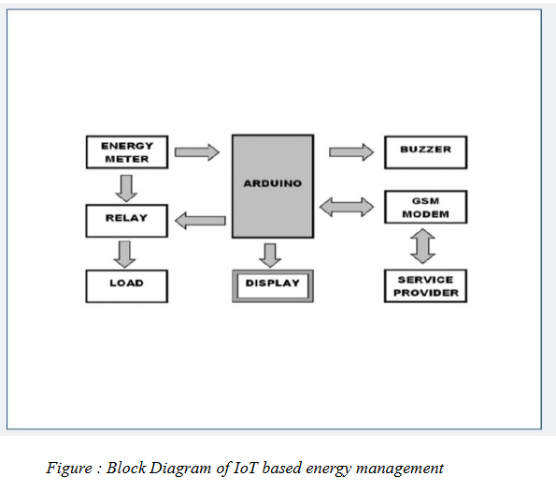

**CONCLUSION:**

An Internet of Things-based energy management system's architecture and execution can greatly optimize energy use, boost productivity, and cut expenses in a number of industries. Organizations can receive real-time insights into energy usage trends, remotely monitor andcontrol energy assets, and take proactive steps to increase energy efficiency and sustainability

by combining IoT technologies with energy management systems.Sensors, actuators, communication networks, data analytics platforms, and smart meters areimportant parts of the Internet of Things-based energy management system. Together, theseparts enable the fast and automatic collection, analysis, and action of energy data.All things considered, the planning and execution of an Internet of Things (IoT)-based energymanagement system provides a comprehensive strategy for energy management by mergingautomation, data analytics, and real-time monitoring to maximize energy use, lowerexpenses, and improve sustainability. In order to drive innovation and achieve long-termenergy goals, IoT-based energy management solutions will be essential as long as enterprisesprioritize environmental sustainability and energy efficiency.

**RESULT:**

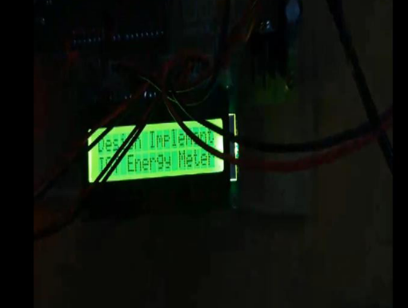

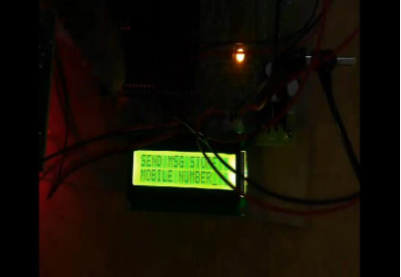

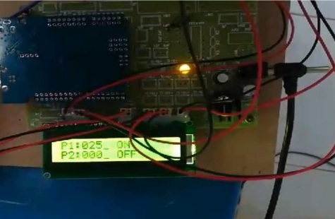

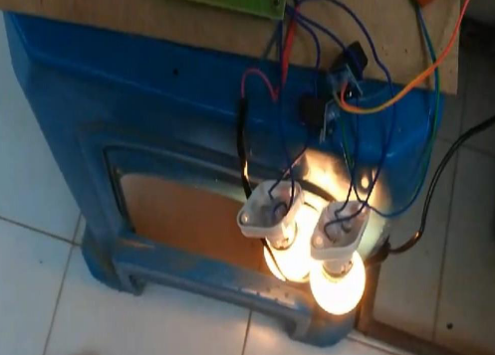

**REFERENCE**:

1. v.nagamani,“multi modal image fusion framework based nsct implementation for achieving better clinical analysis”- ijarcet,2014
2. v.nagamani,‘smart home based on iot using raspberry pi3”,vol-6,issue-1,jan 2019-ijrar.
3. “rfid based warehouse management using raspberry pi”,vol-6,issue-1,jan-2019-jetir
4. v.nagamani,“temperature and humidity sensor based air blower controller for food drying”journal of algebraic statistics volume 13, no. 1, 2022, p. 869 - 876 https://publishoa.com issn: 1309-3452
5. v.nagamani,“a novel image encryption algorithm for grey and color medical”,international journal of research publication and reviews, vol 3, no 8, pp 991-994, august 2022.
6. v.nagamani,“despite non-uniform motion blur, illumination, and noise, face recognition”,international journal of progressive research in engineering management and science (ijprems) vol. 02, issue 08, august 2022, pp : 25-29 e-issn : 2583-1062 impact factor : 2.265.
7. ”automatic gas alerting system,om chandrika, bah bindu,imperial journal of interdisciplinary research (ijir) 2 (6), 2454-1362,2016

ArduinoIDE(Desktop): <https://www.arduino.cc/en/Main/Software>

ArduinoIDE(Cloud): <https://create.arduino.cc/editor>

Cloud IDE Getting Started: Cloud IDE Getting Started <https://create.arduino.cc/projecthub/Arduino_Genuino/getting-started-with-arduino-web- editor-4b3e4>

ArduinoProWebsite: <https://www.arduino.cc/pro>

Project Hub : <https://create.arduino.cc/projecthub?by=part&part_id=11332&sort=trending>