Master’s Thesis On

“Study on Supply chain and Logistics in India’s E-commerce retail.”

### FOR THE PARTIAL FULFILLMENT OF THE REQUIREMENT FOR THE AWARD OF

***MASTER OF BUSINESS ADMINISTRATION***

UNDER THE GUIDANCE OF

Asst.Prof. REJI JOHN SUBMITTED BY ABHIJEET KUMAR 22GSOB2010224 MBA 2022-2024



SCHOOL OF BUSINESS GALGOTIAS UNIVERSITY

MAY, 2024

# CERTIFICATE

This is to certify that the Master’s Thesis “Study on Supply chain and Logistics in India’s E-commerce retail” has been prepared by Mr. Abhijeet Kumar under my supervision and guidance. The project report is submitted towards the partial fulfillment of 2year, Full-time Master of Business Administration.

Name: Reji John

Signature of Faculty:

Date:

# DECLARATION

I, **Abhijeet Kumar Roll No.22042010201**, student of School of Business, Galgotias University, Greater Noida, hereby declare that the Master’s Thesis on “**Study on Supply chain and Logistics in India’s E-commerce retail**” is an original and authenticated work done by me.

I further declare that it has not been submitted elsewhere by any other person in any of the institutes for the award of any degree or diploma.

Name: Abhijeet Kumar Signature:

Date:

# ACKNOWLEDGMENT

I am honoured to extend my heartfelt gratitude to all those who played a pivotal role in the successful completion of my project, " **Study on Supply chain and Logistics in India’s E-commerce retail** " Their invaluable contributions and unwavering support have been instrumental throughout this endeavour.

First and foremost, I am deeply thankful to **Reji John**, my esteemed faculty guide, for his invaluable guidance, expertise, and continuous encouragement. His mentorship has been invaluable in shaping the direction and execution of this project.

Furthermore, I extend my heartfelt thanks to all my dear friends for their unwavering cooperation, insightful advice, and constant encouragement throughout the journey of conducting this project and compiling this report. Their support has been a source of strength and motivation, making the arduous task more manageable.

Lastly, I am grateful to the entire academic community and all individuals who have contributed in any capacity, directly or indirectly, towards the realization of this project.

With deepest regards,

Abhijeet Kumar

# TABLE OF CONTENT

|  |  |  |
| --- | --- | --- |
| S.  No. | DESCRIPTION | PAGE NO. |
| 1 | ABSTRACT | 6 |
| 2 | INTRODUCTION | 7-11 |
| 3 | OBJECTIVE | 12 |
| 4 | COMPANY PROFILE | 13-26 |
| 5 | RESEARCH METHODOLOGY | 27-29 |
| 6 | DATA ANALYSIS | 30-38 |
| 7 | TRENDS IN E-COMMERCE | 39-49 |
| 8 | CONCLUSION AND RECOMMENDATIONS | 49-52 |
| 9 | REFERENCES | 53 |
| 10 | BIBLIOGRAPHY | 54-55 |

**ABSTRACT**

India is witnessing a seismic shift in its approach towards e-commerce retail logistics, marked by a burgeoning interest and curiosity. The realm of e-commerce retail is burgeoning at an unprecedented rate, fueled by a myriad of supply and demand catalysts. Factors such as the ubiquitous presence of the internet and smartphones, the swelling number of urban households, seamless payment options, and tantalizing promotional offers synergize with the convenience, accessibility, and assortment afforded by online shopping, propelling market growth. In this dynamic landscape, e-commerce retailers are incessantly innovating, leveraging novel business paradigms and cutting-edge technology to stay ahead. Embracing customer-centric policies, expeditious deliveries, and hassle-free return mechanisms, these companies entice customers towards online platforms. Novel concepts like exclusive app-only sales, invite-only discounts, and cash-back schemes, coupled with special online events, further galvanize the online shopping experience. The symbiotic relationship between retail e-commerce and the logistics sector is reshaping the industrial panorama, fostering significant investments and value creation. This metamorphosis has birthed a new breed of logistics operators, attuned to the evolving needs of the e-commerce realm. Recognizing logistics as a linchpin for customer satisfaction and market reach, e-commerce giants are investing heavily in fortifying their logistical infrastructure and capabilities. The logistical landscape is evolving at breakneck speed, with an emphasis on elevated service standards, deeper penetration into tier-II and tier-III cities, robust Cash on Delivery services, expansive geographic coverage, and fortified supply chain security measures. This paradigm shift underscores the imperative for adaptability and agility in catering to the ever-changing exigencies of the e-commerce ecosystem.

# INTRODUCTION:

In 2016, the e-commerce landscape in India boasted a valuation of approximately USD 27.5 billion, with projections soaring towards a stratospheric CAGR of 31 percent, envisioning a staggering USD 80 billion benchmark by the dawn of 2020. Amongst the myriad sectors composing this digital panorama, the online travel domain stands as a towering colossus, commanding a lion's share of approximately 61 percent. Within this realm, the echelons of ticketing reign supreme, spearheaded by the inexorable growth of domestic air ticketing services

Market Size and Growth by category

1.1 1.4

1.7

6.7

16.8

Travel E-commerce retail Financial services Classifieds Others

100%= USD27.5 billion Travel= USD16.8 billion

E-Commerce retail= USD6.7 billion Financial Services= USD1.7 billion Classifieds= USD1.1 billion Others= USD1.4 billion

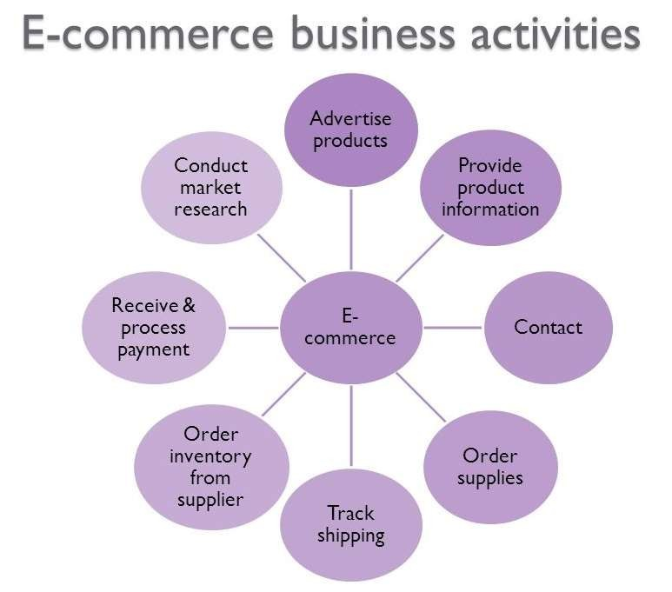The state-owned Indian Railway Catering and Tourism Corporation (IRCTC) has emerged as one of the largest online sites, with the website itself, attracting about 45 per cent of all visitors to travel websites in India and 19per cent of the total internet audiance.

# E-COMMERCE RETAILING IN INDIA

India's e-commerce retail sector stands as a pulsating hub of opportunity, representing one of the nation's most exhilarating and rapidly expanding markets. With a Gross Merchandise Value (GMV) estimated at a robust USD 12 billion in 2016, this industry has traversed a remarkable journey since its inception, consistently amassing momentum and value along the way. Propelled by a confluence of factors, including the widespread penetration of internet and smartphones, targeted advertising strategies, customer-centric shopping experiences.

The top three to four players in the market currently command over 80 per cent of the market share in the overall domestic e-commerce retailing space

Large players are diversified across categories and are building their capabilities to service several of these categories.

# ONLINE RETAIL IN INDIA AS A PERCENTAGE OF TOTAL RETAIL

Despite the burgeoning potential of the online realm, retailers have yet to fully harness its transformative power, hampered by challenges such as limited internet penetration, a relatively modest cohort of online shoppers, and transactions characterized by diminutive sizes. However, the tide is turning, with projections indicating a notable uptick in online retail penetration within the broader retail landscape. Forecasts suggest that the proportion of online retail within the total retail market will ascend from a mere 2.5 percent in 2016 to a more substantial 5 percent by the turn of 2020.

## Sector drivers and trends

Increasing As India embraces the digital age, the online consumer base burgeons with each passing day. With over 243 million web users nationwide, the trajectory of internet penetration in the country is nothing short of meteoric. In the top four metros, internet adoption stands at an impressive 23 percent, while the remaining four metros have witnessed an 11 percent surge in internet penetration.

Yet, amidst this growth, India grapples with a digital divide. While the internet landscape flourishes, only 19 percent of the Indian populace enjoys online access, a figure significantly lower than the 40 percent benchmark observed in peer nations like Brazil, Russia, and China.

## Changing lifestyle of the Indian consumer seeking convenience, comfort and variety:

In bustling metro cities, the allure of shopping online lies in its promise of convenience and efficiency, offering a respite from the hustle and bustle of traditional retail spaces. With just a few clicks, shoppers can secure their desired products, saving precious time and sparing themselves the rigors of navigating through crowded malls.

Moreover, the prospect of swift delivery, often within the same or following day of placing an order, adds an element of immediacy to the online shopping experience, further enhancing its appeal.

# ROLE OF SUPPLY CHAIN

The rapid advancements in technology have spurred business organizations to integrate it seamlessly into their day-to-day operations, revolutionizing traditional approaches and ushering in an era of enhanced efficiency. By leveraging Information and Communication Technology (ICT), businesses have been able to streamline processes, significantly reducing reliance on manpower, paperwork, and time constraints. Today, organizations are embracing the digital realm, conducting transactions and operations online via websites, epitomizing the paradigm shift towards E-commerce.

This digital metamorphosis has not only reshaped business landscapes but has also fostered a new era of competition, one that transcends individual companies and focuses on the optimization of supply chains. A supply chain, comprising a network of facilities and distribution channels, has become the nucleus around which businesses collaborate to design, produce, deliver, and service products. E-commerce, facilitated by websites and advanced technology, emerges as the cornerstone of modern business endeavors, offering unparalleled benefits for both customers and businesses alike.

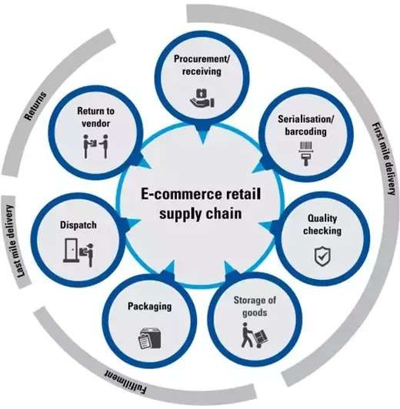

# ROLE OF LOGISTICS IN E-COMMERCE RETAIL

The pivotal role of logistics as a catalyst for the growth of the e-commerce retail industry cannot be overstated, as it increasingly emerges as a linchpin for delivering superior customer service and satisfaction. Evolving in tandem with the dynamic demands of the e-commerce landscape, logistics has become a vital driver of business expansion and differentiation. In India, the logistics sector dedicated to e-commerce retail was valued at USD 0.46 billion in 2016, with projections indicating a staggering CAGR of approximately 48 percent over the next five years, catapulting its worth to USD 2.2 billion by 2020.

While many e-commerce entities have opted to forge partnerships with external logistic service providers to meet their operational needs, a notable fraction has opted to cultivate in-house logistics capabilities. This dichotomy sees roughly 50 percent of the e-commerce logistics market controlled by in-house players, with the remaining 50 percent dominated by third-party logistics (3PLs) service providers, encompassing both traditional Logistics Service Providers (LSPs) and e-commerce-focused entities, including India Post.

# OBJECTIVES

To study the customer response on product purchase from Flipkart. To study Supply Chain Management advantages in E-Commerce. To understand the problems in logistics of E-Commerce retail.

To understand the problems in Supply Chain Management of E-Commerce retail. Risks and challenges ahead for E-Commerce retail logistics.

# COMPANY PROFILE

**ABOUT FLIPKART**



Based in Bengaluru, India, Flipkart stands as a pioneering force in the realm of electronic commerce. Founded in October 2007 by Sachin Bansal and Binny Bansal, both esteemed alumni of the Indian Institute of Technology Delhi, Flipkart swiftly emerged as a trailblazer in the digital marketplace. Initially focused on revolutionizing the online book trade in India, Flipkart quickly diversified its offerings, expanding into a diverse array of products and services.

One notable venture was the launch of its proprietary product line, "DigiFlip," which featured a range of electronic devices including tablets, USB flash drives, and laptop bags. This foray into branded merchandise underscored Flipkart's commitment to innovation and customer satisfaction.

Throughout its journey, Flipkart has demonstrated a penchant for strategic acquisitions, including Mime360.com and the digital catalogue of Chakpak.com in 2011, as well as the minority stake purchase in navigation startup MapmyIndia in 2015. These endeavors bolstered Flipkart's capabilities and bolstered its position as a market leader.

However, not all ventures yielded anticipated results, as evidenced by the closure of its Flyte Digital Music Store in 2013. Despite setbacks, Flipkart persisted and continued to innovate, culminating in the resounding success of its Big Billion Sales in 2014 and subsequent years, which saw staggering business turnovers and cemented Flipkart's status as an e-commerce juggernaut.

## Acquisitions

2010: WeRead, a social book discovery tool.

2011: Mime360, a digital content platform company.

2011: Flipkart's acquisition of Chakpak.com marked a strategic move to bolster its digital offerings, particularly in the realm of Bollywood entertainment. Acquiring the rights to Chakpak's extensive digital catalogue, comprising 40,000 filmographies, 10,000 movies, and nearly 50,000 ratings, Flipkart demonstrated its commitment to enhancing user experience and diversifying its content offerings.

2012: Flipkart made a strategic move by acquiring Letsbuy.com, a prominent Indian e-retailer specializing in electronics, for an estimated sum of US$25 million. Following the acquisition, Letsbuy.com ceased its operations, with all incoming traffic redirected to Flipkart

2014: Acquired Myntra.com in an estimated ₹20 billion (US$310 million) deal.

2015: Flipkart acquired a mobile marketing start-up Appiterate as to strengthen its mobile platform.

2016: Flipkart’s Myntra acquires rival fashion shopping site Jabong for $70 million. 2016: In April, Flipkart acquired payment start-up Phone Pe.

2017: In April, in exchange for an equity stake in Flipkart, eBay agreed to make a

$500 million cash investment in and sell its eBay.

## Awards and recognition

In April 2016, Sachin Bansal and Binny Bansal ascended to Time Magazine's prestigious list of The 100 Most Influential People, a testament to their indelible mark on the global stage of entrepreneurship and innovation. This recognition underscored their visionary leadership and trailblazing contributions to the digital realm.

In September 2015, the dynamic duo made waves once again as they debuted on the Forbes India Rich List, clinching the 86th position with a staggering net worth of $1.3 billion each.

# COMPANY STURCTURE

The whole organizational structure of Flipkart is organized in three broad teams as depicted below:

|  |  |  |
| --- | --- | --- |
| Product and Technology | Business Development | Operations |
| Website Management | Vendor Management | Procurement |
| ERP System | Sales Management | Warehouse |
|  | Pricing Strategies | Logistics |
|  |  | Customer Support |

## Product and Technology Team

At the heart of the company lies its formidable product and technology team, serving as the bedrock of its success and innovation. This dedicated team oversees the entire spectrum of operations, from meticulously curating and listing items to implementing cutting-edge search engine optimization strategies and ensuring the seamless maintenance of the website. With their unparalleled expertise and relentless commitment to excellence, the product and technology team continually propels the company forward, driving growth, enhancing user experience, and spearheading technological advancements that redefine industry standards.

**Supply Chain Management of Flipkart**

Flipkart's organizational structure embodies a strategic division into three distinct pillars, each playing a pivotal role in the company's overarching success. At the forefront stands the Product and Technology division, serving as the cornerstone of Flipkart's operations. This core team spearheads innovation and technological advancements, overseeing everything from product development to website optimization, ensuring a seamless and intuitive user experience.

## Customer Support team

Customer satisfaction lies at the core of Flipkart's ethos, with a relentless commitment to customer delight standing as its utmost priority. To uphold this commitment, Flipkart ensures round-the-clock customer support, guaranteeing assistance and resolution to queries at any hour of the day.

## Logistics

Efficient logistics management stands as a linchpin of success for any thriving e-commerce enterprise, and Flipkart is no exception. With a staggering daily shipment volume exceeding 100,000 items, Flipkart grapples with the complexities of logistics management, further compounded by the financial intricacies of shouldering delivery costs internally. To navigate this multifaceted challenge, Flipkart devised its in-house logistics arm known as "eKart" (EKL), a strategic move aimed at streamlining operations and enhancing customer satisfaction.

Established as a separate brand in April 2013 to cater to the B2C side of Flipkart, eKart has since expanded its reach to encompass approximately 150 cities nationwide. Offering an array of services including delivery logistics, reverse logistics, and cash-on-delivery (COD) options, eKart epitomizes Flipkart's unwavering commitment to excellence in logistics management.

While eKart shoulders the lion's share of deliveries, accounting for over 90% of COD shipments and 60-70% of overall deliveries, Flipkart also collaborates with third-party logistics (3PL) providers to fulfill remaining orders. To ensure seamless coordination and maximize efficiency, Flipkart allocates specific time slots to different logistics partners, enabling streamlined pickup and delivery operations. By developing its in-house logistics capabilities, Flipkart has not only mitigated reliance on external courier firms but also reaped substantial cost savings, circumventing commissions worth more than 2%.

Cash on delivery (COD) transactions constitute a substantial portion, approximately 60%, of Flipkart's orders, underscoring the importance of flexible payment options in catering to diverse consumer preferences. Leveraging advanced tracking technologies, Flipkart is able to monitor packages with unprecedented accuracy, ensuring timely and reliable delivery to customers nationwide.

Benefiting from India's relatively low labor costs, Flipkart boasts a modest delivery cost of ₹65 per package, further enhancing its competitive edge in the e-commerce landscape.

## Reverse logistics / returns processing

Returns pose a significant challenge for Flipkart, with a return rate of 2.6% and a 30-day return policy aimed at fostering trust with consumers. However, this policy has inadvertently opened the door for fraudulent practices, as some customers exploit it by purchasing items, such as books or mobile phones, only to return them after use. To combat such fraud, Flipkart employs robust data management systems to detect and deter fraudulent return attempts, safeguarding its interests and maintaining the integrity of its return process.

Replacement: Flipkart initiates a process whereby the item is returned to the supplier, facilitating a replacement that is subsequently delivered to the customer. This seamless exchange ensures minimal disruption to the customer's experience while maintaining the integrity of Flipkart's supply chain.

Actual cash-back: For Flipkart customers, refunds for returned items are processed in two distinct manners, depending on the original mode of payment. Cash-on-delivery payments are promptly refunded to the customer in cash.

## Procurement

Flipkart adopted the consignment model of procurement, a prudent approach wherein the retailer (in this instance, Flipkart) held inventory owned by the supplier and purchased it only upon sale to the end consumer. This risk-averse strategy provided Flipkart with a secure footing in an uncharted market landscape, mitigating potential losses while navigating the uncertainties of a burgeoning industry

times response to shifting regulatory landscapes and evolving market dynamics, Flipkart made a strategic pivot from its traditional business model to embrace the marketplace model, following the favorable climate for foreign direct investment (FDI) in April 2013. This transformation ushered in a new era of growth and innovation, empowering Flipkart to expand its seller base and diversify its product offerings.

***Inventory:*** In the realm of the marketplace model, Flipkart adopts a proactive approach to inventory management, pre-ordering items based on robust analysis of previous sales data. This data-driven strategy allows Flipkart to effectively stock inventory, particularly focusing on categories characterized by relatively low demand elasticity, fast turnover rates, and extended shelf life..

***Just in-time:*** Items In Flipkart's intricate ecosystem of procurement and order fulfillment, a delicate balance is struck between just-in-time procurement and inventory stocking to meet the diverse demands of consumers while maintaining operational efficiency.

Just-in-time procurement serves immediate outstanding orders and is reserved for items with low or unpredictable demand, expensive items, or those experiencing slow sales growth. While it's a responsive solution, it incurs higher costs due to lower volumes and reduced supplier discounts.

Conversely, inventory procurement entails bulk purchases at favorable prices, allowing Flipkart to meet a significant portion of orders from stocked inventory. Currently, approximately 75% of orders are served from inventory, with the remainder fulfilled through just-in-time procurement.

Sourcing at Flipkart is conducted at two levels: Regional: By Regional Procurement Teams Centre: By the Central Procurement Team

The procurement teams leverage real-time visibility of stock levels for various Stock Keeping Units (SKUs) within their respective supplier networks. This visibility is facilitated by the suppliers' regular updates on stock availability, ensuring that Flipkart remains abreast of inventory levels and can make informed procurement decisions.:

***Stock out:*** Centralized approach empowers the central procurement team to monitor stock availability across the country, facilitating agile decision-making and proactive inventory management. While regional teams handle local supplier relationships and inventory needs, the central team's focus lies on larger suppliers with expansive, country-wide reach.

## Warehouse Management System

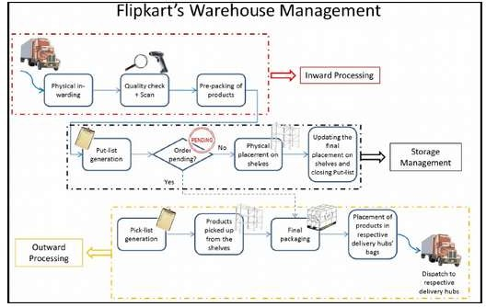

Flipkart's logistical infrastructure is strategically dispersed across the nation, anchored by seven major warehouses strategically located in key metropolitan centers including Mumbai, Kolkata, Delhi, Noida, Pune, Chennai, and Bangalore. Complementing these major hubs, Flipkart maintains a network of smaller regional distribution centers spanning over 500 locations, strategically positioned across Tier I cities and high-volume Tier II cities.

Discussed below are the some of the details regarding each of the sub- processes involved in the WMS.

## Inward Processing

***Physical in-warding:*** This pivotal phase involves the physical receipt and intake of goods from suppliers into the warehouse facilities. This process is meticulously managed to ensure the accurate and timely delivery of incoming shipments, laying the groundwork for subsequent processing and storage activities.

***Pre-packing of products:***  Following the receipt of goods, the pre-packing stage is initiated, wherein preliminary packing procedures are executed for each product..

## Storage Management

***Put-list generation:***  All product inputs are meticulously recorded within Flipkart's IT systems, a streamlined process is initiated to generate a system-generated list of shelves corresponding to each product. This automated procedure optimizes the placement of products within the warehouse, ensuring efficient utilization of storage space and facilitating seamless retrieval during order fulfillment.

### Order pending check:

Upon receiving input of incoming products into the system, Flipkart's automated processes swiftly spring into action. The system performs a comprehensive check to determine if any pending orders exist for the incoming products. If pending orders are identified, the respective products are expedited directly to the Final Packaging Area for Outward Processing.

### Physical placement on shelves:

As part of Flipkart's warehouse management process, the Put-list plays a crucial role in organizing incoming products within the warehouse. When products arrive for placement, they are matched with their designated shelves as per the Put-list.

### Closing Put-list:

Once the product placement is done, Put-list is updated with the actual placement information and the list is closed.

## Outward Processing

***Pick-list generation:*** Based on the orders to be delivered for the day, a Pick-list is generated by the IT system.

### Pick-up from shelves:

The respective products from the Pick-list are picked up from the shelves as per the IT system entries and gathered together to move towards Final Packaging Area.

### Final packaging:

The picked-up products are packed in Flipkart-branded boxes. At this stage, packaging is done according to the Category of the product, e.g., electronic items are packed differently from stationery.

### Placement in respective delivery hubs’ bags:

After the final packaging, a product is placed in a specific bag which is dedicated for that destination area delivery hub. These bags are dispatched to their respective delivery hubs on a fixed timing during the day.

### Issues at the Warehouse Management level:

All the scans while conducting inward processing for each of the products are done manually. There is some scope of automation at this stage.

Due to packaging litter, there emerge chances of difficulty in mobility within the warehouse. Disposal of packing material may be addressed for better streamlining and ease of mobility.

## Order Processing

Flipkart relies on its proprietary ERP systems to manage order processing and track transactional details seamlessly. The typical order journey on Flipkart commences with customers browsing, selecting their desired items, and placing orders, a process that typically involves an average of 8-10 clicks. Each customer's email ID serves as a unique identifier, ensuring accurate record-keeping and personalized service.

In addition to debit and credit cards, Flipkart offers customers the convenience of payment via net banking or Cash on Delivery (COD). To further enhance the payment experience, Flipkart introduced its payments brand, Pay Zippy, in July 2013.

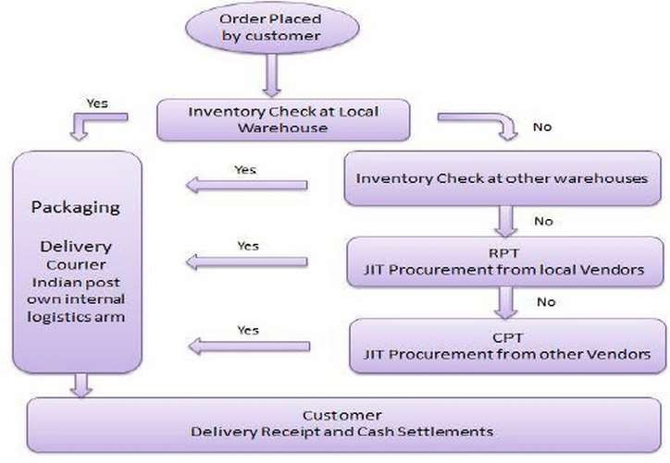

## Order Fulfilment

Once an order is placed and approved, Flipkart initiates a meticulous process to fulfill it, leveraging both inventory and Just-In-Time (JIT) procurement methods based on product availability. The journey begins with an inventory check at the local warehouse. If the item is unavailable locally, the order cascades to the nearest warehouse and subsequently to others until the item is located. Once found, the product undergoes packaging and is promptly dispatched to the customer.

However, if the item remains elusive in the inventory, the order is seamlessly transitioned to the Regional Procurement Team (RPT) for JIT procurement from local vendors.

## Inventory Management

The efficient management of inventory is a cornerstone of Flipkart's operations, with replenishment occurring whenever stock levels dip below the predetermined reorder point. To maintain optimal inventory levels, Flipkart adheres to the FIFO

prioritizing the shipment of older inventory first is a strategic move by Flipkart, particularly beneficial for electronic items where technology rapidly becomes obsolete. This FIFO approach ensures that products are dispatched in the order they were received, minimizing the risk of inventory depreciation and ensuring customers receive the latest technology available.

## Supplier Management

Flipkart's operational philosophy revolves around the principle of gradual expansion in tandem with increasing demand, a strategy reflected in its approach to supplier selection. When venturing into a new product category, Flipkart typically initiates sourcing from local suppliers and distributors. This initial phase allows the company to gauge market interest and validate demand for the category.

This serves two main purposes:

Flipkart's strategic approach to supplier selection not only facilitates better deals from larger manufacturers but also mitigates channel conflict dilemmas often faced by major suppliers. By scaling up orders gradually, Flipkart can negotiate favorable terms with manufacturers while avoiding potential conflicts between online and offline distribution channels.

A prime illustration of this strategy is evident in Flipkart's dominance as India's leading online bookseller. Leveraging its stature, Flipkart procures the majority of its books directly from publishers, showcasing its ability to surpass traditional brick-and-mortar stores in both size and influence. Across diverse product categories, Flipkart collaborates with over 500 suppliers, including international partners. This robust network, cultivated through years of steady growth, enables Flipkart to secure optimal credit lines from suppliers, ensuring seamless operations and timely deliveries.

***Price considerations:*** As mentioned before – credit lines and discount terms play an important part in selecting suppliers.

***Quality Check contract:***Depends on whether QC will be done at supplier’s place and then product will be shipped to Flipkart’s warehouses or if the QC has to be done at Flipkart’s warehouses.

***Percentages of Returns Accepted:*** Higher the percentage of returns accepted by a supplier, the better for Flipkart.

## Customer Support

Flipkart's commitment to delivering a superior shopping experience is epitomized by its approach to customer service. Unlike many counterparts that opt for outsourcing to BPO agencies, Flipkart prioritizes the training and development of its in-house support staff. By investing in comprehensive training programs tailored to their unique service ethos and operational requirements, Flipkart empowers its support team to embody the brand's values and deliver personalized assistance to customers.

At present, a customer calls due to one of the below reasons:

### Sales Assistance General Enquiries

***Product/Shipping related enquiry***

A significant driver behind the volume of calls received by Flipkart's customer support team is the relatively low familiarity of Indian consumers with online shopping protocols. Recognizing this challenge, Flipkart places a premium on user experience, striving to streamline the online shopping process for maximum convenience.

There is also an outbound call-centre that performs the following tasks: Pro-actively inform customers about any delay in deliveries.

Pro-actively check the status of refunds or returns.

In instances where a delivery is unsuccessful due to the customer's absence at the designated address, Flipkart proactively engages with the user to facilitate a seamless resolution. Despite Flipkart's earnest efforts to uphold high standards of customer service, there have been observations on various internet blogs indicating a perceived decline in service quality over the past year.

**SWOT ANALYSIS**

|  |  |
| --- | --- |
| STRENGHTS | WEAKNESSES |
| Internal fleet helps in streamlining deliveries  Various initiatives to boost employee engagement  Development of strong in-house brands  Exclusive tie-ups with established brands to attract customers | Lack of an independent board  Sales not in sync with increase in internet penetration  Too desperate to overcome Amazon increasing levels of uncertainty |
| OPPORTUNITIES | THREATS |
| India’s growing logistics sector can provide a good ground to highlight its own fleet  Leverage the nationwide vibe of ‘Make in India’ | Amazon India, the formidable competitor  Introduction of the GST |

**PESTLE ANALYSIS**

|  |  |
| --- | --- |
| **POLITICAL** | **ECONOMICAL** |
| Government of India to boost rural economy and Digital India | 100% FDI in online retail of goods and services |
| GST | Removal of distinctions in different types of overseas investment |
| **SOCIAL** | **TECHNOLOGICAL** |
| Start-up jobs may suffer a downfall  Empowering youth through employment | Implementation of Data Analytics and cloud |
| Rise in number of online consumers | Leveraging AI for optimization |
|  | Advent of payment banks |
| **LEGAL** | **ENVIRONMENTAL** |
| Infringement of Intellectual Property(IP)  Regulatory changes for protection of online shoppers | Promotion of green environment |

**RESEARCH METHODOLOGY**

Research methodology is the process used to collect information and data for the purpose of making business decision.

## Research Design:

Descriptive Research: Describe the current state of supply chain and logistics in India's e-commerce retail sector.

Cross-sectional Study: Gather data at a single point in time to understand the current situation situation.

## Population and Sample:

Population: E-commerce retailers, logistics providers, and customers involved in the Indian e-commerce market.

Sample: Use stratified sampling to ensure representation from different segments (e.g., large retailers, small retailers, urban and rural customers).

## Data Collection Method:

Survey Questionnaire: Develop a structured questionnaire with closed-ended and open- ended questions to collect quantitative and qualitative data.

Distribution: Administer the questionnaire through online surveys, email, or face-to- face interviews, depending on the accessibility of the target population.

Universe & Sample Design:

Universe: Population of Galgotias University Sample Design: People in MBA.

Sample size - 20 individuals.

Data Collection Tools:

Primary Data: Questionnaire.

Secondary Data: Case study, Website, Newspapers, Research Papers, Journals, Books.

Statistical Tools to be used:

Pie chart

The methodology employed to investigate the research objectives combines primary and secondary data collection techniques. A questionnaire was utilized to gather primary data, focusing on customer opinions regarding product availability and delivery. Additionally, the case study method was employed to analyze secondary data sourced from various sources such as books, journals, and the internet.

The research commenced with an in-depth exploration of the internet retail industry and its key players, facilitated by secondary sources including news articles, industry reports, and databases.

## Defining the problem:

The research objective outlines the essential information required to address the identified problem. In this study, the aim is to investigate the evolving trends, potential risks, and prevalent challenges within the realm of e-commerce retail logistics. Additionally, the research seeks to gain insights into the specific issues encountered within the logistics and supply chain operations of e-commerce retail in India.

## Case Study Research:

A case study serves as an empirical investigation that scrutinizes a contemporary phenomenon within its authentic real-life setting, particularly when the demarcations between the phenomenon and its context are indistinct. Utilizing case studies as a research method entails considering contextual factors while simultaneously delineating the scope of analysis. This approach enables a deep exploration of emerging fields, fostering a fundamental understanding of complex and ambiguous issues.

The potency of the case study method lies in its capacity to capture conceptual advancements without immediately formulating overarching theories. Hence, it is well-suited for exploring nascent research domains..

## Scope of the Study:

The chosen research methodology is the case study method, with Flipkart selected as the focal company. This case study aims to provide valuable insights for aspiring entrepreneurs, elucidating the significance and evolution of efficient supply chain management in achieving business success. While case studies typically focus on individuals, in this instance, the examination extends to a program's efficacy in achieving its desired objectives.

**Limitation of the study:**The conclusion will be based only on the research of single online store, hence the conclusion drawn cannot be generalise to all the online retailers.

# DATA ANALYSIS AND INTERPRETATION

Q1. You are?

Male Female

|  |  |
| --- | --- |
| Total number of respondents | 20 |
| Male | 15 |
| Female | 5 |

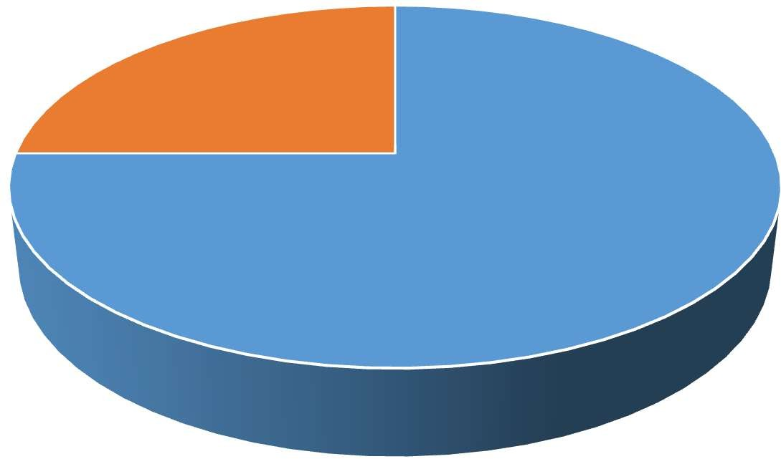

Gender

25%

75%

Male

Female

**CONCLUSION:** 75% of sample population are Male who uses Flipkart.

Q2. Your age? 18-25

25-40

Above 40

|  |  |
| --- | --- |
| Total number of respondents | 20 |
| 18-25 | 15 |
| 25-40 | 4 |
| Above 40 | 1 |

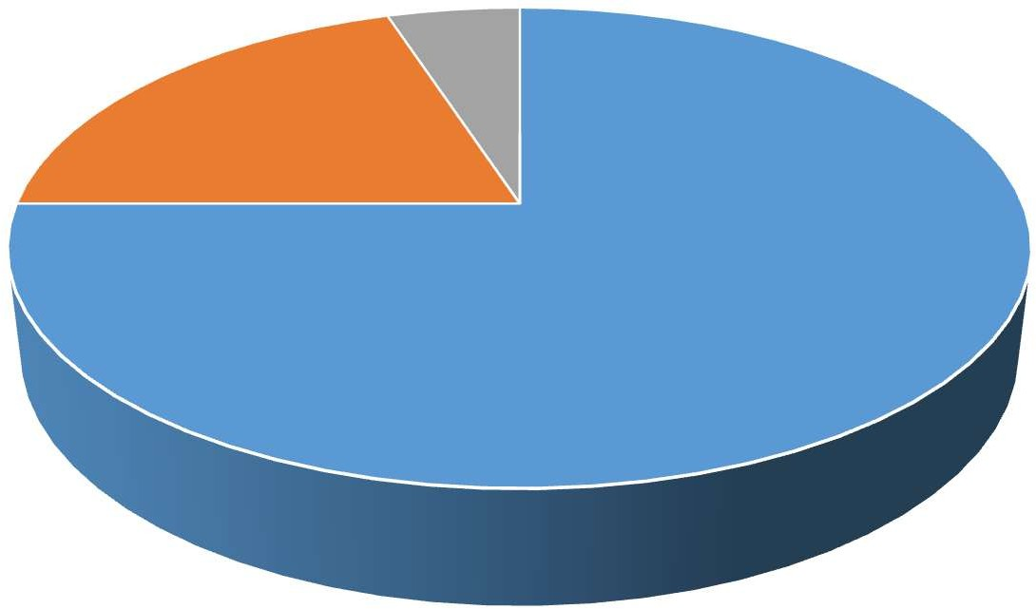

Age

5%

20%

75%

18-25

25-40

Above 40

**CONCLUSION:** 75% of sample populations are of age group 18-25 who uses Flipkart.

Q3. Most of product bought online belongs to

Electronics Apparel/Clothing/Footwear/Watches Books

Grocery Sports/Outdoors Health/Beauty products Tools

Kids/Baby products Others

|  |  |
| --- | --- |
| Total number of respondents | 20 |
| Electronics | 6 |

|  |  |
| --- | --- |
| Apparel/Clothing/Footwear/Watches | 8 |
| Books | 2 |
| Grocery | 1 |
| Sports/outdoors | 1 |
| Health/Beauty products | 1 |
| Tools | 0 |
| Kids/baby products | 0 |
| Others | 1 |

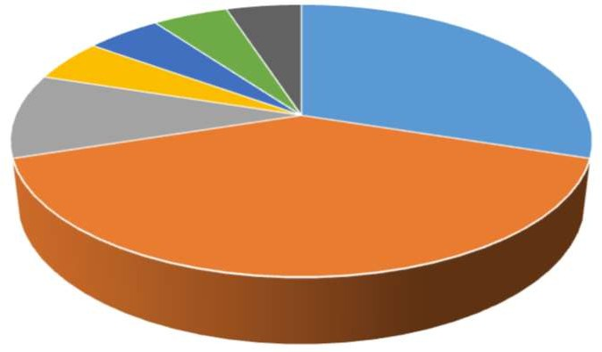

0%

5%

Preferred products

0% 5%

5%

5%

30%

10%

40%

Electronics

Apparels

Books

Grocery Sports/Outdoors Health/Beauty

Tools Kids/Baby products Others

**CONCLUSION:** Electronics and Apparels are the mostly ordered from Flipkart. Q4. Product consistently available for ordering

Strongly disagree Disagree

Neither agree nor disagree Agree

Strongly agree

|  |  |
| --- | --- |
| Total number of respondents | 20 |
| Strongly disagree | 2 |
| Disagree | 4 |
| Neither agree nor disagree | 5 |
| Agree | 6 |
| Strongly agree | 3 |

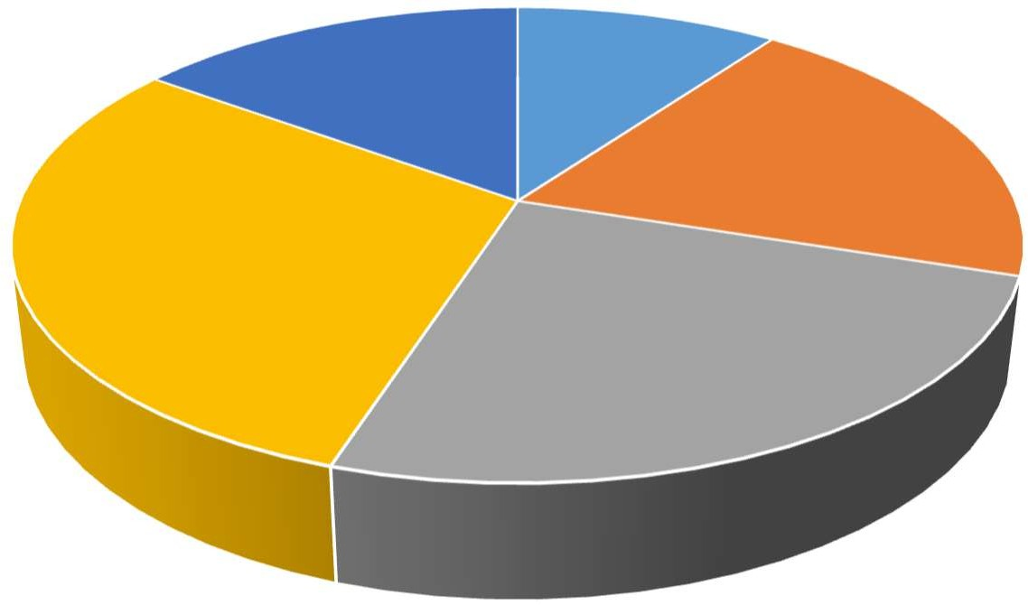

Products availability

15%

10%

20%

30%

25%

Strongly disagree Disagree Neither agree nor disagree Agree Strongly agree

**CONCLUSION:** Most of the sample population thinks that products are consistently available on Flipkart.

Q5. Delivery information communicated is adequate Strongly disagree

Disagree

Neither agree nor disagree Agree

Strongly agree

|  |  |
| --- | --- |
| Total number of respondents | 20 |
| Strongly disagree | 1 |
| Disagree | 3 |
| Neither agree nor disagree | 5 |
| Agree | 6 |
| Strongly agree | 5 |

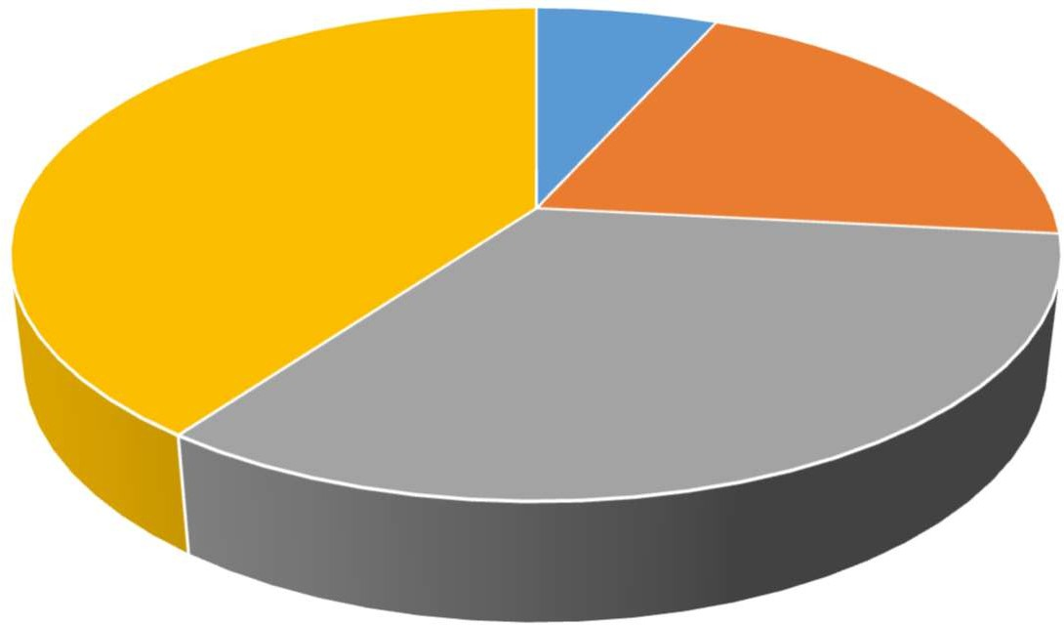

Delivery Information

0

5%

30%

15%

25%

Strongly disagree Disagree Neither Agree nor Disagree Agree Strongly Agree

**CONCLUSION:** Most of the sample population thinks that delivery information is adequate.

Q6. Order tracking facility is good

Strongly disagree Disagree

Neither agree nor disagree Agree

Strongly agree

|  |  |
| --- | --- |
| Total number of respondents | 20 |
| Strongly disagree | 0 |
| Disagree | 3 |
| Neither agree nor disagree | 6 |
| Agree | 6 |
| Strongly agree | 5 |

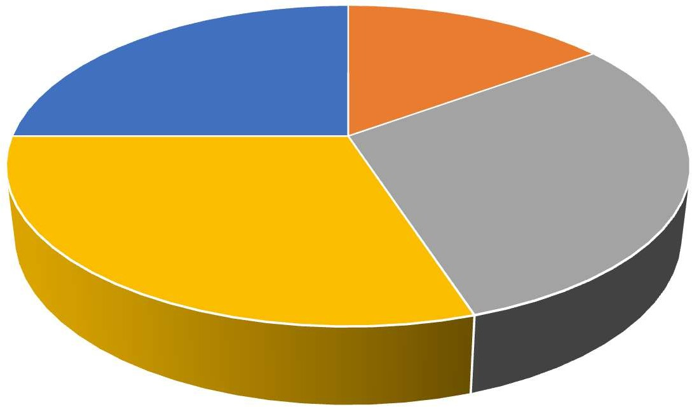

Order tracking

0%

25%

15%

30%

30%

Strongly Disagree Disagree Neither Agree nor Disagree Agree Strongly Agree

**CONCLUSION:** Most of the sample population thinks that order tracking facility of Flipkart is good.

Q7. Order cancellation procedure is quick

Strongly disagree Disagree

Neither agree nor disagree Agree

Strongly agree

|  |  |
| --- | --- |
| Total number of respondents | 20 |
| Strongly disagree | 1 |
| Disagree | 3 |
| Neither agree nor disagree | 8 |
| Agree | 6 |

|  |  |
| --- | --- |
| Strongly agree | 2 |

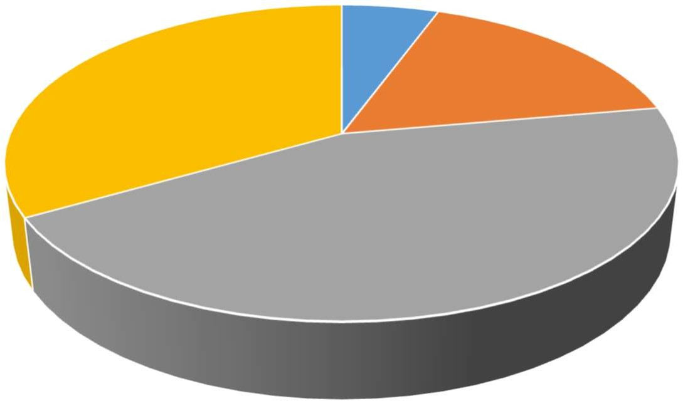

Order cancellation

0

5%

30%

15%

40%

Strongly disagree Disagree Neither agree nor disagree Agree Strongly agree

**CONCLUSION:** 40% of the respondents thinks that the order cancellation process of Flipkart is neither quick nor too slow its needs improvements.

# FINDINGS

Most of the customer are of age group 18-25.

This shows that people mostly prefer to buy Electronics goods and Apparels/Footwear from Flipkart.

This shows that product are consistently available on Flipkart it means Supply chain network of Flipkart is good.

This shows that the delivery information and order tracking facility provided by Flipkart is adequate.

This study clearly shows that order cancellation process needs improvement.

This study shows that the delivery is not arriving on time i.e. logistics needs to be improved.

This study also clears the misbeliefs some has regarding product quality and wrong items delivery.

This study also suggest to improve the return replacement process of Flipkart.

Now, some more findings are made regarding trends in e-commerce, problems in supply chain and logistics of e-commerce retail by the comparative study of Flipkart’s supply chain management and the response get by the questionnaire.

# TRENDS IN E-COMMERCE

## Technology in e-commerce

The surge in India's e-commerce industry can be largely attributed to the extensive integration of technology, revolutionizing various facets including supply chain management, inventory control, enhanced customer experiences, and curbing losses. Technological advancements such as widespread mobile and tablet usage, the introduction of Cash on Delivery (COD) services, sophisticated technology platforms, streamlined inventory tracking systems, and automated fulfillment centers have been pivotal in propelling sectoral growth.

The proliferation of internet services, especially the advent of high-speed connections like 3G and 4G, has significantly facilitated online transactions, making buying and selling goods online more convenient. With the increasing penetration of smartphones, e-commerce players are increasingly prioritizing mobile applications over traditional websites. Digital marketing strategies, encompassing email campaigns, digital billboards, mobile messaging, and targeted emails, play a crucial role in reaching potential customers with tailored offers.

Innovative features like exclusive online discounts, digital coupons, and complimentary shipping services have the potential to fuel further expansion within the e-commerce sector. The remarkable growth of e-commerce, coupled with limited credit and debit card penetration, has spurred the adoption of mobile wallets across India. Leading mobile wallet providers in the country boast over 104 million users, conducting more than 75 million transactions monthly.

To optimize the efficiency of e-commerce supply chains, there's a growing need for Application Programming Interface (API) integration between retailers and third-party logistics (3PL) systems. Currently, data exchange with 3PLs relies heavily on manual processes via emails, lacking seamless integration. The future holds promise for increased API usage and system integration, enabling real-time data exchange for swift issue resolution and enhanced shipment visibility.

The sector is anticipated to transition towards Card Swipe on Delivery (CSOD) and Point of Sale (POS) machines for customer payments, reducing reliance on cash transactions, particularly for high-value orders. This shift could streamline cash management associated with Cash on Delivery (COD) orders and spur sectoral growth.

Tech-enabled logistics solutions are gaining prominence, with major retailers investing in startups leveraging technology for efficient delivery operations. Integration with mapping and taxi applications enables real-time tracking of food deliveries, enhancing customer experience. Moreover, some food delivery platforms leverage GPS technology for automated delivery location retrieval, minimizing manual inputs.

.

## Shift towards outsourced fulfilment models

As the Indian e-commerce retail sector continues its dynamic expansion, it navigates through various stages of growth and evolution. Initially characterized by low product volumes and limited geographic reach, e-commerce players primarily managed operations in-house, driven by higher costs and limited external capabilities for outsourcing fulfilment. However, as the sector matures and witnesses the emergence of mid-tier players, a notable shift towards outsourcing fulfilment processes is underway.

This modular transition towards outsourcing is fueled by several factors, including the adoption of the marketplace model and the growing convenience for vendors. Category-specific requirements and operational concerns further incentivize e-commerce retailers to explore external fulfilment options. While larger players may still opt to manage their own fulfilment, those requiring specialized last-mile delivery, such as furniture retailers, often find it more practical to leverage external fulfilment hubs strategically located near their target markets.

The sustained growth trajectory of the e-commerce sector in India is anticipated to propel the demand for increased warehousing space.

## Novel parcel delivery models — Parcel lockers and PUDO (pick-up and drop- off) locations

As the Indian e-commerce logistics landscape evolves, it takes cues from European markets by introducing innovative concepts like Pick-Up and Drop-Off (PUDO) centers. These centers offer buyers the flexibility to collect or return their online orders conveniently. Large logistics players are repurposing existing outlets into PUDO centers, strategically located for easy access around residential and commercial areas.

In a bid to enhance convenience and optimize last-mile delivery costs, Indian commerce firms are exploring novel approaches such as parcel pick-up services from local grocery stores and petrol pumps. Additionally, experiments with click & collect services and automated parcel delivery terminals are underway. These terminals, operated via mobile apps or one-time passwords, provide a seamless experience for customers to retrieve or return their parcels at their convenience, revolutionizing the traditional delivery process.

The services are aimed at offering delivery security, flexibility and confidence to costumers.

## Faster delivery models

A noticeable trend in the Indian e-commerce retail sector is the rise of same-day, one-day, or two-day delivery services across various product categories. Both international and domestic retailers are now offering expedited delivery options, promising not just quick deliveries within a day or two but also specifying precise time slots, ranging from 90 minutes to two hours, for an extra fee.

## Focus on rural distribution

Major e-commerce players in India are increasingly directing their attention towards rural distribution strategies to reach customers in tier 3 and 4 towns. They are establishing pick-up and drop points by partnering with local stores in rural areas and hiring local residents to facilitate deliveries. This approach not only helps in reducing delivery times and costs but also fosters economic opportunities for rural communities. Specialized skill development and employment firms are collaborating to manage these centers in rural regions.

## Seller driven logistics

There's a growing trend where sellers on e-commerce platforms handle both packing and dispatch, contingent on factors like the number of sellers, transaction volumes, and geographical reach. However, this program typically extends to sellers with a significant tenure on the marketplace, demonstrating consistent sales performance and positive customer feedback over time.

## Differentiating loyalty programs

Top e-commerce platforms are rolling out loyalty programs designed to reward customers, offering various perks for a modest annual fee. These incentives often include complimentary shipping and returns, discounts on expedited deliveries, and priority access to customer support. Leveraging loyalty programs as a unique selling point could effectively foster customer retention and enhance user engagement, encouraging repeat purchases and bolstering brand loyalty.

A diverse array of products, ranging from makeup and lingerie to baby products and furniture, is now readily available for purchase online. This expanding variety of offerings presents logistics service providers with a spectrum of specialized requirements to meet. As the Indian customer base continues to evolve, there's a noticeable shift in priorities, with a heightened emphasis on delivery costs alongside delivery time considerations.

## Increased outsourcing of logistics functions

Logistic service providers within the e-commerce retail sector are pioneering innovative logistic frameworks, including the delegation of last-mile deliveries to hyperlocal e-commerce logistic service providers. Concurrently, there's a rising inclination among e-commerce retailers to handle specialized services like time-sensitive deliveries and card swipe at delivery internally, while entrusting standard deliveries to third-party logistics (3PL) providers. Nevertheless, driven by escalating customer demands and the pursuit of competitive edge, the demand for specialized services is poised to surge in the foreseeable future.

## Regulatory environment for e-commerce retail

The regulatory landscape governing the e-commerce retail sector in India undergoes continuous evolution, driven by the imperative to attract foreign investment and enhance consumer welfare. Presently, the extant Foreign Direct Investment (FDI) Policy permits 100 percent FDI under the automatic route for Business-to-Business (B2B) trading activities, inclusive of e-commerce transactions. However, such entities are restricted to engaging solely in B2B trading through e-commerce platforms, precluded from participating in Business-to-Consumer (B2C) e-commerce endeavors. Previously, uncertainties surrounded foreign investment in the B2C e-commerce segment. Nonetheless, in November 2015, the Department of Industrial Policy and Promotion (DIPP), Ministry of Commerce and Industry, granted companies with foreign investment involved in Single Brand Retail Trading.

A crucial prerequisite for conducting online Single Brand Retail Trading (SBRT) sales entails establishing at least one physical brick-and-mortar store in India. Moreover, FDI in SBRT activities, including via e-commerce portals, is subject to various conditions, such as compliance with the 30 percent local sourcing clause (for FDI exceeding 51 percent), selling products branded during manufacturing, and executing a legally binding brand licensing agreement in India. Over recent years, the Indian government has progressively relaxed the sourcing norms. Initially, companies engaged in SBRT were mandated to adhere to the 30 percent sourcing norm as an average of five years' total value of goods purchased from the opening of the first store in India, subject to certain procedural conditions. However, for foreign retailers employing state-of-the-art technology in manufacturing and unable to source locally, the government has introduced an option for complete exemption from local sourcing for three years, subject to prior approval. Following the exemption period, SBRT retailers must meet the 30 percent sourcing norm at an annualized average rate for the subsequent five years, and thereafter comply with the norm annually. It's worth noting that Indian brands are equally eligible for SBRT, with certain conditions of the FDI policy not being applicable to them. The liberalizations in the FDI regime, particularly in retail trade, have instilled renewed confidence among foreign investors in India. This is evidenced by the clearance of 89 proposals for foreign investment in retail trade up to March 31, 2016, resulting in a significant influx of FDI into the country. Additionally, significant regulatory developments in the e-commerce space include the introduction of guidelines governing FDI in marketplace e-commerce models, aimed at providing clarity and regulation in this domain.

The regulatory landscape in India distinguishes between the 'inventory-based model of e-commerce' and the 'marketplace model of e-commerce.' The former involves the e-commerce entity owning the inventory of goods and services, which are then sold directly to consumers. In contrast, the marketplace model entails the provision of an information technology platform by an e-commerce entity on a digital and electronic network to act as a facilitator between buyers and sellers.

# ADVANTAGES OF SCM IN E-COMMERCE

From a customer's perspective, the ease of internet access emerges as a critical factor enabling them to navigate e-commerce sites and make purchases seamlessly. Ensuring safe and secure payment modes is fundamental in instilling trust among consumers, alongside the imperative to introduce and promote innovations such as Mobile Commerce. E-commerce platforms serve as a vital link for connecting with consumers and facilitating transactions, with virtual stores operating round the clock, 24 hours a day, 7 days a week.

## Improved Supply Chain Network

Supply chain management software serves as a comprehensive tool offering complete visibility across the entirety of the supply chain network. With its capabilities, users can effectively monitor the status of various activities spanning suppliers, production plants, storage facilities, and distribution centers. This enhanced visibility empowers businesses to track and manage all related processes more efficiently, encompassing everything from the procurement and acquisition of raw materials to the manufacturing and shipment of finished goods.

## Enhanced CRM

SCM plays a vital role in establishing a relationship between enterprise and customer. SCM removes intermediate stages of delivery of product and establishes

communication between customer and enterprise directly using websites and internet. Websites help enterprise to keep in touch with the customer directly and they can get requirements and feedback about products directly.

## Trade Globally

SCM provides facility to trade globally. If a business wants to do business globally then their SCM should be such that they can import raw material from anywhere through SCM or can export their finished product in any country easily.

## Virtual Businesses

With the advent of dynamic websites, organizations are focusing on virtual businesses like they are listing their products on websites rather than providing it to distributor or C&F by which many people can see their products and can purchase it from websites and further delivery of the product is dependent upon SCM logistic department.

## Minimized Delays

MSupply chains often grapple with a cascade of delays, breeding dissatisfaction and lost opportunities. Whether it's tardy shipments from vendors, bottlenecks on production floors, or hiccups in distribution channels, these hurdles chip away at a company's capacity to meet customer needs. Enter SCM software: a unifying force that synchronizes operations, from inception to fruition. With its adept coordination, supply chain intricacies, fostering efficiency and fortifying customer satisfaction.

## Reduction in Cost

SCM based on e-commerce removes various stages of distribution, retailers, outlets, outlet staff etc. This decreases the overall cost of the product and customer gets the direct advantage of reduced cost of products as compared to the cost of product available at stores.SCM provides ICT based facilities to establish communication in between enterprise and customer so thatthey can directly communicate with each other and SCM takes care of the delivery of product etc.

## Customer Satisfaction

Meeting customer expectations for timely deliveries is paramount in the e-commerce industry. Businesses strive to ensure customer satisfaction while maintaining optimal inventory levels. Through the integration of e-commerce into the supply chain, companies can effectively track customer demands and adapt to changes in preferences for different products and brands. Leveraging this integrated approach enables enterprises to monitor demand patterns, assess supplier lead times for order fulfillment, and proactively replenish inventories to meet customer needs.

# SCM IN E-COMMERCE --PROBLEMS

E-commerce business in India is completely dependent on effective SCM. It is very important to merge ecommerce business with SCM and for this, we need proper ICT based systems. By which information flow would be proper in between enterprise, customer, and SCM. These days’ e-commerce sites are fighting for developing proper SCM so that they can beat each other. Few problems discussed in this paper are:

## Globalization

One of the biggest challenges that e-commerce companies are facing is how to reduce their supply chain cost. In order to satisfy customers’ price expectations, companies have opted to relocate manufacturing to low-cost countries around the world in an effort to reduce direct and indirect costs and to minimize taxes.

## Improper Flow of Information

SCM in the enterprise needs a proper flow of information in between suppliers, enterprise, and customer etc. If the flow of information is not proper then enterprise won’t able to communicate with the supplier as well as with customer also.

## Problem in Payment Gateways

Indian payment gateways have an unusually high failure rate by global standards. E-business companies using Indian payment gateways are losing out on business, as several customers do not attempt making payment again after a transaction fails. Payment gateways need to be improved.

## Low Internet Penetration

Internet penetration in India is still a small fraction of what is there in a number of Western countries. On top of that, the quality of connectivity is poor in several regions. But both these problems are on their last legs. The day is not far when connectivity issues would not feature in a list of challenges to e-business in India.

# LOGISTICS IN E-COMMERCE- PROBLEMS

## The Rise of Tier 2 and Tier 3 Economies

Tier 2 and 3 cities are expected to contribute around $350 million in 2018, making them extremely viable potential markets. The problem of accessibility towards the tier 2 and 3 cities can be looked at as an opportunity to make the first mover advantage. For this, it is essential for logistics and fulfilment companies to establish a robust network with nodal points delivering to the tier 2 and 3 cities with speed and efficiency. As the internet penetrates deeper into the Indian demography, it is the tier 2 and 3 cities that are going to stand out and make a difference, as opposed to the saturated markets of the tier 1 and metro cities.

## Time to Revolutionize Cash on Delivery

Cash on Delivery was an important selling point for the Indian online retail industry, which was completely taken care of by logistics. In fact, we can even say that it was the Cash on Delivery system that really warmed up the Indian consumer to the idea of online retail – knowing that one did not have to pay until one held the product in their hands was a big relief for the Indian consumer. That said, Cash on Delivery comes with its own set of problems.

## Technology and Analytics

Tracking and handling returns is a major headache for logistics companies. Especially when the delivery is in emergent areas when it comes to ecommerce, the industry is certainly not adept at keeping an eye on the package at this point in time. It is time the Indian ecommerce industry actively invests in technology to find solutions to these problems. With developments in location access technology, wearable computing and data processing, it would be easier to answer questions like

locating shipments in real time, or measuring and analysing service based on data collected on the field, and finding trends in delivery delays by studying the data.

## Last Mile Delivery

Last mile delivery is generally the headache for most online sellers. The big question remains whether to outsource it or to make the extra effort and fulfil it yourself. This is because the company’s reputation is truly on the line when it comes to the last mile delivery. Various things that factor into this decision may be the delivery time, reliability of the courier, reach in terms of a geographical area and the overall cost incurred by the seller.

* Again, monitoring technology seems to be the way forward when it comes to this decision. It would behove the seller to start out slow and test out logistics partners while finding new ways of recording and measuring data for comparison. The tier 2 and 3 cities again emerge as battlegrounds for this purpose, it is expected to be a general trend in the industry to see movement towards these largely untapped markets in the country.

# RISKS AND CHALLENGES IN E-COMMERCE RETAIL LOGISTICS

## Procurement/inventory management

Absence of a defined process for vendor selection/quality checks

Price variances across multiple on-boarded vendors for the same product

Ineffective inventory planning/monitoring of open purchase orders

Challenges associated with warehousing/monitoring of stock levels.

## Customer order management

Multiple tax rates across geographies - compliance of sale invoices to tax laws

Monitoring delivery related service level agreements/pending orders

Products sold at higher than maximum retail price/negative margins

Promotion codes used after expiry/beyond the defined criteria.

## Logistics and shipping

Non-compliance with agreements - cash collection/reconciliation/on-time delivery

Selection of a cost effective and efficient third party logistics vendor for select pin codes

Challenges associated with route planning/consolidation of shipments

Vendor payments based on shipment.

## Returns, replacement and refunds

Incorrect/delays in processing of customer refunds (online and COD)

Replacements/refunds processed to customers without a receipt of goods/adequate quality checks

Absence of a robust process to monitor compensation provided to customers

Non-monitoring of customers with significant number of returns.

## Customer support

Categorisation of customer complaints and response mechanisms

Customer dispute resolution

Monitoring delivery-related service level agreements (customer and seller management)

Review and monitoring of access controls (order cancellations, refunds, etc.).

## Reconciliations

Goods reconciliations: order quantity vs shipped quantity vs. delivered quantity

Amount received from payment gateway vs value of prepaid orders vs payment gateway charges

Purchase order vs invoice vs physical goods

Logistic vendor invoice vs quantity, weight and area code of deliveries assigned.

# CONCLUSION

The robust expansion of the Indian e-commerce retail realm, boasting a sustained growth rate exceeding 50%, illuminates the imperative for streamlined and eco-conscious logistics maneuvers across the spectrum of e-commerce enterprises in the nation. As the marketplace model gains ascendancy and online shopping permeates deeper into Indian consumer habits, a metamorphosis is underway in the landscape of e-commerce logistics. This evolution on a fusion of elements: swift delivery mechanisms, revamped warehousing architectures, enhanced service proficiencies, cutting-edge technological integrations, and a relentless pursuit innovative solutions.

The impending surge in e-commerce is poised to draw momentum from the heartlands of rural and tier II and III cities, forecasted to commandeer approximately 55% of forthcoming orders. As e-commerce enterprises pivot towards the marketplace paradigm, embracing a multitude of merchants spanning diverse categories nationwide, a strategic proliferation of warehouses is underway, strategically positioned to cater to a dispersed network of vendors and clientele. This decentralization of demand and supply holds the promise of bolstering the market share of surface transportation. In the realm of e-commerce, logistics transcends its traditional role as a mere support function, assuming a pivotal role in shaping strategy and execution, thus catalyzing the sector's growth trajectory.

The future landscape envisages a pronounced emphasis on time-definite deliveries, including same-day and next-day services, alongside precision-timed deliveries, highlighting the pivotal role of service reliability in cementing the success of e-commerce entities and their logistical counterparts. The ability to seamlessly manage cash for cash-on-delivery transactions and ensure prompt cash remittance emerges as imperative for servicing this burgeoning sector.

The burgeoning network of e-commerce-focused retail logistics providers and the heightened focus of comprehensive logistics service providers (LSPs) on the e-commerce retail segment are anticipated to intensify market competition, exerting pressure on costs and margins. The notion of captive logistics arms, perceived as peripheral to the core business of e-commerce retailers, might witness divestment. Moreover, while the e-commerce logistics sector experiences exponential expansion, scaling infrastructure and capabilities at a commensurate pace presents a formidable challenge, thereby catalyzing a shift towards outsourcing rather than in-house development.

# RECOMMENDATION

The e-commerce logistics sector continues to evolve rapidly with changes in the business environment. With an expansion in reach and service levels, LSPs need to

evolve to offer a portfolio of a range of services, as well as consistently innovate to keep pace with the rapidly changing dynamics of the sector. The e-commerce landscape is poised for a profound shift towards tier-I and tier-II cities, where more than 50% of shipments find their destinations, spurred by focused local campaigns aimed at cultivating buyers and sellers from smaller urban centers. The meteoric rise in mobile application usage for purchases is reshaping the customer base, with tier-I/II cities emerging as the new epicenters of e-commerce activity. Cash-on-delivery (COD) transactions, currently constituting 60 to 70% of volume, are slated for further escalation, accentuating the need for adept logistics management.

The ascendancy of the marketplace model has prompted e-commerce giants to establish fulfillment centers proximate to sellers, particularly in tier-I cities, catalyzing the outsourcing of fulfillment operations to third-party logistics providers (3PLs) with robust local presence. While air transport has historically dominated long-distance logistics, the advent of the marketplace model is poised to recalibrate preferences towards express surface movements, optimizing logistical costs.

Returns management emerges as a focal point, with dedicated returns management centers operated by select 3PLs facilitating end-to-end returns processing, including quality checks and cargo handover to sellers' or retailers' warehouses. This augurs a trend towards sectoral consolidation, driven by the pursuit of enhanced services and profitability.

# REFERENCES

## Websites:

[http://www.flipkart.com](http://www.flipkart.com/) .

“Innovative Technique Supply Chain Management,” [www.ehow.com,](http://www.ehow.com/) March 6, 2011

<http://www.economist.com/blogs/schumpeter> /2012/04/e- commerce-india?

[http://www.wikepedia.com](http://www.wikepedia.com/)

1. <http://www.business-standard.com/india/news/indian-e-commerce-players-> bullish-/460002/
2. <http://forbesindia.com/printcontent/27042>

**Books:**

Supply Chain Management Chopra, Meindl, Kalra, Pearson Education

Logistics & Supply Chain Management G Raghuram, N Rangaraj, Macmillan Business Books

# APPENDIX

**QUESTIONNAIRE**

## Study question: SUPPLY CHAIN MANAGEMENT AND LOGISTICS IN IN DIA’S

Q1. You are?

Male Female

Q2. Your age?

18-25

25-40

Above 40

Q3. Most of product bought online belongs to

Electronics Apparel/Clothing/Footwear/Watches Books

Grocery Sports/Outdoors Health/Beauty products Tools

Kids/Baby products Others

Q4. Product consistently available for ordering

Strongly disagree Disagree

Neither agree nor disagree Agree

Strongly agree

Q5. Delivery information communicated is adequate Strongly disagree

Disagree

Neither agree nor disagree Agree

Strongly agree

Q6. Order tracking facility is good

Strongly disagree Disagree

Neither agree nor disagree Agree

Strongly agree

Q7. Order cancellation procedure is quick

Strongly disagree Disagree

Neither agree nor disagree Agree

Strongly agree