# **“A STUDY ON BRAND AWARNESS OF DOMINOS PIZZAS IN**

# **SALEM DISTRICT”**

**BHARANIESHWARI M 1, DEEPIKA M2**

1Assistantprofessor, Department of MBA, Paavai Engineering College Anna University,

Namakkal, Tamil Nadu, India

2PG Student, Department of MBA, Paavai Engineering College Anna University,

Namakkal, Tamil Nadu, India

**ABSTRACT**

As a world-renowned pizza company founded in 1960 in the United States, Domino's PizzaenteredtheChinesemarketin1997.SomestudieshavepointedoutthatDomino'sPizzahas been in the Chinese market for 25years, but its brand awareness has been tepid more and more pizza brands enter the market. Therefore, the research topic of this paper is the possible reasons behind it and the growth potential of Domino's Pizza in the Chinese market. The research methods of this paper are as follows: Firstly, SWOT analysis is carried out by collecting data from Domino's prospectus and previous reports and literature. Secondly, according to Porter's four general competitive strategies, the paper puts forward suggestions on the competitive strategy and brand awareness of Domino's pizza. The analysis showed that Domino's marketing effort cities outside Beijing and Shanghai were weak and its visibility was limited by the small number and density of its stores.

## **INTRODUCTION**

Globalization has removed the boundaries of business and globe has become a global village. So now the customer has a wide range of choices around him to choose and buy. In order to satisfy the global customer, extensive product lines, customer centric marketing, highly focused global sales and global marketing strategies has become trend for the companies.

Marketing issued to identify the customer, satisfy the customer, and keep the customer. With the customer as the focus of its activities, it can be concluded that marketing management is one of the major components of business management. The adoption of marketing strategies requires businesses to shift their focus from production to the perceived needs and wants of their customers as the means of staying profitable. The term marketing concept holds that achieving organizational goals depends on knowing the needs and wants of target markets and delivering the desired satisfactions. It proposes that in order to satisfy its organizational objectives, an organization should anticipate the needs and wants of consumers and satisfy these more effectively than competitors.

In this context, I selected the title” the study on brand awareness with respect to Pizza Corner and Dominos” as my study in order to get the practical knowledge regarding marketing concept. In addition to understand the ground reality of any business irrespective of the field the practical knowledge of marketing is essential. The study is all about to know at what extent people know about the brand sin around them. And also, we can learn about the how to educate the customer towards a brand.

## **OBJECTIVESOFTHESTUDY**

1. To study the “brand awareness of consumer with respect to the Dominos and Pizza Corner” is aimed to fulfil the following objectives
2. To experience practical knowledge on marketing
3. To interact with the real customer
4. To understand the conceptual knowledge regarding

## **NEED FORTHESTUDY**

Brand awareness is a very important aspect that a marketing manager should know, because it tells that for what extent we have reached the consumers. And also talks about that we have to do for drawing the attention of the consumers.

* How much to invest in brand-building activities.
* What mix of media or channels to invest (what ratio of print,television,radio, Internet, etc.).
* Which ad campaigns to continue or retire?
* How to adjust brand-building investments by geography

### **SCOPEOFTHESTUDY**

### The approach to study has been made from the point of view of Dominos and Pizza Corner around Rajahmundry. It has not taken into consideration the view point of fast-food beverage-based industries. The overall scope of the present study considers all the variables and factors that have major impact over the customers in considering particular brands. This especially included how a customer really evaluate recognizes the brand and what position particular brand occupies in the customer mind.

## **RESEARCHMETHODOLOGY**

It consists of two phases they are the reliability of managerial decisions depends upon the quality of data. The quality of data can be express term so fits representative feature of the reality which can be ensured by the usage of fitting data collection method.

This data can be classified into primary data and secondary data. The data which is collected from the field under the control and supervision of an investigator is known as primary data. It is made by the self-made and self-managed questionnaire. The simple random sampling was used. And sample size is 50. And my samples are customers of spacers of Rajahmundry.

The data which is collected from journals, magazines, annual reports of companies., then such data is called secondary data.

After collecting data, and percentage analysis was used to study the characteristics of customer with regard to age, brand awareness, after sale service, factors influencing brand preferences.

**DATAANALYSISANDINTERPRETATION**

**TABLE**4.1

### Data analysis and interpretation

##### How do you know about Domino’s and Pizza Corner?

|  |  |  |  |
| --- | --- | --- | --- |
| TV  advertisement | Online advertisement | Tele advertisement | Through friends |
| 8 | 5 | 4 | 13 |

CHARTS

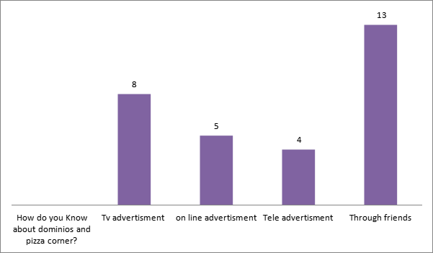

**Data analysis and interpretation**:

The above table shows that TV advertisement, and 5 people through online advertisement, 4members through tele advertisement, 13 members through friends.

From this we can know that most of the33332m came to know through friends.

## **FINDINGS**

##### From the study I found the following:

* + 1. Service given by the Dominos is better than Pizza Corner
    2. Know that most of them came to know through friends.
    3. Best taste of food of the Dominos is better than Pizza Corner
    4. Quality of food items provided by the Dominos is better than Pizza Corner
    5. Brand reliability of the Dominos is better than Pizza Corner
    6. That service given by the Dominos is better than Pizza Corner

## **SUGGESTIONS**

* Consumer retaining policies required for brand improvement especially for Pizza Corner.
* The companies have to work on continuous improvement of Total Quality management.
* New techniques of promotional activities is required to create awareness about the entire company products.

#### **CONCLUSION:**

From the above study we can conclude that Brand awareness plays a major role in the marketing of the products. And brand awareness plays a bigger role in stimulating the customers toward the brands. Branding techniques will help to retain the consumers. of course, the brand awareness is created and spread through the Quality of offerings, Ambience and hygiene which goes to people by word of mouth. The Companies need to focus on these things to improve their customer base.

**REFERENCES**

1. lamb, hair Sharma: **“MKT**G” Cengage learning, new Delhi,2013
2. Philip Kotler:” **marketing management** “Pearson publishers, new delhi,2013
3. *Rajan serena:* ***marketing management*** *“Tatamcgrawhill, newdelhi,2012*
4. *R. Srinivasan: “case* ***studies in marketing*** *“, PHL Learning, new delhi,2012*
5. *Tapan panda:” marketing* ***management:, excel*** *books, newdelhoi,2012*