The impact of e-commerce on traditional retail model in India

Shashank Ranjan (22GSOB201072)

Under The Guidance of

Prof. Dr. Md. Chand Rashid

Galgotias University, Greater Noida

ABSTRACT

Unquestionably, the explosive growth of e-commerce in India has changed the nation's retail environment. E-commerce platforms provide customers with unmatched ease, a wide range of products, affordable prices, and the flexibility to evaluate possibilities while lounging in their own homes. Due of this, consumer behaviour has changed significantly, and traditional brick and mortar establishments have become less common. This abstract examines the various ways in which India's traditional retail industry has been impacted by the e-commerce revolution. It examines the difficulties traditional stores confront in competing with the online behemoths, including their restricted reach, increased operating expenses, and difficulties. It also looks at the attractive potential that e-commerce offers traditional companies, such growing their clientele, cutting costs, and simplifying processes. The abstract goes into additional detail about the tactics that conventional merchants might use to prosper in this new environment. Success requires embracing omnichannel tactics, establishing a strong online presence, offering a unique in-store experience, and utilizing technology. In the Indian retail sector, the combination of e-commerce and conventional models offers exciting prospects for innovation and customer-centric strategies.   
This study analyzes how the rise of e-commerce platforms has changed consumer preferences, market trends, and competitive dynamics through a combination of qualitative and quantitative research approaches. Utilizing conceptual models from the literature on technology adoption, marketing, and economics, it pinpoints the main forces and barriers affecting traditional retailers' acceptance of e-commerce and the ensuing restructuring of the retail sector. In-depth reviews of the body of previous research are included in the study, along with original data gathered through surveys, interviews, and case studies. Combining theoretical concepts with empirical data, this thesis offers a thorough understanding of the intricate interactions that exist between online and offline retail channels, highlighting opportunities for cooperation as well as synergies and conflicts.

**INTRODUCTION**

E-commerce is radically changing how customers shop and engage with businesses in India, functioning as a disruptive force in the retail industry. This thesis explores this change by examining how traditional brick-and-mortar retailers' dominance is being challenged by internet markets. The growth of a more affluent middle class, the widespread adoption of smartphones, and rising internet penetration are all contributing reasons to the explosion of e-commerce. These developments have increased consumer preference for the ease of use and wide range of options provided by online retailers, which allow them to peruse merchandise, evaluate costs, and complete transactions from the comfort of their homes. For traditional merchants, however, this digital transformation poses serious concerns. They face pressure to match the prices of online behemoths, handle the intricacies of overseeing internet sales channels, and adjust to the changing purchasing preferences of their clientele. The thesis analyzes these difficulties in addition to the chances that e-commerce offers. It looks at how rules from the government, such those that control foreign investment in the e-commerce industry, might affect the way markets function. The study also looks at logistical challenges and inventory management concerns that could arise from e-commerce-related interruptions to conventional supply chains. The thesis also looks into how e-commerce affects jobs in the retail industry, taking into account the potential loss of jobs in physical stores as well as the creation of new jobs in e-commerce fulfillment and logistics. The thesis seeks to shed light on the complex interaction between traditional retail and e-commerce in India by thoroughly analyzing these many dimensions. It seeks to clarify the possible course of the industry's future and investigate how these apparently incompatible models might come to understand and adapt to one another. Strategic decision-making for businesses navigating this dynamic and constantly changing landscape will be informed by the research, which will also add to the larger academic discourse on retail transformation in the digital age and offer insightful information to stakeholders throughout the retail value chain.

**LITERATURE REVIEW**

This paper delves further into how the growing popularity of e-commerce has changed the retail scene in India. It analyzes the causes of the e-commerce boom, blaming it on things like the expansion of the middle class and increased internet access as well as the widespread usage of smartphones. These developments have increased consumer preference for the ease of use and wide range of options provided by online retailers, which allow them to peruse merchandise, evaluate costs, and complete transactions from the comfort of their homes. The study also provides insight into the competitive strategies used by the big e-commerce businesses, like Amazon and Flipkart, which frequently entail steep discounts and special offers. After discussing the effects of e-commerce, the paper examines the difficulties faced by conventional brick-and-mortar businesses. These difficulties include a drop in foot traffic and sales as more and more customers shop online. Conventional retailers find it difficult to match the pricing strategies of internet behemoths, who have economies of scale and reduced overhead. Moreover, traditional merchants have an additional degree of complexity in handling online sales channels, necessitating investments in technology and transportation infrastructure. In order to maintain competitive prices and prevent stockouts, traditional merchants struggle with issues related to inventory management and pricing strategy, as the paper illustrates. The research does not, however, present a completely negative picture for traditional shops. It looks at how these companies might change with the times and prosper. Adopting e-commerce channels is a crucial tactic since it enables businesses to combine online and in-person sales. Customers now have a smooth omnichannel experience, allowing them to browse products online and pick them up in-store, or the other way around. The significance of distinction for physical retailers is emphasized in the paper. Traditional shops can distinguish themselves by concentrating on elements that e-commerce cannot match, such as providing individualized customer service, fostering a sense of community, and providing distinctive in-store experiences. To draw clients, a nearby clothes retailer can, for instance, provide in-store tailoring services or hold fashion displays. There is also an examination of the socio-economic effects of online shopping. Although traditional retail may experience job losses, the research also notes that new job opportunities are being created in industries like logistics and e-commerce fulfillment. These positions entail handling deliveries, picking and packing online goods, and assisting customers with online transactions. The report draws attention to the issue of the "digital divide," which is the possibility that certain groups, especially those living in rural regions, may not be able to take advantage of the e-commerce revolution due to a lack of internet connection and technological proficiency. Both public and commercial sectors can fund projects to increase internet connectivity and offer digital literacy training courses in order to close this gap. The final section of the booklet summarizes the thoughts of several subject-matter specialists. It's widely accepted that e-commerce is a force that cannot be ignored that is revolutionizing the retail industry, and conventional businesses need to change with the times. Traditional retailers may coexist peacefully with the emerging e-commerce behemoths by embracing innovation and implementing fresh tactics like omnichannel retail and in-store experience distinction. Policymakers, conventional merchants, and anybody else curious in the changing retail landscape in India would find great value in this paper.

**Research Design & Methodology**

This study delves deeply into how e-commerce and traditional retail are changing in India. Using a mixed-method approach, the study collects information in a variety of ways to create a comprehensive picture.  
Quantitatively speaking, surveys aimed at a representative sample of Indian customers will reveal their preferences and shopping behaviors. The factors affecting their choices, preferred channels (online vs. offline), and general purchasing habits will all be covered in these surveys. Furthermore, the study will make use of pre-existing data sets from reliable sources such as e-commerce platforms, industry studies, and government publications. Understanding industry trends, e-commerce growth patterns, and product categories most affected by this digital change can be gained from analyzing this secondary data. Qualitative data collection methods will further enrich the understanding. Semi-structured interviews with key stakeholders in the retail sector will be conducted. These stakeholders include representatives from traditional retail stores (ranging from single-owner shops to large franchises), leading e-commerce platforms, and logistics service providers. By gathering their perspectives, the research aims to explore their viewpoints on the impact of e-commerce, the challenges faced by traditional retailers in the digital age, and potential adaptation strategies they might be implementing The study will include in-depth case studies of specific businesses to have a greater understanding of how traditional retailers are managing this evolving terrain. These case studies will look at the operational changes made by these businesses. The study will concentrate on how they use e-commerce platforms, how they apply omnichannel retail strategies (which combine physical and online channels), and how they try to improve the customer experience in a setting that is becoming more and more competitive. The research will incorporate the results from both quantitative and qualitative methodologies by using a triangulation approach. This will offer a more thorough comprehension of how e-commerce is affecting traditional retail in India. While the qualitative data will give a deeper understanding of the opportunities and problems experienced by conventional merchants on the ground, the quantitative data will provide generalizable insights into consumer behavior and market trends. This research is anticipated to yield insightful information that can benefit a range of stakeholders. Customers will comprehend how e-commerce is changing the retail environment better. Investigating possible tactics for traditional merchants to remain competitive in the e-commerce age will be beneficial. Policymakers can benefit from this research by developing a balanced retail environment in India that supports the expansion of both conventional brick-and-mortar businesses and online retail models. The ultimate goal of this research is to add to the current conversation on retail's position in the digital era.

**DATA ANALYSIS & INTERPRETATION**

This document presents a plan for data analysis aimed at identifying the factors that influence customer loyalty between traditional retail stores and e-commerce platforms in India.  
Data collection methods for the first step include surveys, social media research, and, if accessible, customer relationship management (CRM) data. Surveys will focus on customer experiences and elements that affect retail and online retailers' loyalty. In order to determine consumer sentiment and loyalty, social media analysis will examine reviews and comments posted on business websites and social media pages. CRM data can reveal information about past purchases, participation in loyalty programs, and interactions with customers. The data needs to be cleansed after it is gathered. This entails obtaining survey respondents' consent, purging unnecessary information from social media data, and anonymizing any client data found in CRM data. Errors and inconsistencies are also rectified at this level.  
The data from multiple sources is combined into a single dataset for analysis after cleaning. As a result, data pieces from different sources can be linked by customer ID or demographics, for example. Once the data is prepared, researchers can extract valuable insights using a variety of statistical techniques. With the use of descriptive statistics, sentiment analysis and survey responses will be compiled to identify patterns in the variables that affect customer loyalty, such as return policies and price. The volume and complexity of the data will determine whether to use more sophisticated analytics. In the data interpretation step, customers' opinions of loyalty programs and their overall experiences in traditional retail stores and e-commerce platforms are analyzed to identify significant discrepancies. Subsequently, by identifying the key factors that influence customer loyalty in each industry, researchers may compare these factors and determine which ones are more important for each kind of organization. The paper recognizes a number of other elements, such as sample size and outside influences, that may affect the study. Lastly, using graphs and charts to visualize data is a useful approach to convey the nuanced conclusions drawn from data research.

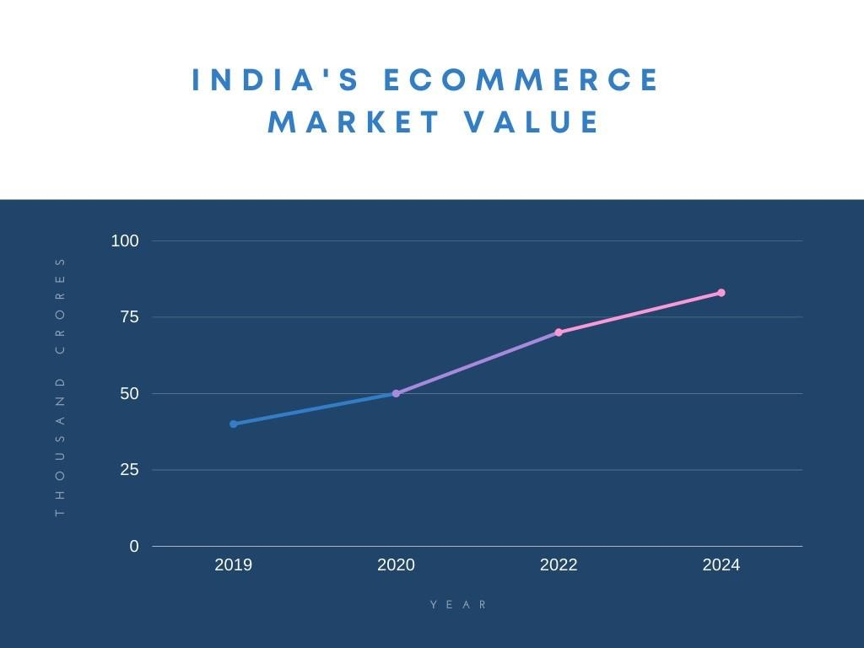

**Interpretation**

Based on the interpretation, 64.7% of respondents fall into the 24–25 age group, 5.9% fall into the under-24 age group, 17.7% fall into the 24–25 age group, and 11.8% fall into the 26 age group.

Most of the respondents are in the 24- to 25-year-old age range.

|  |  |  |  |
| --- | --- | --- | --- |
| GENDER | NO.OF RESPONDENTS | PERCENTAGE | |
| Male | 17 | 100 % |
| TOTAL | 17 | 100% |

Most of the people responded are Graduated. And the occupation of most of the people are Business man. Most of the people doing shopping online weekly. The primary reasons for there shopping online are convenience, wide range of products, competitive pricing, ease of comparison, home delivery, discounts and offers. The total percentage of total purchase have been made in past month are 47.1%. the 64.7% people said that the noticed the change in their buying behaviour. 64.7% people think that traditional retail store can adapt and compete effectively in the e-commerce. The electronic items are prefer for online shopping said by 52.9% people.

**FINDINGS**

According to my findings, it was found that yes there is a significant impact of e-commerce on traditional retail model in India.

**CONCLUSION**

In India, e-commerce is drastically altering consumer purchasing habits. This study looked at how e-commerce affects traditional retail, pointing out both the advantages and disadvantages. Online shopping is growing in popularity, especially in cities, because it's more convenient, offers a greater selection, and might even result in cheaper costs. Traditional retailers are under pressure from this to reduce expenses and adjust to the shifting market. The research presents a positive picture for conventional shops. Traditional retailers can maintain their competitiveness by offering exceptional customer service, distinctive selling features, and a combination of online and offline experiences (an omnichannel strategy). E-commerce has an impact on more than just customer behavior. In order to compete with online delivery, traditional supply chains must be disrupted and efficient logistics must be in place. Even while traditional retail may lose jobs, e-commerce fulfillment and logistics are seeing growth. The study highlights the necessity of well-balanced e-commerce regulations that guarantee honest competition, safeguard customers, and promote creativity. Traditional merchants will be best positioned for success as e-commerce grows because they will be the ones who innovate, adjust to changing consumer preferences, and make use of both online and offline channels. This study opens up new avenues for investigation. To learn more, it is possible to investigate the long-term impacts of e-commerce as well as geographical differences in its uptake. India can establish a vibrant and competitive retail industry that caters to the changing demands of its clientele by comprehending the implications of e-commerce and encouraging cooperation between brick-and-mortar and online retailers.

**BIBLOGRAPHY**

<https://www.tandfonline.com/doi/abs/10.1080/17543266.2023.2225065>

<https://www.assocham.org/>

<https://dpiit.gov.in/>

<https://commerce.gov.in/>

<https://brands.flipkart.com/reporting-dashboard>

<https://ir.aboutamazon.com/annual-reports-proxies-and-shareholder-letters/default.aspx>