Software as a service AI platform

Saurabh Bhekare1; Shreyas Bhoir2; Sahil Deshmukh3; Omkar Dhapte4; Anil Kale5

1,2,3,4B. E Graduate(IV year), Department of Computer Engineering, MGMCET, Maharashtra, India

**Abstract:** **A Software as a Service (SaaS) AI platform is an innovative software delivery model that harnesses the power of artificial intelligence (AI) to provide comprehensive, on-demand solutions to users. This platform offers a diverse range of AI-powered services, enabling businesses and individuals to access cutting-edge technologies without the need for extensive hardware or software installations. By leveraging cloud computing infrastructure, SaaS AI platforms facilitate seamless scalability, flexibility, and cost-effectiveness, allowing users to efficiently manage their operations and optimize their workflow.**

**The abstract nature of a SaaS AI platform lies in its ability to offer customizable and tailored AI solutions, catering to diverse business needs across various industries. Through the integration of machine learning, natural language processing, and predictive analytics, these platforms enable users to automate complex tasks, streamline decision-making processes, and derive actionable insights from vast datasets. Furthermore, SaaS AI platforms often incorporate user-friendly interfaces and intuitive dashboards, ensuring user accessibility and enhancing the overall user experience.**

*Keywords:* Artificial intelligence, Engines, Quality of service, Monitoring

1. **INTRODUCTION**

In today's rapidly evolving technological landscape, the integration of Artificial Intelligence (AI) is transforming the way businesses operate, revolutionizing various sectors such as healthcare, finance, marketing, and more. As the demand for AI-driven solutions continues to surge, the emergence of Software as a Service (SaaS) AI platforms has become instrumental in democratizing access to AI capabilities for organizations of all sizes. This project aims to explore the intricacies of SaaS AI platforms, their functionalities, and their significant impact on businesses and industries globally. SaaS AI platforms serve as a gateway to unlock the potential of AI for businesses that may not have the resources or expertise to develop and maintain their AI infrastructure. These platforms offer a comprehensive suite of AI-powered services, enabling users to harness cutting-edge technologies such as machine learning, natural language processing, computer vision, and predictive analytics. By abstracting the complexities of AI development, SaaS AI platforms empower businesses to leverage advanced AI functionalities without the need for substantial upfront investments in hardware or specialized technical knowledge. The project will delve into the key features and components that characterize SaaS AI platforms, highlighting their scalability, accessibility, and flexibility. Through a detailed analysis, we will explore how these platforms enable seamless integration with existing systems, allowing businesses to streamline their operations and optimize processes through intelligent automation and data-driven insights. Moreover, the project will shed light on the role of SaaS AI platforms in facilitating agile decision-making, enhancing customer experiences, and fostering innovation across diverse industry verticals.

**II.PROBLEM STATEMENT & OBJECTIVES**

Businesses are increasingly relying on artificial intelligence to automate processes, improve decision-making, and enhance customer experiences. However, building and deploying AI solutions can be complex, time-consuming, and costly. Many businesses lack the technical expertise and resources to develop AI applications in-house, leading to inefficiencies and missed opportunities for growth. A SaaS AI platform offers a solution to these challenges by providing businesses with accessible, cost-effective, and scalable AI capabilities. However, there is a lack of SaaS AI platforms that are user-friendly, customizable, and integrated with existing systems. Businesses need an AI platform that can easily integrate with their current infrastructure, adapt to their unique needs, and deliver tangible ROI. In response to these challenges, our goal is to develop a SaaS AI platform that empowers businesses to harness the power of artificial intelligence without the complexities typically associated with AI development and deployment. Our platform will enable businesses to quickly build and deploy AI solutions, automate tasks, gain valuable insights, and drive business growth.

**III. LITERATURE REVIEW**

We studied various papers based on Software as a service AI platform, following are the papers which helped us in getting necessary insights for developing our project.

**1.Software as a Service [SaaS] in view of Security and Multitenancy:**

In this paper,the author developed, becoming evident that now the Organizations are trying to access the components available at Internet cloud irrespective of enterprise value or size (small/ medium/ large). Reliability of cloud services has increased exponentially and users are now acknowledging the benefits in terms of security and multitenancy. New startups as well as well established firms want to explore new technology which is available in market. Along with-it enterprise also wants to register their presence among the unreachable arena across the world. It is becoming the duty of developer community to establish the robust and secure service-based approach for software component on which

**2.Artificial Intelligence as a Service:**

Organizations do not have to decide between adopting or not adopting AI but between adopting it now or deferring that decision. The critical question of how to implement and use AI currently overrides any of the promised benefits that this technology offers. The latest discussions emphasize that AI SaaS could be a promising alternative for organizations dealing with the difficulty of adopting in-house AI because it overcomes major adoption barriers. As more and more providers offer AI SaaS, more organizations from every industry will be able to find solutions that fit their specific use-cases, making AI adoption more global and AI SaaS even more compelling. Besides inheriting valuable cloud characteristics (i.e., on-demand provisioning, resource-pooling, and scalability), AI SaaS comes with unique and innovative features, such as complexity abstraction and pre-trained and customizable AI models, thus enabling companies to achieve AI’s full potential.

**3.Artificial intelligence in service-oriented software design:**

Many different approaches have been proposed to create widely accepted and usable systems for discovering, composing and developing Web Services. In this paper, we have provided a detailed, conceptualized and synthesized analysis of 69 significant research works that presented AI-based approaches aimed at discovering, composing, or developing services in a loosely coupled way. In this context, the use of AI has shed light on both exploiting the semantic resources and achieving quality-attribute

**4.A survey of SaaS AI platform:**

A survey of a Software as a Service (SaaS) AI platform involves systematically gathering information about its features, deployment model, scalability, integration options, performance metrics, user interface, pricing, security, and compliance. This entails identifying relevant platforms, collecting data, analysing comparative strengths and weaknesses, and synthesizing findings into a structured report or presentation. Key steps include defining objectives, selecting criteria, collecting data, analysing results, and offering conclusions and recommendations. Feedback and iteration are crucial for refining the survey methodology and improving the quality of analysis. Ultimately, the survey aims to provide valuable insights for decision-makers considering AI platform adoption or researchers exploring trends and technologies in the field.

**IV. PROPOSED SYSTEM**

A Software as a Service (SaaS) AI platform presents a dynamic system merging advanced technology with user accessibility. It revolves around a cloud-based infrastructure, ensuring seamless access and scalability. At its core lies a sophisticated AI engine designed for natural language processing (NLP) tasks. This AI engine is the backbone, utilizing machine learning algorithms for tasks such as text analysis, sentiment recognition, and language understanding.

The platform's front end offers an intuitive user interface, enabling easy interaction with the AI system. Users can effortlessly input queries, receiving quick and accurate responses. Additionally, customization features empower users to tailor the AI's behaviors, refining its responses to meet specific needs. Data security is paramount, with encryption protocols safeguarding sensitive information. Regular updates and maintenance ensure optimal performance and reliability.

Integration capabilities are key, allowing the platform to seamlessly merge with existing systems and applications. This ensures a smooth transition and enhanced productivity for businesses adopting the SaaS AI platform. Ultimately, the SaaS AI platform revolutionizes user experiences, offering intelligent, responsive, and secure solutions to a myriad of industries and applications.

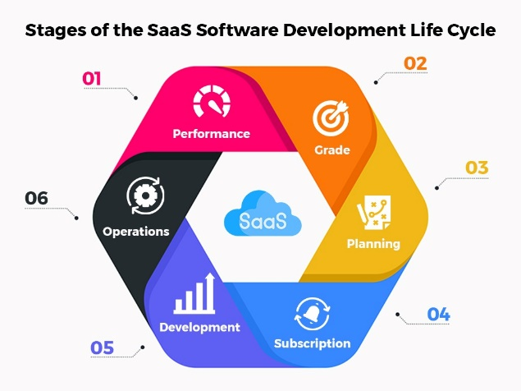

**V. METHODOLOGY**

The process of developing a Software as a Service (SaaS) AI platform like ChatGPT involves several key steps to ensure its functionality, reliability, and user satisfaction.

First, it’s important to have a clear understanding of the platform's purpose and target audience. This helps identify the problems it will solve and the value it will provide.

Next, conducting market research is crucial to understand user needs, competitor offerings, and emerging trends in AI and natural language processing (NLP). Analyzing this data can help inform decision-making.

The platform's architecture must be scalable and efficient, supporting the AI capabilities. Designing intuitive user interfaces is also important for seamless interactions.

During the development phase, implementing AI models, such as transformers for language processing, and integrating APIs for external services like image recognition or data retrieval are crucial. Ensuring robust security measures is also a priority.

Finally, rigorous testing is necessary to identify and fix any bugs or issues before the platform is launched. This helps ensure the overall quality and reliability of the SaaS AI platform.

**VI. WORKING**

Code Generation, Image Generation, Conversation and Music Generation using SaaS (Software as a Service) AI services typically involve the use of cloud based AI platforms and services to automate the generation of various types of content. These services leverage machine learning models and algorithms to create new content based on input data or parameters. Here's an overview of how each of these processes works using SaaS AI services:

Code Generation: Code generation SaaS AI services use natural language descriptions or high-level specifications to generate code. For example, you can provide a description of a software application or a specific function, and the service will generate the corresponding code. The service uses pre-trained machine learning models or custom models to understand the intent and context of the input description and then generate code in a programming language of your choice. Examples of code generation services include OpenAI's GPT-3, which can be fine-tuned for code generation tasks.

Image Generation: Image generation SaaS AI services create new images or modify existing ones based on various inputs or parameters. These services use generative models like GANs (Generative Adversarial Networks) or VAEs (Variational Autoencoders) to generate images. Users can provide textual descriptions, styles, or other images as input to guide the generation process. The AI model then generates images that match the input criteria. Examples include Deep Dream, DALL-E by OpenAI, and Runway ML. Department of Computer Engineering 12

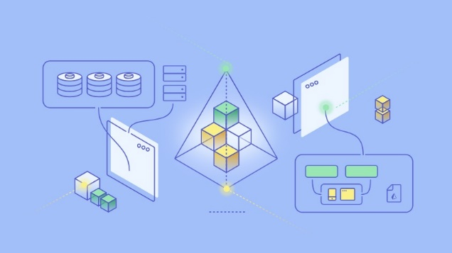

Conversation: Conversational AI theory combines natural language processing (NLP), machine learning (ML), dialogue management, and response generation techniques to enable computers to engage in human-like conversations. NLP helps understand user inputs, ML improves performance over time, dialogue management maintains context, and response generation generates coherent, contextually relevant replies. Effective UX design ensures intuitive interaction, while ethical considerations address issues like bias and privacy. Conversational AI systems can provide engaging and valuable interactions across various domains.

Music Generation: Music generation SaaS AI services create original music compositions or modify existing ones based on user-defined parameters. Users can input musical styles, moods, or specific musical elements, and the AI model generates music accordingly.AI music generation tools use techniques like deep learning, recurrent neural networks, and reinforcement learning to compose music.

**VII. RESULT**



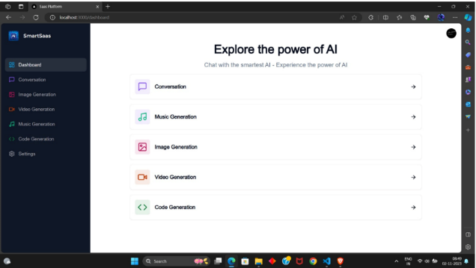

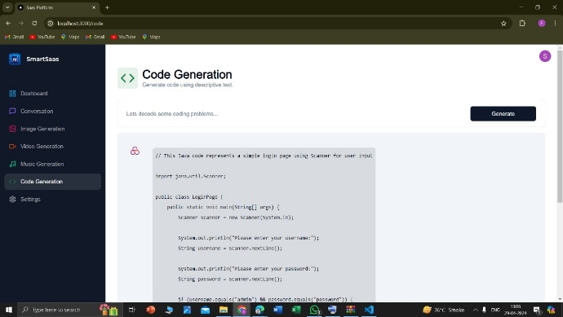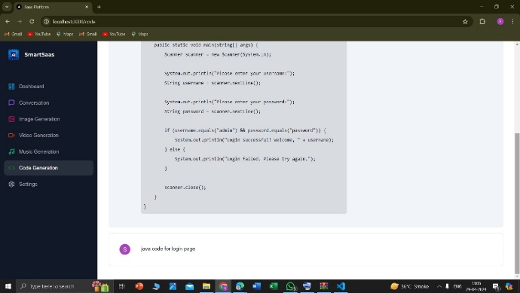



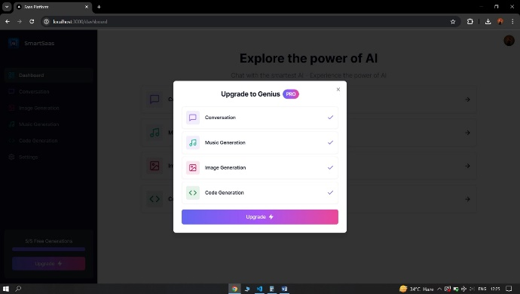

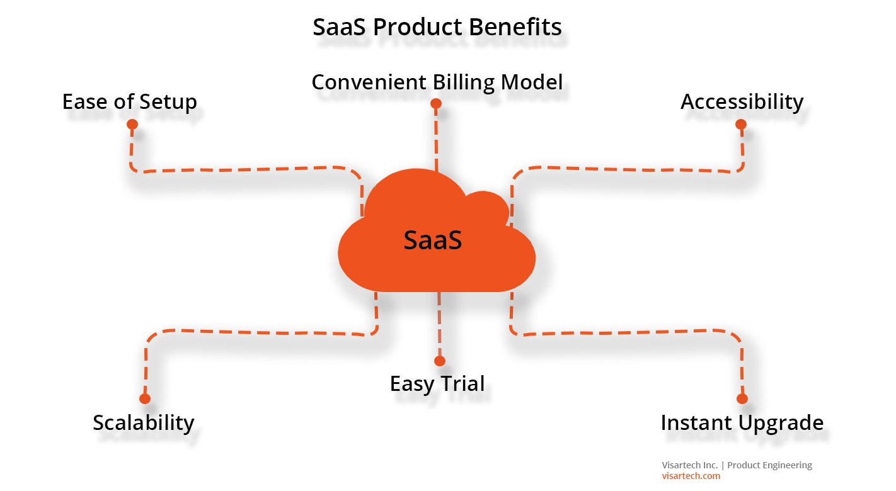

**VIII. FUTURE SCOPE**

Here's an overview of the potential future developments and applications:

1.Advanced Code Generation: As AI algorithms become more sophisticated, they can assist developers in generating code for a wider range of applications. Future advancements could include AI-powered code completion, automatic bug fixing, and even generating entire software modules based on high-level requirements. This could significantly speed up the software development process and reduce human error.

2.Creative Image Generation: AI algorithms like generative adversarial networks (GANs) have shown remarkable progress in generating realistic images. In the future, image generation services could be used for various applications such as creating artwork, designing virtual environments, or even generating personalized visual content for marketing purposes. These capabilities could empower artists, designers, and marketers to unleash their creativity in new ways.

3.Music Generation and Composition: AI algorithms can already compose music in various styles and genres. Future advancements in this area could lead to more sophisticated music generation services, including the ability to compose music tailored to specific moods, settings, or preferences. AI-generated music could find applications in video game development, film scoring, personalized playlists, and even live performances.

4.Integration with Creative Tools: SaaS AI platforms offering code, image, and music generation services could integrate seamlessly with existing creative tools and platforms. For example, developers could use AI-generated code snippets within their integrated development environments (IDEs), artists could incorporate AI-generated images into their design workflows, and musicians could collaborate with AI-generated compositions in digital audio workstations (DAWs).

5.Customization and Personalization: One of the key advantages of AI-powered services is their ability to customize and personalize outputs based on user input and preferences. In the future, users may have more control over the generated content, allowing them to fine-tune parameters, provide feedback, and guide the creative process to better align with their needs and tastes.

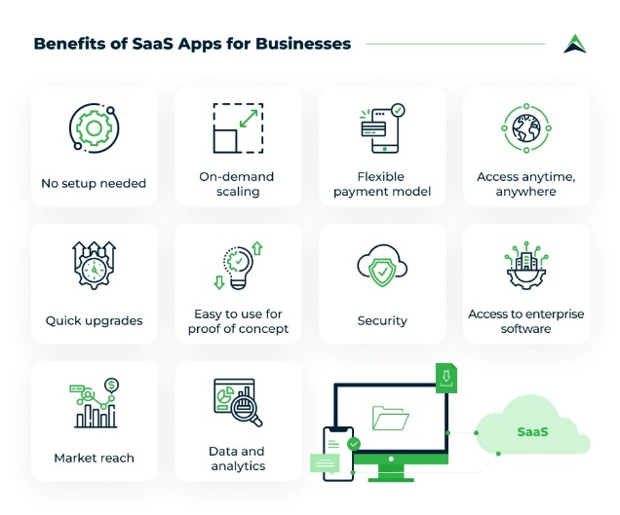

**IX. CONCLUSION**

In the ever-evolving world of AI and technology, SaaS AI platforms are likely to continue evolving and expanding, offering more specialized and sophisticated solutions to meet the diverse needs of businesses and developers. As AI becomes increasingly integrated into various industries, these platforms will play a pivotal role in driving innovation and efficiency. However, it is essential for organizations to carefully evaluate and choose the SaaS AI platform that aligns with their specific requirements and long-term goals.

Ultimately, SaaS AI platforms have the potential to revolutionize how we work, create, and communicate, empowering individuals and organizations to achieve new heights of innovation and productivity in the digital age. As they continue to evolve and mature, SaaS AI platforms will play an increasingly pivotal role in shaping the future of technology and society.

**REFERENCES**

[1] Vijay Raman ; Indranil Gupta , ‘Performance Tradeoffs Among Percolation-Based Broadcast Protocols in Wireless Sensor Networks’, pp 158-165, published in 29th IEEE International Conference on Distributed Computing Systems Workshops, July 2009

[2] King-Chu Hung ; Yu-Jung Huang ; FuChung Hsieh ; Jen-Chun Wang ,‘An AOCA-Based VLSI Architecture for NonRecursive 2D Discrete Periodized Wavelet Transform’, pp 273-276, published in 14th International Conference on Digital Signal Processing, 2002

[3] Shirish Bhide, Nigel John, and M. R. Kabuka, ‘A Boolean Neural Network Approach for the traveling Salesman Problem’, pp 1274-1278, published IEEE TRANSACTIONS ON COMPUTERS, VOL. 42, NO. 10, OCTOBER 1993

[4] Nicolas Gold, Andrew Mohan, Claire Knight, Malcolm Munro, ‘Understanding Service-Oriented Software’, pp 74-77, IEEE Computer Society IEEE SOFTWARE, 2004

[5] King-Chu Hung, Yu-Jung Huang, FuChung Hsieh, and Jen-Chun Wang, ‘An AOCA-based VLSI architecture for nonrecursive 2D discrete periodized wavelet transform’ pp 273-276, 14th International Conference on Digital Signal Processing Proceedings. DSP, published in 2002

[6] Balachandra Reddy Kandukuri ; Ramakrishna Paturi V. ; AtanuRakshit, ‘Cloud Security Issue’, pp 517-520, IEEE International Conference on Services Computing, published 2009

7] Zhi Hu Wang, Chang Jie Guo, Bo Gao, Wei Sun, Zhen Zhang, Wen Hao An, ‘A Study and Performance Evaluation of the MultiTenant Data Tier Design Patterns for Service Oriented Computing.

[8] J. Kang, H. Bannazadeh, H. Rahimi, T. Lin, M. Faraji and A. Leon-Garcia, "Software-defined infrastructure and the future central office", *2013 IEEE International Conference on Communications Workshops (ICC)*, pp. 225-229, June 2013.