**USING SUPER ABSORBENT POLYMERS TO DEVELOP SELF SEALING CONCRETE**

**ZOHIB AKRAM1, Er. REKHA DEVI2**

**1** M.Tech Scholar,Desh Bhagat University Gobindgarh Punjab,India

*Akzohibkhan786@gmail.com*

2 Assistant Professor, Desh Bhagat University Gobindgarh Punjab,India

*Katwalrekha7@gmail.com*

## **ABSTRACT**

The utilisation of superabsorbent polymers (SAPs) in the creation of self-sealing concrete is a notable breakthrough in the field of construction materials engineering. This innovation has the potential to address concerns regarding the long-term durability and upkeep of concrete structures. Self-sealing concrete, enhanced by superabsorbent polymers (SAPs), has the capability to automatically close small cracks that emerge over time as a result of factors like shrinkage, changes in temperature, and mechanical stress. This improves the durability and effectiveness of concrete buildings.

Superabsorbent polymers, known for their remarkable ability to absorb and swell with water, are included into the concrete mixture to act as internal reservoirs that can absorb and hold water. Microcracks in concrete allow water to penetrate by capillary action, causing the expansion of SAP particles. As the superabsorbent polymers (SAPs) increase in size, they apply force on the nearby concrete structure, effectively sealing the cracks and blocking the entry of damaging substances including water, chlorides, and corrosive chemicals.

The usage of selfhealing agents in self-sealing concrete has numerous benefits. Firstly, it fosters sustainability by decreasing the necessity for frequent maintenance and repair tasks, hence minimising the use of materials, expenditure of energy, and related costs. In addition, the use of self-sealing concrete improves the longevity of structures by increasing their resilience and lowering the likelihood of damage caused by environmental conditions and ageing. Furthermore, the self-sealing system enables the maintenance of the structural integrity, guaranteeing adherence to safety standards and legal mandates.

The process of creating self-sealing concrete using SAPs requires careful consideration of several issues, such as choosing appropriate types of SAPs, optimising the dose, ensuring compatibility with concrete components, and evaluating long-term performance. Scientists and engineers are now investigating new methods to improve the efficiency and usefulness of self-sealing concrete technology. This includes finding better ways to disperse superabsorbent polymers (SAP), adjusting the size distribution of particles, and incorporating them into certain concrete mixtures.

Moreover, the utilisation of self-sealing concrete goes beyond conventional construction methods, spanning several industries including infrastructure, transportation, maritime, and underground construction. Self-sealing concrete is a very versatile and adaptable material that shows great promise in tackling sustainability, robustness, and lifecycle management concerns in civil engineering applications.

**Key Words:** Super Absorbent Polymers (SAPs), Self-Sealing Concrete, Material Properties, Construction Materials, Concrete Reinforcement, Crack Healing

Top of Form

# INTRODUCTION

The incorporation of superabsorbent polymers (SAPs) into the production of self-sealing concrete is a major achievement in the field of building materials engineering. This innovation holds great potential for enhancing the strength, flexibility, and eco-friendliness of concrete structures. Conventional concrete, although strong under compression, is prone to many types of decay over time, primarily caused by the development of tiny fractures resulting from factors like shrinkage, temperature changes, and mechanical stress. If these microcracks are not dealt with, they can weaken the strength and functionality of concrete structures, resulting in expensive repairs, maintenance, and early replacement.

The idea behind self-sealing concrete involves utilising the impressive water-absorbing Characteristics of SAPs to automatically counteract the harmful consequences of microcracks by closing them as soon as they appear. SAPs, renowned for its capacity to absorb and store substantial amounts of water, are intentionally integrated into the concrete mixture as internal storage units. Moisture infiltrates into the concrete matrix through capillary action when microcracks spread, causing the SAP particles to expand. As the Super Absorbent Polymers (SAPs) expand, they apply force on the nearby concrete, effectively sealing the tiny breaches and preventing the entry of damaging substances like water, chlorides, and corrosive chemicals.

The utilisation of SAPs in the creation of self-sealing concrete provides a range of advantages that go beyond traditional methods of constructing concrete. Self-sealing concrete helps improve sustainability by minimising the need for traditional repair and maintenance, which in turn reduces the amount of materials used, energy consumed, and carbon emissions produced over the lifespan of concrete structures. Moreover, the enhanced strength and long-lasting nature provided by self-sealing concrete technology result in a prolonged period of use and decreased expenses across the lifespan of infrastructure projects, thereby maximising the return on investment.

The use of self-healing agents in concrete represents a significant change in the field of building materials engineering, providing new opportunities for creativity and improvement in the design and performance of concrete. Scientists and professionals are actively working to improve our understanding of how SAP behaves in concrete, finding the best amount and distribution of SAP, and discovering new ways to use and prepare self-sealing concrete to make it even more effective and useful.

To summarise, incorporating superabsorbent polymers into the creation of self-sealing concrete is an innovative method that aims to create long-lasting, strong, and environmentally-friendly infrastructure.

**SELF HEALING**

In the context of utilising superabsorbent polymers (SAPs) to create self-sealing concrete, self-sealing refers to the concrete's capacity to independently mend or heal small fissures that occur inside the material as time passes. When added to the concrete mixture, superabsorbent polymers (SAPs) function as internal reservoirs that can absorb and hold water. When microcracks form in concrete as a result of variables including shrinkage, changes in temperature, or mechanical stress, moisture seeps into the fissures. Consequently, the SAP particles expand, applying force on the nearby concrete and efficiently sealing the fissures. The self-sealing system prevents additional entry of water and toxic substances, consequently improving the durability and lifespan of the concrete construction.

**SUPER ABSORBENT POLYMERS**

Superabsorbent polymers (SAPs) are attracting growing attention in concrete technology due to their potential to transform the building sector. Hydrophilic polymers, which have a remarkable capability to absorb water, are being studied for their potential to improve the strength and effectiveness of concrete buildings. Self-sealing concrete employs SAPs as a proactive measure to combat the problem of microcracking, which is a prevalent issue that undermines the durability and lifespan of concrete structures. By integrating SAPs into the concrete matrix, these polymers function as internal reservoirs with the ability to automatically seal microcracks when they occur.

**PRINCIPAL MECHANISM.**

Superabsorbent polymers (SAPs) are essential in the advancement of self-sealing concrete due to their distinct features that improve the endurance and performance of the material. The primary methods by which SAPs contribute to the self-sealing behaviour of concrete can be summarised as follows:

**Water Absorption:** Superabsorbent polymers (SAPs) have a remarkable ability to soak up and retain significant amounts of water, usually hundreds of times their own weight. When added to concrete mixtures, Superabsorbent Polymers (SAPs) function as internal storage units, soaking up moisture from the surrounding environment or from small fractures that develop inside the concrete structure.

**Swelling Phenomenon:** When SAPs come into contact with water, they experience substantial expansion, resulting in an increase in size and the application of pressure on the adjacent concrete. The swelling action plays a vital role in the self-sealing mechanism by allowing SAPs to efficiently heal microcracks through the process of filling the empty space and repairing the structural integrity of the concrete matrix.

**Expansion Pressure:** The enlargement of superabsorbent polymers (SAPs) creates internal force within the concrete, aiding in the sealing of tiny fissures and blocking the entry of further water and dangerous chemicals. The expansion pressure serves to preserve the structural integrity of the concrete and bolster its resilience against external pressures and environmental variables.

**Gel Formation:** When superabsorbent polymers (SAPs) come into contact with water, they undergo a transformation from a dry, granular condition to a gel-like consistency. The gel creation enhances the self-sealing process by creating a cohesive substance that can stick to the surfaces of tiny cracks, effectively sealing them and limiting crack growth.

**Extended Durability:** SAPs are designed to maintain their water-absorbing and swelling characteristics for a prolonged duration, guaranteeing long-lasting efficacy in self-sealing concrete. This feature allows the concrete to consistently mend and seal small cracks that emerge over time, so improving its strength, lifespan, and overall effectiveness.

Superabsorbent polymers provide a proactive and sustainable approach to reduce the impact of microcracking and improve the self-sealing ability of concrete by utilising these fundamental principles. The continuous research and improvement in the use of SAPs in self-sealing concrete has the potential to greatly transform the construction industry and contribute to the creation of durable and environmentally-friendly infrastructure solutions.

# OBJECTIVES

The few objectives are as under

* Determine the most effective amount of SAPs needed to produce the highest level of self-sealing effectiveness while also preserving the desired mechanical characteristics of concrete.
* Examine the value of various superabsorbent polymers (SAPs) in improving the ability of concrete to seal itself
* Evaluate the impact of SAP Characteristics, including particle size, chemical composition, and swelling kinetics, on the ability of concrete to self-seal.
* Investigate the extended-term effectiveness and resilience of self-sealing concrete that incorporates superabsorbent polymers (SAPs) in different environmental circumstances, such as freeze-thaw cycles, chloride exposure, and mechanical loads.
* Acquire a thorough comprehension of the main mechanisms by which SAPs enhance the ability of concrete to seal itself, including water absorption, swelling behaviour, expansion pressure, gel formation, and long-term performance.
* nhance the mix design parameters, such as the dose of Superabsorbent Polymer (SAP), the ratio of water to cement, and the arrangement of aggregates, in order to maximise the effectiveness of self-sealing and the physical characteristics of concrete.

# LITERATURE REVIEW

The literature study examines the use of SAPs in the creation of self-sealing concrete. It offers a thorough summary of current research and studies pertaining to this advanced technology. The study investigates the characteristics, actions, and uses of SAPs in the field of concrete engineering, with a specific emphasis on their capacity to improve the self-sealing qualities of concrete and reduce the impact of microcracking. The literature review explores the different methods by which SAPs contribute to self-sealing behaviour, such as water absorption, swelling behaviour, expansion pressure, and gel formation. Furthermore, it investigates the impact of specific attributes of SAP, such as particle size, chemical composition, and swelling kinetics, on the effectiveness of SAP-enhanced concrete. The literature review seeks to uncover knowledge gaps, emphasise areas for additional research, and establish a strong basis for the experimental enquiry and analysis carried out in the thesis by synthesising and analysing prior study findings.

**Smith et al.** explores the application of superabsorbent polymers (SAPs) to enhance the longevity of concrete structures by implementing self-sealing mechanisms. SAPs, renowned for their capacity to absorb and retain water, are incorporated into the concrete structure to automatically seal tiny cracks as they appear. This proactive strategy reduces the entry of damaging chemicals, such as water and chlorides. The research assesses the efficacy of various types and dosages of Superabsorbent Polymers (SAPs) in self-sealing concrete under diverse environmental circumstances through experimental testing. Moreover, the study examines how the features of SAP affect its capacity to self-seal, offering useful insights for enhancing the longevity of mix designs. In conclusion, the outcomes help to the progress of sustainable and economical ways for dealing with typical issues concerning the decay and upkeep of concrete in construction endeavours.

**Johnson and Garcia's** study examines the characteristics of self-sealing concrete when superabsorbent polymers (SAPs) are added. Self-sealing concrete is a novel method for addressing the problem of microcracking, which is a frequent concern in concrete constructions and can result in decreased durability and heightened permeability. The researchers want to improve the material's capacity to automatically seal microcracks and prevent the entry of water and hazardous substances by including SAPs into the concrete mix.

**Johnson and Garcia** conduct experimental tests to assess numerous characteristics of self-sealing concrete reinforced with SAP, such as its mechanical strength, durability, and capacity to seal itself in various climatic circumstances. The researchers inspect the influence of SAP dosage, particle size and chemical composition on the efficacy of self-sealing behaviour. In addition, the study evaluates the extended-term effectiveness and resilience of SAP-enhanced concrete to determine its appropriateness for practical use.

**Patel and Wang's** research examines the efficacy of different superabsorbent polymers (SAPs) in improving the self-sealing characteristics of concrete. Self-sealing concrete is an innovative method for dealing with small cracks in concrete structures. It utilises the water-absorbing and water-retaining Characteristics of SAPs, which causes them to expand and fill the cracks on their own. Patel and Wang seek to identify the SAPs that demonstrate the most favourable self-sealing Characteristics and help to the advancement of long-lasting concrete constructions. The researchers evaluate the effectiveness of several SAP formulations in self-sealing concrete mixtures through extensive experimental testing. The researchers assess important parameters such as the ability of each SAP type to absorb water, the rate at which it swells, and how effectively it seals. Patel and Wang want to systematically compare the efficacy of different SAPs in order to determine the most appropriate formulations that provide the ideal balance of self-sealing performance, mechanical qualities, and durability.

**Lee and Chen's** study centres on optimising the dose of superabsorbent polymers (SAPs) in order to attain the highest level of self-sealing effectiveness in concrete. Self-sealing concrete utilises the capacity of Superabsorbent Polymers (SAPs) to soak up water and expand, effectively sealing small gaps without external intervention. Lee and Chen seek to identify the most effective dosage of SAPs that achieves a compromise among improving the self-sealing qualities of concrete and preserving the desirable mechanical Characteristics and workability of concrete mixtures. The researchers systematically examine the self-sealing capacity of concrete sampless by conducting experiments and adjusting the doses of SAPs. To determine the optimal dose range for achieving successful self-sealing behaviour while maintaining other vital qualities, they evaluate critical factors such as fracture closure efficiency, water absorption capacity, and mechanical strength.The outcomes of this study offer vital information on how to choose the correct dose of SAPs for self-sealing concrete mixes

**Gupta et al**. explores the impact of specific attributes of SAP on the ability of concrete to self-seal. The research examines how the unique Characteristics of superabsorbent polymers (SAPs) impact their ability to effectively seal microcracks in concrete mixtures, acknowledging the crucial role SAPs play in this process. The key features being analysed are the size of the particles, the chemical makeup, the rate at which they swell, and their dispersion within the concrete matrix.

**Gupta et al.** conduct a series of experiments to evaluate how well concrete sampless containing SAPs with different Characteristics can seal themselves. The researchers intend to clarify the characteristics that have the greatest impact on self-sealing behaviour by methodically altering these qualities. The outcomes of this study provide significant information on how to improve the Characteristics of SAP in order to increase the durability and lifespan of concrete buildings. Engineers and researchers can make informed decisions when selecting and designing SAP-enhanced concrete mixes for construction projects by comprehending how various SAP characteristics affect self-sealing efficiency. This will ultimately contribute to the advancement of sustainable and resilient infrastructure solutions.

**Kim & Park's** research is centred around evaluating the long term performance of self-sealing concrete that has been improved using superabsorbent polymers (SAPs). The study conducts thorough examinations to evaluate the long-term durability and effectiveness of SAP-enhanced concrete. It examines how the material performs under different climatic conditions and loading situations. Kim and Park conduct thorough experimental testing and analysis to evaluate important factors such as mechanical characteristics, durability, and self-sealing effectiveness of concrete sampless reinforced with SAP (Superabsorbent Polymers) over long periods of time. The project intends to provide useful insights into the long-term effectiveness and reliability of SAP-enhanced self-sealing concrete in real-world building applications by closely monitoring the material's behaviour and performance over time. The outcomes of this study add to the progress of our knowledge on SAP-enhanced self-sealing concrete technology and offer direction on how to optimise mix designs and dosage levels for the building of sustainable and resilient infrastructure.

**Brown and Martinez** examines the mechanical characteristics of concrete that incorporates superabsorbent polymers (SAPs) for the purpose of self-sealing applications. The research intends to evaluate the impact of incorporating SAPs on important mechanical Characteristics of concrete, including compressive strength, tensile strength, and modulus of elasticity. This is essential for ensuring the structural integrity of the concrete. Brown and Martinez conduct experimental testing and analysis to assess the influence of SAP dosage, type, and distribution on the mechanical Characteristics of SAP-enhanced concrete. The researchers aim to determine the most effective combination of these factors by systematically altering them, in order to achieve a balance among the efficiency of self-sealing and mechanical performance.The outcomes of this study offer significant information for creating concrete mixes that have both effective self-sealing Characteristics and meet the necessary mechanical requirements for construction purposes. This research aims to enhance the progress of creating long-lasting and strong concrete structures by incorporating SAP technology.

**Nguyen and Tran** aims to evaluate the durability performance of concrete that has been upgraded with SAP (Superabsorbent Polymers) under different environmental conditions. The study explores the impact of incorporating SAP on the resilience of concrete structures to elements such as freeze-thaw cycles, chloride exposure, and chemical attacks, with a focus on understanding the importance of durability. The researchers intend to assess the long-term resilience of SAP-enhanced concrete and its capacity to endure severe environmental conditions by experimental testing and analysis. The findings offer vital insights into the efficacy of SAP technology in increase the strength and longevity of concrete structures, hence contributing to the progress of sustainable infrastructure solutions.

# METHODOLOGY

**Materials**

**Cement**

The study will utilise grade 53 cement, commonly referred to as typical Portland cement. The cement has experienced testing for various qualities as per the IS: 4031-1988 standard and has has been determined to fulfil the requirements the standards outlined in the IS: 12269-1987 standard.

**Fine Aggregate**

We will utilise well-graded natural river gravel that passes through a 4.75mm filter. The fine aggregate met the requirements as per the IS 383-1970.

**Coarse Aggregate**

Coarse aggregate refers to the size of the aggregate that is larger than 4.75mm. The crushed aggregate utilised has a size of 10mm and 20mm, and it follows a standard continuous grading. The coarse aggregate's analysis by sieve meets the specified requirements. given in IS: 10262.

**Superabsorbent Polymer**

This study selected four commercially available superabsorbent polymers (SAPs), mostly based on polyacrylate or polyacrylate-co-acrylamide. The designated SAP is cross-linked sodium polyacrylate acquired as a white powder with particle sizes reaching from a few microns to around 500μm. The SAP was acquired from two distinct vendors, Valour Industries in Ahmedabad and A.S. Innovation in Nashik, in order to guarantee uniformity in material qualities. Upon careful analysis, it was determined that the characteristics of SAP from both vendors were indistinguishable.

Table 4.1 Physical and chemical Characteristics of sodium polyacrylate

|  |  |  |  |
| --- | --- | --- | --- |
| **Item** | **Specification** | **Unit** | |
| ≤ Residual Monomer (Acrylic Acid) | 150-300 | PPM | |
| ≤ Moisture Content | 6.0 | % | |
| PH Value | 6.0 – 6.5 | -- | |
| Particle Size Distribution | Among 80 to 120 mesh | % | |
| Density | 0.59 ~ 0.65 | g/cm3 | |
| (Vortex Method) Absorption Rate 0.9% NaCl Solution | ≤10 | S | |
| Absorption in 0.9% NaCl Solution | ≥54 | g/g | |
| (0.9% NaCl Solution) Retention Capacity after Centrifugation | ≤25 | g/g | |
| (0.9% NaCl Solution) Absorption under pressure | ≤26 | 0.3psi | g/g |
| Appearance | White solid |  | |

Typically, SAP has the ability to absorb water at a ratio of 150-200 times its own weight when placed in distilled water. However, the actual amount may differ depending on the hardness of the water. Super Absorbent Polymers are non-toxic, but they can cause irritation to the skin and eyes. It is advisable to wear protective eyewear and gloves when handling them.

**Test Procedure for fineness Test of Cement**

* Precisely measure 100 grammes of cement and set it on a standard sieve with a mesh size of 90 microns.
* Disintegrate any agglomerations in the cement samples using fingers.
* Continuously agitate the samples employing round and horizontal movements for a duration of 15 minutes.
* Determine the mass of the residue remaining on the sieve. According to the IS regulation, the maximum allowable percentage of residue shall not exceed 10%.

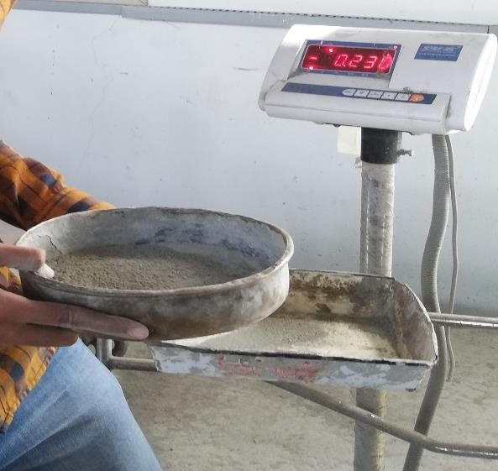

Figure 4.1 Fineness of cement

Table 4.2 Observations of fineness of cement

|  |  |  |  |
| --- | --- | --- | --- |
| Sr. No. | Weight of the samples collected  (gm) | Weight of residue  (gm) | Fineness  (%) |
| 1 | 100 | 8 | 92 |
| 2 | 100 | 7 | 93 |
| 3 | 100 | 9 | 91 |

Avg. fineness of cement = 92 %.

**Test Procedure for Consistency of Cement**

The consistency of cement is determined by the following test procedure: At first, a quantity of 300 grammes of cement is placed in a tray that is coated with enamel. The cement paste is created by thoroughly mixing around 26% water by weight of dry cement, while making sure that the gauging time does not exceed 3 to 5 minutes. Afterwards, the Vicat mould, placed on a glass plate, is filled with the cement paste. After the mould is all filled, the paste's surface is levelled with the top of the mould. Subsequently, the complete assembly, comprising the mould, cement paste, and glass plate, is positioned beneath the rod-bearing plunger. The plunger is delicately lowered to make contact with the surface of the test block, then promptly released to enable it to submerge into the paste. The extent of penetration is measured and documented. The process is iterated using test pastes that have different proportions of water content until the depth of penetration falls within the target range of 33 to 35 mm. This process offers crucial insights on the feasibility and solidification Characteristics of the cement paste.

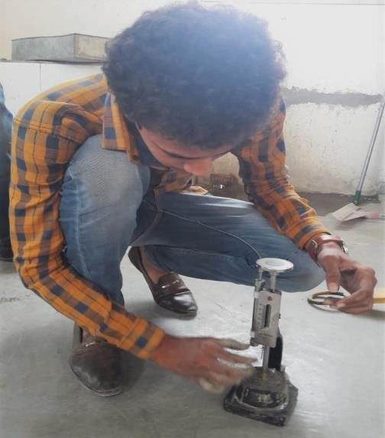

Figure. 4.2 Vicate apparatus for consistency of cement alculation:

Calculate the weight percentage (P) of water required to make a cement paste of standard consistency using the given formula, and express the result to one decimal point.

P = W/C * 100

where

W=Quantity of water added.

C=Quantity of cement used

Table 4.3 Shows Observations of consistency of cement

|  |  |  |  |  |
| --- | --- | --- | --- | --- |
| Sr.  No. | “Wt. of Cement” (gm) | “%age of dry cement” (%) | “water added (ml)” | “Penetration”  (mm) |
| 1 | 400 | 25 | 68 | 30 |
| 2 | 400 | 28 | 84 | 24 |
| 3 | 400 | 30 | 90 | 20 |
| 4 | 400 | 32 | 96 | 18 |
| 5 | 400 | 34 | 102 | 5 |

**Result:**

The measured consistency of the provided cement samples is 34%.

**Test Procedure for Initial and Final Setting time of Cement**

The test procedure for determining the initial and final setting time of cement involves several steps. First before beginning the setting time test a consistency test is conducted to determine the water required to achieve normal consistency (P) of the cement paste. Then 400 grams of cement are mixed with 0.85 times the water needed for normal consistency to prepare a neat cement paste. The gauging time is kept among 3 to 5 minutes, and the stopwatch is started when water is added to the cement, with this time recorded. Next, the Vicat mould, positioned on a glass plate, is filled with the cement paste, ensuring it is completely filled and the surface is leveled with the top of the mould to create a test block. For the initial setting time test, the test block is placed under the rod bearing the needle of the Vicat apparatus, and the needle is gently lowered until it penetrates the surface of the block, with this process repeated every 2 minutes until the needle fails to pierce the block for about 5 mm from the bottom of the mould. To determine the final setting time, the Vicat apparatus replaces the tip of the needle with one that has an annular connection. The cement is regarded to be finally set if the needle produces a mark on the surface while the connection does not, and this time is noted. The offered samples of cement has a weight of 300 grm and a normal consistency of 34%.

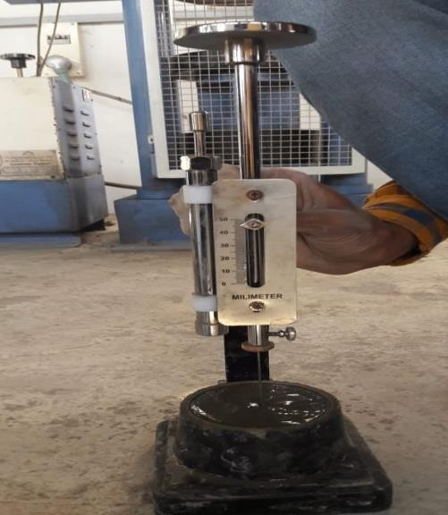

Figure. 4.3 Vicate apparatus and Glass plate for initial and final setting time

The volume of water added for the manufacture of the test block is 87ml, which is 0.85 times the amount of water needed to create a paste of standard consistency.

Table 4.4 Shows initial and final setting of cement

|  |  |  |
| --- | --- | --- |
| **Sr. No.** | **Setting Time (sec)** | **Penetration (mm)** |
| 1 | 2160 | 5 |
| 2 | 2340 | 5.5 |

* The cement samples's initial setting time is determined to be 37.5 minutes.
* The cement samples's ultimate setting time is determined to be 9 hours.

**Procedure for sieve analysis of aggregate**

**Coarse aggregate procedure:**

The process of doing sieve analysis on coarse aggregate comprises multiple sequential steps. Initially, a 1 kilogramme samples of coarse aggregate with a nominal size of 20 mm is obtained by dividing it into four equal parts. The sieving process is performed manually by shaking each sieve in succession, starting from 80 mm and going down to 4.75 mm, over a clean and dry tray for a minimum duration of 2 minutes. During the process of sieving, a range of motions such as backwards and forward, left to right, circular, clockwise, and anticlockwise, combined with regular jarring, are used to guarantee that the material moves properly across the sieve surface in different directions. Following the process of sieving, the weight that remains on each sieve is measured and documented in the corresponding sequence. This approach enables the investigation of the particle size distribution of the coarse aggregate samples.

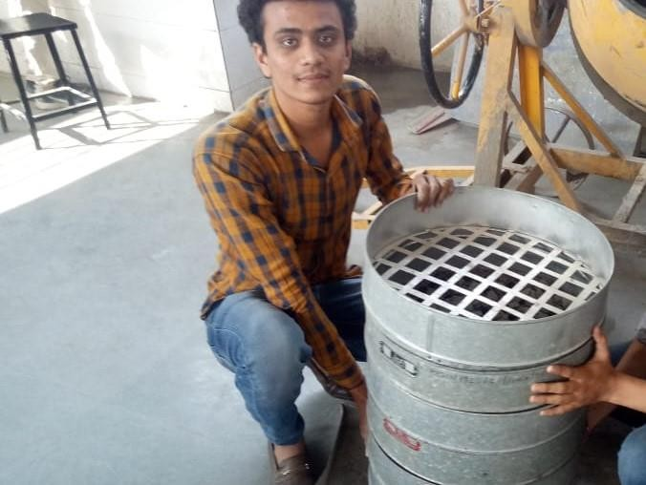

Figure 4.4 Sieve analysis for coarse aggregate

Table 4.5 Shows particle size distribution for coarse aggregate

|  |  |  |  |  |  |
| --- | --- | --- | --- | --- | --- |
| IS Sieve | “Weight Retained on Sieve (gm)” | “Percentage of Weight Retained”  (%) | “Percentage of Weight Passing” (%) | “Cumulative Percentage of Passing”  (%) | Remark |
| 80 mm | 0 | 0 | 100 | 100 | Zone-II |
| 40 mm | 0 | 0 | 100 | 200 |
| 20 mm | 40 | 4 | 96 | 296 |
| 12.5 mm | 670 | 67 | 33 | 329 |
| 10 mm | 190 | 19 | 8 | 410 |
| 4.75 mm | 100 | 10 | 90 | 500 |
| **Total** | 1000 |  |  |  |

**Fine aggregate procedure:**

The process of conducting sieve analysis on fine aggregate consists of the following steps. At first, a 1 kilogramme portion of sand is collected from the samples by dividing it into four equal parts and then placed on a clean and dry plate. The sieves are thereafter organised in ascending order based on their mesh sizes: No. 4.75 mm, 2.36 mm, 1.18 mm, 600-micron, 300 micron, and 150 micron, with the No. 4.75 mm sieve positioned at the highest level. The sieves are securely attached to the sieve shaking machine, with the pan positioned at the bottom and the cover placed on top. The sand is deposited onto the uppermost sieve (No. 4.75) and the process of sifting is carried out utilising the collection of sieves positioned in the machine for a minimum duration of 10 minutes. Following the process of sieving, the weight that remains in each sieve is measured, which gives valuable data on the distribution of particle sizes in the samples of fine aggregate.

Table 4.6 Shows particle size distribution for fine aggregate

|  |  |  |  |  |  |
| --- | --- | --- | --- | --- | --- |
| IS Sieve | “Weight Retained on Sieve” (gm) | “Percentage of Weight Retained”  (%) | “Percentage of Weight Passing” (%) | “Cumulative Percentage of Passing”  (%) | Remark |
| 4.75 mm | 30 | 3 | 97 | 92 | Zone - I |
| 2.36 mm | 50 | 5 | 95 | 192 |
| 1.18 mm | 300 | 30 | 70 | 262 |
| 600 micron | 440 | 44 | 56 | 318 |
| 300 micron | 150 | 15 | 85 | 403 |
| 150 micron | 20 | 2 | 98 | 501 |

**Calculation:**

The modulus of fineness is a quantitative measure obtained by adding up all of the amounts of aggregates that remain on every typical filter dimension that ranges from 4.75 mm to 150 micron, and subsequently reducing this total by the random value of 100.

𝐹𝑖𝑛𝑒𝑠𝑠 𝑀𝑜𝑑𝑢𝑙𝑢𝑠, 𝐹𝑀 =

𝑇𝑜𝑡𝑎𝑙 𝑜𝑓 𝐶𝑢𝑚𝑢𝑙𝑎𝑡𝑖𝑣𝑒 𝑃𝑒𝑟𝑐𝑒𝑛𝑡𝑎𝑔𝑒 𝑜𝑓 𝑃𝑎𝑠𝑠𝑖𝑛𝑔 (%) 100

= 502

100

= 5.02 %

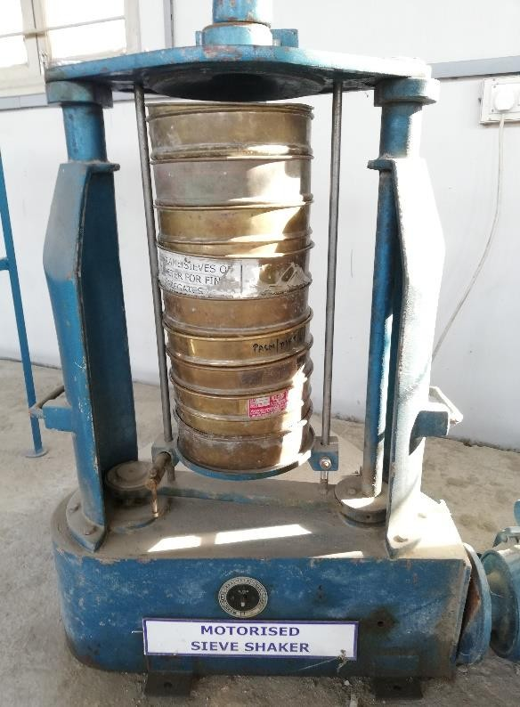

Figure 4.5 Sieve shaker for fine aggregate

Table 4.7 Grading limits of fine aggregates IS: 383-1970

|  |  |  |  |  |
| --- | --- | --- | --- | --- |
| IS Sieve Designation | Percentage passing by Weight for | | | |
| Grading  Zone I | Grading  Zone II | Grading  Zone III | Grading  Zone IV |
| 10mm | 100 | 100 | 100 | 100 |
| 4.75mm | 80-95 | 80-95 | 85-95 | 80-95 |
| 2.36 mm | 65.90 | 60-90 | 90-95 | 80-95 |
| 1.18 mm | 40-75 | 40-80 | 70-90 | 80-95 |
| 600 micron | 14-34 | 30-65 | 50-80 | 70-90 |
| 300 micron | 4-24 | 7-25 | 10-35 | 10-60 |
| 150 micron | 1-9 | 1-9 | 1-9 | 1-15 |

**Result:**

The fineness modulus of a given samples of fine aggregate is 5.02%, which indicates that it falls into the category of coarse sand, medium sand, or fine sand.

The provided samples of fine aggregate belongs to Grading Zone II.

1. **RESULT**

**EXPERIMENTAL STUDY**

**WATERFLOW TEST THROUGH CRACKS FOR M20**

**TEST SET-UP**

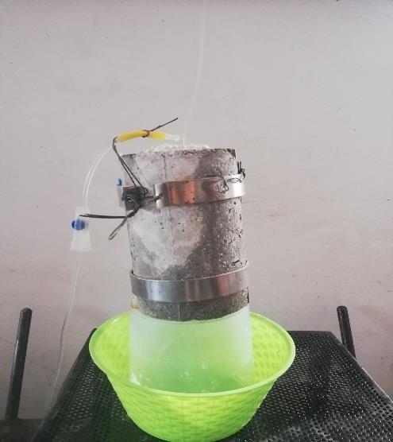The water flow test sampless are cylinder in shape. The object has a height of 150 mm and a diameter of 100 mm. The purpose of the test is to examine the Characteristics of concrete in order to reduce the passage of water through a deliberately created fracture. The water flow samples is divided into nearly two equal halves, which are subsequently reassembled. The combined samples depicts a concrete crack with a depth of 150 mm and a breadth of 30 mm. A total of 10 sampless were prepared. Two separate sampless were evaluated for each %. The quantities of SAP utilised in this investigation were 0%, 0.1%, 0.2%, 1%, and 2% relative to the weight of Portland cement. This study also aims to investigate the impact of increasing the quantity of SAP incorporated into the concrete mixture. The sampless underwent testing after a cure period of 28 days. The initial samples tested had a SAP concentration of 0%. This samples serves as a control samples. The illustration depicts a standard water flow samples. This process is standardised to ensure that all sampless were exposed to identical circumstances. A specialised configuration was employed to generate the water flow sampless. A silicone rubber seal is affixed to a plate with side grooves, which is then assembled into the samples.

Figure. 5.1 Water flow through crack in samples

The gathered samples was secured using a pair of stainless-steel hose clamps. The water flow samples is returned to its mould and thereafter secured within a steel hose clamp. The samples is thereafter positioned within the testing chamber in a manner that restricts the water from flowing elsewhere other than through the concrete sampless, specifically via the fracture in the concrete. Water pressure is exerted on the upper side of the water flow samples. The sampless underwent testing under declining head water pressure. Experimental arrangement for the hydraulic flow test depicted in figure 6.

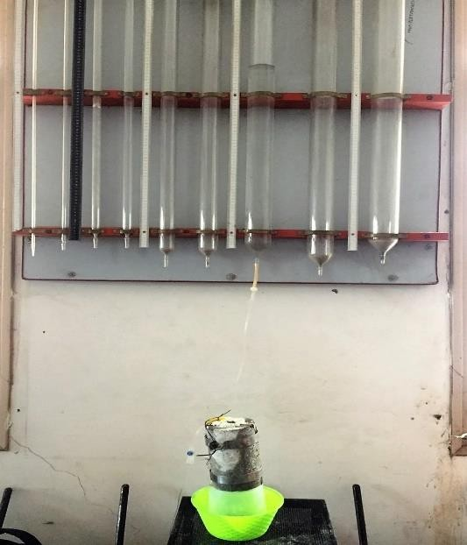

Figure. 5.2 Set-up for water flow test

The measurement of water flow through concrete, controlled by employing an IV pipe, is of utmost importance in evaluating the water resistance and sealing Characteristics. A decreased water flow rate signifies enhanced water tightness and sealing, particularly when concrete is combined with superabsorbent polymers (SAP). The water discharge is calculated using the equation (V = QSAP \ t), where (QSAP) represents the water flow rate through the concrete samples in millilitres per minute, (V) is the volume of water flowing through the samples in millilitres, and (t) is the time measured in minutes.

**OUTCOMES**

This study examines the influence of superabsorbent polymers (SAP) on the strength and sealing abilities of concrete. Multiple SAP concentrations were examined, and the rate of water flow through concrete sampless was evaluated using falling head water pressure. The plain concrete samples demonstrated a consistent flow rate, whereas the SAP concrete sampless displayed substantial Reducings in flow rate with time, with larger SAP percentages resulting in accelerated drops. This indicates that increasing the SAP percentages may improve the ability of concrete to seal.

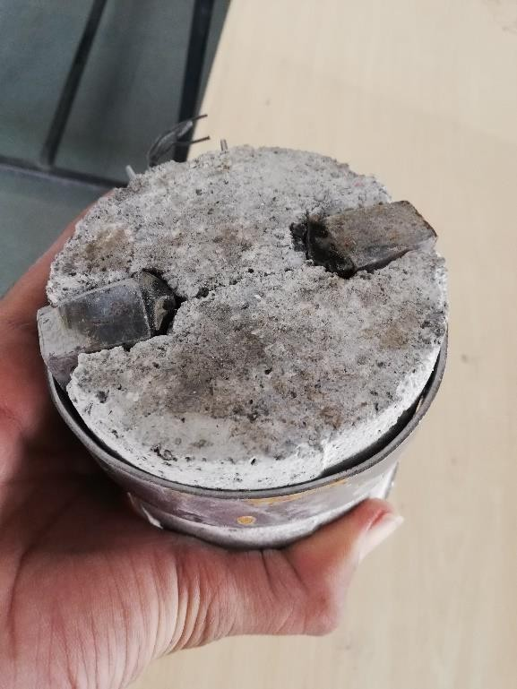

Figure. 5.3 Self-sealed samples

* + - * Water flowing test for NA SAP:

Table 5.1 Water flowing test of 0% SAP

|  |  |  |  |
| --- | --- | --- | --- |
| **NA SAP** | | | |
| **Time (mins)** | **Samples 1 (ml)** | **Samples 2 (ml)** | **Average (ml)** |
| **0** | 0 | 0 | 0 |
| **15** | 140 | 156 | 148 |
| **30** | 115 | 151 | 133 |
| **45** | 102 | 148 | 125 |
| **60** | 140 | 140 | 140 |
| **75** | 143 | 141 | 142 |
| **90** | 138 | 138 | 138 |
| **105** | 141 | 137 | 139 |
| **120** | 144 | 141 | 142.5 |

**NA SAP**

Sample 1 (ml) Sample 2 (ml)

Average (ml)

180

160

140

120

100

80

60

40

20

0

0

15

30

45

60

75

90

105

120

**Time (mins)**

**Flow (ml)**

Figure. 5.4 Graph of water flowing test of 0% SAP concrete

**RESULT ANALYSIS**

The provided table represents the outcomes of a water flow test conducted on concrete without the addition of Super Absorbent Polymers (SAP) (0% SAP). The purpose of this test is to assess the flow or permeability characteristics of the concrete. Here is a summary of the data:

* + - * The test was conducted over a period of 120 minutes, with measurements taken at specific time intervals.
      * At the beginning of the test (0 minutes), both Samples 1 and Samples 2 had a volume of 0 ml, indicating that no water flow was observed at that time.
      * As time progressed, the volume of water flowing through the concrete increased. At 15 minutes, Samples 1 had a flow volume of 140 ml, while Samples 2 had a flow volume of 156 ml.
      * Subsequent measurements taken at 30-minute intervals showed fluctuations in the flow volumes for both sampless. The volumes ranged from 115 ml to 151 ml for Samples 1 and from 137 ml to 156 ml for Samples 2.
      * The average flow volumes at each time interval were calculated by taking the average of the measurements for Samples 1 and Samples 2. The average flow volumes ranged from 125 ml to 142.5 ml over the duration of the test.

This data suggests that without the addition of SAP (0% SAP), the concrete exhibited a varying degree of water flow or permeability over time.

**Water flowing test for 0.1% SAP**

Table 5.2 Water flowing test of 0.1% SAP

|  |  |  |  |
| --- | --- | --- | --- |
| **0.1% SAP** | | | |
| **Time (mins)** | **Samples 1 (ml)** | **Samples 2 (ml)** | **Average (ml)** |
| **0** | 0 | 0 | 0 |
| **15** | 110 | 168 | 139 |
| **30** | 144 | 135 | 139.5 |
| **45** | 142 | 120 | 131 |
| **60** | 141 | 115 | 128 |
| **75** | 135 | 132 | 133.5 |
| **90** | 103 | 122 | 112.5 |
| **105** | 99 | 117 | 108 |
| **120** | 85 | 115 | 100 |

**0.1% SAP**

Sample 1 (ml) Sample 2 (ml)

Average (ml)

180

160

140

120

100

80

60

40

20

0

0

15

30

45

60

75

90

105 120

**Time (mins)**

Figure. 5.5 Graph of water flowing test of 0.1% SAP concrete

**Flow (ml)**

**Result Analysis**

* + - * At the start of the test (0 minutes), both Samples 1 and Samples 2 had a volume of 0 ml, indicating no water flow initially.
      * As the test progressed, the volume of water flowing through the concrete with 0.1% SAP increased. At 15 minutes, Samples 1 had a flow volume of 110 ml, while Samples 2 had a flow volume of 168 ml.
      * Subsequent measurements taken at 30-minute intervals showed some variations in the flow volumes for both sampless. The flow volumes ranged from 85 ml to 144 ml for Samples 1 and from 115 ml to 168 ml for Samples 2.
      * The average flow volumes at each time interval were calculated by taking the average of the measurements for Samples 1 and Samples 2. The average flow volumes ranged from 100 ml to 139.5 ml over the duration of the test. rom the data, the addition of 0.1% SAP to the concrete appears to have influenced the water flow characteristics compared to the previous scenario with 0% SAP.

**Here are some observations**

* + - * + Generally, the average flow volumes for the sampless with 0.1% SAP (ranging from 100 ml to 139.5 ml) are lower compared to the sampless without SAP (ranging from 125 ml to 142.5 ml).
        + The presence of 0.1% SAP seems to contribute to a more consistent and controlled water flow, as indicated by the relatively smaller fluctuations in flow volumes compared to the 0% SAP scenario.
        + As the test progressed, the flow volumes decreased gradually for both Samples 1 and Samples 2, suggesting a potential decrease in the permeability or flow rate of water through the concrete with the addition of SAP.

Water flowing test for 0.2% SAP

|  |  |  |  |
| --- | --- | --- | --- |
| **0.2% SAP** | | | |
| **Time (mins)** | **Samples 1 (ml)** | **Samples 2 (ml)** | **Average (ml)** |
| **0** | 0 | 0 | 0 |
| **15** | 132 | 140 | 136 |
| **30** | 117 | 131 | 124 |
| **45** | 125 | 128 | 126.5 |
| **60** | 115 | 122 | 118.5 |
| **75** | 101 | 115 | 108 |
| **90** | 99 | 102 | 100.5 |
| **105** | 100 | 99 | 99.5 |
| **120** | 104 | 96 | 100 |

**0.2% SAP**

Sample 1 (ml) Sample 2 (ml)

Average (ml)

160

140

120

100

80

60

40

20

0

0

15

30

45

60

75

90

105 120

**Time (mins)**

**Figure. 5.6 Graph of water flowing test of 0.2% SAP concrete**

**Flow (ml)**

1. **CONCLUSION**

* SAP provide a viable alternative for the development of self-sealing concrete, which effectively addresses the problem of permeability in infrastructure.
* Experimental research revealed that SAP-modified concrete exhibited superior sealing Characteristics in comparison to conventional concrete.
* Different proportions of SAP were examined, demonstrating that higher SAP concentrations led to more substantial decreases in water flow rates.
* The integration of SAP successfully decreased the permeability of concrete, hence enhancing its durability and lifespan.
* This study emphasises the viability and efficacy of utilising SAP (Superabsorbent Polymers) for the production of self-sealing concrete, providing a sustainable resolution for construction endeavours.
* The findings have practical consequences for the construction sector, offering valuable insights into novel approaches for improving concrete performance.
* Potential areas for future research involve investigating further characteristics of SAP-modified concrete and fine-tuning the amount of SAP used for certain purposes.
* Overall, this thesis enhances the subject of concrete technology by providing a practical answer for tackling significant obstacles in infrastructure development.
* Implementing SAP in concrete production has the potential to bring significant advantages to infrastructure projects on a global scale.
* In the future, more research and development in this field will improve the effectiveness and practicality of self-sealing concrete technology.

1. **REFERENCES**
2. Chanvillard, S. Rigaud, Complete characterization of tensile properties of Ductal® UHPFRC according to the French recommendations, Proceedings of the 4th International RILEM workshop High Performance Fiber Reinforced Cementitious Composites 2003, pp. 21-34.
3. B.A. Graybeal, Material property characterization of ultra-high performance concrete, 2006.
4. K. Habel, M. Viviani, E. Denarié, E. Brühwiler, Development of the mechanical properties of an ultrahigh performance fiber reinforced concrete (UHPFRC), Cem. Concr. Res., 36 (2006) 1362-1370.
5. M. Behloul, K. Lee, Ductal® Seonyu footbridge, Structural Concrete, 4 (2003) 195-201.
6. E. Brühwiler, E. Denarie, Rehabilitation of concrete structures using ultra-high performance fibre reinforced concrete, UHPC2008: The Second International Symposium on Ultra High Performance Concrete, Citeseer, 2008, pp. 05-07. Citeseer
7. J. Justs, M. Wyrzykowski, F. Winnefeld, D. Bajare, P. Lura, Influence of superabsorbent polymers on hydration of cement pastes with low water-to-binder ratio, Journal of Thermal Analysis and Calorimetry, 115(2014) 425-432.
8. V. Mechtcherine, L. Dudziak, S. Hempel, Internal curing to reduce cracking potential of Ultra High Performance Concrete by means Super Absorbent Polymers, Proceedings of 2nd International RILEM Workshop on Concrete Durability and Service Life Planning (ConcreteLife09), 2009, pp. 31-38.
9. G. Chanvillard, S. Rigaud, Complete characterization of tensile properties of Ductal® UHPFRC according to the French recommendations, Proceedings of the 4th International RILEM workshop High Performance Fiber Reinforced Cementitious Composites 2003, pp. 21-34.
10. IS 516-1959, “Methods of Tests for Strength of Concrete”, Bureau of Indian standard, 2002
11. IS 1199-1959, “Methods of Sampling and Analysis of Concrete”, Bureau of Indian standard, 1959.
12. IS 10262-2009, “Concrete Mix Proportioning-Guidelines”, Bureau of Indian standard, 2009
13. IS 456-2000, “Plain and Reinforced Concrete-Code of Practice”, Bureau of Indian standard, 2000.
14. Estefanía Cuenca, Antonio Tejedor 2018, A methodology to assess crack-sealing effectiveness of crystalline admixtures under repeated cracking-healing cycles, Construction and Building Materials, 179 619–632.