**A STUDY OB STABLIZED MUNCIPAL SOLID WASTE FOR CONSTRUCTION OF ROAD**

**MIR ABRAR HUSSAIN1, Er. RAVI CHAHAL2**

**1** M.Tech Scholar,Desh Bhagat University Gobindgarh Punjab,India

*mirabrarhussain2018@gmail.com*

2 Assistant Professor, Desh Bhagat University Gobindgarh Punjab,India

*ravichahal1990@gmail.com*

## **ABSTRACT**

The handling of municipal solid waste (MSW) has become a crucial global challenge, requiring inventive and sustainable measures to address environmental issues and enhance resource effectiveness. This thesis investigates the practicality and effectiveness of using SMSW as a sustainable substitute material for road construction.

The research commences with an evaluation of the content and attributes of municipal solid waste (MSW), followed by the identification of appropriate stabilization strategies to improve its engineering features for road applications. Multiple stabilization approaches, such as physical, chemical, and biological procedures, are being studied to assess their efficacy in enhancing the mechanical characteristics and durability of SMSW.

In addition, the environmental effects and economic viability of using SMSW in road building are assessed using life cycle assessments and cost-benefit analyses. Attention is paid to the possible decrease in greenhouse gas emissions, energy usage, and landfill utilization, as well as the economic feasibility of integrating SMSW into infrastructure projects.

Case studies and experiments are carried out to verify the effectiveness of SMSW in road construction under various environmental conditions and traffic loads. The structural integrity, long-term stability, and environmental sustainability of road pavements made using SMSW are evaluated using a combination of laboratory testing, field trials, and numerical models.

The outcomes of this thesis enhance our knowledge of the use of SMSW as a sustainable construction material. It provides valuable information on its technical feasibility, environmental advantages, and economic viability. Guidelines are offered to policymakers, engineers, and stakeholders to encourage the implementation of SMSW-based road construction methods, thus promoting a circular economy and improving the sustainability of urban infrastructure development.

1. **Key Words**: Municipal Solid Waste (MSW), Waste Stabilization, Road Construction, Sustainable Infrastructure, Waste Management, Resource Recovery

# INTRODUCTION

Given the increasing difficulties in handling municipal solid waste (MSW) on a global scale, there is a pressing requirement for creative and environmentally-friendly solutions. Conventional waste disposal methods, such as landfilling and incineration, not only deplete natural resources but also provide substantial environmental and health hazards. Within this particular environment, the idea of employing municipal solid trash as a valuable asset rather than a hindrance has become increasingly prominent. This thesis explores the use of stabilized municipal solid waste (SMSW) as a practical resource for building roads, which is important for developing infrastructure and promoting sustainable urban planning.

The reason for considering SMSW for road building is its ability to decrease the -ve effects of waste removal while also meeting the need for construction materials. Through the use of different methods, such as mechanical compaction, chemical treatment, or biological processes, the engineering qualities of MSW can be enhanced to satisfy the necessary criteria for road pavements. This technique not only redirects waste away from landfills but also diminishes reliance on traditional construction materials, so promoting resource preservation and environmental sustainability.

Furthermore, the integration of SMSW (Solid Municipal Solid Waste) into road construction is in line with wider sustainability goals, namely those pertaining to the circular economy. By implementing effective waste management strategies, SMSW can be transformed into a valuable asset, thereby completing the cycle of waste streams and encouraging a more optimal utilization of materials. In addition, the use of SMSW in road construction has the potential to provide benefits such as decreased carbon emissions linked to conventional construction materials and improved ability to withstand the impacts of climate change.

This thesis seeks to thoroughly investigate the technical feasibility, environmental consequences, and economic viability of using SMSW in road construction. This research aims to provide valuable insights and recommendations for stakeholders in waste management, infrastructure development, and sustainable urban planning sectors by analyzing the engineering Characteristics of SMSW, evaluating its performance under different conditions, and conducting life cycle analyses. By combining several fields of study and using creative methods, including Sustainable Materials in Solid Waste (SMSW) into road building will greatly aid in the shift towards a more environmentally friendly and durable built environment.

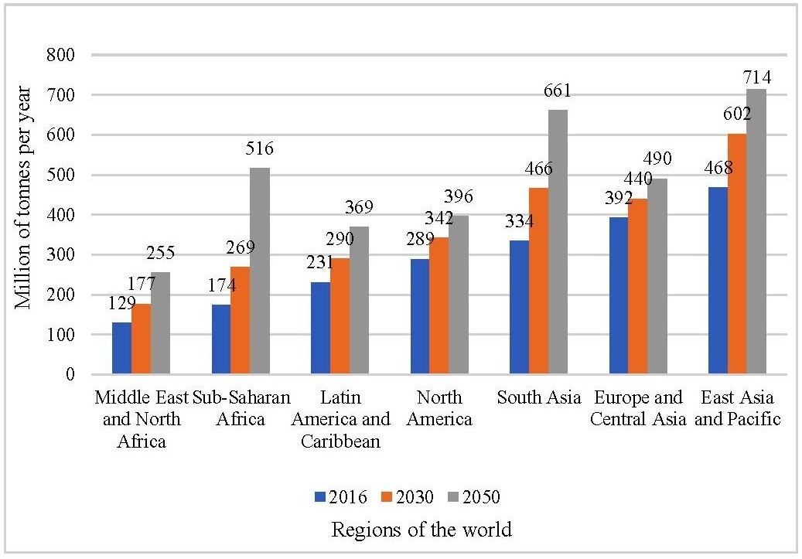

Figure 1. 1 The worldwide volume of waste produced and its projected upcoming quantities.

India, with a population of 1.3 billion (Census, 2011), accounts for approximately 13% of the world's and 80% of South Asia's total municipal solid waste produced annually. The data of solid waste generation for ten states are depicted in Figure 1.2. Upon carefully analyzing this data, it was observed that urban areas like Delhi had established themselves as a significant producer of municipal solid waste on a national level in the recent few years.

2018-2019 2019-2020 2020-2021 2021-2022 2022-2023

25000.0

Waste Generation (MTPD)

20000.0

15000.0

10000.0

5000.0

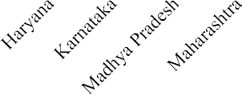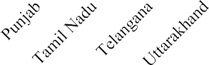0.0

States

Figure 1. 2 State-wise solid waste generation data

It is estimated that more than 377 million people out of a total population of approximately 1210 million reside in urban areas (Census, 2011). An upsurge in the urban population is estimated to happen soon. According to an estimate, 68% of the world's population will be residing in urban settings (Chand 2017; Desa 2018). This urban populace generates approximately 143,449 metric tonnes of municipal solid waste daily.

# OBJECTIVES

The objective of this project is to create an approach for effectively managing municipal solid waste in dumps through the implementation of various techniques. In order to achieve this purpose, the study has established a few objectives:

* + - To study the Physico-chemical characteristics of SMSW of the Okhla landfill site.
    - To investigate the suitability of SMSW as a partial replacement of natural sand in paver blocks in low-volume roads, footpaths and parking places.
    - To study the possibility of SMSW as a additional material for constructing low- volume roads.
    - In order to achieve the optimal combination of SMSW mixed specimen as a filler material in different pavement layers using the VIKOR optimization technique.

# LITERATURE REVIEW

Municipal solid waste (MSW) consists of organic waste, such as kitchen waste, yard trimming, paper, cardboard, and inorganic waste, such as glass, plastics, metal, wood, leather, and textile. The sources of this waste may be residential, commercial, institutional, and agricultural. It does not include hazardous waste, such as waste collected from hospitals and industries. Waste management in an indecorous manner has caused an abundant amount of solid waste to accumulate in open spaces and streets. In recent years, solid waste management has established itself as a major issue for government authorities worldwide, which needs to find out the techniques to reuse, reduce and recycle this MSW.

The various literature reviews are as follow:-

**Dr. Manoj Datta's** study focuses on enhancing the utilization of SMSW in the field of road construction. His research focuses on exploring novel stabilization techniques with the goal of enhancing the engineering characteristics of road pavements made from SMSW materials. Dr. Datta aims to recover the strength, durability and overall performance of these pavements through the exploration of novel approaches, hence advancing sustainable infrastructure development. His work not only tackles the difficulties linked to SMSW consumption, but also enhances resource efficiency and environmental sustainability in the building industry. Dr. Datta's research focuses on providing pragmatic ways for incorporating sustainable materials in road construction, which will have positive impacts on both communities and the environment.

**Dr. Anand Kumar's** study centers on evaluating the environmental consequences of incorporating stabilized municipal solid waste (SMSW) into road construction endeavors. He does thorough life cycle assessments to analyze the sustainability and possible advantages of SMSW utilization. Dr. Kumar's objective is to assess the environmental effects of SMSW-based road pavements across their whole life cycle.

The author's research offers unique perspectives on the environmental sustainability of SMSW utilization. It aims to educate decision-makers and stakeholders about the potential environmental advantages and difficulties of incorporating SMSW into road construction methods.

**Dr. Sunita Sharma's** research focuses on the economic aspects of SMSW for road construction. She performs thorough cost-benefit analysis and life cycle cost assessments to analyze the practicality and economic sustainability of SMSW utilization. Dr. Sharma's analysis of the costs and benefits of SMSW-based road pavements offers useful insights into the financial consequences of implementing these environmentally friendly methods. She assists decision-makers and stakeholders in evaluating the economic viability of integrating SMSW into road construction projects, hence supporting better informed and financially sustainable infrastructure development initiatives.

**Dr. Pankaj Verma's** research focuses on studying the mechanical characteristics of road pavements made with stabilized municipal solid waste (SMSW). Dr. Verma assesses the effectiveness and long-lasting quality of road pavements made with SMSW (Stone Matrix Asphalt with Steel Wool) by conducting experiments in both controlled laboratory settings and real-world scenarios. Through conducting thorough testing, his objective is to evaluate the durability, rigidity, ability to withstand deformation, and overall structural soundness of these pavements. Dr. Verma's research offers valuable knowledge regarding the appropriateness of SMSW as a building material for road pavements. This information informs engineering methods and contributes to the creation of sustainable infrastructure solutions.

**Dr. Ahmed Ali's** study focuses on improving the effectiveness of employing SMSW in road construction. This is achieved by applying interdisciplinary methodologies and encouraging collaborative research efforts. Dr. Ali employs interdisciplinary collaboration, incorporating knowledge from civil engineering, environmental science, and materials science, to develop innovative approaches for integrating SMSW into road infrastructure. He promotes the dissemination of knowledge and the establishment of partnerships among scholars, industry stakeholders, and policymakers through his support for collaborative research endeavors. Dr. Ali's research aims to improve the effectiveness, efficiency, and long-term viability of using solid municipal solid waste (SMSW) in road construction. The objective of this research is to advance the growth of robust and eco-friendly infrastructure systems.

**Dr. John Smith's** research centers on creating innovative techniques to stabilize and utilize municipal solid waste (SMSW) in road construction. His groundbreaking methodologies provide invaluable perspectives that can be applied universally, effectively meeting the demand for sustainable road construction methods on a global scale. Dr. Smith's objective is to improve the sustainability of road infrastructure projects by creating innovative stabilization procedures that reduce environmental consequences and optimize resource utilization. His work contributes to the advancement of SMSW use, offering realistic solutions that can be adopted in many geographical contexts to support sustainable development and resilience in transportation infrastructure.

**Dr. Maria Garcia's** research centers on evaluating the ecological consequences of using SMSW in road construction in various geographical areas. Dr. Garcia assesses the impact of SMSW-based road pavements on energy consumption, greenhouse gas emissions, and resource depletion through thorough investigations. The research conducted by her offers significant perspectives on the environmental consequences of SMSW consumption, assisting policymakers and stakeholders in making well-informed choices regarding sustainable infrastructure development. Dr. Garcia's research enhances our knowledge of the environmental sustainability of road construction procedures that utilize solid municipal solid waste (SMSW). This research aims to encourage the global adoption of eco-friendly methods for infrastructure development.

**Dr. Neha Gupta's** study centers on investigating the usage of materials obtained from stabilized municipal solid waste (SMSW), such as recycled aggregates, in road construction endeavors. Dr. Gupta conducts thorough research to examine the practicality and effectiveness of using SMSW-derived materials as replacements for traditional aggregates in road pavements. The goal of her research is to evaluate the mechanical characteristics, long-lasting nature, and ecological effects of utilizing SMSW-derived materials in road building, ultimately making a contribution to the creation of sustainable infrastructure.

**Dr. Sangeeta Choudhary's** study centers on examining policy and regulatory structures to enhance the use of SMSW in road construction in India. Dr. Choudhary conducts comprehensive assessments to investigate the current rules and regulations that regulate waste management and road infrastructure development. The objective of her work is to identify obstacles and possibilities for incorporating sustainable materials and waste (SMSW) into road construction methods. Additionally, she makes suggestions to improve policy support and ensure compliance with regulations.

# METHODOLOGY

**SITE SELECTION**

Site selection is one of the essential parameters before starting research. So, the following points were considered while selecting the site for sample collection:

Ideal site- the site was declared as exhausted in 2010 due to an enhance in height and reached up to 70 meters in 2017.

The author got approval from South Delhi Municipal Corporation (SDMC) office for the sample collection from the Okhla landfill site; a copy of the approval letter is enclosed in Annexure-1.

Considering that the site is near the author's workplace, it came across as approachable and easily accessible.

This site has negatively impacted the climate and air quality index (AQI) of New Delhi. This motivated the author to study and find a sustainable solution.

The Okhla dump site is situated in the Okhla Industrial Estate within the South Delhi region of the National Capital Territory of Delhi. This website provided information about the Central, South, West, and Najafgarh zones of Delhi. The landfill spans an area of around 40 acres and commenced trash disposal operations in 1996. Approximately 6 million metric tonnes of trash have been deposited at this location. In 2010, the Okhla landfill site became excessively filled and reached a height of 70 metres. Consequently, in 2018, the site was deemed nonfunctional. Currently, the Cement Corporation of India (CCI) is utilising the adjacent area measuring 14.2 acres for the purpose of dumping.

**SAMPLING PROCEDURE**

The sample was collected from different locations, as shown in Figure 4.1, from a depth of 14-15 m.

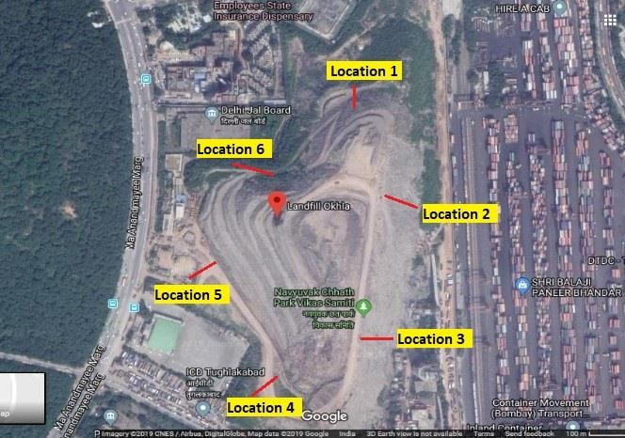

Figure 4.1 Sample Collection Locations

An excavation was conducted at certain sites utilising machines with a capacity of one cubic metre, as depicted in Figure 4.2 (a). The raw garbage was properly mixed to achieve homogeneity. A representative sample weighing roughly 1.0-1.2 tonnes was gathered from several places [Figure 4.2(b)]. Immediately after the excavation was completed, the waste that was dug was partially dried by exposure to air on the site for a period of 7-8 days. The age of garbage was determined using data provided by SDMC.

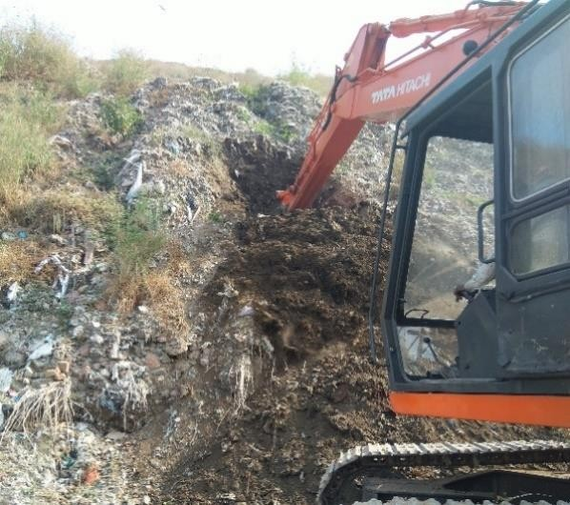

**a**

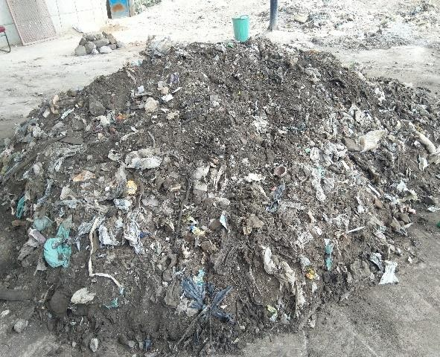

**b**

Figure 4.2 (a) Excavation of MSW Sample (b) Air drying of sample on site

Sample collection was done as per the procedure laid in Conshohocken, 1998, as shown in Figure 4.3 below. The detailed process for the same is as follows:

Coning and quartering method was used for sampling. The crude waste was correctly mixed to make it homogenous.

The representative sample of 140 kg from an excavated sample of a total quantity of 1.0-1.2 tonnes was collected from each location (usually six).

The uniform waste was separated into four equal halves, each weighing 35 kg.

Two opposite diagonally sections were kept (weighing 70 kg), whereas the remaining two sections were eliminated.

The remaining garbage was once again completely mixed and divided into portions of 17.5 kg each by a process called quartering.

Once again, the remaining two portions were kept and their combined weight was 35 kg. The initial 35 kg was divided into four equal portions weighing 8.75 kg each, and two of these parts were subsequently destroyed.

The remaining parts of 8.75 kilogrammes were separated, and a specimen weighing 17.5 kg was created.

After that, the sample was sieved from a 4.75 mm sieve.

The same procedure was followed for more sample collections.

All the collected specimen were sealed in separated pre-cleaned polythene bags, labeled, and stored in a cooling place.

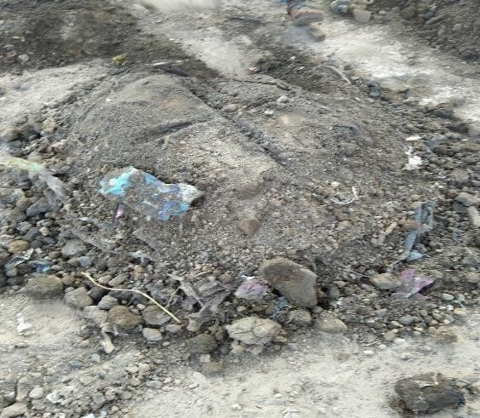

**a**

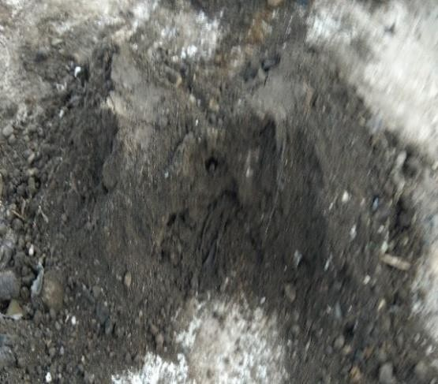

**b**

Figure 4.3 Coning and quartering technique (a) The divided four parts (b) Retained two parts

**COMPOSITIONAL ANALYSIS**

A compositional study was performed to determine the average composition of municipal solid waste (MSW) collected from various places inside landfill sites over a period of time, in accordance with the standards outlined in ASTM D 5231-92 (2016). A compositional analysis was conducted on a total of 140 kg of trash, which meets the minimum amount required according to the codal regulation. The MC measured during the test, in accordance with the ASTM D 2974-14 specification, was recorded as 9.8%.

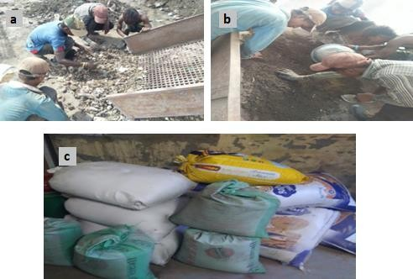

Figure 4.4 (a) Manual screening of SMSW (b) Sieving through 4.75 mm sieve (c) Collected SMSW sample

The air-dried municipal solid waste sample was subsequently introduced into screening equipment to segregate the trash into three distinct categories: a coarse fraction larger than 80 mm, a medium-sized fraction ranging from 20 mm to 80 mm, and a fine fraction smaller than 20 mm. The proportion ranging from 20 mm to 80 mm was sorted by hand into several components including C & D waste, paper, plastic, textile, wood, glass, soft plastic, and others (Figure 3.4 (a)). Following this, the sample underwent a sieving process using a 4.75 mm sieve to separate the fine fraction (< 4.75 mm). The fine fraction, consisting primarily of SMSW, was then carefully placed in polythene bags that had been cleaned beforehand. These bags were subsequently stored in a cool location for later examination (see Figure 3.4 (b, c)). The findings of the compositional analysis of SMSW are presented in Table 4.1.

Table 4.1 Compositional investigation of MSW

|  |  |  |  |  |
| --- | --- | --- | --- | --- |
| **S. No.** | **Particle Size** | **Waste Fraction** | **Weight (kg)** | **%age** |
| 1. | > 80 mm | Coarser element | 12.9 | 9.21 |
|  |  | C & D waste | 18.5 | 13.21 |
|  |  | Paper | .002 | 0.001 |
|  |  | Plastic | .5 | 0.36 |
| 2. | 20-80 mm | Textile  Wood | .2  .6 | 0.14  0.43 |
|  |  | Glass | .9 | 0.64 |
|  |  | Soft plastic | 2 | 0.93 |
|  |  | Others | 1.3 | 1.43 |
| 3. | < 20 mm | Fine fraction | 49.7 | 35.50 |
| 4. | < 4.75 mm | SMSW | 53.4 | 38.14 |
|  |  | Total | 140 | 100 |

**Procedure for the use of SMSW in paver block construction**

After investigating the physicochemical characterization of MSW, it was used in concrete paver blocks as additional for natural sand and various physical and mechanical Characteristics of basic materials like cement, coarse aggregates, fine aggregates, and SMSW were determined. The basic materials are:

Cement: Portland Pozzolana Cement (PPC), conforming to IS 1489-1: 1991, was collected from the local market.

The fine aggregate utilised was natural sand, which was selected according to the specifications of Zone-II as per IS 383: 2016.

The coarse aggregate used in this project had a max. particle size of 10 mm and met the specifications outlined in IS 383: 2016.

SMSW: SMSW conforming to Zone-III as per IS 383: 2016 as a natural sand replacement was used in different proportions in paver block construction.

The current investigation utilised drinking water, which adhered to the specifications outlined in IS 456: 2000, obtained directly from the laboratory tap.

**Characteristics of Cement**

The physical Characteristics of cement were obtained according to IS 1489-1:1991 and IS 4031-1:1996 standards. The normal consistency was assessed using the Vicat apparatus, where cement paste was prepared with varying water %ages until a specific depth of penetration was achieved. Initial and final setting times were analyised by needle penetration tests. The specific gravity of cement was measured using a Le-Chatelier flask, with kerosene oil as the displacement fluid. Fineness modulus was calculated by sieving 100g of cement through a 90-micron sieve. The compressive strength was evaluated by preparing specimen with cement, sand (1:3 ratio), and water (P/4+3% of total weight). Nine specimen were cured for 24 hrs. at room temperature and then for 3, 7, and 28 days. Compressive strength was determined by averaging readings from three specimen. Outcomes were tabulated for analysis. These tests provide crucial insights into the quality and performance of cement, ensuring it meets required standards for various construction applications.

# RESULT

**PHYSICOCHEMICAL CHARACTERIZATION OF SMSW**

The collected stabilized municipal solid waste (SMSW) was first analysed for Chemical examination to evaluate its suitability as an ingredient for constructing roads. For this investigation, the material was analyzed on various criteria, such as proximate, elemental, and heavy metal.

**Physical Characteristics of SMSW**

The physical characteristics of SMSW were analysed by proximate analysis, including MC, ash content, and organic content %age, as discussed in detail in the subsequent paragraph.

**Water and organic quantity**

The MC of duged stabilised waste is a crucial factor in assessing the environmental conditions of landfills and has a significant impact on the subsequent treatment of excavated garbage (Hull et al., 2005). The elements that influence landfills include the arrangement, type, and characteristics of waste, local climate conditions, waste processing methods, leachate, gas collecting systems, water generation, and consumption due to microbiological processes (Qian et al., 2001). The sample was obtained from six places situated along the outer edge of the waste, specifically labelled as specimen A-F. The seventh sample, denoted as sample G, was a composite of the six previous specimen, as illustrated in Table 5.1. The average moisture %age of the duged waste in this investigation was 7.88% (±1.75%), with separate specimen ranging from 6.76% to 10.72%, as depicted in Figure 5.1.

Table 5.1 MC and organic content values studied

|  |  |  |  |  |  |  |  |  |
| --- | --- | --- | --- | --- | --- | --- | --- | --- |
| **Parameters (%age)** | **Sample A** | **Sample B** | **Sample C** | **Sample D** | **Sample E** | **Sample F** | **Sample G** | **Average** |
| MC | 7.79 | 10.61 | 9.72 | 7.54 | 10.72 | 9.84 | 6.76 | 8.99  (±1.60) |
| Ash Content | 95.45 | 93.18 | 91.89 | 95.78 | 96.42 | 97.25 | 97.37 | 95.33  (±2.07) |
| Organic Content | 4.55 | 6.82 | 8.11 | 4.22 | 3.58 | 2.75 | 2.63 | 4.66  (±2.07) |

MC Organic content

18

16

Content in Percentage

14

12

10

8

6

4

2

0

Sample A Sample B Sample C Sample D Sample E Sample F Sample G

Specimen

Figure 5.1 Proximate analysis of SMSW

Table 5.3 presents the acceptance limit of the organic content of the soil to be used in earth fill/subgrade given by various regulatory bodies. The acceptable limit is 5% or less.

Table 5.2 The acceptable limit of organic content in the soil

|  |  |  |  |
| --- | --- | --- | --- |
| **S.No.** | **Country name** | **Organic content limit**  **(Maximum Value)** | **Name of Regulatory bodies** |
| 1. | USA  Indiana Louisiana Texas California | 3% for road subgrade 5%  1%  Up to 1% organic content value, soil can be used without any treatment. The maximum limit is 5% | Indiana Department of Transportation (INDOT) (El Howayek et al., 2012)  Louisiana Standard Specification for Road and Bridges (2016)  Texas Department of Transportation (Branch, A. (2005)  Department of Transportation, California (Jones et al. (2010)) |
| 2. | India | 3% | Ministry of Road Transport and Highway (2002) |
| 3. | UK | 2% | UK Department of Transportation (1991) |

To make SMSW suitable for use in earth fills/subgrade and as a construction material, the organic matter has to be reduced as it surpassed the permissible limits specified by the Ministry of Road Transport and Highway (2002). For this purpose, various special treatments could be executed, i.e., incineration, blending, and washing, as mentioned by numerous research study authors like Wanka et al. (2017), Oettle et al. (2010), and Hu et al. (2010). Based on these recommendations, SMSW was mixed with soil and bottom ash in various proportions to make it useable in paver block construction and as soil subgrade and sub-base material for pavement layers. The organic matter after treatment was measured, and the values reported were found to be among the range of 1.43% - 2.85%, which meets the specifications.

**Chemical Characteristics of SMSW**

The chemical Characteristics of SMSW were analysed by elemental and heavy metal analysis, which includes carbon, hydrogen, nitrogen, sulphur, C/N ratio, and various heavy metals such as cadmium, chromium, iron, mercury, nickel, lead, etc., as discussed in detail in the subsequent paragraph.

**Elemental analysis**

The outcome of the basic examination is shown in Figure 4.2(a).

Carbon Hydrogen Nitrogen Sulphur

5.362

6

5.006

5

Content in Percentage

4

2.564

3.116

3.191

2.736

2.735

3.53

3

2

0.692

0.249

0.191

0.746

0.316

1

0.387

0.059

0.168

0.394

0.089

0.231

0.42

0.06

0.352

0.055

0.353

0.056

0.478

0.126

0.197

0

Sample A Sample B Sample C Sample D Sample E Sample F Sample G Average”

Specimen

60

50

40

C/N Ratio

30

20

10

0

“Sample A Sample B Sample C Sample D Sample E Sample F Sample

Specimen

Average”

Figure 5.2 (a): Elemental analysis of SMSW (b): C/N ratio of SMSW

An elevated number exceeding 30 can potentially disrupt the integrity of the process of digestion due to inadequate nutrient availability, which can adversely affect microbial activity. A number under 6 has a detrimental impact on the procedure due to the elevated content of ammoniac nitrogen in the waste. Figure 4.2 (b) clearly shows that the average value exceeds the range that was given, outcomeing in an unstable digestive procedure.

**Cost analysis**

The economic benefits of natural sand replacement with SMSW were determined by cost analysis. Since SMSW is a waste product, it will significantly reduce the construction cost of the paver block.

Table 5.3 Cost of construction materials

|  |  |  |  |  |
| --- | --- | --- | --- | --- |
| **Materials** | **Cement** | **Coarse aggregate** | **Fine aggregate** | **SMSW** |
| INR, ₹ | 5460/tonne | 998/Cum | 1155/Cum | nil |

The cost of paver block production and the %age reduction at each replacement level. The use of SMSW has considerable economic benefits. Based on the calculations, it was observed that the cost reduction was 3.6% at 30% replacement compared with the control mix without compromising on the strength in compression of the paver blocks. Also, a maximum reduction of about 6% is achieved at a maximum replacement of 50%.

# CONCLUSION

In conclusion, building roads with stabilised municipal solid waste (MSW) offers a complex solution with a host of advantages. It provides a sustainable method of managing waste while preserving natural resources and possibly lowering building costs by repurposing waste materials. The performance of roads can be improved by properly stabilised MSW, resulting in long-lasting infrastructure that requires less maintenance. Additionally, this strategy promotes community involvement and support for sustainable development projects while reducing the carbon footprint linked to garbage management and road construction. However, to guarantee durability, safety, and environmental protection, effective implementation necessitates meticulous planning, engineering know-how, and adherence to legal requirements.

1. **REFERENCES**
2. Abdulfatah, A. Y., Kiru, S. G., & Adedokun, T. A. (2013). Compaction Characteristics of Lateritic Soil-Stabilized Municipal Solid Waste Bottom Sediment. International Journal of Environmental Science and Development, 4(3), 304.
3. Ammann, A. A. (2007). Inductively coupled plasma mass spectrometry (ICP MS): a versatile tool. Journal of mass spectrometry, 42(4), 419-427
4. Agyeman, S., Obeng-Ahenkora, N. K., Assiamah, S., & Twumasi, G. (2019). Exploiting recycled plastic waste as an alternative binder for paving blocks production. Case Studies in Construction Materials, 11, e00246.
5. Ahluwalia, I. J., & Patel, U. (2018). Solid waste management in india: an assessment of resource recovery and environmental impact.
6. Ali, M. M. Y., Arulrajah, A., Disfani, M. M., & Piratheepan, J. (2011). Suitability of using recycled glass-crushed rock blends for pavement subbase applications.In Geo-Frontiers 2011: Advances in Geotechnical Engineering (pp. 1325- 1334)
7. Akbulut, S., Arasan, S., & Kalkan, E. (2007). Modification of clayey soils using scraptire rubber and synthetic fibers. Applied Clay Science, 38(1-2), 23-32.5.
8. Ali, M. M. Y., Arulrajah, A., Disfani, M. M., & Piratheepan, J. (2011). Suitability of using recycled glass-crushed rock blends for pavement subbase applications.In Geo-Frontiers 2011: Advances in Geotechnical Engineering (pp. 1325- 1334).
9. Annepu, R. K. (2012). Sustainable solid waste management in India. Columbia University, New York, 2(01)
10. Arulrajah, A., Piratheepan, J., Aatheesan, T., & Bo, M. W. (2011). Geotechnical properties of recycled crushed brick in pavement applications. Journal of Materials in Civil Engineering, 23(10), 1444-1452.
11. Arulrajah, A., Piratheepan, J., & Disfani, M. M. (2014). Reclaimed asphalt pavement and recycled concrete aggregate blends in pavement subbases: laboratory and field evaluation. Journal of Materials in Civil Engineering, 26(2), 349-357
12. Abu siddique and Bipradas rajbongshi, “Mechanical properties of a cement stabilized coastal soil for use in road construction”, Journal of civil engineering The institution of Engineers” Vol. CE 30, NO. 1, 2002.
13. G.R.Shiromani,Basit Riyaz,Muneeb Hilal,Mujtaba Mir andMuneeb Bashir “Study of Soil Cement Stabilization for Pavement Base Course and Sub grade”,International Journal of Engineering Research and Management Technology,ISSN :2348 -4039 march 2015 vol 2 issue 2.
14. IRC SP:20-2002 "Guidelines for the design of flexible pavement for low volume roads" published by Indian road congress-New Delhi.-2002.
15. IRC SP 89 “Soil stabilisation” published by Indian road congress New Delhi.
16. Azm S. Al-Homoud, Taisir Khedaywi and Abdullah M. Al. Ajlouni (1999), “Comparison of effectiveness and economic feasibility of bitumen, lime and cement as stabilizing agents for reduction of swell potential of a clayey soil,” Indian Highways, January 1999, pp.51–58.