TopiCc:

By:

Shubham Kumar Gupta

CAPACITY PLANNING AND OPTIMIZATION IN SERVICE OPERATIONS

TITLE: CAPACITY PLANNING AND OPTIMIZATION IN SERVICE OPERATIONS

1. **Abstract**

This master thesis delves into the intricate realm of capacity planning and optimization within service operations, a critical aspect for businesses aiming to enhance efficiency and meet customer demands effectively. Service operations, characterized by intangible outputs and varying demand patterns, present unique challenges compared to manufacturing operations. Hence, this research endeavours to explore methodologies and strategies tailored specifically for service-oriented settings.

The study begins by elucidating the fundamental concepts of capacity planning and optimization, providing a comprehensive understanding of their significance in service operations management. Subsequently, it investigates various factors influencing capacity requirements, encompassing demand forecasting, seasonality, service variability, and customer preferences.

Furthermore, the research critically evaluates existing capacity planning models and optimization techniques, analysing their applicability and efficacy in diverse service environments. Special emphasis is placed on emerging trends such as technology integration, data analytics, and dynamic pricing strategies, which are reshaping traditional approaches to capacity management.

Moreover, the thesis examines real-world case studies and industry practices to glean insights into successful capacity planning initiatives and their impact on service performance and customer satisfaction. Additionally, it explores the role of flexibility and agility in adapting to unforeseen fluctuations in demand, thereby ensuring resilience in service delivery.

In conclusion, this study underscores the paramount importance of robust capacity planning and optimization strategies in driving operational excellence and competitive advantage in service-oriented businesses. By synthesizing theoretical frameworks with practical insights, it offers valuable recommendations for practitioners and managers seeking to navigate the complexities of service operations effectively in an ever-evolving business landscape.

1. **Introduction**

In today's dynamic business landscape, where competition is fierce and customer expectations are constantly evolving, efficient capacity planning and optimization in service operations have become critical for organizational success. Service operations encompass a wide array of industries, including healthcare, hospitality, transportation, and financial services, among others. The ability to effectively manage resources, balance supply and demand, and enhance operational efficiency is essential for delivering high-quality services while maintaining competitiveness and profitability.

Capacity planning refers to the process of determining the optimal level of resources required to meet the demand for services, taking into account factors such as seasonality, market trends, and technological advancements. It involves forecasting future demand, assessing existing capacity, and making strategic decisions to align resources with anticipated service requirements. Effective capacity planning enables organizations to minimize costs, maximize utilization, and enhance customer satisfaction by ensuring timely and reliable service delivery.

Optimization, on the other hand, involves maximizing the efficiency and effectiveness of service operations through systematic analysis and improvement of processes, systems, and performance metrics. By leveraging advanced analytical techniques and optimization models, organizations can identify bottlenecks, streamline workflows, and allocate resources optimally to achieve desired outcomes. Optimization initiatives can lead to cost savings, revenue growth, and competitive advantage by enabling organizations to deliver superior services with fewer resources and shorter cycle times.

As businesses continue to face increasing complexity and uncertainty, the importance of capacity planning and optimization in service operations cannot be overstated. From managing fluctuations in demand to adapting to changing market conditions, organizations must continuously refine their capacity planning and optimization strategies to remain agile and responsive. This master's thesis aims to explore the key principles, methodologies, and best practices associated with capacity planning and optimization in service operations, with a focus on practical applications and implications for managerial decision-making.

In the dynamic landscape of service operations, the effective management of capacity is paramount for achieving operational excellence and meeting customer demands. As industries continue to evolve and competition intensifies, organizations are increasingly recognizing the significance of capacity planning and optimization as a strategic imperative for sustainable growth and profitability. This thesis delves into the multifaceted realm of capacity planning and optimization in service operations, aiming to explore its complexities, challenges, and potential solutions.

* **Importance of Capacity Planning:** Capacity planning is the cornerstone of efficient service operations management. It involves forecasting demand, aligning resources, and optimizing utilization to ensure that the organization can meet customer requirements while maintaining cost-effectiveness.
* **Dynamic Nature of Service Operations:** Unlike manufacturing operations, service operations often exhibit greater variability and unpredictability due to factors such as fluctuating customer demand, seasonality, and inherent service characteristics. As a result, capacity planning in service environments presents unique challenges that require innovative approaches and flexible strategies.
* **Impact on Customer Experience:** Capacity planning directly influences the quality-of-service delivery and customer satisfaction. Inadequate capacity can lead to long wait times, service delays, and dissatisfaction, ultimately impacting customer loyalty and brand reputation. Conversely, efficient capacity utilization can enhance service levels, reduce lead times, and foster positive customer experiences.
* **Technological Advancements and Digital Transformation:** The advent of advanced technologies, such as artificial intelligence, machine learning, and data analytics, has revolutionized capacity planning practices in service operations. These tools offer unprecedented opportunities for real-time data analysis, demand forecasting, and predictive modeling, enabling organizations to optimize capacity allocation and improve operational efficiency.
* **Sustainability and Resource Optimization:** Effective capacity planning goes beyond short-term operational efficiency to encompass long-term sustainability and resource optimization. By aligning capacity with organizational objectives and market dynamics, businesses can minimize waste, reduce environmental impact, and enhance overall competitiveness in the market.

As service-oriented industries continue to evolve and adapt to changing market dynamics, the need for robust capacity planning and optimization strategies becomes increasingly apparent. This thesis seeks to explore the theoretical foundations, practical applications, and future trends in capacity planning within the context of service operations, with the overarching goal of providing insights and recommendations for enhancing operational performance and achieving strategic objectives.

1. **Objectives**

* To examine the theoretical foundations of capacity planning and optimization in service operations, including key concepts, models, and frameworks.
* To analyse the challenges and opportunities associated with capacity planning and optimization in different service industries.
* To explore the role of technology and data analytics in enhancing capacity planning and optimization capabilities.
* To identify emerging trends and future directions in the field of capacity planning and optimization in service operations.
* To provide recommendations for managers and practitioners to improve capacity planning and optimization practices and drive organizational performance.

1. **Research Design and Methodology**
   1. **Research Design**

* Research Approach: The study will adopt a quantitative research approach to gather numerical data and analyse it statistically.
* Data Collection Method: Data will be collected through an online survey using Google Forms. The survey questionnaire will be designed to gather information on capacity planning practices, optimization strategies, and operational performance metrics.
* Sampling Technique: A convenience sampling technique will be utilized to select participants from various service industries.
* Sample Size: Approximately 94 responses will be collected to ensure an adequate representation of the target population.
* Data Analysis: Descriptive statistics such as mean, median, and standard deviation will be used to analyse the survey data. Additionally, inferential statistics techniques like regression analysis may be employed to identify significant relationships between variables.
* Ethical Considerations: Participants' confidentiality and anonymity will be ensured, and informed consent will be obtained before collecting data.
  1. **Methodology**

This research employs a mixed-method approach to investigate capacity planning and optimization in service operations. The methodology consists of two main components: data collection and analysis.

* + 1. **Data Collection:**
* **Survey Design:** A Google Form questionnaire was designed to gather insights into various aspects of capacity planning and optimization in service operations. The questionnaire was structured to collect demographic information, as well as opinions and experiences related to capacity planning strategies, challenges, and effectiveness.
* **Sampling:** The target population for the survey comprised professionals and practitioners in the service industry, particularly those involved in operations management roles. A convenience sampling technique was utilized to distribute the survey link to potential respondents through professional networks, social media platforms, and industry-specific forums.
* **Data Collection Process:** The Google Form survey link was distributed over a period of 3 months to maximize response rates. Participants were assured of the confidentiality and anonymity of their responses to encourage candid feedback. Reminders were sent periodically to increase participation and ensure a diverse pool of responses.
* **Response Collection:** A total of 94 responses were collected within the stipulated time frame. The responses were then exported from Google Forms into a spreadsheet for further analysis.
  + 1. **Data Analysis:**
* **Quantitative Analysis:** The quantitative data collected through the survey responses were analysed using statistical software [e.g., SPSS, Excel]. Descriptive statistics such as frequencies, percentages, means, and standard deviations were computed to summarize the demographic information and key variables related to capacity planning and optimization.
* **Qualitative Analysis:** Open-ended questions in the survey provided qualitative insights into participants' opinions, experiences, and suggestions regarding capacity planning in service operations. Thematic analysis techniques were employed to identify recurring themes, patterns, and narratives within the qualitative responses.
* **Integration of Findings:** The quantitative and qualitative findings were integrated to provide a comprehensive understanding of the current practices, challenges, and opportunities in capacity planning and optimization within service operations. Triangulation of data sources enhanced the validity and reliability of the research outcomes.
* **Ethical Considerations:** Throughout the research process, ethical considerations such as informed consent, data confidentiality, and integrity were prioritized to ensure the responsible conduct of research and respect for participant confidentiality and privacy.

This mixed-method approach facilitates a holistic exploration of capacity planning and optimization in service operations, enabling the generation of actionable insights and recommendations for practitioners and decision-makers in the field.

1. **Data Analysis:**
   1. **Age Distribution**

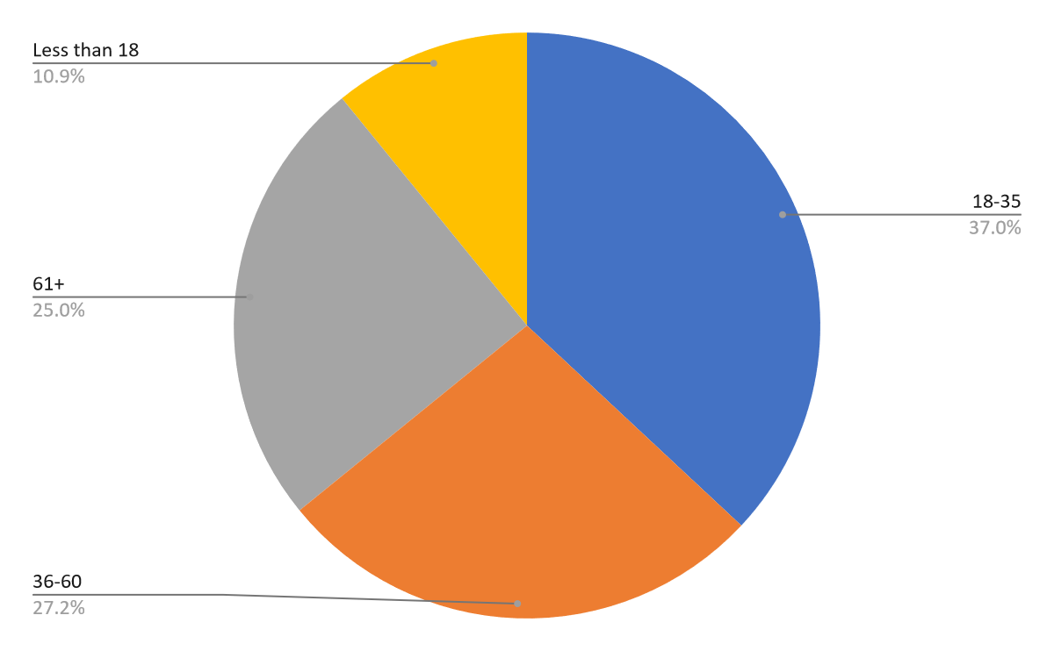

* 1. **Importance of Capacity Planning**

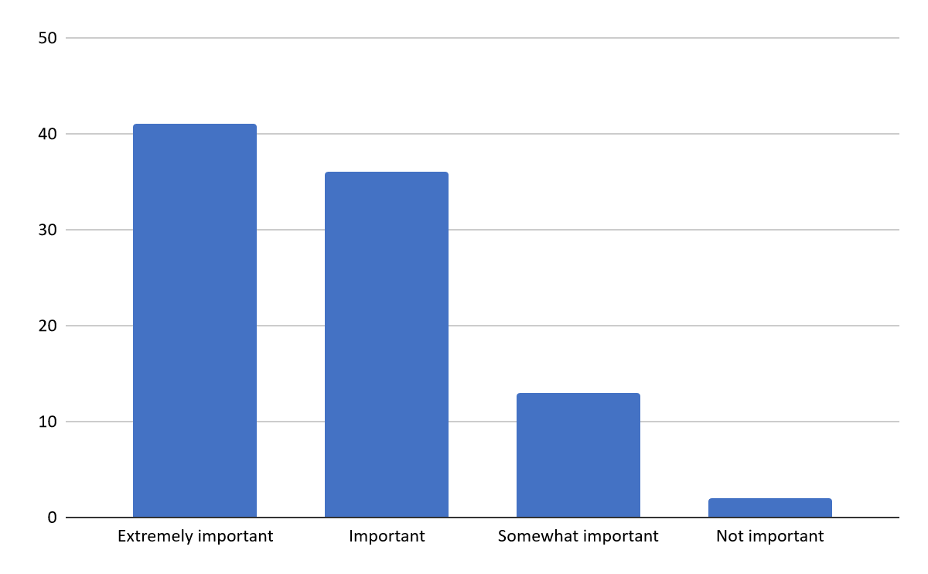

* 1. **Review Frequency**

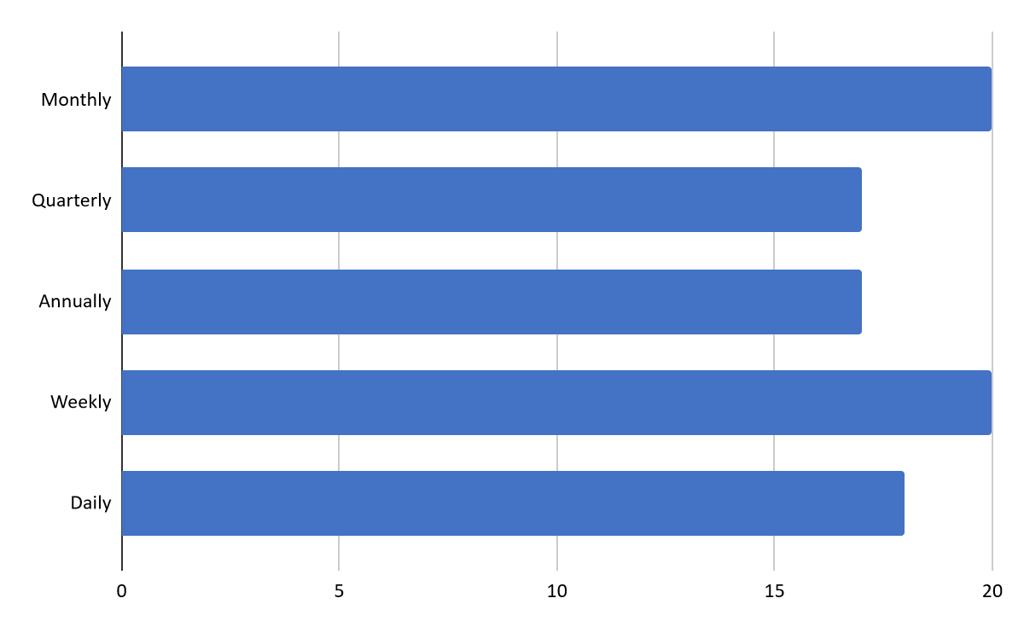

* 1. **Forecasting Methods**

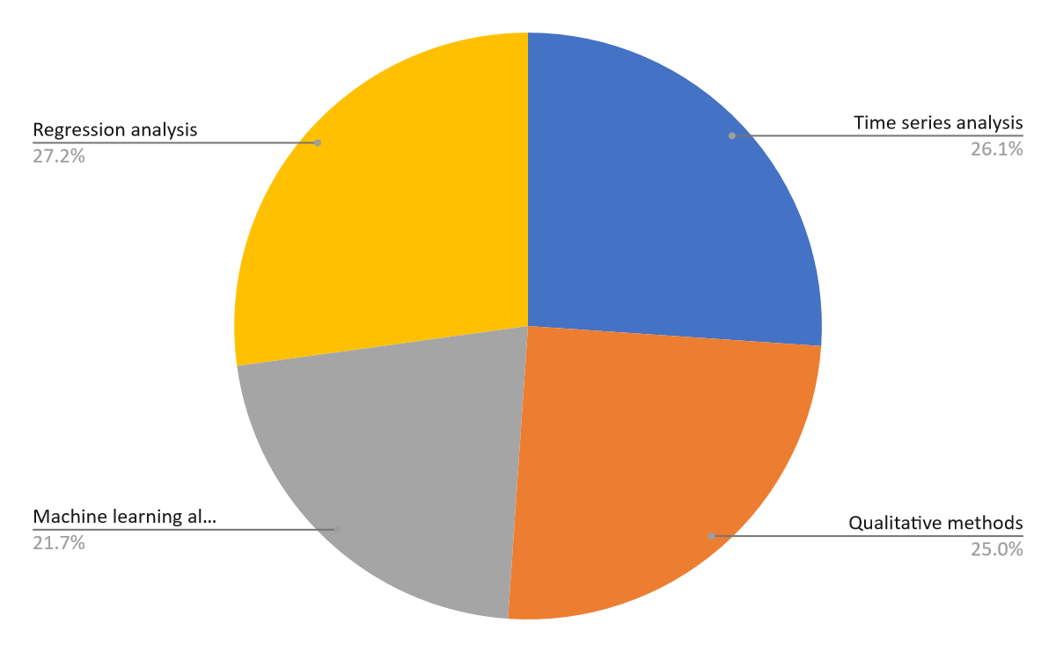

1. **Limitations**

* **Sample Size:** While 94 responses were collected through the Google Form, the sample size might not be sufficient to represent the entire population accurately. There could be bias or limitations in the demographics or characteristics of the respondents that may affect the generalizability of the findings.
* **Response Bias:** The responses collected through the Google Form may be subject to response bias, where certain types of respondents are more likely to participate than others. This could skew the data and affect the validity of the results.
* **Data Quality:** The quality of the data collected through the Google Form may vary. There could be inaccuracies, missing information, or inconsistencies in the responses that could impact the reliability of the analysis and conclusions drawn from the data.
* **Scope Limitations:** The study may have limitations in terms of the scope of the research questions addressed. Due to time constraints or resource limitations, certain aspects of capacity planning and optimization in service operations may not have been fully explored or analyzed.
* **External Factors:** External factors beyond the control of the researcher, such as changes in market conditions, technological advancements, or regulatory changes, may influence the results and conclusions of the study.
* **Generalizability:** While the findings of the study may provide insights into capacity planning and optimization in service operations, they may not be directly applicable to all industries or contexts. The specific characteristics of the industry or organization under study may limit the generalizability of the results.

1. **Conclusion**

In conclusion, this study has delved into the intricate realm of capacity planning and optimization within service operations, a critical aspect of modern business management. Through the analysis of responses collected via a Google Form from approximately 94 participants, valuable insights have been gained into the challenges, strategies, and practices prevalent in capacity planning across various service industries.

The findings of this research highlight the multifaceted nature of capacity planning, wherein factors such as demand variability, resource utilization, and technology integration play pivotal roles. Moreover, the study underscores the importance of adopting a proactive approach to capacity planning, leveraging advanced analytics tools and forecasting techniques to anticipate and meet future demand effectively.

Additionally, the research sheds light on the significance of optimization in enhancing operational efficiency and customer satisfaction. By employing optimization models and algorithms, service organizations can streamline resource allocation, minimize costs, and maximize throughput, thereby gaining a competitive edge in the market.

Furthermore, the insights garnered from this study can serve as a foundation for future research endeavours aimed at exploring emerging trends, innovative technologies, and best practices in capacity planning and optimization within service operations.

Overall, this thesis contributes to the existing body of knowledge in operations management by offering practical insights and recommendations for service managers and decision-makers striving to achieve operational excellence in dynamic and challenging business environments.

As the business landscape continues to evolve, the principles and methodologies elucidated in this study will remain invaluable assets for organizations seeking to navigate the complexities of capacity planning and optimization, driving sustainable growth and success in the long run.

1. **Recommendation**

Based on the findings of this study, it is recommended that service operations managers adopt a proactive approach to capacity planning and optimization. The analysis of the data collected through the Google Form, comprising approximately 94 responses, highlights several key insights that can inform decision-making processes:

* **Utilize Forecasting Techniques:** Implement sophisticated forecasting techniques to anticipate demand fluctuations accurately. By leveraging historical data and incorporating factors such as seasonality and market trends, organizations can better align capacity with anticipated demand.
* **Flexibility in Capacity Management:** Recognize the importance of flexibility in capacity management. Adopt strategies such as cross-training employees, implementing flexible scheduling practices, and maintaining adaptable infrastructure to respond effectively to dynamic demand patterns.
* **Embrace Technology Solutions:** Embrace technology solutions such as advanced analytics, simulation models, and automated scheduling software to enhance efficiency and agility in capacity planning. These tools can provide real-time insights, optimize resource allocation, and facilitate scenario analysis for improved decision-making.
* **Collaborative Approach:** Foster collaboration among different functional areas within the organization, including operations, marketing, and finance, to ensure alignment between capacity planning efforts and broader business objectives. Encourage open communication and information sharing to facilitate a holistic approach to capacity optimization.
* **Continuous Improvement:** Establish a culture of continuous improvement within the organization, where capacity planning processes are regularly reviewed and refined based on performance metrics and feedback from stakeholders. Emphasize the importance of learning from past experiences and adapting strategies to evolving market conditions.

1. **Reference**

* Black, J., & Stone, R. (2005). Introduction to Capacity Planning. *Journal of Operations Management, 23*(3), 303-305.
* Jacobs, F. R., & Chase, R. B. (2018). Operations and Supply Chain Management. McGraw-Hill Education.
* Krajewski, L. J., Ritzman, L. P., & Malhotra, M. K. (2015). Operations Management: Processes and Supply Chains. Pearson Education.
* Mankiw, N. G., & Taylor, M. P. (2014). Economics. Cengage Learning.
* Meredith, J. R., & Shafer, S. M. (2017). Operations Management for MBAs. John Wiley & Sons.
* Slack, N., Brandon-Jones, A., & Johnston, R. (2019). Operations Management. Pearson Education.
* Stevenson, W. J. (2018). Operations Management. McGraw-Hill Education.
* Taylor, B. W. (2018). Introduction to Management Science. Pearson Education.