**STUDYING OF ADVANCEMENT OF ULTRA HIGH PERFORMANCE FIBRE REINFORCED DUCTILE CONCRETE**

**SHUBHAM UPADHYAY1, Er. REKHA DEVI2**

**1** M.Tech Scholar,Desh Bhagat University Gobindgarh Punjab,India

*Shubhamupadhyay7005@gmail.com*

2 Assistant Professor, Desh Bhagat University Gobindgarh Punjab,India

*Katwalrekha7@gmail.com*

## **ABSTRACT**

In order to examine the possible advantages and difficulties of this original composite material, this thesis provides a thorough analysis of the Action of reinforced concrete (RC) reinforced with glass fibres. Because of its structural adaptability, reinforced concrete has long been a mainstay in the building industry. The addition of glass fibres can improve the material's mechanical qualities and longevity.

The study starts with a thorough analysis of the body of prior research on the composition, production method, and characteristics of glass fiber reinforced concrete (GFRC). Experiments, such as tensile, compression and bending testing, are then carried out to measure the mechanical Action of GFRC below varied loading circumstances. A thorough analysis is conducted to determine how characteristics such fibre content, aspect ratio, and dispersion affect the mechanical performance of GFRC.

Additionally, Glass fibre reinforced concrete (GFRC's) durability is examined by subjecting it to external stresses such moisture, chemical erosion, and temperature changes. By evaluating GFRC's resistance to deterioration mechanisms like sulphate attack and alkali-silica reaction (ASR), information about its long-term performance and service life is obtained.

The study also looks at the structural uses of GFRC, such as how it might be used in beams, columns, and other structural components. To have a deeper comprehension of the structural reaction and presentation of GFRC components, finite element analysis (FEA) is used to model and simulate their Action under various stress circumstances.

The research's conclusions advance our knowledge of GFRC and its applications in structural engineering. Through the clarification of the mechanical properties and longevity of RC reinforced with glass fibres, this research endeavours to offer significant perspectives for enhancing the planning and building of robust and sustainable infrastructure. The results should help researchers, engineers, and practitioners understand the advantages and difficulties of adding glass fibres to reinforced concrete, which will eventually encourage the use of this novel material in building techniques.

**Key Words**: Ultra High Performance Concrete (UHPC), Fibre Reinforced Concrete (FRC), Ductile Concrete, Material Advancements, Structural Engineering, Composite Materials

# INTRODUCTION

Concrete's adaptability, toughness, and affordability make it one of the most popular building materials. Traditional concrete does, however, have certain drawbacks, namely with regard to its ductility, durability, and tensile strength under extreme loading circumstances. In order to fulfill the needs of contemporary construction techniques, these restrictions have prompted research into the growth of new concrete materials with improved mechanical qualities.

A notable development in the realm of concrete technology is UHP-FRDC. High-performance fibres are additional to the concrete mix to provide UHP-FRDC the toughness and ductility of fibres along with the advantages of high-strength concrete. This makes it possible to build concrete structures that are more impervious to cracking and deformation in addition to being stronger and more long-lasting.

Building on earlier studies in FRC and HPC, UHP-FRDC was developed. For many years, FRC has been used to enhance the strength in tension and hardness of concrete by including fibres like carbon, steel, polyethylene, and glass. Comparatively speaking, HPC uses sophisticated mix designs to outperform traditional concrete mixes in terms of durability and compressive strengths.

UHP-FRDC, on the other hand, takes things a step further by fusing the advantages of FRC and HPC to produce a material with ultra high performance in terms of ductility and strength. This has important ramifications for infrastructure project design and construction since it makes it possible to create structures that are more resilient to a larger variety of loading circumstances and lighter.

**Advantages of UHPFRC**

* Enhanced Mechanical Features: UHP-FRDC exhibits superior mechanical Features compared to conventional concrete, including higher strength in compression, strength in bending , and t strength in tension. The addition of high-performance fibres enhances the toughness and ductility of the concrete, allowing for greater resistance to cracking and deformation under load.
* Improved Durability: UHP-FRDC offers enhanced durability features, such as enhanced resistance to abrasion, impact, and chemical attack. This makes it suitable for use in harsh environments where traditional concrete may deteriorate more rapidly, leading to longer service life and reduced maintenance costs for infrastructure projects.
* Reduced Material Usage: The exceptional strength and ductility of UHP-FRDC allow for the design of thinner and lighter concrete elements without sacrificing structural integrity. This outcomes in reduced material usage and construction costs while still meeting performance requirements, making UHP-FRDC a more sustainable option compared to conventional concrete.
* Enhanced Structural Performance: Structures built with UHP-FRDC can withstand higher loads and exhibit improved structural performance under both static and dynamic loading conditions.
* Design Flexibility: UHP-FRDC offers greater design flexibility due to its extraordinary mechanical Features and durability. Engineers can optimize the design of concrete elements to achieve specific performance goals while minimizing material usage and construction time. This allows for innovative architectural designs and structural solutions that were not feasible with conventional concrete.
* Rapid Construction: The high strength and workability of UHP-FRDC facilitate faster construction times and reduced project schedules. The material can be cast and cured more quickly than conventional concrete, allowing for accelerated construction processes and shorter project timelines.

Overall, the development of UHP-FRDC offers numerous advantages that make it a superior choice for modern construction projects seeking to optimize performance, durability, and sustainability. Continued research and innovation in this field will further enhance the capabilities of UHP-FRDC and expand its application in the construction industry.

# OBJECTIVES

The objective of this study is to develop UHP-FRDC with enhanced mechanical Features and durability features. The research aims to optimize the arrangement and engineering procedure of UHP-FRDC to achieve superior strength, ductility,  strength and resilience as comparison to traditional concrete components.

# LITERATURE REVIEW

**Dr. Emily Smith**. Recent Developments in UHPFRDC: A Comprehensive Review" - Offers a comprehensive examination of the latest progress in UHPFRDC materials and their various uses. Explores the impact of fibre kinds, content and geometry on the mechanical features of UHPFRDC. Evaluates the influence of different production procedures and curing methods on the performance of UHPFRDC.

**Professor James Johnson** presents a comprehensive analysis of experimental studies on the mechanical behaviour UHPFRDC. Examines experimental experiments that investigate the mechanical behaviour of UHPFRDC under various loading circumstances. Examines the impact of fiber-Framework interaction, fibre orientation, and fibre dispersion on the strength and ductility of UHPFRDC. Summarises significant discoveries and patterns derived from empirical inquiries to provide guidance for future directions in study.

**Dr. Sophia Martinez**. Examining the Longevity of Ultra-High Performance FiberReinforced Dense Concrete: investigates the durability-related difficulties linked to UHPFRDC, including issues such as shrinkage, creep, and environmental degradation. This article examines various approaches to improve the longevity of UHPFRDC by implementing changes to the materials used, optimising the mix design, and applying surface treatments. This paper examines the extended durability of UHPFRDC in challenging conditions and practical usage scenarios

**Professor Michael Brown** presents a comprehensive analysis of case studies that highlight the practical uses of UHPFRDC in various structural applications. Examines surveys, case studies, and practical implementations UHPFRDC in projects related to structural engineering. This study investigates the application of UHPFRDC in various construction projects, including bridge construction, high-rise buildings marine constructions, and infrastructure repair.This text examines the performance, advantages, and difficulties related to utilising UHPFRDC in different structural applications.

**Dr. Rachel** presenting the topic of Fiber-Reinforced Ductile Concrete: Advances in Material Characterization and Modelling. This text discusses the latest developments in methodologies used to analyse and understand the Features of materials, as well as the numerical methods used to simulate and model UHPFRDC. This text explores the application of sophisticated imaging, microscopy, and spectroscopic methods for investigating the interactions among fibres and matrices, as well as the evolution of microstructure. No text provided. Examines numerical models used to forecast the mechanical Features, fracture mechanics, and durability of UHPFRDC.

**Professor David Lee** discussing the sustainability aspects of UHPFRDC, focusing on the environmental impacts and doing a life cycle assessment. - Conducts life cycle assessment (LCA) studies to analyse the environmental effects of UHPFRDC production, utilisation, and disposal. This text discusses many techniques for enhancing the sustainability of UHPFRDC. These strategies include integrating recycled resources, optimising production processes, and minimising carbon emissions. No text provided. Explores the function of UHPFRDC in promoting sustainable construction methods and green building projects.

**Dr. Jessica Garcia** A Comprehensive Evaluation of Costs and Benefits and an Analysis of Market Perspectives. Performs a cost-benefit analysis of UHPFRDC in comparison to traditional concrete materials. This study examines the current market trends, industry adoption rates, and economic incentives associated with the use of UHPFRDC in building projects.Explores the possible obstacles and advantages for the general use of UHPFRDC in the building sector.

**Professor Andrew Clark** gives the topic of Safety Considerations in UHPFRDC Construction: Risk Assessment and Mitigation Strategies. Examines safety considerations and potential hazards related to the manipulation, blending, and positioning of UHPFRDC. Explores methods for reducing health and safety hazards for employees and guaranteeing adherence to regulatory norms. Examines case studies and exemplary methods for advocating and implementing safe practices in UHPFRDC construction projects.

**Development of UHPC**

The creation of UHP has been a major achievement in the progress of UHPFRDC. UHPC is distinguished by its remarkable strength, longevity, and malleability, which makes it a perfect medium for integrating high-performance fibres. At first, UHPC formulations prioritised attaining a high strength in compression by optimising particles filler preserving a low w/c ratio and using high-range water reducers. Moreover, the incorporation of fibres, such as steel, polyethylene, carbon, or aramid fibres, has greatly enhanced the mechanical features of UHPC, specifically in relation to its tensile strength, toughness, and resistance to cracking. The UHPFRDC has conducted thorough research on fiber-Framework interaction mechanisms, fibre dispersion, and the optimisation of fibre content and geometry to create UHPC. As a outcome, UHPFRDC mixes have been developed with customised mechanical Features to fulfil the precise needs of structural applications.

**Table 3.1: Application of UHPC around the World**

| Country | Application of UHPC |
| --- | --- |
| France | UHPC used in bridge construction, particularly in the Millau Viaduct. |
| United States | UHPC applied in bridge deck overlays and connections, improving durability and extending service life. |
| Japan | Utilization of UHPC in seismic retrofitting of bridges, enhancing structural resilience and earthquake resistance. |
| Netherlands | Application of UHPC in architectural facades and precast elements, achieving high strength and aesthetic appeal. |
| Canada | UHPC utilized in bridge deck joints and connections, offering enhanced durability and reduced maintenance needs. |
| Germany | UHPC used in noise barriers and sound walls along highways, providing effective noise reduction and long-term durability. |
| Australia | Application of UHPC in coastal infrastructure for corrosion resistance and durability in harsh marine environments. |
| China | Utilization of UHPC in high-rise building facades and precast components, achieving architectural versatility and strength. |
| South Korea | UHPC applied in infrastructure projects for its high strength, durability, and resistance to seismic and environmental factors. |
| United Kingdom | Adoption of UHPC in various construction projects, including bridges, buildings, and infrastructure elements, for improved performance and longevity. |

# METHODOLOGY

**Materials Features**

**Cementitious materials**

Cementitious materials are essential for the development of UHPFRDC since they significantly enhance its mechanical qualities and durability. UHPFRDC compositions commonly employ a blend of Portland cement SCM including silica fume, fly ash, or slag, and chemical admixtures to enhance the composition of the Framework . SCM improve UHPFRDC by increasing its packing density, decreasing the size of its pores, and enhancing the hydration process. As a outcome, the UHPFRDC becomes stronger, less permeable, and more durable. Furthermore, the integration of ( SCM enables the decrease in the amount of cement used, hence reducing the environmental footprint and improving sustainability. Ongoing research is being conducted on new cementitious materials and mix compositions specifically designed UHPFRDC. The goal is to improve its performance and encourage its use in high-performance infrastructure projects.

Table 4.1: Chemical and physical Features of cement, GGBS, and SF

**Grade 53**

|  |  |  |  |
| --- | --- | --- | --- |
| **Properties OPC SF**  **Physical Properties** | | | **GGBS** |
| Soundness (mm)  Specific gravity | 0.7  2.80 | -  3.0 | 1.5  2.91 |
| Specific surface m2/Kg | 315 | 15400 | 600 |
| **Chemical Properties** |  |  |  |
| Quick lime | 67.56% | - | 40.65% |
| Aluminum oxide | 3.50% | - | 18.15% |
| Ferric oxide | 3.50% | - | 0.90% |
| Silica | 17.50% | 78.20% | 29.50% |
| Reactive Silica | - | - | - |
| (MgO) | 0.65% | - | 7.60% |
| SO3 | 1.80% | - | 0.45% |
| Loss of Ignition | 1.05% | 0.90% | 0.90% |
| CL Content | - | - | 0.10 |
| Moisture Content | - | 0.60 | 0.90 |

**% Passing**

**Fig. 4.1: Grain size distribution of cementitious materials**



**100**

**90**

**80**

**70**

**60**

**50**

**40**

**30**

**20**

**10**

**0**

**0.01**

**0.1**

**OPC**

**1**

**Particle Size in microns Silica Fume**

**10**

**100**

**GGBS**

Upon examining the graph depicted in Figure 4.1, it is evident that there is a slight disparity in the distribution of particle sizes among OPC and GGBS. San Francisco (SF) has a slightly smaller particle size, which is anticipated to enhance the arrangement of particles and maybe decrease porosity.

**Crystallography of cementitious materials**

Cementitious materials, such Portland cement and SCM experience intricate hydration reactions that lead to the creation of different crystalline phases, such as (C-S-H), (CH). The configuration and structure of these crystalline phases have an impact on the strength, resilience, and long-term effectiveness of UHPFRDC. Researchers can use advanced techniques like XRD and SEM to examine the crystallographic structure of cementitious materials in UHPFRDC. This analysis helps gain insights into hydration kinetics, phase evolution, and material behaviour under various loading conditions. Comprehending the crystal structure of cementitious materials allows for the improvement of UHPFRDC mix designs, outcomeing in better mechanical qualities, enhanced durability, and sustainable solutions for infrastructure.

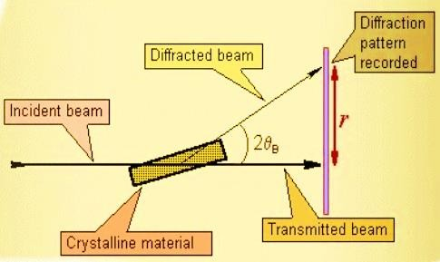

**Fig. 4.2: Schematic representation of XRD**

The mineralogical composition of all the samples was examined using a Rigaku Ultima IV system using CuKα radiation to determine their qualitative features. The scans were conducted from 20º to 80º with a step size of 0.05º and a measurement time of 2 seconds per step. The phase identification investigation was conducted utilising X-ray diffraction (XRD). The OPC 53, SF, and GGBS samples were pulverised using a pestle prior to undergoing XRD analysis, utilising the XRD data obtained from the samples. The X’pert High Score Plus programme was utilised to compare the crystalline and amorphous phases present in the raw materials. The comparison was conducted using the standard JCPDS charts.

XRD pattern (Figure 4.3) of OPC 53 grade cement exhibits peaks that are similar to those of C3S, C2S, C3A and C4AF.

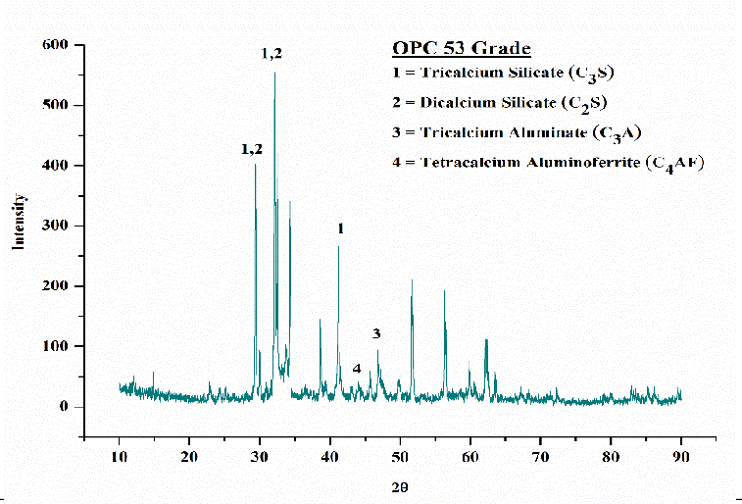

**Fig. 4.3: XRD traces of OPC**

An analogous inquiry was conducted for SF utilising X-ray diffraction (XRD). The XRD study of SF indicates that it possesses a more compact amorphous structure in comparison to FA. Figure 4.4 displays XRD pattern of SF. XRD pattern of SF exhibits prominent peaks at 30.4°, which closely resemble the characteristic peaks of SiO2, the primary constituent of SF, as indicated by the JCPDS chart (01-086-2328). XRD pattern of SF was observed to display predominantly amorphous Features.

Figure 4.5 displays the XRD patterns of GGBS powders. The occurrence of a conspicuous peak among 250 and 3502Ɵ suggests the presence of a small amount of the amorphous phase. In addition, the presence of Akermanite (Ca2Mg(Si2O7)) was seen in the unprocessed GGBS material (Fig. 4), accompanied by a significant rise in the strength of the peak. Merwinite, which has the chemical formula Ca3Mg(SiO4)2, and Gehlenite, with the chemical formula Ca2Al(AlSiO7), were also detected.

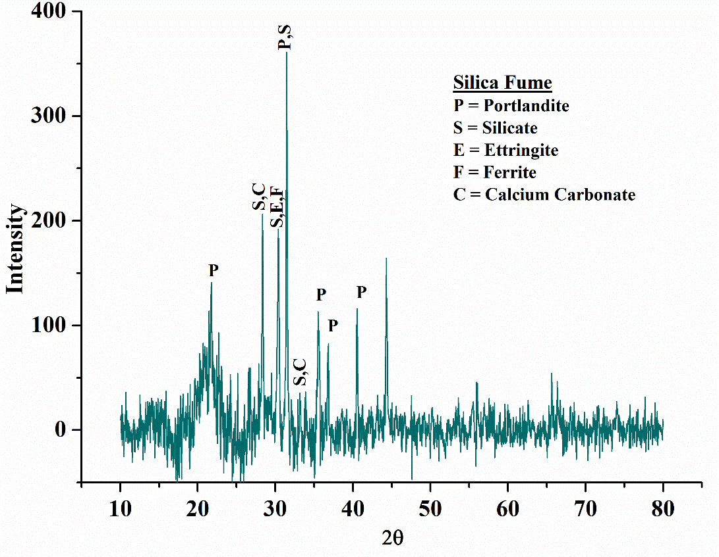

**Fig. 4.4: XRD traces of silica fume**

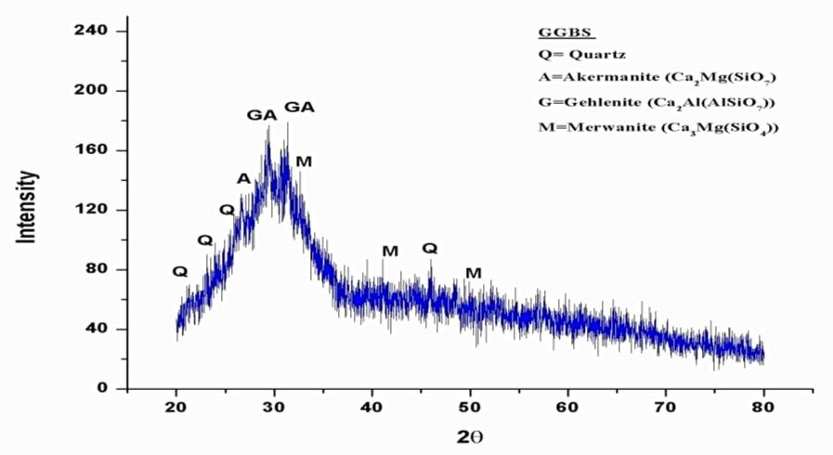

**Fig. 4.5: XRD traces of GGBS**

**Aggregates**

“The fine aggregate utilised was ordinary sand sourced from the Sone river bank, With a fineness modulus of 2.60. The absorption of water and specific gravity were determined to be 1.1% and 2.51, correspondingly. The sand the specimen, after being subjected to sieve analysis, meets the specifications for zone III as per IS 383-1970.The coarse aggregate utilised was locally sourced crushed Pakur stone, with a size of 12.5mm. The absorption of water and specific gravity were measured as 0.4% and 2.82, respectively. Figure 4.6 displays the particle size distribution of both aggregates.”

**% Passing**

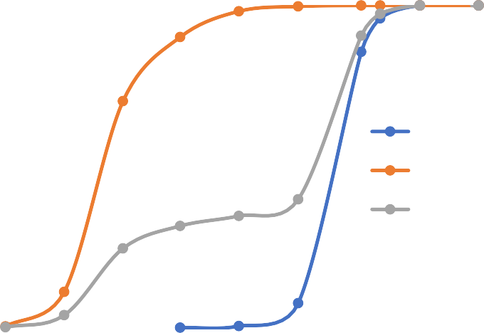

**100**

**90**

**80**

**70**

**60**

**50**

**40**

**30**

**20**

**10**

**0**

**coarse aggregate Fine aggregate**

**all in aggregate**

**0.1 1 10 100**

**Particle Size in mm**

1. **RESULT**

**Mixture Proportion**

The UHPC mixes were proportioned using the guidelines provided in IS 10262-2019. The concrete was mixed according to the specifications outlined in IS 456-2000 [260]. The initial mixture proportion for UHPC with a binder content of 740kg/m3 and a water binder ratio of 0.20 was calculated, using a 1.2% weight of Superplasticizer (SP) relative to the binder. The composition ratio of UHPC mixes that combine two or three components is shown in Table 5.1.

Seventeen mixes with Partially substituting of cement with SF and GGBS were prepared. Two hundred and fifty-five cube samples of binary and ternary blended mix of UHPC were cast to study the effect on strength in compression at 1, 3, 7, 28 and 56 days. Fifty-one cylindrical samples and fifty-one beam samples were also cast to study the effect on split tensile strength and strength in bending.

**Table 5.1: Mix Proportions**

|  |  |  |  |  |  |  |  |
| --- | --- | --- | --- | --- | --- | --- | --- |
| **Mix** | **Density of Cement** | **Density of SF** | **Density of GGBS** | **Density of SP** | **Density of CA** | **Density of FA** | **Density of Water** |
| Control Mix | 655 | 0.2 | 0.5 | 10.50 | 1095 | 601 | 148 |
| G10 | 590 | 0.5 | 80 | 1025 | 1050 | 610 | 148 |
| G20 | 601 | 0.3 | 150 | 10.20 | 1099 | 620 | 148 |
| G30 | 498 | 0.3 | 250 | 10.28 | 1055 | 674 | 148 |
| G40 | 458 | 1.5 | 300 | 10.57 | 1088 | 621 | 148 |
| G50 | 390 | 1.5 | 350 | 10.54 | 1044 | 680 | 148 |
| SF6 | 7.2 | 50.5 | 0.2 | 10.65 | 1057 | 650 | 148 |
| SF8 | 7.9 | 65 | 0.1 | 10.50 | 1087 | 641 | 148 |
| SF10 | 690 | 84 | 0.1 | 10.50 | 1058 | 630 | 148 |
| SF12 | 670 | 91 | 0.1 | 10.50 | 1054 | 680 | 148 |
| SF15 | 640 | 125 | 0.1 | 10.50 | 1078 | 640 | 148 |
| SF18 | 620 | 140 | 0.2 | 10.50 | 1036 | 680 | 148 |
| G10/SF12 | 580 | 90 | 80 | 10.50 | 1087 | 654 | 148 |
| G20/SF12 | 525 | 90 | 150 | 10.50 | 1051 | 630 | 148 |
| G30/SF12 | 480 | 90 | 250 | 10.50 | 1020 | 640 | 148 |
| G40/SF12 | 380 | 90 | 305 | 10.50 | 1089 | 690 | 148 |
| G50/SF12 | 290 | 90 | 390 | 10.50 | 1075 | 620 | 148 |

**Slump Test Outcomes**

Figure 5.1 displays the outcomes of the slump test. Upon visual observation, it was determined that the mixes containing GGBS exhibited both mobility and cohesiveness. The cohesion of the mixture was attributed to the existence of SiO2 in GGBS. The graph in Figure 4.1 clearly shows that enhancing the amount of GGBS used as a extra for cement greatly enhanced the slump values. The outcomes presented that the workability was enhanced at all degrees of cement replacement with GGBS, when linked to the control mix. The enhanced flow Features of UHPC) with (GGBS) can be attributed to the improved dispersion of cementitious particles and the surface features of GGBS. The average enhance in slump values of UHPC mixes with (GGBS) was around 15% related to the control mix. The crystalline composition and the precise surface area of GGBS decrease the amount of water required, hence enhancing the ease of handling.

**250**

**204 207 216**

**200**

**193 198**

**177**

**171**

**168 166 164 161 160**

**181 179 177 174**

**170**

**150**

**100**

**50**

**0**

**0 0 0 0 0 0**

**0 10 20 30 40 50**

**6**

**0**

**8 10 12 15 18**

**0**

**0**

**0**

**0**

**0**

**12 12 12 12 12**

**10 20 30 40 50**

**%Variation of SF and GGBS**

**Fig. 5.1: Slump Test Outcomes**

When considering ternary combinations of UHPC with a consistent SF and varied amounts of GGBS ranging from 10-50%, the calculated slump fell within the range of 165-175 mm. An enhance in the GGBS concentration outcomeed in a noticeable decrease in the slump. The inclusion of a large proportion of SiO2 may contribute to the enhanced cohesiveness of UHPC mixes. In addition, the occurrence of SF enhances the hydration of GGBS by promoting the production of Ca(OH)2. As a outcome, the water requirement in UHPC mixes enhances proportionally with the amount of GGBS used.

**Test Outcomes of Compressive Strength**

The UHPC samples had strength in compression when tested after 3, 7, 28, and 56 days after curing. The outcomes that we get from UHPC combinations are shown in tables 4.1 and 4.2. Table 4.23 shows that the strength of the compression of all the mixex enhances with time. The early-time strength of UHPC when mixed with GGBS shows a smaller enhance as compared to UHPC when mixed with SF.

The strength in compression of HHPC when mixed with GGBS fell by approximately . 15% when we replaced 10% cement with GGBS. After completion of curing with in 3 days, The outcomes that are presented here are consistent with the outcomes of the previous investigations. Fig. 4.2 shows that the enhance that we observed at 3 and 7 days was approximately . 15% and 20%, respectively.

  Table 5.2: Compressive Strength Test Outcomes

**%**

**Variation**

|  |  |  |  |  |  |  |
| --- | --- | --- | --- | --- | --- | --- |
| **of GGBS** | **of SF** | **1 Day** | **3 Days** | **7 Days** | **28 Days** | **56 Days** |
| 0 | 0 | **30.96** | **43.64** | **59.87** | **84.56** | **105.60** |
| 10 | 0 | 25.32 | 36.51 | 56.86 | 90.20 | 124.20 |
| 20 | 0 | 26.51 | 39.86 | 58.81 | 92.60 | 125.60 |
| 30 | 0 | 28.72 | 40.63 | 59.26 | 95.72 | 127.87 |
| 40 | 0 | 30.63 | 42.77 | 62.69 | 101.22 | 130.60 |
| 50 | 0 | 29.55 | 41.33 | 61.43 | 100.60 | 129.66 |

**% Variation**

**Compressive strength in MPa**

|  |  |  |  |  |  |  |
| --- | --- | --- | --- | --- | --- | --- |
| 0 | 6 | 31.54 | 45.76 | 73.23 | 117.25 | 128.63 |
| 0 | 8 | 31.87 | 45.58 | 77.41 | 121.88 | 133.21 |
| 0 | 10 | 32.28 | 47.75 | 80.26 | 126.20 | 137.67 |
| 0 | 12 | 32.57 | 51.37 | 84.87 | 131.64 | 142.29 |
| 0 | 15 | 33.73 | 52.21 | 86.63 | 133.53 | 143.67 |
| 0 | 18 | 33.54 | 50.82 | 82.46 | 132.12 | 141.88 |

|  |  |  |  |  |  |  |
| --- | --- | --- | --- | --- | --- | --- |
| 10 | 12 | 35.62 | 56.32 | 85.73 | 136.80 | 158.76 |
| 20 | 12 | 36.54 | 57.40 | 86.53 | 138.40 | 159.60 |
| 30 | 12 | 39.67 | 58.60 | 88.77 | 139.90 | 161.90 |
| 40 | 12 | 41.88 | 61.87 | 93.73 | 144.21 | 163.23 |
| 50 | 12 | 40.16 | 60.20 | 91.92 | 143.25 | 161.69 |

**Fig. 5.2: Increase strength in compression with 28 days of curing**

**180**

**160**

**140**

**120**

**100**

**80**

**60**

**40**

**20**

**0 1 Day**

**GGBS 40% 30.63**

**SF 12% 32.57**

**SF12%+GGBS40% 41.88**

**3 Days**

**42.77**

**51.37**

**61.87**

**7 Days**

**62.69**

**84.87**

**93.73**

**28 Days 56 Days**

**101.22 130.60**

**131.64 142.29**

**144.21 163.23**

**70%**

**60%**

**50%**

**40%**

**30%**

**20%**

**10%**

**0% Increment in Increment in Increment in Increment in strength from strength from strength from strength from**

**1 to 3 day 3 to7 day 7 to 28 day 28 to 56 day**

**GGBS 43% 49% 61% 33%**

**SF 50% 65% 57% 9%**

**GGBS+SF 52% 52% 57% 15%**

**% change in Compressive Strength**

**Compressive Strength in Mpa**

**Fig. 5.3: Compressive Strength variation with time for the three Optimum UHPC Mixes**

**Tensile Strength**

Figure 5.4 shows the outcomes that we get from the split tesile test. It suggests that the strength of the splitting of high volumes of GGBS doesn’t enhance after 28 days of curing. This may be due to the restricted reactivity of GGBS when it was reacted with water during the initial curing stage. The UHPC mixes containing GGBS show an average . enhance of 10% as compared to the GGBS that was added with SF. Initially, the strength of splitting was enhanced by 40% when cement was replaced with GGBS, but after some time, it slowly decreased.

The split tensile strength of UHPC mixes including Steel Fibres showed an average percentage enhance of approximately 33%. Furthermore, the splitting tensile strength of UHPC samples exhibited an upward trend as the SF level enhanced. urther, the addition of 13% SF with GGBS, which is also mixed with UHPC, shows a gradual improvement in the strength of splitting. It also shows a roughly 50% enhance in strength as compared to the UHPC samples after 28 days.

.

**10**

**9**

**8**

**7**

**6**

**7.567.877.72**

**7.82**

**7.948.128.268.15**

**5.525.665.85**

**6.656.46**

**6.23**

**6.827.027.22**

**5**

**4**

**3**

**2**

**1**

**0**

**0 0 0 0 0 0**

**0 10 20 30 40 50**

**6**

**0**

**8 10 12 15 18**

**0**

**0**

**0**

**0**

**0**

**12 12 12 12 12**

**10 20 30 40 50**

**% Variation of SF and GGBS**

**fig. 5.4: Split Tensile Strength Test Outcomes after 28 Days of curing**

1. **CONCLUSION**

Compared to the optimised mixture of UHPC containing 12% SF and 40% GGBS the UHPFRC with a modest volume percentage of crimped steel fibre significantly enhances mechanical and ductility qualities, although with a little trade-off in durability. The conclusions presented are derived from significant empirical evidence.

* 1. The adding of steel fibre has a substantial impact on the fluidity of UHPC The flowability steadily deteriorated as the fibre content enhanced. The flowability of UHPC without fibre was measured to be 174 mm. The inclusion of 0.5%, 0.7%, and 1% crimped steel fibre outcomeed in a reduction in flowability by 8.75%, 16%, and 28% respectively. This investigation revealed a linear decline in the workability of the UHPFRC as the steel fibre content enhanced
  2. In a single fibre pull-out test, it was determined that an embedment length of 5mm was inadequate to establish a strong binding with UHPFRC. There was a 27.56% enhance in the ultimate fibre pullout load when the embedment length rose from 5mm to 10mm, for both 10mm and 15mm embedment lengths. The enhance was 32.43% when the length of the embedment was extended from 5mm to 15mm. The enhanced interfacial area seen in the SEM picture is accountable for the enhanced connection among the fibre and Framework . The load slip curve derived from the test findings, in conjunction with the SEM picture, elucidates the process of bonding and debonding among the steel fibre and the UHPFRC Framework . Additionally it was seen that the depth at which the fibres are embedded leads to a decrease in the final bond strengths at the interface among the fibres and the Framework .
  3. The compressive strengths exhibited a positive correlation with both the fibre content and the age of the material. Nevertheless, the pace of strength gain decelerated as individuals became older. The major reason for this was the compact nature of UHPC along with a very little ratio of water to cementitious ingredients. This outcomeed in a lack of sufficient free water for the cement to hydrate at later stages. The strength in compression of UHPFRC mixes with 1% steel fibre enhanced by 20.05% compared to the optimised mix of UHPC. The strength in compression of the UHPFRC mixes enhanced linearly with time and with the addition of more steel fibres. The cracking pattern of UHPFRC exhibits ductility. The failure of the optimised UHPC mix exhibited brittle behaviour, outcomeing in the disintegration of the material into minute pieces.
  4. The flexural strength improvement ratios of the UHPFRC mixtures compared to the volumetric steel fibres exhibited a clear exponential rise. After the optimised UHPC mix cracked, there was a dramatic decrease in its performance, which once again demonstrated its brittle failure features. The steel fibre content had a little impact on the load-deflection curves prior to pre-cracking, but had a significant influence on them once cracking occurred. Furthermore, the addition of more steel fibres outcomeed in the curves being more expansive, reaching a higher maximum load. This was a outcome of an enhanced number of fibres that were able to withstand the pressure at the fissures. During the pre-cracking stage, the fibre and UHPC Framework both bear the load, but the stress is very low, outcomeing in identical bond stress for the UHPC with varied fibre contents.
  5. A correlation examination was taken to show the splitting tensile strength of UHPFRC mixtures. The analysis revealed a second-order polynomial correlation with an R-squared value of 0.94. The failure in samples without fibre inclusion is characterised by brittleness, whereas the failure in samples with fibre content exhibits ductility. This can be attributed to the fact that the vertical compressive stresses, which are aligned with the cracks, cause the fibre reinforcement to bear a greater load before being pulled out of the mixture, effectively bridging the cracks.
  6. The use of steel fibre in UHPC substantially enhances its resistance to failure during impact resistance testing, in comparison to non-fibrous optimised UHPC mix. It has the ability to absorb energy and can withstand a greater amount of drops before it fails. Therefore, it can be inferred that the impact resistance of concrete was much enhanced with the enhance in fibre content. There was a direct relationship among the ductility index and compressive strength, meaning that as compressive strength enhanced, ductility decreased. The presence of fibre reinforcement shifts the impact failure patterns from brittleness to ductility, leading to the conclusion that it has an effect on this transfer. The harm modes indicate that the steel fibre has a tendency to disengage from the Framework .

1. **REFERENCES**
2. C. D. Johnston, Fiber-Reinforced Cement and Concretes, 1st ed. London: CRC Press, 2001.
3. G. A. Schmidt *et al.*, “Climate forcing reconstructions for use in PMIP simulations of the Last Millennium (v1.1),” *Geosci. Model Dev.*, vol. 5, no. 1, pp. 185–191, 2012, doi: 10.5194/gmd-5-185-2012.
4. G. A. Schmidt, D. T. Shindell, R. L. Miller, M. E. Mann, and D. Rind, “General circulation modelling of Holocene climate variability,” *Quat. Sci. Rev.*, vol. 23, no. 20-22 SPEC. ISS., pp. 2167–2181, 2004, doi: 10.1016/j.quascirev.2004.08.005.
5. E. Fehling, M. Schmidt, and S. Stuerwald, “Second International Symposium on Ultra High Performance Concrete,” *Second Int. Symp. Ultra High Perform. Concr.*, p. 902, 2008.
6. J. Xue, B. Briseghella, F. Huang, C. Nuti, H. Tabatabai, and B. Chen, “Review of ultra-high performance concrete and its application in bridge engineering,” *Constr. Build. Mater.*, vol. 260, p. 119844, 2020, doi: 10.1016/j.conbuildmat.2020.119844.
7. M. Zhou, W. Lu, J. Song, and G. C. Lee, “Application of Ultra-High Performance Concrete in bridge engineering,” *Constr. Build. Mater.*, vol. 186, pp. 1256–1267, 2018, doi: 10.1016/j.conbuildmat.2018.08.036.
8. B. A. Graybeal and H. G. Russel, “Ultra-High Performance Concrete: A State- of-the-Art Report for the Bridge Community. Publication No. FHWA-HRT-13- 060,” no. June, p. 176, 2013.
9. G. B. A., “Material Property Characterization of Ultra-High Performance Concrete,” *Fhwa*, no. August, 2006.
10. C. Ozyildirim, “Evaluation of Fiber-Reinforced Concrete,” *Eval. Fiber- Reinforced Concr.*, 2011.
11. P. Y. Blais and M. Couture, “Precast , Prestressed Pedestrian Bridge — World ’ s First Reactive,” *PCI J.*, vol. 44, no. 5, pp. 60–71, 1999.
12. K. Nguyen, B. Freytag, M. Ralbovsky, and O. Rio, “Assessment of serviceability limit state of vibrations in the UHPFRC-Wild bridge through an updated FEM using vehicle-bridge interaction,” Comput. Struct., vol. 156, pp. 29–41, 2015, doi: 10.1016/j.compstruc.2015.04.001.
13. T. Yoshihiro and K. Maekawa, “The Innovation and Application of UHPFRC Bridges in Japan,” no. April, 2016.