**USE OF GEOSYNTHESIS IN ROAD PAVEMENT CONSTRUCTION**

**SAJID BASHIR1, Er. MAANI SHARMA2**

**1** M.Tech Scholar,Desh Bhagat University Gobindgarh Punjab,India

*Bhatsajid4747@gmail.com*

2 Assistant Professor, Desh Bhagat University Gobindgarh Punjab,India

*Man_harma@deshbhagatuniversity.in*

## **ABSTRACT**

Indian has made substantial expenditures over the course of the last two centuries toward the construction of its infrastructure in order to meet its growing needs. The government's plan to achieve its Vision 2030 of speeding the country's transition into a growing middle-income countries society by the year 2030 places a significant emphasis on the development of the country's infrastructure. Accelerating the country's growth into a society that is quickly developing as a middle-income nation by the year 2030 is the means by which this objective is planned to be accomplished. Vision 2030 seeks to achieve this goal by accelerating the country's transition into as rapidly increasing middle-income countries society.

The costs of creating infrastructure, such as those related with the construction of highways, have been increasing at a rapid pace, particularly in recent years. This can possibly be at least partially ascribed to the rapid depletion of building supplies from nature as well as the rise in population volume, which in turn decreases the amount of land that is available to utilize for the installation of planned infrastructure projects. Consequently, this situation has become more difficult to resolve. These variables, taken together, lead to a reduction in the total quantity of property that is now accessible. Over the course of the past few years, there has been a sizeable spike in the cost of purchasing land. The architect or constructor is often compelled to stick to the existing route balance, despite the fact as the existing conditions could render this decision inappropriate in some instances.

The number of vehicles using the roadways in Indian is likewise at a record high. For a significant amount of time, there has been a pressing need to construct roadways that are capable of supporting greater axle loads. Currently, there are substitute construction supplies available that ensure a reduction in both installation and ongoing expenses expenditures are very much appreciated. Additionally, these materials should be able to handle the extra loading that has been placed on our roads.

Geosynthetics have a vast variety of possible uses in the world today. This research was conducted with the intention of determining, from a monetary point of view, whether or not geosynthetics may be useful in the process of constructing road pavements. After making the decision to look into geosynthetic support for the base or foundation courses, the strategy that was provided was put into action. In this article, the long-term viability of using geosynthetics in asphalt surfaces development and constructing as well as the potential cost savings that may be realized via the use of geosynthetics were also examined.

It has been shown that geosynthetic components that are potential of being employed to improve road pavements

are accessible on sale in Indian. This is the case according to the findings of the aforementioned demonstration. According to the results of the inquiry into the reinforcement option, the application of a geotextile blanket under the age of the ground or base of asphalt would result in considerable cost savings not only during the construction phase but also all over the course of the lifespan of the pavement. besides to these cost reductions, associated advantages also include a lessening of emissions of harmful chemicals and a speeding up of the building process.

**Key Words**: Geosynthetics, Road pavement construction, Infrastructure materials, Reinforcement, Soil stabilization, Geotextiles, Geogrids

# INTRODUCTION

When design the highway road engineers push themselves to produce things that will satisfy the present needs of users while additionally preventing them from becoming obsolete in a short amount of time. This is a challenge that they face on a daily basis. In conjunction with this, the structures must not provide any danger during construction and must have a low ongoing maintenance cost. In the past, neither the one-time costs associated with launching the effort in Indian nor the ongoing costs associated with sustaining the initiative have been taken into consideration.

Geosynthetics have made it possible to create novel pavement designs that are better able to achieve all of the intended goals. It is a commonly held view that regularization reduces the number of options for imaginative problem-solving. However, innovation is necessary in order to pave the way for the acceptance of suitable technologies or uniformity (state in practice) of that technology. According to my observations, the rate at which novel technologies make their way into the state of practice at transportation and regulatory bodies in Indian is much slower than it is in other engineering groups. This might be attributed to the robustness of our economy, since we are aware that technological advancement often comes at a high price until it is accepted as the industry norm. However, the most significant part is played by conservative policies in government, which encourage people to stick with what is already established.

Road engineers need to be more open-minded about the use of innovative materials in projects such as geosynthetic-reinforced roadway constructions when it comes to geosynthetics. When this is done, the innovation will have the chance to become the standard, which will, in turn, result in lower costs for the project.

The purpose of The purpose of this study was to assess the viability of utilising synthetic soils in the development of road surfaces in Indian in order to produce long-lasting pavements in a manner that is financially viable. The research is broken up into five parts, with the first chapter providing an introduction to the study as well as some background information on it. The second chapter evaluates existing literature on studies that are comparable to this one, as well as reviewing existing theories on this study.

* 1. **Glossary**

The phrase "horizontal product made from polymers that is used wit rocks, dirt, earth, or a geo associated materials as an essential component of a developed project, structure, or system" is what is meant by using the word "geosynthetic." In addition, geosynthetics may be utilized in combination with several other materials that are relevant to mechanical engineering.

Bathurst (2009) primarily divided geosynthetics into categories based on the methods that were used in their manufacturing. The following paragraphs provide concise explanations of certain geosynthetic materials that are often utilized in the building of roads.

Longitudinal rolls of constructed, ou pas-woven, knitted, or stitch-bonded fibers are what are referred to as **geotextiles** and the name "geotextiles describes these types of fibers. These thin layers are often cloth-like in appearance, and they possess a degree of pliability as well as permeability. Figures 1.1 and 1.2 illustrate the two different kinds of geotextiles that are available.

**Geomembranes** are continuous elastic sheets that may be produced from a single synthetic material or a combination of synthetic materials.

**Geocomposites** are a kind of geosynthetic materials that are created by merging two or more distinct types of geosynthetic material. This process is known as "geocompositization.



**Plate 1.2:** Woven geotextile (Author, 2017 is the source for this phrase)



**Plate 1.1:** Geotextile made of non-woven material (Author 2017 as the source)

* 1. **Description of the problem**

The Road Design Handbook Part III is used as a reference for the design of pavement in Indian. This manual is based on the conventional catalogue method. The structures of the pavement are made out of organic substances for the most part. Gravels and stone that has been crushed are two examples of these naturally occurring materials. Because of the never-ending demand and the inability to find suitable replacement materials, their resources are rapidly running out. This indicates that natural supplies of building materials are often situated more away from the project roads. As a result, extensive haulage routes are required, which drives up the cost of constructing roads and contributes to environmental degradation.

In addition, since there is a shortage of natural building materials of high quality, the quality of those that are utilized is often reduced, and as a result, the longevity of our roadways is typically poor. It is possible that a lack of inventive ideas on the part of the design engineers is to blame for the early collapses that have happened on our highways. This is the case in the majority of cases. As an immediate outcome of this, there is a scarcity of substitute resources to adequately counteract the fast reduction of natural resources.

As a direct consequence of an enhance in population, the quantity of land that is now accessible has decreased. frequently, once the architects are hit by very poor in-situ substances along stated tasks, the layout manual necessitate either that the placement change or that the the poor goods be cut away and swapped with a better material. This is because the design manual assumes that the engineers will have access to better materials. At other times, the design of something that is manually operated necessitates that the alignment be maintained. Both options will culminate in a sizeable jump in the total amount spent on the construction.

Because of the focus that the geosynthetics industry is putting on this particular field, the technique of using geosynthetic materials to strengthen pavements is quickly becoming one that is encouraged. Unfortunately, there is a relatively limited amount of information available to assist designers in making decisions regarding the right application of geosynthetic supplies for applications involving pavement reinforcement.

Plates 1.3 through 1.6 show the condition of some of the roads that were tested. Some of the issues that have been seen on these roads may be alleviated if the groundbreaking technology of geosynthetics were included into the construction of the pavement.

However, if a geosynthetic were to be incorporated into the asphalt foundation of this road, it might result in a thinner street structure and make it possible to build over less desirable in-situ material.

|  |  |
| --- | --- |
| **Plate 1.3:** Crack in the surface that reflects light in a longitudinal direction | **Plate 1.4:** Rumblings about the surface and the potholes |
| **Plate 1.4:** a portion of a township Road that is riddled with potholes | **Plate 1.6:** Roads That Have Ruts |

# OBJECTIVES

Main objectives are as under:

* + 1. Determining the mechanical Characteristics of synthetic materials that are appropriate for use in flexible roads in order to produce inexpensive pavement constructions employing such geosynthetics; this is necessary in order to meet the demands of modern transportation infrastructure.
    2. Determining the potential amount of money that may be saved by using synthetic materials into the preparation, creation, and installation of flexible pavements.

# LITERATURE REVIEW

**Background of geosynthetics**

It is believed that Beckham and Mills (1935) made the initial allusion to the use of fabric for a geosynthetic application. On a road that was not paved over, the soil subgrade was partitioned off and stabilized with the help of a woven cotton fabric. It was said that within eight years, the cloth had disintegrated so significantly owing to soil bacteria that it was almost impossible to distinguish it. The term "geosynthetics" is presently used all over the globe.

**characteristics  of geosynthetics**

There is a well-established category of geo-materials known as artificial grass, and it is used in a broad number of applications that fall within the purview of civil engineering. Geosynthetics are made up of a vast array of polymers, many of which are commonplace in our everyday lives. According to Koerner (2016), the most frequent types are polyolefin and polyester. In the next parts of this article, a short discussion is provided on the geotextile materials and geogrid forms of geosynthetics, as well as their respective uses.

**Geotextiles**

Geotextiles may be broken down into two primary categories: woven and nonwoven materials. Either staple fibres, which range in length from approximately 25 to 100 millimetres, or continuous filaments are used in the production of nonwovens. According to research conducted by the Geosynthetic Materials Association in 2002, nonwovens are often put to use in applications involving drainage and stability.

# 

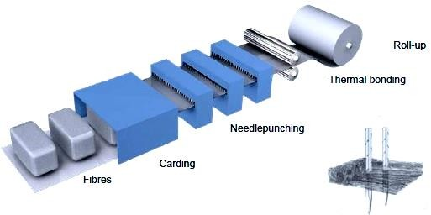

“

Figure 31: This diagram illustrates the production process for non-woven geotextile

* + 1. **Geogrids**

Extruding and straining dense polyethylene or polypropylene that has been woven or knitted and then coating high-tenacity polyester yarns is the process that is used to create geogrids. Their arrangement is similar to a grid, and it contains apertures that improve the contact they have with the soil. Geogrids are especially useful as a kind of soil reinforcement due to their high tensile strength and their high stiffness. (GMA, 2002).

* 1. **Geosynthetics undergo quality assurance examination.**

The mechanical activity tests may be broken down into two distinct groups: those that address load-extension qualities and are often obtained from tensile tests, and those that deal with stability Characteristics и are typically obtained from tear propagation and penetration testing (Zanzinger, 2016). Both of these categories fall under the umbrella term "mechanical activity tests.

* + 1. **Tensile Behaviour**

It's feasible that the flexible characteristics of plastic might give soil reinforcement by increasing the structural integrity of the soil, however this hypothesis needs more investigation. The goal has been completed successfully. The ability of the geosynthetic fabric to stretch while it is being stressed is of the utmost importance for applications that call for soil reinforcement. According to research conducted by Zanzinger (2016), the slight-width, grab and wide width tests are the most effective methods for evaluating the tensile Characteristics of geosynthetics.

* + 1. **Function of Reinforcement**

When employed as reinforcement, geosynthetics have the potential to improve the building and life cycle functionality of paved, rough, and rail roads. This is especially true of paved roads. This is true irrespective of if the roads in question are designated as rail roads. It makes no difference whether or not the roads in issue are classified as rail roads or not; this will always be the case. Their interaction with substances that already exist naturally in the roadway results in the improvements, which ultimately lead to an enhance in the carrying bulk of the sidewalk as well as an enhance in its rigidity over the course of the pavement's design life. It is necessary for the efficacy of geosynthetic reinforcement that it executes its job in conjunction with other geosynthetic techniques, such as separate and filtration, in order to attain this level of success. This will ensure that the geosynthetic reinforcement is successful. (2017) The information that was supplied by Christopher.

# METHODOLOGY

**Experimental Technique**

The objective of this study was to ascertain whether or not geosynthetic materials may be useful in the planning and building of flexible pavements for Indiann highways. The route from Lamu to Garissa, which is about 250 kilometres in length, served as an experimental road for the purposes of the research. The road has a significant impact on Indian's economy, as well as the economies of the nations that border it to the north and east. It is a component of one of the major projects of Vision 2030 known as The LAPSSET Corridor. The project is spread over three counties: Garissa, Tana River, and Lamu. It is situated on the eastern bank of the River Tana. According to design papers produced by Sai Consulting Engineers Pvt. (2015), there was a significant lack of building materials, particularly gravel material and hardstone.

Research was done to determine whether or not the roadways of this route may benefit from the use of geosynthetics. One of the designs used geosynthetic reinforcement, while the other did not use any geosynthetics in its construction. Both of these designs were tested. M-E design was utilized for the design without geosynthetic reinforcement, and the mePADS program from South Africa was used to simulate the pavement and figure out the estimated useful life of the pavement. For the design of geosynthetically reinforced base and subbase courses, the AASHTO R50-09 (AASHTO 2014b) criteria were used.

**Collection of Data**

In this part, the main and secondary sources of information that were used to compile the data are described in their unprocessed form.

In the course of this research, the following information was gathered and examined.: -

* + 1. Testing of geotextiles in a laboratory environment, with samples coming from Geotextiles that that East Africa Ltd. in India; the analysis was done. Testing of geotextiles in a field setting. The many different kinds of tests that were carried out in the lab are broken down into the categories listed in the following list: This category consists of three different tests: the grab snapping load test, which is commonly referred to as the CBR Test, the stress-strain stretch test, and the static pierced force test. These tests were carried out in order to demonstrate compliance with the standards that were outlined by the ASTM; nevertheless, the results were compared to the requirements that were supplied by the manufacturer.
    2. in addition data for traffic flow (axle loads) and attainable Materials used for construction associated with the Lamu-Garissa the road and which came from a database owned by the Indian Nationwide Highways Agency along with is based on the full engineering and architectural studies that the were performed and reported by Sai Consult Architects in 2015. This information was obtained from a database that was acquired from a database that was owned by the Indian National Highways Agency. The data on the volume of traffic on the road that was being tested were used in the design of that pavement, and this was done regardless of whether or not geosynthetic augmentation was being used. After analyzing the differences in the pavement dimensions that were produced as a consequence of the changes, the costs associated with the changes were estimated and analyzed.
    3. On the worksheet labeled "Pavement Structure," the following input boxes were present with the goal to define the sidewalk system:

**Material:** This word indicates the chemical structure of the pavement material in line with the South African Product Classification that may be found in 1996. The types of materials were selected from a list that was shown in the pull-down menu as an option.Thickness: Specify the thickness of the layer in millimetres. It was expected that a stiff layer existed at the bottom of the previous layer, namely at a depth of 1000 mm below the designated pavement.

**No. of Stages**: The amount of design stages required for analysis is determined by the incorporation of cemented materials and their inherent character. The research estimated the number of phases incorporated mathematically by considering the number of cemented layers in the construction.

Climatical Area: Mention to rainfall area which was dry.

**Category of Road:** The concept of dependability, denoted as A, was established to have a reliability of 95%. Quantities and Assessment Points

**Design Site**: The location on the surface of the road where the road layout will be implemented.

Stresses and Strains: The designated area on the road for assessing stresses and strains. The evaluation was conducted separately from the bearing capacity study.

**Design Parameters**

On this worksheet, the load and strain parameters that were measured at critical points in the concrete were presented. Calculations about the bearing capacity were carried out using these parameters. The value ranges and critical points shift depending on the kind of material being used, as shown below:

**Asphalt Layers**: The transverse tensile strain that remains at the base of the layer is what determines how long the layer will last prior showing signs of fatigue.

**Cemented Layers:** The lateral compression force that is applied to the top of the layer is what determines the tearing life of that layer, while the plane if tensile strain that is applied to the bottom of the layer is what decides the rate of fatigue of the layer.

**Granular Layers:** The ripping ability of the layer is determined by the major stresses that are located in the layer's middle third.

**Soil (Subgrade) Layers:** The amount of compressive strain in the horizontal direction that remains at the top of the layer is what determines how long the rutting will continue on the layer.

**Software Output Parameters**

**Pavement Life:** The worksheet presents an overview of the primary design outputs generated by the program. After the design phase has been finished and the 'Calculate' button has been clicked, the worksheet will become visible.

**Layer Bearing Capacity:** The bearing capacity of the various layers at the specified level of reliability is shown both in the table and in the graphic that is presented. This capacity is measured by means of the defined load. In addition to being shown by bars, the design circulation class was also shown by lines on the chart. Regarding Standard Axles, this was accomplished as such. The capacity to bear load was calculated by using transfers that were designed specifically for the kind of material in question.

**An Approximate Distribution of the Pavement's Life:** The distribution of pavement their lives that may be acquired by altering the design consistent input in transferring functions.

**Crushing in layers that have been cemented:** The crushing load that the cemented layers are able to withstand before they fail.

**Cemented Life:** The amount of time that the fixed life cycle of the solidified layer is really in action.

**Calculation Table:** The outputs of the transfer function are provided for the design reliability that you choose. This feature is made available so that specific information on the method of calculation may be accessed at any time.



**Examination  in laboratory**

Both the Indian Directorate of Guidelines (KEBS) and Norken Intl Laboratories conducted tests on material samples of geotextile. The results of the various tests carried out on the material samples may be seen in Table 4.1 and appendix A, respectively. Plates 4.1 through 4.4 detail the procedures that were followed during the testing.

**Table 4.1 “Materials Samples and Tests Conducted**

|  |  |  |  |  |  |  |
| --- | --- | --- | --- | --- | --- | --- |
| **Sample**  **Description** | **Test Conducted** | **Test Procedure** | | **Results** | **Specification**  **(AASHTO, 2014a)** | **Remarks** |
| Betatex (600 gsm) | Machinery rotation causes extension at the break. | ASTMD4563 | | 86.3% | - | > 50% |
|  | Elongation during Break, in the Direction of the Machine | ASTMD4564 | | 73.0% | - | > 50% |
|  | Take the Breaking Load While Going Against the Machine Direction | ASTMD4565 | | 2215N | 900N | Adequate |
|  | Grab the Breaking Load – The Direction of the Machine | ASTMD4566 | | 2687N | 900N | Adequate |
|  | The Direction of the Trapezoidal Tear-Cross Machine | ASTMD4567 | | 163N | 350N | Inadequate |
|  | The Trapezoidal Tear Follows the Direction of the Machine | ASTMD4568 | | 184N | 350N | Inadequate |
|  | Resistance to Being Pierced | ASTMD4569 | | 11384N | 1925N | Adequate |
| Fibertex F32 | Machine rotation causes extension at the break | ASTMD4570 | | 56.6% | - | > 50% |
|  | The extension at Break in the Machine Rotation | ASTMD4571 | | 48.3% | - | < 50% |
|  | Maximum tensile strength in the cross machine direction. | ASTMD4572 | | 818N | 900N | Inadequate |
|  | maximum load capacity - Determine the orientation of the machine | ASTMD4573 | | 1031N | 1400N | Inadequate |
|  | The Direction of the Trapezoidal Tear-Cross Machine | ASTMD4574 | | 213N | 350N | Inadequate |
|  | Trapezoidal Tear – Machine Direction | ASTMD4575 | | 291N | 500N | Inadequate |
|  | Resistance to Being Pierced | ASTMD4576 | | 2785N | 2750N | Adequate” |
| **Plate 4.1:** Grab Strength Testing | | | | **Plate 4.2:** Trapezoidal Tear test | | | | |
| **Plate 4.3:** Evaluation of Static Puncture Resistance | | | | **Plate 4.4:** Trapezoidal Tear test | | | | |

# Road Loads

In accordance with the Indian Road Design Guide (RDM), Part III (1987), a calculation known as the Cumulative Numerical of Standard Axles, or CNSA, was performed in order to establish the concrete loading class. This computation was completed in a manner that was consistent with the suggestions that were provided in the year 1987. This was done so that the loading class of the pavement could be determined more accurately. Table 4.2 contains the information that pertains to CNSA for a planning horizon of twenty years, together with the transportation category that corresponds to it.

1. **RESULT**

**Geosynthetics’ mechanical characteristics**

The results of the tests, which are shown in Table 41, provide evidence suggesting there are now geotextile supplies available on market that are both capable of accomplishing the obligations of a reinforce geosynthetic and satisfy the prerequisites that are essential to do so. This is evidenced by the fact that there are now geotextile materials that are available on the market that are shown in Table 41. In addition, the results of the tests showed that the the geotextile was able to fulfill the standards that were given by the manufacturers of the material, which indicated that the conclusion of the testing was positive.

**Characteristics of commonly used constructional materials**

There are five potential gravel borrow pits that can be utilized as a subbase layer prior to the final road being enhanced with cement, as indicated by the findings of the investigation into the components that make up the road on which the job is being constructed, which are indicated in Table 3.6 to Table 3.9, respectively. This is according to the findings of the investigation into the substances that make up the asphalt on which the undertaking is being constructed..

**Designs as per the IS**

It is suggested that standard pavement constructions be discussed in Indian Road Engineering Manual Part III (1987), which was published in 1987. The key contributors to the construction of these structures are the design subgrade stiffness class as well as the amounts of traffic that need to be handled. It is possible to witness the execution of this criteria in tables 43 and 44, respectively. Tables 4.1 and 4.2 provide the catalogue pavement construction alternatives for the highest traffic in the Indiann Standard, which is referred to as Traffic Class T1, and design The foundation Class S3, respectively. These options may be found in the catalogue.

**Table 5.1: “Catalogue Road Construction Option 1 – Type 11.**

|  |  |  |  |
| --- | --- | --- | --- |
| **Layer No.** | **Pavement Layer** | **Material** | **Thickness (mm)** |
| 1 | Wearing Course | Asphalt Concrete | 45 |
| 2 | Base | Dense Bitumen Macadam  (DBM) | 140 |
| 3 | Subbase | Material Improved with Cement or Lime (Quality at a Base Level) | 300 |
| 4 | Subgrade, S3 | Fly Ash Concrete” | 275 |

**Table 5.2: Catalogue Asphalt Layout Alternative 2 – Type 5.**

|  |  |  |  |
| --- | --- | --- | --- |
| **Layer No.** | **Pavement Layer** | **Material** | **Thickness (mm)** |
| 1 | Wearing Course | Asphalt Concrete | 100 |
| 2 | Base | Cement Stabilised Gravel | 150 |
| 3 | Subbase | Cement or Lime Improved  Material (Base Quality) | 225 |
| 4 | Subgrade, S3 | Fly Ash Concrete” | 275 |

The pavement constructions that are mandated by the Indian Standards were modelled in the manner that is mentioned in the part that follows in order in coming up with modified alternatives that would be able to manage the loads for an anticipated period of 20 years. This was done in order to come up with choices that could handle the loads for a total of 20 years. This was done in order to come up with a solution.

The Indian Highway Design By Hand, Part III, 1987: Modelling of Asphalt Structures Option 1 – Type 11 [The Indian Road Design Manual].

In order to come up with modified options that would be able to handle the loads for a design duration of 20 years, the pavement structures that are prescribed by the Indian Specifications were modelled in the way stated in the section that follows.

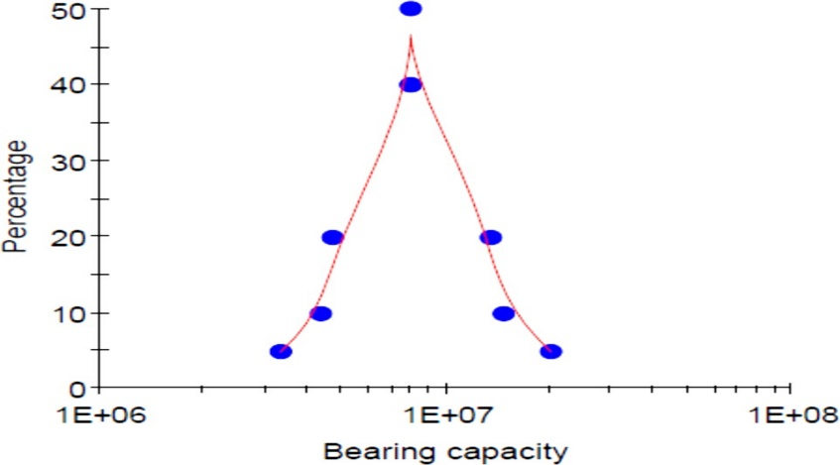

**Figure 5.1:** A rough estimate of the distribution of the bearing capacity of the pavement (in terms of standard axles).

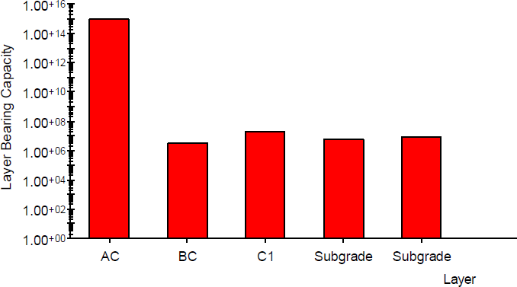

Figure 5.2: The estimated bearing capacity of the layer (expressed in units of standard axles).

The Indian Highway Design Manual, Part III, 1987 presents a modeling of Paving Structure Option 2 – Type 5.

The modelling of the road option 2 – Type 5 resulted in the distribution of the carrying capacity of the pavement that is shown in Figure 4.3. Figure 4.4 is an illustration of the separate layer carrying capabilities.

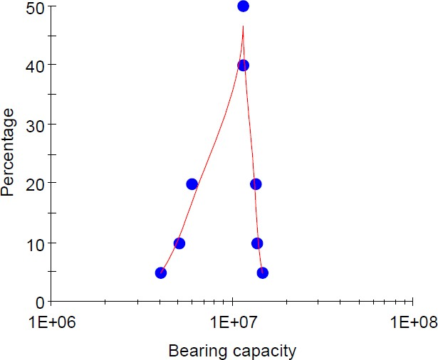

Figure 5.3: A rough estimate of the distribution of the bearing capacity of the pavement (in terms of ordinary axles).

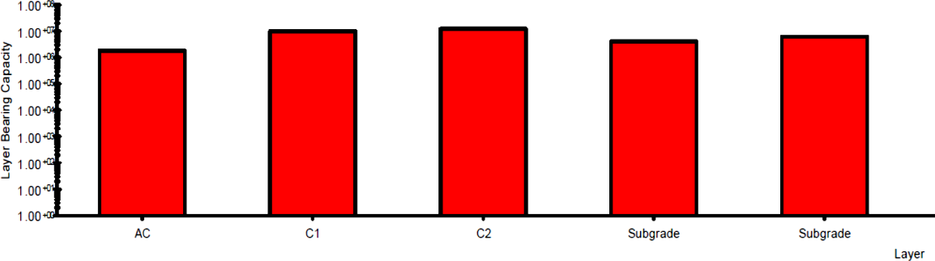

Figure 5.4: The estimated bearing capacity of the layer (expressed in units of standard axles).

When modeled on the sections illustrated in Figures 5.2-5.5, it was discovered that the pavements offered by the booklets, such as choice 1 (type 11) and the second option (type 5), did not have adequate bearing capabilities to deal with the loads that were anticipated to be induced by traffic. These portions were stated previously in this paragraph. On the other hand, taking into account the fact that gravel was present in the project road but siderite was rare, as shown on Figure 5.2 and Table 5.10, It was decided that option 5 of the pavement would benefit most from having further changes done to it in order to enhance the bearing capacity so that it could better handle the projected levels of traffic usage. This decision was made so that the road's capacity to resist the estimated level of traffic volumes it would be subjected to may be improved. This was done to strengthen the capacity of the asphalt to handle the anticipated loading from the traffic in the surrounding areas.

**Modified Pavement Structure**

Figure 4.6 presents a visual representation of the various layer carrying capacities that were evaluated. It was found that the average capacity for bearing was sufficient, coming in at more than forty trillion ESALs, with each layer in particular demonstrating strong bearing capabilities as a consequence of the changed pavement layers and enhanced material qualities. This was a discovery that came about as a result of the enhanced material qualities and the modification of the pavement layers. This was discovered as a consequence of the changes that were made to optimize the material Characteristics . After making some adjustments to the pavement layers and attempting to perfect the material qualities, this became apparent. It was estimated that the pavement life, with routine maintenance, would be sufficient to handle the projected level of traffic for the whole of the design life. This was because it was anticipated that the volume of traffic would be.

**Table 5.3: Option 2 of the Modified Pavement Structure for Type 5.**

|  |  |  |  |
| --- | --- | --- | --- |
| **Layer No.** | **Pavement Layer** | **Material** | **Thickness (mm)** |
| A | Wearing Course | Asphalt Concrete | 100 |
| B | Base | Hard Gravel | 300 |
| C | Subbase | Lime Improved  Material | 450 |
| D | Subgrade | Selected subgrade | 300 |

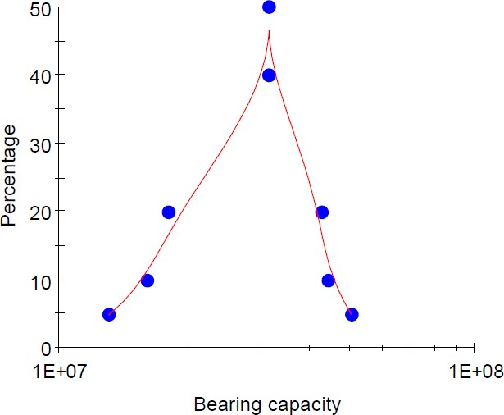

Figure 5.5: A rough estimate of the distribution of the bearing capacity of the pavement (in terms of ordinary axles).

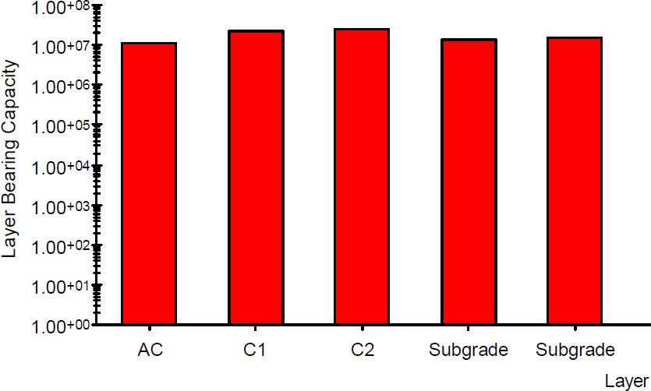

Figure 5.6: The estimated bearing capacity of the layer (expressed in units of standard axles).

1. **CONCLUSION**

The following results are based on the examination of the flexible pavement, without or with a geotextile, as well as the inspection of the geotextiles as that are easily accessible in the region. These findings are presented in the order in which they were discovered:

* + 1. In India, here are currently geosynthetic materials on the market that are able to be used to strengthen flexible pavements. These materials may be purchased from a variety of stores. Given that these materials meet the requirements for their mechanical Characteristics , they are suitable for use in the reinforcing function of pavement.
    2. The positioning of a geotextile underneath the ground level of the pavement will result in considerable cost savings both throughout the construction phase and during the lifespan of the pavement. These savings in expenses will be realized both during the construction phase and throughout the lifetime of the pavement. Apart from to these cost reductions, associated advantages also include a lessening of emissions of harmful chemicals and a speeding up of the building process.

1. **REFERENCES**
2. AASHTO, (1993). AASHTO Guide for Design of Pavement Structures. American Association of State Highway and Transportation Officials, Washington, DC.
3. AASHTO MEPDG-1, (1995). Mechanistic-Empirical Pavement Design Guide, Interim Edition: A Manual of Practice. American Association of State and Highway Transportation Officials, Washington, DC.
4. AASHTO, (2000). Standard Specifications for Geotextiles-M288, Standard Specifications for Transportation Materials and Methods of Sampling and Testing, 34th Edition. American Association of State Transportation and Highway Officials, Washington, DC.
5. AASHTO, (2004b). Geosynthetic Reinforcement of the Aggregate Base Course of Flexible Pavement Structures - R 50-09, Standard Specifications for Transportation of Materials and Methods of Sampling and Testing, 34th edition. American Association of State Transportation and Highway Officials, Washington, DC.
6. ASTM, (2005). Annual Books of ASTM Standards, Volume 4.09 (II), Soil and Rocks; Geosynthetics. American Society for Testing and Materials, West Conshohocken, PA.
7. ASTM D4354-99: Standard Practice for Sampling of Geosynthetics for Testing.
8. ASTM D4533-91: Standard Test Method for Trapezoid Tearing Strength of Geotextiles.
9. ASTM D4595-11: Standard Test Method for Tensile Characteristics of Geotextiles by the Wide- Width Strip Method.
10. ASTM D4632-91: Standard Test Method for Grab Breaking Load and Elongation of Geotextiles
11. ASTM D6241-99: Standard Test Method for Static Puncture Strength of Geotextiles and Geotextile-Related Products Using a 50-mm Probe.
12. Bathurst, R. J., (2009). Geosynthetics Classification. International Geosynthetics Society, IGS.
13. Beckham, W. K., W. H., Mills, (2010). Cotton-Fabric-Reinforced Roads. Engineering News Record.
14. Berg, R. R., B. R. Christopher, S. W. Perkins, (2010). Geosynthetic Reinforcement of the Aggregate Base/Subbase Courses of Pavement Structures. GMA White Paper II. Geosynthetic Materials Association, Roseville, MN.
15. Brundtland, G., (2011). Our Common Future: The World Commission on Environment and Development. Oxford University Press, Oxford, UK.
16. Christopher, B. R. (2012). Geotextiles used in reinforcing paved and unpaved roads and railroads. Christopher Consultants, Roswell, Georgia, United States. Woodhead Publishing Series in Textiles: Number 175.