**ROBOTICS IN THE CONSTRUCTION OF HIGHWAY PAVEMENT**

**ZEENAT MUSHTAQ1, Dr. POOJA SHARMA2**

**1** M.Tech Scholar,Desh Bhagat University Gobindgarh Punjab,India

*kzeenat291@gmail.com*

2 Assistant Professor, Desh Bhagat University Gobindgarh Punjab,India

*deshbhagatcivil@gmail.com*

## **ABSTRACT**

The research presented here looks at the state-of-the-art of robots in the concrete and masonry fields as well as the construction business. The fundamental principles in robotics are first explored in order to properly comprehend the potential applications of robotics in the construction sector. The broad summary of robotics is addressed, including definitions, a short history, the key elements that make up robots, and present advances in many disciplines. The thesis's primary section focuses on robots' the use in the construction sector. The primary drivers for the industry's impending robotization are investigated as well as the upsides and downsides of robotics use in the construction sector. A small sample of robots was chosen for analysis to demonstrate the variety of applications that are possible. Finally, the prospect of robots in building is discussed.

As a way for the economy to grow and for folks to be personally satisfied, transportation is crucial. The structural designing vocation has a sizable portion devoted to transportation designing. It comprises the organization's planning, creation, repairs, and operation of transportation offices. New advancements in transportation may be made possible by cutting-edge innovation in info frameworks, automated production, and media transmission. These advancements may also result in cost savings and efficiency gains. The goal of this article is to examine the areas where the latest innovations may have a significant impact on how transport planning is done. Systems for using the fundamental changes in the future are also discussed, along with the typical impact on the educational program for structural design. The study put a strong emphasis on surface transportation.

The practice of structural designing has an important component related to transportation designing. The number of ASCE divisions that are directly related could impact the importance of transportation designing within the structural designing field. transportation Six of these divisions (Aviation, Air Transportation, Parkway, Pipeline, Stream, Port, Beach front and Sea, and Metropolitan Transportation) represent 33% of the ASCE's total 18 specialized divisions as of 2014 figures.

**Key Words:** Robotics, Highway pavement construction, Automation, Robotic pavers,3D printing in construction

# INTRODUCTION

The growth of technology has always been a major factor in the growth and accomplishment of mankind as a species. Around 5500 B.P., the development of animal-drawn vehicles signaled the start of the Civilization Revolution. This has greatly boosted humanity's capacity to grow and collect food. The Industrial Revolution was sparked by the invention of steam engines at the beginning of the 18th century. The biggest revolution, however, was the explosion of information, which occurred at the dawn of the 20th century and gave rise to contemporary technologies, including the Internet. According to some academics, the 21st century will usher in a new industrial revolution known as robotics as "our society is about to become a 'robot society.

There is a widespread misunderstanding regarding robots, one that is often based on the field of entertainment or science fiction literature. There are innumerable fanciful tales about very malevolent robots which might exterminate the human species.2 While almost all of contemporary robots were constructed to support and aid humans in difficult or risky industries. Today, robotics has applications in a variety of fields, such industrial, medical, construction, and even space exploration missions.

In contrast to other businesses, robotics use in the construction sector is not as advanced. Robotics applications in constructing sector has not seen much research and development (R&D), yet being within the oldest and most significant economic sectors.3 However, in recent years, worries about the safety of building laborers as well as growing labor shortage issues have prompted academics to create new, cutting-edge robots for use in the industry.

This study's goal is to supply a snapshot of robotics technology as it exists now in the construction sector. This thesis also intended to list as many robotics applications in the construction field as it could, along with possible benefits for the building industry as a whole. Further research on robots' an opportunity and trends for use in the construction industry.

The present state of robotics in many sectors is briefly covered in the first section of this study project. The primary components of the robot, their operation, movement, and explanation of how they carry out the specified duties. The main aim of this study is to use robots to the concrete and masonry industries as well as to building in general. Here are a few instances of robots that were already created. Finally, the advantages, difficulties, social repercussions, and possible advances of robots in the construction business are examined.

**General overview of robotics**

* 1. **Definitions**
     1. **Robot**

Famous Czech actor Karel apek used the term "robot" in his 1920s play (Rossum's Universal Robot). "robot" comes from the Czech term "robota," which implies "forced labor," "drudgery," or "work" in Slavic languages involving Czech, Slovak, Russian, Polish, and others. For those who are inexperienced with the term, "rab" is a slang term for "slave" in Slavic cultures. This is an outstanding account of a drama in which humanoid robots are created to aid their masters by doing menial tasks that humans formerly did. Since then, the term "robot" has been used to refer to many sorts of things, such toys for children, programmed systems operated by humans, humanoid robots in movies, and individuals who display little or minor emotion.6 However, as of

today, there is no agreed-upon description of what a robot is or how it differs from other devices. A machine may be upgraded in categorizing and labeled a robot if it unexpectedly acquires resembling capabilities.7 While all machines may be referred to as robots, the reverse is not true. A robot is essentially a tool that has the capacity to perceive its surroundings, interpret information, and respond appropriately.

* + 1. **Robotics**

Robotics is the name given to the scientific study of robots and robotic creations by the well-known American author Isaac Asimov. Isaac defines robotics as the science of manipulating of the creation, assembly, and use of robots, or devices that may be instructed to carry out mechanical tasks and move under automated guidance. As an alternative, robotics might be thought of as the science, technology, and art of creating and applying robots or the technology of making and deploying robots for automation.

* 1. **Brief history of robotics**

Scientists have been trying to create devices that mimic animals and people for decades. In Greek mythology, a robot by the name of Talos emerges as the first of its kind. The author calls this robot a "artificial servant for the Gods on Mount Olympus, able to think, speak, and move around thanks to the blacksmith/craftsman Hephaestus.

In the nineteenth century, machines were not nearly as complex as they are now. Nonetheless, they represent key innovations that stimulated the work of later investigators and established the groundwork for the continuing development of robotics. Jacques de Vaucanson created a robotic duck that looked very much like a live duck in 1738 (see Figure 1).

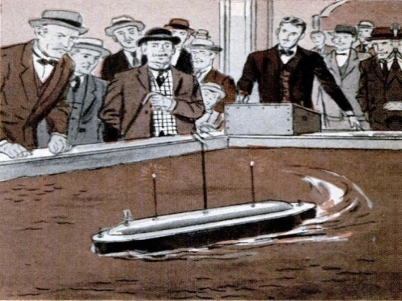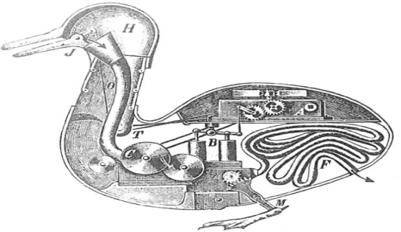

Fig.1 The mechanised duck of Jacques Vaucanson Fig.2 Nicholas the company’s robot-boat

experimentation

His duck could quack, sip water, and eat seeds and grains with a very lifelike gulping motion.16 In addition, he created three different humanoids, one of which played the mandolin, another the piano, and the third the flute. Radio wave. During the Electrical Exhibition, he showed off his The bulky shape of the computer system made it difficult to create a mobile robot at the turn of the 20th century. However, things shifted in the 1930s and 1940s with the development of the first digital computers. An early version of this article

incorrectly entered the author's name as William Grey Walter. (See Fig. 3) It could be programmed to go in a particular way, avoid hazards, and seek out a place to recharge when its power was running low.

Frederick Engelberger and George Devol, who had previously constructed the Unimate, which was the first commercial robotic arm, formed Unimation in 1954. Architectural engineers practice transport designing, including organising, planning, developing, supporting, and operating transportation offices. Transportation via air, the expressway, railway, pipeline, water, and even space is supported by the offices. Examining the topics covered by the expert panels of the six transportation-related divisions might provide a specific indication of the smaller parts of the transportation architectural area that are now important to structural experts (ASCE2014). There are 37 specialized boards and the majority of them include the actual framework of surface

transportation modes.. The Unimation PUMA (Programmable Portable Machine for Assembly) robot (Figure 4) was the first of its kind, and its release in 1978 sparked a global boom in the use of robots in manufacturing.Wabot-1 (Figure 5) was the first humanoid robot, created in the 1970s by researcher Hirokazu Kato of Japan's Waseda University. The robot included touch sensors and was operated by a computer. The robot was also able to move, carry things with its hands, and converse at a basic level.

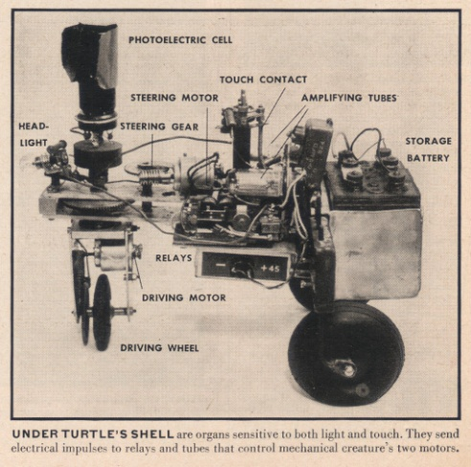 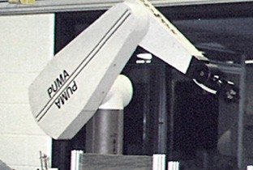

Fig.3 Grey, Walter William Tortoise Walter Fig.4 PUMA robotic arm from Unimation

The Genghis robot was created at the MIT AI lab in 1988. A little insectoid robot, it has six legs. It has 12 servomotors, a motor controller, and 22 sensors. Its unique construction allowed it to traverse rough terrain and negotiate obstacles with a minimum of difficulty.

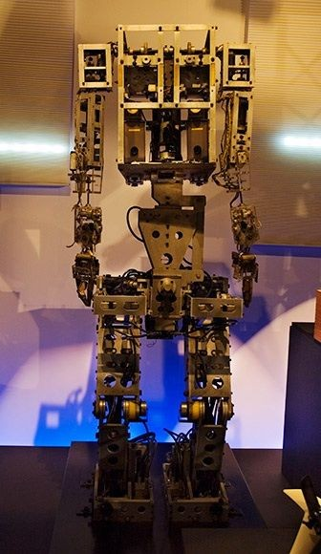 

Fig.5 Robots Wabot-1, a humanoid creature Fig.6 Automated vacuum machine Robo

Innovations in robots have multiplied in the 21st century. Numerous varieties of robots are now in use across a wide range of industries. The iRobot Roomba (Figure 6) is a notable robotic vacuum cleaner that was first offered to the public in 2002.29 The robot may be set to activate at certain periods and retrace its course when comes across an obstruction.Main parts of a robot.

* 1. **Body**

The majority of robots have bodies that perform similar tasks to human bodies. It protects the interior component from outside forces and also gives it its solid form. The body also serves as a mounting point for different parts like sensors.

The body of the robot should be lightweight, sturdy, and vibration-resistant for economical and efficient design. However, for social or humanoids, it's important that its design be intuitive to the humans it will be interacting with. Therefore, the robot's productivity would rise dramatically if it had humanlike characteristics or a sociable design.

* 1. **Locomotion**

A robot's means of moving from one place to another is called locomotion. In the past, robots were generally divided into two categories: those that could walk and those that could roll on wheels. Nonetheless, a number of other modes of propulsion have been created recently. Modern robots may enter places that are difficult for people to get since they can fly, swim, crawl, and use other abilities.

Consider the robot's ultimate function while deciding on a mode of movement. There are costs and benefits to using any locomotion method, whether it be on multiple or multiple legs, with wheels, or with treads. More energy is needed for multi-legged mobility than for wheels or treads to cover the same ground.

**Sensors**

Robots need sensors to operate in the actual world, much as humans rely on their five senses. The environment is monitored by sensors that transmit electrical messages to the brain.35 Sensors in robots may range from the simply useful (allowing the robot to proceed along an identified course) to the very sophisticated. The simplest use of sensors is to prevent robot collisions with obstacles or to allow for nighttime and daytime navigation.

Cameras are among the most fundamental types of visual sensors, since they provide the control unit with visual input in the form of pictures. The robot may use this information to determine things like the object's size, color, and distance. There are a lot of things that may be used as a substitute for the word "touch" in a sentence.

Laser range finders, which estimate distance by timing how long it takes a laser beam to reflect off an object and return to its sender, are an example of a more sophisticated kind of sensor. GPS, acoustic range finders, and sensors that detect movement are just a few examples of possible replacement sensors.

# OBJECTIVES

* The objective is to create self-driving construction vehicles that can effectively install highway pavement while maintaining accuracy and safety.
* The objective is to examine the incorporation of drones for the purpose of conducting aerial surveys, mapping, and monitoring in the context of highway pavement building projects.
* The objective is to develop and deploy robotic paving systems that can automate the task of laying asphalt and concrete pavement with exceptional accuracy and efficiency.
* The objective is to investigate intelligent compaction solutions that utilise robotic systems to enhance pavement quality and uniformity.
* The objective is to investigate the application of robotics in road marking and signpost installation to improve precision and productivity in highway construction.
* The objective is to create machine learning algorithms that can enhance construction processes and accurately forecast the performance of pavements in highway projects.
* The objective is to evaluate the ecological consequences of robotics in pavement building and devise approaches to ensure long-term viability.
* To assess the safety implications related to the implementation of robotic technologies in highway pavement construction.
* To do cost-benefit assessments on the use of robotics in highway pavement construction in order to assess its economic viability and return on investment.
* The objective is to analyse the challenges and opportunities associated with implementing robotics in highway pavement construction and provide ideas for overcoming any obstacles.

# LITERATURE REVIEW

**Dr. Emily Smith** examines the progress made in self-driving construction trucks, highlighting advantages such as improved productivity and enhanced safety. She also addresses the obstacles faced, including issues with sensor dependability and navigation. Professor James Johnson evaluates the use of drones for aerial surveying, mapping, and monitoring in pavement building. He emphasises the progress in technology and the incorporation of drones into construction processes.

**Dr. Sophia Martinez** evaluates robotic paving methods designed for the installation of asphalt and concrete pavement. These systems demonstrate advantages in terms of accuracy, efficiency, and quality management. Professor Michael Brown is doing research on intelligent compaction technologies to enhance the quality of pavement. He is specifically focusing on the issues associated with interpreting data and integrating equipment. Dr. Rachel White investigates the use of robots in the placement of road markings and signs, with a focus on achieving improved precision and efficiency.

**Professor David Lee** explores the use of machine learning in enhancing building processes and forecasting pavement performance. He emphasises the use of data-driven models and addresses the difficulties encountered during implementation.

**Dr. Jessica Garcia** conducts research on the environmental effects of robotic building technologies, with a focus on promoting sustainability and developing methods to reduce their ecological imprint. Professor

**Andrew Clark** investigates the safety factors involved in the creation of robotic pavements. He examines research on reducing risks and the establishment of regulatory frameworks.

**Dr. Jennifer Adams** does a cost-benefit study on the use of robotic techniques for constructing pavements. She examines the economic consequences and many elements that affect the return on investment. Professor Robert Wilson discusses the difficulties and advantages of using robots, with a focus on working together and developing plans to overcome obstacles.

**Dr. Jessica Garcia** conducts research on the environmental effects of robotic building technologies, with a focus on sustainability and methods for reducing their ecological imprint.

**Professor Andrew Clark** examines the safety factors involved in the creation of robotic pavements, analysing research on reducing risks and the establishment of regulatory frameworks. Materials like precast concrete and wood pieces make on-site construction a breeze. Bricks are still commonly utilized in modern building, nevertheless. Bricks are also manufactured in a diverse selection of forms and materials. Despite several failed efforts in the past, two firms have lately achieved commercial success with their bricklaying robots: Robotics for Building and Fast-Building.

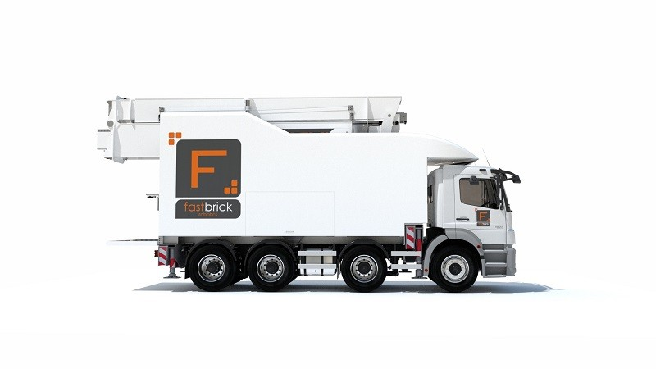

Fig. 7 Hadrian X robot.

* + 1. **Hadrian X robot by Fastbrick Robotics**
       1. ***How robot works***

Hadrian X (Figure 43) was created by Fastbrick Robotics, an Australian firm. The robot is readily transported to the building site thanks to its broad manipulator arm and truck-mounted base. The robot may also be mounted into a boat or a crane, depending on the circumstances at the location (Figure 44). Robots have metal and aluminum and carbon fiber composites for their bodies. Dynamic Stabil Technology (DST) mitigates the impacts of wind et vibration when the robot's arm extends to a maximum of 30 meters in length (Figure 45). Using this technlogy, the robot can account for and correct for any alterations to its trajectory.

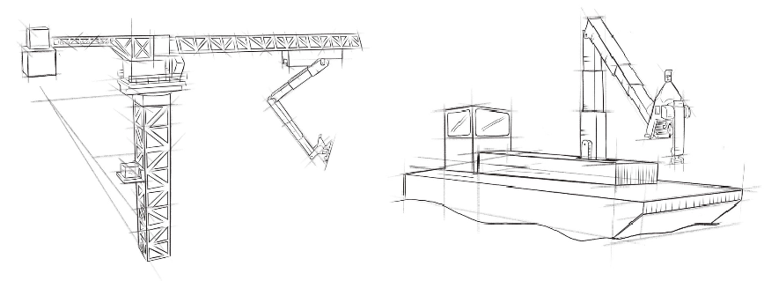

Fig. 8 A proposed basic applications method.

The blueprint is digitized into a three-dimensional model, which is then sent into the robot's command center, where the robot "prints" the model brick by brick. The purpose of the robot is to use a huge variety of brick sizes (up to 500 mm in length, width, and height). The bricks are kept in the robot's truck, and it is responsible for all the labor involved in constructing the structure, including loading, cutting, applying glue, and putting bricks. The robot's accurate brick-laying is made possible by a laser tracker. The glue used by the robot only takes 45 minutes to dry. When compared to the time and effort required to remove the adhesive, the time and effort saved is worth the cost. When compared to regular mortar, the unique glue utilized greatly improves the structure's durability. There is a 70% improvement in thermal and acoustic qualities.

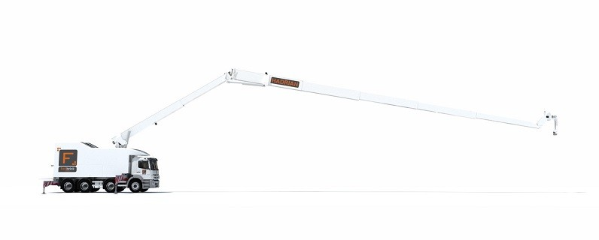 Fig. 9 The robotic arms length.

* + - 1. ***Productivity***

Hadrian X can lay almost a thousand blocks each hour, whereas humans can only manage roughly 400 blocks per day. Furthermore, the robot can operate continuously for long periods of time, regardless of the time of day or the weather. So, in two or three days, the robot can construct a typical home.

* + - 1. ***Market price***

Each Trajan X robotic is estimated to cost two million dollars AUD (approximate 31,7 million CZK).

* + - 1. ***Application***

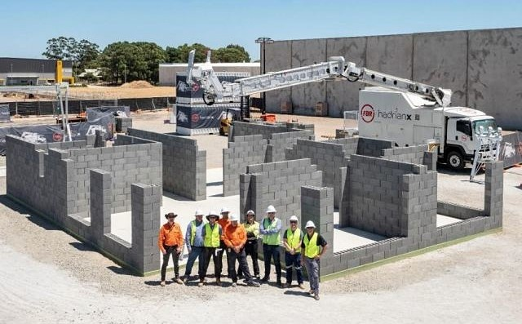Hadrian 105, the previous iteration of a robot, has begun its actual testing phase in 2015. There are three bedrooms and two bathrooms in this roomy, open concept home. The home was 180 square meters in size, and construction took fewer than three days, including both daytime and nighttime hours. All applicable building codes were checked, and the structure was found to be in compliance. Fastbrick Robotics signed a deal with Saudi Arabia to construct 50,000 homes by 2022 after positive test results.

Fig. 10 Build1 project.



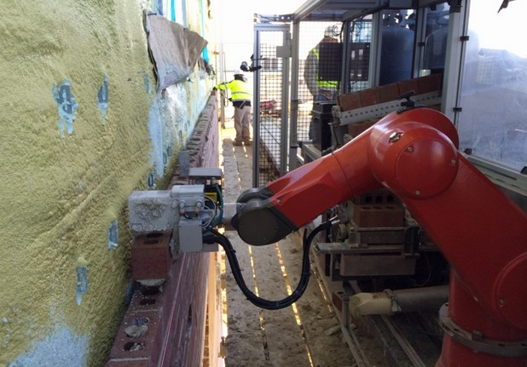

Fig. 11 SAM100 in process.

The robot can boost production by a factor of three to five, and it can eliminate up to 80 percent of the need for employees to do heavy lifting. Companies who have used SAM100 have claimed a 400% improvement in bricklaying productivity.

* + - 1. ***Market price***

Each SAM100 costs $500,000. This is equivalent to around 11.5 million CZK. Additionally, the firm claims that renting the space would only cost you $3,300 a month (approximately 76,000 CZK).

The following scenario demonstrates a monetary upside to buying the robot. For construction employees in the United States, the minimum hourly salary is $15. When you consider that a person can only lay 400–500 bricks in a single day, the price of placing a single brick rises to almost 27 cents. However, the cost per brick drops to 4.5 cents if the robot can lay around 3,000 each day. As a result, the robot may reduce bricklaying expenses by as much as 7 times.

The same math may be used if the robot is headed towards the Czech Republic. If a bricklayer is paid 100 CZK per hour and 400-500 bricks are placed in a single shift, then the cost per brick is around 2 CZK. When compared to the robot, which will set you back 1 CZK (about 4.5 cents) to place a single brick. Even so, the robot will save half the money.

* + - 1. ***Application***

Several construction sites around the United States have already included the SAM robot into their workflow. Figure 49 depicts a hospital and health center under development in Michigan, USA. More than 17,000 bricks for this structure were laid by robot.

* 1. **Control system**

The "brain" of a robot is its control system. The data collected by sensors is sent to the control system where it is analyzed. The majority of industrial robots are used for continuous duties that have already been programmed into the robot. However, most recent progress has focused on integrating AI into the authority and control infrastructure. Artificial intelligence (AI) would make it unnecessary to pre-program robots by allowing them to learn from their mistakes and make choices based on the information they are fed.

# METHODOLOGY

The earliest robots were built for use in factories, where they liberated employees from dangerous and tedious duties like welding and assembly line labor.46 However, now robots are being created in a variety of industries. There has been a proliferation of robotic innovations in recent decades, serving a wide range of functions in industries as diverse as defense, building, medical, and social welfare.

One of the rare instances is the well recognized Segway scooter, which is powered by a battery and using specialized sensors to maintain its equilibrium. A social robot, like the Roomba, is assisting people with domestic cleaning; While number are tunnel-crawling robots used to examine pipelines that are inaccessible to humans, number  are humanoid robots that serve as guides at museums. Not every advancement in robotics can be included, however several notable robots are provided here.

* 1. **Robots in different fields**
     1. **Robotics application in medical field**
        1. ***Surgical robots***

Almost two decades have passed since robots were first employed in surgery. Instead than replacing doctors and nurses, much recent research in robotics has sought to complement them. These robots have better monitoring systems, and this improves surgical accuracy. Intuitive Surgical's Da Vinci system is one such example (Figure 7). Robotic components include a 3D camera that may be inserted into a patient via a tiny cut and sent to an external screen. There are three or four robotic arms on the robot, each holding a surgical tool; the surgeon operates the robot from a remote monitor.

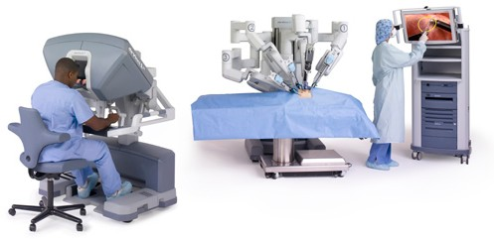

Fig. 11Da Vinci robotic surgery assistant

* + - 1. ***Robotic prosthetics***

A prosthesis is a medical device meant to replace or improve the function of a human biological aspect. There are about 45 million amputees in the globe. Figure 8 shows an example of a robotic prosthetic limb. The biosensors in the prosthetic limb allow the actuator to receive signals from the patient's central nervous system. As a result, mental control of the limb is feasible.

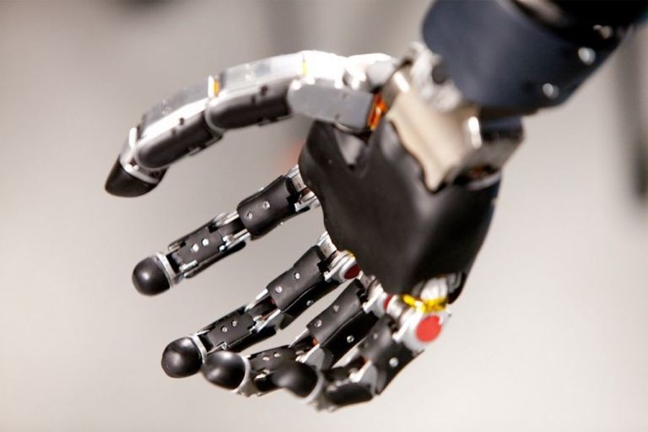

Figure 12. Initial robotic hand with robotics

* + 1. **Robotics application in military**
       1. ***Humanoids***

The Defense Advanced Research Programs Agency (DARPA) of the United States military has invested much in research and development of military robots.55 Military robots are multi-purpose, serving not only in battle but also in search-and-rescue missions. Humanoid robot Atlas (Figure 13) is one such instance. It was designed for emergency situations, such as nuclear meltdowns or earthquakes. The Atlas is capable of penetrating barriers and withstanding radiation and other environmental hazards.

* + - 1. ***Unmanned Ground Vehicles***

Wheels, rails, or even two legs may be used to propel an Unmanned Ground Vehicle (UGV). Over the last two decades, tracked UGVs have seen widespread employment in the military, particularly in the region between Europe and Asia. Figure 14 shows an iRobot PackBot robot, a tracked UGV that can be operated remotely. It has been put to use in the combat zone to locate and safely dispose of thousands of explosives.

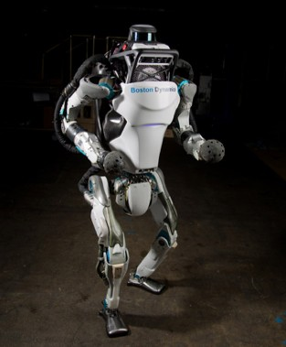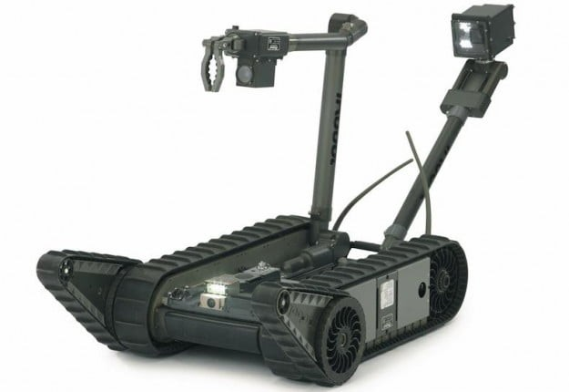

Fig. 13 Robotic Atlas human-like Fig. 14. UGV’s PackBot for use in the armed forces.

* + 1. **Industrial robots**

Historically, industrial robots have been created to take over jobs that people find tedious, dangerous, or otherwise unappealing to do. Industrial robots also provide improved accuracy and productivity, both of which lead to cost savings. Welding a vehicle frame by hand may take four to six hours, while welding robots can do the same job in half that time.

* + - 1. ***Robotic arms***

Most industrial robots nowadays are variations on Figure 15's robotic arm. Whether or whether it can move or turn in space is one of the criteria for categorizing it. Although both cylindrical and spherical arms may rotate, Cartesian robots are limited to linear motion along the x, y, and z axes. Robots with articulated joints more mobility, so they're put to use doing jobs that need more precision, like welding.61 The majority of robotic arms utilized in industry today are found in the automobile industry.

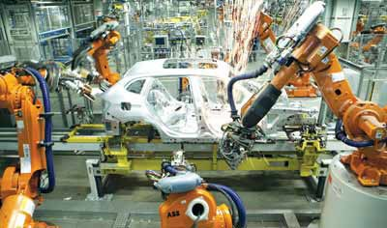

Fig. 15 Riveting an automobile frame using a robotic arm.

* + 1. **Space exploration robots**

Since the 1970s, there has been a major focus to create robots for use in space exploration. It is significantly more cost-effective and risk-free to send robots to space than humans. Robots can work for long periods of time without sleep, food, or a pleasant environment. In addition, they are able to thrive in hostile situations.

* + - 1. ***Rovers***

Spirit (2004) and Opportunity (2004) are two well-known rovers that were deployed to investigate the Martian environment. The primary function of these rovers was observation. Curiosity, a more advanced rover, was sent to Mars in 2012 (Figure 16). It could collect soil samples and even carry out geological surveys.

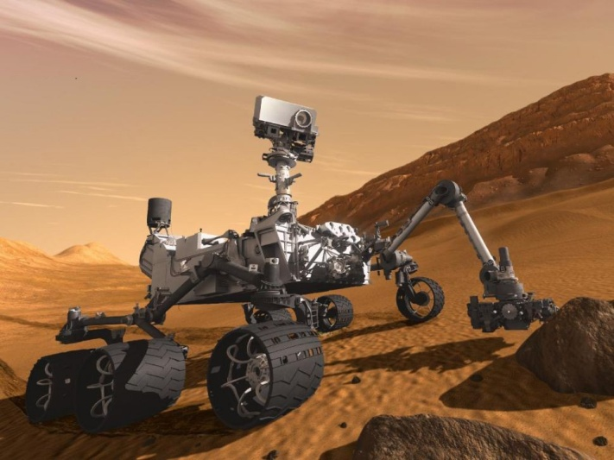

Fig. 16 The agency’s Discovery Rover on its Journey to Mars

* + - 1. ***Humanoids***

The National Astronautics and Space Administration (NASA) developed the humanoid robot Valkyrie (Figure 17). It stands at a height of 190 centimeters and has a mass of around 136 kilograms; its purpose is to inhabit the planet Mars in the not too distant future. Valkyrie has high-definition cameras on its torso, 38 senses on each hand, and a small number of motors to manage its 44 degrees of freedom.

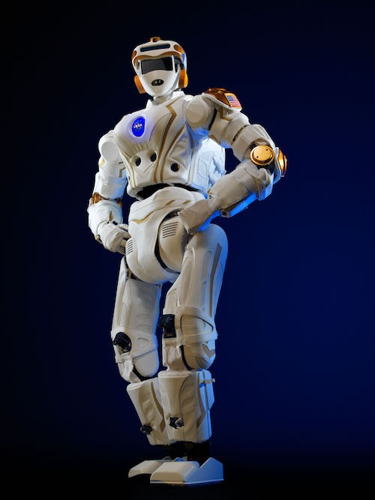

1. **RESULT**

**Robots in concrete and masonry field**

* + 1. **printing robots**

Three-dimensional (3D) printing is one of the latest discoveries that has the potential to radically alter the way buildings are constructed in the future. While the robot's installation may take some time, it may greatly improve construction efficiency once it's up and running. The use of 3D printing will reduce material waste, shorten production times, and make it possible to make complex geometries with ease.

In order to print a 3D item, a computer software must first convert a 3D model of the object into a 2D series of layers. The model is then printed by a robotic arm (Figure 18) in layers, one on top of the other. Plastic resins, metals, wood, carbon fibers, and even concrete are just some of the many materials that may be utilized in 3D printing.

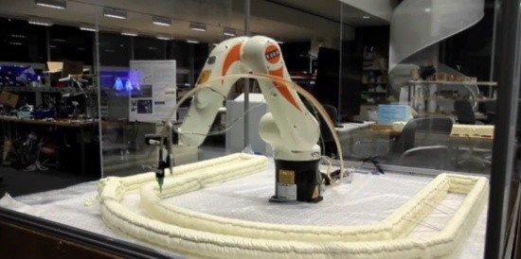

Fig. 18 A representation of a robotic arm made using 3D printing.

In the event that you're looking for a building that can be created in a short amount of time, then you've come to the right place.139 A Shanghai construction firm, for instance, erected ten modest homes for families in a single day at a cost of less than $5,000.140 The world's biggest 3D-printed bridge was recently constructed in Shanghai (Figure 38a). It took 450 hours to print with two robotic arms and measures 26.3 by 3.6 meters.

There is currently no method developed by researchers to add steel reinforcing to 3D printed buildings. The arch construction of the bridge puts its whole cross section under compression, negating the requirement for steel reinforcing bars. The bridge's walkway was constructed of regular concrete with white pebbles placed inside of decorative molds (Figure 19).



Fig. 19 the city’s 3D manufactured bridge.

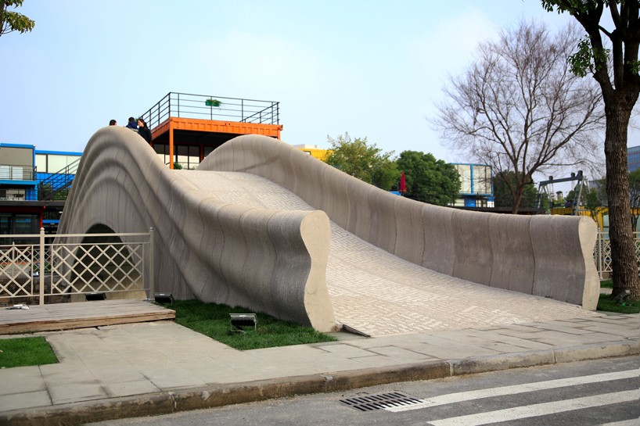

* + 1. **Steel reinforcement placing robots**

Reinforcing steel bar installation takes time if done manually. Workers' health might deteriorate rapidly from constantly lifting heavy bars. In particular, bars used for strengthening the length and weight of a foundation are indicative of its size. Figure 20 depicts a reinforcement-placing robot created by the Kajima Corporation for use in the building industry. This tracked robot's manipulator is equipped with an end effector for handling steel bars. It can transport around 20 bars at once and put them at precise intervals.

Fig. 20 Reinforcement positioning robot.

* + 1. **Concrete laying robots**

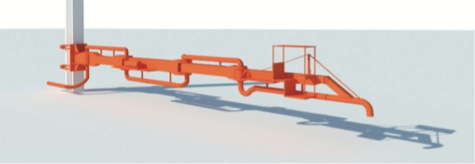When it comes to laying concrete, robots can do a better and quicker job than humans. Takenaka Corporation's robot is a good example (see Figure 21). It is small enough to be utilized on the spot, making it ideal for repairs to concrete floors. The instrument may be installed on an upright or other horizontal stand, and its reach can be modified up to 20 metres. either programming the robot to operate continuously in accordance with preset parameters or physically by a human who may adjust the rate as well as the direction of pouring concrete when necessary. The amount of physical labor performed by construction employees was reduced by 30% in testing, although the robot has not yet been marketed.

Fig. 21 Robotic cement pouring method.

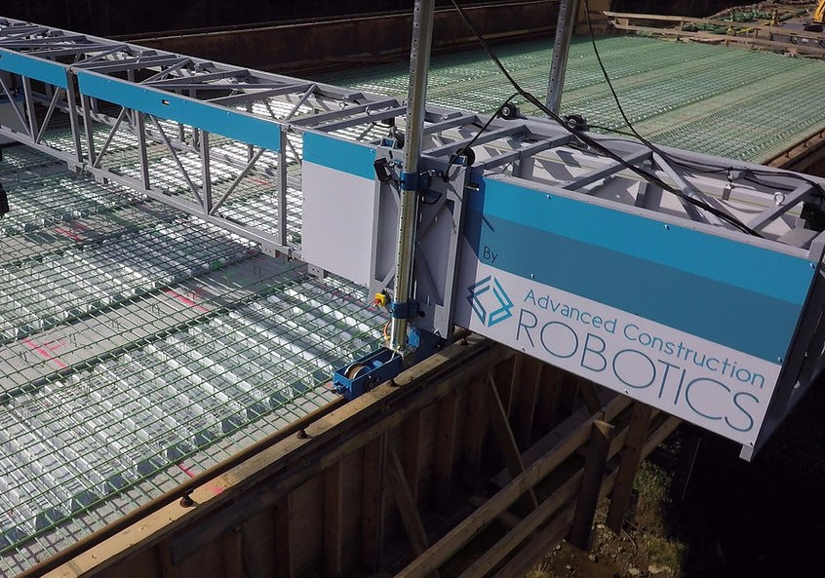

Fig.22 Robotic cement pouring method.

* + 1. **Steel reinforcement tying robots**

TyBot (Figure 22) is a reinforcement-tying robot recently created in the United States by Advanced Construction Robotics (ACR). It used to take a lot of time and effort to do the task by hand. This robot comes in handy while working on massive projects like building bridges. The system comprises of a robotic arm mounted on a crane, which uses sensors to locate intersections at which ties must be placed.

* + 1. **Concrete floor finishing robots**

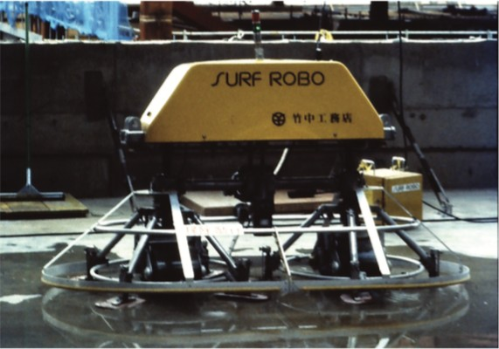Floor trowelling is the last step in concrete flooring installation, and it requires employees to spend several hours in the bent posture. In order to speed up and improve the quality of this procedure, a select few businesses developed trowelling robots. Takenaka Corporation's Surf Robo (Figure 23) is one such example. The robot has eight trowels attached to two end effectors, and it may be commanded either by predetermined instructions or by remote control. In order to get a certain look, one need just vary the rate at which they apply pressure.

.

Fig. 23 Surf Robo concrete finishing robot

1. **CONCLUSION**

What seems like science fiction to some may be common sense to others, and vice versa. The robotics sector is making modest but steady growth, much as other new technical innovations have done throughout human history.

Similarly, advancements in robots for the building trades have accelerated in recent years. This study aimed to determine the ways in which robots may eventually change and be used in the building sector. Future use of robots may greatly improve the construction sector, which has seen a decline in productivity and professional personnel. The majority of robots are built for repetitive activities, as shown by an assessment of the currently marketed and research-stage robotic technology. Nonetheless, there is tremendous room for development in the years to come.

It's no secret that the construction industry is rife with shady characters and shadier practices. Although there are enormous opportunities, there are also numerous obstacles in the way of a completely roboticized building site. This concerns the security of humans who would be working alongside the robot in an unpredictably hazardous environment. However, progress in the years to come should allow robots to be equipped with artificial intelligence. It has the potential to totally transform the building sector and provide solutions to the issues stated above.

In addition, the findings demonstrate that the reception of robots varies from one culture to the next. There are also few societal concerns associated with robot adoption. There is widespread panic about robots taking human occupations because of widespread misinformation about them. Many scientists are of the opinion that humans should welcome the robotic revolution with open arms, realizing that their use would vastly enhance human existence. To the extent that robots accomplish anything, the monotonous labor We as a species need to divert our efforts and put out more originality and creativity.

Writing this study has been a challenging yet rewarding experience for me. As a result of my education, I now consider the potential of totally robotizing the building site to be more than just a pipe dream of a select group of scholars. Most significantly, I've been interested in this area of study and may pursue it further in the future by attending university for robots.

The development and use of robots have accelerated in recent years. The proliferation of robots is expected to accelerate in the near future. According to industry experts, the trajectory of robotics development is mirroring that of computers in the 1990s. At originally, only a select group of professionals had access to and made use of computers. However, with the development of the Internet, home computers quickly gained popularity. Similarly, robots will eventually be integrated into every facet of human life.

Increasing numbers of nations are welcoming the robots revolution with open arms. By 2020, the government of South Korea hopes to put robots in every home, while the Japanese estimate that $65 billion will be generated by the robotics industry by 2025.

The robotics industry as a whole will be affected by the following trends and developments. The progress of robotics in general and the growth of construction robots are inextricably linked. Future progress is also dependent on issues such as public opinion and how humans will work together with robots. As a result, we also talk about certain societal factors.

The degree to which robots are accepted in human communities varies greatly throughout cultures. Studies indicate that Eastern countries are more inclined than Western ones to support the development of robots. It's interesting to note that the prevailing religious views in both cultural settings often have an impact on the general public's acceptance of robots.

1. **REFERENCES**
2. Sara Reichenbach, Benjamin Kromoser 2021. State of practice of automation in precast concrete production. Journal of Building Engineering,43, (2021)
3. Xiaojuan Li ,Chen Wang , Ali Alashwal 2021. Case Study on BIM and Value Engineering Integration for Construction Cost Control. Hindawi Advances in Civil Engineering.
4. Pathan.Md Rafi, K.J.Brahma Chari 2019. 5D Applications of BIM in Construction Management International Journal of Recent Technology and Engineering,7, Issue-6C2
5. Suvash Chandra Paul A review of 3D concrete printing systems and materials properties: current status and future research prospects” Rapid protyping Journal . 24, Issue 4
6. Zuzana Strukova, B Matej Liska . Application Of Automation And Robotics In Construction Work Execution. Journal Of Interdisciplinary Research
7. Celaschi F. 2017. Advanced design-driven approaches for an industry 4.0 framework: The human-centred dimension of the digital industrial revolution. Strat Des Res J. 10(2):97–104
8. Akshatha, D. Vimala M, Sahana S and Manjula M, “Robotics in Construction Technology”, International Journal of Advance Research in Science and Engineering, Vol. No.6, Issue No.10, (2017): 547-553
9. alaguer Carlos and Mohamed Abderrahim (2008), “Trends in Robotics and Automation in Construction”, Robotics and Automation in Construction, Carlos Balaguer and Mohamed Abderrahim (Ed.), ISBN: 978- 953-7619-13-8, InTech
10. Bock Thomas (2007), “Hybrid Construction Automation And Robotics”, 24th International Symposium on Automation & Robotics in Construction (ISARC 2007) Construction Automation Group, I.I.T. Madras
11. Chaitanya Goyal (2012), “Automation and Robotics in Construction: Applications, Advances and Challenges.
12. Elattar S.M.S. (2008) “Automation and Robotics in Construction, Opportunities and Challenges”, Emirates Journal for Engineering Research, Vol. 13(2),p. 21-26
13. Nashwan Dawood and Serafim Castro (2009), “Automating Road Construction Planning With A specific-Domain Simulation System” Journal of Information Technology in Construction - ISSN 1874- 4753