MBA Project Dissertation Report on

**Customer Engagement Behavior on Social Media Platforms**

***Submitted by***

**Shivam Tomar**

**Roll No: 22GSOB2010584**

**Under the Guidance of**

**Dr. Diksha Bisht**



**GALGOTIAS SCHOOL OF BUSINESS**

**Galgotias University**

Gautam Buddh Nagar, Greater Noida, Uttar Pradesh 201308

**CERTIFICATE**

This certificate confirms that Aditya Raj has completed their master's thesis titled **"Customer Engagement Behavior on Social Media Platforms"** under my supervision and guidance. The project report is submitted as part of the requirements for completing a two-year, full-time Master of Business Administration (MBA) degree.

Name & signature of faculty

**Dr Diksha Bisht**

Assistant Professor

Date: -

**Declaration**

I, **Shivam Tomar,** roll no. **22GSOB2010584,** student of School of Business, Galgotias University Greater Noida, hereby declare that the Master’s Thesis on “**Customer Engagement Behavior on Social Media Platforms”** is an original and authenticated work done by me. I further declare that it has not been submitted elsewhere by any other person in any of the institutes for the award of any degree or diploma.

Name and signature of the student

**Shivam Tomar**

Date:-

**Acknowledgement**

I would like to express my heartfelt appreciation to all those who have contributed to the completion of this project. I am deeply grateful for the knowledge and expertise shared by everyone involved. Special thanks to **Dr Diksha Bisht**, my faculty guide, for providing invaluable guidance and support throughout the project. I am truly thankful for their mentorship and assistance.

I would also like to extend my gratitude to my dear friends for their cooperation, advice, and encouragement during the challenging journey of completing this project and preparing the report.

Overall, I am thankful for the opportunities and resources provided to me, and I am grateful for the collaborative efforts that have made this project possible.

**Executive Summary**

The aspect of social community, social ties has the most significant effects among the antecedents influencing consumer engagement in social media advertising. This indicates that a higher level of interaction between a user and other social community members stimulates the exchange of information or thoughts. By contrast, in terms of advertising, entertainment level and interactivity exert a more significant effect. Social media advertising with a higher perceived entertainment level or a mutual connection with users increases the favourability of users towards advertising, thus increasing their attention and interest. According to these findings, among the seven antecedents affecting users’ engagement behaviour in social media advertising, social ties, entertainment level, and interactivity have the most significant effects. Moreover, according to the consequences of users’ engagement behaviour in social media advertising, sharing, commenting, and creating behaviour in social media advertising have significant effects on the enhancement of the relationship of the users with social community members, brands, and products. This finding indicates that more frequent consumer engagement in social media advertising represents that consumers have a specific emotional preference for the brands involved, thus increasing their satisfaction and connection with the brands and products, consequently resulting in positive effects.

This study contributes to the existing research in several ways. We found that, among the antecedents affecting users’ engagement in social media advertising, social capital and social influence had nonsignificant effects. This could be because the brands used in this study comprised a generalised brand and a masstige brand. Users thus faced lower risk when purchasing such brands or a lower level of complexity in their purchase decisions. Therefore, social capital and social influence have nonsignificant effects on relationship enhancement. Future research should target apparel brands with higher price levels to generate different consequences.

Regarding the practical contribution of this study, we explored the consequences generated from social media advertising by measuring social media engagement behaviour. According to the research results, marketers and researchers should consider the following recommendations when designing social media advertising. First, during the design of social media advertising, marketers should focus on managing fan pages or social communities on online social platforms to increase the activity and connection between users and social community members or fan pages, thereby enhancing users’ engagement behaviour. Moreover, because we reveal that the perceived informational degree and credibility of advertising had nonsignificant effects, marketing personnel should focus on the level of entertainment and interactivity in advertising designs, enabling users to perceive the fun and novelty of advertising. Users’ interests and purchasing preference are highly correlated; hence, enhancing such interests in advertising can stimulate users’ engagement behaviour. In addition, according to the results of examining the consequences of users’ engagement behaviour in the social media advertising, users’ engagement behaviour may vary depending on their perceptions of social media advertising. Moreover, users’ activity level in a social media community changes. This study selected the relatively well-known brands Uniqlo and Lativ, and the overall evaluation of these two brands was considered to be satisfactory, without many negative comments. Therefore, commenting behaviour had less significant effects on advertising. Future research should consider the fact that the valence of comments can influence the brand relationship. Moreover, marketing personnel can organise creation events focusing on the brands or products on the communities or fan pages to stimulate consumer engagement in the fan pages.

|  |  |  |
| --- | --- | --- |
| **S.NO.** | **Particular** | **Page No.** |
| **1.** | Certificate | 3 |
| **2.** | Declaration | 4 |
| **3.** | Acknowledgement | 5 |
| **4.** | Executive summary | 6-7 |
| **5.** | Introduction | 9-10 |
| **6.** | Objective of the study | 10-12 |
| **7.** | Literature Review | 13-16 |
| **8.** | Research Methodology | 17 |
| **9.** | Hypothesis Development | 18-27 |
| **10** | Data analysis and results | 28-35 |
| **11.** | Discussion | 36-39 |
| **12**. | Limitations and Future Research | 40 |
| **13.** | Conclusion | 41 |
| **14.** | References | 42 |
| **15.** |  |  |
| **16.** |  |  |
| **17.** |  |  |

**Content**

**Introduction**

In recent years, advances in technology and the prevalence of the Internet have resulted in the rapid development of social media. According to the 2013 statistics for eMarketer, a quarter of the total global population uses social networking sites, and this number is expected to reach 2.55 billion people in 2017. This indicates that social networking sites are widely used and that their influence should not be underestimated. According to Kelsey, the amount of money invested in community advertising in the United States was US$6.8 billion in 2014, and this amount was projected to increase to US$9.2 billion in 2016. Social media advertising has become a focal topic in social marketing, and it plays an increasingly vital role in corporate marketing. With the emergence of social media websites, firms and corporations have drastically increased their investments in social media advertising, thus indicating its significance in their success. Previous studies have investigated the influence of media advertising, including consumers’ acceptance of social media advertising as well as the effects of social media advertising on consumers’ decision-making process. The preceding observations indicate that previous studies on social media advertising have focused on the conventional effects of Internet advertising; however, few studies have discussed consumer engagement behaviour in Internet advertising and its consequences.

With the rapid growth and development of social network services, companies have largely increased their advertising budgets for social media advertising. Social media advertising has attracted a great deal of attention among marketers and researchers. However, very few works of research have focused on social media advertising and have only concentrated on measuring clicking effects. This study established a model to analyze customers’ engagement in social media advertising, the relationship among the antecedents of social media advertising engagement, the engagement behaviours in social media advertising, and the consequences of social media advertising. This study conducted an online survey among 502 valid Internet users. Partial least squares regression was used to analyze the relationship among the antecedents and consequences of user engagement in social media advertising. Finally, based on the findings, discussions and conclusions will be provided regarding further research and practices.

**Objective of the study**

With the emergence of social media websites, firms and corporations have drastically increased their investments in social media advertising, thus indicating its significance in their success. Previous studies have investigated the influence of media advertising, including consumers’ acceptance of social media advertising as well as the effects of social media advertising on consumers’ decision-making process. The preceding observations indicate that previous studies on social media advertising have focused on the conventional effects of Internet advertising; however, few studies have discussed consumer engagement behaviour in Internet advertising and its consequences.

The current study developed a model to explore the antecedents of consumer engagement behaviour in social media advertising and the consequences of such behaviour on the social community member relationship, product relationship, and brand relationship. Therefore, the objectives of this study are outlined as follows:

1. To explore the antecedents of consumer social media advertising engagement and the value generated from such engagement.
2. To confirm the constructs of the antecedents of social media advertising engagement in this study by using factor analysis.
3. To investigate the causal relationship between the antecedents of engagement in social media advertising and consumer engagement behaviour in such advertising as well as to explore the social community member relationship, product relationship, and brand relationship derived from such behaviour.
4. To generalize the empirical results of this analysis and provide suggestions and conclusions related to social media advertising marketing as a reference for future corporate social marketing strategies and academic studies.
5. To study customer engagement behaviour on social media platforms involvement has a significant influence on positive emotion.

1. To study different types of customer behaviour on social media.
2. To study whether consumption has a significant influence on Product-oriented impulse buying.
3. To study the reason of Impulse customer buying behaviour for different products on social media platforms.
4. The need for research to identify the antecedents of Customer Engagement Behaviour (CEB) in relation to social media platforms.

**Literature Review**

A literature review on the topic of consumer engagement behavior on social media platforms a rich body of research that explores various aspects of this consumer behavior. The literature spans disciplines such as psychology, marketing, consumer behavior, and retail studies, providing valuable insights into the drivers, motivations, and consequences of impulse buying in the fashion industry. The term engagement has been used in the academic literature since 2005 and has become increasingly popular in conceptual and empirical studies alike defines customer engagement on social media as “the extent to which the organization’s important customers are active in using social media tools”. In line with this notes that “consumers use an array of tools and resources to engage with brands”. Thus, activities related to a brand on social media can entail different behavioural manifestations of engagement. The qualitatively varied forms of customer engagement on social media can be classified according to the COBRA typology (consumer online brand related activities) according to whether the activity exhibits one of three dimensions: content consumption, contribution or creation.

In addition to the behavioural manifestations of engagement on social media argues that “consumer interactions with brands have a much stronger impact on consumer behaviour compared with traditional forms of communication”. As a result, significant power has shifted from brands directly to consumers. Social media has transformed online customer behaviour, as consumers now often depend on each other more than on companies for information and this has important consequences for firms, products and brands. CEB on social media goes beyond financial transactions and incorporates a wide range of examples. The behavioural manifestations can be positive (e.g. posting a brand message on a blog) or negative (e.g. organizing public actions against a firm) and include posting, commenting, sharing and liking. Consequently, engaged customers play a key role in marketing activity by providing referrals or recommendations for specific products, services and brands to other potential consumers. In addition, although customer engagement behaviours have a brand/firm focus, they may be targeted to a much broader network of actors, current and potential customers. Customer engagement as a process includes commitment for new customers, increased levels of involvement, increased levels of trust for repeat purchase customers and the development of affective commitment towards the brand, leading to a state of brand loyalty. Despite the increasing importance of CEB on social media for firms, there is yet no existing systematic review of the antecedent causes of the phenomena. In order to redress this knowledge gap, we undertook a systematic review of the literature to identify antecedent causes identified through empirical study, and subsequently to provide a

qualitative synthesis of the contemporary engagement literature. In the following section we

outline the method used to generate a corpus of extant literature.

In addition to the long-drawn technology adoption literature a parallel stream of research has evolved analysing post-adoption use and adaptation. For instance, the Coping Model of User Adaptation (CMUA), developed by Beaudry & Pinsonneault, highlighted the essence of user-end adaptation and inspired quantitative analysis to ascertain nomological interrelationships amongst constructions of adaptation. They treated adaptation as post-adoption actions and/or processes. However, they fell short of capturing the integrative dimension to discover collective adaptation practice. Issues such as technostress and technology appropriation have received increased research attention in the last decade. Simultaneously, a fairly strong research stream within IS has developed in the last two decades that seeks to assess the impact of consumers’ interaction and engagement with technology. Both technology adoption and adaptation models mostly focus on the changes in users’ beliefs, attitude, knowledge and skills towards a technology. Attitudinal components have been identified as significant antecedents to adoption and adaptation decisions. However, there is a lack of scholarly works on the combined effects of cognitive and affective attitudinal components on technology adaptation, as suggested in relevant and contemporary scholarship.

Nevertheless, semantic and conceptual debates surrounding technology use and adaptation are far from over. Two of the leading scholars championing various forms of technology adoption models, such as the UTAUT, UTAUT2 and the Multi-Level Framework recently coined a new model of Adaptation to Information Technology. In that particular model, performance expectancy and perceived usefulness have been classified as perceived opportunity. Other researchers make a similar argument that individuals develop their beliefs and understanding of different aspects of technology that are critical to functionality, which they perceive to be novel, to provide compatibility and task technology fit and to improve their performance. Therefore, they would perceive technology as an opportunity.

Similarly, individuals’ adaptation of technology is based on their evaluation of the level of control they have over that technology. Consumers engage more with technology when they are given control over it. Bala & Venkatesh argue that perceived control has conceptual similarities with the technology adoption literature. It has similar dimensions to perceived behaviour control in TPB and facilitating conditions in UTAUT. Individuals’ level of competence and ability to leverage resources determine their technology adaptation behaviour. Thus, they react positively when technological platforms give them control. Equally, social influence, in adaptation literature, is described to affect technology adaptation behaviour, as it has an impact on individuals’ primary appraisal of a technological disruption. Venkatesh describes that social factors, subjective norms and social image are related terms and combines them into social influence. This concept also constitutes social interaction, social ties and social support. In addition, enjoyment is an intrinsic hedonic motivation that encourages individuals to engage with technology. constituting fun and pleasure to enhance technology interaction, it constitutes pleasure and flow. Similarly, self-enhancement affects adaptation behaviour, as it increases individuals’ self esteem, due to which they overwhelmingly update and present their self-focused status online, and share information regarding themselves that they feel would enhance their status and image to attract attention from others. It also accounts for self fulfilling dimensions of self-esteem and self-status. Accordingly, individuals’ fear has a huge impact on the post adoption and adaptation of technology. Individuals make emotional appraisals when coping with technological threats, as it comprises their feeling of threat, susceptibility to a malicious technology or the sense that technology harms their well-being (Liang & Xue, 2009). Similarly, trust is an important factor which reflects predictability in post-adoption use of technology. It constitutes behavioural beliefs about technological attributes determining predictability and is also conceptualised as a propensity to depend on technology, protection and confidence in technology.

**Research Methodology**

To empirically validate the framework, following the guidelines provided by Krejcie & Morgan and Saunders, Lewis & Thornhill, a random survey questionnaire using quantitative data was chosen (as also illustrated in Figure 2). The survey questionnaire is considered to be an appropriate confirmatory means to measure consumers’ attitude and adaptation behaviours. The survey was carried out in three steps: a pre-pilot test, a pilot test and a main survey. The target population was social media consumers, as social media platforms are a rich source of insight for practitioners and marketers. For a theoretically sound conceptualization, scale development and a valid measurement scale, the paper consulted Anderson and Gerbing. Consistent with the scaling literature, multiple items were developed for each dimension. The domain of constructs were defined and items were generated for the instruments and scales were adapted from earlier studies so that items measuring the constructs are adapted appropriately for the reliability and validity purposes. Instruments and scales from previous studies are adapted to match the context of this research. Furthermore, hypotheses are developed based on cause and effect relationship in the model. Appendix B (Table 8) provides details of the literature used to scale each dimension. The experience survey was used to ask an expert panel (academics and PhD students having expertise in the area) how far each item represented the domain of the constructs using a three-point Likert scale (1 = clearly representative, 2 = somewhat representative, and 3 = not at all representative). Pre-tests followed to reach the final survey. Finally, to identify any remaining inconsistencies, a pilot study was conducted among 40 social media consumers. These respondents suggested no further improvements. As a result of the final survey, a total of 733 responses were achieved, which was sufficient for the purpose of this study. Finally, Confirmatory Factor Analysis (CFA) and a full structural model to assess nomological validity were carried out.

**3. Research model and hypothesis development**

**3.1 Hypothesis development**

In consumer studies and IS literature, attitude has been identified as a strong antecedent to behavioural intention in general, which also leads to specific behaviour such as technological adaptation. It is also understood that attitude is an outcome of belief. Nevertheless, psychologists widely argue that the emotional or affective parts of attitude also play significant roles in this process. As such, a number of affective components such as enjoyment, self enhancement, fear and trust have been identified and discussed as constituents of affective components of attitude. Thereby, it is essential to consider these affective attitudinal components along with the cognitive components, which are identified as an evaluative response to the attitude object (positive or negative evaluation of the performing behaviour). In relation to the core conceptual underpinning of this study, the influence of affective attitudinal components cannot be under emphasised due to the myriad emotional attributes that have been discussed in consumer studies.

This study develops the following conceptual framework (Figure 1) and hypotheses with the cognitive and affective attitudinal components as antecedents to social media adaptation. The model is parsimonious towards the antecedents and posits that Perceived Opportunity (PO), Perceived Social Influence (PSI) and Perceived Control (PC) are the cognitive utilitarian attitudinal components and Enjoyment, Self-enhancement, Fear and Trust are the affective attitudinal components. This study suggests that consumers have positive adaptation behaviour towards social media features on cutting edge social media platforms to explore or exploit technological benefits or negative adaptation behaviour to revert from social media or avoid them altogether. Appendix A (Table 5) provides the details about consumers’ adaptation behaviours, source and their contributions to hypotheses. This study, unlike CMUA, postulates that social media disruption bring about changes in consumers’ adaptation behaviours based on the simultaneous and combined attitudinal attributes. They have not only cognitive appraisals but strong emotional attachments with these cutting edge platforms.

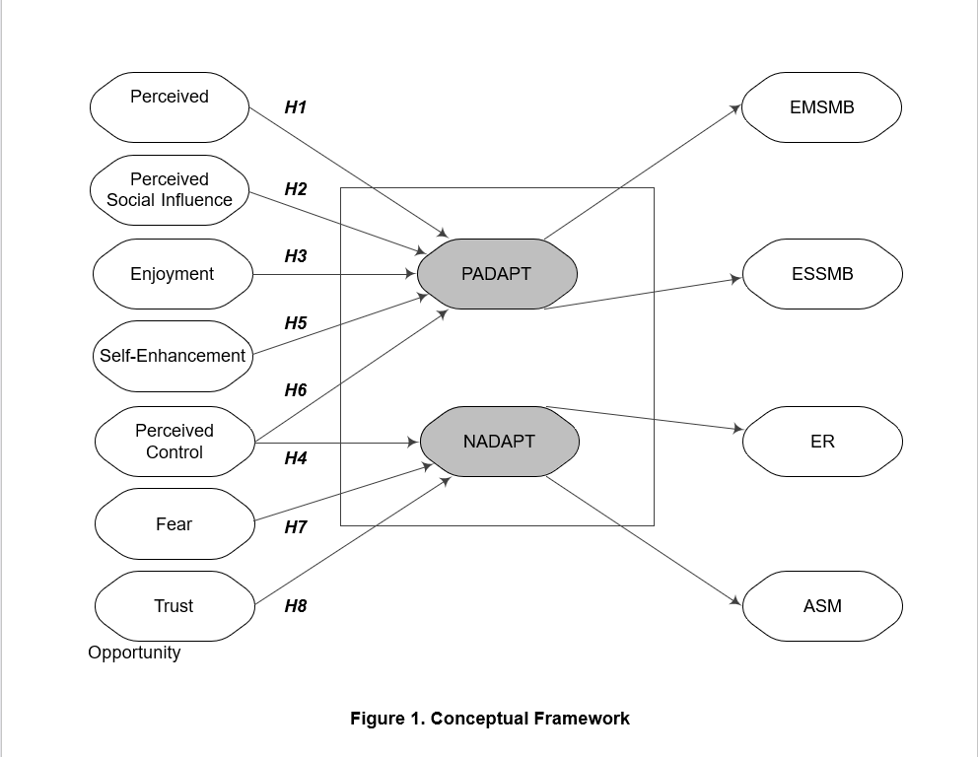

**Cognitive attitude**

Eagly & Chaiken argue that attitudinal cognitive components exist when individuals process information about an object, which forms into beliefs. Similarly, this study postulates that PO, PSI and PC are the cognitive beliefs that determine consumers’ cognitive utilitarian attitude towards social media adaptation. Appendix A provides details about the cognitive attitudinal components, their source and their contributions to hypotheses.

### 3.1.1.1 Perceived opportunity (PO)

Perceived opportunity is consumers’ cognitive belief that technology offers them ease of use and usefulness, improves their performance and has a relative advantage. Consumers develop a holistic assessment of the opportunities offered by social media which enhance their performance reduce the effort they need to make. These are the cognitive functional elements of perceived usefulness, enhanced performance; perceived ease of use and freedom from effort; and having a relative advantage, such that social media is perceived to be better than its precursor This study postulates that PO embodies performance and effort expectancy along with the theme of utility for social media. Consumers with high personal innovativeness would tend to perceive social media as an opportunity to improve their effectiveness and a strong fit with what they want to accomplish. Consumers develop their assessment of social media features and functional characteristics that they perceive as useful and novel. Thus, the following hypothesis is formulated to suggest that consumers would perceive social media as an opportunity for its functional attributes of performance, relative advantage and ease of use and that they would tend to engage in positive adaptation behaviour (Exploration to Maximise Social Media Benefits ‘EMSMB’ and exploitation to Satisfice Social Media Benefits ‘ESSMB’).

**H1–** Perceived opportunity has a positive effect on positive adaptation behaviour.

### 3.1.1.2 Perceived social influence (PSI)

Social influence is consumers’ perceived social pressure, which denotes their cognitive psychological goals to develop and maintain social relations with others on social media platforms. Such perceived social pressure drives social interaction, and establishes social ties and social support. PSI is the desire to communicate, interact with others and build relationships. Social media is perceived by consumers to enhance social interaction, connect them anywhere and complement their offline relationships. Consumers are led by psychological goals to develop social relations to gratify their socialisation needs that affect their technology adaptation behaviour. Consumers’ attitude is positively associated with social strengths determined by social influence. Hence, this study predicts the following hypothesis to suggest that PSI is consumers’ perceived cognitive social pressure for social interaction, social ties and social support, which gives them psychological pressure to engage in positive social media adaptation behaviour and explore to maximise or satisfice social media benefits.

H2– Perceived social influence has a positive effect on positive adaptation behaviour.

3.1.1.3 Perceived control (PC)

Perceived control builds consumers’ cognitive belief of confidence and they tend to evaluate social media platforms positively if they have more control over these platforms. They evaluate social media and subsequently interact with these cutting edge platforms due to their personal relevance and importance. This study suggests the following hypothesis: that perceived control is consumers’ cognitive attitude and enhances their positive attitude to engage in positive social media adaptation behaviour (exploration to maximise or exploit to satisfice social media benefits). They are likely to maximise or satisfice social media benefits if they perceive that social media gives them a strong locus of control, which is their personal belief, autonomy and information control (Table 2). They would tend to engage in positive social media adaptation behaviour with exploration to maximise and exploitation to satisfice social media behaviours.

**H3–** Perceived control has a positive effect on positive adaptation behaviour.

In addition, perceived control has conceptual similarities with the technology adoption literature (Bala & Venkatesh, 2016). Technology users would explore to revert from a technology if they perceive that they have little control over it. They would tend to minimize the negative consequences of the technological disruption. Furthermore, individuals would tend to avoid technology altogether if they have no control over it. They would resort to self-preservation adaptation efforts to eliminate the psychological distress caused by the technological disruption and completely abandon technology. Thus, this study postulates the following hypothesis to suggest that consumers would engage in negative adaptation behaviour and would tend to either revert from social media or avoid social media altogether if they perceive a lack control on social media platforms.

**H4–** Perceived control has a negative effect on negative adaptation behaviour.

## 3.1.2 Affective attitude

Affective attitudinal components are emotional experiences or preferences, composed of affective components such as enjoyment, delight and fear. Positive emotions such as enjoyment, pleasure and self-enhancement arise from positive social media experiences, which make consumers’ attitudes towards the social media more favourable. Negative emotions such as fear arise from negative social media experiences, which make consumers’ attitudes towards the social media less favourable. Appendix A (Table 7) provides details about the affective attitudinal components, their sources and their contributions to the hypotheses.

### 3.1.2.1 Enjoyment

Consumers are driven by their hedonic intrinsic sensory elements of pleasure, enjoyment and flow, with emotional self-focused dimensions originating from self-interest driving their attitude. Enjoyment is pleasure or fun while interacting with social media. Consumers immerse themselves in social media platforms that give them enjoyment, with a significant impact on their behaviour. Thus, this study formulates the following hypothesis to suggest that enjoyment comprises consumers’ intrinsic emotional factors driving their intrinsic emotional pleasure, which satisfies their hedonic needs for enjoyment, encouraging them to engage in positive adaptation behaviours on the cutting edge social media platforms.

**H5–** Enjoyment has a positive effect on positive adaptation behaviour.

### 3.1.2.2 Self-enhancement (SE)

Self-enhancement is consumers’ positive feelings about themselves. Self-status, self-image and self-esteem are their self-fulfilling hedonic needs of self-enhancement to portray the desired impression on social media platforms. In order to attract attention, their self-fulfilling emotions would enhance their self-status and image, and they would overwhelmingly engage with social media platforms. Emotional attachments are good predictors of interaction with social media. Positive words from users affect other users’ emotional state. High self-enhancement of consumers would enhance their self-esteem and they would tend to overwhelmingly present their status on social media platforms and share information. Therefore, this study proposes the following hypothesis to suggest that consumers’ self-enhancement goal of self-esteem to use social media is likely to lead to positive adaptation behaviour that includes exploration to maximise and exploitation to satisfice social media led benefits.

**H6–** Self-enhancement has a positive effect on positive adaptation behaviour.

### 3.1.2.3 Fear

Individuals would avoid technology altogether if they assess a technological disruption as a threat . Social media providers accumulate and share consumers’ information. Thus, fear and susceptibility to malicious social media disruptions (with harm to their well-being), abuse or unauthorised access to their personal information may cause fear and anxiety amongst consumers. Fear negatively affects people’s online buying. Similarly, this study formulates the following hypothesis to suggest that fear of social media platforms tend to drive negative social media experiences, such that consumers would feel threatened and they would engage in negative adaptation behaviours and explore ways to revert from social media platforms or avoid them. Consumers reveal personal information on social media, which may lead to their fear of privacy and security risks. They would feel that their well-being is at risk and they would tend to avoid social media altogether. Therefore, it would be reasonable to hypothesise that such risks would cause emotional distress in consumers and consumers would tend to engage in negative behavioural efforts (ER or ASM). The following hypothesis is formulated.

**H7**– Fear has a positive effect on negative adaptation behaviour.

### 3.1.2.4 Trust

Trust is consumers’ feelings of uncertainty and protection on social media platforms. Consumers’ attitude towards social media platforms and sharing of information depends on the integrity and reliability of these platforms. This refers to how consumers feel about the reliability, credibility and integrity of social media platforms, lack of which may make them emotionally sensitive to their privacy and security.It is their feeling of trustworthiness in the reliability of social media providers. Similarly, this study suggests that trust is consumers’ affective attitudinal attribute rather than a rational paradigm because they may not be aware of every aspect of social media platforms. Therefore, their trustworthiness in social media platforms does not undergo a careful and methodical thought process on these cutting edge platforms; rather, it is more affect-based, comprising their emotions, feelings and instincts. They rely on affective signals from other social media users, such that these emotional connections enhance their trust in social media platforms beyond beliefs and awareness of social media features. Thus, this study formulates the following hypotheses to suggest that consumers would not engage in negative adaptation behaviours (neither tend to avoid nor engage in exploration to revert from social media platforms) when they feel that social media platforms are trustworthy.

**H8**– Trust has a negative effect on negative adaptation behaviour. 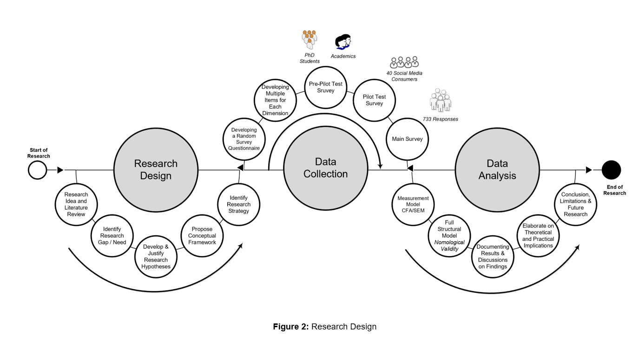

**5. Data analysis and results**

The respondents’ profiles revealed that around 99.05% of respondents were social media consumers. The main social media platforms used by consumers were Facebook, Instagram, WhatsApp, YouTube, Twitter, and LinkedIn, amongst others, and their main engagements with social media were shopping-related.

Data analysis was carried out in two steps by using SEM as suggested by Anderson & Gerbing. In the first step, factor loading was carried out, followed by reliability and validity measurement through confirmatory factor analysis (CFA) of the latent constructs for the measurement model. In the second stage, a Structural Equation Modelling process was undertaken to test for hypothesised connections amongst the latent constructs of the model. In order to validate the scale, structural equation modelling (SEM) was implemented using AMOS 25 and the default method-maximum likelihood. A Two-Step approach tested the measurement model’s validity and reliability, and nomological validity (the full structural model in Step 2). Upon validation confirmation, the study tested nomological validity.

The adaptation behaviours of positive adaptation behaviour and negative adaptation behaviour were determined using three cognitive (PO, PSI and PC) and four affective (enjoyment, self-enhancement, fear and trust) attitudinal attributes. In particular, the subsequent engagement was expected from the *a* priori theoretical structure. A thorough investigation of the construct validity was undertaken. This is important as it deals with validation of the scale. Table 1 shows the structural relationships (or factor loadings) covaried from one dimension to another when they were tested in first order CFA.

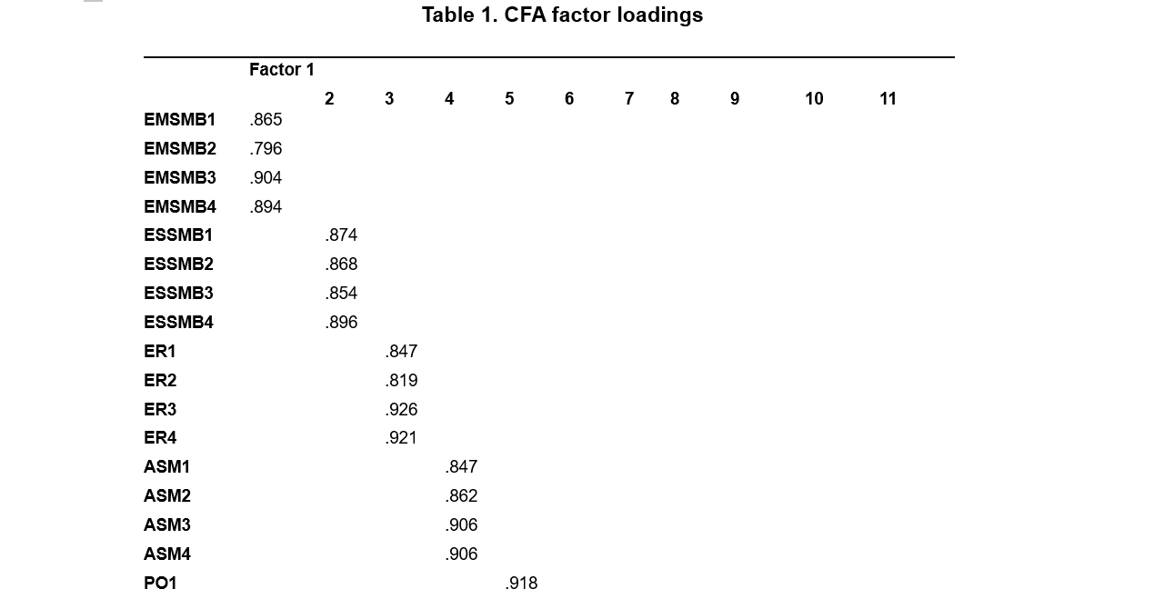

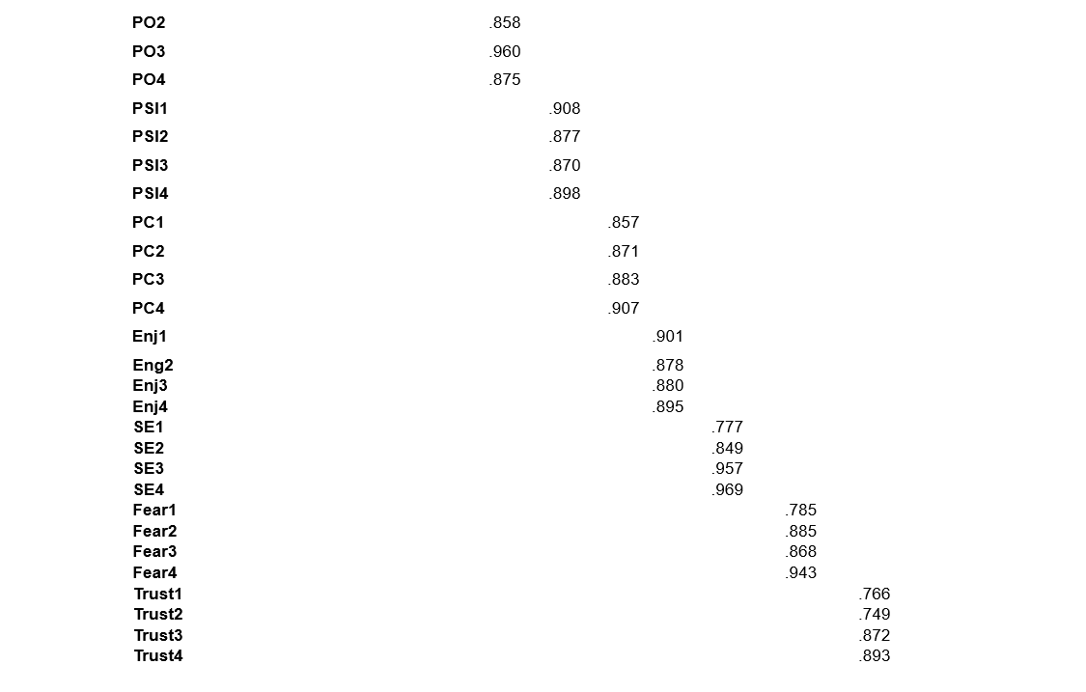

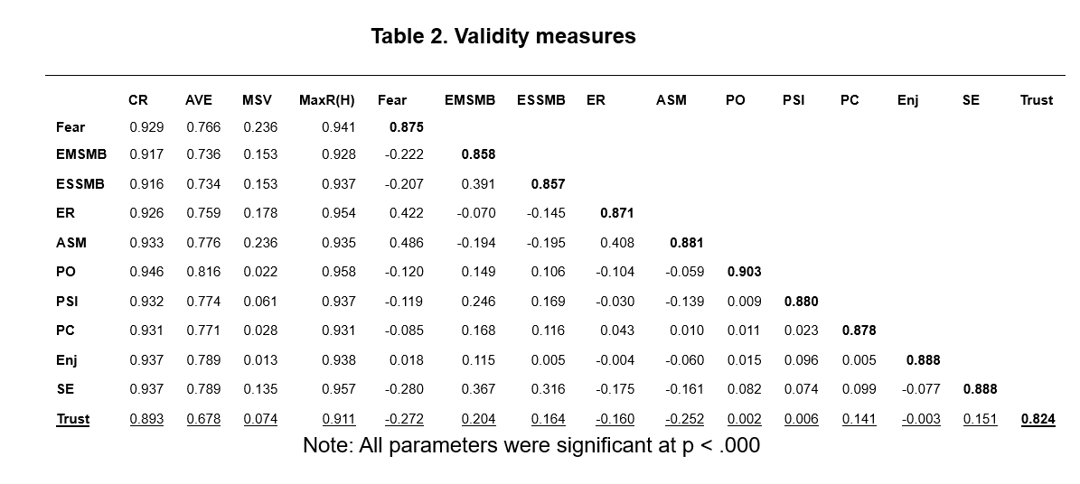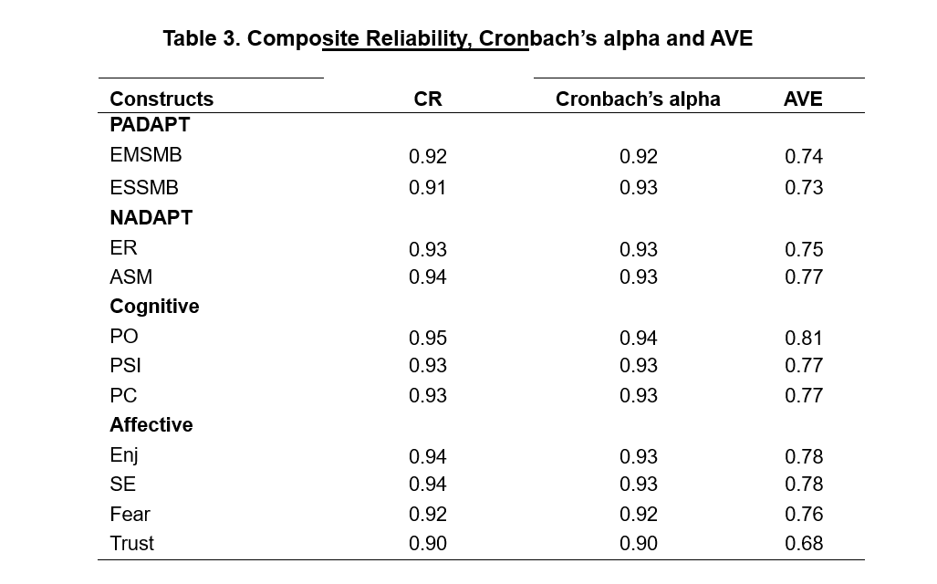

Discriminant validity was performed by comparing all the AVE estimates with the square pairwise correlation between the factors and the examination of cross-loadings among the measured variables and error terms. Additionally, discriminant validity was confirmed for all of the latent constructs, since the square root of each construct’s AVE was greater than the bivariate correlation (see Table 2). Cross-loadings between both measured and error terms also did not suffer from substantial cross-loadings; standardized residuals were all < 2.58 (Byrne, 2016). Convergent validity was supported, with all parameter estimates >. Table 2 shows details of each CFA individual item’s convergent validity and all items were statistically significant at p < .000.

A second order approach was conducted on both outcome variables in order to establish which dimensions represent both positive and negative adaptation behaviours. This was also guided by a priori theory for example both EMSMB and ESSMB were reflected of positive adaptation and both ASM and ER were explained through negative adaptation. Misfits in the models involving items that were cross-loaded on more than one dimension were relaxed one at a time as suggested by. Besides relaxing parameters, removing or adding parameters from one dimension to another, where there was high cross-loading, was also performed based on theoretical, statistical and practical considerations. The final results indicate two dimensions representing Positive Adaptation Behaviors: (1) Exploration to Maximise Social Media Benefits and (2) Exploitation to Satisfice Social Media Benefits. Negative Adaptation Behaviour, on the other hand, is also represented by two dimensions: (1) Exploration to Revert and (2) Avoidance of Social Media. Both models achieve good statistics, viz first order: (² = 137.108; p < .000; ²/df = 1.987; GFI = .97; IFI = .99; TLI = .98; CFI = .99; and RMSEA = .038). Goodness-of-fit statistics show that both first and second order model (² = 139.152; p < .000; ²/df = 1.988; GFI = .97; IFI = .99; TLI = .98; CFI = .99; and RMSEA = .038) respectively fit the data well.

The results of both first and second order models were compared, both performed similarly where the second-order model produced near identical results to the first-order model, hence both models are acceptable for further analysis. After all steps are taken to ensure validation process, decision for further analysis was taken on selecting second order over the first. This is based on: (1) the a priori status of both scales theoretically; (2) statistically construct validity, which is when models are acceptable, both could be used for further analysis and (3) second order would allow a stronger statement. Finally, all items that represent the nine constructs were then tested in stepone measurement model. The full measurement model fits the data well (² = 1564.779; p < .000; ²/df = 2.014; GFI = .90; IFI = .97; TLI = .97; CFI = .97; and RMSEA = .038).

## 5.2 Step 2: The full structural model – nomological validity

The concern in the step-two approach was to test the study's theoretical models as well as the objectives and hypotheses. The step-two model indicates an acceptable fit (χ2= 1598.006, p < .000; χ2/df = 2.038; GFI = 0.89; IFI = 0.96; TLI = 0.96; CFI = 0.97; RMSEA = 0.03), with deletion of two items. Convergent validity was supported with all parameter estimates >.5, and all items were statistically significant at p = .000. Constructs reliability was tested using both composite and Cronbach’s alpha and they were all above the recommended level, as shown in Table 3. The correlation (covariance) among the constructs is also acceptably low ranging from .01 to .55, and AVE =>.5 (Fornell & Larcker, 1981) (see Table 3). A further test to ensure the adequacy of discriminant validity was performed by comparing all the AVE estimates with the square pairwise correlation between factors and cross-loadings examinations among the measured variables and error terms (Hair et al., 2010). The results show that discriminant validity is confirmed for all latent constructs since the square root of each construct's AVE's are all greater than the bivariate correlations. Cross loadings between both measured and error terms also do not suffer from a substantial cross loadings with standardised residuals all <.258. Thus, the assessment results support the adequacy of discriminant validity of the measurement model.

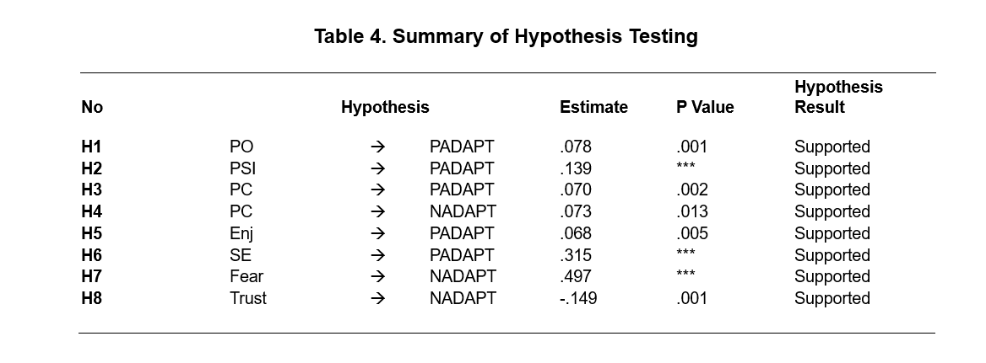

All hypotheses were tested and they demonstrated significant positive effects (H1– H8). Both cognitive and affective attitudinal attributes were statistically significant explaining the positive adaptation and negative adaptation behaviours. Table 4 summarises the hypotheses results and parameter estimates. Thus, in step 2, the nomological validity of the scales was tested with the positive and negative adaptation behaviours and their determinants. Theoretically, a positive association was likely between social media adaptation behaviours and their determinants. The nomological validity results showed that PO (p < .001), PSI (p < .000), PC (p < .002 and p < .013), and SE (p < .000) had a significant positive effect on positive adaptation behaviour. Similarly, the results show that fear (p < .000) has a significant effect on negative adaptation behaviour. On the other hand, trust has a positive effect on negative adaptation behaviour (p < .001).

The results of this study indicate that attitude plays a central and significant role in consumers’ engagement of social media adaptation behaviours. The framework was developed with 8 causal relationships (Figure 1), as shown in Table 4. The results show that consumers’ cognitive beliefs of perceived opportunity, perceived social influence and perceived control are the constituents of cognitive utilitarian attitude. As shown in Table 4, H1, H2 and H3 are supported (perceived opportunity, perceived social influence and perceived control have a significant direct effect on positive adaptation behaviour). Likewise, Perceived control has a significant direct effect on negative adaptation behaviour. Therefore, H4 is supported as shown in Table 4. The results also indicate that consumers’ attitude consists of the affective components of enjoyment, self-enhancement, trust and fear. The affective components have significant effects on consumers’ subsequent interactions with social media platforms. As shown in Table 4, H5 and H6 are supported (enjoyment, self-enhancement have direct significant effect on positive adaptation behaviour). On the other hand, the empirical results indicate that affective components in the form of fear and trust have direct significant effect on negative adaptation behaviour. H7 and H8 are supported as shown in Table 4.

**6. Discussion**

From the proposed hypotheses, it can be seen that consumers’ positive and negative adaptation behaviours with regard to social media use are driven by both cognitive and affective attitudinal components. Combining both attitudinal components provide a much deeper and comprehensive understanding of consumers’ attitudes in a particular context as alluded in existing literature. Unlike CMUA and UTAUT, the results of this study show that cognitive (perceived opportunity, perceived social influence and perceived control) and affective (enjoyment, self-enhancement, fear and trust) attitudinal components are the antecedents of positive and negative adaptation behaviours*.* Cognitive and affective components (positive or negative) constitute beliefs and affect Thus, based on the empirical evidence from this study, social media consumers hold both cognitive and affective attributes such that positive attitudes that lead to positive adaptation behaviours and negative attitudes result in negative adaptation behaviours.

The results of this research support that PO has a significant and direct effect on positive adaptation. Consumers tend to regard social media as a perceived opportunity due to its performance, relative advantage, ease of use and convenience, which affect their cognitive utilitarian attitude. Consumers perceive that social media is compatible with their needs and provides them with convenience, success and improved performance. As a result, consumers tend to explore various features on social media (exploration) and also make more intense use of the social media platforms or applications that they find much useful (exploitation). This may provide a plausible explanation for consumers’ use of various features within the likes of Facebook and Instagram. The findings also provide an explanation for why consumers try various social media platforms such as Facebook and LinkedIn. Having said that, it is often noticed that some consumers are less likely to try and/or explore all features and continue to use certain platforms and their features in a more frequent manner. This is why, it is noticed that Twitter is often preferred by special interest groups, while TikTok became popular during the COVID-19-induced stay home period when consumers made innovative video applications.

Furthermore, the findings indicate that PSI has a significant direct effect on positive adaptation. This means that consumers perceive cognitive social pressure for social interaction, social ties and social support. Thereby, they seek to maximise as well as satisfice social media led benefits. Peer pressure and normative practices encourage and also may enforce them to positive engagement behaviours. Social influence further enhances engagement with these cutting-edge platforms. Consumers tend to believe that they are socially supported on social media platforms and harness these platforms for continuous social engagement. Hence, the result alludes to the influence of consumers’ cognitive psychological pressure on their social relations, interaction and provide social support, as suggested in existing literature. However, this paper advances existing body of knowledge that suggests social influence as an antecedent to adoption. This paper hypothesises and validates PSI’s influence on positive adaptation.

Our findings also indicate that perceived control has a significant direct effect on positive adaptation, which means that consumers tend to explore to maximise and exploit to satisfice social media benefits when they have control over social media platforms. Their attitude in growing autonomy on social media platforms, aligned with prior post-technology-adoption literature, concurs with the empirical findings of this study. This is aligned with prior literature that consumers would have a positive attitude towards social media platforms if they were provided with more control. Thus, PC is consumers’ cognitive attitude, which enhances their positive attitude towards positive adaptation behaviour. On the other hand, it is also interesting to note that perceived control has a significant direct effect on negative adaptation. The more control an individual is likely to have, they are likely to enjoy the liberty to revert and/or avoid cutting edge social media platforms.

The findings in this research provide empirical support that consumers’ attitude also constitutes the affective components of enjoyment, self-enhancement, trust and fear, which means that cognitive attitudinal attributes are not the sole determinants of the adaptation behaviours. Affective components play a significant role in consumers’ subsequent interactions with social media platforms. Results of this research indicate that enjoyment has a direct effect on positive adaptation. Consumers are driven by enjoyment (hedonic and emotional), which drives their attitude to positive adaptation. Hence, when consumers enjoy social media platforms, they tend to explore ways to maximise and exploit to satisfice social media benefits. According to Bala & Venkatesh, exploitation engagement behaviour refers to more routine use of technology, while exploration to maximise refers to optimum exploration of technological benefits. Thus, the findings of this study confirm that consumers tend to go beyond the regular features of social media platforms to positive adaptation behaviour when they enjoy these platforms. This also underpins consumers’ desire for innovation and characterises their desire to explore new features, which has a bearing on the success of Web 2.0 and smart technologies. Hence, consistent with prior research, this paper asserts that consumers’ affective needs lead to pleasant hedonic motivation, which drives their elements of enjoyment and their engagement in sensations.

Another important finding of this research is the important role of self-enhancement on positive adaptation, which means that consumers seek to maximise as well as exploit to satisfice social media benefits when their hedonic self-enhancement increases. Their self-fulfilment status and image on social media platforms enhance their self-esteem, due to which they present more of their self-focused status on these platforms. Self-status and self-esteem gratify social media consumers’ self-fulfilling hedonic needs of self-esteem and enable them to portray the desired impression on social media platforms. Thus, the empirical evidence from this study confirms that self-enhancement drives consumers’ positive social media adaptation behaviour.

The other major finding of this research is that fear of social media platforms enhances consumers’ negative attitude. Our results indicate that fear has a significant direct effect on negative adaptation, which means if consumers feel that their well-being is threatened by social media platforms, they will tend to revert and avoid these platforms. Thus, the findings provide empirical support that as consumers’ fear of social media platforms increases, they tend to revert or abandon social media platforms altogether. Consumers develop feelings of anxiety towards the social media platforms, and this anxiety may lead to incompatibility with these cutting-edge technologies. With the growing concerns regarding big data digital footprints, consumer privacy and breaches of data security, consumers’ fear is justifiably linked with their decision to revert or abandon social media. Fear may well be prevalent for all forms of cutting-edge technology and can be attributed as a reason behind consumers’ decision to revert or abandon the use of such technology.

In addition to fear, the results show that trust has a direct negative effect on negative adaptation behaviours. This result signals that trust has a significant role in consumers’ negative social media adaptation behaviour. Drawing on this finding, it can be argued that consumers would not tend to revert or avoid social media if they feel that these platforms are trustworthy. This finding is aligned with prior literature that consumers’ trust is influenced by trustworthiness in service providers’ reliability and credibility. Such feelings enhance their loyalty and influence their social media adaptation. Thus, the findings provide empirical support that consumers’ lack of emotional trust would engage them in negative engagement behaviour.

## **Limitations and future research**

This study has some limitations that should be acknowledged. First, it was carried out using social media platforms in general. It was difficult to confine this research to a single social media platform. Therefore, identifying the impact of the cognitive and affective attitudinal components for a single social media platform is an avenue for future research. Second, this study tested the model on social media consumers, whereas future studies could focus on social media users in general. Third, this study tested both cognitive and affective attitudinal attributes on social media technologies: future research could extend the model to other technologies. The proposed model in this study has a broader scope and therefore future research could also extend it to different contexts, including cross-cultural settings. Finally, this study used cognitive and affective attitudinal components as the antecedents of the positive and negative adaptation behaviours. Future research could extend the model by giving consideration to the hierarchical and causal nature of cognitive attitude preceding affect or vice versa, thereby giving deeper insight into the causal nature of attitudinal attributes. Thus, future work could be extended to use different approaches to examine the attitudinal attributes and adaptation behaviours.

# **Conclusion**

This study examines the combined impact of cognitive (perceived opportunity, perceived social influence, perceived control) and affective (enjoyment, self-enhancement, trust and fear) attitudinal attributes on positive and negative social media adaptive behaviours and how they influence consumers’ engagement with social media platforms. The study confirms that cognitive and affective attitudinal components drive consumers’ both positive and negative adaptation behaviours on cutting edge social media platforms. These findings provide rich understandings to marketers to make appropriate psychographic and behavioural segmentations for cutting-edge technology users. In addition, the positive and negative adaptation behaviours also extend our understanding to identify why consumers choose to engage in new technological applications and, notably, how factors such as fear and trust can influence their decision to continue and/or discontinue to use technology despite their perceived utilities and benefits.

# **References**

Agarwal, N., Chauhan, S., Kar, A. K., & Goyal, S. (2017). Role of human behaviour attributes in mobile crowd sensing: a systematic literature review. *Digital Policy, Regulation and Governance*, 19(2), 168-185.

Agarwal, R., and Prasad, J. (1999). Are individual differences germane to the acceptance of new information technologies? *Decision sciences*, 30(2), 361-391.

Akar, E., and Topçu, B. (2011). An examination of the factors influencing consumers' attitudes toward social media marketing. *Journal of Internet Commerce*, 10(1), 35-67.

Akpan, I. J., Soopramanien, D., & Kwak, D. H. (2020). Cutting-edge technologies for small business and innovation in the era of COVID-19 global health pandemic. *Journal of Small Business & Entrepreneurship*, 1-11.

Akter, T., & Nweke, G. E. (2016). Social media users and their social adaptation process in virtual environment: Is it easier for Turkish Cypriots to be social but virtual beings?. *Computers in Human Behavior*, 61, 472-477.

Ali, H. (2011). Exchanging value within individuals’ networks: Social support implications for health marketers. *Journal of marketing Management*, 27(3-4), 316-335.

Ali, M., & Lee, H. (2010). Culture or social interaction? A study of influential factors on weblog design.

Alwi, S. F. S., & Kitchen, P. J. (2014). Projecting corporate brand image and behavioral response in business schools: cognitive or affective brand attributes?. *Journal of Business Research*, 67(11), 2324-2336.

Anderson, J. C., & Gerbing, D. W. (1988). Structural equation modeling in practice: A review and recommended two-step approach. *Psychological bulletin*, 103(3), 411.

Bagozzi, R. P., & Heatherton, T. F. (1994). A general approach to representing multifaceted personality constructs: Application to state self‐esteem. Structural Equation Modeling: A Multidisciplinary Journal, 1(1), 35-67.