**PerAdvancements in Sustainable Construction: A Contemporary Examination of Plastic Brick Manufacturing from Waste Plastic**

**Prof Varpe Akshay B1**

1Lecturer, Civil Department,Amrutvahini Polytechnic Sangamner,Ahmednagar, Maharashtra, India,

**ABSTRACT**

The proliferation of plastic waste poses a significant environmental challenge worldwide. In response, innovative solutions are being explored to mitigate this issue. This paper presents an experimental study focused on the creation of plastic bricks utilizing waste plastic materials. The study investigates the mechanical properties, durability, and environmental impact of these bricks, aiming to provide insights into their feasibility and potential as a sustainable alternative to conventional building materials. This paper explores the latest developments in sustainable construction through an examination of plastic brick production using waste plastic materials. With escalating concerns about plastic pollution and the urgent need for eco-friendly building materials, this study investigates the viability, mechanical properties, and environmental impact of plastic bricks. Through experimental analysis and assessment of various formulations, this research sheds light on the potential of plastic bricks as a sustainable solution for addressing plastic waste while meeting the demands of modern construction practices.

1. **INTRODUCTION**

Plastic pollution has emerged as a pressing global issue, with vast amounts of plastic waste accumulating in landfills, oceans, and natural ecosystems. Traditional disposal methods, such as incineration and landfilling, contribute to environmental degradation and pose risks to human health. In this context, recycling and up cycling initiatives have gained traction as viable strategies to manage plastic waste.

One promising approach is the utilization of waste plastic in construction materials. Plastic bricks, fabricated from a mixture of waste plastic and binding agents, offer a sustainable alternative to conventional bricks. These bricks not only provide a means of diverting plastic waste from landfills but also offer potential advantages in terms of durability, insulation properties, and cost-effectiveness. Plastic pollution has reached critical levels globally, necessitating innovative solutions to mitigate its environmental impact. In response, sustainable construction practices have gained prominence, emphasizing the use of recycled materials and eco-friendly building techniques. Plastic bricks, fabricated from waste plastic, offer a promising avenue for reducing plastic waste while contributing to sustainable building practices. This paper provides an overview of recent advancements in plastic brick manufacturing and their implications for sustainable construction.

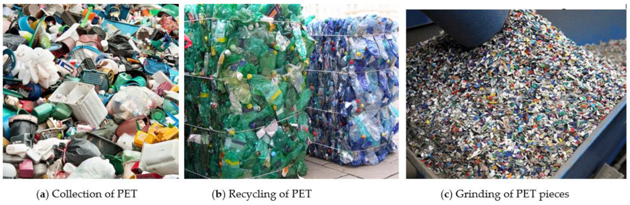**Methodology:**

The experimental study involved the fabrication of plastic bricks using different types of waste plastic, including polyethylene (PE), polypropylene (PP), and polyethylene terephthalate (PET). The waste plastic was collected from various sources, including household recycling centers and industrial facilities.The manufacturing process involved shredding the waste plastic into small particles and mixing them with a binding agent, such as cement or bitumen. The mixture was then compressed into brick molds and allowed to cure under controlled conditions. Different formulations were tested to optimize the mechanical properties and durability of the plastic bricks. The study encompasses a comprehensive review of recent literature on plastic brick manufacturing techniques, including material selection, processing methods, and performance evaluation. Experimental investigations were conducted to assess the mechanical properties, durability, and environmental impact of plastic bricks fabricated from various types of waste plastic. The research methodology integrates laboratory experiments, numerical simulations, and life cycle assessments to provide a holistic understanding of the feasibility and sustainability of plastic brick production

**Results and Discussion:** The plastic bricks exhibited promising mechanical properties, including compressive strength, flexural strength, and impact resistance. The addition of reinforcing agents, such as fiberglass or mesh, enhanced the structural integrity of the bricks, making them suitable for load-bearing applications.

Durability tests, including water absorption, freeze-thaw cycling, and accelerated weathering, were conducted to assess the performance of the plastic bricks under various environmental conditions. The results indicated that the bricks maintained their structural integrity and dimensional stability, even after exposure to harsh conditions.

Furthermore, life cycle assessments (LCAs) were conducted to evaluate the environmental impact of the plastic bricks compared to conventional building materials, such as clay bricks or concrete blocks. The LCAs considered factors such as energy consumption, greenhouse gas emissions, and resource depletion. The findings suggested that plastic bricks have the potential to reduce environmental burdens associated with traditional construction materials, particularly in terms of energy use and carbon footprint. The findings reveal significant advancements in plastic brick manufacturing, with improvements in mechanical strength, durability, and thermal insulation properties. Enhanced formulations, incorporating additives and reinforcement materials, have led to plastic bricks that rival traditional building materials in performance and durability. Life cycle assessments indicate favorable environmental outcomes, with plastic bricks demonstrating reduced carbon footprint and energy consumption compared to conventional materials.

**Conclusion:** The experimental study demonstrates the feasibility of using waste plastic to manufacture durable and environmentally friendly building materials. Plastic bricks offer a sustainable solution for addressing the challenges of plastic waste while providing benefits in terms of performance and cost-effectiveness. Further research is needed to scale up production, optimize manufacturing processes, and validate the long-term performance of plastic bricks in real-world applications. However, the results of this study suggest that plastic bricks have the potential to play a significant role in promoting a circular economy and mitigating the environmental impact of construction activities. The study underscores the potential of plastic bricks as a sustainable alternative for construction, offering benefits in terms of waste reduction, energy efficiency, and environmental sustainability. Despite challenges in scaling up production and ensuring regulatory compliance, the advancements in plastic brick manufacturing signal a promising trajectory towards more sustainable construction practices. Continued research, innovation, and collaboration across academia, industry, and government are essential to realizing the full potential of plastic bricks in sustainable construction.

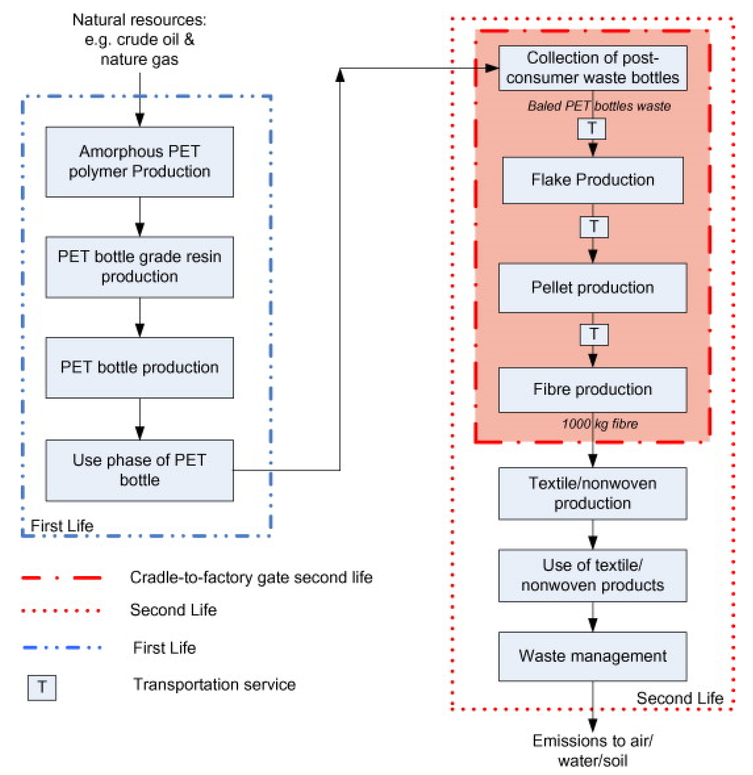

**5. Future Directions:** Future research directions could focus on refining the composition of plastic bricks to enhance their mechanical properties and sustainability. Additionally, studies on the long-term performance of plastic bricks in real-world applications, such as building construction and infrastructure projects, would provide valuable insights into their feasibility and durability. Collaboration between researchers, industry stakeholders, and policymakers is essential to facilitate the adoption of plastic bricks and promote sustainable practices in the construction sector. Future research endeavors could focus on optimizing manufacturing processes, exploring novel recycling techniques, and investigating the long-term performance of plastic bricks in real-world applications. Additionally, efforts to standardize quality control measures, address regulatory barriers, and raise awareness among stakeholders would facilitate the widespread adoption of plastic bricks in the construction industry. Collaboration between researchers, policymakers, and industry stakeholders is paramount to driving innovation and promoting sustainability in construction practices.

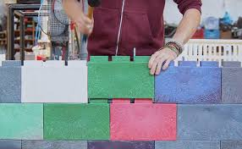

**ACKNOWLEDGEMENTS**

The authors can acknowledge Professor Abhale Rahul B

**REFERENCES**

1. Dhawan, S S Chauhan, Bhusan Kumar, Prem Shankar Singh, Abuzaid Khan, Hrithik Goyal, Shivank Goyal, “Fabrication and testing of Plastic Sand Bricks” on ICCEMME 2019.
2. Rajarapu Bhushaiah, Shaik Mohammad, D. Srinivasa Rao, “An Overview of Study of Plastic Bricks Made From Waste Plastic” International Research Journal of Engineering and Technology (IRJET) (April 2019)
3. V. Velumurugan , R. Gokul Raj , A.Harinisree, “An Overview of Rebuilding of Plastic Waste to Pavement Bricks” International Journal for Research in Applied science & Engineering and Technology (April 2019)
4. Arvind Singhal, Dr. Om Prakash Netula, “Utilization of plastic waste in manufacturing of plastic sand bricks” on 17th June 2018 at 3rd International conference on New Frontiers of Engineering, Science, Management and Humanities. ISBN: 978-93-87433-29-8.
5. Siti Nabilah Amir & Nur Zulaikha Yusof, “Plastic in Brick Application” on 4th September 2018 by LUPINE PUBLISHERS. ISSN: 2637-4668. DOI: 10.32474/TCEIA.2018.03.000152.
6. Aiswaria K, Khansa Abdulla, E B Akhil, Haritha Lakshmi V G, Jerin Jimmy “Manufacturing and Experimental Investigation of Bricks with Plastic And M-Sand” International Journal of Innovative Research in Science, Engineering and Technology Vol.7, Issue 6, June 2018