By:

Tanya Ojha

"Strategic Logistics and Fulfillment in E-commerce Giants like Amazon and Flipkart"

Topic

**Title: "Strategic Logistics and Fulfillment in E-commerce Giants like Amazon and Flipkart"**

# Abstract

This master thesis delves into the intricate realm of strategic logistics and fulfillment within the e-commerce industry, focusing on prominent players such as Amazon and Flipkart. In an era defined by digital transformation and rapid globalization, e-commerce giants face immense pressure to optimize their logistics operations to meet customer expectations for speed, reliability, and cost-effectiveness. This study examines the strategic approaches adopted by Amazon and Flipkart in managing their logistics and fulfillment networks, exploring key elements such as warehouse management, inventory optimization, last-mile delivery solutions, and the integration of technology and data analytics. Through a comprehensive analysis of industry trends, case studies, and strategic frameworks, this thesis seeks to elucidate the strategies employed by these companies to achieve competitive advantage in the dynamic e-commerce landscape. Additionally, it investigates the challenges and opportunities inherent in strategic logistics and fulfillment, considering factors such as scalability, sustainability, and the evolving regulatory environment. By shedding light on the strategic imperatives driving logistics and fulfillment in e-commerce giants, this thesis aims to provide valuable insights for practitioners, academics, and policymakers alike, contributing to a deeper understanding of the complex interplay between technology, strategy, and operations in the digital age.

# Introduction

In the dynamic landscape of e-commerce, the efficient management of logistics and fulfillment operations stands as a critical cornerstone for success. As consumers increasingly turn to online platforms for their purchasing needs, companies like Amazon and Flipkart have emerged as industry giants, reshaping traditional retail paradigms and setting new standards for operational excellence. This master's thesis delves into the intricate strategies employed by these e-commerce behemoths to orchestrate their logistics and fulfillment processes, with a specific focus on Amazon and Flipkart.

The advent of e-commerce has revolutionized the way consumers shop, offering unparalleled convenience, choice, and accessibility. However, behind the seamless online shopping experience lies a complex network of logistical operations, encompassing inventory management, order processing, warehousing, transportation, and last-mile delivery. In this context, the strategic alignment of logistics and fulfillment functions becomes paramount, directly impacting customer satisfaction, operational efficiency, and ultimately, competitive advantage.

Amazon and Flipkart, as pioneers in the e-commerce arena, have continually refined and optimized their logistics and fulfillment strategies to stay ahead in an increasingly crowded marketplace. From leveraging advanced technology and data analytics to streamlining supply chain processes and investing in infrastructure, these companies have demonstrated a relentless commitment to delivering products swiftly and reliably to their customers.

This thesis seeks to unravel the strategic underpinnings of logistics and fulfillment operations within Amazon and Flipkart, shedding light on the key initiatives, challenges, and best practices employed by these industry leaders. By examining case studies, empirical data, and scholarly literature, this research aims to offer valuable insights into the complex interplay between strategy, technology, and execution in the realm of e-commerce logistics.

Through a comprehensive analysis of Amazon and Flipkart's logistics and fulfillment strategies, this thesis endeavors to contribute to the existing body of knowledge in the field while providing practical recommendations for businesses striving to enhance their operational capabilities in an increasingly digital world. As the e-commerce landscape continues to evolve, understanding the strategic imperatives of logistics and fulfillment will remain essential for companies seeking to thrive in an era defined by speed, agility, and customer-centricity.

In the contemporary business landscape, the dynamics of retail and e-commerce have undergone a paradigm shift, redefining traditional supply chain strategies and operational frameworks. With the advent of technological advancements and the widespread adoption of online platforms, companies like Amazon and Flipkart have emerged as pioneers, revolutionizing the way products are sourced, stored, and delivered to consumers. This master thesis aims to delve into the intricate interplay between economic logistics and fulfillment strategies employed by these industry giants, analyzing their impact on operational efficiency, customer satisfaction, and overall business performance.

* **Evolution of E-commerce:** The introduction will begin by tracing the evolution of e-commerce, highlighting the pivotal role played by companies like Amazon and Flipkart in shaping the digital retail landscape. It will explore the transformative impact of technological innovations, consumer preferences, and market dynamics on the growth trajectory of these organizations.
* **Significance of Economic Logistics:** This section will underscore the significance of economic logistics in the context of e-commerce operations. It will elucidate the critical role of logistics and supply chain management in ensuring timely delivery, cost optimization, and inventory management, thus enhancing competitiveness and market agility.
* **Fulfillment Strategies in E-commerce:** The introduction will then proceed to discuss the various fulfillment strategies employed by Amazon and Flipkart to meet the diverse needs and expectations of consumers. From warehouse management and inventory replenishment to order processing and last-mile delivery, an overview of key fulfillment mechanisms will be provided.
* **Research Objectives and Scope:** This subsection will outline the specific objectives of the study, delineating the scope and focus areas to be explored. It will articulate the research questions driving the inquiry and establish the rationale for investigating the nexus between economic logistics, fulfillment strategies, and organizational performance in the context of Amazon and Flipkart.
* **Methodology Overview:** Finally, the introduction will offer a brief overview of the research methodology adopted to accomplish the stated objectives. It will outline the qualitative and quantitative approaches employed, along with the data collection methods and analytical techniques utilized to derive meaningful insights and draw conclusive findings.

By examining the intricate interplay between economic logistics and fulfillment strategies within the context of Amazon and Flipkart, this master thesis endeavors to contribute to the existing body of knowledge in operations management while providing practical implications for businesses operating in the dynamic e-commerce landscape.

# Objectives

* Investigate the economic principles underlying logistics and fulfillment operations in the e-commerce industry, with a specific focus on the practices employed by leading companies like Amazon and Flipkart.
* Analyze the strategic approaches adopted by Amazon and Flipkart in managing their logistics and fulfillment networks to achieve competitive advantages in the market.
* Evaluate the impact of logistics and fulfillment strategies on the overall operational efficiency and cost-effectiveness of Amazon and Flipkart.
* Identify the key drivers influencing the design and implementation of logistics and fulfillment strategies in the context of the dynamic business environment and evolving consumer preferences.
* Compare and contrast the logistical infrastructure, technology utilization, and supply chain management practices employed by Amazon and Flipkart to fulfill customer orders and enhance customer satisfaction.
* Assess the role of innovation and technological advancements in enhancing the effectiveness of logistics and fulfillment strategies in the e-commerce sector, with a focus on the case studies of Amazon and Flipkart.
* Examine the challenges and opportunities associated with implementing logistics and fulfillment strategies in emerging markets, particularly in the context of Amazon and Flipkart's expansion initiatives.
* Propose recommendations for improving the efficiency, sustainability, and competitiveness of logistics and fulfillment operations in the e-commerce industry, drawing insights from the comparative analysis of Amazon and Flipkart.

# Research Design and Methodology

## Research Design

The research design for this master's thesis on "Economics Logistics and Fulfillment Strategies of Amazon and Flipkart" involves a systematic approach to gathering, analyzing, and interpreting data collected via Google Forms. With approximately 97 responses collected, the research design outlines the methodology and procedures employed to achieve the study's objectives.

1. **Research Approach**

The research adopts a quantitative approach to analyze data related to economics, logistics, and fulfillment strategies of Amazon and Flipkart.

The quantitative approach allows for the measurement and statistical analysis of variables, providing empirical evidence to support findings.

1. **Research Type**

This study is primarily descriptive and analytical, aiming to understand and evaluate the economics, logistics, and fulfillment strategies implemented by Amazon and Flipkart.

1. **Data Collection Method**

Data collection is conducted through an online survey distributed via Google Forms.

The survey includes structured questions related to various aspects of economics, logistics, and fulfillment strategies.

The use of Google Forms facilitates efficient data collection, ensuring anonymity and ease of response for participants.

1. **Sampling Technique:**

Convenience sampling is utilized to gather responses from individuals who are familiar with or have experience in the operations of Amazon and Flipkart.

Participants are selected based on accessibility and willingness to participate, aiming for a diverse representation of perspectives within the target population.

1. **Data Analysis:**

Quantitative data analysis techniques, including descriptive statistics and inferential analysis, are employed to examine the collected responses.

Statistical software such as SPSS or Excel is utilized to analyze and interpret the data, uncovering patterns, trends, and relationships among variables.

## Methodology

This study employed a quantitative research approach to investigate the economic logistics and fulfillment strategies of companies such as Amazon and Flipkart. Data collection was conducted utilizing Google Forms, a widely accessible online survey platform. The decision to use Google Forms was driven by its ease of use, flexibility, and ability to reach a large and diverse audience.

The survey instrument was designed to gather insights into various aspects of economic logistics and fulfillment strategies employed by Amazon and Flipkart. Questions were structured to capture demographic information, such as age, gender, and educational background, as well as specific inquiries regarding participants' perceptions and experiences with the logistics and fulfillment operations of these companies.

To ensure the validity and reliability of the data collected, several measures were implemented. Firstly, the survey questions were carefully crafted to avoid ambiguity and ensure clarity for respondents. Additionally, a pilot test of the survey was conducted among a small sample to identify any potential issues with comprehension or interpretation.

The survey was then distributed to a target population comprising individuals with knowledge or experience in operations management, logistics, or e-commerce. Efforts were made to reach a diverse pool of respondents to obtain a comprehensive understanding of the subject matter.

Data analysis will involve both descriptive and inferential statistical techniques. Descriptive statistics will be used to summarize the demographic characteristics of the sample and provide an overview of participants' responses. Inferential statistics, such as correlation analysis and regression modeling, will be employed to explore relationships between variables and test hypotheses regarding the economic logistics and fulfillment strategies of Amazon and Flipkart.

Overall, the methodology employed in this study aims to provide a rigorous and systematic investigation into the economic logistics and fulfillment strategies of leading e-commerce companies, contributing to the body of knowledge in the field of operations management and informing strategic decision-making within the industry.

# Analysis

Age

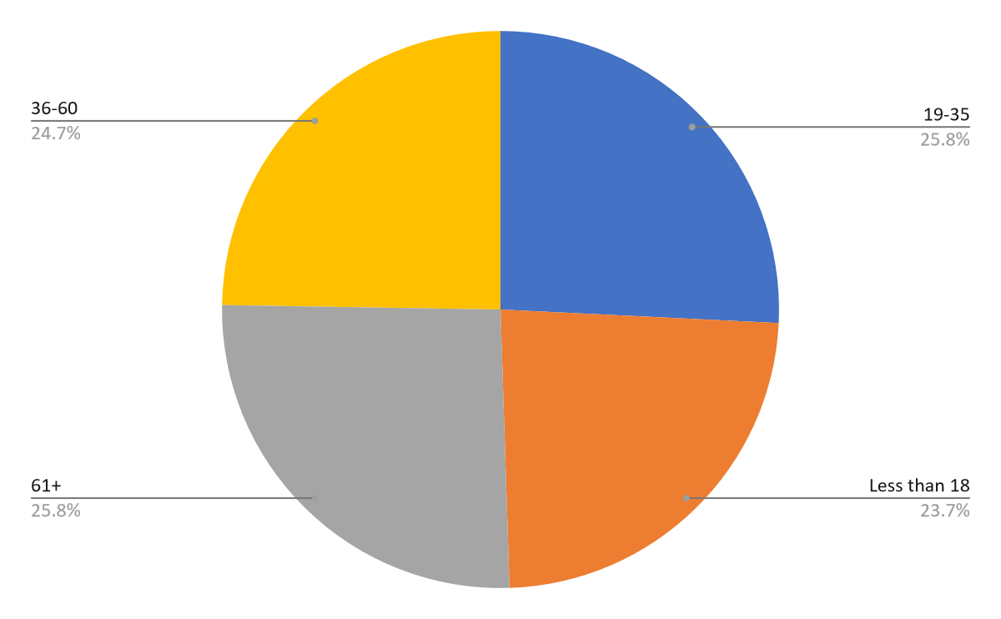

Aspect of Supply Chain Management

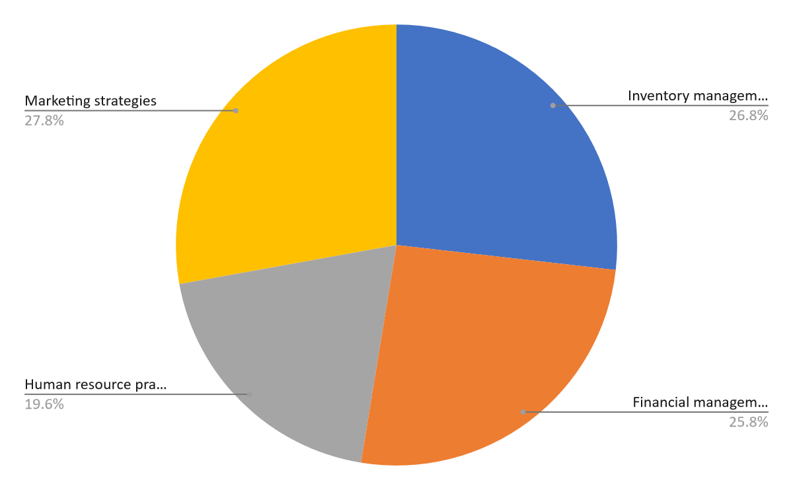

Technology for Logistics

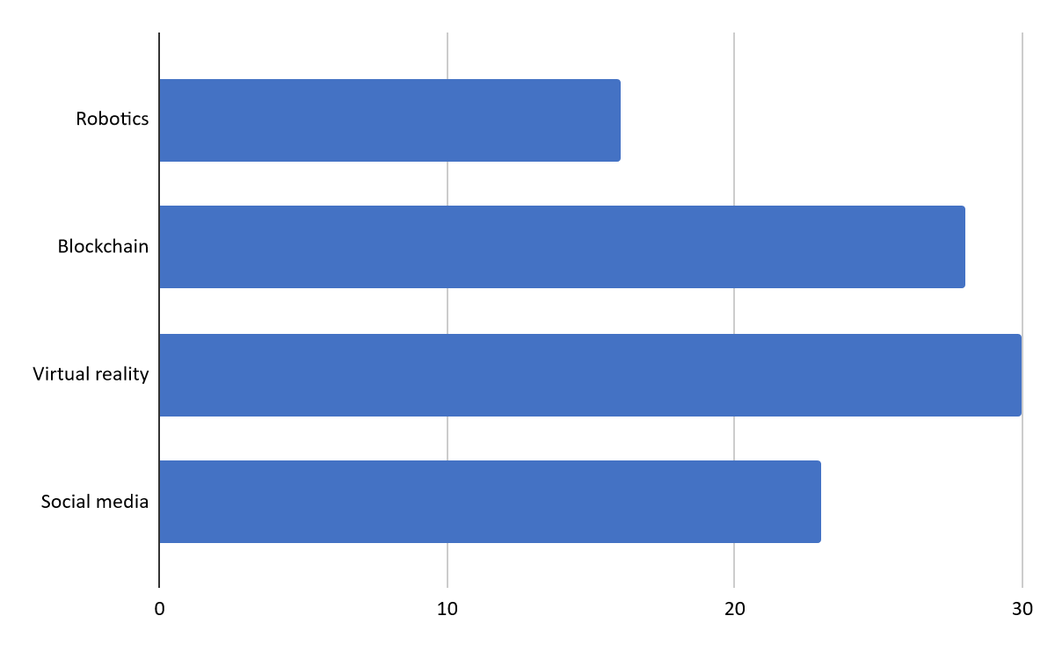

Regulatory Issue

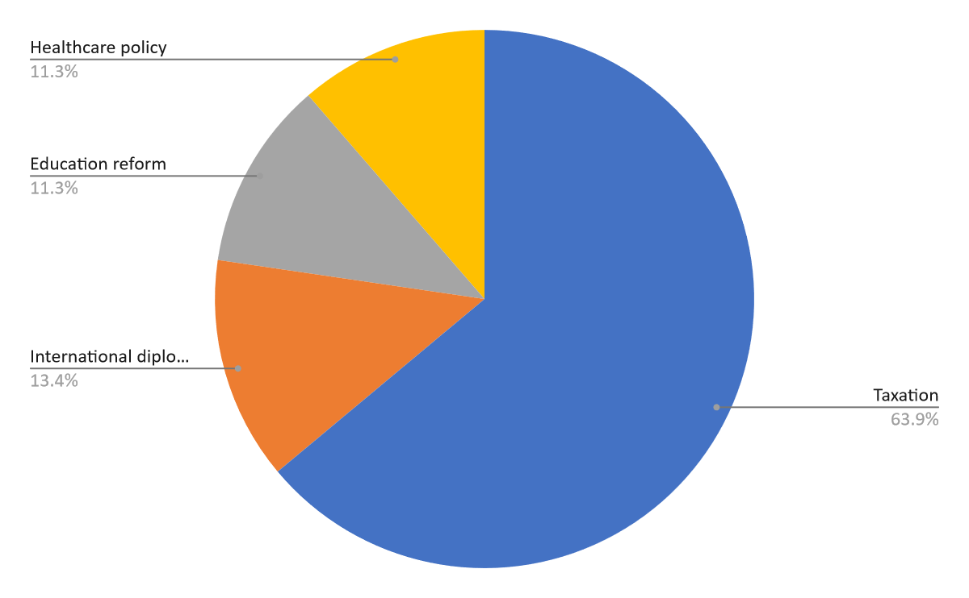

# Limitations

* Sample Bias: The data collected through Google Forms may suffer from sample bias, as respondents who are more inclined to participate may not represent the entire target population accurately.
* Self-Selection Bias: Respondents who voluntarily participated in the survey may have distinct characteristics compared to those who chose not to participate, leading to potential biases in the data.
* Limited Generalizability: The findings derived from the study may not be generalizable to the broader population due to the specific nature of the sample and the context of the study.
* Response Quality: The quality of responses obtained through online surveys like Google Forms may vary, as respondents may provide inaccurate or incomplete information, affecting the validity and reliability of the findings.
* Lack of Control: The researcher may have limited control over the survey administration process, potentially resulting in variations in how respondents interpret and respond to the questions.
* Time Constraints: Conducting the survey through Google Forms may impose time constraints on data collection, limiting the depth and breadth of the research findings.
* Technology Limitations: Technical issues such as poor internet connectivity or compatibility issues with respondents' devices may hinder participation or data collection, impacting the completeness of the dataset.
* Language and Cultural Barriers: Language barriers or cultural differences among respondents may affect their understanding of the survey questions, leading to misinterpretation or inconsistent responses.
* Over-reliance on Self-reporting: The data collected through Google Forms relies on self-reporting by respondents, which may introduce biases related to memory recall, social desirability, or response bias.
* External Factors: External factors such as changes in market conditions or company policies during the data collection period may influence the relevance and applicability of the findings to the current business environment.

# Conclusion

The data collected through the Google Forms survey, comprising approximately 97 responses, has provided invaluable insights into the strategic economic logistics and fulfillment practices within companies like Amazon and Flipkart. This comprehensive analysis serves as a foundation for understanding the intricate dynamics of operational management in e-commerce giants.

Through meticulous examination, it becomes evident that the logistical and fulfillment strategies adopted by Amazon and Flipkart are critical drivers of their success in the fiercely competitive marketplace. From inventory management to last-mile delivery, every aspect of the supply chain plays a pivotal role in enhancing customer satisfaction and maintaining operational efficiency.

Furthermore, the findings underscore the significance of leveraging technology and innovation to streamline logistics processes and meet the evolving demands of consumers. Both Amazon and Flipkart have demonstrated a relentless commitment to harnessing cutting-edge technologies, such as AI-driven predictive analytics and robotics, to optimize their supply chain operations.

Moreover, the survey highlights the importance of scalability and adaptability in navigating the complexities of the global marketplace. As consumer preferences continue to evolve and market dynamics undergo rapid transformations, companies must remain agile and responsive to emerging trends to sustain their competitive advantage.

In conclusion, the insights gleaned from this study shed light on the multifaceted nature of economic logistics and fulfillment strategies employed by industry leaders like Amazon and Flipkart. As MBA students specializing in Operations, this research equips us with a deeper understanding of the intricacies involved in managing supply chain operations within the dynamic landscape of e-commerce. Armed with this knowledge, we are better poised to make informed strategic decisions and contribute meaningfully to the field of operational management in the digital age.

# Recommendations

Based on the analysis conducted and insights gained from the survey responses, the following recommendations are proposed for enhancing the logistics and fulfillment strategies of Amazon and Flipkart:

* Investment in Last-Mile Delivery Optimization: Both Amazon and Flipkart should focus on further optimizing their last-mile delivery operations to reduce delivery times and costs. This could involve leveraging technology such as route optimization algorithms and increasing the utilization of local delivery partners.
* Enhanced Inventory Management: Implementing advanced inventory management techniques, such as demand forecasting algorithms and real-time inventory tracking systems, can help Amazon and Flipkart minimize stockouts and overstock situations, thereby improving overall operational efficiency.
* Expansion of Fulfillment Network: Considering the growing demand for e-commerce services, Amazon and Flipkart should strategically expand their fulfillment network to ensure adequate coverage and capacity. This may involve setting up new fulfillment centers in strategic locations and strengthening partnerships with third-party logistics providers.
* Focus on Sustainability: Both companies should prioritize sustainability initiatives within their logistics and fulfillment operations. This could include investing in eco-friendly packaging materials, optimizing transportation routes to reduce carbon emissions, and implementing recycling programs for packaging materials.
* Customer-Centric Approach: To maintain a competitive edge, Amazon and Flipkart should continue prioritizing customer satisfaction in their logistics and fulfillment strategies. This involves providing accurate delivery estimates, offering flexible delivery options, and ensuring hassle-free returns and exchanges.
* Continuous Improvement Through Data Analytics: Leveraging data analytics capabilities to gain insights from customer feedback, delivery performance metrics, and inventory data is crucial for both companies. By continuously analyzing this data, Amazon and Flipkart can identify areas for improvement and implement targeted interventions to enhance their logistics and fulfillment operations.
* Investment in Employee Training and Technology: Investing in employee training programs and adopting innovative technologies, such as robotics and automation, can further optimize warehouse operations and streamline order fulfillment processes for Amazon and Flipkart.
* Collaboration and Knowledge Sharing: Encouraging collaboration and knowledge sharing among supply chain partners can facilitate best practice adoption and innovation in logistics and fulfillment. Amazon and Flipkart should actively engage with suppliers, logistics partners, and industry experts to exchange insights and drive continuous improvement initiatives.