**SMART DOOR LOCK SYSTEM USING ESP32 CAM IOT BASED**

**Yashaswi R1, Abdulwahab Ahmed Mohamed Omer2, Nikhil Reji3, Muhammed Mishal4,**

**Nagaraja P S5**

1Asst Professor, Dept. Of CSE, Sambhram Institute of Technology, Bengaluru Urban, Karnataka, India

2,3,4,5 Final Year Students, Dept. Of CSE, Sambhram Institute of Technology, Bengaluru Urban, Karnataka, India

**ABSTRACT**

**In terms of house security, the door is vital. To keep the roof secure, the owner will keep the door locked at all times. still, owing to a rush when leaving the house, the house owner may forget to lock the door, or they may be doubtful if they have closed the door or not. In this paper, we have presented a smart Wi – Fi Door Cinch using the ESP32 CAM and the Blynk App. In this simple working model, when a person hits the doorbell, the owner receives a advertisement on his/ her phone with a print of that person. The owner can also unleash the door from a mobile phone after checking the print. The proposed Door Security System operation uses Wi- Fi Door ice with ESP32 CAM and Internet of goods( IoT) technology to cover the status of the door, manage the door, and increase security in a home. Blynk is a communication protocol that connects a smartphone to a door ice system and is used to increase the security of a home**.

1. **Keywords**— IoT based door lock, Wi-Fi lock system, House security, ESP32 Camera, Blynk, TCP/IP
2. **INTRODUCTION**

**Everyone nowadays is concerned about security, whether it's data security or their own home. As technology and the use of IoT have improved, digital door locks have become increasingly common. A digital lock does not require a physical key to function; instead, it uses Radio-Frequency Identification (RFID), fingerprint, Face ID, pins, passwords, and other methods. We have already developed a number of digital door lock solutions using these various technologies.**

**Using Espressif Systems Camera (ESP32 CAM) IoT-based Wi-Fi Door Lock system can be built. AI-Thinker ESP32-CAM module is a low-cost development board with a micro-SD card slot and a small Omni-Vision OV2640 camera.**

**Smart door lock includes a built-in Wi-Fi ESP32 S processor, two high-performance 32-bit LX6 CPUs, and a 7-stage pipeline. The Door Security System application employs ESP32 CAM and Internet of Things (IoT) technologies to monitor the door's state. Blynk is a communication protocol that connects a smartphone with a door lock system. The Door Security System is available for both Android and iOS.**

1. **METHODOLOGY**

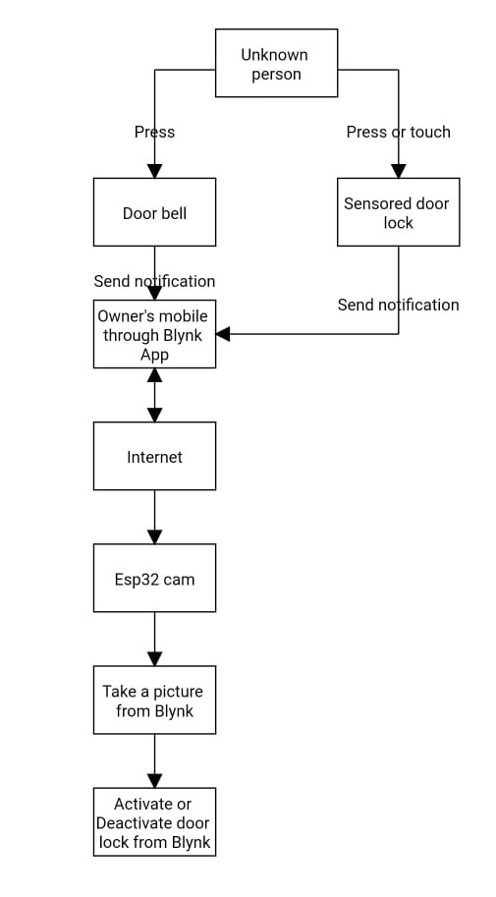

**Figure 1:** operational steps

1. The sensor of the door informs the status of the door whether it is locked or and unlock, it sends a notification to the owner in case the door is unlock.
2. Whenever someone approach the door and press the doorbell a message goes to smartphone of the owner informing that somebody is at the door .
3. The ESP32 CAM that implemented will activate once the doorbell is pressed and send the photo of a person who is standing in front of the door through a Wi-Fi connection to the owner.
4. If the picture that is taken by the ESP32 CAM is not clear enough to recognize a person who is standing in front of the door, User can press (take picture) option in his phone and another image can be sent again.
5. If the person is recognized then the user can press the option of unlock to allow the visitor to get inside the house otherwise he/she can disallow the visitor by keeping the door locked.
6. **MODELING AND ANALYSIS**

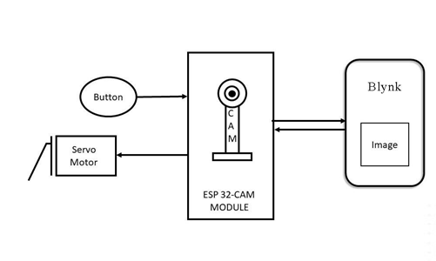

**Figure 2:** block diagram.

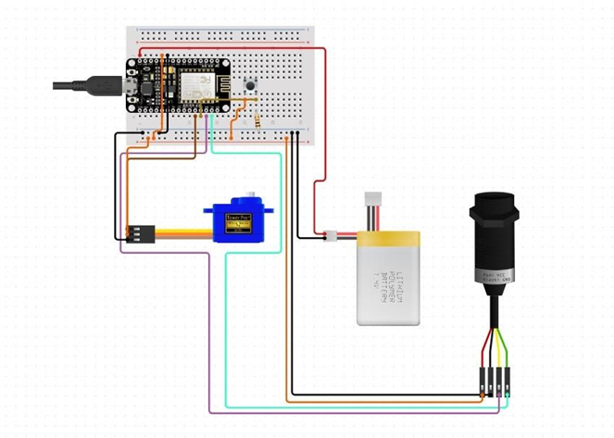

**Figure 3:** circuit diagram.

**ESP32 microcontroller board** - The ESP32 is a low-cost, low-power microcontroller with built-in WiFi and Bluetooth capabilities, making it ideal for IoT projects.

**Electric lock** - The electric lock will be used to control the door lock mechanism.

**Power source** - A suitable power source will be required to power the system.

**Wi-Fi connectivity** - The firmware will need to establish a Wi-Fi connection with the user's local network in order to communicate with the user's smartphone or web app.

**Security** - The firmware will need to implement security measures to prevent unauthorized access to the system.

**Communication protocol** - The firmware will need to implement a communication protocol to allow the user's smartphone or web app to communicate with the ESP32 microcontroller.

**Control of electric lock** - The firmware will need to control the electric lock mechanism based on commands received from the user's smartphone or web app.

**Mobile app or web app** - The user will interact with the system through a mobile app or web app, which will allow them to lock and unlock the door remotely.

**Cloud service** - A cloud service will be used to store user data and facilitate communication between the user's smartphone or web app and the ESP32 microcontroller.

The overall system architecture for the Wi-Fi door lock using ESP32 will involve the ESP32 board serving as a hub that will connect to a user's home network via Wi-Fi. The user will then be able to interact with the system through a mobile app or web app. The ESP32 board will use the cloud service to store user data, and the firmware will handle the control of the electric lock mechanism based on the user's commands received through the communication protocol.

1. **RESULTS AND DISCUSSION**

The user can send commands to the ESP32CAM board through a smartphone app or web interface, such as: "Lock" to activate the electric lock mechanism and take a picture of the door "Unlock" to deactivate the electric lock mechanism and take a picture of the door The ESP32CAM board receives and verifies the commands, activates or deactivates the lock mechanism and takes a picture of the door with the camera module, and sends a notification with the picture to the user's device. If the door was unlocked, the ESP32CAM board waits for it to be opened and takes another picture. If the door was opened, the ESP32CAM board sends a notification with the new picture to the user's device and waits for the door to be closed again. The ESP32CAM board monitors the door open/close status using the door sensor and updates the status in real-time, so the user can see the current status of the door through the smartphone app or web interface. If any unexpected events or errors occur, the ESP32CAM board handles them and alerts the user through a notification or other means. Overall, a Wi-Fi door lock using an ESP32CAM combines the features of a smart lock with a camera module, allowing the user to control and monitor the door remotely while also capturing images of the door and detecting changes in its open/close status.

1. **CONCLUSION**

Smart door lock with an ESP32 CAM is a convenient and secure way to remotely operate and monitor a door, as well as capture photographs of the door and detect changes in its open or closed position. With a microcontroller board, electric lock mechanism, camera module, and Wi-Fi connectivity, it provides a variety of functions that may be tailored to specific needs and tastes. Implementing best practices for hardware and software installation, as well as security measures for wireless connection and user identification, ensures the system's functioning and stability.

**REFERENCES** Smart door lock with an ESP32 CAM is a convenient and secure way to remotely operate and monitor a door, as well as capture photographs of the door and detect changes in its open or closed position. With a microcontroller board, electric lock mechanism, camera module, and Wi-Fi connectivity, it provides a variety of functions that may be tailored to specific needs and tastes. Implementing best practices for hardware and software installation, as well as security measures for wireless connection and user identification, ensures the system's functioning and stability.

[1] Norarzemi, Ummi Annisa, et al. "Development of Prototype Smart Door System with IoT Application." Progress in Engineering Application and Technology 1.1 (2020): 245- 256.

[2] Aldawira, Cornelio Revelivan, et al. "Door security system for home monitoring based on ESp32." Procedia Computer Science 157 (2019): 673-682.

[3] Babiuch, Marek, and Jiri Postulka. "Smart Home Monitoring System Using ESP32 Microcontrollers." Internet of Things. IntechOpen, 2020.

[4] Eethamakula, Kosalendra, et al. "Automatic Detection, Controlling and Monitoring of Temperature in Sericulture Using IOT," IJAEMA 12.8 (2020): 1099- 1103.

[5] Pavelić, Marko, et al. "Internet of things cyber security: Smart door lock system." 2018 international conference on smart systems and technologies (SST). IEEE, 2018.

[6] Guduru, Tabu Sravani, and SURYA NARAYANA MURTHY THATAVARTHY. "IoT Based Home Monitoring System." (2019).

[7] Nascimento, David Barbosa de Alencar, and Jorge de Almeida Brito Júnior. "Application of the Internet of Things in the Development of a “Smart” Door.