**Topic:** “Examining the Role of Talent Management in Organisational Success and Employee Retention”

**Abstract:**

In today's competitive business landscape, organizations are increasingly recognizing the critical importance of talent management in fostering employee retention and driving organizational success. This abstract delves into the multifaceted relationship between talent management practices, employee retention, and organizational performance.

Effective talent management encompasses various strategies, including recruitment, training and development, performance management, and succession planning. By strategically aligning these practices with organizational objectives, companies can attract, develop, and retain top talent, thereby gaining a competitive edge in the marketplace.

Employee retention emerges as a key outcome of robust talent management initiatives. When employees feel valued, supported, and provided with opportunities for growth and advancement, they are more likely to remain committed to their organizations. High retention rates not only reduce turnover costs but also contribute to a stable workforce, fostering continuity and institutional knowledge. Furthermore, talent management plays a pivotal role in driving organizational success. A skilled and engaged workforce is better equipped to innovate, collaborate, and adapt to changing market dynamics. By nurturing talent and cultivating a culture of continuous learning and development, organizations can enhance productivity, drive innovation, and achieve sustainable growth.

This abstract underscore the integral link between talent management, employee retention, and organizational success. As businesses navigate an increasingly competitive and dynamic environment, investing in strategic talent management practices emerges as a critical imperative for building resilient, high-performing organizations.

In the contemporary business landscape, talent management stands out as a pivotal tool for organizational success in the twenty-first century. It serves as a mutually beneficial instrument for both employees and organizations, enhancing efficiency while fostering individual growth. Talent management entails the strategic identification of employees' unique skills and competencies, aligning them with suitable roles within the organization. Spearheaded by Human Resource Management (HRM), this process optimizes workforce productivity and elevates the quality of output. In today's globalized economy, characterized by heightened competition and technological advancements, the imperative for effective talent management has never been more pronounced.

**Introduction**

Talent management thus assumes a strategic significance in ensuring the optimal deployment and retention of skilled personnel. By nurturing and retaining exceptional talent, organizations can fortify their competitive edge and sustain operational excellence.

Talent management is a multifaceted strategic approach employed by organizations to secure, develop, and retain skilled individuals who contribute to their long-term success. At its core, talent management encompasses a series of interconnected processes aimed at optimizing the workforce's capabilities and potential. Firstly, talent acquisition involves attracting top talent through various means, including recruitment strategies, employer branding, and rigorous candidate evaluation. Once onboard, employees undergo continuous development through training programs, mentorship, and skill enhancement initiatives, ensuring they remain agile and adaptable to evolving business needs.

In the globalized business environment, where opportunities for employment span across borders, talent management takes on a more complex dimension. Organizations must adapt their strategies to effectively recruit, develop, and retain top talent from diverse cultural backgrounds and geographical locations., the emergence of new industries and the evolution of existing ones demand a continuous focus on talent management to ensure that organizations have the necessary expertise and skills to navigate changing market dynamics

**Literature Riview**

Meyers et al., (2020) he looks out into the Hr view of the talent management and bought out the practices thata plays a very important role involing the nature value importance pf talent. Based on size, ownership and orientation the talent management practices exercised in the organization is analyzed in their paper. It revealed that organizational size significantly influences the adoption of talent philosophies; smaller organizations tend to favor an inclusive approach. However, the findings were contradictory regarding any correlation between talent philosophies and the criteria organizations use to identify talent among employees.

Bibi' 2019 study investigated how talent management practices influence employee performance within the healthcare sector. Conducted with 364 employees, the study focused on addressing their basic needs and provisions through a questionnaire. Results revealed that the organization prioritized talent attraction through recruitment and selection, invested in coaching and mentoring for talent development, and provided compensation to retain talent, all of which positively impacted employee performance. These practices were suggested as effective strategies for motivating employees to excel and achieve organizational goals.

Mwanzi, Jane's study examined the real impact of talent management practices on organizational performance, involving 138 companies. The study emphasized the importance of understanding and meeting the needs of talented individuals to attract and retain them effectively. It highlighted the value of specialized programs within companies that recognize and reward talent, combining promising work opportunities with appreciation and incentives. Measurement of organizational performance considered financial, management, and human resources outcomes. The findings underscored the significant impact of talent management practices aligned with strategic planning and overall company objectives on profitability. Thus, companies that align talent management strategies with employee motivation toward organizational goals significantly contribute to overall performance.

Ozçelik's study delves into the factors influencing organizational success in talent management, particularly focusing on employee retention strategies to minimize recruitment costs. Using nurses in a hospital setting as a research sample, the study identified a direct correlation between organizational trust and employee retention. Additionally, researchers incorporated job satisfaction variables to measure their impact on employee retention alongside organizational trust.

HamidReza Boustani has Examined the impact of talent management and six other dimensions—career management, mentoring, coaching, training, job experience, and succession planning—on employee retention is the goal of this essay. The findings of this study indicate that employee retention and organizational trust are positively correlated with talent management. Nonetheless, talent management as a stand-alone integrated process will be more effective if it is built as an integrated pool to supply data to every other function rather than as an underprocess. Distribution under functions is likely to be lost or reduced when transmitting to other actions, particularly if talent management methods are implemented.

Mubashir Majid has examined the role of talent management on organisational trust and employee retention he explained that talent management associated with organisational trust and has a great impact on employee engagement also he has shown the relationship between organisational trust with employee engagement he also include the field of talent management, which includes training, job experience, career management, mentoring, coaching, and succession planning. In this sense, managers play a crucial role, especially in terms of knowing what drives individuals, providing access to educational opportunities, and treating staff members with dignity, all of which contribute to building trust within the company and retaining talent.

**RESEARCH METHODOLOGY**

The data was collected by the means of survey that was done by circulation questionnaire to the respondants. In order to increase the number of responses the respondants were askes to forward the questtionare to the collegues and teams.the data has been collected from various respondants working in different organisations which include freshers as well as the experienced employees.the number of respondants were 53 where 52% were female and 48% were male.

**Data Analysis and Interpretation**

**Data Analysis**

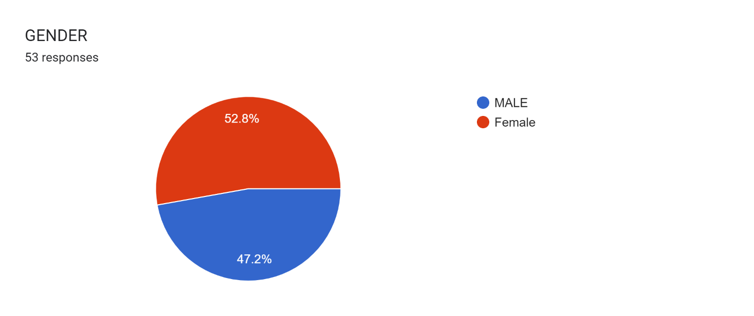

**Interpretation:** The data collected clearly indicates that maximum people who filled the questionnaire i.e. 52.8% are females and 47.2 %are males.

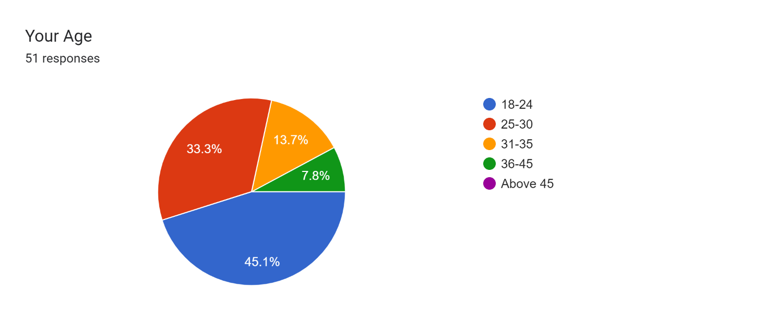

Interpretation: here mostly respondant are from the age group of 18-24 and 25-30

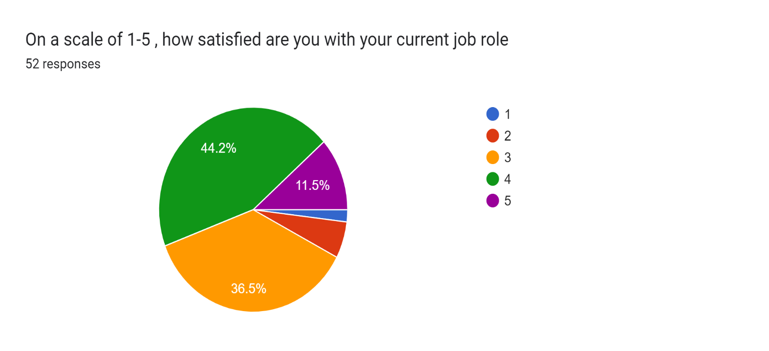

**Interpretation:** This data shows how satisfied the repondant are with their current job role rating from lowest to highest 5. Here data specify that 11.5% are highly satisfied, 44.2% are satisfied and 36.5% are low satified. There was total 52 respondants.

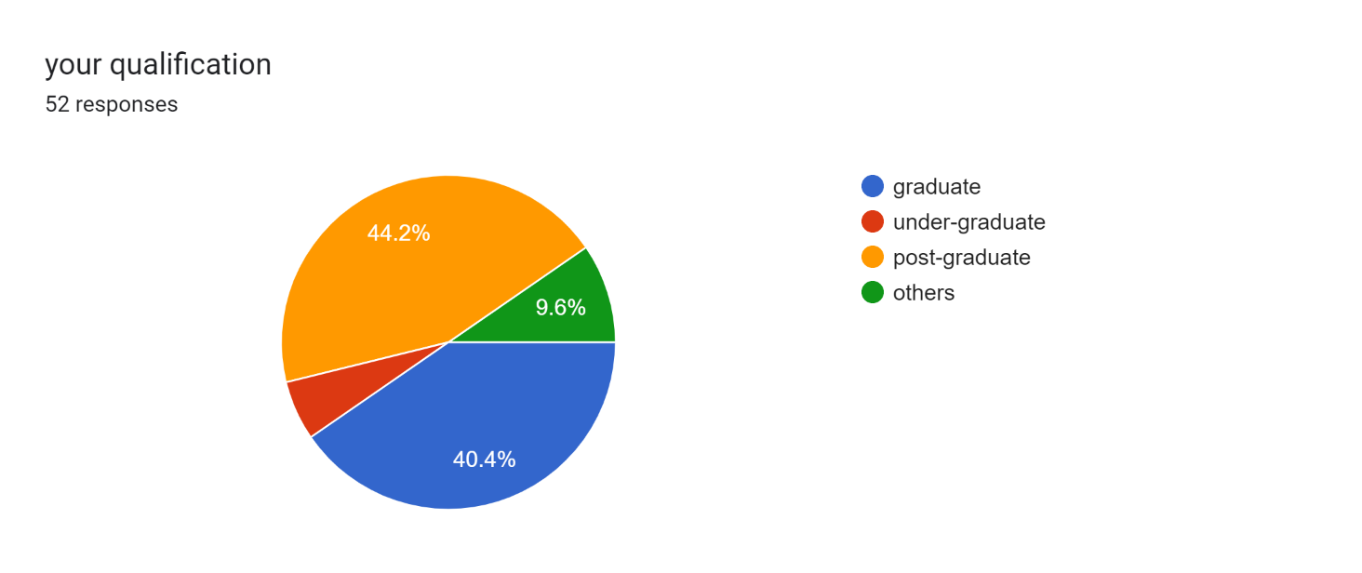

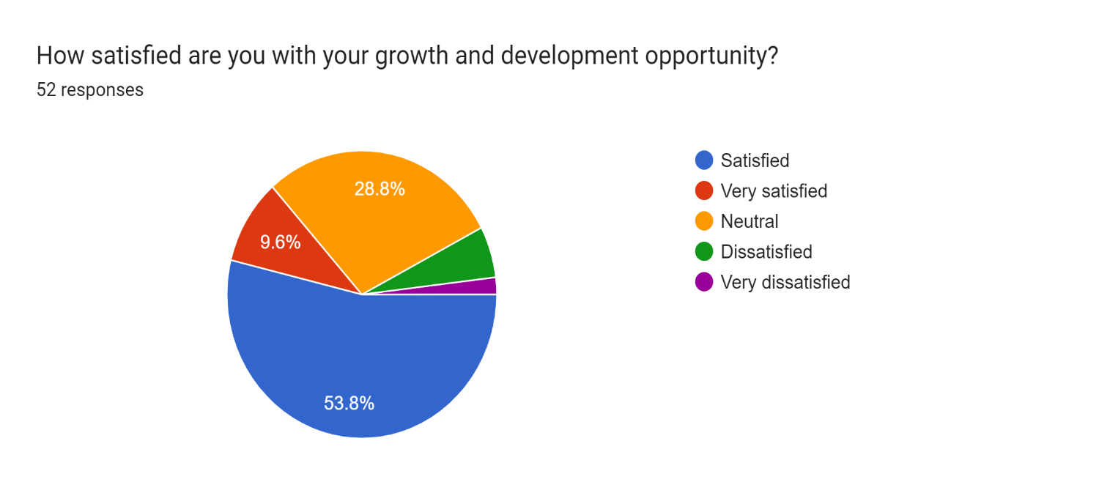

**Interpretation**: the above representation show the level of satissfaction and dissatisfaction of the respondant here 53.8% are satisfied with growth and devlopment opportunity in the organisation, where 9.6% are highly satisfied, 28.8% show neutral result.

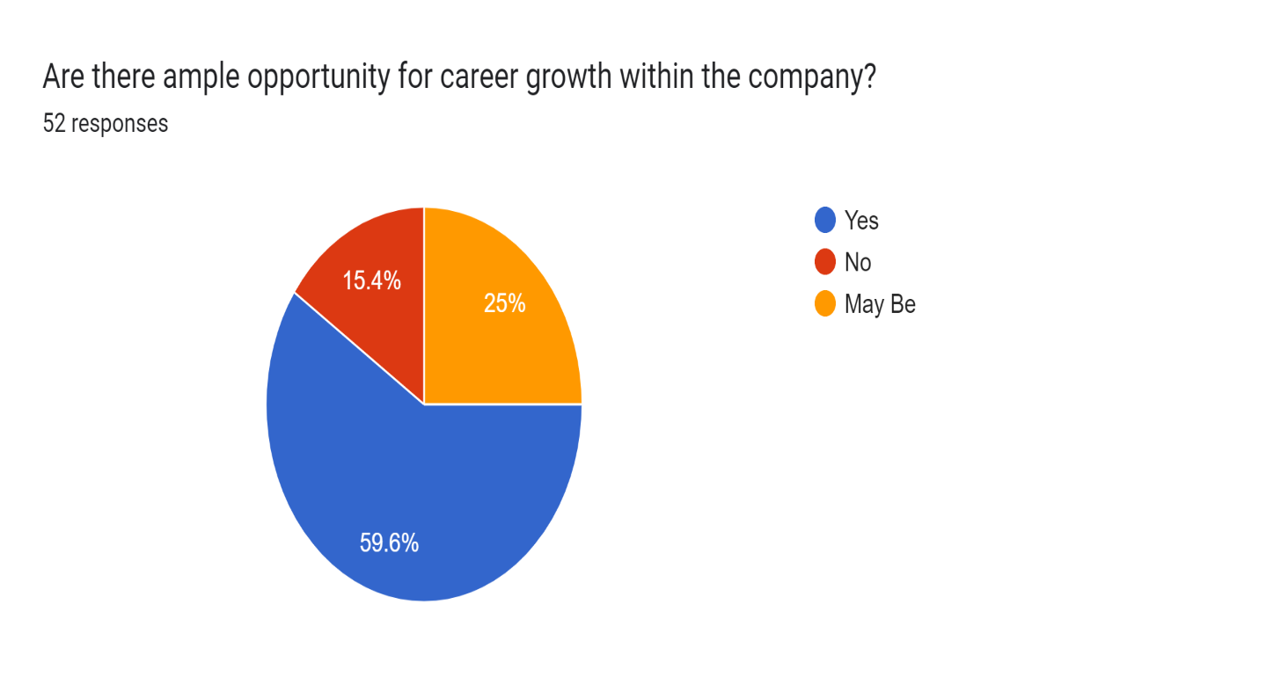

**Interpretation:** The result shows that 59.6% respondent sees opportunity for career growth within the company and 15.4% does seek any opportunity where 25% did not knew about the opportunity within company.

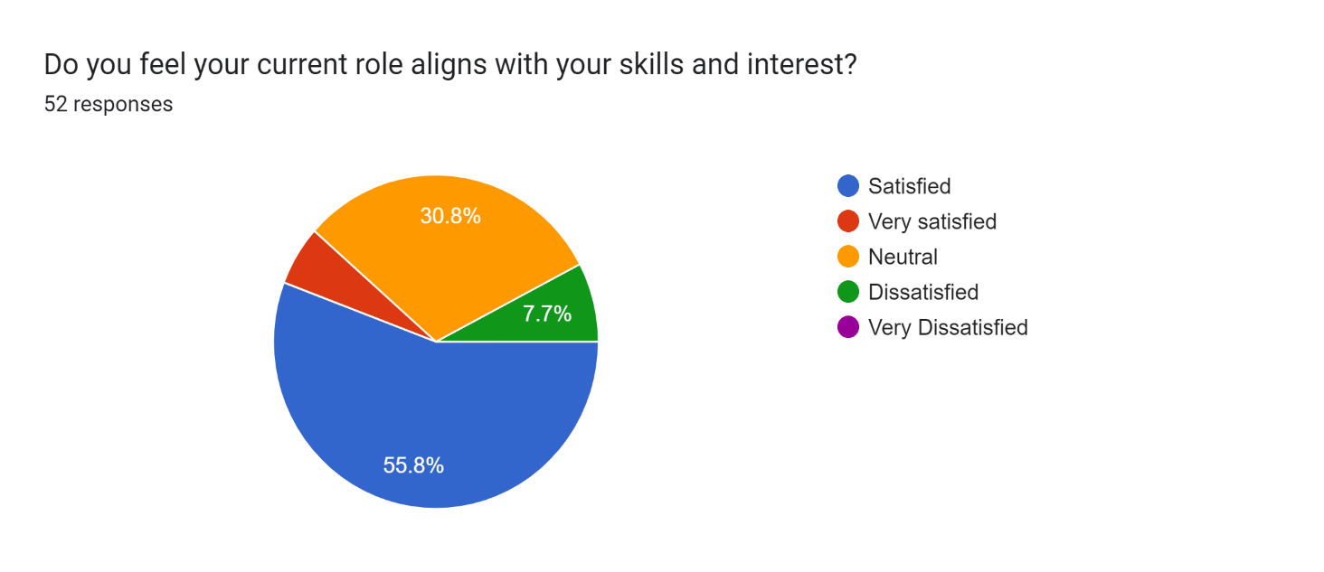

**Interpretation**: the data shows the current role are align with skills and interest ehere respondant shows 55.8% are satisfied, 30.8% show neutral result and 7.7% are dissatisfied.

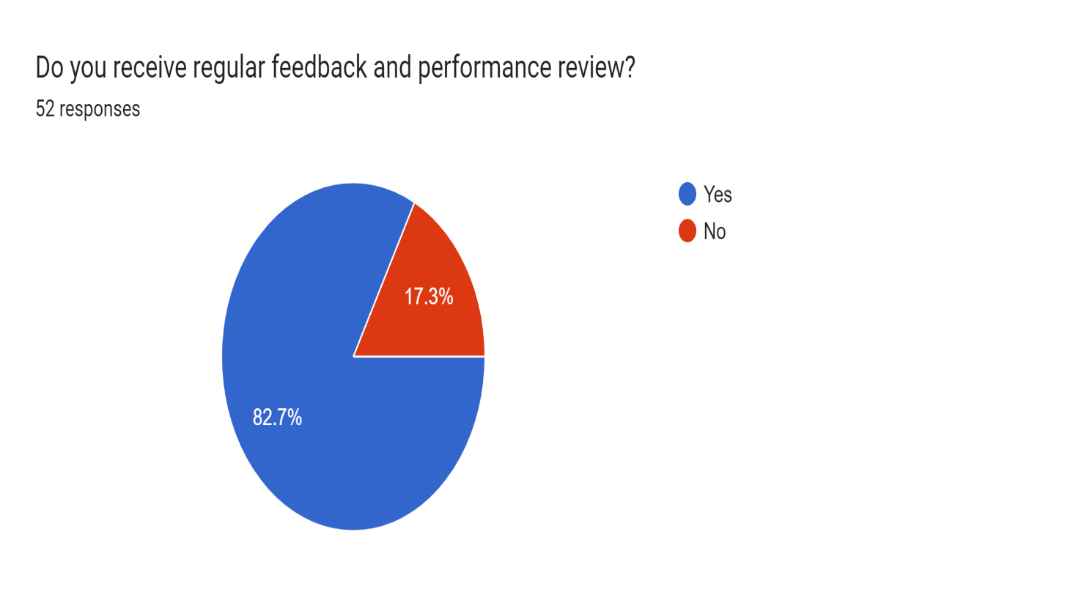

**Interpretation:** the respondant answer to the question about regular feedback and performance review where 82.7 % say yes and 17.3% says no. whwere it shows the review andfeedback are given to most of the organisations.

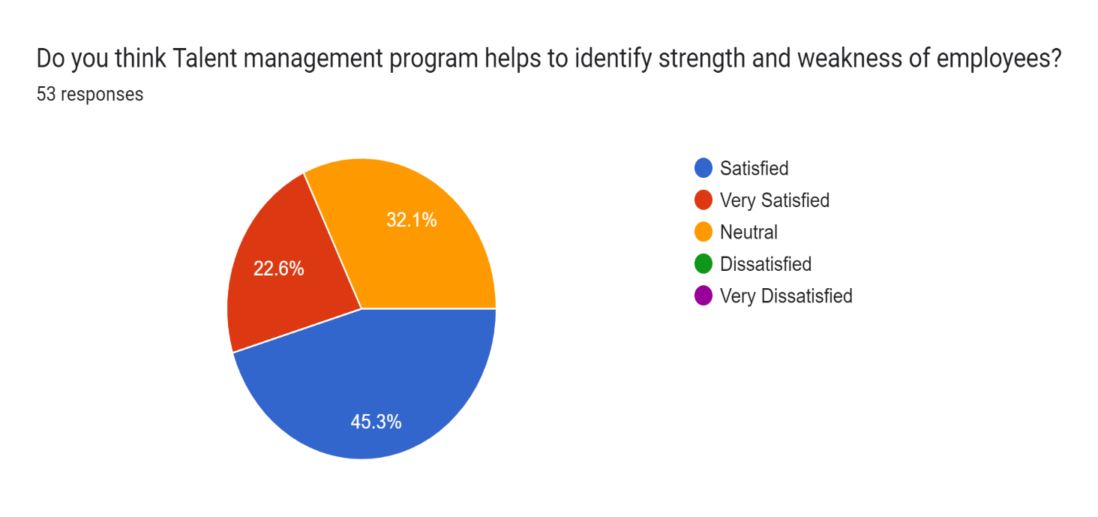

**Interpretation**: the above chart shows the effectiveness of talent management for strenght and weakness identification where 45.3% are satisfied, 22.6% are highly satisfied and 32.1% are niether satisfied nor dissatisfied.

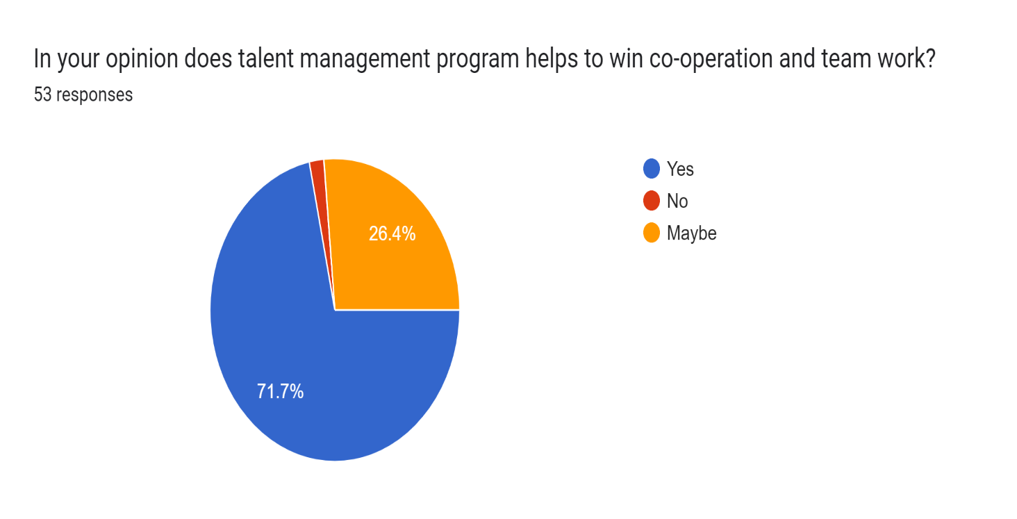

**Interpretation**: according to above data 71.7% respondant believe talent management programme wins coopertion and team work where 26.4% does know the exact outcome.

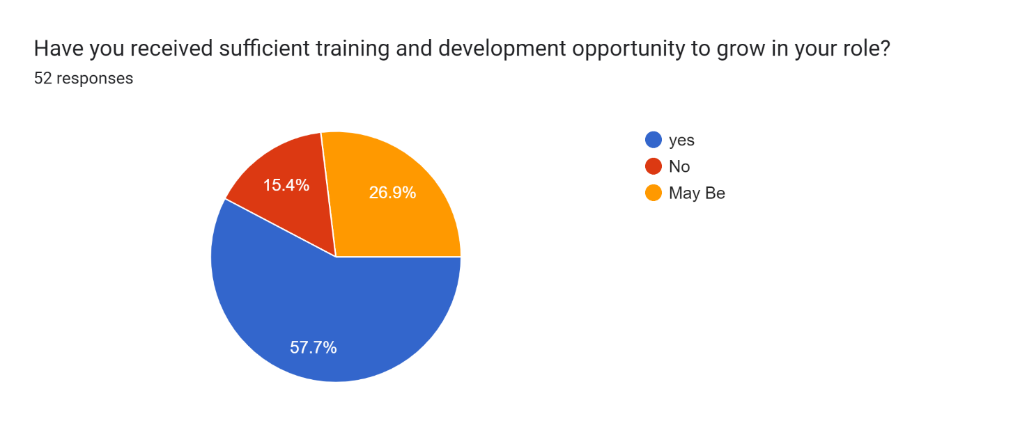

Intrepretation: according to the result 57% respondant says there are sufficient training and developmant opportunity to grow where 26.9% does know exactly whether the traing and development programmes are available and 15.4 % says no T&D available.

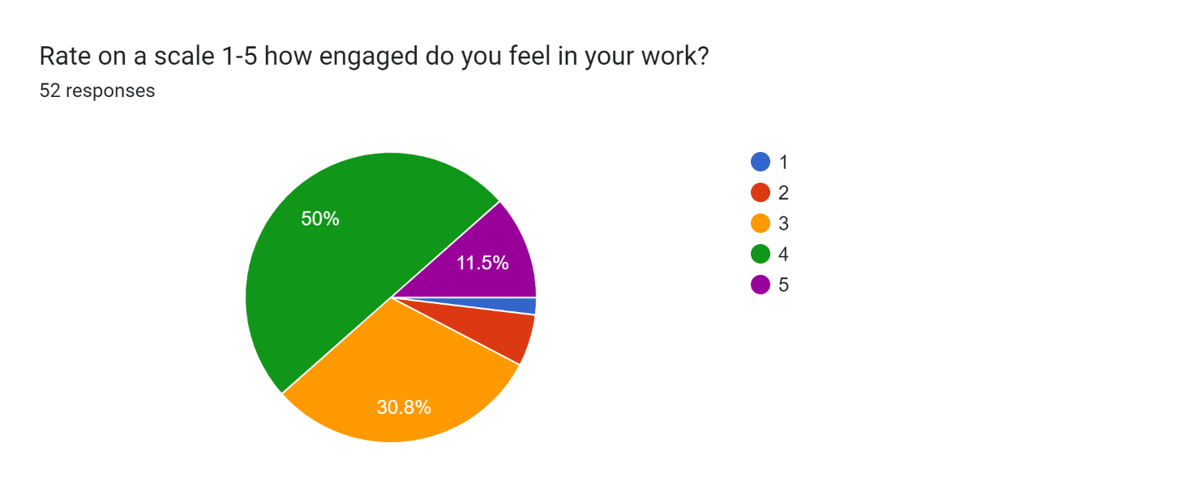

Interpretation: according to above data 50% respondent are satisfied, 30%are less satisfied and 11.5% are highly satisfied with their engagement in work the scale move from 1 being lowest and 5 being highest.

**Findings of research:**

**1-positive impact of Talent management on Employee Retention:** Recruitment and Selection:

Proficient talent management methodologies, such as precise recruitment and selection procedures, aid in identifying candidates who align well with the organization. Well-crafted recruitment strategies, emphasizing attracting candidates possessing requisite skills, experience, and cultural compatibility, can lead to elevated employee retention rates.

Training and Development:

Facilitating avenues for training and development assists employees in honing their skills, maintaining engagement, and advancing in their careers within the organization. Employees who perceive organizational investment in their professional growth and development are more inclined to remain dedicated and loyal.

Career Pathing and Succession Planning:

Transparent career trajectories and succession planning schemes furnish employees with clarity and direction, mitigating turnover risks arising from limited growth prospects. Employees envisioning a future within the organization are more likely to persist and contribute to its sustained success.

**2-Serve as a link between talent management and organisational success**

Employee Engagement and Productivity:

Talent management practices geared towards nurturing employee engagement, including regular feedback, recognition, and avenues for advancement, culminate in heightened productivity and performance. Engaged employees demonstrate heightened commitment towards their tasks and the organization's objectives, leading to enhanced overall performance and success.

**3-Innovation and Creativity:**

Nurturing a culture valuing and fostering innovation is imperative for organizational success amidst today's dynamic business landscape. Talent management initiatives promoting creativity, risk-taking, and knowledge sharing among employees serve as catalysts for innovation and competitive advantage.

**4-Financial Performance:**

Organizations prioritizing investment in talent management witness favorable impacts on financial performance, encompassing augmented revenues, profitability, and shareholder value. Employee retention and productivity play pivotal roles in generating cost efficiencies and revenue streams, thereby underpinning overall organizational triumph.

**Conclusion**

By looking into the finding and analysis it can accomplish that the critical importance of talent management in driving employee retention and organizational success. Through an analysis of various talent management practices and their impact on key outcomes, we have uncovered valuable insights that have significant implications for organizations across industries

Our finding highlights the connection between effective talent management strategies, such as staffing and selection, training and development, and career pathing, and higher levels of employee retention. By participating in these practices, organizations can create a helpful and engaging work environment that fosters employee loyalty and commitment, ultimately reducing turnover rates and retaining top talent.

Furthermore, our research has underscored the link between talent management and organizational success. We have demonstrated how talent management initiatives that prioritize employee engagement, innovation, and customer satisfaction contribute to improved

performance, productivity, and financial results. Organizations that strategically align their talent management efforts with their business objectives are better positioned to achieve supportable growth and competitive gain in today's dynamic marketplace.

In conclusion, the findings of this study underscore the critical role of talent management as a planned imperious for organizations seeking to attract, develop, and retain top talent and achieve long-term success. By prioritizing talent management practices that nurture employee engagement, foster innovation, and drive organizational performance, organizations can create a advantage and thrive in today's rapidly evolving business landscape.

Reference:

[. According to Alias et al. (2016),](https://doi.org/10.1007/978-981-287-426-9)

[Bibi (2019](https://doi.org/10.33215/sjom.v2i1.83)talent mangementpractices on employee performance. *SEISENSE Journal of Management*.

[According to Boudreau & Ramstad (2005](https://www.taylorfrancis.com/books/mono/10.4324/9780203889015/routledge-companion-strategic-human-resource-management?refId=d9588941-dea8-480a-97a8-8754bd592050&context=ubx))

boustani, H. (2014). Effects of Talent Management on Employees Retention. *International Journal of Academic Research in Economics and Management Sciences 3(5)*.

[HamidReza Boustani](https://www.researchgate.net/publication/287697338_Effects_of_Talent_Management_on_Employees_Retention_The_Mediate_Effect_of_Organizational_Trust)  (2014). Effects of Talent Management on Employees Retention. *International Journal of Academic Research in Economics and Management Sciences 3(5)*.

[Mubashir Majid](https://doi.org/10.51983/ajms-2018.7.1.1289)2018). Examining the Impact of Talent Management on Organizational Trust and Employee Retention. *Asian Journal of Managerial Science,* .

[Meyers et al., (2020)](https://doi.org/10.1080/09585192.2019.1579747)role of talent management in employee retention and organisational trust. *The International Journal of Human Resource Management*.

[Mwanzi, Jane](http://www.iosrjournals.org/iosr-jbm/papers/Vol19-issue8/Version-8/A1908080136.pdf)Influence of Talent Management on Organizational Growth. *IOSR Journal of Business and Management (IOSR-JBM)*.

Majid, M. (2018). Examining the Impact of Talent Management on Organizational Trust and Employee Retention. *Asian Journal of Managerial Science,* .

Ozçelik (2015)(2015), O. (2015). determinants of organisational sucess in talent management. *International journal of business and management*.

[**https://www.researchgate.net/publication/374147805_The_Impact_of_Talent_Management_Strategies_on_Employee_Retention**](https://www.researchgate.net/publication/374147805_The_Impact_of_Talent_Management_Strategies_on_Employee_Retention)