## TITLE OF MASTER THESIS

THE INVESTMENT PATTERN AND BANKING NEEDS OF THE HOUSING SOCIETIES

**Abstract:**

The Investment Industry is highly growing amidst the pandemic issues. With the development of infrastructure today, we have a wide range of investment alternatives. There are two main categories of investments: active and passive. Active investing calls for expertise, patience, and time as the investor must adjust the assets in their portfolio in accordance with market developments. The passive, sometimes known as the industry's "buy and hold" strategy, doesn't require you to be active. This is for those who are unable to fully indulge. High investments are considered active, whereas lower investments are considered passive. While passive risk decreases over time as securities are held, active risk rises with an increase in the buying and selling of assets and securities. As a result, the study only considers these two variables and evaluates how Indian citizens' investment behavior has changed. Their actions are monitored based on majority criteria and the advancements in technology.

**Keywords:**

***Investment, Banking, Savings, Stock market, securities, Indian investors***

**Objective:**

* To study the investment patterns of the citizens of India.
* To study the various investment options provided by the system to the citizens.
* To analyse the investment decisions and changes with changes in the economic development of the country.
* To identify awareness of the study topic.
* To understand attitude of investors on profitability factors of investment.
* To provide adequate information of the study to convince the citizens to invest smartly and explain to them the advantage of the process.
* To comprehend Indian residents' purchasing habits in the stock market.
* To understand the lack of awareness about Investment market in the citizens of India.
* To study the volatility of the Indian Investment market. 10) To reach to customers to invest in Indian Market.
* To understand the options, ways to invest, costing system, procedures and benefits of the Investment Market.

**Introduction:**

Investment in India has a long history dating back to the 1850s. The history of the world began with a conflict in one of the other countries, not with India. The United States and Great Britain were at war. The British were unable to get enough cotton for clothes as a result of this battle. The British now had to look for alternatives to this source. When they saw that there were roads, railroads, and waterways available, they concluded that the waterways would be the most practical and affordable alternative for importing cotton. Since India was the largest cotton market, they turned their attention to the Indian market for supplies of cotton. The British were unable to discover a means to get to Calcutta, the main market for cotton exports, because they had to cross the entire continent of Africa and pass through the Indian peninsula. Now, the British discovered a different path that they now refer to as the Swiss Canal route, which took them straight to Bombay. Bombay is now the British Empire's main cotton export hub. As a result, new companies focused on exports started to arise in Bombay. The businesses now look for significant capital commitments to run their operations.. Securities are now a thing in India because to this investment requirement. In India, the idea of securities first appeared in this way. Now that we know how the idea came to be, let's go back to 1855, when two Indians, a Parsi and a Gujrati, were sitting beneath a banyan tree when they had the idea to use security as a commercial tool. However, they discovered a permanent location in Bombay in 1874, which they named "Dalal Street." This was the location where everyone who was in favor of securities came forward to expand the company. They formally changed their name to "The Native Share And Stock Broker Association" in 1875. In 1925, this organization changed its name to BSE. The classification for this BSE was AOP, or Association of Person. Perhaps this was an unregistered business. However, it was transformed and acknowledged as India's first stock market in 1957 upon independence. This is the correct corporation that is now registered. Let's talk about rules and regulations now. Without them, no organization could operate. The BSE Regulations Act, 1925 is a law that the BSE created for itself back in 1925. However, this law only applied to the BSE's operations. It was now necessary to establish laws and rules that would allow trading to occur, whether it be for firms listing, investors investing, brokers, etc. The Capital Issue Control Act of 1945 entered the picture for that reason.

For brokers, listing businesses, investors, and other parties, the matter was settled by this statute. However, the Stock Exchange Board of India (SEBI) took the place of Capital Issue Control in 1988, as decreed by the government. SEBI was now designated as the regulatory body by the 1945 Capital Issue Control Act. The SEBI Act of 1992 was now passed and put into effect. However, all authority was transferred in 1995. SEBI is now the primary stock market regulator. Since there was just SEBI and BSE at the time, the general public had very little knowledge and access to information, and investors were completely dependent on brokers to do business because no one can trade for any reason without a broker. Therefore The National Stock Exchange, or NSE, was founded in 1992 with the intention of facilitating trade through electronic means and ensuring that all investors have constant access to all information. Thanks to the NSE's groundbreaking innovations, we can now obtain data about any company, trend, performance, stock rate, etc. in a matter of seconds. The idea of electronic shares of securities was created, along with the requirement to convert all of these securities from paper to electronic format. This resulted in the Depository Authorities Act of 1996, which gave the depository authority over the shares' dematerialization.

Subsequently, numerous other exchanges, laws, and regulations were enacted to create the modern investing industry.Thus, this was the development of the Indian investment market.

India wants to expand its investment market potential. Indian is attempting to be steadfast in gaining 15% on the benchmark indices when the mid- and small-cap industries have thrived, despite the fact that the market has become so unpredictable as a result of the COVID-19 epidemic. The phase and pattern of investment have altered as a result of research on investments made during the COVID era. India is focusing on the biggest industries that could flourish in this scenario, including real estate, life insurance, pharmaceuticals, information and technology, chemicals, and steel. According to market estimates, investors will benefit from these industries. The 2020 worldwide lockout left the market bleeding, with the indexes shattering to over 40% in just two weeks. This has led to fears of a market crash, which has been exacerbated by the lockdown in major states. However, the disaster is unlikely to occur until 2021. Additionally, India has widened its doors to accept foreign direct investments. Although there is always uncertainty in the market, corrections are aiding in price stabilization, and the market's rebound is also showing promise. However, the fast expanding US economy has put India in jeopardy since there would be a larger push for dollar rates, which is counter to the current circumstances. US had already accelerated by 6.4% in the first quarter. When compared to the United States, the Indian market will be severely impacted by the second and third waves of COVID-19. India's GDP is currently declining due to trade and manufacturing setbacks; by FY2022, the country was only predicted to increase by 12.5%, compared to the current GDP growth of 12%. With the rate at which the US economy is growing in terms of wealth and health, they will soon overtake all other nations. The United States' growth may boost global growth.

**CONSUMERS' PERCEIVED INVESTMENT PATTERN IN THE SECURITIES MARKET**

We will now examine how Indian individuals have benefited from the investment market following the brief summary of the securities market. Upon comparing investment statistics between India and the USA, we find that although 50% of Americans invest in markets, just 5% of Indians do the same. This is a straightforward explanation of how much awareness is generated in the US market compared to the lack thereof in the Indian market. As we already knew, an economy does well when investment patterns are favorable. The county will witness greater growth and greater supply in proportion to the level of demand.

The stock market According to analysts, the above image shows that India's stock market, valued at $2.7 trillion, has risen to the seventh rank as the country looks to improve its domestic demand recovery amid the COVID-19 pandemic and as governments step in to boost the flagging economy. India too plans to expand at 11.5% in FY 22.

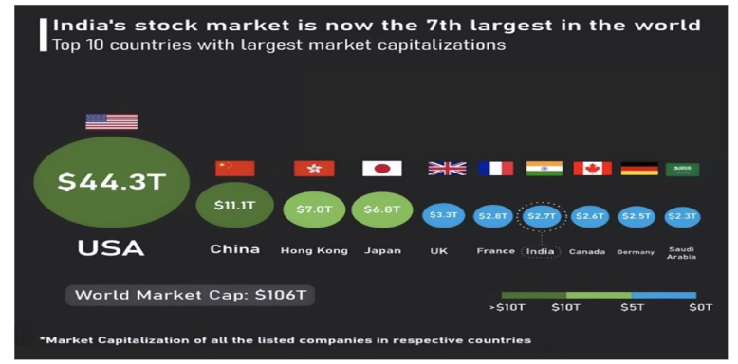

The USA The figure above displays data on state-by-state investment contributions during the previous four years. This helps us to realize that Uttar Pradesh is the state that contributes the most, indicating that investors are the majority there and that the other states follow suit. Studies show that the Lucknow Municipal Corporation raised ₹200 crore for the state when it listed on the BSE in December 2020. By using a municipal corporation to raise finance at this level, Lucknow became the ninth city in the nation. These bonds were really purchased for 7.25%, but they were issued for 8.5% for ten years. The Uttar Pradesh government encouraged MSME owners to invest in the stock market in order to raise a sizeable sum of money and expand their companies. With this ₹200 crore statement, the municipal bond's listing signaled the start of a new age in growth and paved the path for self-reliance. By using these bonds, ₹3,600 crore was raised up till FY2020.

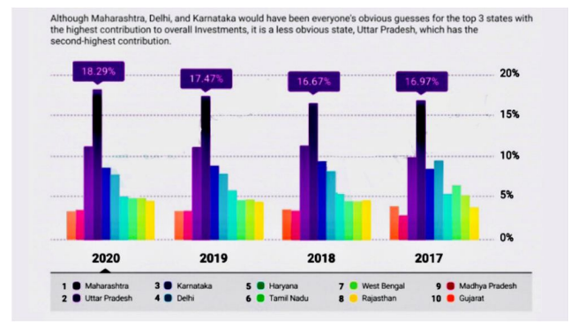

1. Allocation of Capital

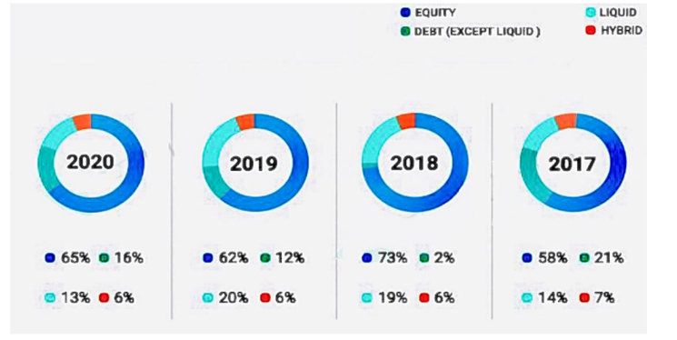

We can deduce from the following figure that there have been changes in the way investors deploy their funds based on their portfolios between 2017 and 2020. As of right now, equities investments account for the majority of the allocation; liquid, debt, and hybrid funds come next. This allotment is for mutual fund investments that are examined and evaluated nationally. One benefit of using mutual funds is that they allow for diversification into a variety of securities. Even in the event of a market decline, diversification of investments helps to mitigate risk. In the Indian market, mutual funds are typically viewed as long-term investments, with investors looking to use their gains to pursue family-oriented objectives. As of March 2021, the mutual fund sector was valued at ₹31,42,764 crores, surpassing the ₹30 trillion threshold. 9.79 crore accounts (folios) in total were present, of which 8.18 crore were in equity and hybrid schemes. Now that we know, what is preventing Indians from investing in the market?

1. Insufficient Funds/Capital In India, there is a misconception that investing in the market necessitates large sums of money, yet small quantities of money can also be used.
2. Investment Ignorance Investors are not drawn to markets in which they have little or no understanding.
3. Conventional wisdom Indians tend to think that safer ways of investing, such as precious metals or fixed deposits, guarantee returns and prevent capital loss. Even though the stock market yields higher profits, FDs are still a viable option because citizens lack a risk-taking mindset. Past Incidents If one has experienced losses in the past because of investing in wrong stocks, this creates fears instead of them realising their mistake and rectifying it.
4. To dispel the aforementioned market fallacies, investing is simpler and less complicated than it used to be thanks to advancements in technology. Customers have two easy options for investing: they can adopt a systematic plan that allows them to invest little sums at regular intervals, or they can trade with the total amount they want to invest. Additionally, the market has made it simple to contribute or take money at any moment from anywhere in the world. You can easily make money if you take advantage of the market's volatility and comprehend financial concepts rather than misconceptions. Developing astute portfolios can aid investors in becoming wealthy as well. Early investment is also seen as a benefit over time, changing a person's likelihood of financial success. Experts advise keeping monetary emergency reserves on hand in case of a pandemic.

**INVESTING IN THE BANKING SECTOR**

Is investing in the banking sector a wise financial decision? Now let's examine the study's second area of focus, the banking sector. Investing in securities is one type of investment; another is in the banking industry. For all value investors, banking is a wise option. This bank's payment of dividends to split holders is an example of its long history of making money for investors. The bank stock appeals to these value-seekers. One form of theory utilized in value investing is allowing investors to choose equities that are trading below book value. These particular stocks have been undervalued by the market. They buy a large number of stocks at once then sell them off when the economy or market decline. This happens when rival companies try to offload their expensive stocks, which encourages buyers to buy the stocks at a lower price. Long-term goals are likewise given precedence by value investors over short-term ones. Now, we'll understand the perspectives of both short-term and long-term investors in the banking business. Benjamin Graham, a legendary figure in investment, is credited with remarking that "short-term investing is like voting machines."

**SERVICES FOR THE INVESTORS FROM THE COMMERCIAL BANK**

India is renowned for its myths and superstitions, some of which are also quite plausible.One such is that there is significantly less worry of money loss because banks keep our money safe.The majority of Indians still invest in banking services such as mutual funds, post office deposits, savings bank accounts, life insurance deposits, provident funds, and fixed deposits when they wish to make money.Banks have an advantage over the stock market in that they are safer overall, but the main drawback is that banks rarely offer as high of returns as equities do.   
For example, banks might provide as much as 7.5% interest on fixed deposits if the same amount was invested in the investment market:-

1) Savings accounts: They resemble short-term investment schemes.They serve as investors' main tool.Interest is paid on your contributions to a savings bank account, usually once a month.To invest in the bank that offers the best return, one must compare banks, their policies, and their rates. In India, banks typically offer interest rates between 2.5 and 7.2% .

2) Fixed Deposits: These provide investors higher interest rates than standard savings accounts. They are financial instruments with too little risk. In India, fixed deposit yields start at 6.50% and can reach a maximum of 6.75%. It has good higher rates for older persons and is a wonderful long-term alternative.

3Life Insurance: Banks offer a range of life insurance coverage options to suit different investor types. The nation's government introduces these programs, with banks acting as an intermediary. Given the high cost of healthcare, the programs are quite reasonable and inexpensive.

4) Provident Fund: These long-term programs have a 15-year maturity period and require minimum payments of ₹100 and maximum payments of ₹60,000, with interest rates ranging from 7-8%. Due to its government management and guaranteed returns, this scheme is quite popular. Tax benefits under the EEE category are also favorable. Retraction of the invested sum is only possible after a 15-year maturity period.

a) Statistics

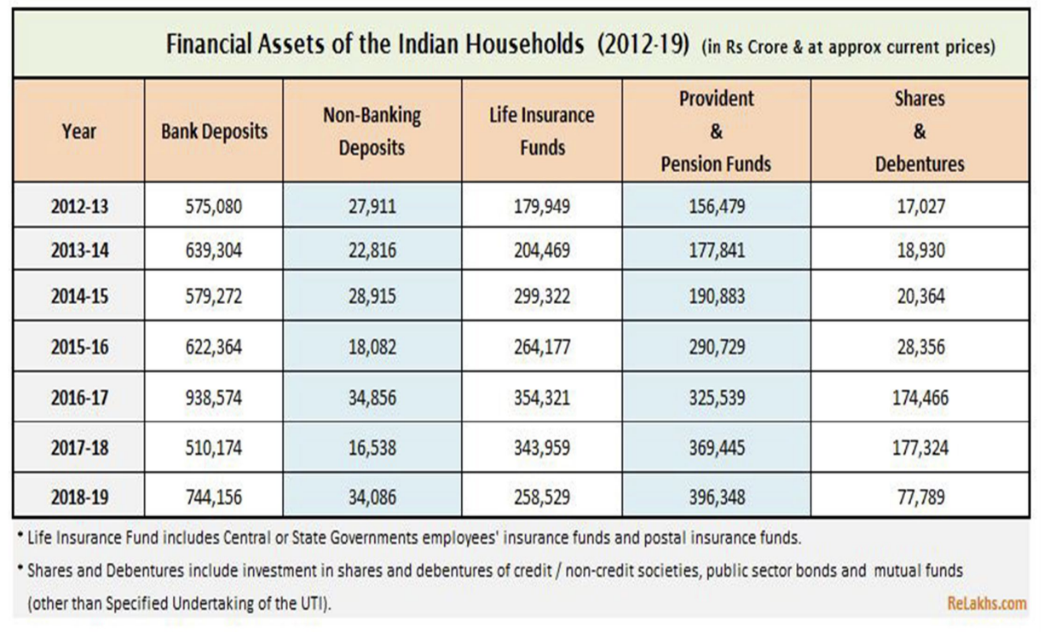

b) Interpretation:

We may observe how Indian households invest in bank-provided plans and services by looking at the secondary data table above.Data spanning seven years reveals a sharp rise in bank deposits, which have been followed by a twofold increase in non-banking deposits between FY 17–18 and FY 18–19.Given the current circumstances, life insurance has also doubled throughout the previous seven years.Positive increase has been observed with appropriate knowledge of the significance of life insurance and life covers.Additionally, investments in shares and debentures have increased more than 4.5 times, and provident funds have doubled.Investors have grown and made more favorable investments in the market's services throughout time.

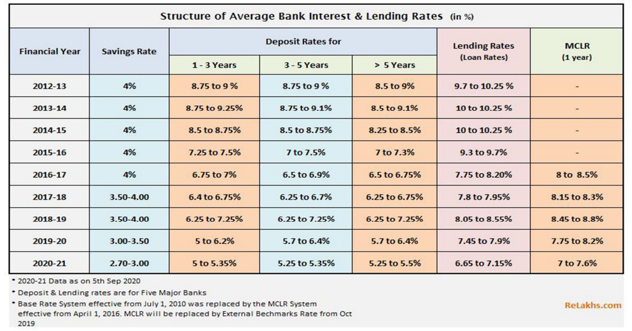

In order to help investors assess and make methodical investments to increase their returns on investment, secondary data was used to create the following table, which displays all of the interest rates that banks have offered for the services they have supplied over the years. From the last seven years of data, the rates have gotten lower with time. With large declines in deposit rates and just slight declines in leading, MCR, and savings rates.

**Literature review:**

* Asli Demirguc-Kunt, Beck, Thorsten, and Maria Soledad Martinez Peria. 2007. Reaching Out: Access to and Use of Banking Services Across Countries. 234–266 in Journal of Financial Economics, 85(1).
* J. Black, D. Jeffreys, and D. de Meza. 1996. Home Prices, Collateral Supply, and the Enterprise Economy. Journal of Economics 106:60–75.
* Harvey, J., and T. Blackman. 2001. A case study on the relationship between mental health and housing renewal. Mental Health Journal 10 (5): 571–583. R. Bon (1992).
* The Future Prospects of Global Construction: Secular Development and Recession Trends. International Habitat 16(3): 119–128.
* Bon, R., and R. Pietroforte. 1990. Using input-output tables, a historical comparison of the construction sectors in the US, Japan, Italy, and Finland. Construction Management and Economics 8:233–247.
* Bon, R., T. Birgonul, and I. Ozdogan. 1999. An Input Output Analysis of the Turkish Construction Sector, 1973–1990: A Note.
* Construction Management and Economics 17:543–551. Breysse, P., N. Farr, W. Galke, B. Lanphear, R. Morley, and L. Bergofsky. 2004.
* An historical comparison of the US, Japan, Italy, and Finland's construction industries using input-output tablesz. Environmental Health Perspectives 112(15): 1583–1588.
* Buckley, R., and J. Kalarickal. 2005. Housing Policy in Developing Countries: Conjectures and Refutations. The World Bank Research Observer 20(2): 233–257. Buckley, R., L.
* Chiquier, and M. Lea. 2009. Housing Finance and the Economy. In L. Chiquier and M. Lea, eds. Housing Finance Policy in Emerging Markets. Washington, DC: World Bank.
* Erbas, S., and F. Nothaft. 2005. Mortgage Markets in Middle East and North African Countries: Market Development, Poverty Reduction, and Growth, Journal of Housing Economics 14:212–241.
* Fogel, R. 1994. Economic Growth, Population Theory and Physiology: The Bearing of Long Term Processes on the Making of Public Policy. American Economic Review June:369– 395.
* Green, R., and M. White. 1997. Measuring the Benefits of Home Owning: Effects on Children. Journal of Urban Economics 41:441–461.
* Hardt, J., and J-D Lichtenberger. 2001. The Economic and Financial Importance of Mortgage Bonds in Europe. Housing Finance International June:19–29.
* Haurin, D., Parcel, T., and Haurin R. 2001. The Impact of Homeownership on Child Outcomes. Low-Income Homeownership Working Paper Series LIHO-01.14.
* Joint Center for Housing Studies of Harvard University. Holzmann, R., T. Packard, and J. Cuesta. 2001.
* Extending Coverage in Multi-pillar Systems: Constraints and Hypotheses, Preliminary Evidence and Future Research Agenda. In R. Holzmann and J. Stiglitz, eds. New Ideas about Old Age Security: Toward Sustainable Pension Systems in the 21st Century.
* Washington, DC: World Bank. ILO. 2008. Labour Statistics. International Labour Organization. Jamison, D. T., H. W. Mosley, A. R. Measham, and J. L. Bobadilla, eds. 1993.
* Disease Control Priorities in Developing Countries. Washington, DC: World Bank. Jappelli, T., and M. Pagano. 1994. Saving, Growth and Liquidity Constraints.
* The Quarterly Journal of Economics 109 :83–109. Kofowolora, O., and S. Gheewala. 2008.
* An Input–Output Analysis of Thailand’s Construction Sector. Construction Management and Economics 26:1227–1240. Klyuev, V., and P. Mills. 2007. Is Housing Wealth and “ATM”? The Relationship between Household Wealth, Home Equity Withdrawal and Saving Rates.
* IMF Staff Papers 54(3): 539–5621. Laskar, A., and C. Murty. 2004. Challenges Before Construction Industry in India. Department of Civil Engineering, Indian Institute of Technology, Kanpur ([www.iityk.ac.in](http://www.iityk.ac.in)).
* Lean, S. C. 2001. Empirical Tests to Discern Linkages between Construction and Other Economic Sectors in Singapore. Construction Management and Economics 13:253– 262.
* Le Blanc. 2009. Residential Rental Housing Finance. In L. Chiquier and M. Lea, eds. Housing Finance Policy in Emerging Markets. Washington, DC: World Bank.

**Methodology:**

Sampling is a part of the whole research method. Once market researchers decide to conduct a field survey, they must decide whether to use a census survey or a sample survey. In place of complete censuses, sample surveys are often used due to their numerous advantages. In order to perform a sample survey, it is necessary to first identify the target population. After that, choosing a suitable method of sampling is possible. What kind of sample design is used is decided by how easily obtainable the required sample frame is. Because of the need for substantial human engagement in the data gathering process, a sample survey was selected as the sampling technique. Their involvement is also unnecessary since every housing cooperative has the same fundamental framework and procedures. In addition, open-ended replies cannot be gathered through census. A lack of benefit would also cause frightened people to lose interest. This is why a survey based on a representative sample is superior than a census. A random sample does not favour any one segment of the population over any other segment since each individual is picked at random. Since all housing cooperatives are bound by the same set of bylaws, it stands to reason that their investment policies, revenue streams, and banking needs are all fairly standard across the board. Therefore, there is no need for a massive sample size. In addition, the time required to complete the project will skyrocket if the sample size is very huge. A community of 50 dwellings is an adequate target for social improvement.

### **Results And Analysis:**

Investment planning Questionnaire

Is investment better than saving?

1. Individual data   
   a. Name

b. Age

1. Your Position   
   a. What kind of work do you do?   
   a. What is your salary per month?   
   b. How much do you get paid annually?
2. For what duration are you hoping to invest your money?   
   A. 0–5 years;

B. 5–10 years;

C. Up to 10 years: I have sufficient funds for unforeseen expenses.   
d. Open term: I require access to money at all times

1. What is the estimated amount of money you want to invest?   
   a. Ten lakhs or less b. Ten to thirty lakhs   
   b. Between 30 and 50 lakhs   
   c. Amounts beyond 50 lakhs
2. I would take pleasure in looking at potential investments for my money.   
   a. I wholeheartedly concur with this assertion.   
   b. I generally concur with this assertion.   
   C. Between   
   d. I generally don't agree with this assertion.   
   e. I vehemently disagree with this assertion.
3. Should there be danger involved, I would still pursue the best return possible?   
   a. Consistently

b. Typically

c. Infrequently

d. Seldom e. Never

1. How do you typically think about making important financial decisions?   
   a. Extremely daring

b. Rather daring

c. Average

d. Rather cautious

e. Extremely cautious

1. How much risk do you believe you have taken on when making past financial choices?   
   a. Extremely large;

b. Large;

c. Medium;

d. Small;

e. Extremely small

1. To achieve my financial goal I want safe investments that increase gradually, even if that means overall progress is slowed down.   
   The following statements apply to me:

a. I strongly agree;

b. I tend to agree;

c. In between; and

d. I tend to disagree.   
 e. I vehemently disagree with this assertion.

1. 10. I become really nervous when I think about making investments that include some level of risk.   
   The following statements apply to me:

a. I strongly agree;

b. I tend to agree;

c. In between; and

d. I tend to disagree.   
e. I vehemently disagree with this assertion.

1. 11. Contemplate After investing, the financial market begins to perform poorly six months later. Accordingly, you have an investment that experiences a large decline. How would you respond to that?   
   a. Move funds to safer investments to lower risk and prevent additional losses.   
   b. Keep an eye on the investment and see if it improves.

c. Invest additional money in order to take advantage of the current low prices and hope for future growth.

1. 12. My goal is to achieve a high rate of return on investment. To accomplish this, I'm ready to consider the potential for bigger losses, right?   
   The following statements apply to me:

a. I strongly agree;

b. I tend to agree;

c. In between; and d. I tend to disagree.   
e. I vehemently disagree with this assertion.

1. 13. How much money, if any, would you be ready to put in an investment that has the potential to yield large returns but also has a similar risk of losing some of it?   
   All of it; more than half; half; and so on.Approximately half e.hardly any at all
2. 14. How do you think a close friend would characterize your approach to making financial decisions?   
   a. Bold;

b. Occasionally bold;

c. Considerate risk-taker;

d. Alert;

e. Extremely cautious and risk-averse

1. 15. How would you feel if you had chosen an investment that had both a high chance of losing money and the possibility of making huge gains?   
   a. Nervous and extremely uncomfortable

b. Quite nervous

c. A little worried

d. Accepting the potential highs and lows

e. Excited about probable gain

1. 16. Given a choice between two investment products and a certain amount of money to invest, which would you pick?   
   A product that has a modest average yearly return but virtually little chance of losing the initial deposit   
   b. A product that carries a little higher risk of losing some of the original investment but has higher average annual returns.   
   c. Combining the two items
2. 17. I would rather have tiny, definite profits than big, ambiguous ones?   
   The statements are:

a. I firmly agree with them;

b. I tend to agree with them;

c. in between;

d. I tend to disagree with them;

e. I strongly disagree with them.

1. Which of the following statements best sums up how you weigh the potential rewards or losses when making a big financial decision?   
    a. I'm thrilled about the potential rewards.   
    b. I'm upbeat about the potential rewards.   
    c. I consider both potential profits and losses.   
    d. I'm concerned about potential losses.
2. Even with modest profits, I want my investment money to be secure.   
   The statements are:
   1. I firmly agree with them;
   2. I tend to agree with them;
   3. in between;
   4. I tend to disagree with them;

**FINDINGS**

1. Of the total, men made up the majority (56%), while women made up the minority (44%). This indicates that men are more inclined to invest than women.
2. Of the total number of responders, 42% were between the ages of 20 and 30, and 5% were above 50. According to their opinion of investing, this indicates that younger people are more interested in it.
3. Of the total respondents, 49% are businessmen, 36% are in the corporate category, and 15% are entrepreneurs. This demonstrates that businesspeople invest more frequently than respondents in any other category.
4. Of all respondents, 56% have a monthly income of or more than $1,000,000; 15% have a monthly income between $20,000 and $50,000; 29% have an income between $50,000 and $1,000,000 per month. This demonstrates that people who make more than $1,000,000 per month tend to invest.
5. Of the total respondents, 100% have an annual income of more than $20,000, 40% have an income between $0 and $10,00,000, 22% have an income between $0 and $10,00,000, and 38% have an income between $20,000 and $20,00,000.This indicates that the individuals who earn more than $20,000 each year make regular investments.
6. Of the respondents, 32% invest for up to ten years, minority responders for zero to five years, 26% for five years or more, and 22% for an open term. This indicates that the respondents often make investments lasting up to ten years.
7. Of the respondents, 44% want to invest between $10,00 and $30,00,000; 13% want to invest above $50,000; 25% want to invest less than $10,00,000; and 18% want to invest between $30,00 and $50,000,000. This demonstrates that the respondents regularly invest between $100,000 and $300,000.
8. Sixty-nine percent of respondents strongly agree with the statement, twenty-one percent tend to agree with it, seven percent are neither in agreement nor disagreement, and three percent tend to disagree. This indicates that respondents would like to look into investing opportunities with their money.
9. Of the respondents, 28% occasionally pursue the potential return, 23% do so consistently, 14% do it regularly, 21% do so infrequently, and 14% say they would never want to.
10. When it comes to making financial decisions, 28% of the respondents have a fairly cautious attitude, 14% have a very adventurous attitude, 7% have a fairly adventurous attitude, 25% have an average attitude, and 26% have a very cautious attitude.
11. Of the respondents, 49% take very tiny amounts of risk, 7% take very large amounts, 5% take huge amounts, 14% take medium amounts of risk, and 25% take very small amounts of risk.
12. The respondents' percentages are in the middle: 35% strongly agree, 25% tend to agree, 17% tend to agree, 15% tend to disagree, and 8% strongly disagree with slow growth.
13. Of the 37% of respondents, 14% strongly agree that they feel anxious, 22% tend to agree that they feel worried, 19% tend to disagree that they feel uncomfortable, and, finally, 8% strongly disagree that they feel anxious when investing.
14. To take advantage of the lower price and expect future growth, 44% of the respondents said they would invest more money. 43% said they would move their money to a more secure investment product to avoid the danger of further losses. 13% said they would keep an eye on the investment and wait to see if it improves.
15. Of the respondents, 39% strongly disagree that taking risks is a good idea, 18% strongly agree that taking risks is a good idea, 15% tend to agree that taking risks is a good idea, 14% are in the middle of taking risks, and 14% strongly disagree that taking risks is a bad idea even if it means suffering losses.
16. Of those surveyed, 35% would invest half of their money, 14% would invest all of their money, 12% would invest more than half of their money, 28% would invest less than half of their money, and 11% would invest very little.
17. Of the respondents, 38% believe their friends would occasionally describe them as bold, 28% believe their friends would describe them as bold, 25% believe their friends would describe them as thoughtful risk-takers, 8% believe their friends would describe them as careful, and 1% believe their friends would describe them as extremely cautious.
18. Of the respondents, 38% were a little concerned about losing all of their money, 17% were panicked and extremely uncomfortable, 19% were quite nervous, 21% were willing to accept that there might be highs and lows, and 5% were excited about the possibility of making money.
19. Of the respondents, 51% choose to invest in a combination of the two products; 29% select a product with a low average annual return and little chance of losing the initial investment, and 20% select a product with a higher average annual return but a slightly higher chance of losing some of the initial investment.
20. The majority of respondents (29%), 13% strongly agree to have small certain gains, 26% are in between having small certain gains and large uncertain ones, 22% tend to disagree to have small certain gains, and 10% strongly disagree to have small certain gains but large uncertain ones.
21. Of the respondents, 43% consider both potential gains and losses; 10% are enthusiastic about potential gains, 17% are upbeat about potential gains, 25% are aware of potential losses, and 5% are concerned about potential losses.
22. Four thirds of the participants contemplate both possible gains and losses; ten percent are positive about prospective gains, seventeen percent are optimistic about potential gains, twenty-five percent are aware of potential losses, and five percent are worried about potential losses.

**Recommendations:**

* Financial institutions should take a more proactive approach to informing local clients about development schemes and securities on a regular basis and providing sufficient updates.
* Investors ought to recognize the significance of investing in the current environment, wherein they should be independent in their market knowledge rather than depending on brokers for guidance.
* Improved facilities and infrastructure should be provided by financial institutions and the stock market since investors are expecting improved services.
* The secret to success in the modern world is advertising. Since the worldwide epidemic struck, social media advertising and targeting the hardest-hit areas with social media content are imperative.
* In order to inform the public about its services and how they might benefit them, the government must offer virtual drives on social media.
* Indians must see the urgency of the situation and begin transforming their old, conventional ways of thinking into fresh, trustworthy perspectives.
* The market's risk factor shouldn't deter investments, so the banking industry may manage risk to keep investors interested.
* More intermediate services must be added to the securities market, together with adaptable and adjustable securities patterns and appropriate laws.
* By utilizing portfolio diversification, one can expand significantly across multiple industries, thanks to increased capital indulgence and the robust growth of the stock market and securities.
* Customer feedback and transparency should be implemented right away in order to stay in line with investors' expectations.
* Rather than adopting foreign trends, India could create securities with an Indian flair to better connect with its clients.

**Conclusion:**

Understanding Indian investment patterns in the banking and securities industries was the study's primary goal. After conducting this study, the researcher concluded that the economic stability and GDP factors of the nation—which include policy, taxation, employment rate, inflation, and other financial elements—largely impact investors' investment patterns. This study demonstrates how the risks and return factors associated with various financial products vary. The study highlights for readers the significance of investing for the good of oneself and the national economy, and adequate data has demonstrated that economic expansion has led to improved performance in the near future. The market is a very erratic environment. Nobody is able to predict the state of the market with absolute certainty. There is no doubt about it: although we cannot forecast the future, we can shape it. The paper describes how to shift toward better developmental circumstances by taking use of this unpredictability. The study demonstrates the distinctiveness of every financial service offered to give investors a wider range of options. The securities market has contributed to the industry's recent explosive growth, and banks have expanded in line with RBI guidelines by merging smaller banks into larger ones to reduce the number of banks and increase their capital and long-term viability. We discuss money-saving strategies today. This study disproves the myth that saving money will grow its worth; instead, wise investments will.

**Reference:**

1. [www.icici.com](http://www.icici.com)
2. [www.infoplease.com](http://www.infoplease.com)
3. Brochures & booklets of ICICI Bank
4. ‘Marketing Management’ by Philip Kotler Published by Pearson Education (Singapore) Pte. Ltd.
5. ‘Research Methodology: Methods & Techniques’ by C.R.Kothari
6. ‘The Marketing of Services’ by Donald Covell Published by Heinamall, London
7. ‘Marketing Research’ by G.C.Bery Published by Tata McGraw-Hill Publishing Company Limited, New Delhi
8. Aaronson, D. 2000. A Note on the Benefits of Homeownership. Journal of Urban Economics 47:356–369.
9. Agus, R. 2002. The Role of the State and Market in the Malaysian Housing Sector. Journal of Housing and the Built Environment 17:49–67.
10. Wright, C., M. El Alamy, H. DuPont, A. Holguin, B. Hsi, S. Thacker, A. Zaki, and M. Habib. 1991. The Role of House Environment in Infant Diarrhea in Rural Egypt. American Journal of Epidemiology 134(8): 887–894.
11. Zhang, Xing Quan. 2008. Housing and Urban Upgrading in Yantai, [People’s Republic of] China. Nairobi: United Nations Human Settlement Programme (UN-HABITAT).
12. Zhuang, J., H. Gunatilake, Y. Niimi, M. E. Khan, Y. Jiang, R. Hasan, N. Khor, A. Lagman-Martin, P. Bracey, and B. Huang. 2009. Financial Sector Development, Economic Growth, and Poverty Reduction: A Literature Review. ADB Economics Working Paper No 173. Manila: Asian Development Bank.
13. Li, X. 2001. Mortgage Market Development, Savings, and Growth. IMF Working Paper WP/01/36.
14. Majale, M., G. Tipple, and M. French. 2011. Affordable Land and Housing in Asia: Volume 2. United Nations Human Settlement Program (UN-HABITAT). Nairobi: Union Publishing Services.