**RESEARCH PAPER ON**

**ENHANCING ORGANIZATIONAL DECISION MAKING BY THE USE OF HR METRICS AND ANALYTICS AT RELIANCE COMMUNICATION LTD**

***FOR THE PARTIAL FULFILLMENT OF THE REQUIREMENT***

***FOR THE AWARD OF***

***MASTER OF BUSINESS ADMINISTRATION***

**UNDER THE GUIDANCE OF**

**Prof. Mamta Gaur**

**Submitted By**

**Shilpy Kumari**

**22GSOB2010647**

**MBA 2022-2024**



**SCHOOL OF BUSINESS**

**GALGOTIAS UNIVERSITY**

**May, 2024**

**ABSTRACT**

The project report delves into the intricate relationship between human resources (HR), human resources management (HRM), and human resource information systems (HRIS) in the context of forest resource management. It underscores the multifaceted role of HR functions, emphasizing their significance in motivating, retaining, training, and deploying employees for tasks related to forest management. Effective HRM practices are shown to bolster sustainable forest management objectives and ensure efficient personnel management through strategic recruitment, targeted training, and compliance with relevant regulations. HRIS platforms are depicted as vital tools for streamlining HR processes, maintaining accurate records, and enabling informed decision-making. Additionally, the report explores the application of HR analytics in various areas, including performance management and compensation. Through primary data collection methods and literature reviews, it provides insights into HR data monitoring challenges and underscores the importance of leveraging HR analytics for optimizing staff performance and operational efficiency. Overall, the report offers a comprehensive framework for enhancing HR practices in the forest sector, illustrating the synergies between HR, HRM, and HRIS, and providing valuable recommendations for organizations seeking to improve their capabilities and achieve conservation goals.

**INTRODUCTION TO HR METRICS AND ANALYTICS**

An HR matrix is a tool used in Human Resources (HR) management to organize and analyze various HR-related data points. It typically involves organizing data in a tabular format, with rows representing employees and columns representing different aspects such as performance ratings, training completed, skills possessed, attendance records, etc.

HR analytics can encompass a wide range of activities, including:

**1.** **Predictive Analytics:** Using historical HR data to forecast future trends, such as identifying which employees are at risk of leaving the company or predicting future workforce needs.

**2. Descriptive Analytics:** Analyzing past HR data to understand what has happened and why, such as analyzing turnover rates or identifying patterns in employee performance.

**3. Prescriptive Analytics**: Providing recommendations for actions to take based on HR data analysis, such as suggesting interventions to improve employee engagement or recommending training programs to address skill gaps.

**There are several tools available for HR metrics and analytics that cater to different needs and preferences. Here are some commonly used tools:**

**1**. **Human Resource Information Systems (HRIS):** Many HRIS platforms come with built-in reporting and analytics capabilities. These systems typically collect and store HR data, allowing users to generate various reports and analyze key metrics related to employee demographics, performance, training, and more.

**2. Microsoft Excel:** Excel is a versatile tool widely used for HR metrics and analytics. It offers powerful features for data manipulation, visualization, and analysis, making it suitable for creating custom HR reports and dashboards.

**3. Business Intelligence (BI) Tools:** BI tools enable users to analyze large datasets and create interactive dashboards and reports.

**4. Survey Tools:** Survey tools are used to collect employee feedback and conduct surveys related to HR initiatives, employee satisfaction, engagement, and other relevant topics.

**5. Statistical Analysis Software:** Statistical analysis software is used for advanced statistical modeling and analysis of HR data. These tools are suitable for conducting complex analyses, such as regression analysis, cluster analysis, and factor analysis.

**6. Text Analytics Tools:** Text analytics tools analyze unstructured data, such as employee comments, reviews, and feedback, to extract meaningful insights.

**HR metrics and analytics play a crucial role in improving HRIS (Human Resource Information Systems) in an organization in several ways:**

**1. Data-driven Decision Making:** HR metrics and analytics provide quantifiable insights into various aspects of HR management, such as recruitment, retention, performance, training, and employee engagement.

**2. Identifying Key Performance Indicators (KPIs):** HR metrics help in identifying and defining KPIs that are essential for measuring the effectiveness of HRIS. These KPIs could include metrics related to recruitment efficiency, turnover rates, training effectiveness, employee satisfaction, and more.

**3. Optimizing HR Processes:** HR analytics can uncover inefficiencies in HR processes within the HRIS. By analyzing metrics related to process duration, bottlenecks, and resource utilization, organizations can identify areas for streamlining and automation within the HRIS.

**4. Forecasting and Planning:** Predictive analytics techniques can help in forecasting future HR needs based on historical data trends. By analyzing metrics related to workforce demographics, turnover rates, succession planning, and talent gaps, organizations can anticipate future staffing requirements and adjust their HRIS accordingly.

**5. Enhancing Employee Experience:** HR metrics and analytics can provide insights into employee satisfaction, engagement levels, and performance. By analyzing these metrics, organizations can identify factors that contribute to positive employee experiences and those that may lead to dissatisfaction or turnover.

**RESEARCH METHODOLOGY**

The present study was formatted on both Primary and Secondary data. Whereas the questionnaire and observation method has been adopted for former and extensive literature.

As the topic, HRIS helps in the HRP (like – planning and other functions of the HR department.) So, HRIS is especially used by HR people. Then the data was collected from total No. of people in the HR circle in Reliance Communication, Lucknow.

**Methodology of Research**

**Questionnaire:**

The questionnaire contains the closed as well as 2 open ended questions. The starting question is related to the employee feelings about reliance, then questions are related to awareness and use of HRIS in reliance and open question are related with strong areas of HRIS and ask some suggestions for the improvement.

**Observation:**

Employees in the reliance have no lots of time to give unformed about HRIS. So, I used to collect information by my own observations within interview respondent.

### **RESEARCH METHODOLOGY**

**Population and Sample**

**Target population:**- The target population appears to be employees working across various companies. The respondents hold diverse designations ranging from HR Officer, Assistant Vice President (AVP), Assistant Manager, Senior Officer, and HR Recruiter.

### **Data and Sources of Data**-

**For Sampling Method:** The primary data was collected using a simple random sampling method. This means each population member had an equal chance of being selected for the study.

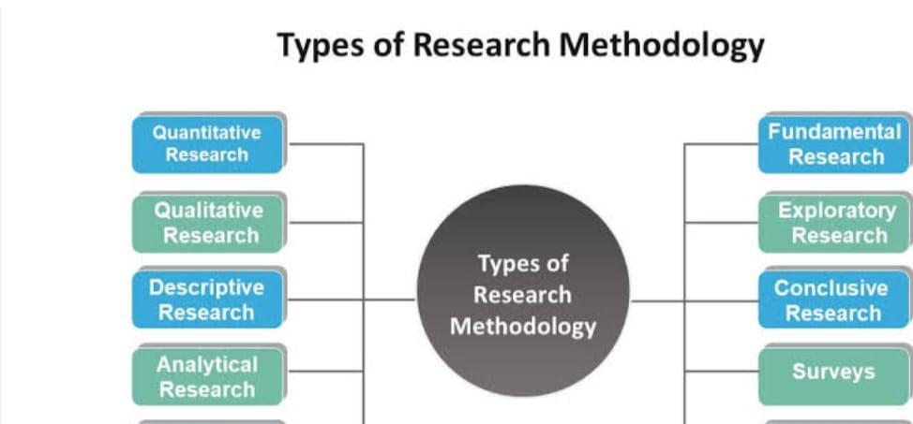

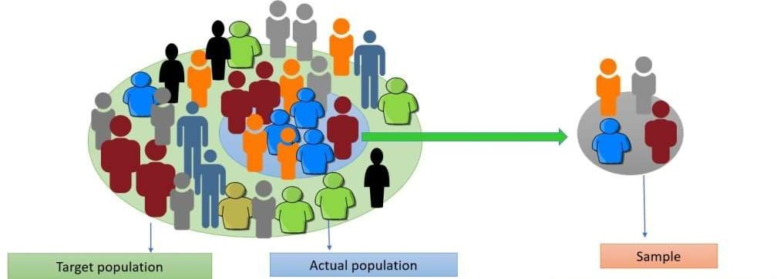

### 

### **DATA ANALYSIS**

### 

This section provides a thorough examination of the information gathered from Reliance company to understand how HR Matrics is used in talent acquisition. A variety of statistical tools and techniques are used in the analysis to find patterns, connections, and trends in the data.

### **Descriptive Statistics:**

* + Measures of central tendency (mean, median, mode)
  + Measures of dispersion (range, variance, standard deviation)

Descriptive statistics can be used to summarize and describe the continuous variables, such as the duration of the on boarding process, as well as the categorical variables like recruitment processes, candidate sourcing channels, assessment methods, and integration measures.

### **Measures of Central Tendency:**

* Mean Duration of Monthy Income: To calculate the mean, we need to convert the duration responses to numerical values.

# **QUANTITATIVE RESEARCH**

# **Descriptive Statistics**

## Monthly Income, Performance Rating, Years At Company , Education, Job Level

**Monthly Income**

|  |  |
| --- | --- |
| Mean | 6306.95 |
| Standard Error | 504.46 |
| Median | 4477.50 |
| Mode | #N/A |
| Standard  Deviation | 5044.57 |
| Sample Variance | 25447675.08 |
| Kurtosis | 1.28 |
| Skewness | 1.50 |
| Range | 18897.00 |
| Minimum | 1102.00 |
| Maximum | 19999.00 |
| Sum | 630695.00 |

Count 100.00

# **Analysis**:

* + The mean monthly income is approximately $6,307 with a considerable standard deviation, indicating a wide range of incomes.
  + The distribution is positively skewed, suggesting that there are some individuals with very high incomes.
  + The kurtosis indicates a distribution with slightly heavier tails than a normal distribution.

## Performance Rating

|  |  |
| --- | --- |
| Mean | 3.22 |
| Standard Error | 0.04 |
| Median | 3.00 |
| Mode | 3.00 |
| Standard  Deviation | 0.42 |
| Sample Variance | 0.17 |
| Kurtosis | -0.12 |
| Skewness | 1.37 |
| Range | 1.00 |
| Minimum | 3.00 |
| Maximum | 4.00 |
| Sum | 322.00 |

Count 100.00

# **Analysis**:

* Most employees have a performance rating of 3.00, which is the mode and median.
* The ratings range from 3.00 to 4.00.
* The skewness suggests a rightward skew, meaning more individuals have higher ratings

## Years At Company

Shape

Years At

Company

|  |  |
| --- | --- |
| Mean | 7.24 |
| Standard Error | 0.70 |
| Median | 5.00 |
| Mode | 5.00 |
| Standard  Deviation | 7.05 |
| Sample Variance | 49.66 |
| Kurtosis | 5.69 |
| Skewness | 2.13 |
| Range | 40.00 |
| Minimum | 0.00 |
| Maximum | 40.00 |
| Sum | 724.00 |

Count 100.00

# **Analysis**:

* The mean years at the company is 7.24 with a wide range from 0 to 40 years.
* The distribution is positively skewed, indicating that more employees have shorter tenures.
* The kurtosis is positive, suggesting heavy tails in the distribution.

## Education

Education

|  |  |
| --- | --- |
| Mean | 2.76 |
| Standard Error | 0.10 |
| Median | 3.00 |
| Mode | 3.00 |
| Standard  Deviation | 1.03 |
| Sample Variance | 1.05 |
| Kurtosis | -0.47 |
| Skewness | -0.19 |
| Range | 4.00 |
| Minimum | 1.00 |
| Maximum | 5.00 |
| Sum | 276.00 |

Count 100.00

# **Analysis**:

* The majority of individuals have an education level of 3.00.
* The distribution is slightly negatively skewed, meaning more individuals have higher education levels.
* The kurtosis is negative, suggesting a distribution with slightly flatter tails.

# **Job Level**

Shape

*Job Level*

Shape

|  |  |
| --- | --- |
| Mean | 2.01 |
| Standard Error | 0.12 |
| Median | 2.00 |
| Mode | 1.00 |
| Standard Deviation | 1.19 |
| Sample Variance | 1.42 |
| Kurtosis | 0.60 |
| Skewness | 1.18 |
| Range | 4.00 |
| Minimum | 1.00 |
| Maximum | 5.00 |
| Sum | 201.00 |
| Count | 100.00 |

# **Analysis**:

* The most frequent job level is 1.00.
* The distribution is positively skewed, indicating more individuals have lower job levels.
* The kurtosis is positive, suggesting a distribution with slightly heavier tails.

# **Dashboard**

## Average Years at Company by Job-

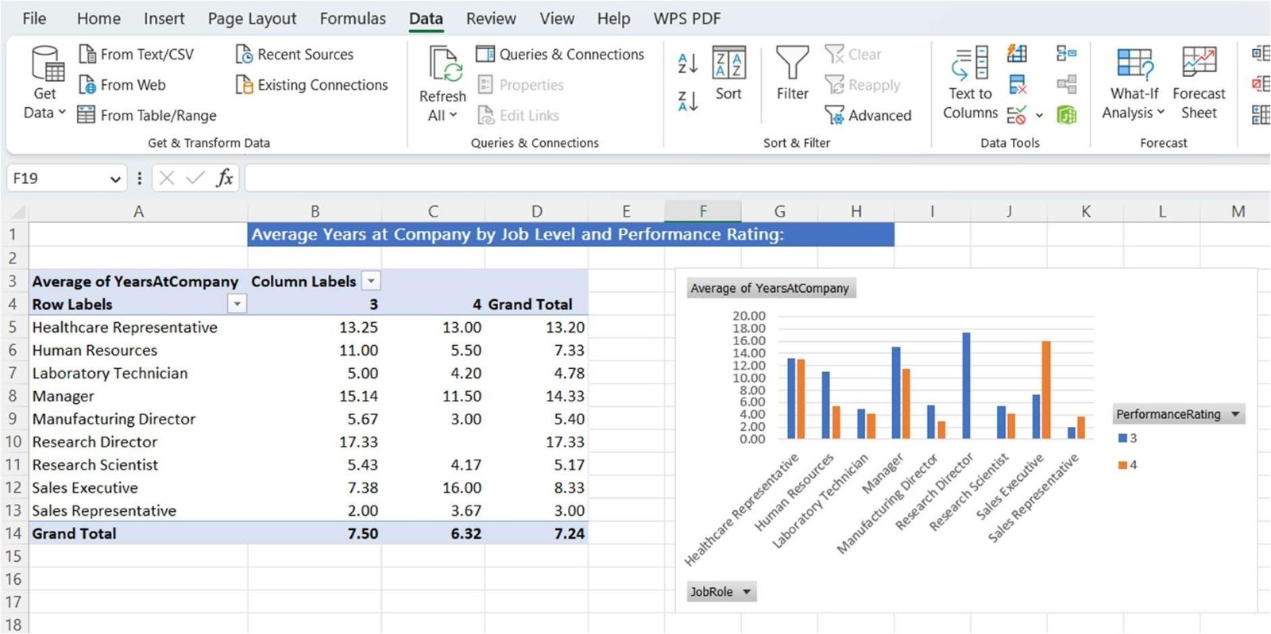

**Analysis-**

Research Director has the highest average years at the company among the presented job levels.

The relationship between average years at the company and performance rating varies across job levels.

Some job levels show a decrease in average tenure from Performance Rating 3 to Performance Rating 4, while others show an increase.

The Grand Total provides an overall average years at the company for all job levels and performance ratings.

## Regression Analysis Between Year at company and monthly income-

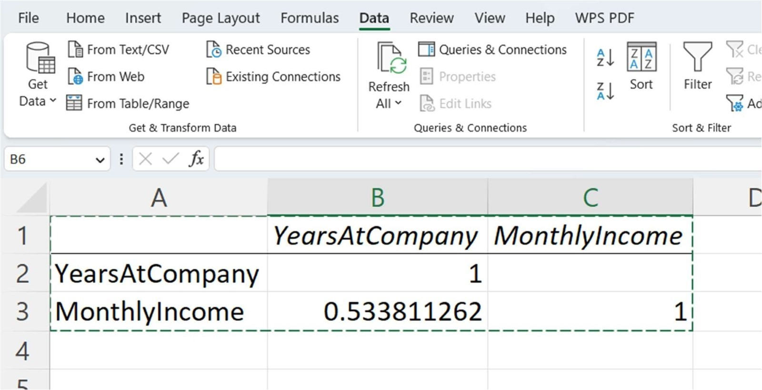

**Analysis-**

The correlation coefficient between "Years at Company" and "Monthly Income" is approximately 0.534. This positive correlation suggests a moderate positive linear relationship between the two variables.

However, correlation does not imply causation, and additional analysis, such as regression, can help explore the nature of the relationship more comprehensively.

**CONCLUSION**

1. Demonstrated Importance: The study highlights the critical role of HR metrics and analytics in enhancing organizational decision-making processes at Reliance Communication Ltd.

2. Strategic Alignment: Findings indicate that aligning HR metrics with organizational goals and objectives significantly improves decision-making effectiveness.

3. Data-Driven Insights: Utilizing HR analytics provides actionable insights derived from data, enabling informed decision-making across various aspects of human resource management.

4. Performance Evaluation: The implementation of HR metrics allows for the systematic evaluation of employee performance, aiding in the identification of areas for improvement and development.

5. Predictive Capabilities: Leveraging HR analytics enables Reliance Communication Ltd to forecast future trends and anticipate potential challenges, thereby facilitating proactive decision-making.

6. Resource Optimization: By analyzing HR metrics, the organization can optimize resource allocation, ensuring efficient utilization of human capital and financial resources.

7. Continuous Improvement: The integration of HR metrics and analytics fosters a culture of continuous improvement within the organization, driving innovation and agility in decision-making processes.

8. Competitive Advantage: Reliance Communication Ltd gains a competitive edge by harnessing HR metrics and analytics to make data-driven decisions, enhancing operational efficiency and driving business performance.

9. Recommendations for Future Research: Future research endeavors could explore the implementation of advanced analytics techniques, such as predictive modeling and machine learning, to further enhance decision-making processes within the organization.

10. Overall Impact: The study concludes that the integration of HR metrics and analytics significantly enhances organizational decision-making capabilities, positioning Reliance Communication Ltd for sustained success in a dynamic and competitive business environment.

**BIBLIOGRAPHY**

***BOOK REFERENCES***

* **Human Resource Planning**
* **Research Methodology**  **-C.R. Kothari**
* **Business environment**  **-Francis Cherunilam**
* **Employee handbook** **-Reliance Communication**
* **HR-SAP Mannual** **- Reliance Communication**

***WEBSITES***

[**www.ril.com**](http://www.ril.com/)

[**www.corporateinformation.com**](http://www.corporateinformation.com/)

[**www.google.com**](http://www.google.com/)

[**www.msn.com**](http://www.msn.com/)

[**www.relianceinfo.com**](http://www.relianceinfo.com/)