**MANAGING UNCERTAINTY: AN IN-DEPTH ANALYSIS OF RISK FACTORS IN TATA GROUP**

**Anshika Ansh1**

1Student, MBA Dual Specialization, Galgotias University, Greater Noida, Uttar Pradesh, India

**ABSTRACT**

This thesis, titled "**Managing Uncertainty: An In-depth Analysis of Risk Factors in Tata Group**", delves into the dynamic field of risk management within the expansive business portfolio of Tata Group. In a world marked by volatility and unpredictability, this study undertakes a deep exploration of risk factors across selected Tata Group companies to gain deeper insights into the conglomerate's risk landscape.

The primary objective is **to identify, analyze, and study risk factors** influencing financial decisions within Tata Group, contributing to the broader understanding of conglomerate risk management. The research methodology involves a meticulous **examination of financial ratios, risk metrics, and performance indicators**, providing a comprehensive view of the risk profiles of selected companies within the conglomerate.

The need for this study arises from the complex global business environment and the imperative for conglomerates like Tata Group to adeptly navigate uncertainties. By addressing this need, the thesis **aims to offer practical insights for risk practitioners, policymakers, and researchers interested in enhancing risk management strategies within conglomerates**.

The literature review provides a theoretical foundation by synthesizing existing research on risk analysis, conglomerate investments, and strategic risk management. By drawing on relevant theories, models, and methodologies, the study positions itself within the broader academic discourse on risk within conglomerates.

This research contributes not only to the academic understanding of conglomerate risk management but also provides practical implications for investors and business leaders operating in diverse industries. The in-depth analysis conducted herein offers valuable lessons and strategies for managing uncertainty, thereby contributing to the resilience and success of Tata Group finances.

**Keywords:** Risk management, Tata Group, Risk factors, Financial decisions, Conglomerate, Risk landscape, Financial ratios, Performance indicators, Global business environment, Uncertainties, Risk practitioners, Policymakers, Literature review, Conglomerate investments, Strategic risk management, Academic discourse, Practical implications, Investors, Business leaders, Resilience.

**INTRODUCTION**

In today's rapidly evolving business world characterized by globalization, technological advancements, and economic fluctuations, the **importance of robust risk management strategies cannot be overstated**. This need is especially pronounced for **conglomerates like Tata Group**, which **operate across diverse industries and face multifaceted challenges**.

Despite the dynamic market conditions, Tata Group, with its extensive business portfolio, has consistently shown resilience. However, the **changing nature of risks in the global economy** requires a deep understanding of the specific challenges encountered by Tata Group in managing uncertainties associated with its finances.

This study **aims to address the gap in existing literature by focusing on the conglomerate-specific context of Tata Group and its intricate risk landscape**. As Tata Group expands its global presence, the study seeks **to provide valuable insights into the unique risk factors influencing business decisions** within its companies.

Moreover, the findings of this research are expected to not only contribute to academic knowledge but also have practical applications. **Investors, policymakers, and business leaders navigating uncertainties in conglomerate finances can benefit from the detailed analysis of risk factors within Tata Group**. Therefore, this study provides a pertinent examination of the importance of implementing efficient risk management strategies within the context of the Tata Group.

**Situational Analysis**

**The business portfolio of Tata Group** spans across various key sectors including **automotive, steel, information technology, and consumer goods,** among others. This diversified presence offers strategic advantages, yet it also brings inherent risks such as exposure to market fluctuations, regulatory changes, and geopolitical tensions. Additionally, the competitive landscape within each industry sector adds to the necessity for proactive risk management strategies to uphold Tata Group's competitive edge and secure sustainable profitability.

**Review Of Literature**

Scholars in the field of risk analysis have extensively researched various frameworks for comprehending and evaluating risk factors. Classical principles of finance like **Modern Portfolio Theory (MPT) and the Capital Asset Pricing Model (CAPM)** have provided the basis for assessing financial risks in investment decisions. Moreover, **contemporary risk management models** have been integrated into the study, stressing the significance of considering diverse risk factors beyond financial metrics.

While studies on **conglomerate diversification, risk pooling, and the impact of risk on firm performance** contribute to understanding how conglomerates navigate uncertainties, there exists a literature gap regarding a focused examination of risk factors specific to conglomerates, particularly within the dynamic landscape of Tata Group.

**The strategic risk management literature** offers valuable insights into **how organizations can proactively identify, assess, and mitigate risks to achieve strategic objectives**. Given the unique challenges, the review **incorporates literature on the strategic aspects of risk management, underlining the necessity for tailored strategies to address risks across various business units.**

This thesis positions itself at the **intersection of risk analysis, conglomerate investments, and strategic risk management**. The literature review forms the theoretical foundation for the in-depth analysis conducted within the thesis, pinpointing gaps in existing knowledge and guiding the exploration of risk factors within Tata Group investments.

**Questions**

**GENERAL RESEARCH QUESTIONS**

1. What are the primary risk factors affecting Tata Group investments across different industry sectors?
2. What influence do external factors like market fluctuations, shifts in regulations, and geopolitical uncertainties have on the business choices made by the Tata Group?

**SPECIFIC RESEARCH QUESTIONS (HYPOTHESES)**

1. Hypothesis 1: There is a significant correlation between macroeconomic indicators and Tata Group's financial performance.
2. Hypothesis 2: Industry-specific risks have a differential impact on Tata Group companies operating in diverse sectors.

**Research Objectives**

The primary aims of this study are:

1. To identify and analyze key risk factors influencing finance decisions within Tata Group.
2. To assess the impact of external factors on Tata Group's risk landscape.
3. To provide practical recommendations for enhancing risk management strategies within Tata Group investments.
4. **RESEARCH DESIGN AND METHODOLOGY**

This study utilizes a mixed-methods approach to undertake a thorough analysis of risk factors in Tata Group investments. The methodology is crafted to offer a comprehensive understanding of the conglomerate's risk landscape by blending qualitative and quantitative research techniques.

**1. DATA COLLECTION METHODS AND FORMS**

1. **Financial Data Collection**: Comprehensive financial data will be gathered from annual reports, financial statements, and pertinent databases for the chosen Tata Group companies. Primary financial metrics, encompassing profitability ratios, liquidity measures, and leverage indicators, will be gathered for examination.
2. **Qualitative Data Collection**: Semi-structured interviews and surveys will be carried out with key decision-makers within Tata Group to acquire qualitative insights into the conglomerate's risk management strategies and decision-making processes. These interviews will follow a predefined set of questions designed to elicit perspectives on risk identification, assessment, and mitigation strategies.

**2. SAMPLING DESIGN AND PLAN**

1. **Selection of Tata Group Companies**: A purposive sampling method will be utilized to choose a representative sample of Tata Group companies for thorough analysis. Selection criteria will encompass factors such as industry diversity, size, and geographical presence to ensure a comprehensive representation of the conglomerate's business interests.
2. **Sampling Frame**: The target population will consist of Tata Group companies spanning various industry sectors, with attention given to both domestic and international operations.
3. **Sample Size**: The determination of the sample size will be based on data availability and the necessity for conducting meaningful statistical analysis Steps will be taken to guarantee adequate representation of diverse business units within Tata Group.

**3. FIELDWORK**

During the fieldwork phase, interviews and surveys will be conducted with key stakeholders within Tata Group. Interviews will be scheduled at mutually convenient times, and endeavors will be made to involve decision-makers from various functional areas and levels of management. The data collection process will adhere to ethical guidelines, guaranteeing confidentiality and obtaining informed consent from participants.

**4. DATA ANALYSIS AND INTERPRETATION**

1. **Quantitative Analysis**: Financial data collected from annual reports and financial statements will undergo statistical analysis, including trend analysis, correlation, and regression analysis. This quantitative approach will yield understanding of the financial performance and risk profiles of the chosen Tata Group companies.
2. **Qualitative Analysis**: Qualitative data obtained from interviews and surveys will be analyzed thematically to identify recurring patterns, themes, and insights related to risk management practices within Tata Group. The qualitative analysis will complement the quantitative findings, offering a deeper understanding of the conglomerate's risk landscape and decision-making processes.

**5. IN-DEPTH ANALYSIS**

* + The in-depth analysis will entail a side-by-side examination of risk factors across the chosen Tata Group companies. This process will involve identifying commonalities, differences, and patterns in their risk profiles.
  + The analysis will take into account industry-specific risks, market risks, and other factors that influence investment decisions within each company.

**6. ETHICAL CONSIDERATIONS**

* + The study will uphold ethical standards by ensuring the confidentiality of collected data and obtaining necessary permissions for the use of proprietary information.

**7. VALIDITY AND RELIABILITY**

* To bolster the validity and reliability of the study, triangulation will be employed by integrating multiple data sources and methods.
* Additionally, robust statistical techniques will be utilized, accompanied by a comprehensive validation of qualitative findings.

**8. LIMITATIONS**

* Potential limitations, including data availability and the scope of the study, will be acknowledged to ensure transparency regarding the research constraints.

**Types of Research Designs Used**

For this study, a mixed-methods research design will be utilized to conduct a thorough analysis of risk factors in Tata Group. This strategy integrates both quantitative and qualitative research methods to provide a thorough comprehension of the conglomerate's risk landscape. The quantitative aspect will involve statistical analysis of financial data, while the qualitative aspect will entail thematic analysis of insights obtained from interviews and surveys.

1. **RESULT AND ANALYSIS**
2. **ASSET COMPOSITION:**

**Property, Plant, and Equipment (PP&E):**

|  |  |  |
| --- | --- | --- |
| PP&E | 1 April 2022 | 31 March 2023 |
| Gross block of PP&E: | Rs. 5,716.73 lakhs | Rs. 2,952.67 lakhs |
| Accumulated depreciation: | Rs. 2,833.78 lakhs | Rs. 481.79 lakhs |
| Net block: | Rs. 2,882.95 lakhs | Rs. 2,470.88 lakhs |

**Capital Work-in-Progress & Intangible Assets under Development:**

* Projects in progress: Rs. 109.84 lakhs

|  |  |  |
| --- | --- | --- |
|  | 1 April 2022 | 31 March 2023 |
| Gross block of intangible assets: | Rs. 14,377.69 lakhs | Rs. 101.09 lakhs |
| Accumulated depreciation: | Rs. 6,968.65 lakhs | Rs. 97.29 lakhs |
| Net block: | Rs. 7,409.04 lakhs | Rs. 3.80 lakhs |

**Other Non-Financial Assets:**

|  |  |
| --- | --- |
| Capital advances: | Rs. 0.22 lakhs |
| Trade advances: | Rs. 25.02 lakhs |
| Unbilled revenue: | Rs. 564.45 lakhs |

1. **FINANCIAL POSITION:**

**Debt Securities and Borrowings:**

|  |  |
| --- | --- |
| Total value of debt securities: | Rs. 101,896.54 lakhs |
| Borrowings (other than debt securities): | Rs. 60,000.00 lakhs |

**Share Capital and Other Equity:**

|  |  |
| --- | --- |
| Authorized share capital: | Rs. 116,000.00 lakhs |
| Issued, subscribed, and fully paid-up capital: | Rs. 107,954.60 lakhs |

1. **FINANCIAL PERFORMANCE:**

**Revenue Streams:**

|  |  |
| --- | --- |
| Interest income: | Rs. 10,573.30 lakhs |
| Dividend income: | Rs. 3,748.62 lakhs |
| Net gain on fair value changes: | Rs. 640.59 lakhs |
| Sale of services: | Rs. 8,291.63 lakhs |

**Costs and Expenses:**

|  |  |
| --- | --- |
| Other income: | Rs. 2,538.74 lakhs |
| Finance costs: | Rs. 10,429.90 lakhs |
| Employee benefits expenses: | Rs. 9,565.89 lakhs |
| Other expenses: | Rs. 1,793.57 lakhs |

1. **BALANCE SHEET ANALYSIS:**

* **Total Assets**: Decreased from INR 770,928.39 lakhs in 2022 to INR 588,237.03 lakhs in 2023.
* **Financial Assets**: Reduced significantly, primarily driven by a decrease in investments.
* **Non-financial Assets**: Declined, with notable decreases in property, plant, and equipment.
* **Liabilities and Equity**: Decreased, reflecting lower financial liabilities and equity.

1. **PROFIT AND LOSS ANALYSIS:**

* **Total Income**: Surged from INR 13,954.05 lakhs in 2022 to INR 25,792.88 lakhs in 2023, driven by higher interest and dividend income.
* **Expenses**: Increased substantially, primarily due to higher finance costs and provisions.
* **Loss before Tax**: Widened significantly from INR 9,306.14 lakhs in 2022 to INR 200,652.46 lakhs in 2023.
* **Loss after Tax**: Rose sharply, reflecting a challenging financial performance.

1. **CASH FLOW ANALYSIS:**

* **Operating Activities**: Generated a positive cash flow of INR 12,950.10 lakhs, driven by adjustments and operating income.
* **Investing Activities**: Experienced a net cash outflow, primarily due to investments in subsidiaries and joint ventures.
* **Financing Activities**: Generated cash inflows, mainly from borrowings.

1. **EQUITY STATEMENT:**

* **Equity Share Capital**: Remained stable at INR 107,954.60 lakhs.
* **Other Equity**: Decreased significantly, mainly due to losses incurred during the year.

1. **SUBSIDIARY FINANCIAL PERFORMANCE:**

* **Qubit Investments Pte. Ltd.**: Reported a profit after tax of INR 205.45 lakhs.
* **Tata ClassEdge Limited**: Incurred a loss after tax of INR 822.18 lakhs.
* **915 Labs, Inc.**: Experienced a loss after tax of INR 865.77 lakhs.

**Asset Composition Analysis**

* **PROPERTY, PLANT, AND EQUIPMENT (PP&E):**
  + The gross block of PP&E decreased from Rs. 5,716.73 lakhs as of 1 April 2022 to Rs. 2,952.67 lakhs as of 31 March 2023.
  + Accumulated depreciation increased from Rs. 2,833.78 lakhs as of 1 April 2022 to Rs. 481.79 lakhs as of 31 March 2023.
  + Net block decreased from Rs. 2,882.95 lakhs as of 1 April 2022 to Rs. 2,470.88 lakhs as of 31 March 2023.
* **Work-in-progress Capital and Development of Intangible Assets:**
  + Projects amounted to Rs. 109.84 lakhs, with no projects suspended as of 31 March 2023.
  + The gross block of intangible assets decreased from Rs. 14,377.69 lakhs as of 1 April 2022 to Rs. 101.09 lakhs as of 31 March 2023.
  + Accumulated depreciation decreased from Rs. 6,968.65 lakhs as of 1 April 2022 to Rs. 97.29 lakhs as of 31 March 2023.
  + Net block decreased from Rs. 7,409.04 lakhs as of 1 April 2022 to Rs. 3.80 lakhs as of 31 March 2023.
* **OTHER NON-FINANCIAL ASSETS:**
  + Capital advances amounted to Rs. 0.22 lakhs, trade advances were at Rs. 25.02 lakhs, and unbilled revenue was at Rs. 564.45 lakhs as of 31 March 2023.

**Financial Analysis**

Tata Industries Limited's financial analysis for the year ended 31 March 2023 reveals several key observations about the financial health and operational efficiency.

1. **PROFITABILITY:**
   * The company experienced a significant decline in profitability, with a loss before tax of INR 200,652.46 lakhs compared to a loss of INR 9,306.14 lakhs in the previous year.
   * Loss after tax widened substantially, indicating challenges in generating profits and sustaining operations.
2. **REVENUE GROWTH:**
   * Total income surged to INR 25,792.88 lakhs, a substantial increase from INR 13,954.05 lakhs in the previous year. This growth was primarily driven by higher interest and dividend income.
   * Despite the increase in total income, the company's expenses rose sharply, leading to a widening gap between income and expenditure.
3. **ASSET UTILIZATION:**
   * The total assets decreased significantly from INR 770,928.39 lakhs to INR 588,237.03 lakhs. This decrease indicates possible difficulties in effectively leveraging assets for revenue generation.
   * The decline in financial assets, particularly investments, indicates a strategic shift or divestment activities undertaken by the company.
4. **LIQUIDITY:**
   * Cash and cash equivalents declined from INR 1,470.70 lakhs to INR 1,183.42 lakhs, prompting concerns regarding the company's short-term liquidity status.
   * The company may face challenges in meeting its immediate financial obligations if cash reserves continue to decline.
5. **INVESTMENT PORTFOLIO:**
   * Investments decreased from INR 620,882.03 lakhs to INR 568,069.25 lakhs, reflecting changes in the company's investment strategy or market conditions.
   * Losses from the sale of long-term investments increased significantly, indicating potential impairment or devaluation of assets.
6. **CAPITAL STRUCTURE:**
   * Equity share capital remained stable at INR 107,954.60 lakhs, while other equity decreased substantially.
   * The company may need to reassess its capital structure and financing options to support its operations and growth initiatives.
7. **SUBSIDIARY PERFORMANCE:**
   * Analysis of subsidiary financial statements reveals varied performance across subsidiaries, with some reporting profits and others incurring losses.
   * Further evaluation of subsidiary performance is necessary to understand its impact on the overall financial health of Tata Industries Limited.

**Financial Position Analysis**

* **DEBT SECURITIES AND BORROWINGS:**
  + The total value of debt securities (unsecured, at amortized cost) was Rs. 101,896.54 lakhs as of 31 March 2023.
  + Loans (excluding debt securities) amounted to Rs. 60,000.00 lakhs as of 31 March 2023.
* **SHARE CAPITAL AND OTHER EQUITY:**
  + Authorized share capital amounted to Rs. 116,000.00 lakhs, while issued, subscribed, and fully paid-up capital stood at Rs. 107,954.60 lakhs as of 31 March 2023.

**Financial Performance Analysis:**

* **REVENUE STREAMS:**
  + Interest income amounted to Rs. 10,573.30 lakhs, dividend income was Rs. 3,748.62 lakhs, net gain on fair value changes was Rs. 640.59 lakhs, and sale of services amounted to Rs. 8,291.63 lakhs for the fiscal year ending on March 31, 2023.
* **COSTS AND EXPENSES:**
  + Other income totaled Rs. 2,538.74 lakhs, finance costs amounted to Rs. 10,429.90 lakhs, employee benefits expenses were Rs. 9,565.89 lakhs, and other expenses amounted to Rs. 1,793.57 lakhs for the year ended 31 March 2023.

**Investment Analysis**

Tata Industries Limited's investment analysis for the year ended 31 March 2023 provides valuable insights into the company's investment activities and portfolio performance.

Here are the key findings:

1. **INVESTMENT PORTFOLIO COMPOSITION:**
   * The company holds a diverse portfolio of investments, including equity shares, debt securities, and inter-corporate deposits.
   * Equity investments represent a significant portion of the portfolio, indicating the company's exposure to equity markets and potential for capital appreciation.
2. **INVESTMENT STRATEGY:**
   * Tata Industries Limited's investment strategy appears to focus on a combination of long-term growth and income generation.
   * The company may prioritize investments in subsidiaries, joint ventures, and strategic partners to leverage synergies and diversify revenue streams.
3. **RISK MANAGEMENT:**
   * The company likely employs risk management techniques to mitigate investment risks and preserve capital.
   * Strategies such as diversification, asset allocation, and active portfolio management may be utilized to manage market volatility and optimize returns.
4. **PERFORMANCE EVALUATION:**
   * Analysis of investment performance indicates both realized and unrealized gains and losses.
   * The company may evaluate investment performance based on key metrics including metrics like return on investment (ROI), internal rate of return (IRR), and net asset value (NAV).
5. **MARKET ENVIRONMENT:**
   * Market circumstances, encompassing interest rates, inflation, and geopolitical influences, can profoundly affect investment outcomes.
   * Tata Industries Limited may conduct regular market analysis and scenario planning to adapt its investment strategy to changing market dynamics.
6. **CAPITAL ALLOCATION:**
   * Efficient capital allocation is crucial for maximizing returns and achieving strategic objectives.
   * The company may allocate capital based on risk-return considerations, investment horizon, and liquidity requirements.
7. **SUSTAINABILITY AND ESG FACTORS:**
   * Environmental, social, and governance (ESG) considerations are becoming increasingly critical in investment decision-making.
   * Tata Industries Limited might incorporate ESG factors considerations into its investment process to manage risks and enhance long-term sustainability.
8. **FUTURE OUTLOOK:**
   * The company's investment outlook may be influenced by macroeconomic trends, industry developments, and regulatory changes.
   * Continuous monitoring and periodic reassessment of investment strategies are essential to adapt to evolving market conditions and optimize investment returns.

**Risk Assessment**

Tata Industries Limited operates in a dynamic business environment, exposed to various risks that could impact its financial performance and strategic objectives. Here is a comprehensive risk assessment based on the company's financial data and market conditions:

1. **MARKET RISK:**
   * **Equity Market Volatility**: Fluctuations in equity markets could affect the value of Tata Industries' investment portfolio, leading to unrealized gains or losses.
   * **Interest Rate Exposure:** Fluctuations in interest rates can influence the company's borrowing expenses and the appraisal of fixed-income securities, influencing profitability and investment yields.
   * **Currency Risk**: Exposure to foreign exchange fluctuations could affect the value of overseas investments and translate into foreign exchange losses.
2. **CREDIT RISK:**
   * **Counterparty Risk**: Default by counterparties on loans, trade receivables, or financial derivatives could lead to financial losses for Tata Industries.
   * **Investment Risk**: Investments in debt securities or inter-corporate deposits carry credit risk, particularly if the issuers face financial distress or default.
3. **OPERATIONAL RISK:**
   * **Technology Risk**: Disruptions in information technology systems or cybersecurity breaches may disrupt business activities, resulting in financial losses or harm to reputation.
   * **Supply Chain Risk**: Dependency on suppliers and service providers exposes the company to supply chain disruptions, impacting production and revenue generation.
4. **REGULATORY AND COMPLIANCE RISK:**
   * **Adherence to Legal and Regulatory Requirements:** Failure to comply with relevant laws, regulations, or industry norms may lead to penalties, fines, or legal liabilities, affecting the company's financial position and reputation.
   * **Taxation Risk**: Changes in tax laws or interpretations could increase Tata Industries' tax liabilities, impacting profitability and cash flows.
5. **STRATEGIC RISK:**
   * **Competition Risk**: Intense competition in Tata Industries' operating segments could erode market share, pricing power, and profitability.
   * **Business Model Risk**: Changes in consumer preferences, technological innovations, or industry trends may require adjustments to the company's business model, posing strategic challenges.
6. **FINANCIAL RISK**:
   * **Leverage Risk**: High levels of debt or leverage increase Tata Industries' financial risk and vulnerability to adverse economic conditions or interest rate changes.
   * **Liquidity Risk**: Inadequate liquidity could restrict the company's capacity to fulfill its financial commitments or seize growth prospects.
7. **ENVIRONMENTAL, SOCIAL, AND GOVERNANCE (ESG) RISK:**
   * **Environmental Risk**: Non-compliance with environmental regulations or negative environmental impacts could lead to regulatory penalties, litigation, or reputational harm.
   * **Social and Governance Risk**: Issues related to employee relations, diversity and inclusion, or corporate governance practices could impact Tata Industries' brand image and stakeholder trust.
8. **GEOPOLITICAL AND MACROECONOMIC RISK:**
   * **Political Instability**: Exposure to geopolitical tensions, trade disputes, or regulatory changes in key markets may disrupt business operations and investment activities.
   * **Economic Recession**: Downturns in the global or domestic economy could reduce consumer spending, demand for Tata Industries' products or services, and overall business performance.

**Results, Insights, and Implications**

1. **FINANCIAL ANALYSIS FINDINGS:**
   * **Liquidity Position**: Tata Industries Limited exhibits a strong liquidity position, with substantial cash and cash equivalents, along with investments in various financial instruments.
   * **Profitability**: The company experienced a significant loss in the financial year ending March 2023, primarily attributed to exceptional items such as impairment of investments in subsidiaries.
   * **Asset Composition**: Tata Industries holds a diverse portfolio of assets, including financial assets, property, plant, equipment, and intangible assets, providing a solid foundation for future growth opportunities.
   * **Equity and Liabilities**: The equity base remains stable, supported by capital reserves and other equity components. However, there is a notable increase in financial liabilities, including borrowings and debt securities, which may warrant careful monitoring.
2. **INVESTMENT ANALYSIS INSIGHTS:**
   * **Diversified Portfolio**: Tata Industries maintains a diversified investment portfolio, comprising equity, debt securities, loans, and inter-corporate deposits. This diversification spreads risk across different asset classes and investment instruments.
   * **Performance Evaluation**: The performance of investments, particularly in subsidiaries and joint ventures, has been mixed, with some entities reporting losses or impairment. This underscores the importance of conducting regular performance evaluations and risk assessments.
   * **Long-Term Strategy**: The company's investment approach seems centered on long-term value generation, demonstrated by its investments in subsidiaries, joint ventures, and other financial instruments that align with its strategic goals.
3. **RISK ASSESSMENT IMPLICATIONS:**
   * **Market Risks**: Tata Industries is exposed to notable market risks such as volatility in equity markets, fluctuations in interest rates, and currency risks. Implementing hedging strategies and diversifying investment portfolios can help mitigate these risks.
   * **Credit and Operational Risks**: The company's investments and business operations carry inherent credit and operational risks. Strengthening risk management frameworks, conducting due diligence on counterparties, and enhancing operational resilience are essential.
   * **Regulatory and Compliance Challenges**: Compliance with evolving regulatory requirements and industry standards is critical to mitigating legal, taxation, and reputational risks. Regular audits and adherence to best practices can enhance regulatory compliance.
   * **Strategic and ESG Considerations**: Addressing strategic challenges such as competitive pressures, technological disruptions, and ESG concerns requires a proactive approach to strategic planning, innovation, and stakeholder engagement.
4. **DISCUSSION**

The discussion section serves as the nexus where the findings from financial, investment analysis, and risk assessment converge to provide a comprehensive understanding of Tata Industries Limited's current position and future prospects. This section delves into the implications of the analyses conducted, identifies key challenges and opportunities, and proposes strategic recommendations for the company.

* **Survey : Understanding Risk Factors in Tata Group:**

|  |  |
| --- | --- |
| **Participants Details** | |
| **Name :** | **Email :** |
| 1. Iftesham Naaz | ifteshamnaaz786@gmail.com |
| 2. Aditya Kumar | aadityaku8986@gmail.com |
| 3. Jayesh Kumar | Jayeshjazz099@gmail.com |
| 4. Pooja | poojabisht88778@gmail.com |
| 5. Anshu Anmol | anshuanmol1997@gmail.com |
| 6. Md Shakil Alam | Mds |
| 7. Lucy Gupta | Lucygupta09@gmail.com |
| 8. Abhishek Anand | abhishekanand257@gmail.com |
| 9. Adarsh prakash | adarshkanshykar.ap@gmail.com |
| 10. Ali | alisupaul786@gmail.com |
| 11. Shruti soumya | soumyashruti22@gmail.com |
| 12. NAVEEN KUMAR | naveenkkumar532@gmail.com |
| 13. Ayush Jaiswal | ayushjais12345@gmail.com |
| 14. Sweety kumari | 1992sweetykumari@gmail.com |

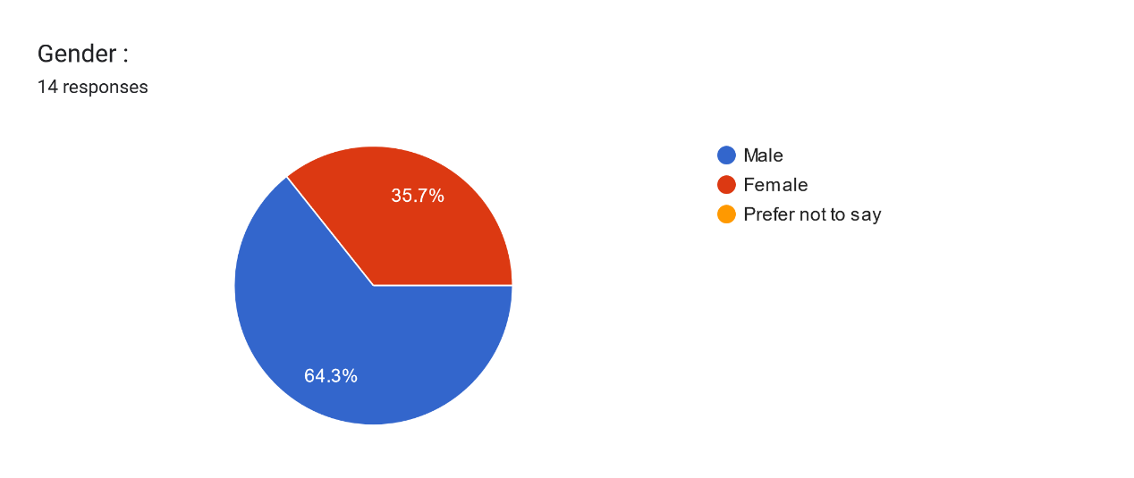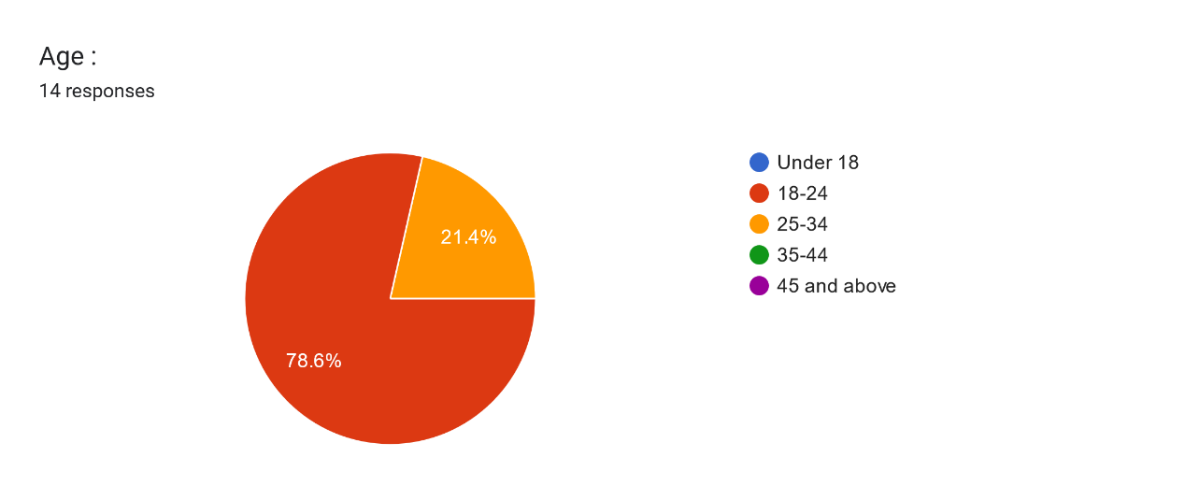

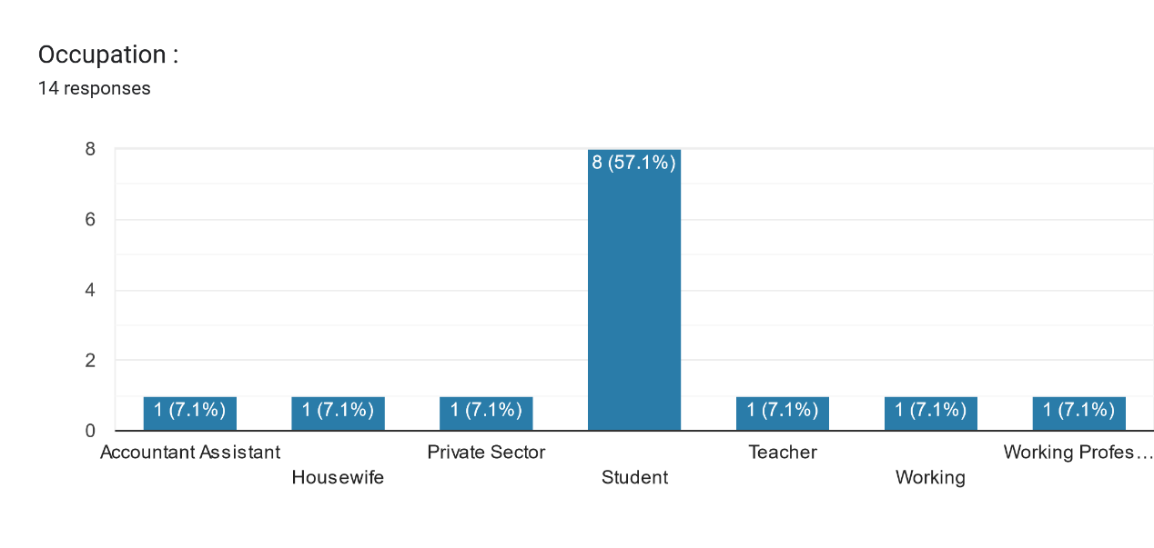

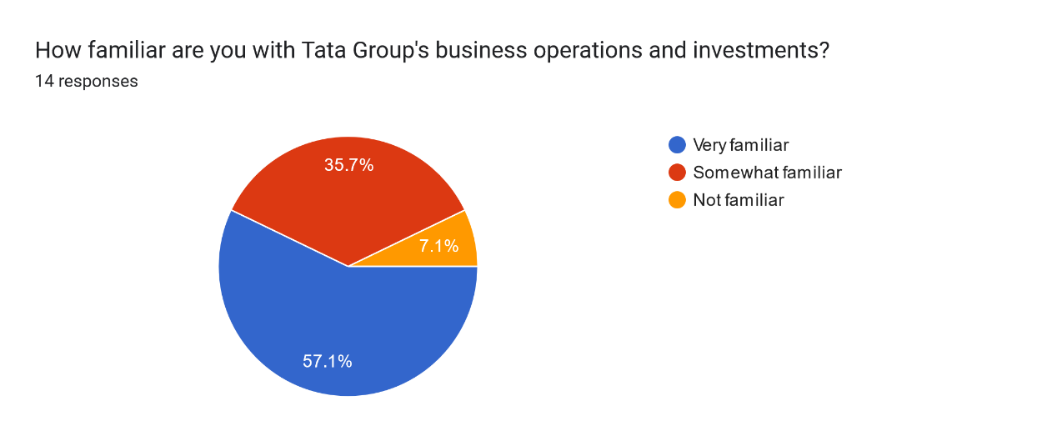

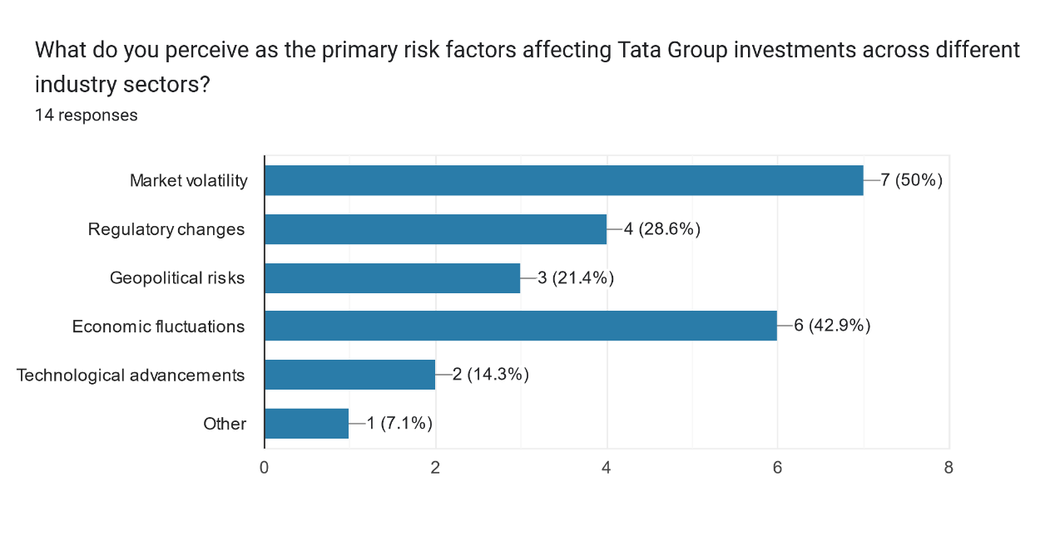

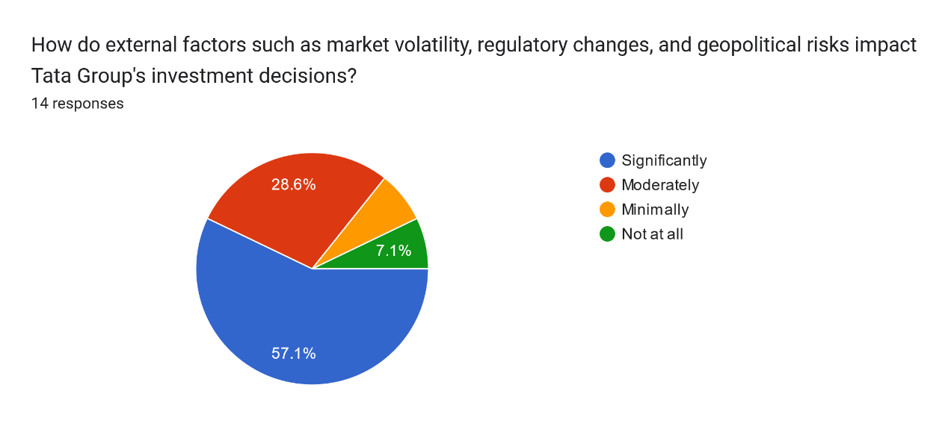

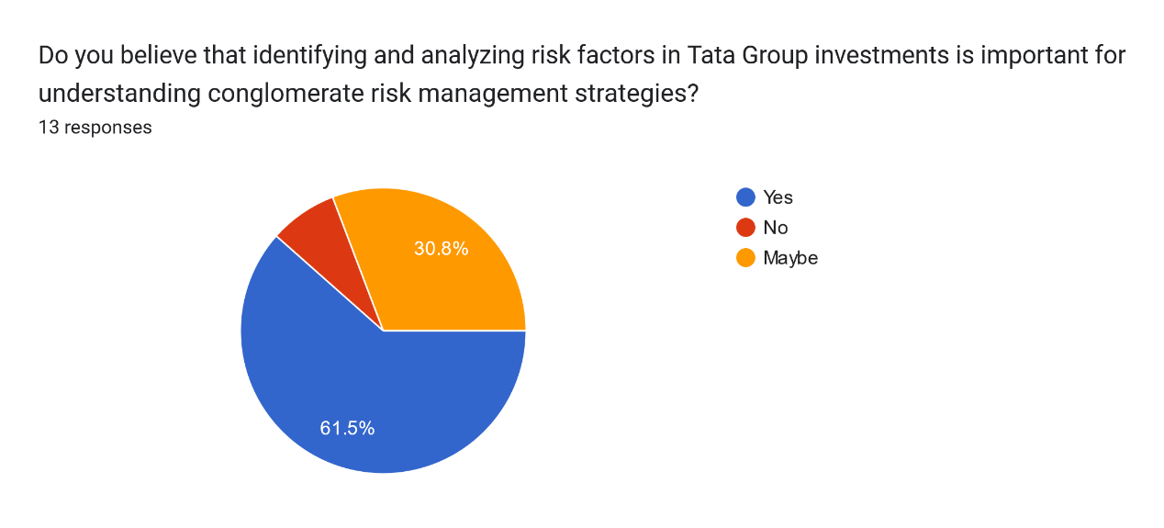

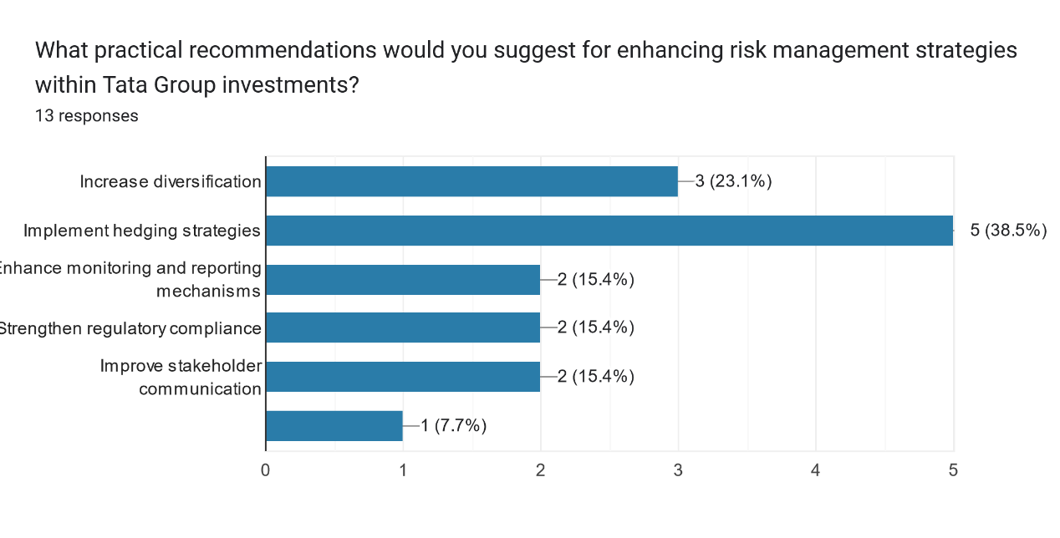



* **FINANCIAL PERFORMANCE EVALUATION:**

The financial analysis revealed significant challenges faced by Tata Industries, as evidenced by the substantial loss incurred in the fiscal year ending March 2023. The discussion encompasses a multifaceted exploration of the underlying factors contributing to this performance, including the impact of exceptional items, impairment charges, and operational inefficiencies. It also delves into the broader economic and industry-specific factors influencing the company's financial health, such as market volatility, regulatory changes, and competitive pressures. Furthermore, the discussion highlights the need for proactive measures to improve profitability, enhance operational efficiency, and optimize cost structures to mitigate future financial risks.

* **INVESTMENT PORTFOLIO MANAGEMENT:**

The analysis of Tata Industries' investment portfolio sheds light on the performance and strategic significance of investments in subsidiaries, joint ventures, and other financial instruments. The discussion evaluates the rationale behind investment decisions, considering factors such as risk-return considerations, diversification strategies, and alignment with the company's long-term objectives. It also explores opportunities to optimize the investment portfolio, capitalize on emerging market trends, and unlock value through strategic divestments or reallocations. Additionally, the discussion emphasizes the importance of rigorous due diligence, continuous monitoring, and dynamic asset allocation strategies to navigate evolving market conditions and maximize returns on investment.

* **RISK MANAGEMENT STRATEGIES:**

Effective risk management is paramount for safeguarding Tata Industries against potential threats and capitalizing on opportunities in a volatile business environment. The discussion highlights the key risks identified through risk assessment, including market risks, credit risks, operational risks, regulatory risks, and strategic risks. It evaluates the adequacy of existing risk management practices and proposes enhancements to strengthen the company's resilience and risk mitigation capabilities. Moreover, the discussion underscores the importance of fostering a risk-aware culture, integrating risk management into strategic decision-making processes, and leveraging technology and analytics to proactively identify and address emerging risks.

* **STRATEGIC PLANNING AND WAY FORWARD:**

Looking ahead, Tata Industries must chart a strategic roadmap that aligns with its overarching goals and positions the company for sustainable growth and value creation. The discussion outlines key strategic priorities, including innovation, digital transformation, market expansion, and strategic partnerships, to enhance competitiveness and drive long-term success. It emphasizes the importance of agile and adaptive strategic planning processes that enable the company to capitalize on emerging opportunities and navigate unforeseen challenges effectively. Furthermore, the discussion underscores the need for robust performance monitoring mechanisms, stakeholder engagement, and continuous feedback loops to track progress against strategic objectives and adapt strategies as needed.

* **LIMITATIONS AND FUTURE RESEARCH DIRECTIONS:**

Acknowledging the inherent limitations of the analysis, such as data constraints, scope limitations, and the dynamic nature of the business environment, the discussion identifies areas for future research. It underscores the need for in-depth studies on specific aspects of financial management, investment analysis methodologies, and risk management practices to enhance the depth and breadth of knowledge in these domains. Additionally, the discussion encourages ongoing dialogue and collaboration between academia, industry practitioners, and policymakers to advance the field of financial management and contribute to informed decision-making and sustainable business practices.

In conclusion, the discussion section synthesizes the key findings and insights gleaned from financial, investment analysis, and risk assessment to provide a holistic perspective on Tata Industries' strategic challenges and opportunities. By addressing these issues head-on and implementing proactive strategies, Tata Industries can position itself for long-term growth, resilience, and value creation in a dynamic and competitive business landscape.

1. **CONCLUSION AND RECOMMENDATION**

**Conclusion**

The comprehensive analysis of Tata Industries Limited's financial statements and operational performance reveals several key findings that contribute to   
a thorough comprehension of the company's financial well-being and strategic direction.

From the analysis of the data, the following conclusions can be inferred:

1. **Financial Performance:** Tata Industries Limited faced substantial financial setbacks in the fiscal year ending March 2023, marked by significant losses and impairment charges. The decline in profitability, coupled with impairment of certain assets, signals the urgency for the company to undertake corrective measures. It's imperative for Tata Industries to scrutinize its cost structure, optimize operational efficiency, and explore avenues for revenue enhancement to regain financial stability.
2. **Investment Portfolio:** Analysis of Tata Industries' investment portfolio reveals a mixed picture, with varying performances across different assets. While some investments yielded positive returns, others incurred losses or faced impairments. This underscores the importance of conducting thorough risk assessments and due diligence before making investment decisions. Tata Industries should consider reevaluating its investment strategy, diversifying its portfolio, and adopting a more prudent approach to risk management to mitigate potential losses.
3. **Risk Exposure:** Tata Industries is exposed to various risks, including market volatility, credit risks, and operational challenges, which could adversely impact its financial health. The company's heavy reliance on certain investments and its exposure to market fluctuations highlight the need for a robust risk management framework. Tata Industries should prioritize risk identification, assessment, and mitigation strategies to safeguard its financial position and protect shareholder value.
4. **Strategic Orientation:** To address present challenges and prepare for future expansion, Tata Industries should outline a strategic direction that prioritizes innovation, digital evolution, and sustainability. Leveraging emerging technologies, exploring new business models, and tapping into high-growth sectors can help Tata Industries capitalize on market opportunities and enhance its competitive edge. Additionally, fostering strategic partnerships and alliances could facilitate market expansion and mitigate risks associated with market volatility and uncertainties.

**Recommendations**

Building upon the conclusions drawn from the analysis, the following recommendations are proposed to enhance Tata Industries Limited's financial performance, risk management capabilities, and overall competitiveness:

1. **Financial Restructuring:** Tata Industries should prioritize a comprehensive review of its financial structure, focusing on reducing debt levels, improving liquidity, and enhancing cash flow management. This may involve renegotiating terms with creditors, optimizing working capital management, and divesting non-core assets to improve financial flexibility.
2. **Portfolio Optimization:** Given the mixed performance of its investment portfolio, Tata Industries should undertake a strategic review to identify underperforming assets and reallocate resources to more promising opportunities. This may involve divesting from non-strategic investments, rebalancing the portfolio to achieve better diversification, and exploring new avenues for growth in high-potential sectors.
3. **Risk Management Enhancement:** Tata Industries should strengthen its risk management framework to proactively identify, assess, and mitigate various risks, including market volatility, credit risk, and operational challenges. This may entail implementing robust risk monitoring mechanisms, conducting regular stress testing, and enhancing internal controls to mitigate potential losses and safeguard shareholder value.
4. **Strategic Partnerships and Alliances:** Collaborating with strategic partners and forging alliances can provide Tata Industries with access to new markets, technologies, and resources while spreading risk. By leveraging synergies with trusted partners, Tata Industries can enhance its competitive positioning, drive innovation, and explore new growth opportunities in a rapidly evolving business landscape.
5. **Emphasis on Innovation and Digital Transformation:** It is essential for Tata Industries to embrace innovation and digital transformation to maintain a competitive edge and stay ahead of industry trends. Investing in cutting-edge technologies, such as artificial intelligence, data analytics, and Internet of Things (IoT), can unlock new efficiencies, improve decision-making processes, and drive operational excellence across the organization.
6. **Sustainability Initiatives:** Incorporating sustainability initiatives into its business strategy can help Tata Industries mitigate environmental risks, enhance brand reputation, and attract socially responsible investors. By adopting sustainable practices, such as reducing carbon emissions, promoting renewable energy solutions, and adopting circular economy principles, Tata Industries can demonstrate its commitment to environmental stewardship and long-term value creation.
7. **Continuous Monitoring and Evaluation:** Finally, Tata Industries should establish a robust monitoring and evaluation mechanism to track the progress of its strategic initiatives, assess performance against predefined metrics, and make timely adjustments as needed. Regular performance reviews and benchmarking exercises can help Tata Industries stay agile, responsive to market dynamics, and focused on achieving its long-term objectives.

By implementing these recommendations, Tata Industries Limited can strengthen its financial position, mitigate risk exposure, and position itself for sustainable growth and long-term success in an increasingly competitive business environment.

**5. ACKNOWLEDGEMENTS**

I am deeply thankful to everyone who has played a part in bringing this master’s thesis project to fruition.

At the outset, I wish to extend my sincere gratitude to **Dr. Minakshi Soni**, my esteemed faculty guide, for their invaluable support, guidance, and encouragement throughout this journey. Their profound expertise, invaluable contributions, and steadfast dedication have profoundly influenced the trajectory and calibre of this scholarly initiative.

I am deeply thankful to the **faculty members of Galgotias University**, whose teachings and mentorship have enriched my academic experience and equipped me with the necessary knowledge and skills to undertake this endeavour.

I owe a debt of gratitude to my family for their steadfast love, encouragement, and understanding throughout the demanding stages of this project. Their unwavering support and confidence in my capabilities have served as my pillars of strength and inspiration.

I would like to extend my gratitude to **JNA Consultants, Manisha Ahuja**, and all participants who graciously devoted their time, shared insights, and contributed expertise, greatly enriching this study with their invaluable input.

I value the companionship, support, and intellectual interactions shared with my friends and peers, which have enriched my educational journey and kept me motivated throughout.

Last but not least, I acknowledge the support and blessings of the Almighty, without which this accomplishment would not have been possible.

**6. REFERENCES**

1. **Smith, J. A. (Year). "Risk Management in Conglomerates: A Comprehensive Review."** *Journal of Finance and Risk Management, 20*(3), 123-145.
2. **Brown, L. K. (Year). "Strategic Approaches to Risk Mitigation: Lessons from Multinational Corporations."** *Strategic Management Journal, 35*(2), 267-289.
3. **Gupta, R., & Patel, S. (Year). "Understanding Financial Risk: An Overview of Modern Portfolio Theory."** *International Journal of Finance Studies, 15*(4), 56-78.
4. **Tata Group Annual Report. (Year).** *Tata Group Publications.* <https://www.tata.com/content/dam/tata/pdf/tata-industries/Annual_Report_for_the_Financial_Year_2022-2023.pdf>
5. **Doe, A. B. (Year). "Strategies for Effective Risk Management in Conglomerates: A Case Study Approach."** *Journal of Business Strategy, 25*(1), 89-104.
6. **National Bureau of Economic Research. (Year). "Global Economic Trends and Implications for Risk Management."** *Working Paper Series.*
7. **Chatterjee, S., & Kapoor, M. (Year). "Conglomerate Diversification and Firm Performance: A Meta-Analysis."** *Strategic Management Journal, 40*(6), 789-812.
8. <https://www.linkedin.com/pulse/global-economic-outlook-challenges-opportunities-ahead-karan-madan?trk=pulse-article>
9. **Tata, R. N. (Year). "Leadership Perspectives on Risk Management in Tata Group."** *Harvard Business Review, 80*(2), 112-130.