**Robotic Arm Review**

Sagar Jarecha 1, Dr.Bhavesh Mewada2, Anju Mistry3

PG Scholar, Department of Mechanical Engineering, Parul Institute of Engineering & Technology, Post Limda, Waghodia, Gujarat 3917601

Faculty of Engineering & Technology, Parul Institute of Engineering & Technology, Post Limda, Waghodia, Gujarat 3917602

Design & Development Manager at Indutch Composite Technology Pvt. Ltd.Waghodia Gidc Gujarat 3917603

a)sagarjarecha7233@gmail.com, b) bmewada@paruluniversity.ac.in c) anuj.mistry@indutch.in

**Abstract**: This study explores optimizing a 6 Degrees of Freedom (DOF) robotic arm to boost machining efficiency by examining the potential benefits of employing composite materials over aluminum alloy T 6061. It entails two key components: analyzing forward and inverse kinematics to comprehend the arm's motion and refining motion control strategies, and conducting a thorough evaluation of various composite materials through Ansys static structural analysis. Initially, the focus lies on understanding the arm's motion range and refining motion control strategies through kinematics analysis. Subsequently, a detailed examination evaluates replacing aluminum alloy T 6061 with diverse composite materials. Findings are compared with the aluminum alloy's performance metrics, offering insights into potential enhancements in machining efficiency and structural integrity. Ultimately, the research seeks to advance robotic arm technology by identifying materials capable of enhancing performance and durability in machining applications.

Key words-Robotic Arm, 6-axis, DoF, Forward kinematics, inverse kinematics

# **Introduction:**

A robotic arm is a versatile and sophisticated mechanical device designed to replicate the functions of a human arm with a high degree of precision and flexibility. These remarkable machines have revolutionized automation, manufacturing, and a wide range of industries by performing tasks that range from simple pick-and-place operations to complex, delicate procedures. Robotic arms typically consist of a series of joints and links, which can move in multiple degrees of freedom (DOF). They are equipped with various sensors and end-effector, enabling them to interact with their environment and execute tasks with incredible accuracy. The applications of robotic arms are diverse, encompassing industries such as manufacturing, health-care, agriculture, space exploration, and many others. Over the years, robotic arm technology has continued to evolve, incorporating advanced materials, control systems, and artificial intelligence to enhance their capabilities. These machines have become integral to modern automation, enabling higher levels of efficiency, productivity, and precision in a world where technological innovation is reshaping the way we live and work.

A robotic arm is meant a set of rigid jointed bodies able to take different configuration, and to move between these configurations with prescribed limits on velocity and acceleration. Industrial robotic arm differs by the size of the fixed bodies, the type of joint, the sequence in which the joints are connected and the range of motion acceptable at each joint. The individual fixed bodies are called links. Robotic arms are manufactured by using different parameters like number of axis, degree of freedom, working envelope and working space that arm cover, kinematics, payload, speed and acceleration, accuracy and repeat-ability, motion control and drive of an arm etc.

# **Design of Six DOF Robotic Arm**

A simple design was created with referred models from literature and online. The manipulator was designed using solid works software shown in figure 1. The factors such as Density, Tensile Strength, Yield Strength, and Modulus of elasticity, Machinability and Weld ability are considered for the process of material selection. The Aluminum 7075 t6 is chosen since its easy availability in market, good weld ability and more yield Strength. It is also commonly used as building material in robots. So, the links are made of Aluminum 7075 t6 and Gray cast Iron is used for base and gripper tool because it absorbs high vibration and has low wear and tear.

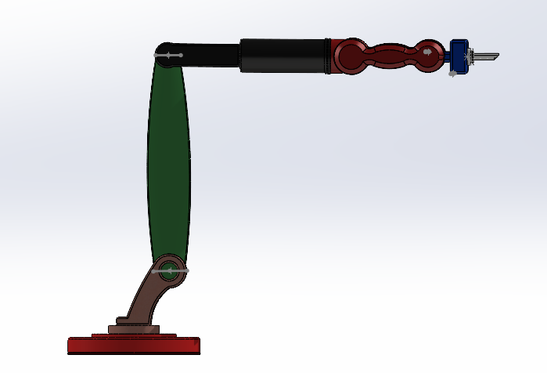

Figure1: six Dof Manipulator

# **Forward Kinematics**

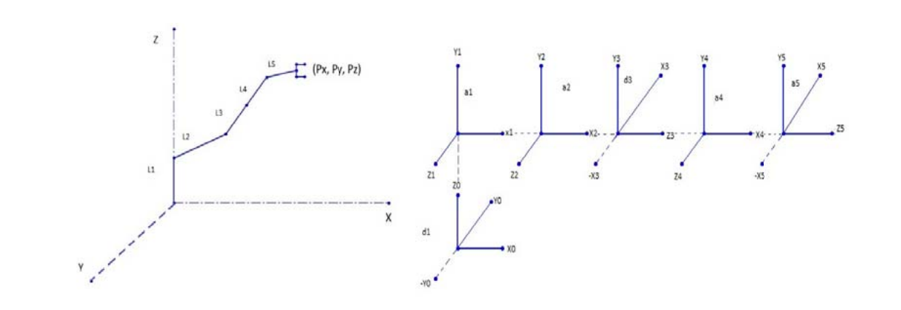

Figure 2: Manipulator link

In forward kinematics the joint angles of the robot is given then the end effector position of the robotic arm which is calculated using the kinematics equations. This six DOF robotic manipulator has 6 links and 6 angles. The length of links is

*Link 1 = 490 Link 4=451*

*Link 2= 1270 Link 5=230*

*Link 3= 961 Link 6=185*

The representation of links and frame assignment of the manipulator is shown in the figure 2. The D-H parameter convention is used to assign coordinate frames to each joint of the robotic arm in a simple and consistent way. From these parameters, a homogeneous transformation matrix can be defined, which is useful for both forward kinematics and inverse kinematics of the robotic arm.The DH parameters for the 6 DOF robotic manipulator are calculated and shown in Figure 3.

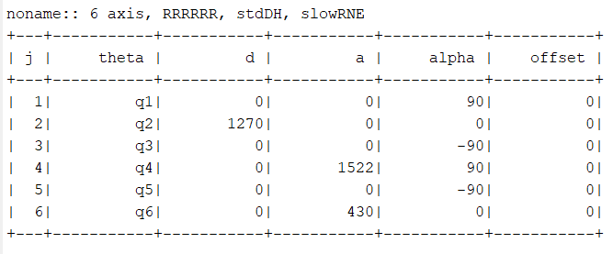

Figur 3: Dh Parameter

The transformation matrixes T1, T2, T3, T4, T5, T6 and Final transformation matrix T are calculated based on the above D-H Table and it is shown as follows,



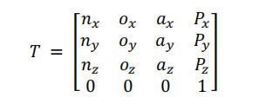

Figure 4: Final Transformation matrix

From solving the equations 1 to 7 we get the final transformation matrix T, which has Px, Py, Pz.

This gives the position of the end effector. If the link parameters and joint angles are given the

position of the end effector of the robotic manipulator can be found.

* 1. **Inverse Kinematics**

In Inverse kinematics if the end position is known that is the Px, Py, Pz and the link parameters we can find all the joint angles using inverse kinematics. The inverse kinematics will give different combination of joint angles for a single position of end effector. By solving the equations 8 the results obtained are shown as follows,

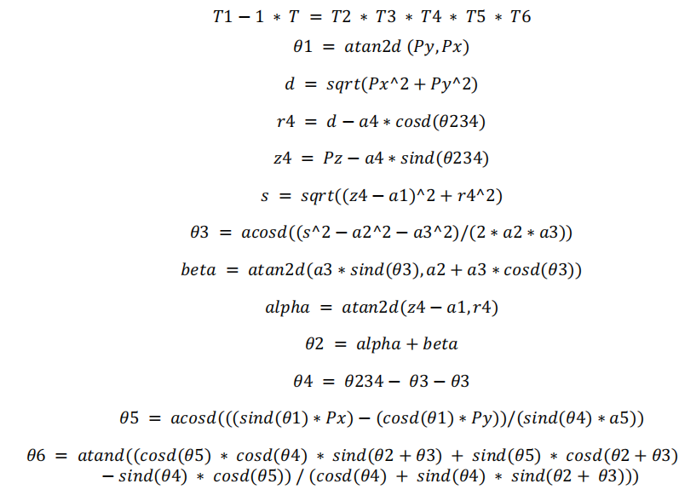

Figure 5: Inverse Kinematics Formulation

1. **Simulation and Creation of GUI**

3.1 Conversion of SolidWorks Model Into MATLAB

The SolidWorks model of six DOF robotic manipulator is converted into simmechanics model in order to simulate the designed model in the Simulink environment. The final workable file in MATLAB which is created after this conversion is used for simulation in MATLAB is shown in the figure 3.By running this simulation, we can control the joint motion of the manipulator in MATLAB.

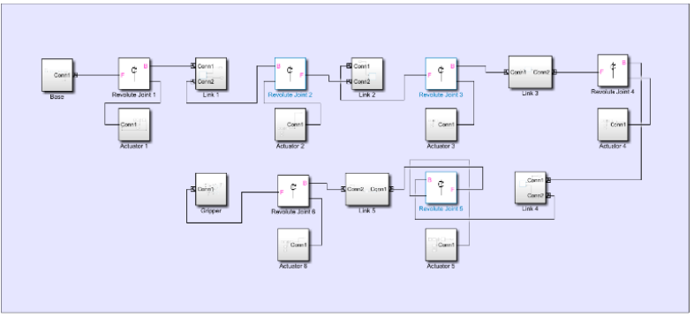

Figure 6: Simmechanics model of the manipulator

3.2. Creation of GUI

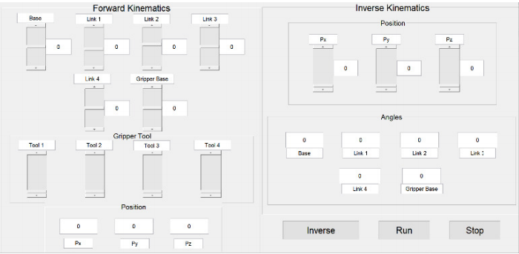

Figure 7: Gui

In GUI if we enter the joint angle entered in the text boxes are can b effector in the inverse kinematics p only gives the values it also animated the data to understand the performed the GUI. Simmechanics model of the manipulator ward and inverse kinematics of the six DOF robot he figure 4.Using this GUI, we can get and send validation If we click the run button in the GUI. The data 0btained. We can use the GUI to control the six Forward kinematics and inverse kinematics.

#### **4. Analysis of Manipulator**

##### 4.1. Kinematic Analysis

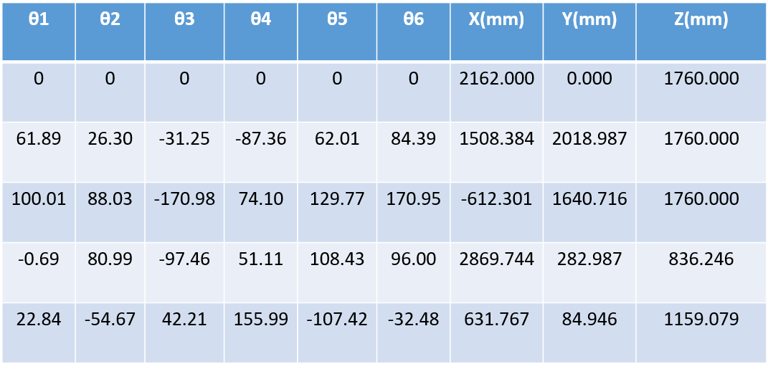

Figure 8:Forward kinematics

For kinematic analysis the joint angles were given as inputs. These positions were given as inputs for then inverse kinematics and the joint angles were calculated. This was calculated for more than 100 different combinations of joint angles and these were compared. The comparison results show that the joint angles provided by inverse kinematics equation is not same as the joint angles given for forward kinematics calculation. Only 10% of the results are similar. Mostly the values of one or two joint angles varies in a single combination. A randomly selected 5 such combinations are shown in figure5. Some joint values obtained by inverse kinematics contains the joint angles that exceeds the offsets of the joint angles.

#### 4.3. Inverse Kinematics algorithm

Since the results of the inverse kinematics equations we derived were not satisfactory we created a Rigid Body Tree model of the manipulator using the robotics system toolbox. This model is used to calculate the forward kinematics of the manipulator. Here we have also used the Brayden-Fletcher-Goldfarb-Shannon (BFGS) gradient projection algorithm. Using this model, we validated the results of forward and inverse kinematics of the manipulator. The forward kinematics results from these models are compared in the figure 6. In the table only 5 results are compared from more than100 results. The same for inverse kinematics is shown in figure 7 and 8.



Thus, from comparing the results of Inverse Kinematics kinematics got by the equation, by BFGS algorithm and Peter Croke Toolbox we can come to a conclusion that the End effector position we got are comparatively ±.02 mm imprecision. The results of inverse kinematics of BFGS Algorithm and Peter Croke model is same.

#### 4.3. Load Analysis

This manipulator has been analysed for various displacement, stress, and strain of materials by applying different loads using Ansys software and shown in Table 2. Using mate controller and motion study in Ansys we animated the pick and place operation. In the animation the robot will be in home position initially then it will move to the objects position and picks it. Later it moves to the final position and places the object there and moves to the home position again. This manipulator is designed for both welding and pick and place application. When it comes to welding operation the manipulator must move in complex path to make a proper weld. We have designed a gripper tool for welding operation. The manipulator is shown in figure 9. This is attached with the manipulator to study how it traces a path.

Since the Factor of Safety is 2 the maximum load that can be applied is limited to 100 KN. This load analysis shows that as the load applied to the manipulator increases the maximum stress and strain are found near the links joints. Especially the stress and strain near the joint between link 3 and link 4 is significantly high. When the load is increased further the location of maximum stress and strain is found near the edges of link 2 near the joint between link 1 and link 2. This Stress is higher than the stress found between link 3 and link 4. This shows a change in the location of maximum stress and strain in the manipulator as the load increases. We have to change the design of the link as there will be less stress and strain near the joints. The strain for 250 KN is 7.562-03. This will not affect the manipulator. If we have to reduce the strain then we have to redesign the links edges. It is better to design all the links as hollow structure as link 3. Material is changed to composite material

Table 2: Load analysis

|  |  |  |  |
| --- | --- | --- | --- |
| Aluminium alloy T-6061 | | | |
| Load Applied (kN) | Stress ( N/mm2 ) | Strain | Displacement ( mm ) |
| 100 | 2.412e+02 | 2.257e-03 | 2.518e+01 |
| 150 | 3.629 e+02 | 3.383 e-03 | 3.777 e+01 |
| 200 | 4.597 e+02 | 4.377 e-03 | 4.852 e+01 |
| 250 | 7.737 e+02 | 7.562 e-03 | 8.257 e+01 |

#### 







**5. Conclusion**

The six DOF robotic manipulator was successfully designed in SolidWorks for welding, pick and place application. A teach pendent for study the forward and inverse kinematics of the six DOF robotic manipulator is done. The forward and inverse kinematics was modelled and was implemented in GUI for studying the performance of the robotic manipulator. The inverse kinematics is comparatively complex has the DOF increases. An experimental analysis was done by calculating the end effector position for various joint angles and the joint angles for various position of end effector using the forward and inverse kinematics with the help of GUI. The joint angles obtained in the inverse kinematics had many combinations for a single manipulator position. The Results obtained have a precision of about ±.02mm. And the material is replaced with Epoxy Carbon UD (230 GPa) Prepreg is the more suitable.

## References

[1]Dahari, Mahidzal, and Jian-Ding Tan 2011 Forward and inverse kinematics model for robotic welding process using KR-16KS KUKA robot *Fourth International Conference on Modelling, Simulation and Applied Optimization.* IEEE 5775598

[2]Parhi Dayal R, et al. 2012 Forward and Inverse Kinematic Models for an Articulated Robotic Manipulator*International Journal of Artificial Intelligence and Computational Research* 4.2 : 103-109

[3]Kofinas, Nikos, Emmanouil Orfanoudakis, and Michail G Lagoudakis 2013 Complete analytical inverse kinematics for NAO *13th International Conference on Autonomous Robot Systems*. IEEE 1364451

[4]Deshpande, Vivek, and PMGeorge 2014 Kinematic Modelling and Analysis of 5 DOF Robotic Arm *International Journal of Robotics Research and Development (IJRRD)* 4.2 : 17-24

[5]Singh, Tarun Pratap, P. Suresh, and Swet Chandan 2017 Forward and inverse kinematic analysis of robotic manipulators *International Research Journal of Engineering and Technology (IRJET)* 4.2 : 1459-1468

[6]Mohammed, Amin A., and Mehmet Sunar 2015 Kinematics modeling of a 4-DOF robotic arm*2015 International Conference on Control, Automation and Robotics*. IEEE 716608

[7]Gan, John Q., et al. 2005 A complete analytical solution to the inverse kinematics of the Pioneer 2 robotic arm *Robotica* 23.1 : 123-129

[8]KuCuk, Serdar, and Zafer Bingul 2004 The inverse kinematics solutions of industrial robot manipulators *Proceedings of the IEEE International Conference on Mechatronics, 2004. ICM'04.*. IEEE 1364451

[9]Hayawi, Mustafa Jabbar 2011 Analytical inverse kinematics algorithm of a 5-DOF robot arm *Journal of Education for Pure Science* 1.4 : 92-104

[10]KÜTÜK, Mehmet Erkan, Memik Taylan DA, and Lale Canan DÜLGER 2017 Forward and inverse kinematics analysis of Denso robot*Proceedings of the International Symposium of Mechanism and Machine Science*

[11]Xu, De, et al. 2005 An analysis of the inverse kinematics for a 5-DOF manipulator *International Journal of Automation and Computing* 2.2 : 114-124

[12]Iqbal, Jamshed, R. Ul Islam, and Hamza Khan 2012 Modeling and analysis of a 6 DOF robotic arm manipulator *Canadian Journal on Electrical and Electronics Engineering* 3.6 : 300-306

[13]Singh, Harpreet, Naveen Dhillon, and Imran Ansari 2015 Forward and inverse Kinematics Solution for Six DOF with the help of Robotics tool box in matlab*IJAIEM* 4.3

[14]Gouasmi, Mahmoud, et al. 2012 Kinematic modelling and simulation of a 2-R robot using solidworks and verification by MATLAB/Simulink *International Journal of Advanced Robotic Systems* 9.6 : 245

[15]Kumar, Vikash 2019 Kinematics/Dynamics Analysis with ADAMS/MATLAB Co-simulation of a SolidWorks Designed Spatial Robot Arm with Control and Validation of Results. No. 1619. *Easy Chair*