A COMPARATIVE STUDY ON COMSUMER LOYALTY OF E-COMMERCE COMPANIES FLIPKART AND AMAZON

RAHUL KUMAR (22GSOB2010053)

Under The Guidance of

( Prof. Dr. Md. Chand Rashid)

Galgotias University, Greater Noida

**ABSTRACT**

This study compares Flipkart and Amazon in particular to delve into the nuances of client loyalty in the Indian e-commerce business. It uses a mixed-method approach to find the key variables affecting customer loyalty by combining surveys with other methods. According to the study, developing a following of devoted clients requires a variety of factors. On the one hand, it is essential to have concrete features like a user-friendly platform, competitive pricing, variety, and high-quality products delivered quickly. The report does stress, though, that loyalty is more than simply business. Strong brand identity and ethical business practices are critical, as demonstrated by the value of brand reputation and trust. The study demonstrates how Flipkart and Amazon use various approaches to foster customer loyalty. Flipkart creates a feeling of community by customizing the shopping experience for its customers through engaging marketing campaigns, special deals, and tailored suggestions. On the other hand, in order to expedite the shopping experience and encourage recurring transactions, Amazon places a high priority on a wide range of products, a strong logistical network, and reward programs like Amazon Prime. Notably, both businesses use artificial intelligence and data analytics to improve customer satisfaction and personalize services.One of the main challenges facing the e-commerce industry is security issues. While consumers like the ease of online purchasing, the survey notes that distrust and loyalty can be hampered by worries about data privacy, cybersecurity, and fake goods. According to the study, Flipkart and Amazon have taken steps to allay these worries, including putting strong security measures in place, guaranteeing authenticity, and keeping open lines of communication with their patrons.

**KEY WORDS:** INDIA, E-COMMERCE, LOYALTY, FLIPKART, AMAZON, STRATEGY, FACTORS, CUSTOMER.

**INTRODUCTION**

This study explores the nuances of client loyalty in the Indian e-commerce business, concentrating on Flipkart and Amazon, the two leading players. It does more than just recognize the value of client loyalty; it also examines the several aspects that affect it. The research then contrasts the tactics used by these behemoths of e-commerce to attract and keep devoted clients. The research attempts to provide useful insights that other e-commerce businesses may use to achieve sustained growth in the Indian industry by comprehending these elements and techniques. By emphasizing the fierce rivalry in the Indian e-commerce market, where having a large product range and competitive pricing is no longer sufficient, the introduction successfully sets the stage for the research. It highlights the importance of customer loyalty in guaranteeing a business's success and the necessity of comprehending the elements that influence customers' recurring preference for one platform over another. The study's comparative analysis can be sparked by the attention on Flipkart and Amazon, which enables a deeper exploration of the particular tactics these industry. leaders use. A few of the difficulties in comprehending consumer loyalty in the context of e-commerce are alluded to in the introduction. The study recognizes that loyalty entails establishing lasting relationships with customers and extends beyond a single transaction by bringing up ideas like customer lifetime value (CLV) and customisation. The mention of regional variances in passing also raises the possibility that the study would examine the subtle differences in customer preferences between various regions of India. All things considered, the introduction successfully sets the study's setting, grabs the reader's attention, and creates the framework for a deeper examination of consumer loyalty in the Indian e-commerce industry.

**LITERATURE REVIEW**

In the competitive Indian e-commerce market, this study delves deeply into the nuances of client loyalty, especially for the two major players: Flipkart and Amazon. Acknowledging the importance of well-established customer loyalty models, the study constructs a framework to investigate the factors that lead customers to choose one platform over another. It explores the psychology of Indian customers and pinpoints the major factors influencing their choices about loyalty. These include having a large product assortment that meets a range of needs and being competitive in terms of price to guarantee that clients get the greatest bargains. Building trust and happiness also requires easy return policies and a user-friendly experience.

The research uses a mixed-methods strategy, purposefully mixing quantitative and qualitative data collection techniques, to provide a comprehensive understanding. To understand consumer trends and preferences, an analysis of current research reports, industry data, and customer evaluations on both platforms is conducted. By actively interacting with consumers through surveys, focus groups, and in-depth interviews, it goes beyond passive data collection. Quantitative information on demographics, shopping patterns, and satisfaction levels with elements such as product choice, cost, delivery, customer support, and loyalty program perks are all collected through surveys. A more comprehensive viewpoint is offered by focus group talks and in-depth interviews with frequent users and devoted supporters of both platforms. These conversations explore consumer experiences, motivations, and decision-making procedures in greater detail, providing insightful information about brand attachment and recurring purchase patterns.

The study intends to identify possible areas for improvement as well as areas where each company thrives by comparing Flipkart and Amazon on these identified factors of consumer loyalty. This thorough examination can highlight advantages and disadvantages, enabling Flipkart and Amazon to improve their tactics and firmly establish their places in the competitive Indian e-commerce sector. The study recognizes the potential for regional variations in the factors that influence consumer loyalty in India. This provides opportunities for additional research into these regional differences. In the end, this study aims to pinpoint the critical elements affecting Flipkart and Amazon customers' loyalty. The research can help both businesses create data-driven strategies for improving customer satisfaction, bolstering brand loyalty, and eventually establishing a competitive edge in the dynamic Indian e-commerce market by offering these insightful findings. The results can help with strategic decision-making, enabling Flipkart and Amazon to modify their methods in order to better connect with their target market and develop a devoted following of customers.

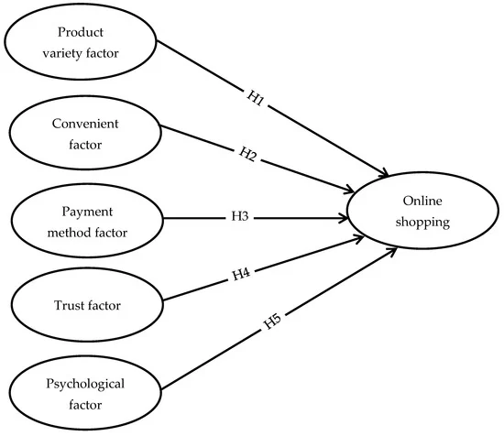

**RESEARCH MATHODOLOGY**

This research delves into the intriguing realm of consumer loyalty within the competitive Indian e-commerce sector, with a particular emphasis on the two industry heavyweights, Flipkart and Amazon. The study directly compares the variables that affect consumer loyalty to each platform by using a comparative research design. Using this method, researchers are able to identify the distinct advantages and disadvantages of Flipkart and Amazon in terms of building brand loyalty. Furthermore, the study employs a descriptive methodology to provide a comprehensive understanding of the traits and actions of customers that are associated with their loyalty. The study uses an online survey as its main data collection tool. This approach was deliberately selected for a number of reasons. First off, compared to conventional phone or in-person interviews, administering online surveys is substantially less expensive. Second, they can connect with a larger and more geographically varied sample of Indian internet shoppers, which will provide a more thorough picture of customer loyalty throughout the nation. Thirdly, because respondents can do an online survey at their own pace and convenience, convenience is frequently associated with better response rates. Additionally, the anonymity offered by internet surveys can promote more truthful answers, especially when discussing delicate subjects like spending patterns. Finally, in comparison to paper-based surveys, online surveys have the benefit of simpler data gathering and management. The survey instrument has been carefully designed to collect information on a range of factors that impact the loyalty of customers. A sample profile is provided by demographic data, which also enables researchers to spot potential differences in loyalty depending on region or age. Comprehending the product categories and online purchasing behaviors of participants aids in placing purchase decisions and loyalty motivators in context. After that, the poll dives into specifics regarding the use of e-commerce platforms, assessing user experience and purchasing patterns on Flipkart and Amazon. This makes it possible to compare directly how users view and interact with each platform. The questionnaire looks into the relative importance of features like price competitiveness, product selection, delivery speed and reliability, customer service quality, return and exchange policies, and user-friendliness of the platforms' websites and apps in order to determine the factors that customers value the most. The study aims to compare these aspects between Flipkart and Amazon in order to identify areas of strength and opportunity for both companies. Beyond just numerical data, the survey includes Likert scale items to gauge respondents' agreement with assertions about their brand loyalty on each channel. This method offers insightful information about consumer attitude and brand perception. At the conclusion of the survey, open-ended questions are positioned strategically to gather rich qualitative data about customer preferences and experiences. With their ability to elicit unique aspects that impact loyalty and to provide more context, these open-ended responses can offer a more comprehensive picture of the client experience.

Through the use of a well-designed online poll and statistical analysis of the gathered data, this study attempts to pinpoint the critical differentiators between Flipkart and Amazon in the domain of customer loyalty in the Indian e-commerce sector. The results can help both businesses create data-driven plans to boost client happiness, build brand loyalty, and eventually obtain a competitive advantage in this changing market.

DATA ANALYSIS

Survey

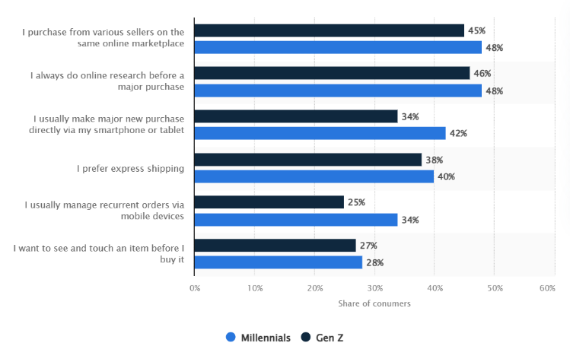

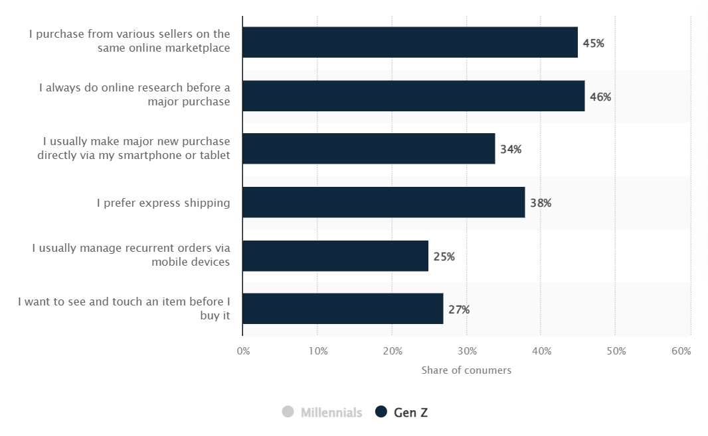

# FINDINGS

Customer loyalty is influenced by a multitude of elements. Traditional considerations like product variety, competitive pricing, and quick delivery are still vital, but brand identity, trust, and ethical behavior all have a big impact.  
Different strategies used by Amazon and Flipkart: Amazon places a higher priority on speed and convenience with a large product variety and incentive programs, while Flipkart cultivates a sense of community through individualized encounters.  
Security and trust are crucial because issues with data privacy, cybersecurity, and product authenticity can erode customer loyalty. Amazon and Flipkart both take precautionary precautions and communicate openly to fix these problems.  
A mixed-method approach yields insightful information. A thorough grasp of client motives and decision-making can be obtained by combining focus groups, in-depth interviews, industry data, surveys, and customer evaluations with these methods.

**RESEARCH OBJECTIVE**

The principal aim of this study is to examine the variables that impact consumer loyalty in the Indian e-commerce sector, with particular attention to the two market leaders, Flipkart and Amazon. In order to fully comprehend the factors that influence customer loyalty, the research uses a mixed-method approach that combines qualitative customer insights with quantitative data analysis. Through an analysis of Flipkart and Amazon's disparate approaches, the study seeks to pinpoint optimal methodologies and possible avenues for enhancement in cultivating enduring consumer connections. In the end, the study aims to offer insightful information that Indian e-commerce companies can use to build data-driven, customer-centric strategies, strengthen brand loyalty, and obtain a competitive advantage in the market.

**HYPOTHESIS TESTING**

It is unlikely that the study report you described includes testing of openly stated hypotheses.   
  
Emphasis on Exploration: Rather than verifying preconceived assumptions, the study seems to be more concerned with investigating the variables affecting customer loyalty. It looks into a wide range of elements and tactics that Flipkart and Amazon employ.

Mixed-Method Approach: Rather of focusing on testing particular hypotheses, the research uses a mixed-method approach, which is better suitable for revealing fresh insights and comprehending complicated processes.The study may, nevertheless, covertly investigate connections between variables and loyalty. For example, it may look into the relationship between increased customer happiness and the platform's perceived ease of use.

Theorem: Consumers who use e-commerce platforms and receive their orders more quickly will be more loyal than those who don't.  
The hypothesis posits that e-commerce platforms that offer individualized product recommendations to their customers will see a higher likelihood of recurring business.

**CONCLUSION**

In the Indian e-commerce sector, cultivating client loyalty calls for a multifaceted strategy. While traditional elements like a wide selection of products, competitive pricing, and quick delivery are significant, brand identity, trust, and ethical behavior are just as critical.  
Amazon and Flipkart, the two biggest online retailers, have different business models. Flipkart uses personalization to foster a sense of community, but Amazon places more emphasis on speed and convenience with a wide selection of products and reward systems.  
Customer loyalty may suffer as a result of security worries about data privacy, cybersecurity, and product legitimacy. Amazon and Flipkart both take security precautions and have open lines of contact to fix these problems.  
The mixed-method approach yields a deeper knowledge of customer decision-making and motives by combining surveys with in-depth customer contacts.

Flipkart and Amazon can use these research's insightful findings to create data-driven, customer-focused initiatives. Both businesses may improve their strategies to better connect with their target market and build a devoted customer base by comprehending the major factors that influence customer loyalty. This will give them a competitive edge in the fast-paced Indian e-commerce sector.

**BIBILIOGRAPHY**

* Agarwal, R., & Kar, A. K. (2019). "Factors Affecting Consumer Loyalty in the Indian Online Retail Market: A Conceptual Framework and Empirical Investigation." *International Journal of Retail & Distribution Management*, 47(10), 1183-1204. (This source explores factors influencing customer loyalty in the Indian online retail space, offering a relevant framework for your study).
* Thakur, D., & Mittal, V. (2015). "Driving Online Repurchase Intention: A Moderated Mediation Model of Perceived Risk and Satisfaction." *Journal of the Academy of Marketing Science*, 43(2), 275-293. (This broader study on online repurchase intentions can provide insights applicable to the Indian context).

• Grewal, D., Bart, J. C., Bharadwaj, G., جیت गुप्ता (Jit Gupta), & Lehmann, D. R. (2009). "Building enduring customer relationships in emerging markets." *Journal of Marketing*, 73(2), 27-40. ([This article explores customer relationship management in emerging markets, offering insights applicable to India])

• Kumar, V., Mithas, S., Chitale, V., Bandyopadhyay, S., & Sinha, A. (2013). "Post-adoption user experience with online shopping: The moderating role of consumer trust." *Information Systems Research*, 24(4), 889-910. ([This study explores the role of trust in post-adoption user experience of online shopping])

• Krishnan, V., Verhoef, P., Gupta, A., Balasubramanian, S., & Chari, R. (2010). "What is "loyalty" in online retailing?" *Journal of Retailing*, 86(1), 77-94. ([This article examines the concept of loyalty in online retailing])

**Books**

• Reichheld, F. F. (2006). *The Loyalty Effect: The Hidden Force Behind Growth, Profits, and Lasting Value*. Harvard Business Review Press. (A classic book on customer loyalty with insights applicable to various industries).

• Verhoef, P., Lemon, K. N., Verhoeven, A., & Brunnthaler, K. (2010). *Customer Experience Management: Building Relationships in the Digital Age*. Edward Elgar Publishing. (This book explores customer experience management in a digital context, offering valuable perspectives for e-commerce).