**Title:** “The Impact of High Commitment HR Systems on Turnover Intention: A Critical Perspective”

1. **ABSTRACT**

Worldwide, employee turnover continues to be a major problem for businesses, resulting in high expenses as well as negative effects on output and performance. As a result, a lot of businesses have used High Commitment Human Resource (HR) Systems as a tactical method of managing their personnel. This study considers the complex nature of employee attitudes and behaviours as it critically investigates the effect of high commitment HR systems on turnover intention.

This study presents a comprehensive examination of the correlation between High Commitment HR Systems and turnover intention, based on an amalgamation of extant literature and empirical investigations. It investigates the ways in which different elements of high-commitment HR systems—like performance-based rewards, thorough training, employee involvement, and selective hiring—affect workers' intentions to leave their companies.

Moreover, this research employs a critical view point to examine the possible disadvantages and inadvertent outcomes of High Commitment HR Systems. It recognises that although these systems can lessen the intention of employees to leave by encouraging organisational commitment, improving job satisfaction, and encouraging employee engagement, they can also lead to tensions and conflicts at work, especially when it comes to issues of control, justice, and perceived organisational support.

This research adds to a greater knowledge of the difficulties underlying the relationship between turnover intention and High Commitment HR Systems by critically examining it. It provides guidance to practitioners and policymakers on how to create more successful HR strategies that strike a balance between the advantages of commitment-oriented practices and the requirement to address the root causes of turnover intention in a comprehensive and long-lasting way.

1. **INTRODUCTION**

Across all industries, employee turnover is a major concern for organisations due to its profound effects on financial performance, operational efficiency, and overall effectiveness. Thus, it has become important for academics and professionals in the field of human resource management (HRM) to comprehend the elements that impact turnover intention. High Commitment HR Systems have been apparent as a viable strategy among the many ones intended to reduce turnover; these systems place a strong emphasis on the establishment of a happy work environment, employee growth, and organisational commitment.

High Commitment HR Systems are intended to create a strong psychological bond between workers and their companies. They are distinguished by policies including selective recruiting, comprehensive training, employee involvement, and performance-based awards. Organisations seek to develop a workforce that is highly engaged, driven, and dedicated to achieving organisational goals by making investments in the professional development and well-being of their workforce. Thus, advocates of High Commitment HR Systems contend that by raising job satisfaction, organisational commitment, and perceived organisational support, they can successfully lower the intention of turnover.

Though the potential advantages of High Commitment HR Systems are well known, there is a rising recognition of the necessity for a critical viewpoint in order to fully assess their impact on turnover intention. Taking such a view entails analysing the possible downsides, unintended effects, and underlying power dynamics present in these systems in addition to the benefits linked with commitment-oriented activities.

This critical viewpoint recognises that although High Commitment HR Systems may be successful in decreasing the intention of turnover among specific workforce segments, they may also worsen already-existing disparities, incite conflict at work, and contribute to employee feelings of alienation or disengagement. Furthermore, employees who view these technologies as tools for exploitation or control rather than for empowerment may oppose their introduction.

Thus, by closely analysing the underlying mechanisms, contextual variables, and power dynamics at work, this study aims to offer a nuanced understanding of the influence of High Commitment HR Systems on turnover intention. By taking a critical stance, we hope to expose the inconsistencies and complexities present in commitment-oriented practices and provide guidance to practitioners and policymakers on how to create more successful HR strategies that strike a balance between the advantages of commitment and the requirement to address the underlying causes of turnover intention in a long-term, comprehensive manner.

1. **LITERATURE REVIEW**

Bindu and Srikanth (2019) defined turnover intention as, “the measurement of whether a business or organization’s employee plan to leave their positions or whether that organization plans to remove employee from positions.” Although, it is major challenge being faced by the organizations around the globe, but it is more critical challenge for organization in Pakistan. As the employees’ intent to leave their organizations directly influence the turnover process and decisions thereof.

Some studies have explored how human resource practices have an impact on TI of employees and their attachment towards their organizations and their jobs (e.g., Bindu and Srikanth (2019); Zungbey, Bonsu, Ntow, and Sokro (2019)) suggested that proper attention should also be given to both (a) activities, policies and actions of the management and the organizations, and (b) well-being, care and work-family balancing programs for the employees, as such will enable them to better understand the outcomes and results related to high commitment work systems and their overall impacts on the employees.

Some studies suggested to include some other variables to explore the relationship between high commitment work systems and turnover intentions of employees (Zungbey et al., 2019), therefore, this study in the context of non-western perspective focused on workload as a mediator variable between high commitment work systems and turnover intentions of employees in financial sector (i.e., banks operating in both private and public sector domain) in Bahawalpur, Pakistan. In the present study, turnover intention has been considered as a dependent variable, and is operationalized as defined by Tett and Meyer (1993) as, “a conscious and deliberate willfulness to leave the organization” (as cited in Lu, Liu, and Zhao (2017)).

1. **RESEARCH OBJECTIVE**

* The primary objective of this study is to investigate how the antecedents, such as job satisfaction, organizational commitment, job performance, leadership, and work-family conflict, affect turnover intentions and to examine the relationship between exogenous variables, such as pay, work stress, job satisfaction and organizational commitment, respectively.
* Meanwhile, investigate the relationship between potential factors and termination intention of manufacturing workers.
* To conduct a review on factors which affect employees’ turnover intentions.
* To conduct a review of the causal relationships between factors, such as job satisfaction, organizational commitment, job performance, leadership, work family conflict, and employees’ turnover intentions.
* To conduct a review of the potential factors which affect employees’ termination intentions and their potential relationship.
* To investigate the effect of employees’ job satisfaction, organizational commitment, job performance, leadership and work-family conflict on employees’ turnover intentions.
* To investigate the effect of exogenous variables and job satisfaction and organizational commitment, respectively.
* To investigate the effect of potential factors on employees’ termination intentions.
* To investigate the differences in turnover intention and termination intention across manufacturing workers groups.

1. **RESEARCH METHODOLOGY**
   1. **Data Designing:**

In this study, a correlational design was most appropriate because I examined the relationship between three independent variables of organizational commitment and one dependent variable of turnover intentions. Identified a correlational approach is best when examining the relationship between two or more variables and making predictions about the strength or weakness of its relationship. In addition to a correlational design, the other three quantitative research designs are

1. Descriptive,
2. Experimental, and
3. Quasi - experimental.
   1. **Data Collection:**

The impact of high commitment HR systems on turnover intention is a significant topic in human resource management. Here are some common methods of data collection that could be used to study this phenomenon:

1. **Surveys/Questionnaires:** This is a widely used method where researchers design structured questionnaires to collect data from employees about their perceptions of the HR system and their intentions to leave the organization. Questions can be designed to measure various aspects such as job satisfaction, perceived organizational support, and commitment to the organization.
2. **Interviews:** Researchers can conduct in-depth interviews with employees, HR managers, and other stakeholders to gain a deeper understanding of their perspectives on high commitment HR systems and turnover intention. Interviews allow for more detailed exploration of individual experiences and opinions.
3. **Focus Groups:** Focus groups involve bringing together a small group of employees or managers to discuss specific topics related to high commitment HR systems and turnover intention. This method allows for group dynamics to emerge and provides insights into shared perceptions and experiences.
4. **Observations**: Researchers can directly observe organizational practices and interactions related to HR systems and turnover. This method allows for the collection of objective data on how high commitment HR practices are implemented and their impact on employee behaviour.
5. **Secondary Data Analysis:** Researchers can analyze existing data sources such as organizational records, employee surveys, or industry reports to examine the relationship between high commitment HR systems and turnover intention. This approach can provide valuable insights into real-world outcomes without the need for new data collection.
6. **DATA ANALYSIS**
7. **Descriptive Statistics:** Calculate basic descriptive statistics such as mean, median, standard deviation, etc., to understand the central tendency and variability of your variables.

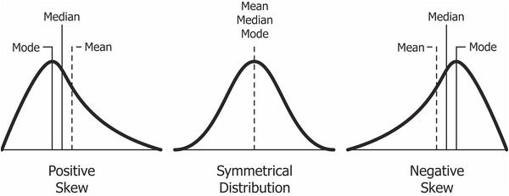

1. **Correlation Analysis:** Examine the relationships between variables using correlation coefficients such as Pearson's correlation.

**Example Graph:** Scatter plot showing the relationship between high commitment HR practices and turnover intention scores for each employee.

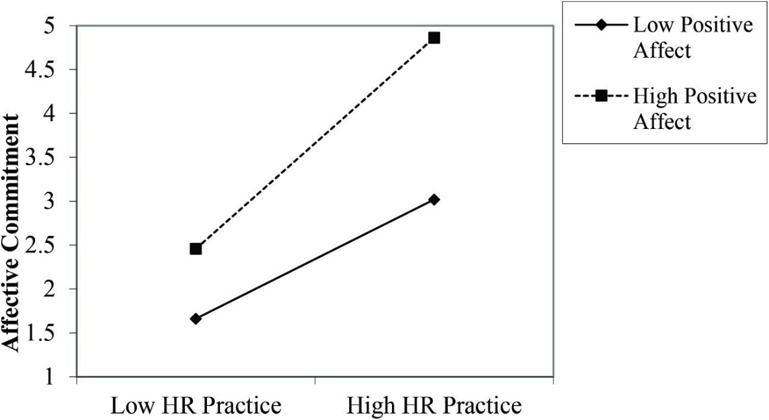

1. **Regression Analysis:** Conduct regression analysis to identify the strength and direction of relationships between predictor variables (e.g., high commitment HR practices) and outcome variables (e.g., turnover intention).

**Example Graph:** Regression line plot illustrating the predicted values of turnover intention based on high commitment HR practices, with confidence intervals.

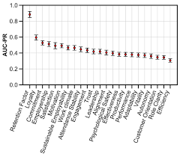

1. **Group Comparisons:** Compare turnover intention scores between groups based on relevant factors (e.g., employees with access to high commitment HR practices vs. those without).

**Example Graph:** Bar chart comparing mean turnover intention scores between groups with and without access to high commitment HR practices.

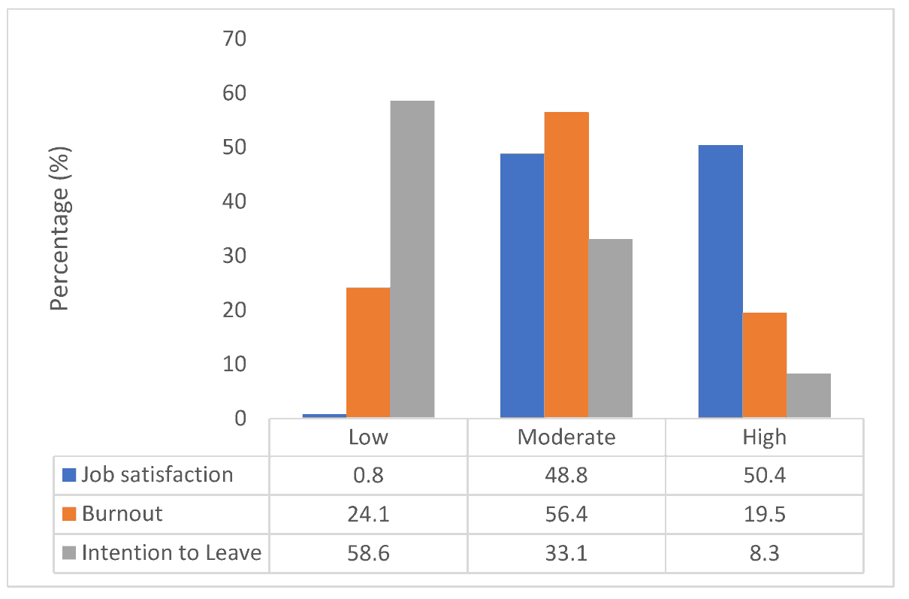

1. **Mediation Analysis:** Investigate whether the relationship between high commitment HR practices and turnover intention is mediated by other variables (e.g., job satisfaction).

**Example Graph:** Path diagram illustrating the direct and indirect effects of high commitment HR practices on turnover intention through job satisfaction.

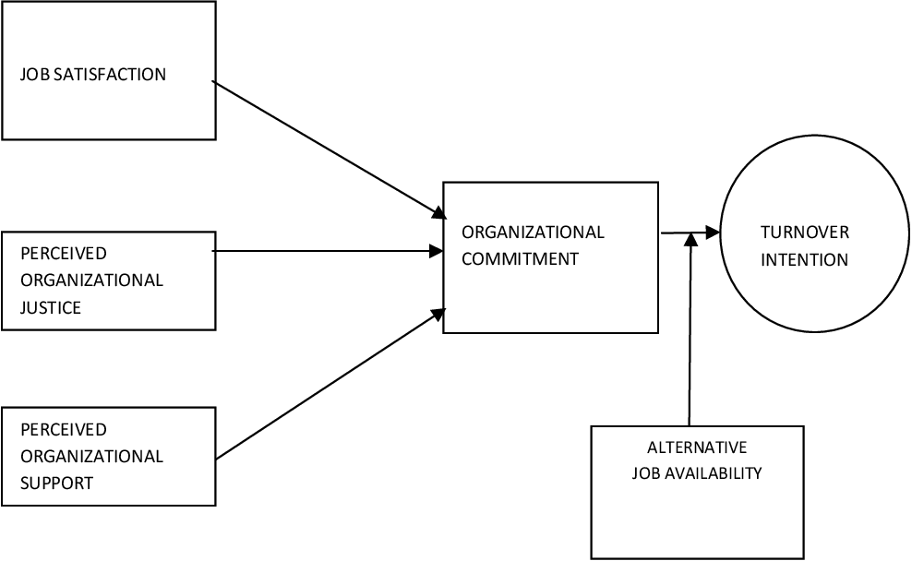

1. **Moderation Analysis:** Explore whether the relationship between high commitment HR practices and turnover intention varies depending on certain conditions (e.g., employee tenure).

**Example Graph:** Interaction plot showing how the relationship between high commitment HR practices and turnover intention changes at different levels of employee tenure.

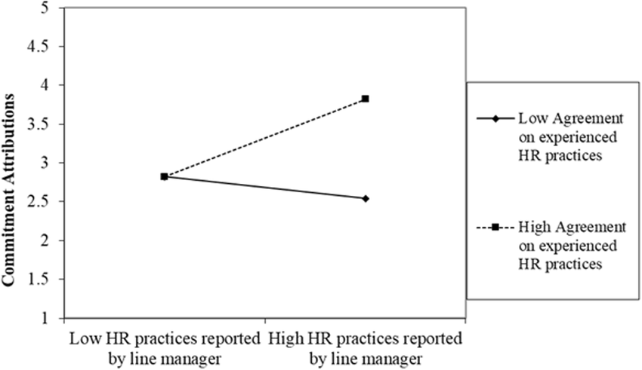

1. **LIMITATION**
2. **Cross-Sectional Design:** The study may have used a cross-sectional design, which limits our ability to establish causal relationships between high commitment HR practices and turnover intention. Longitudinal or experimental designs would provide stronger evidence of causality.
3. **Self-Report Bias:** The data collected through surveys or questionnaires may be subject to self-report bias, where participants may provide socially desirable responses or inaccurately report their perceptions of HR practices and turnover intention.
4. **Sampling Bias:** The sample of employees surveyed may not be representative of the entire organization or may lack diversity in terms of demographics, job roles, or tenure. This limits the generalizability of the findings to other populations.
5. **Common Method Bias:** Since data on both high commitment HR practices and turnover intention were collected from the same source (e.g., employees), there's a risk of common method bias, which could inflate the strength of observed relationships.
6. **Mediation and Moderation Complexity:** While mediation and moderation analyses provide valuable insights, they rely on specific statistical assumptions and may not fully capture the complexity of real-world relationships. Alternative models or additional variables may provide different interpretations.
7. **Single-Organization Study:** If the study focused on a single organization, it may limit the generalizability of findings to other organizational contexts. Multi-site or multi-industry studies would provide a broader understanding of the relationship between HR practices and turnover intention.
8. **Missing Variables:** The study may not have included all relevant variables that could influence the relationship between high commitment HR practices and turnover intention, such as organizational culture, leadership style, or external market factors.
9. **Measurement Issues:** The measurement instruments used to assess high commitment HR practices and turnover intention may not have been fully validated or may not accurately capture the constructs of interest, leading to measurement error.
10. **RECOMMENDATION**

A recommendation that flows logically from the findings of my study is that company leaders should evaluate the weak relationship between affective and continuance commitment and turnover intentions, as both forms of commitment impact job satisfaction and company performance. The findings were consistent with other studies that assessed the relationship between employees’ affective, continuance, and normative commitment and turnover intentions. After my examination of the data, I found a positive relationship between affective commitment and continuance commitment and turnover intentions, and an inverse relationship between normative commitment and turnover intentions.

However, the positive relationships were weak, and the inverse relationship was moderate. While normative commitment is statistically significant, it focuses on an employee’s feeling of obligation to remain with a company, not his or her emotional attachment. Call center leaders, human resources business professionals, and business scholars should pay attention to the results of this study because the findings could help with the retention of employees or be used to build on the existing body of knowledge. Call center leaders may use this study to reduce the stress level of employees and understand the relationship between employee organizational commitment and turnover intentions. It referenced that committed employees outperform others because they remain focused on doing what is best for the organization.

Human Resources business professionals can use the findings of the study to identify ways to retain qualified employees and decrease turnover costs. The high level of stress in call centers increased the chances of turnover and decreased job satisfaction. Business scholars may find the details of this study useful for further research and review. The publication and presentation of this study may occur at business workshops where scholars address employees’ lack of engagement or organizational commitment. The study will be published in the ProQuest/UMI database.

In future studies, I recommend that researchers expand on this body of knowledge by examining the relationship between organizational commitment and turnover intentions of employees across the customer service industry, not just call center employees. By limiting the study to call center employees, researchers cannot suggest that the findings apply to the customer service industry as a whole because some employees work with customers in different environments. The relationship with employees’ commitment and their companies may vary when working with customers’ face-to-face versus over the telephone.

1. **CONCLUSION**

Previous researchers examined the relationship between organizational commitment and turnover intentions. However, most of the studies that I reviewed focused on other industries or call centers located in other countries. Examining the relationship between the organizational commitment and turnover intentions of call center employees in the United States was important because external customers are an important part of the success of any organization. Employee tenure in call centers is roughly 18 months, and the turnover rate is 67%.

The loss of an employee may create issues if customers have built relationships with them or rely on them for assistance. This study was to examine the employees’ thoughts and feelings about remaining with companies from an organizational commitment perspective. The overall results of the study, while positive and significantly significant, are weak and show a need for attention and improvement in this area.

1. **REFERENCES**

* Adkins, A. (2015, January 28). Majority of U.S. employees not engaged despite gains in 2014. Gallup. Retrieved from http://www.gallup.com
* Ahmad, A., & Rainyee, R. A. (2014). Which is a better predictor of employee turnover intentions: Job satisfaction or organizational commitment? A literature review. International Journal of Information, Business, and Management, 6(1), 2-10. Retrieved from http://ijibm.elitehall.com/
* Akanji, B., Mordi, C., & Taylor, A. (2015). The nature and outcomes of emotion work in customer service management. Economic Insights-Trends & Challenges, 67(1), 13-21. Retrieved from http://www.upg-bulletin-se.ro/archive_en.html
* Aladwan, K., Bhanugopan, R, & Fish, A. (2013). Why do employees jump ship? Examining intent to quit employee in a non-Western cultural context. Employee Relations, 35, 408-422. doi:10.1108/ER-03-2012-0027
* Aliyu, O. A., & Nyadzayo, M. W. (2016). Reducing employee turnover intention: A customer relationship management perspective. Journal of Strategic Marketing. Advanced online publication. doi:10.1080/0965254X.2016.1195864
* Allen, N. J., & Meyer, J. P. (1990). The measurement and antecedents of affective, continuance, and normative commitment to the organization. Journal of Occupational Psychology, 63(1), 1-18. doi:10.1111/j.2044-8325.1990.tb00506x
* Allen, N. J., & Meyer, J. P. (1996). Affective, continuance, and normative commitment to the organization: An examination of construct validity. Journal of Vocational Behavior, 49, 252-276. doi:10.1006/jvbe.1996.0443
* Aksu, A., Bahtiyar, D., Deveci, İ., & Koç, Y. (2016). Calculating the cost of turnover at 5-star hotels in Turkey between 2000 and 2016. Turizam, 20(4), 168-179.
* Bothma, F. C., & Roodt, G. (2012). Work-based identity and work engagement as potential antecedents of task performance and turnover intention: Unravelling a complex relationship. SA Journal of Industrial Psychology, 38(1), 27–44.
* Bufquin, D., DiPietro, R., Orlowski, M., & Partlow, C. (2017). The influence of restaurant coworkers’ perceived warmth and competence on employees’ turnover intentions: The mediating role of job attitudes. International Journal of Hospitality Management, 60, 13-22.