##### Master Thesis On

**“The “Perfect” Warehouse: How Third-Party Logistics Providers Evaluate Warehouse Features and Their** **Performance"**

###### UNDER THE GUIDANCE OF

**Prof. Neha G Bhatia**

##### SUBMITTED BY

**Md. Jubed Alam**

(Admission Number: -22GSOB2040005)

MBA (LSCM) 2022-2024

Galgotias University

**School of Business Galgotias University**



## CERTIFICATE

This is to certify that the Master’s Thesis **“The “Perfect” Warehouse: How Third-Party Logistics Providers Evaluate Warehouse Features and Their Performance"** has been prepared by Mr. Md Jubed Alam. under my supervision and guidance. The project report is submitted towards the partial fulfillment of 2 year, Full time Master of Business Administration.

Name:- Prof. Neha G Bhatia Signature of Faculty:-

Date:

## DECLARATION



I, Md Jubed Alam, Roll No.22GSOB2040005, student of School of Business, Galgotias University, Greater Noida, hereby declare that the Master’s Thesis on **[The “Perfect” Warehouse: How Third-Party Logistics Providers Evaluate Warehouse Features and Their Performance]** is an original and authenticated work done by me.

I further declare that it has not been submitted elsewhere by any other person in any of the institutes for the award of any degree or diploma.

Name and:- Md Jubed Alam Signature of the Student:- Date:-



**DECLARATION BY THE STUDENT**

I hereby declare “**The “Perfect” Warehouse: How Third-Party Logistics Providers Evaluate Warehouse Features and Their Performance**" that is the result of the project work carried out by me under the guidance of Mrs. Neha Bhatia in partial fulfilment for the award of MBA in Galgotias University, Greater Noida.

I also declare that this project is the outcome of my efforts and that it has not been submitted to any other university or institute for the award of any other degree Diploma or Certificate.

**Place:** Greater Noida **Name:** MD JUBED ALAM

**Date: Roll No.:**22GSOB2040005



**CERTIFICATE OF ORIGINALITY**

Date: 12-04-2024

This is to certify that the dissertation titled “**The “Perfect” Warehouse: How Third-Party Logistics Providers Evaluate Warehouse Features and Their Performance**” is an original work of Mr. Md Jubed Alam. bearing Roll Number 22GSOB2040005 and is being submitted in partial fulfilment for the award of the MBA of Galgotias University, Greater Noida. The research work has not been submitted elsewhere for award of any degree. The material borrowed from other sources and incorporated in the research report has been duly acknowledged.

Name of Guide: Mr. Vinay Sabharwal Signature of Guide:-

Date:-

## ACKNOWLEDGEMENT



Practical knowledge is that which makes the connection between reality and imagination; theory is the first and fundamental step that serves as a foundation. The career and promotion system is intimately linked to research, which is a component of work environments. No thesis is complete if the people who made it possible for it to exist are not acknowledged. Nonetheless, a gratitude statement is never sufficient or whole, no matter how broad it is. Not an exception applies to this acknowledgement.

I would like to express my deepest gratitude to my guide, [ Mr Vinay Sabharwal ] sir for their invaluable guidance, unwavering support, and insightful feedback throughout the entire journey of conducting this research.

I am also profoundly grateful to all my team members and colleague who generously shared their expertise and participated in the surveys and interviews, without whom this study would not have been possible.

Furthermore, I extend my sincere appreciation to my family and friends for their endless encouragement and understanding during the demanding process of writing this thesis.

Lastly I acknowledge the support of my mentor [ Mrs Neha Bhatia ] ma’am, Galgotias University for providing the resources and environment conducive to academic growth and exploration.

**INDEX**

|  |  |  |
| --- | --- | --- |
| **CHAPTER**  **NO** | **PARTICULAR** | **PAGE NO** |
| 1 | INTRODUCTION | 9-17 |
| 2 | PROFILE OF THE ORGANIZATION | 18-22 |
| 3 | LITERATURE REVIEW | 23-25 |
| 4 | INTRODUCTION OF THE STUDY | 27-36 |
| 5 | SCOPE & IMPORTANCE | 37-39 |
| 6 | IMPORTANCE OF STUDY | 40-42 |
| 7 | METHODOLOGY | 43-45 |
| 8 | RESEARCH DESIGN | 46-48 |
| 9 | DATA ANALYSIS & INTERPRETATION | 49-52 |
| 10 | FINDING & SUGGESTION | 53-56 |
| 11 | CONCLUSION & SUGGESTION | 57 |
| 12 | REFERENCES | 59 |
| 13 | QUESTIONNAIRE | 60-62 |

# CHAPTER-1

**INTRODUCTION**

##### INTRODUCTION

**AAJ ENTERPRISES PVT. LTD.**

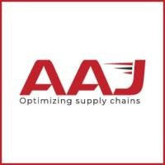

##### BACKGROUND OF THE ORGANIZATION

AAJ is a supply chain service provider established and operating in India. The service portfolio includes 3PL, in plant warehouse operations management, last mile transportation and value added supply chain services. We are a new age and trusted supply chain working for several multinational and national companies across industries.

Had a humble beginning in 2010 and has since then gained the trust of our customers as their only third-party warehouse service provider with pan India presence handling over 70,000 SKU’s and more than 25 million units in stock. We dispatched slightly over 50 million units from all our facilities combined in year 2020.

We pioneer developing and operating large scale, shared warehouses for our customers with AAJ’s own investment in infrastructure of racking, technology, and material handling Equipment’s, resulting in zero capex costs for our clients. Our customized and in house WMS is our USP which allows for information transfer through EDI to all ERP’s and has advanced warehouse management functionalities.

The mission is to build an organization which can take India at the helm of global supply chain with its reliable, cost effective and innovative solutions.

AAJ Enterprises is one of the India’s leading 3PL and Warehousing Management

Organization. The company’s service accuracy level of 99.9 percent, 7 lakh sq. ft. state of the art warehouse infrastructure backed with cutting-edge technological innovation, challenges the status quo. AAJ is a supply chain service provider established and operating in India and provide some value added service like printing, shrink wrapping etc. AAJ was established by Anil Kumar Jain in 2006 who is currently the chairman of AAJ Enterprises Pvt. Ltd.

With more than 500 employees, decade of experience, deep understanding of multiple industries & business functions; we bring expertise in managing Warehouse Infrastructure, Operations, Technology and Transportation ecosystem through solutions tailored to transform businesses and shape future.

Currently operational in:-

* Bangalore
* Kolkata
* Delhi NCR
* Mumbai
* Ghaziabad
* Greater Noida
* Sonipat
  1. Kundli 1
  2. Kundli 2

Over the last 10 years AAJ has achieved a CAGR of 26% in revenue and CAGR of 30% in warehouse space. AAJ aims to represent India globally and wants to become a global supply chain service provider in future.

1. GMV of INR 8 Billion
2. 70,000 SKUs in Stock
3. Yearly Dispatch of 40 million Units
4. Space 7 Lack square feet

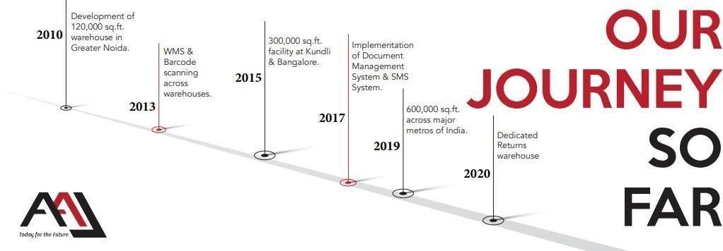

10



**COMPETITION**

There is a huge competition into the market and the competitors are from the core logistics background. The main reason of the competition is there network and availability in each zone and region. Some of the competitions are

* Aegis Logistics All cargo Logistics
* Gati
* Transport Corporation of India
* ABC India
* AFL Logistics
* AQUA Logistics
* DHL Express (India)
* Dynamic Logistics
* Geologistics (Pty)
* Mahindra Logistics
* Om Logistics
* Patel Logistics
* Reliance Logistics
* Safe Express
* Schenker India
* SembCorp Logistics
* SICAL Logistics
* Take Solutions
* Total Logistics (India)
* Transystem Logistics International
* TVS Logistics Services

One of the biggest competition is the local transportation which is been used for limited quantity by the small companies and organisations to save money.



**COMPANY’S OVERVIEW**

* + Vision

What AAJ aims to become in the future Be a global supply chain service provider, taking India at the helm of supply chain in the world.

* + Mission

The Mission that AAJ aspires to fulfill in society Solving complex supply chain problems with reliable, cost effective and innovative solutions.

* + Slogan

Optimizing supply chain.

* + Values
* Uncovering possibilities.
* Integrity.
* Joyful place of work.
* Customer Delight.

**History of company**

AAJ is a supply chain service provider established and operating in India. The service portfolio includes 3PL, in plant warehouse operations management, last mile transportation and value- added supply chain services. They are a new age and trusted supply chain working for several multinational and national companies across industries.

Had a humble beginning in 2010 and has since then gained the trust of their customers as their only third-party warehouse service provider with pan India presence handling over 70,000 SKU’s and more than 25 million units in stock. They dispatched slightly over 50 million units from all our facilities combined in year 2020.

They pioneer developing and operating large scale, shared warehouses for our customers with AAJ’s own investment in infrastructure of racking, technology, and material handling Equipment’s, resulting in zero capex costs for our clients. They are customized and in house WMS is our USP which allows for information transfer through EDI to all ERP’s and has advanced warehouse management functionalities.

Over the last 10 years they have achieved a CAGR of 26% in revenue and CAGR of 30%in warehouse space. This has been possible with a value driven approach which delivers customer delight by exceeding the expectations on the agreed KPI’s as well continuous innovation of warehouse processes and technology. Today 100% their facilities use mobile barcode scanners for all operational activities.

The mission is to build an organization which can take India at the helm of global supply chain with its reliable, cost effective and innovative solutions.

AAJ Enterprises is India’s leading 3PL and Warehousing Organization. We have over 7 lakh sq. state of the art warehouse infrastructure backed with cutting-edge technology which challenges the status quo. With more than 500 employees, decade of experience, deep understanding of multiple industries & business functions; we bring expertise in managing Warehouse Infrastructure, Operations, Technology and Transportation ecosystem through solutions tailored to transform businesses and shape future.

**Product And Service offered by AAJ Enterprises**

These are the services offered at AAJ enterprises.

1. 3PL & Warehouse Management
2. Value Added Services
3. Consulting & Advisory
4. [E-commerce Fulfilment.](https://www.aajenterprises.com/fulfillment/)
5. [Operations Management.](https://www.aajenterprises.com/operations/)
6. [Transportation.](https://www.aajenterprises.com/transportation/)
7. [Returns Management.](https://www.aajenterprises.com/returns/) 8. [Value Added Services.](https://www.aajenterprises.com/vas/)

* 3PL & Warehouse Management:

AAJ Enterprises provides third-party logistics (3PL) services, including the management of warehouses and distribution centers. They ensure efficient storage, inventory management, order fulfillment, and timely delivery of goods.

* Value Added Services:

This service category includes additional services designed to enhance the value of logistics and supply chain operations. These services may include kitting, labeling, packaging customization, and quality control.

* Consulting & Advisory:

AAJ Enterprises offers consulting and advisory services to help businesses optimize their logistics and supply chain strategies. They provide expert guidance on process improvement, cost reduction, and efficiency enhancement.

* E-commerce Fulfilment:

E-commerce fulfillment services cater to online businesses. AAJ Enterprises manages order processing, pick and pack, and last-mile delivery to ensure a seamless shopping experience for online customers.

* + **Operations Management:** AAJ Enterprises assists in optimizing overall operations within a supply chain. This includes inventory management, demand forecasting, process improvement, and cost control to achieve greater efficiency.
  + Transportation:

The transportation service involves managing the movement of goods from one location to another. AAJ Enterprises handles transportation logistics, route optimization, and carrier selection to ensure timely and cost-effective deliveries.

* + Returns Management:

Returns management focuses on handling product returns efficiently. AAJ Enterprises helps businesses establish processes for returns, inspections, restocking, and recycling or disposal, minimizing losses.

* + Value Added Services (Reiteration):

This category encompasses various additional services tailored to specific client needs. It may include customization, bundling, repackaging, or any value-enhancing services beyond basic logistics.

* + AAJ Enterprises offers a comprehensive range of services to support businesses in managing their supply chain and logistics operations effectively, allowing them to focus on their core competencies while achieving operational efficiency and cost savings.

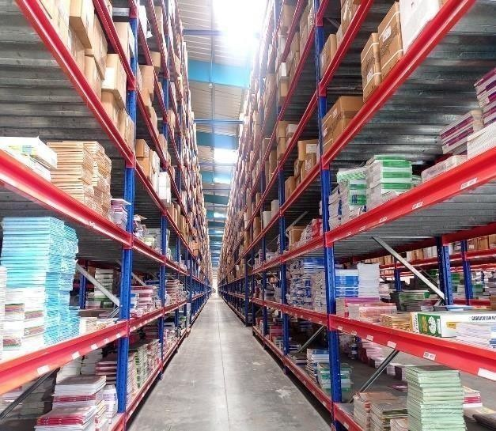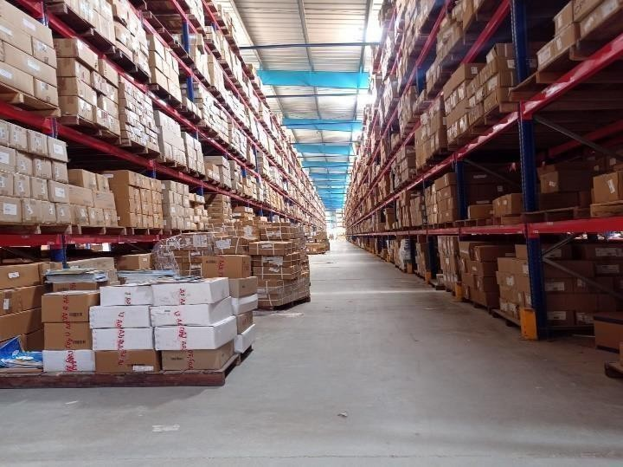

* Different Operations in 3PL Warehouse at AAJ Enterprises.

1. INWARD.
2. INVENTORY.
3. PICK & PACKING.
4. DISPATCH.
5. CS (CLIENT SUCCESS)

* Why we need efficiency in warehouse operations

Efficiency in warehouse operations is crucial for several reasons, and it plays a vital role in the overall success of a business, particularly in supply chain management and logistics. Here are some key reasons why efficiency in warehouse operations matters:

* + **Cost Reduction**: Efficient warehouse operations can help reduce operational costs significantly. Streamlining processes, optimizing inventory management, and minimizing errors can lead to lower labour, storage, and transportation costs.
* **Improved Customer Service**: Efficient warehouses can fulfil customer orders faster and more accurately. This results in improved customer satisfaction, repeat business, and positive word- of-mouth recommendations.
* **Inventory Management**: Effective warehouse management ensures that inventory levels are optimized. This reduces holding costs, prevents overstocking or understocking, and minimizes the risk of product obsolescence.
* **Faster Order Fulfillment**: Efficient warehouses can pick, pack, and ship orders quickly, reducing lead times and ensuring that products reach customers faster. This is particularly important for meeting customer expectations in today's fast-paced market.
* **Reduced Errors**: Efficient warehouse processes often result in fewer errors, such as picking mistakes or inventory discrepancies. This not only saves time and money but also enhances customer trust.
* **Scalability:** An efficient warehouse can adapt to changes in demand and scale operations as needed without significant disruptions. This flexibility is essential for businesses looking to grow or adapt to market fluctuations.
* **Safety**: Efficient warehouses are typically safer environments for workers. Properly organized and well-maintained facilities reduce the risk of accidents and injuries, improving employee morale and reducing workers' compensation costs.
* **Sustainability:** Efficiency often goes hand in hand with sustainability initiatives. By optimizing processes and reducing waste, warehouses can minimize their environmental footprint, which is increasingly important to customers and regulators.
* **Competitive Advantage**: In today's competitive business landscape, those with more efficient warehouse operations can respond quickly to market changes and gain a competitive edge over competitors with slower, less efficient logistics.
* **Data Insights**: Efficient warehouses leverage data analytics and technology to gain valuable insights into their operations. This data-driven approach helps identify areas for improvement and make informed decisions.
* **Compliance and Regulations**: Many industries have specific regulations and compliance requirements for inventory management and storage. Efficient warehouse operations ensure that businesses can meet these standards, avoiding legal and financial penalties.
* **Supply Chain Optimization**: Efficient warehouses are a critical component of a well- functioning supply chain. They help ensure that products flow smoothly from suppliers to customers, reducing bottlenecks and disruptions. The efficiency of warehouse operations matters because it directly impacts a company's bottom line, customer satisfaction, and overall competitiveness. By optimizing warehouse processes, businesses can reduce costs, improve service quality, and position themselves for long-term success in a dynamic and competitive marketplace.
* Third Party Logistics (3PL) Market Analysis

The global third-party logistics market size was valued at USD 1,034.43 billion in 2022 and is expected to expand at a compound annual growth rate (CAGR) of 10.7% from 2023 to 2030.

The development of transport logistics infrastructure in the Asia and Middle East regions, the rapid growth of the [e-commerce s](https://www.grandviewresearch.com/industry-analysis/e-commerce-market)ector, and the development of new technologies are expected to significantly contribute to the market growth. Shippers are focusing on outsourcing the transport

activity to enhance their operations and cost-effectiveness. The increased working capital and globalization lead to the demand for efficient inventory management services. Moreover, the restructuring of the brick-and-mortar business model continues to provide dynamic growth to the industry.

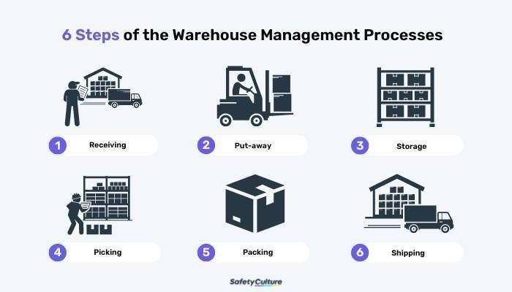

The India 3PL market size is estimated at USD 37.31 billion in 2023, and is expected to reach USD

53.03 billion by 2028, growing at a CAGR of 7.28% during the forecast period (2023-2028).

The market is expected to be driven by the growth in manufacturing, FMCG, retail and e-commerce sectors. The Indian companies are demanding new logistics capabilities and complex solutions from the 3PL service providers to help them in the successful management of supply chain processes, bring down conventional logistics costs and handle more complicated tasks.



**CHAPTER-2**

**PROFILE OF AAJ ENTERPRISES**

#### TRANSPORTERS AND PUBLISHERS/CLIENTS

AAJ Enterprises is India’s leading 3PL and Warehousing organisation, with more than 500 employees, decade of experience, deep understanding of multiple industries & business functions.

##### Transporters Selection

Each and every transporter have already given the specific terms In the agreement as docket charge and Volumetric weight charge for different hubs in different regions and the minimum charge for the shipment.

All the factors are been compared through WMS (Warehouse Management System) and the best transporter is selected for the process for every individual shipment.

After selecting the appropriate transportation the shipment is been traced till it gets delivered to the client.

Whole process has to completed within the given time i.e., TAT (Turn-Around Time) AAJ itself do the transportation for some particular places but on a very low scale.

##### TRANSPORTERS WITH AAJ ENTERPRISES PVT. LTD.

There are 8 main transporters working with the company:

1. Bluedart
2. FedEx
3. Gati
4. Safe Express
5. Shri Maruthi
6. Speed Post
7. Spot-on
8. TCI Express

Basically, The company has many others transporters also that do the delivery for the company but on the very low scale.

* + Delhivery



* + DTDC
  + Amazon etc.

##### PUBLISHERS WITH AAJ ENTERPRISES

The main publishers are:

1. HarperCollins Publishers India Ltd.
2. Hachette Publication
3. Golden Times
4. Next Education
5. RELX

#### TAT (Turn Around Time) of Publishers

1. Hachette Book Publishing India Pvt. Ltd.
2. Harper Collins Publishers India Ltd.

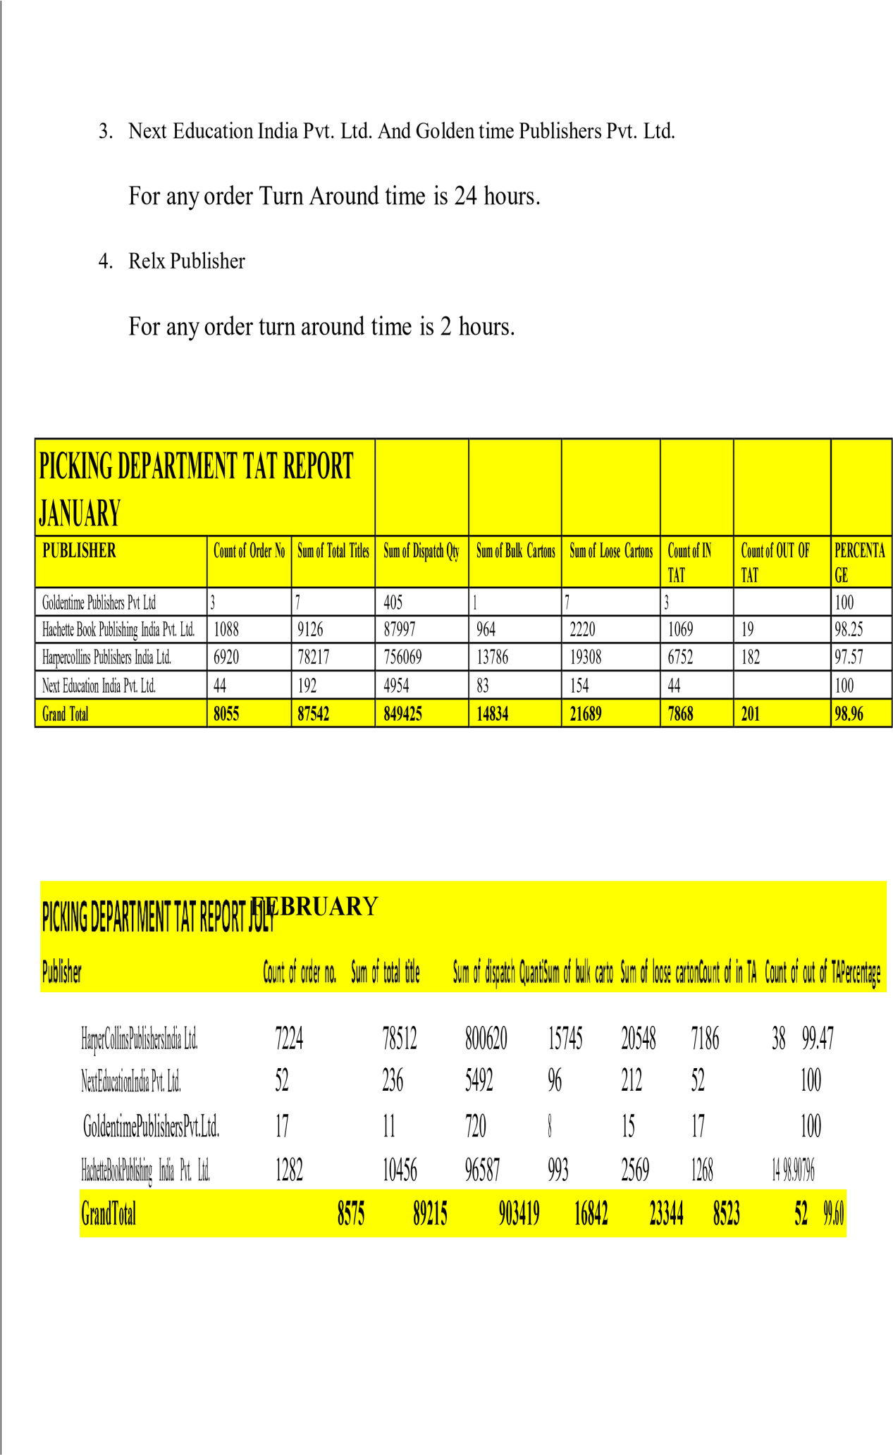

#### INDUSTRIES AAJ SERVE

These are the Industries AAJ serve:

* + Apparels
  + Health care
  + E-Commerce
  + FMCG
  + Energy
  + Publishing
* Automobiles
* **SERVICES PROVIDED BY AAJ ENTERPRISES**
  + **Transportation Management**
  + Operations Management
  + **E-Commerce Operations**
  + Returns Management
  + **Technology Management**
  + Consultancy and Advisory Services
  + **Value Added Services**
    - Online Portal Sale Management
    - Kitting/ Insertions
    - Digital as well as Offset printing
    - Customer Services
    - Credit Control

# CHAPTER-3 LITERATURE REVIEW

Warehouses play a crucial role in facilitating efficient product management, thereby enhancing productivity and minimizing costs for businesses. They serve as essential hubs for organizing and controlling various products, ensuring timely fulfillment of customer orders. Additionally, the warehousing process contributes to creating time utility by bridging the temporal gap between production and consumption periods.

In addition to serving as storage facilities, warehouses also facilitate activities such as packaging and grading of products, further adding value to the supply chain. Moreover, warehouses help mitigate price fluctuations in the market by strategically holding excess supply during periods of oversupply and releasing it when demand surpasses regular supply levels.

The effective design of warehousing and distribution networks is crucial for third-party logistics (3PL) companies to meet the evolving demands of their clients and remain competitive in the dynamic global market. This literature review aims to explore key concepts, methodologies, and best practices in warehousing and distribution network design from a 3PL company perspective.

* Warehousing Operations and Optimization:
  + The efficient operation of warehouses is essential for 3PL firms to meet customer requirements while minimizing costs and maximizing service levels (Dias & Canelas, 2021).
  + Various strategies such as slotting optimization, layout design, and automation have been proposed to enhance warehouse efficiency and throughput (Rouhani & Bostani, 2020).
  + Advanced technologies like Warehouse Management Systems (WMS), robotics, and Internet of Things (IoT) play a crucial role in modern warehouse optimization (Cheng et al., 2020).
* Distribution Network Design:
  + The design of distribution networks involves determining the optimal number, location, and size of warehouses and distribution centers to minimize transportation costs and lead times (Simchi-Levi et al., 2019).
  + Mathematical modeling techniques such as network optimization, facility location, and inventory management are commonly used to design distribution networks (Huang et al., 2019).

Factors influencing distribution network design include customer demand patterns, product characteristics, transportation costs, service level requirements, and regulatory constraints (Cagliano et al., 2011).

* Collaborative Logistics and Supply Chain Integration:
  + Collaboration among supply chain partners, including 3PL providers, is essential for achieving synergies and optimizing distribution networks (Tan et al., 2020).
  + Integration of information systems and data sharing among stakeholders enable real- time visibility and coordination across the supply chain, leading to improved responsiveness and efficiency (Liu et al., 2020).
* Sustainability and Green Logistics:
  + With growing environmental concerns, sustainability considerations are increasingly important in warehousing and distribution network design (Chen et al., 2021).
  + Green logistics practices such as energy-efficient warehouse design, eco-friendly packaging, and alternative transportation modes contribute to reducing carbon emissions and environmental impact (Ghadimi et al., 2020).
* Customer-Centric Approaches:
  + 3PL companies are adopting customer-centric approaches in designing warehousing and distribution networks to meet the unique needs and preferences of their clients (Fernie & Sparks, 2014).

Customization, flexibility, and value-added services play a significant role in enhancing customer satisfaction and loyalty (Daugherty et al., 2018).



### CHAPTER-4 INTRODUCTION OF THE STUDY

Manpower affects everything in a business from production to client relationships. Without adequate and supportive manpower, a business will never be successful. And in Warehousing Management Organization efficiency of manpower matters the most. Basically, Cost and Efficiency are directly proportional to each other. If there is a person getting no money for his work will not do work efficiently. Everyone wants to be paid as per their work.

AAJ Enterprises Pvt. Ltd., like any Warehouse Management Organization (WMO), recognizes the paramount importance of manpower in achieving operational excellence. An adequately staffed and well-supported workforce directly impacts every facet of the organization, from efficient product handling to fostering positive client relationships. AAJ Enterprises' commitment to this principle is evident in their investment in over 950 employees and their potential through training and development initiatives. Furthermore, the company acknowledges the crucial link between cost and efficiency. By leveraging technology like their proprietary WMS and fostering a culture of fair compensation, AAJ Enterprises strives to optimize manpower utilization, ensuring cost-effectiveness and achieving its business objectives.

**The complete process is completely divided in two parts:-**

1. Warehousing
2. Logistics

### WAREHOUSING PROCESS (OPERATIONS)

**Warehousing process and working:**

This role plays a vital role in ensuring the smooth functioning of the warehousing operation by:

* + Adhering to Standard Operating Procedures (SOPs): Guaranteeing all activities align with designated protocols, fostering consistency and quality.
  + Optimizing Turnaround Time: Monitoring and minimizing the time taken to complete assigned tasks, leading to improved efficiency and responsiveness.
  + Ensuring Accuracy: Maintaining meticulous attention to detail throughout all operations and associated documentation, minimizing errors and discrepancies.
  + Workforce Management & Planning: Strategically planning daily tasks and efficiently managing the workforce, ensuring optimal resource utilization.
  + Performance Monitoring: Maintaining and analyzing efficiency reports to identify areas for improvement and optimize workflows.
  + Client Collaboration: Coordinating effectively with the customer service team to fulfill specific client requirements, fostering satisfaction and exceeding expectations.

By effectively fulfilling these responsibilities, this role contributes significantly to the success of the warehousing operation by ensuring efficiency, accuracy, and a clientcentric approach.

**Locations in Warehouse:**

* 1. Bulk Location
  2. Shelf Location
  3. Loose Location
  4. Pulp Location

##### The warehousing process consist of the factors

1. Inwards
2. Inventory
3. Outwards



**INWARD**

**Load Arrival**: Many companies in supply chain management leverage preliminary inbound planning to optimize and streamline their logistics services. This proactive approach minimizes errors and maximizes efficiency by:

* Automating Information Entry: Receipt information, including dock reservations, staging area allocation, and appointment scheduling, is automatically entered into the system within minutes, eliminating manual data entry and reducing the risk of human error.
* Enhanced Efficiency: This automation allows for faster processing, smoother execution, and better utilization of resources throughout the inbound logistics process.
* Error Reduction: Eliminating manual data entry minimizes the potential for errors in information like dock allocation, appointment scheduling, and staging areas, ensuring a smoother and more efficient operation.
* By implementing preliminary inbound planning, companies gain a significant advantage in terms of efficiency, accuracy, and overall logistics optimization.

**Bar Coded Information:** This approach utilizes barcodes to encode a combination of data points while maintaining confidentiality. Here's how it works:

* Data Concatenation: The barcode combines information like store ID, register ID, date, and a transaction number specific to that store and register.
* Hashing for Security: A hash function is then applied to this entire data string. A hash function produces a unique, fixed-length output value based on the input data. This means even minor changes to the original data will result in a completely different hash value.

Pattern: The resulting hash value is displayed in the barcode following a consistent pattern. This ensures uniformity and facilitates scanning.

**Benefits of this Design:**

* Data Obfuscation: While the barcode reveals the overall structure, the actual content (store ID, register ID, date, transaction number) remains concealed due to the hash function.
* Error Detection: Any discrepancy in the original data will be detectable upon scanning, as the generated hash won't match the one encoded in the barcode.
* Overall, this barcoding strategy offers a balance between data integrity and information security.
* **Tracking:** Incorporating truck license plate tracking for enhanced monitoring capabilities and data collection. This tracking is facilitated by Radio Frequency Identification (RFID) technology, specifically utilizing a solution known as "RFID Insider."

### Benefits of Truck License Plate Tracking:

* Improves visibility and control over fleet movements.
* Facilitates automated gate access and tracking.
* Enables real-time location tracking for improved logistics planning.
* Providesvaluable data for security and safety purposes.

RFID Technology: RFID utilizes radio waves to identify and track objects equipped with RFID tags. In this case, RFID tags would likely be attached to trucks, allowing for their automatic identification and data capture as they enter and exit designated areas.

Overall, this combination of truck license plate tracking and RFID technology empowers organizations with a sophisticated solution for improved logistics management, enhanced security, and streamlined data collection.

* **Put Away:** The put away process signifies the final stage in a product's journey within a warehouse, where it's moved from the receiving area to its designated storage location. This crucial step involves:
* Precise placement: Goods are strategically positioned within the warehouse based on pre-defined storage rules, ensuring efficient retrieval and space optimization.
* capture: Serial numbers and lot numbers are meticulously recorded during the putaway process. This data is vital for inventory management, enabling accurate tracking and traceability of individual items or specific batches.

By meticulously focusing on these aspects, the put away process plays a critical role in:

* Maintaining inventory accuracy: Recording serial and lot numbers ensures a clear understanding of which specific items are available in the warehouse.
* Facilitating efficient picking and fulfillment: Precise product placement based on a well-defined storage strategy streamlines order picking and expedites fulfillment processes.
* Enhancing traceability: Capturing and storing serial and lot number information enables tracing specific items throughout the supply chain, providing valuable insights for quality control and product recalls.

Therefore, the putaway process goes beyond simply storing goods; it lays the foundation for efficient inventory management, streamlined fulfillment operations, and enhanced traceability within the warehouse environment.

### Inward Dock Standard Operating Process.

* Dock shutter will open only and only when the vehicles arrive at dock otherwise it will remain close all the time.
* Entry from operations main gate is only approved with safety belt for Unloaders and for driver / or the person who will take the receiving as well.
* No person is allowed to enter the Warehouse premises from Inward dock or by bypassing the SOP.
* Driver or the person with the driver have to come from operations gate after frisking process and after wearing Visitor belt to Inward department with document for dock opening process.
* Gate will be close immediately once the vehicle gets unloaded and the person who will take the receiving (driver / the person with the driver) from Inward will hand over the visitor belt to the security guard first and after that he will leave the premises.
* The dock supervisor will maintain the register for doing entry at consignment level for all type of inward
* The receiving of consignment should be given by authorized person only (On Roll Staff is allowed)
* The proper receiving should be given along with full name and signature of receiver and also both security and inward stamp should be mentioned on the receiving.

The receiving of boxes or qty should be given only after physical verification and in case not able to count/verified physical stock then receiving should be given with remark- Qty and Quality subject to physical verification.

### INVENTORY

Inventory management lies at the heart of effective supply chain management. It serves two critical functions:

##### Maintaining Accurate Product Data:

A comprehensive inventory management system records and maintains detailed information about every product present in the warehouse. This data includes:

Product details (type, specifications, dimensions) Quantity on hand

Location within the warehouse (storage section, bin number) Serial numbers and lot numbers (if applicable)

Additional information relevant to specific products

##### Facilitating Optimal Replenishment:

By analyzing real-time inventory data, businesses can:

Identify products nearing depletion.

Trigger timely reorders based on pre-defined thresholds and lead times. Prevent stockouts that can disrupt production or customer fulfillment. Optimize storage space by avoiding overstocking of slow-moving items.

Benefits of Effective Inventory Management:

Improved customer satisfaction: Ensures products are readily available to meet customer demand, minimizing order delays and cancellations.

* + **Reduced costs:** Minimizes storage, handling, and carrying costs associated with excess inventory.
  + **Enhanced operational efficiency:** Streamlines order fulfillment processes and optimizes warehouse space utilization.
  + **Increased accuracy and control:** Provides real-time data for better decisionmaking and risk management.

By effectively managing inventory, businesses can achieve greater efficiency, costeffectiveness, and customer satisfaction throughout the supply chain.

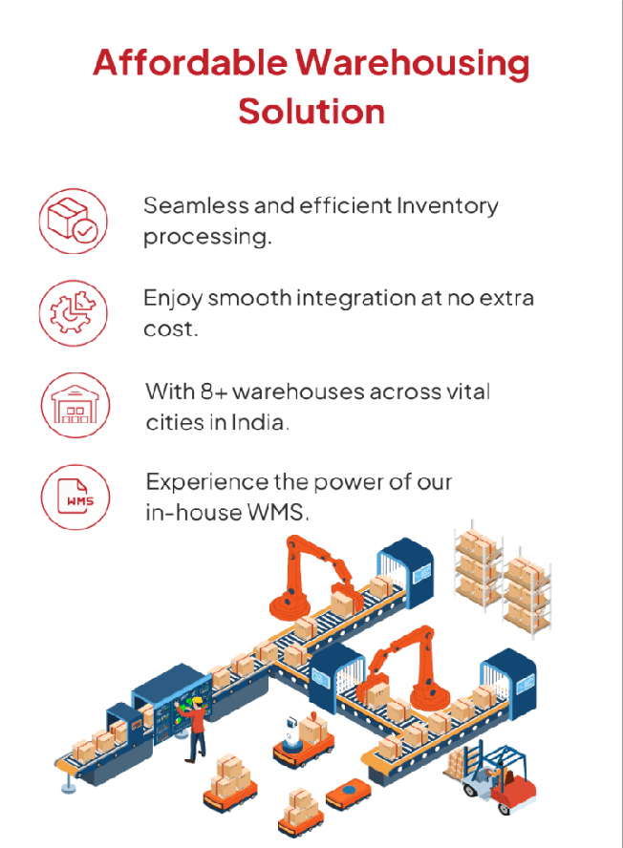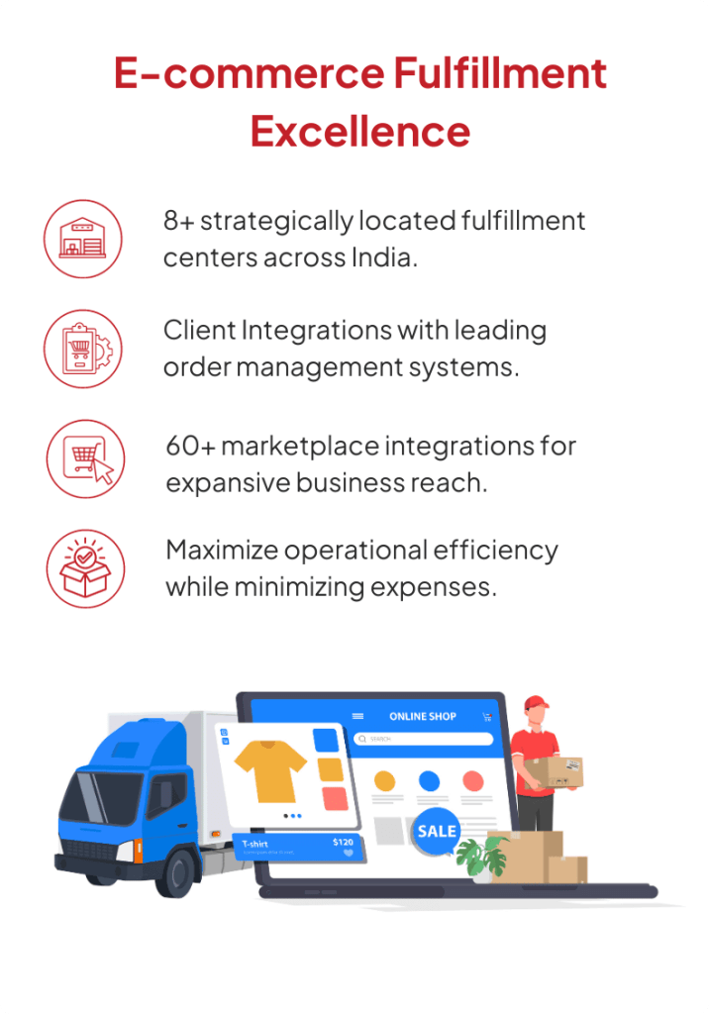

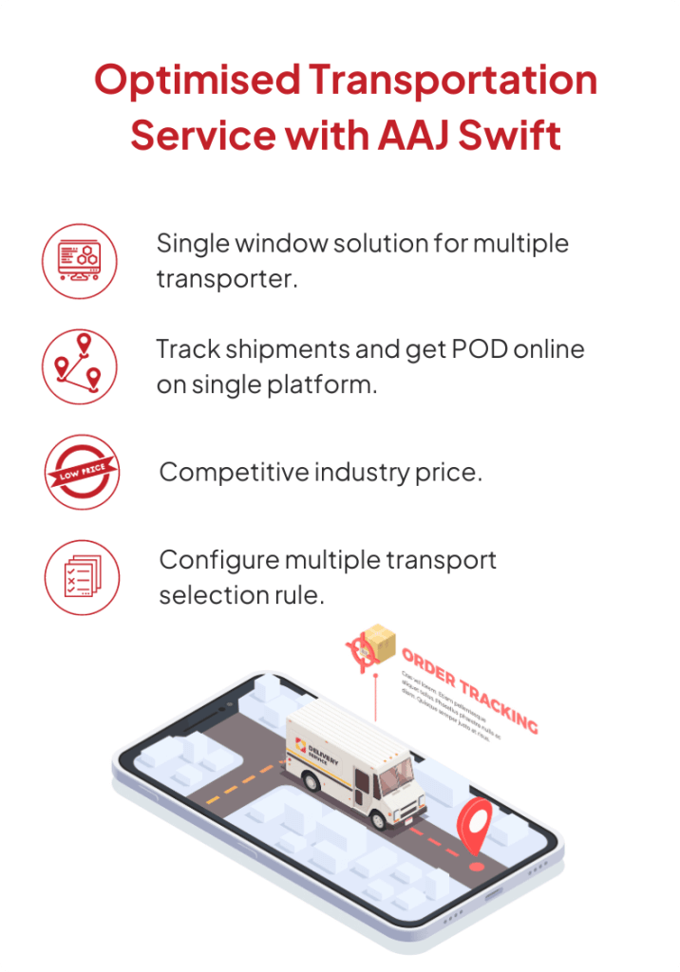

### OUTBOUND

* **Quality Check**: Checking expiry dates is a crucial step in both inbound and outbound processes within the supply chain, especially for products with shelf-life limitations. This practice ensures:
* **Maintaining product quality:** By prioritizing the outbound shipment of Enhancing items with longer expiration dates, businesses can guarantee customers receive high- quality products with sufficient remaining shelf life.
* **Minimizing waste and losses:** Expired products become unusable and incur disposal costs. Strict expiry date management helps prevent unnecessary waste and associated financial losses.
* **Customer satisfaction:** Delivering products within their designated shelf life fosters customer trust and satisfaction, reducing the risk of receiving unusable or expired items.

Therefore, quality check is an essential practice for businesses to ensure they deliver products that meet quality standards and satisfy customer expectations. This practice is implemented during the inbound process to maintain proper stock rotation and prioritize the outbound shipment of items with longer expiration dates.

* **Sales Order**: A sales order serves as more than just an indication; it's a formal confirmation between a seller and a customer that the latter has agreed to purchase specific products at a set price and under defined terms. This document typically includes details like:
  + **Product details:** Item descriptions, quantities, and pricing.
  + **Customer information:** Billing and shipping addresses, contact details.
  + **Delivery and payment terms:** Delivery window, payment method, and any applicable discounts or surcharges.

By issuing a sales order, the seller acknowledges the customer's intent to purchase and initiates the order fulfillment process. This document serves as a binding agreement thatprotects both parties and streamlines the transaction.

* **Pick and Pack**: The outbound process in a warehouse plays a crucial role in fulfilling customer orders efficiently and accurately. It involves a series of coordinated steps, including:
* Order Management:
  + Download and Release: Orders are downloaded from the sales system and released for picking.
* **Picking**: This stage involves selecting the ordered items from the warehouse. There are various picking methods used to optimize efficiency, such as:
  + **Discrete order picking:** Picking individual items for each order.
  + **Batch picking**: Picking multiple orders simultaneously for similar items or destinations.
  + **Wave picking:** Picking multiple orders in smaller batches throughout the day.
  + **Zone picking:** Assigning specific picking zones to pickers based on item location.
  + **Forward picking:** Picking items directly into shipping containers for specific destinations.
  + **Cluster picking:** Grouping similar items from various orders for efficient picking.
  + **Paper-based picking & pack:** Using paper pick lists and packing slips for manual order fulfillment.
* **Packing:**
  + **Preparation:** Picked items are gathered and assembled for shipment. This may involve packing materials, labeling, and documentation preparation.

##### Shipping:

* + **Dispatch:** Prepared shipments are handed off to the designated carrier for delivery to the customer.

By employing various picking methods and efficient packing processes, warehouses can ensure timely order fulfillment while optimizing their resources and minimizing errors.

This overall outbound process contributes significantly to customer satisfaction and overall business success.

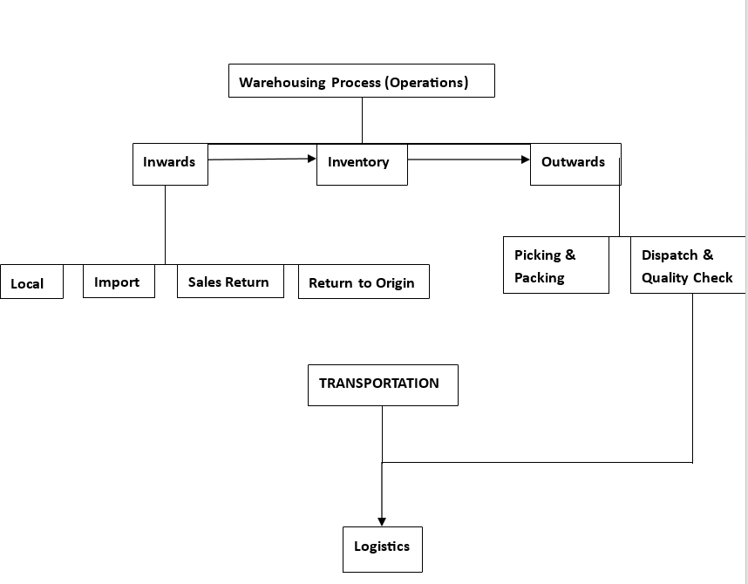

#### LOGISTICS PROCESS

**Logistics Process and working:**

* Need assessment & vendor identification, on boarding and other related activities.
* Managing the turn-around time of assigned activities.
* Coordinating with internal & external stakeholders for fulfilment of specific requirements.
* Service level improvement in various aspects.

The logistics process mainly uses hub and spoke model:-

**The hub-and-spoke model creates numerous benefits, including:**

* **Continuous movement for loads** thanks to centralized handoffs.
* **Reduced lengths-of-haul**, which improve scheduling, reduce transit time and help drivers comply with hours-of-service regulations.
* **Consistent on-time performance**, which enhances service levels and ensures products arrive in the right place at the right time.
* **Improved driver recruiting and retention**. Drivers are able to return home each night, thus experiencing an improved quality of living. This produces additional benefits, including higher tenure, route consistency, increased transit dependability and performance, and improved safety.
* **Reduced costs and enhanced productivity** thanks to Penske’s economies of scale (larger loads reduce per-unit costs) and the elimination of the need for team drivers.
* **Lower carbon footprint**, because few empty miles driven reduces wasted fuel and emissions.
* **Consistent pricing** mitigates the risk of third-party carrier price fluctuations.

Just-in-time doesn’t have to mean high costs. By partnering with Penske and leveraging our hub-and-spoke system, you can strategically use your transportation resources and steer a course toward efficiency.

LOGISTICS PROCESS

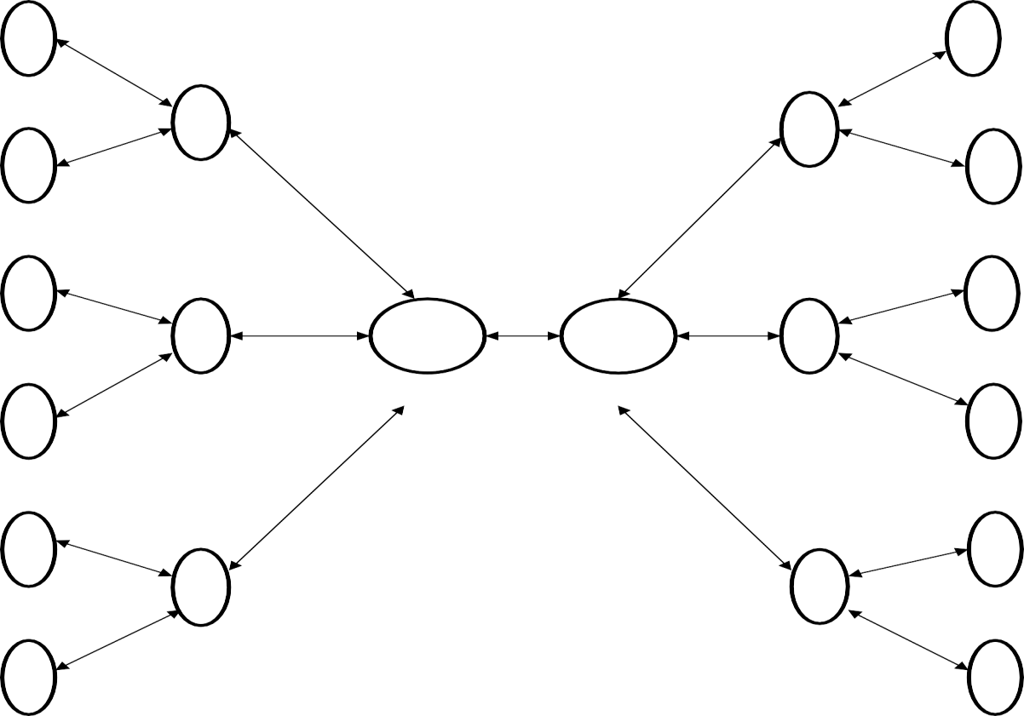

**W1**

**gnee 1**

**Hub 1/Spoke Hub 1/Spoke**

**W2**

**gnee 2**

**W3**

**gnee 3**

**Hub 2/Spoke Mother Hub Mother Hub Hub 2/Spoke**

**W4**

### CHAPTER-5

**SCOPE AND IMPORTANCE OF THE STUDY**

This project has been instrumental in providing me with valuable insights into the world of 3PL and warehousing, specifically through the lens of Aaj Enterprises' operations. It has offered me practical exposure to the company's environment, allowing me to understand the daily workings and dynamics involved. Additionally, the project has emphasized the importance of building relationships with various stakeholders, including customers, managers, clients, and transporters, a crucial skill set for any industrial setting. By delving into the complexities of warehousing and logistics processes at Aaj Enterprises, I have gained invaluable knowledge that prepares me for the demands of an industrial career.

This knowledge encompasses a comprehensive understanding of both 3PL and warehousing processes, including inbound and outbound operations, inventory management, expiry date management, and the interconnected functions of various warehousing and logistics departments. Overall, this project has served as a stepping stone to industrial readiness, equipping me with the necessary knowledge and skills to navigate the complexities of the professional world.

### EXTEND

This project delves into several key aspects of warehousing and logistics, providing valuable insights that extend beyond theoretical knowledge:

I. **Cost-Efficiency and Manpower**: The project aims to analyze the relationship between cost and manpower efficiency within warehousing operations. This will shed light on how cost factors influence workforce productivity and identify strategies for optimizing both.

**Unlocking Operational Realities:** By delving into the actual warehousing and logistics processes, the project goes beyond textbook theory to reveal the practical day-to-day operations within a functioning organization. This practical understanding is crucial for navigating the realities of the industry.

1. **Optimizing Logistics:** The scope encompasses the analysis of transportation routes and finding the perfect transporter for specific shipments. This knowledge can be utilized to streamline logistics, minimize costs, and ensure timely deliveries.
2. **Financial Management Strategies:** The project aims to explore costcutting methods, cash management, and inventory management, equipping you with valuable financial strategies applicable to diverse organizational settings.
3. **Real-World Organizational Dynamics:** Through this project, you gain firsthand knowledge about how organizations function in real-world environments. This understanding provides valuable context for navigating professional settings and building your career path.

In essence, this project bridges the gap between theoretical knowledge and practical application, providing you with a comprehensive understanding of warehousing, logistics, and organizational dynamics within the field.

### LIMITATIONS



This project strives to deliver objective and unbiased results by carefully considering potential limitations:

* 1. **Individual Variations in Responses:** Recognizing that employee expectations can differ, efforts were made to account for diverse perspectives and minimize bias in interpretation.
  2. **Resource Constraints:** While detailed record-keeping is crucial, the project acknowledges the potential cost associated with additional clerical staff. Strategies were employed to optimize data collection and analysis within available resources.
  3. **Challenges in Forecasting:** The project acknowledges the inherent difficulty in predicting future changes, particularly in technology and government policies. These uncertainties were considered during data analysis and interpretation to ensure realistic and adaptable findings.
  4. **Uncertainty in Long-Term Manpower Planning:** The project recognizes the uncertainties associated with long-term manpower planning, especially in dynamic business environments. Despite these challenges, the project aimed to provide insights valuable for informed decision-making within plausible future scenarios.

By acknowledging these limitations, this project fosters transparency and strengthens the reliability of its findings, offering valuable insights applicable to real-world scenarios.

### CHAPTER-6 IMPORTANCE OF STUDY

This research project aims to achieve the following objectives:

1. **Understanding Aaj Enterprises' Operations:**
   * **Analyze the role of 3PL and Warehouse Management:** This involves examining how Aaj Enterprises utilizes third-party logistics providers and manages its warehousing operations to deliver value to its clients.
   * **Assess Aaj Enterprises' responsibilities towards clients**: This entails evaluating the services and commitments Aaj Enterprises offers to its clients in the context of 3PL and warehousing.
   * **Evaluate the impact on Aaj Enterprises:** This involves examining how these 3PL and warehousing activities contribute to Aaj Enterprises' overall performance and success.
2. Exploring the Cost-Efficiency and Manpower Relationship:

**Investigate the connection between cost and manpower efficiency:** This core objective delves into whether and how cost factors influence the productivity and effectiveness of Aaj Enterprises' workforce within their warehousing operations.

1. Research Scope and Impact:
   * **Location of Study:** The research was conducted in the specific areas of Sonipat (Kundli 1 and Kundli 2) and Greater Noida.
   * **Potential Benefits:** The findings of this study are intended to be valuable for both organizations and employees in the following ways:
   * **Organizations:** Gain insights into optimizing manpower efficiency while managing costs related to 3PL and warehousing activities.
   * **Employees:** Understand the potential for fair compensation based on performance and contribution within the context of the costefficiency relationship.

Overall, this research project focuses on understanding the interdependencies between 3PL, warehousing management, cost, and efficiency within Aaj Enterprises. By analyzing these factors, the study aims to provide valuable insights beneficial to both organizations and employees striving for sustainable growth.

**OBJECTIVES:**

* + To understand the efficiency of Manpower at AAJ enterprises
  + To know the relationship of cost and efficiency of Manpower at AAJ Enterprises.
  + To understand how to handle Manpower in warehouse. To understand the warehousing process at AAJ Enterprises To understand the Supply Chain Management.



* + To understand the Logistics, its process and working.
  + To know the Cash management, Route Management, Contract Management, Contract Negotiations.

### HYPOTHESIS

**Ha:-**If manpower getting proper cost for their work, then their efficiency automatically increases.

Proper cost shows a positive impact on the efficiency of manpower, they took less time do the same work. Half of the manpower that are getting more cost looks more efficient than those are getting low cost.

**Ho:-** There is no relationship between cost and efficiency of manpower if they are getting more time and a specific task to do.

### NEED OF THE PROJECT

The results of the study will be of great benefit to the following:

* + **Organisation:** Given data will help the Organisation to know the basic necessities of the employees and will know the reason so that the organization can grow fast.

**Employees:** It is very necessary to any person to be sufficiently paid for his work and most importantly in this current pandemic.

# CHAPTER-7 METHODOLOGY

Objective:



* To comprehend the picking and packing procedures and attain the Turnaround Time (TAT) for daily tracker orders.
* Identify discrepancies in picking and packing methods and propose remedies.
* Identify inefficiencies in current warehouse operations and propose solutions to enhance efficiency.
* The objective is to determine appropriate sampling strategies, including purposive and random sampling techniques, to select participants and data sources that represent the diverse aspects of warehouse operations within 3PL companies.
* Hypotheses:
* Hypothesis 1: Providing cross-training to warehouse staff to handle tracker orders alongside regular orders will result in a more adaptable workforce capable of fulfilling tracker orders promptly, thus reducing processing delays.
* Hypothesis 2: Implementing worker training and skill development programs focused on refining picking and packing techniques will lead to a decrease in errors as employees gain proficiency in these tasks.
* Hypothesis 3: Conducting regular quality control checks and audits of randomly selected orders before shipment will aid in identifying and rectifying errors in both picking and packing operations, thereby reducing the likelihood of shipping incorrect items.
* Hypothesis 4: Analyzing customer feedback and return data regularly will offer insights into common picking and packing errors, enabling targeted process improvements.
* Hypothesis 5: Introducing advanced technologies such as AI and IoT in warehouse operations will result in a significant reduction in operational errors, ultimately improving overall efficiency.
* Data Collection:

To conduct this project, two types of data are required:

* Primary Data:

Qualitative research data was obtained from sources such as the strategic plan for AAJ Enterprises, feedback from associates and executives regarding efficiency, and secondary research papers.

Secondary Data:

* Quantitative research data, concerning picking and packing orders and monthly order data, was collected from sources including the Warehouse Management System (WMS), documents provided by AAJ Enterprises, and historical records related to inventory, picking, and packing.
* Research Approach:
* A mixed-method research approach combining quantitative and qualitative methods will be adopted to ensure a comprehensive analysis.
* Population Size:
* The population consists of all warehouse operations within AAJ Enterprises, including inventory management, picking and packing, communication channels, and overall workflow.
* Sample Size:
* The sample size will vary based on specific aspects of warehouse operations under investigation, utilizing random and purposive sampling techniques.
* Sample Design:
* Both random and purposive sampling techniques will be employed to ensure representativeness and include individuals with relevant expertise.
* Statistical Tools:
* Various statistical tools and techniques, including descriptive statistics, regression analysis, hypothesis testing, data visualization tools, and qualitative data analysis software, will be utilized to analyze and interpret the collected data.
* Limitations:
* Despite efforts to mitigate bias and misinterpretation, limitations such as biased employee responses, limited time, and differing perspectives between employers and employees may impact the study findings

# CHAPTER-8 RESEARCH DESIGN

Type of Research –Quantitative & Qualitative Research

Quantitative research deals with numbers and statistics, while qualitative research deals with words and meanings. Quantitative methods allow you to test a hypothesis by systematically collecting and analysing data, while qualitative methods allow you to explore ideas and experiences in depth.

For the study during the project both qualitative and quantitative approaches were used to gather and study the important factors in warehousing and logistics which need to be developed for the smooth and effective process.

For the primary study both quantitative and qualitative approaches were employed in achieving its purpose.

A qualitative research technique was used to gain insights into the prevailing roles and functions of the people handling shipment from AAJ Enterprises. It provided insights into the setting of a problem, generating ideas and/or hypotheses for later quantitative research.

Quantitative research quantifies data and generalizes results from a sample to the population of interest. It measures the frequency of various views and opinions in that chosen sample.

Scaling technique

Nominal scale is used for the measurement of variables as it is very simple and the most widely used when relationship between two variables is to be studied.



**DATA COLLECTION**

* Primary data

Primary data was collected for the calculation of relationship between cost and efficiency of manpower.

Information for the qualitative research was obtained from: Strategic plan for AAJ Enterprises

* Feedback taken by the Associates and Executives of AAJ Enterprises regarding their efficiency  Secondary research papers  Job Descriptions:
* Mr. Vinay Sabarhwal (Warehouse manager, kundli-1 warehouse) (operations) Mr. Mayank Batham (Logistics head Manager).
* Mr. Prajwal Gupta(Assistant manager- kundli-1 warehouse)
* Mr. Happy Mutreja (Team Lead,[Inward] kundli-1 warehouse) (operations)

1. Secondary Data

Secondary data was collected to understand the Cost cutting, cash management and Route management.

For my quantitative research, I used

* Diagnostic data from shipments.
* Data from WMS & WMS Med (Warehouse Management System) i.e., Fixed charge, ODA charge, Volumetric weight, Docket charge, Fuel surcharge.
* Documents provided by AAJ Enterprises.

Sampling Methodology

The sampling methodology used is Non-Probability

**Sampling Technique**: Purposive Sampling

Purposive sampling technique that often used in qualitative research, where the researcher wants to gain detailed knowledge about a specific phenomenon.

Sample Size: I had chosen 80 samples for the analysis.

* 1. **Questionnaire:**

I formed the questions in such a manner that I acquired all the information that I required. Here I used the Nominal scale for the measurement of the relationship between two variables. I took the responses of most of the associates working in the co

* 1. Sampling Design:

Selection of study area: Sonipat (Kundli 1, Kundli 2), Haryana. Selection of Sample size: 80

**LIMITATIONS OF THE STUDY**

At most attention was taken to eliminate any kind of biasness & mi- interpretation in the study to get optimum result. Even though the following limitations could have certain degree of impact on the findings.

1. The response from every individual was different as the expectation of every employee was different.
2. Data collected about satisfaction & awareness level may not represent the real picture.
3. Due to lots of work of the company we had the limited time only.
4. As logistics is really a hectic job so many respondents were not interested to give the required time.
5. The response picture is different from employer end and employee end.

**CHAPTER-9**

**DATAANALYSIS AND INTERPRETATION**

The following data have been collected during the research period taken by me through the questionnaire method on 60 associates of three warehouses of the company i.e., Sonipat (Kundli 1, Kundli 2), Greater Noida.



Frequency Table

**Table 1: Frequency and Percentage of the Associates confirmed whether there is relationship between Cost and Efficiency.**

|  |  |  |
| --- | --- | --- |
| Have relationship b/w Cost & Efficiency | Frequency | Percentage |
| Yes | 49 | 81.6 |
| No | 11 | 18.3 |
| Total | 60 | 100 |

Table 2: Frequency and Percentage of the Executives confirmed whether there is relationship between Cost and Efficiency.

|  |  |  |
| --- | --- | --- |
| Have relationship b/w Cost & Efficiency | Frequency | Percentage |
| Yes | 14 | 70 |
| No | 6 | 30 |
| Total | 20 | 100 |

**Cost and Efficiency Graph**

Fig 1: Frequency and Percentage of the Associates confirmed whether there is relationship between Cost and Efficiency.

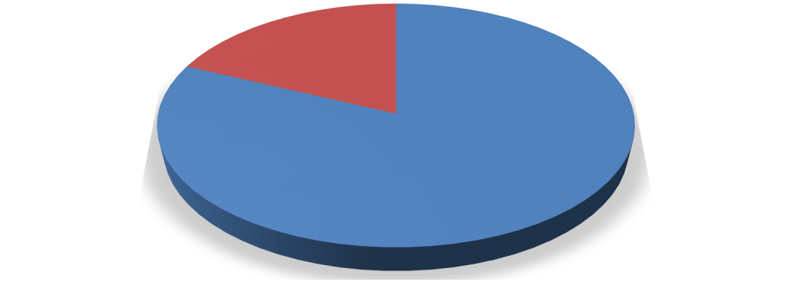

**Responses**

**No 18%**

**Yes 82%**

Yes No

**Interpretation**

The total no. of associates includes in the research is 60. Out of 60 associates, 81.6% (49) confirmed that there is relationship between cost and efficiency and 18.3% (11) said that there isn’t any relationship between cost and efficiency.

Fig 2: Frequency and Percentage of the Executives confirmed whether there is relationship between Cost and Efficiency.

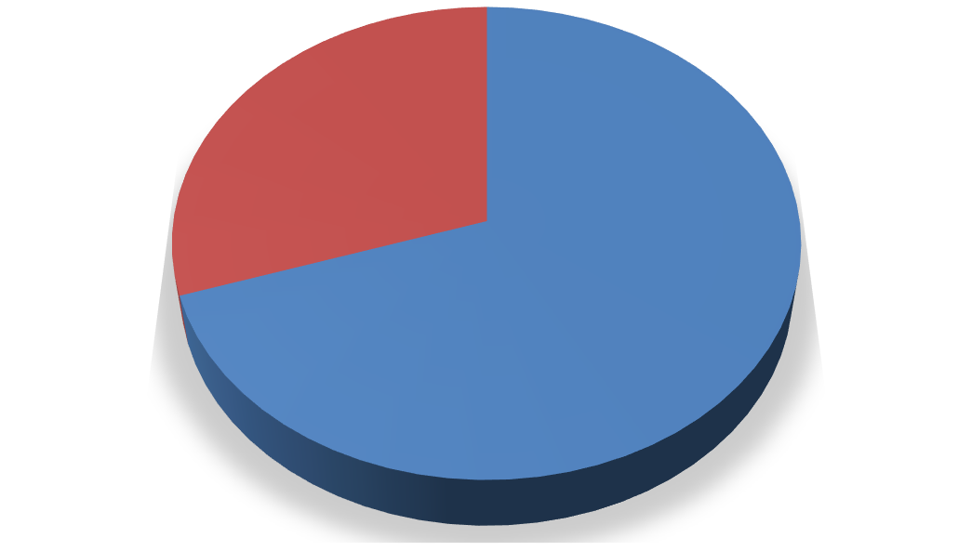

**Responses**

**No 30%**

**Yes 70%**

Yes

No

The total no. of executives includes in the research is 20. Out of 20 executives, 70% (14) confirmed that there is relationship between cost and efficiency and 30% (6) said that there isn’t any relationship between cost and efficiency.

Table 3: Frequency and Percentage of the Executives confirmed whether they need Experienced & Costly staff or Freshers & In-budget staff.



|  |  |  |
| --- | --- | --- |
| Preference | Frequency | Percentage |
| Experienced & Costly | 22 | 73.3 |
| Freshers & In-budget | 8 | 26.6 |
| Total | 30 | 100 |

**Graph**

Fig 3: Frequency and Percentage of the Executives confirmed whether they need Experienced & Costly staff or Freshers & Inbudget staff.

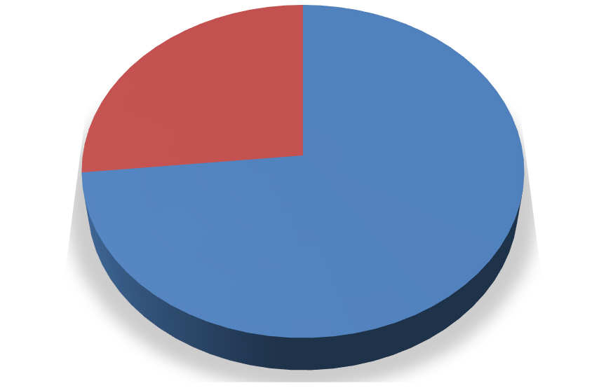

**Preferences**

**Freshers & In- budget 27%**

**Experienced & Costly 73%**

Experienced & Costly

Freshers & In-budget

**Interpretation**

The total no. of executives includes in the research is 30. Out of 30 executives, 73.3%

1. prefer experienced & costly staff as they are more efficient compared to freshers while 26.6% (8) prefer freshers & Inbudget staff for smooth working of an organization thinking that they will train them due to which cost would also be saved.

# CHAPTER-10 FINDING AND SUGGESTION

After thoroughly analyzing the operations and available data of AAJ Enterprises, the following findings and recommendations have been derived.

Location Management:

* + It is advisable to institute a robust location management system to mitigate the occurrence of erroneous picking instances by ensuring that each ISBN is associated with a distinct and clearly delineated location.
  + Regular audits and updates of location assignments are recommended to forestall any instances of duplication.

Inventory Accuracy:

* + Regular cycle counts should be conducted, and any inventory discrepancies promptly reconciled to forestall instances of excess picking and inventory discrepancies.
  + Implementation of barcode or RFID technology is recommended to enhance the accuracy of inventory tracking.

Communication Improvement:

* + Establishment of open communication channels between associates and executives is vital to promptly address any delays or issues that may arise.
  + Clear delineation of roles, responsibilities, and instructions is imperative to circumvent misunderstandings and errors

.

Standard Operating Procedures (SOPs):

* + Adherence to SOPs during packing should be strictly enforced to eradicate instances of bypass. Provision of training and incentives for compliance is advised.
  + Regular reviews and updates of SOPs are essential to ensure that they embody the most efficient and error-free processes.

5S Implementation:

* + Development of a comprehensive plan to instill 5S principles in the warehouse is recommended.

Regular audits and continuous improvement efforts are imperative to sustain the 5S framework.

Work Management Optimization:

* + Conducting workload analysis to align work distribution with the workforce's capacity is essential. Adjustment of staffing levels as necessary is advised to preempt delays.
  + Implementation of task management software can aid in prioritizing and assigning tasks efficiently.

Inventory Replenishment:

* + Development of a formal replenishment process utilizing data analytics to determine optimal reorder points and quantities is recommended.
  + Investment in automation or technology solutions to streamline and expedite the replenishment process is advisable.

Automation Integration:

* + Assessment of the warehouse's automation requirements is recommended, followed by investment in technology solutions such as conveyor systems and automated picking and packing robots to enhance efficiency.
  + Exploration of the integration of warehouse management software (WMS) and Enterprise Resource Planning (ERP) systems for real-time data synchronization is advised.

Cross-Departmental Communication:

* + Facilitation of regular meetings and collaboration between the Customer Service (CS) team and other departments is essential to address issues, share insights, and enhance coordination.
  + Implementation of a centralized communication platform can augment information flow.

Resource Allocation:

* + Resource allocation, including human resources and automation equipment, should be based on workload and demand fluctuations.
  + Regular reviews of resource optimization are recommended to ensure efficient allocation

Continuous Improvement Culture:

* Instillation of a culture of continuous improvement within the warehouse team is imperative. Encouragement of employees to identify and report issues and propose solutions is advised.
* Reward and recognition of employees for suggestions leading to increased efficiency are recommended.

Training and Development:

* Investment in ongoing training and development programs for warehouse staff to enhance their skills and knowledge is advisable.
* Cross-training of employees to perform various warehouse tasks can enhance versatility and flexibility.

Implementing these recommendations should assist in addressing the identified issues, resulting in increased efficiency, reduced errors, and enhanced customer satisfaction in your warehouse operations.

81.6% associates confirmed that in most of the cases, Cost is directly proportional to Efficiency of manpower while 18.3 % confirmed that there isn’t much relationship between these two variables.

Out of 20 Executives of AAJ, 14(70%) said that there is a relationship between cost and efficiencyas all they had experienced while 6(30%) said “No” to this theory.

The respondents who confirmed the relationship between these two variables i.e., Cost and Efficiency, said that the manpower that got sufficient money do more work but the manpower thatgot less money lose their interest in work and show less activity or low efficiency because they allneed to be paid as per their work.

Out of 30 executives, 73.3% (22) prefer experienced & costly staff as they are moreefficient compared to freshers to run the business smoothly while on the other hand26.6% (8) prefer fresher’s & In-budget staff for smooth working of an organization thinking that they will train them due to which cost would also be saved.

**CHAPTER-11 CONCLUSION AND RECOMMENDATIONS**

### CONCLUSION

I have concluded the survey for the associates and executives at AAJ Enterprises Pvt. Ltd. to checkthe relationship between the cost and efficiency of manpower.

I had chosen the cost and efficiency as it is the one of the most critical structures in warehousing and in any industry. The efficiency matters a lot in production as well as in anyof the organization.

I was very lucky to join the company and formulating like the relationship between the manpower and efficiency, working style of intern, the effect of experience in the worth and the strategies of the company and the working style of the company. I had met different kindof people from different region and different work experience and profile they all have different views and mindsets.

After the survey I came to conclusion that there is the direct relationship between cost and efficiency, as the cost increases the efficiency also increases. Company has to understand the relation between cost and efficiency and should take the decisions accordingly to maintain theefficiency of the organization as well as to control the cost.

No doubt there is a relationship between cost and efficiency in every organization.Employees feel motivated when they paid more and work more efficiently.

### RECOMMENDATIONS

LABOUR:

Company has to understand the no. of labour acquired to do any job. There should not be anyshortage as well as excess of manpower.

COSTING:

Understand the budget of the organization to control over costing, otherwise it can create ahuge problem to the company.

The turnover should be kept less so that there is no extra cost of training of employees.

ENVIRONMENT:

The environment in the company should be kept good so that people feel motivated working there.

**REFERENCES**

* Chopra, S., & Meindl, P. (2020). Supply Chain Management: Strategy, Planning, and Operation. Pearson.
* Fernie, J., & Sparks, L. (2014). Logistics and Retail Management: Emerging Issues and New Challenges in the Retail Supply Chain. Kogan Page Publishers.
* Mentzer, J. T., Stank, T. P., & Esper, T. L. (2008). Supply Chain Management and Its Relationship to Logistics, Marketing, Production, and Operations Management. Journal of Business Logistics, 29(1), 31–46
* Mollenkopf, D. A., Frankel, R., Russo, I., & Daugherty, P. J. (2010). The Supply Chain Triple-A Supply Chain. Harvard Business Review, 88(10), 102–111.
* Wisner, J. D., Tan, K. C., & Leong, G. K. (2020). Principles of Supply Chain Management: A Balanced Approach. Cengage Learning.
* https:/[/ww](http://www.aajenterprises.com/blog/)w[.aajenterprises.com/blog/](http://www.aajenterprises.com/blog/)
* <https://www.forbes.com/advisor/business/software/what-is-wms/>
* https:/[/ww](http://www.sciencedirect.com/science/article/pii/S2351978920301967V)w[.sciencedirect.com/science/article/pii/S2351978920301967V](http://www.sciencedirect.com/science/article/pii/S2351978920301967V)

### BIBLIOGRAPHY

* + [www.aajenterprises.com](http://www.aajenterprises.com/)
  + Website
  + Internet

**QUESTIONNAIRE**

Section 1: Demographic Information

What is your role within the third-party logistics (3PL) company?

* Warehouse Associate
* Warehouse Manager
* Distribution Manager
* Operations Manager
* Executive/Management
* Other (please specify)

How many years have you been working in the logistics industry?

* Less than 1 year
* 1-3 years
* 4-6 years
* 7-10 years
* More than 10 years

Section 2: Warehousing Operations

How would you rate the current efficiency of your warehousing operations?

* Excellent
* Good
* Fair
* Poor

What factors do you believe contribute most to the efficiency of your warehousingoperations? (Select all that apply)

* Warehouse layout and design
* Inventory management systems
* Staff training and performance
* Technology and automation
* Transportation and logistics integration

Section 3: Distribution Network Design

How would you describe the current effectiveness of your distribution network design? ☐

Highly effective

* Moderately effective
* Somewhat effective
* Ineffective

What challenges do you face in optimizing your distribution network design? (Select allthat apply)

* High transportation costs
* Inefficient route planning
* Limited visibility and tracking
* Inadequate infrastructure
* Customer demand fluctuations
* Other (please specify)

Section 4: Technology and Innovation

To what extent does your company utilize technology and innovation in warehousing anddistribution operations?

* Extensively
* Moderately
* Minimally
* Not at all

Which technologies or innovations have been most beneficial for improving your warehousing and distribution operations? (Select all that apply)

* Warehouse management systems (WMS)
* RFID technology
* Automated guided vehicles (AGVs)
* Robotics and automation
* Predictive analytics

Section 5: Future Outlook

In your opinion, what are the most important areas for improvement in warehousing anddistribution network design for your company?

* Cost reduction
* Efficiency improvement
* Enhanced customer service
* Adoption of new technologies
* Expansion of distribution network
* Other (please specify)

How do you envision the future of warehousing and distribution network design in the3PL industry?

* More centralized and automated facilities
* Increased focus on sustainability and green initiatives
* Greater integration of technology and data analytics
* Enhanced collaboration and partnerships within the supply chain