Impacts of Corona-virus on Global Supply Chains

# ABSTRACT

The corona virus (COVID-19) pandemic has brought unprecedented disruptions to global supply chains, impacting industries worldwide. This research report examines the multifaceted effects of the pandemic on supply chain operations, from manufacturing to logistics and consumer behavior. Drawing on a comprehensive review of existing literature and original research findings, this report identifies key challenges faced by businesses, including disruptions in manufacturing, delays in transportation, shifts in consumer demand, and regulatory changes. Case studies from various sectors illustrate the real-world impacts of COVID-19 on supply chains and highlight strategies adopted by companies to mitigate risks and enhance resilience. The implications of these findings are discussed, and recommendations are provided for businesses, policymakers, and other stakeholders to build more adaptable and resilient supply chain networks in the face of future disruptions. Through this analysis, this report contributes to a deeper understanding of the evolving dynamics of global supply chains in a post-pandemic world.

**Keywords:** COVID-19 · Logistics · Supply chain management · Pandemic impact on supply chain · Supply chain resilience · Supply chain recovery

# INTRODUCTION

The corona virus (COVID-19) pandemic has triggered an unparalleled global crisis, impacting nearly every aspect of human life and economic activity. One of the most profoundly affected domains has been the intricate network of global supply chains that underpin modern commerce. From raw material sourcing to manufacturing, distribution, and retail, the pandemic has disrupted supply chain operations at an unprecedented scale, exposing vulnerabilities and prompting organizations to reassess their strategies for resilience and adaptability. The corona virus (COVID-19) pandemic, which erupted in late 2019, swiftly morphed into a global crisis of unprecedented proportions, disrupting economies, societies, and daily life around the world. Among the many facets of human activity impacted, the intricate networks of global supply chains bore a particularly heavy brunt. As countries implemented lockdown, restricted travel, and enforced social distancing measures to contain the spread of the virus, supply chains faced disruptions at every stage, from production to distribution to consumption. It was also excellent, had an overall impact an it had various estimations.

# OBJECTIVES OF THE STUDY

1. Analyze the multifaceted impacts of the COVID-19 pandemic on global supply chain operations.
2. Examine disruptions in manufacturing, logistics, inventory management, and consumer behavior resulting from the pandemic.
3. Identify vulnerabilities inherent in global supply chains and assess how they have been exacerbated by the COVID-19 crisis.
4. Investigate the strategies and best practices adopted by businesses to mitigate the impacts of the pandemic and enhance the resilience of their supply chain networks.
5. Synthesize insights from academic studies, industry reports, and real-world case studies to provide a comprehensive understanding of the challenges and opportunities facing global supply chains in the post-pandemic era**.**

# LITERATURE REVIEW

Yossi Sheffi: Sheffi is a professor at the Massachusetts Institute of Technology (MIT) and an expert in supply chain management. He has written extensively on the disruptions caused by the pandemic, particularly in his book "The New (Ab)Normal: Reshaping Business and Supply Chain Strategy Beyond Covid-19."

Willem Smit and Omera Khan: Smit and Khan are authors of the book "Supply Chain Risk Management: A Resilience Approach." They have contributed to the discourse on how organizations can build resilience into their supply chains to mitigate the impacts of events like the coronavirus pandemic.

Richard Wilding: Wilding is a professor of supply chain strategy at Cranfield School of Management in the UK. He has written articles and provided commentary on the disruptions caused by COVID-19, offering insights into how businesses can adapt their supply chain strategies to navigate through the challenges.

Pankaj Ghemawat and Steven A. Altman: Ghemawat and Altman authored the article "How Global Supply Chains Will Change Post-COVID-19" for the Harvard Business Review. They discuss the potential shifts in global supply chain dynamics and the implications for businesses and policymakers.

Wilfried Aulbur and Thilo Henkes: Aulbur and Henkes co-authored an article titled "COVID-19: Implications for business" for McKinsey & Company. They explore the effects of the pandemic on various industries, including supply chain disruptions, and provide recommendations for organizations to adapt to the new normal.

# RESEARCH METHODOLOGY

The research methodology employed in this study combines qualitative and quantitative approaches to comprehensively analyze the impact of COVID-19 on global supply chains. This research intends to explore the studies tackled covid-19 and supplychain & logistics to identify what has been achieved in this field using systematic literature review methodology. Drawing upon a diverse range of data sources, including academic literature, case studies, and empirical evidence, this section outlines the research design, data collection methods, and analytical techniques utilized in the study.

## Research Design:

This research adopts a mixed-method approach, combining qualitative and quantitative methodologies to provide a holistic understanding of the impact of COVID-19 on global supply chains. The qualitative component involves a comprehensive review of existing literature, including academic journals, books, reports, and industry publications, to identify key themes, trends, and insights related to supply chain disruptions.

**Questionnaire**

The data collection process for the Impacts of Corona virus on Global Supply Chains involved the following steps:

* A structured questionnaire was developed to capture various aspects related to the Impacts of Corona virus on Global Supply Chains
* The survey was hosted on a reliable online survey platform and distributed to potential participants using convenience sampling methods. The survey link was shared across various online channels, including social media platforms, community groups, and Google Forms.
* The number of responses received was monitored throughout the data collection period to ensure that the target sample size of 100 respondents was reached. Recruitment and promotion strategies were adjusted as needed to encourage more participation and achieve the desired response rate.
* A predetermined data collection period was specified during which participants could respond to the survey. This helped create a sense of urgency and encouraged timely participation, ensuring that data collection was completed within the specified time frame.

# DATA ANALYSIS AND INTERPRETATION

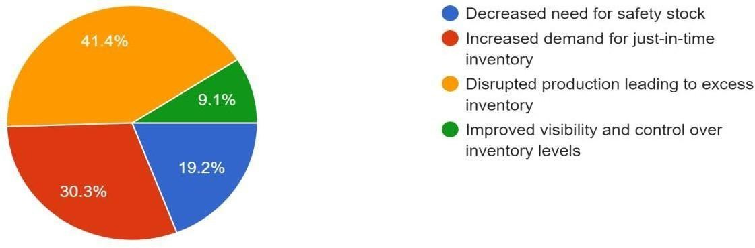

## Fig 1: Impact of COVID-19 on Inventory Management

**Interpretation-** From the above graph we can see that 19.2% responses for Decreased need for safety stock, 30.3% for Increased demand for just-in-time inventory,41.4% for Disrupted production leading to excess inventory,9.1% for Improved visibility and control over inventory levels

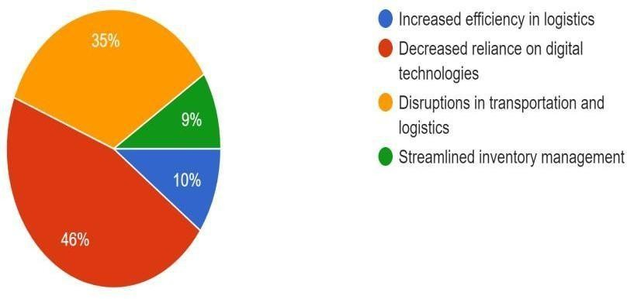

## Fig 2: Challenges to global supply chain due to COVID-19

**Interpretation-** From the above graph we can see that 10 % of responses for Increased efficiency in logistics,46% for Decreased reliance on digital technologies, 35% for Disruptions in transportation and logistics,9% for Streamlined inventory management.

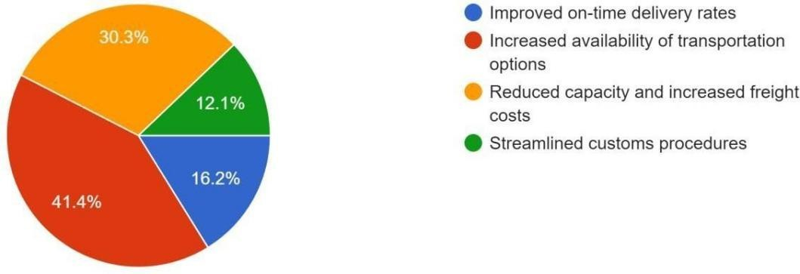

## Fig 3: Effects of COVID-19 on global supply chain transportation

**Interpretation-**From the above graph, we can see that 16.2% responses for Improved on-time delivery rates,41.4% for Increased availability of transportation options,30.3% for Reduced capacity and increased freight costs,12.1% for Streamlined customs procedures

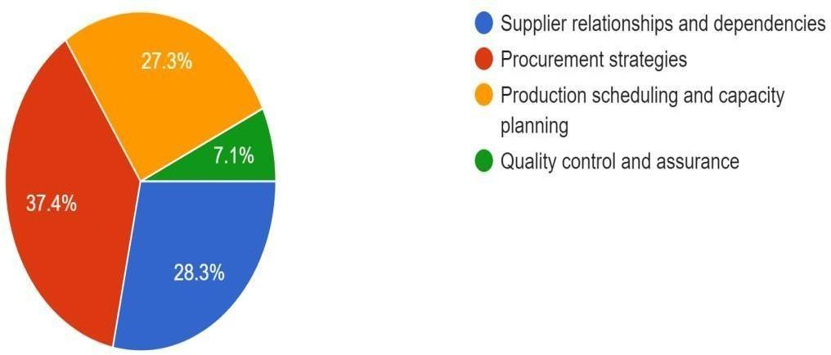

## Fig 4: Aspects of the global supply chain that has been affected by COVID-19

**Interpretation-**From the above graph, we can see that 28.3% of responses for Supplier relationships and dependencies,37.4% for Procurement strategies,27.3% for Production scheduling and capacity planning,7.1% for Quality control and assurance

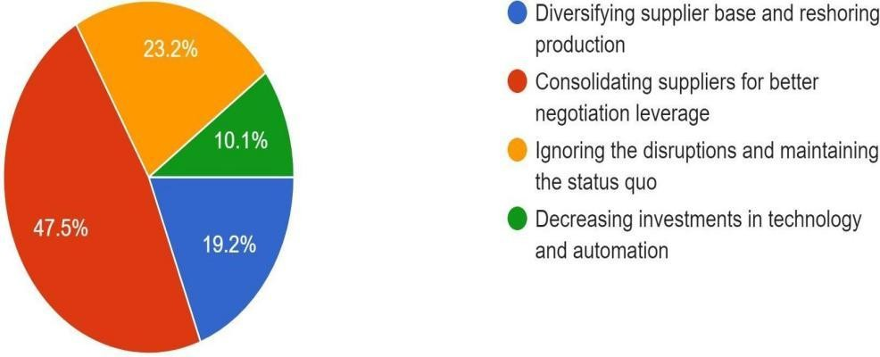

## Fig 5: Businesses responded to the disruptions caused by COVID-19 in the supply chain

**Interpretation-**From the above graph, we can see that 19.2% responses for Diversifying supplier base and reshoring production,47.5% for Consolidating suppliers for better negotiation leverage,23.2% for Ignoring the disruptions and maintaining the status quo,10.1% for Decreasing investments in technology and automation

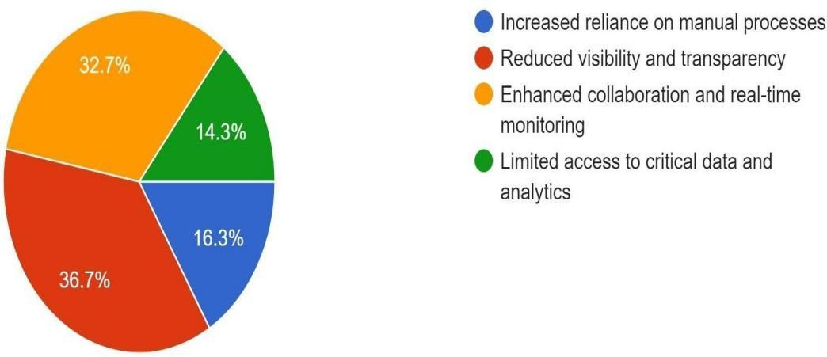

## Fig 6: Role of IT in mitigating the impact of COVID-19

**Interpretation-**From the above graph, we can see that 16.3% of responses were for Increased reliance on manual processes,36.7% for Reduced visibility and transparency,32.7%for Enhanced collaboration and real-time monitoring,14.3% for Limited access to critical data and analytics

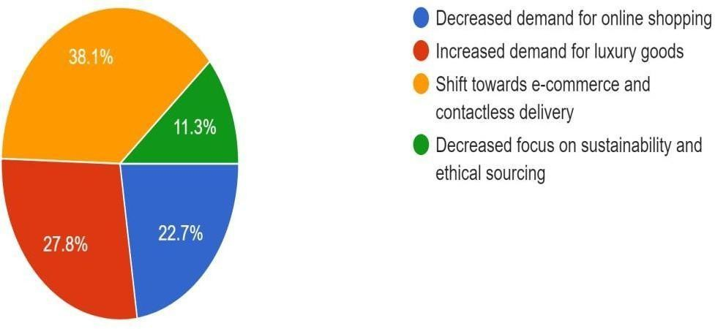

## Fig 7: Effects of COVID-19 on customer demand patterns and behaviors

**Interpretation-**From the above graph, we can see that the22.7% responses for Decreased demand for online shopping,27.8% for Increased demand for luxury goods,38.1% for Shift towards e-commerce and contactless delivery,11.3% for Decreased focus on sustainability and ethical sourcing

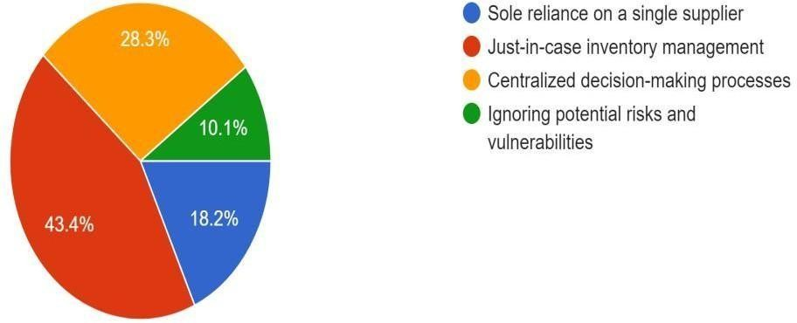

## Fig 8: Strategies that enhance resilience in the supply chain post-COVID-19

**Interpretation-**From the above graph, we can see that 18.2% of responses for Sole reliance on a single supplier,43.4% for Just-in-case inventory management,28.3% for Centralized decision-making processes,10.1% for Ignoring potential risks and vulnerabilities

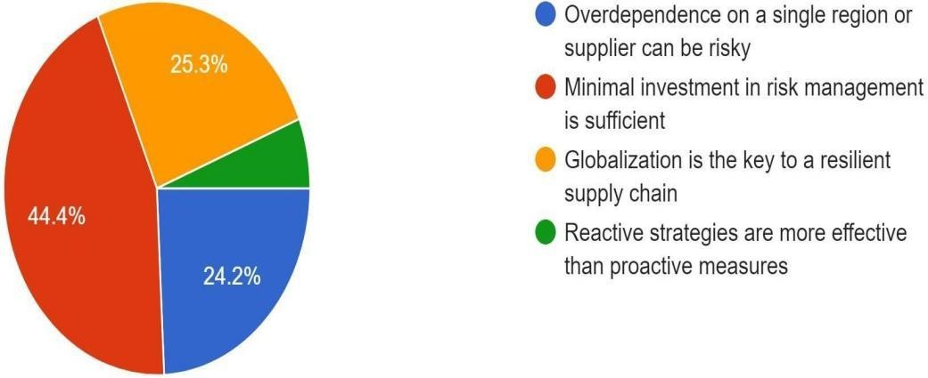

## Fig 9: Lessons from the COVID-19 pandemic regarding supply chain management

**Interpretation-**From the above graph, we can see that 24.2% for Over-dependence on a single region or supplier can be risky,44.4% for Minimal investment in risk management is sufficient,25.3% for Globalization is the key to a resilient supply chain,0% for Reactive strategies are more effective than proactive measures

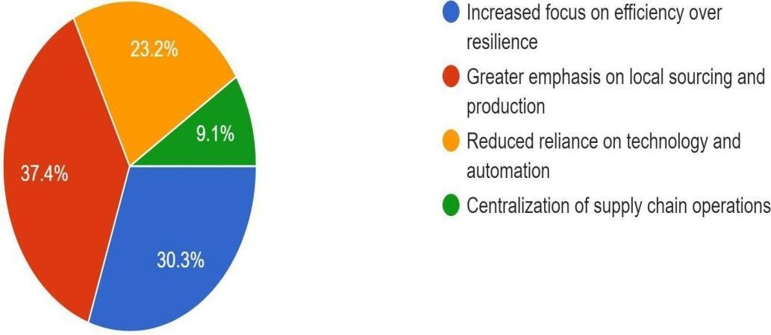

## Fig 10: Anticipation of global supply chain in evolving post-COVID-19

**Interpretation-**From the above graph, we can see that 30.3% responses for Increased focus on efficiency over resilience,37.4% for Greater emphasis on local sourcing and production,23.2% for Reduced reliance on technology and automation,9.1% for Centralization of supply chain operations.

# FINDINGS

The findings from the research on the impact of COVID-19 on global supply chains reveal several key insights into the challenges, responses, and implications of the pandemic. Below are some of the key findings:

Widespread Disruptions: The COVID-19 pandemic has caused widespread disruptions across global supply chains, affecting various industries and sectors. These disruptions have manifested in production delays, transportation bottlenecks, inventory shortages, and shifts in consumer demand.

Vulnerabilities Exposed: The pandemic has exposed vulnerabilities inherent in supply chains, including over-reliance on single-source suppliers, lack of inventory buffers, and limited visibility into supply chain networks. Businesses with inflexible supply chains and inadequate risk management strategies have been particularly susceptible to disruptions.

Resilience Strategies: Supply chain actors have implemented various resilience strategies to mitigate the impact of disruptions and ensure business continuity. These strategies include diversifying suppliers, adopting digital technologies, enhancing supply chain visibility, and strengthening collaboration with partners.

# RECOMMENDATIONS AND SUGGESTIONS

Based on the findings of the research on the impact of COVID-19 on global supply chains, the following recommendations and suggestions are offered to supply chain actors and policymakers:

Embrace Digitization: Accelerate the adoption of digital technologies and automation in supply chain management to improve efficiency, optimize operations, and enable faster decision-making in response to disruptions.

Strengthen Collaboration: Foster greater collaboration and partnerships among supply chain stakeholders, including suppliers, manufacturers, logistics providers, and retailers, to share resources, mitigate risks, and collectively address challenges.

Enhance Supply Chain Visibility: Invest in supply chain visibility platforms and digital ecosystems to enhance transparency, traceability, and accountability across supply chain networks, enabling better risk management and compliance with regulatory requirements.

# CONCLUSION

In conclusion, the COVID-19 pandemic has had a profound impact on global supply chains, exposing vulnerabilities, disrupting operations, and prompting a reassessment of supply chain strategies and practices. The pandemic has highlighted the importance of resilience, agility, and collaboration in navigating unprecedented challenges and building more robust supply chain ecosystems capable of withstanding future disruptions. It’s the very first time that a lot of countries shut down their economy and enforce their citizens to stay home and for an unknown time.

The research findings have revealed several key insights into the challenges, responses, and implications of the pandemic on global supply chains.

Widespread disruptions across industries have underscored the need for businesses to diversify suppliers, embrace digitization, and strengthen collaboration with partners to mitigate risks and ensure business continuity. Shifts in sourcing strategies, acted digital transformation, and a growing emphasis on sustainability have emerged as key trends shaping the future of supply chain management.

# REFERENCES

1. **https:://www.research gate.net**
2. **https://ieeexplore.ieee.org**
3. [**www.nature.com**](http://www.nature.com/)
4. **https://**[**www.academia.edu**](http://www.academia.edu/)
5. **https:://journals.sagepub.com**

**https:// link .springer.com**