## Master’s Thesis On

**“Warehousing and distribution network design from a third-party logistics (3PL) company perspective"**

### UNDER THE GUIDANCE OF

**Prof. Neha G Bhatia**

SUBMITTED BY

### NADEEM AHMAD

(Admission Number:-22GSOB2040021).

MBA (LSCM) 2022-2024

Galgotias University



### School of Business Galgotias University



**Certificate**

This is to certify that the Master’s Thesis **“WAREHOUSING AND DISTRIBUTION NETWORK DESIGN FROM A THIRD-PARTY LOGISTICS (3PL) COMPANY PERSPECTIVE"** has been prepared by Mr. Nadeem ahmad. under my supervision and guidance. The project report is submitted towards the partial fulfillment of 2 year, Full time Master of Business Administration.

Name:- Prof. Neha G Bhatia Signature of Faculty:-

Date:

**Declaration**

I, NADEEM AHMAD, Roll No.22GSOB2040021, student of School of Business, Galgotias University, Greater Noida, hereby declare that the Master’s Thesis on **[WAREHOUSING AND DISTRIBUTION NETWORK DESIGN FROM A THIRD-PARTY LOGISTICS (3PL) COMPANY PERSPECTIVE]** is an original and

authenticated work done by me.

I further declare that it has not been submitted elsewhere by any other person in any of the institutes for the award of any degree or diploma.

Name :- Nadeem Ahmad Signature of the Student:- Date:-

**DECLARATION BY THE STUDENT**

I hereby declare “**WAREHOUSING AND DISTRIBUTION NETWORK DESIGN FROM A THIRD-**

**PARTY LOGISTICS (3PL) COMPANY PERSPECTIVE** " that is the result of the project work carried out by me under the guidance of Mrs. Neha Bhatia in partial fulfilment for the award of MBA in Galgotias University, Greater Noida.

I also declare that this project is the outcome of my efforts and that it has not been submitted to any other university or institute for the award of any other degree Diploma or Certificate.

**Place:** Greater Noida **Name:** NADEEM AHMAD

**Date: Roll No.:**22GSOB2040021

**CERTIFICATE OF ORIGINALITY**

Date: 21-04-2023

This is to certify that the dissertation titled “WAREHOUSING AND DISTRIBUTION NETWORK DESIGN FROM A THIRD-PARTY LOGISTICS (3PL) COMPANY PERSPECTIVE” is an original work of Mr. NADEEM

AHMAD bearing Roll Number 22GSOB2040021 and is being submitted in partial fulfilment for the award of the MBA of Galgotias University, Greater Noida. The research work has not been submitted elsewhere for award of any degree. The material borrowed from other sources and incorporated in the research report has been duly acknowledged.

Name of Guide: Mr. Vinay Sabharwal Signature of Guide:-

Date:-

**ACKNOWLEDGEMENT**

Theory is the first and important step which acts as a base, but practical knowledge is that aspect which bridges the gap between imagination and realities. Research is the part of the work situations and is closely related to the career and promotion structure. No dissertation is complete without a mention of all those who contributed is very existence. However, an expression of thanks, no matter how extensive it is, never complete or adequate. This acknowledgement is no exception.

I wish to express my gratitude and sincere thanks to my guide Mr. Vinay Sabharwal, I Business Institute for her keen and guidance offered in an amicable and pleasant manner through this project work. I owe much too all faculty members of I Business Institute for their blessing and encouragement. At last, but not least, I would also like to thank all those people who spared time out of their busy schedules to provide me with relevant information and feedback.

**INDEX**

|  |  |  |
| --- | --- | --- |
| **CHAPTER NO** | **PARTICULAR** | **PAGE NO** |
| 1 | INTRODUCTION | 8-13 |
| 2 | COMPANY’S OVERVIEW | 14-22 |
| 3 | LITERAURE REVIEW | 23-25 |
| 4 | METHODOLOGY | 26-28 |
| 5 | ANALYSIS OF WAREHOUSING AND NETWORK DESIGN | 29-47 |
| 6 | DATA ANALYSIS AND INTERPETETION | 48-51 |
| 7 | FINDING AND SUGGESTION | 52-55 |
| 8 | CONCLUSION | 56-57 |
| 9 | REFERENCES | 58-59 |

# CHAPTER -1 INTRODUCTION

In today's fast-paced and dynamic business environment, the effective design and management of warehousing and distribution networks are critical for third- party logistics (3PL) companies to remain competitive and meet the evolving needs of their clients. As globalization, e-commerce expansion, and technological advancements continue to reshape the logistics landscape, 3PL providers face increasing pressure to optimize their operations, enhance efficiency, and deliver value-added services to their customers.

This introduction sets the stage for a comprehensive exploration of warehousing and distribution network design from the perspective of 3PL companies. It provides an overview of the significance of this topic in the context of modern supply chain management and highlights the key challenges and opportunities faced by 3PL firms in this domain.

The effective design of warehousing operations involves optimizing layout, storage systems, inventory management, and workflow processes to maximize efficiency and minimize costs. Furthermore, the strategic design of distribution networks entails determining the optimal location, number, and size of warehouses and distribution centers to streamline transportation, reduce lead times, and improve service levels.

To address these challenges and capitalize on opportunities, 3PL companies must leverage advanced technologies, collaborate with supply chain partners, adopt sustainable practices, and prioritize customer-centric approaches in their warehousing and distribution network design strategies.

This literature review aims to provide insights into the latest concepts, methodologies, and best practices in warehousing and distribution network design from a 3PL company perspective. By synthesizing existing research and industry knowledge, this study seeks to contribute to the body of knowledge in supply chain management and offer practical recommendations for 3PL firms striving to optimize their warehousing and distribution operations in today's competitive marketplace.

Breaking it down, warehouse operations cover a number of important areas, from the receiving, organization, fulfillment, and distribution processes. These areas include:

* Receiving of goods
* Cross-docking of goods
* Organizing and storing inventory
* Attaching asset tracking solutions (like barcodes) to assets and inventory
* Integrating and maintaining a tracking software, like a warehouse management system
* Overseeing the integration of new technology
* Selecting picking routes
* Establishing sorting and packing practices
* Maintaining the warehouse facility
* Developing racking designs and warehouse infrastructure

**Need of Project**

In today's highly competitive business environment, achieving efficiency in warehouse operations is paramount. Warehouse efficiency encompasses various facets, including forecasting demands, optimizing storage, and streamlining transportation requirements. Here's why warehouse efficiency is crucial:

* + Smooth management of warehouse processes ensures the safety of goods, swift order processing, and timely product shipments. Efficient operations facilitate the seamless flow of inventory and help minimize errors.
  + Implementing warehouse equipment, policies, and software solutions contributes significantly to enhancing efficiency in logistics and warehousing activities. Continuous improvement efforts aid in reducing errors such as stockouts and picking mistakes, thereby boosting annual revenue.
  + Regular monitoring of stock-keeping units (SKUs) enables companies to maintain better control over their inventories. Additionally, automated operations play a vital role in improving warehouse management efficiency.
  + Warehouse efficiency directly translates to improved customer service. By optimizing processes from order placement to delivery, businesses can accurately determine product availability and provide customers with realistic shipping timelines, thereby enhancing their overall experience.

**OBJECTIVE**

* To Evaluate Current Warehousing and Distribution Network Design Practices: Assess the existing strategies and methodologies employed by 3PL companies in designing warehousing and distribution networks.
* To Identify Key Challenges and Opportunities: Explore the challenges faced by 3PL companies in designing efficient warehousing and distribution networks, as well as identify opportunities for improvement and innovation.
* To Analyze Best Practices and Emerging Trends: Investigate industry best practices and emerging trends in warehousing and distribution network design, with a focus on their applicability and effectiveness in the context of 3PL operations.
* To Develop Frameworks and Methodologies: Develop frameworks or methodologies tailored specifically for 3PL companies to design and optimize their warehousing and distribution networks, considering factors such as client requirements, industry dynamics, and technological advancements.
* To Assess the Impact of Technology Adoption: Evaluate the impact of advanced technologies such as warehouse management systems (WMS), automation, and data analytics on the efficiency and effectiveness of warehousing and distribution network design in 3PL operations.
* To Investigate Customer-Centric Approaches: Explore customer-centric approaches to warehousing and distribution network design, aiming to align strategies with client needs and preferences while delivering superior value- added services.
* To Provide Practical Recommendations: Offer practical recommendations and guidelines for 3PL companies to enhance their warehousing and distribution network design capabilities, improve operational efficiency, and better meet the evolving demands of their clients.
* To Assess the Sustainability Implications: Examine the sustainability implications of warehousing and distribution network design decisions in 3PL operations, with a focus on reducing environmental impact and promoting sustainable supply chain practices**.**

**Scope and Limitations of Project**

#### Scope:

* + - Focus on 3PL Perspective: The scope of the study will primarily revolve

around the warehousing and distribution network design practices adopted by third-party logistics (3PL) companies. It will delve into the specific challenges, strategies, and best practices relevant to 3PL operations.

* + - Warehousing Operations: The study will cover various aspects of warehousing operations, including layout design, inventory management, order processing, storage systems, and material handling processes. It will explore how 3PL companies optimize these operations to meet client requirements and industry standards.
    - Distribution Network Design: The research will examine the strategic design of distribution networks, encompassing the determination of warehouse locations, network configuration, transportation routes, and mode selection. It will assess the factors influencing distribution network design decisions and their implications for 3PL firms.
    - Technological Integration: The scope will include an analysis of the role of technology, such as warehouse management systems (WMS), automation, data analytics, and emerging technologies, in enhancing efficiency and effectiveness in warehousing and distribution network design within the 3PL context.
    - Client Requirements and Industry Trends: The study will explore how 3PL companies align their warehousing and distribution network design strategies with client needs, industry trends, and market dynamics. It will investigate the customization, flexibility, and value-added services offered by 3PL providers to meet client expectations.

#### Limitations

* + Generalizability: The findings of the study may be limited to the specific context of the 3PL industry and may not be directly applicable to other sectors or types of logistics service providers.
  + Data Availability: Access to comprehensive and up-to-date data on specific warehousing and distribution network design practices within 3PL companies may be limited due to confidentiality agreements or proprietary information restrictions.
  + Geographic Focus: The study may be limited to specific geographic regions or market segments within the 3PL industry, and the findings may not fully represent the diversity of practices and challenges across different regions or market segments.
  + Time Constraints: Time constraints may limit the depth and breadth of the research, particularly in conducting extensive empirical studies or longitudinal analyses of warehousing and distribution network design practices within 3PL companies.
  + Resource Constraints: Resource limitations, including budgetary constraints and access to specialized tools or expertise, may impact the scope and execution of the research, potentially limiting the depth of analysis or the range of methodologies employed

# CHAPTER -2

**COMPANY’S OVERVIEW**

#### AAJ ENTERPRISES PVT. LTD.

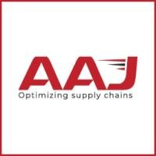

* **Vision**

What AAJ aims to become in the future Be a global supply chain service provider, taking India at the helm of supply chain in the world.

#### Mission

The Mission that AAJ aspires to fulfill in society Solving complex supply chain problems with reliable, cost effective and innovative solutions.

#### Slogan

Optimizing supply chain.

#### Values

* + Uncovering possibilities.
  + Integrity.
  + Joyful place of work.
  + Customer Delight.

#### History of company

AAJ is a supply chain service provider established and operating in India. The service portfolio includes

3PL, in plant warehouse operations management, last mile transportation and value- added supply chain

services. They are a new age and trusted supply chain working for several multinational and national

companies across industries.

Had a humble beginning in 2010 and has since then gained the trust of their customers as their only

third-party warehouse service provider with pan India presence handling over 70,000

SKU’s and more

than 25 million units in stock. They dispatched slightly over 50 million units from all our facilities

combined in year 2020.

They pioneer developing and operating large scale, shared warehouses for our customers with AAJ’s

own investment in infrastructure of racking, technology, and material handling Equipment’s, resulting

in zero capex costs for our clients. They are customized and in house WMS is our USP which allows for

information transfer through EDI to all ERP’s and has advanced warehouse management

functionalities.

Over the last 10 years they have achieved a CAGR of 26% in revenue and CAGR of 30%in warehouse

space. This has been possible with a value driven approach which delivers customer delight by

exceeding the expectations on the agreed KPI’s as well continuous innovation of warehouse processes

and technology. Today 100% their facilities use mobile barcode scanners for all operational activities.

AAJ Enterprises stands as a beacon for India's ascent in the global supply chain arena, offering a suite of cutting-edge solutions marked by reliability, cost-effectiveness, and innovation.

At the core of their operations lies a sprawling infrastructure of over 7 lakh sq. ft. of state-of-the-art warehouses, fortified by advanced technology that challenges conventional norms. Backed by a team of over 500 seasoned professionals boasting a decade of industry experience, AAJ Enterprises brings to the table a profound understanding of diverse sectors and business facets.

Their service portfolio encompasses:

1. **3PL & Warehouse Management:** AAJ Enterprises spearheads third-party logistics services, orchestrating the seamless management of warehouses and distribution hubs. Their expertise ensures streamlined storage, inventory control, order processing, and punctual delivery.
2. **Value Added Services:** Beyond conventional logistics, AAJ Enterprises offers a

spectrum of supplementary services aimed at enriching supply chain operations. These services encompass bespoke solutions such as kitting, labelling, packaging customization, and stringent quality assurance.

1. **Consulting & Advisory:** Leveraging their wealth of experience, AAJ Enterprises extends consulting and advisory services to empower businesses in refining their logistics and supply chain strategies. Their adept guidance spans process optimization, cost rationalization, and efficiency augmentation.
2. **E-commerce Fulfilment:** In the realm of online commerce, AAJ Enterprises takes charge of order fulfilment, from processing and packaging to last-mile delivery. Their seamless integration ensures a frictionless shopping journey for online patrons.
3. **Operations Management:** AAJ Enterprises assumes the mantle of optimizing overall supply chain operations, encompassing facets like inventory optimization, demand forecasting, process enhancement, and cost containment.
4. **Transportation:** Seamlessly orchestrating the movement of goods, AAJ Enterprises manages transportation logistics, route optimization, and carrier selection, guaranteeing timely and cost-efficient deliveries.
5. **Returns Management:** Recognizing the significance of streamlined returns handling, AAJ Enterprises aids businesses in establishing robust processes for returns, inspections, restocking, and eco-friendly disposal, mitigating losses.

With a steadfast commitment to delivering tailored solutions that elevate supply chain efficacy, AAJ Enterprises empowers businesses to channelize their focus on core competencies while reaping the rewards of operational efficiency and cost savings.

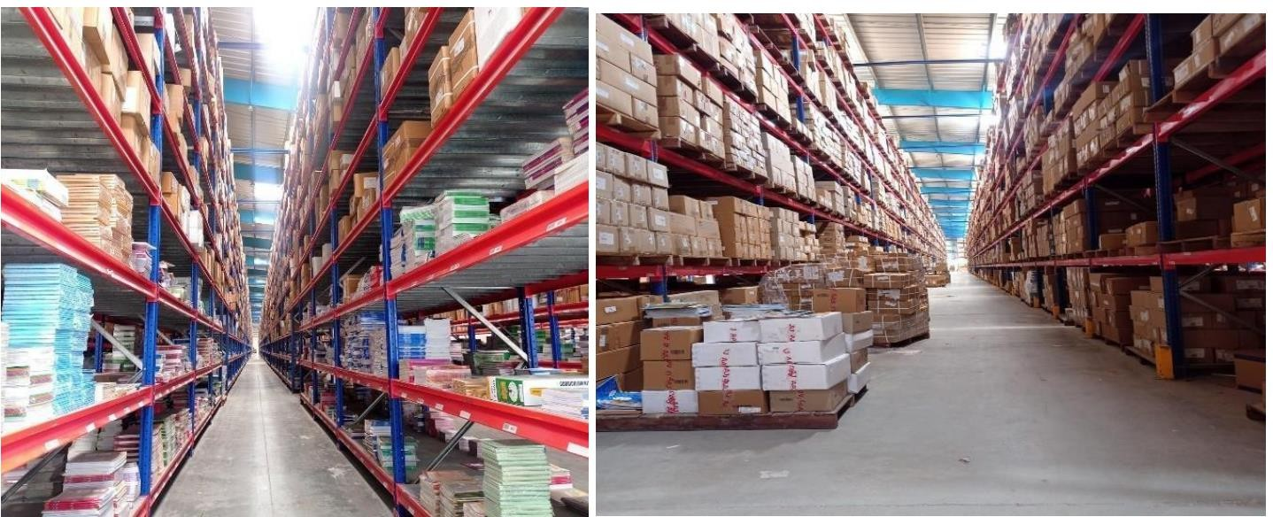

AAJ Enterprises stands out as a premier player in India's 3PL and Warehousing Management sector. With an impressive service accuracy rate of 99.9 percent, backed by a sprawling 7 lakh sq. ft. state-of-the-art warehouse infrastructure, coupled with cutting-edge technological innovations, the company sets a new standard in the industry. Founded in 2006 by Anil Kumar Jain, who currently serves as the chairman, AAJ Enterprises has become synonymous with reliability and excellence in supply chain services.

Employing over 500 skilled professionals with a wealth of experience spanning a decade, AAJ Enterprises brings unparalleled expertise in managing Warehouse Infrastructure, Operations, Technology, and Transportation ecosystems. With a deep understanding of various industries and business functions, the company offers tailored solutions aimed at driving transformation and shaping the future of businesses.

Operating across key locations including Bangalore, Kolkata, Delhi NCR, Mumbai, Ghaziabad, Greater Noida, Sonipat, Kundli 1, and Kundli 2, AAJ Enterprises has demonstrated remarkable growth over the past decade.

Achieving an impressive Compound Annual Growth Rate (CAGR) of 26% in revenue and 30% in warehouse space, the company has firmly established its position in the market.

With aspirations to represent India on the global stage, AAJ Enterprises aims to evolve into a leading global supply chain service provider in the future.

Key metrics such as a Gross Merchandise Value (GMV) of INR 8 Billion, an inventory of 70,000 SKUs, yearly dispatch of 40 million units, and a warehouse space of 7 lakh square feet underscore the company's

scale and ambition

**Different Operations in 3PL Warehouse at AAJ Enterprises.**

1. **Inward**
2. **Inventory**
3. **Picking and Packing**
4. **Dispatch**
5. **CS (Client success)**

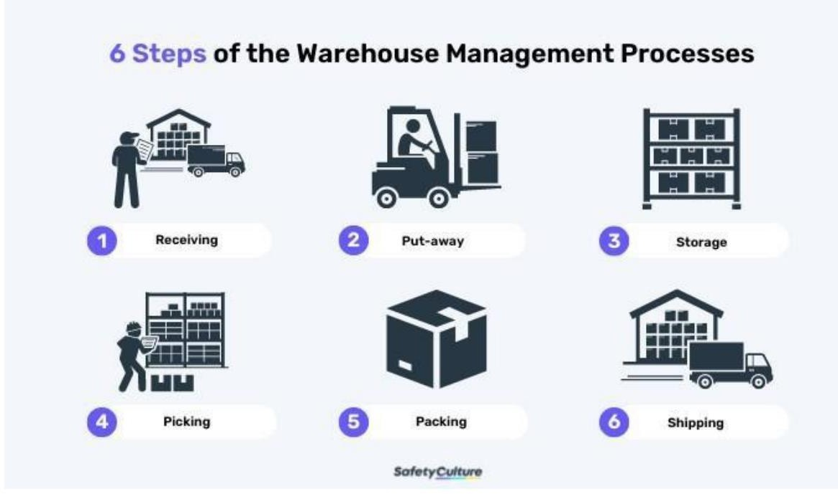

**Why we need efficiency in warehouse operations**

Efficiency in warehouse operations is indispensable for various reasons, pivotal to the overall prosperity of a business, especially within supply chain management and logistics. Here's why it matters:

**Cost Reduction**: Streamlining warehouse operations can significantly lower operational expenses. Processes optimization, inventory management enhancements, and error reduction lead to diminished labor, storage, and transportation costs.

**Enhanced Customer Service**: Swift and precise order fulfillment from efficient warehouses translates to heightened customer satisfaction. These fosters repeat

business and positive referrals, bolstering the company's reputation.

**Optimized Inventory Management:** Effective warehouse management ensures optimal inventory levels, curbing holding costs, preventing overstocking or understocking, and mitigating product obsolescence risks.

**Speedier Order Fulfillment:** Quick order processing and delivery from efficient warehouses reduce lead times, meeting customer expectations in today's fast- paced market.

**Error Reduction:** Efficient processes minimize errors like picking mistakes or inventory discrepancies, saving time, money, and enhancing customer trust.

**Scalability**: Efficient warehouses can adapt to demand fluctuations, facilitating seamless operations adjustments without significant disruptions.

**Safety:** Properly organized and maintained warehouses are safer for workers, reducing accident risks and enhancing morale.

**Sustainability:** Efficiency often aligns with sustainability efforts, reducing waste and environmental impact, which is increasingly important to customers and regulators.

**Competitive Advantage**: Businesses with efficient warehouse operations can swiftly respond to market changes, gaining an edge over competitors with slower logistics.

**Data Utilization:** Leveraging data analytics and technology, efficient warehouses gain insights for operational improvements and informed decision- making.

**Compliance**: Efficient warehouses ensure compliance with industry regulations and standards, averting legal and financial penalties.

**Supply Chain Optimization**: Efficient warehouses are vital for smooth product flow within the supply chain, reducing bottlenecks and disruptions.

In essence, warehouse efficiency directly influences a company's profitability,

customer satisfaction, and competitive stance. By optimizing warehouse processes, businesses can lower costs, elevate service quality, and establish themselves as leaders in a dynamic market landscape.

#### Third Party Logistics (3PL) Market Analysis

The global third-party logistics market reached a value of USD 1,034.43 billion in 2022 and is projected to grow at a compound annual growth rate (CAGR) of 10.7% from 2023 to 2030. Factors such as the expansion of transport logistics infrastructure in Asia and the Middle East, the rapid rise of the e-commerce industry, and advancements in technology are anticipated to drive this growth. Companies are increasingly outsourcing transport operations to improve efficiency and cost-effectiveness. The need for efficient inventory management services is also growing due to increased working capital and globalization. Furthermore, the ongoing restructuring of traditional brick-and-mortar business models continues to fuel growth in the industry.

#### Key trends in the 3PL market up to 2022 included:

**Technological Integration**: The integration of advanced technologies like Internet of Things (IoT), blockchain, and artificial intelligence (AI) to optimize supply chain processes, improve visibility, and enhance efficiency.

**E-commerce Boom:** The rapid growth of e-commerce has been a major driver for 3PL providers, as companies seek to outsource their logistics operations to experts who can handle the complexities of online retail fulfillment.

**Globalization:** As businesses expand their global footprint, they increasingly rely on 3PL providers to manage complex international logistics networks and navigate regulatory challenges.

**Focus on Sustainability**: Environmental concerns have led many companies to seek 3PL partners who can help them implement more sustainable supply chain practices, such as reducing carbon emissions and minimizing waste.

**Customization and Flexibility:** Demand for flexible, customizable logistics solutions tailored to specific industry needs and market dynamics.

In India, the 3PL market size is estimated at USD 37.31 billion in 2023, with

expectations to reach USD 53.03 billion by 2028, growing at a CAGR of 7.28% during the forecast period (2023-2028). This growth is primarily attributed to expansions in manufacturing, FMCG, retail, and e-commerce sectors. Indian companies are seeking advanced logistics capabilities and tailored solutions from 3PL service providers to optimize supply chain management, reduce traditional logistics costs, and handle increasingly complex tasks.

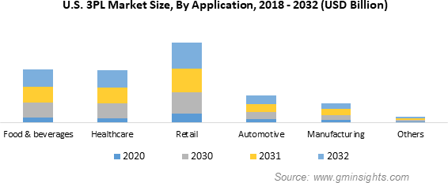

# CHAPTER -3 LITERATURE REVIEW

Warehouses play a crucial role in facilitating efficient product management, thereby enhancing productivity and minimizing costs for businesses. They serve as essential hubs for organizing and controlling various products, ensuring timely fulfillment of customer orders. Additionally, the warehousing process contributes to creating time utility by bridging the temporal gap between production and consumption periods.

In addition to serving as storage facilities, warehouses also facilitate activities such as packaging and grading of products, further adding value to the supply chain. Moreover, warehouses help mitigate price fluctuations in the market by strategically holding excess supply during periods of oversupply and releasing it when demand surpasses

regular supply levels.

The effective design of warehousing and distribution networks is crucial for third-party logistics (3PL) companies to meet the evolving demands of their clients and remain competitive in the dynamic global market. This literature review aims to explore key concepts, methodologies, and best practices in warehousing and distribution network design from a 3PL company perspective.

* Warehousing Operations and Optimization:
  + The efficient operation of warehouses is essential for 3PL firms to meet customer requirements while minimizing costs and maximizing service levels (Dias & Canelas, 2021).
  + Various strategies such as slotting optimization, layout design, and automation have been proposed to enhance warehouse efficiency and throughput (Rouhani & Bostani, 2020).
  + Advanced technologies like Warehouse Management Systems (WMS), robotics, and Internet of Things (IoT) play a crucial role in modern warehouse optimization (Cheng et al., 2020).
* Distribution Network Design:
  + The design of distribution networks involves determining the optimal number, location, and size of warehouses and distribution centers to minimize transportation costs and lead times (Simchi-Levi et al., 2019).
  + Mathematical modeling techniques such as network optimization, facility location, and inventory management are commonly used to design distribution networks (Huang et al., 2019).
  + Factors influencing distribution network design include customer demand patterns,

product characteristics, transportation costs, service level requirements, and regulatory constraints (Cagliano et al., 2011).

* Collaborative Logistics and Supply Chain Integration:
  + Collaboration among supply chain partners, including 3PL providers, is essential for achieving synergies and optimizing distribution networks (Tan et al., 2020).
  + Integration of information systems and data sharing among stakeholders enable real-time visibility and coordination across the supply chain, leading to improved responsiveness and efficiency (Liu et al., 2020).
* Sustainability and Green Logistics:
  + With growing environmental concerns, sustainability considerations are increasingly important in warehousing and distribution network design (Chen et al., 2021).
  + Green logistics practices such as energy-efficient warehouse design, eco-friendly packaging, and alternative transportation modes contribute to reducing carbon emissions and environmental impact (Ghadimi et al., 2020).
* Customer-Centric Approaches:
  + 3PL companies are adopting customer-centric approaches in designing warehousing and distribution networks to meet the unique needs and preferences of their clients (Fernie & Sparks, 2014).
  + Customization, flexibility, and value-added services play a significant role in enhancing customer satisfaction and loyalty (Daugherty et al., 2018).

# CHAPTER -4 METHODOLOGY

#### Objective:

* + To comprehend the picking and packing procedures and attain the Turnaround Time (TAT) for daily tracker orders.
  + Identify discrepancies in picking and packing methods and propose remedies.
  + Identify inefficiencies in current warehouse operations and propose solutions to enhance efficiency.
  + The objective is to determine appropriate sampling strategies, including purposive and random sampling techniques, to select participants and data sources that represent the diverse aspects of warehouse operations within 3PL companies.
* Hypotheses:
  + Hypothesis 1: Providing cross-training to warehouse staff to handle tracker orders alongside regular orders will result in a more adaptable workforce capable of fulfilling tracker orders promptly, thus reducing processing delays.
  + Hypothesis 2: Implementing worker training and skill development programs focused on refining picking and packing techniques will lead to a decrease in errors as employees gain proficiency in these tasks.
  + Hypothesis 3: Conducting regular quality control checks and audits of randomly selected orders before shipment will aid in identifying and rectifying errors in both picking and packing operations, thereby reducing the likelihood of shipping incorrect items.
  + Hypothesis 4: Analyzing customer feedback and return data regularly will offer insights into common picking and packing errors, enabling targeted process improvements.
  + Hypothesis 5: Introducing advanced technologies such as AI and IoT in warehouse operations will result in a significant reduction in operational errors, ultimately improving overall efficiency.
* Data Collection:

To conduct this project, two types of data are required:

* Primary Data:
  + Qualitative research data was obtained from sources such as the strategic plan for AAJ Enterprises, feedback from associates and executives regarding efficiency, and secondary research papers.
* Secondary Data:
  + Quantitative research data, concerning picking and packing orders and monthly order data, was collected from sources including the Warehouse Management System (WMS), documents provided by AAJ Enterprises, and historical records related to inventory, picking, and packing.
* Research Approach:
  + A mixed-method research approach combining quantitative and qualitative methods will be adopted to ensure a comprehensive analysis.
* Population Size:
  + The population consists of all warehouse operations within AAJ Enterprises, including inventory management, picking and packing, communication channels, and overall workflow.
* Sample Size:
  + The sample size will vary based on specific aspects of warehouse operations under investigation, utilizing random and purposive sampling techniques.
* Sample Design:
  + Both random and purposive sampling techniques will be employed to ensure representativeness and include individuals with relevant expertise.
* Statistical Tools:
  + Various statistical tools and techniques, including descriptive statistics, regression analysis, hypothesis testing, data visualization tools, and qualitative data analysis software, will be utilized to analyze and interpret the collected data.
* Limitations:
  + Despite efforts to mitigate bias and misinterpretation, limitations such as biased employee responses, limited time, and differing perspectives between employers and employees may impact the study findings

# CHAPTER -5

**ANALYSIS OF WAREHOUSING AND NETWORK DESIGN**

Warehousing and distribution play a critical role in the supply chain management ecosystem, ensuring the seamless flow of goods from production to consumption. In this section, we analyze the warehousing and distribution practices at AAJ Enterprises, focusing on key aspects such as facility design, inventory management, order fulfillment, and technology utilization.

* Facility Design:

AAJ Enterprises boasts state-of-the-art warehouse facilities spanning over 7 lakh square feet, strategically located across key regions in India. The design of these facilities reflects a commitment to efficiency, scalability, and safety. Key features of the facility design include:

* + Layout Optimization: Warehouses are designed to maximize space utilization, with efficient aisle layouts and storage configurations tailored to different product categories.
  + Racking Systems: The use of advanced racking systems ensures optimal storage density and facilitates easy access to inventory, reducing picking and retrieval times.
  + Material Handling Equipment: AAJ Enterprises invests in modern material handling equipment such as forklifts, pallet jacks, and conveyors, enhancing operational efficiency and safety.
  + Safety Measures: Stringent safety protocols and infrastructure, including fire suppression systems, emergency exits, and designated storage areas for hazardous materials, prioritize the well-being of employees and protect valuable inventory.
* Inventory Management:

Effective inventory management is crucial for minimizing carrying costs, preventing stockouts, and optimizing order fulfillment. At AAJ Enterprises, inventory management practices encompass:

* + Real-time Tracking: Leveraging advanced warehouse management systems (WMS), AAJ Enterprises maintains real-time visibility into inventory levels, enabling proactive replenishment and accurate demand forecasting.
  + ABC Analysis: Products are classified based on their importance and value using ABC

analysis, allowing for prioritized allocation of resources and space based on demand variability and profitability.

* + Just-in-Time (JIT) Inventory: Where applicable, AAJ Enterprises adopts JIT inventory principles to minimize holding costs and optimize cash flow, ensuring that inventory levels are aligned with demand fluctuations.
* Order Fulfillment:

Timely and accurate order fulfillment is paramount for meeting customer expectations and driving satisfaction. AAJ Enterprises excels in order fulfillment through:

* + Streamlined Processes: Standardized order picking, packing, and shipping processes minimize lead times and errors, ensuring prompt delivery to customers.
  + Pick-to-Light Systems: Utilizing pick-to-light systems and voice picking technologies, AAJ Enterprises optimizes order picking efficiency and accuracy, reducing picking errors and enhancing productivity.
  + Cross-docking: Where feasible, AAJ Enterprises employs cross-docking strategies to expedite order processing and minimize inventory holding times, enabling faster throughput and reduced storage costs.
* Technology Utilization:

AAJ Enterprises leverages cutting-edge technology to drive efficiency, visibility, and innovation across its warehousing and distribution operations. Key technological initiatives include:

* + Warehouse Management Systems (WMS): AAJ Enterprises' proprietary WMS offers robust functionalities for inventory control, order management, labor optimization, and performance analytics, empowering informed decision-making and process optimization.
  + RFID and IoT Integration: Integration of RFID and Internet of Things (IoT) technologies enables real-time asset tracking, inventory monitoring, and predictive maintenance, enhancing operational transparency and asset utilization.
  + Artificial Intelligence (AI) and Machine Learning (ML): AI and ML algorithms analyze historical data and operational patterns to optimize inventory replenishment, route planning, and resource allocation, driving continuous improvement and cost savings
* Quality Assurance:
  + Quality Control Measures: AAJ Enterprises implements stringent quality control measures to ensure the accuracy and integrity of stored inventory. Regular inspections,

cycle counts, and audits are conducted to identify and rectify discrepancies, minimizing the risk of shipping errors and product defects.

* + Compliance Standards: The company adheres to industry-specific compliance standards and regulatory requirements governing product handling, storage, and distribution. Compliance certifications such as ISO 9001 and Good Manufacturing Practices (GMP) demonstrate AAJ Enterprises' commitment to quality and regulatory compliance.
  + Customer Feedback Integration: AAJ Enterprises actively solicits and integrates customer feedback into its quality assurance processes. Customer complaints, returns, and satisfaction surveys are analyzed to identify areas for improvement and enhance service quality.
* Sustainability Initiatives:
  + Environmental Responsibility: AAJ Enterprises prioritizes environmental sustainability by implementing eco-friendly practices and minimizing its carbon footprint. Initiatives such as energy-efficient lighting, waste recycling, and green packaging contribute to resource conservation and environmental stewardship.
  + Sustainable Supply Chain Partnerships: The company collaborates with sustainable suppliers and logistics partners to promote responsible sourcing and transportation practices. Ethical supply chain management principles guide supplier selection and procurement decisions, ensuring compliance with social and environmental standards.
  + Carbon Neutrality Commitment: AAJ Enterprises is committed to achieving carbon neutrality across its operations through carbon offsetting initiatives, renewable energy adoption, and emissions reduction strategies. Carbon footprint assessments and sustainability reports transparently communicate progress towards sustainability goals.
* Continuous Improvement:
  + Kaizen Philosophy: AAJ Enterprises embraces the Kaizen philosophy of continuous improvement, fostering a culture of innovation and excellence. Cross-functional teams participate in regular Kaizen events to identify process inefficiencies, brainstorm solutions, and implement incremental improvements.
  + Lean Six Sigma Practices: The company employs Lean Six Sigma methodologies to streamline operations, eliminate waste, and enhance productivity. Process mapping, root cause analysis, and performance metrics drive data-driven decision-making and operational excellence initiatives.
  + Employee Training and Development: AAJ Enterprises invests in employee training and development programs to cultivate a skilled workforce capable of driving continuous improvement. Training modules on lean principles, problem-solving techniques, and quality management empower employees to contribute to process optimization and innovation.
* Disaster Preparedness and Business Continuity:
  + Risk Mitigation Strategies: AAJ Enterprises develops comprehensive risk mitigation strategies to safeguard against potential disruptions such as natural disasters, supply chain disruptions, and operational emergencies. Business continuity plans outline protocols for crisis management, contingency operations, and disaster recovery.
  + Redundancy Measures: The company incorporates redundancy measures into its infrastructure and operations to enhance resilience and minimize downtime. Backup power systems, redundant data storage, and alternate transportation routes mitigate the impact of unforeseen events on warehouse operations.
  + Collaborative Partnerships: AAJ Enterprises collaborates with local authorities, emergency responders, and community stakeholders to coordinate disaster response efforts and ensure the safety and well-being of employees, customers, and communities.

### TRANSPORTERS WITH AAJ ENTERPRISES PVT. LTD.

There are 8 main transporters working with the company:

1. Bluedart
2. FedEx
3. Gati
4. Safe Express
5. Shri Maruthi
6. Speed Post
7. Spot-on
8. TCI Express

Basically, the company has many others transporters also that do the delivery for the company but on the very low scale.

* + Delhivery
  + DTDC
  + Amazon etc.

### PUBLISHERS WITH AAJ ENTERPRISES

#### The main publishers are:

1. HarperCollins Publishers India Ltd.
2. Hachette Publication
3. Golden Times
4. Next Education
5. RELX

Manpower affects everything in a business from production to client relationships. Without adequate and supportive manpower, a business will never be successful. And in Warehousing Management Organization efficiency of manpower matters the most. Basically, Cost and Efficiency are directly proportional to each other. If there is a person getting no money for his work Will not do work efficiently. Everyone wants to be paid as per their work.

AAJ Enterprises Pvt. Ltd., like any Warehouse Management Organization (WMO), recognizes the paramount importance of manpower in achieving operational excellence. An adequately staffed and well-supported workforce directly impacts every facet of the organization, from efficient product handling to fostering positive client relationships. AAJ Enterprises' commitment to this principle is evident in their investment in over 950 employees and their potential through training and development initiatives. Furthermore, the company acknowledges the crucial link between cost and efficiency. By leveraging technology like their proprietary WMS and fostering a culture of fair compensation, AAJ Enterprises strives to optimize manpower utilization, ensuring cost-effectiveness and achieving its business objectives.

The complete process is completely divided in two parts: -

1. Warehousing
2. Logistics

#### Warehousing Process (Operations)

The operations within the warehouse are crucial for ensuring its smooth functioning. Key responsibilities include:

* + Adhering to Standard Operating Procedures (SOPs): Ensuring all activities align with designated protocols to maintain consistency and quality.
  + Optimizing Turnaround Time: Monitoring and minimizing the time taken to complete tasks, leading to improved efficiency.
  + Ensuring Accuracy: Maintaining meticulous attention to detail in operations and documentation to minimize errors.
  + Workforce Management & Planning: Strategically planning daily tasks and efficiently managing the workforce for optimal resource utilization.
  + Performance Monitoring: Analyzing efficiency reports to identify areas for improvement and optimize workflows.
  + Client Collaboration: Coordinating effectively with the customer service team to meet specific client requirements and exceed expectations.

These responsibilities significantly contribute to the success of the warehousing operation by ensuring efficiency, accuracy, and client satisfaction.

#### Locations in Warehouse:

* + Bulk Location
  + Shelf Location
  + Loose Location
  + Pulp Location

The warehousing process comprises three main factors:

1. Inwards
2. Inventory
3. Outwards Inwards:
   * Load Arrival: Preliminary inbound planning is leveraged to optimize logistics services, minimizing errors and maximizing efficiency.
   * Bar Coded Information: Barcodes encode data points while maintaining confidentiality through hashing for security, enhancing efficiency and error reduction.
   * Truck License Plate Tracking: Utilizes RFID technology for improved fleet visibility, automated gate access, real-time tracking, and security purposes.
   * Put Away: The final stage where products are moved from the receiving area to designated storage locations, involving precise placement and meticulous recording of serial and lot numbers.

Inventory:

Inventory management maintains accurate product data and facilitates optimal replenishment to prevent stockouts and minimize costs.

Outbound:

* + Quality Check: Ensures product quality, minimizes waste, and enhances customer satisfaction by prioritizing items with longer expiration dates.
  + Sales Order: Serves as a formal confirmation between seller and customer, including product details, customer information, and delivery/payment terms.
  + Pick and Pack: Involves order management, picking items from the warehouse using various methods, packing, and dispatching prepared shipments to the designated carrier for delivery to the customer.

#### LOGISTICS PROCESS:

The logistics process involves several key aspects, including need assessment, vendor identification, onboarding, and coordination with internal and external stakeholders to fulfill specific requirements. Additionally, it focuses on managing turnaround times, improving service levels, reducing costs, and implementing process/product improvements.

The logistics process predominantly utilizes the hub-and-spoke model, which offers numerous advantages:

* + - Continuous Movement: Centralized handoffs enable continuous movement for loads, reducing transit time and improving scheduling.
    - Reduced Lengths-of-Haul: Shorter distances improve efficiency, comply with regulations, and enhance on-time performance.
    - Consistent Service Levels: The model enhances service levels by ensuring products arrive punctually.
    - Driver Benefits: Drivers benefit from improved quality of life, higher tenure, route consistency, and safety due to returning home each night.
    - Cost Reduction: Economies of scale and elimination of the need for team drivers lead to lower costs and enhanced productivity.
    - Environmental Impact: Fewer empty miles driven result in a lower carbon footprint and reduced fuel consumption.
    - Price Stability: Consistent pricing mitigates the risk of third-party carrier price fluctuations.

By partnering with Penske and leveraging their hub-and-spoke system, organizations can strategically utilize transportation resources and improve efficiency without

incurring high costs.

* + - * **Order Picking**
    - **What is Order Picking?**

In warehousing, order picking is basically the picking out of individual or multiple products from the inventory of a warehouse or fulfillment center in order to complete the received customer orders. Maintaining efficiency in warehousing operations is a labor-intensive and tedious job. Withthe eCommerce boom and thus, an increase in demand for [e fulfillment services](https://aajenterprises.com/fulfillment/) in India, order picking strategies become growingly important for warehousing and eCommerce companies worldwide.

* **Importance of Order Picking**
  + **Decreases Warehousing Costs and Optimizes Order Pickers’ Efforts:** The right order picking strategy can help you decrease your [warehousing and](https://aajenterprises.com/warehousing/) [distribution](https://aajenterprises.com/warehousing/) costs by providing the order pickers with the most efficient route along for the product pick-ups thereby saving time and optimizing the pickers’ efforts for each item. This helps to reduce a substantial amountof operational costs.
  + **Improves Order Accuracy:** An order picking system can result in grouping similar orders, which along with saving time, improves order accuracy as there is less scope for human error and the picking list guides the efforts to make sure that the right item is picked through the right route. This reduces returns for e- commerce fulfillment orders as well.
  + **Enhances Customer Satisfaction:** Owing to fast and accurate deliveries, customer satisfactionis enhanced as the experience of buying products improves for the customer. Late deliveries and product mismatch are one of the main reasons businesses is lost in this customer-centric industry which an efficient picking system helps to solve.

Therefore, choosing the most suitable strategy for your e-commerce fulfillment and warehousing needsis a must.

## Order Picking Strategies

* + **Single Order Picking (or Discrete Picking)** – This is the most basic order picking strategy where single orders are picked up one at a time by the order pickers for the complete order fulfilment. This is suitable when received operations/orders are simple in nature, warehouse space is smaller and involves limited SKUs, and the business is small-scale with a restricted investment towards warehouse management systems.
  + **Batch Order Picking** – This is suitable when multiple orders from similar SKUs are to be fulfilled at the same time. Similar orders from the same SKUs are batched together and pickedup which saves time, and repetitive trips and improves order picking efficiency. It is advisablefor a large volume of similar items.
  + **Cluster Order Picking** – This strategy is suitable for picking up multiple orders but unlike batch order picking, a variety of orders from different SKUs are fulfilled. They can be manualor automated, but commonly a cart is used with multiple compartments towards the picking zone and the picker is directed towards the next SKU. It is advisable for large volumes of dissimilar items.
  + **Zone Order Picking (or Pick & Pass)** – In this strategy, division of the warehouse into severalphysical zones as per similar SKUs is done and pickers are assigned to each zone who are responsible for orders from their respective zones in shifts. e fulfilment service is done by passing through several zones. It is suitable for multiple orders from the same or multiple SKUsinvolving complex orders in large warehouse spaces as it saves time, and effort, and pickers often get used to their zones.
  + **Wave Order Picking** – It is schedule-based order picking where planning is done taking into account pickers, delivery times, shipping dates, warehouse location of the products, and carrierpick-ups to determine an optimum wave of orders that can be grouped together and prioritized according to time and urgency. The scheduling windows help to maximize the pick-up and deliveries.

Standard Operating Procedure- (Picking & Packing)

PURPOSE

To establish a system for Packing by DCU

SCOPE

This procedure is applicable to publisher in which packing is done through DCU

RESPONSIBILTY ACTIVITY COMMENT

DEO

Generate Orders and make plan accordingly, after that Assign the orders to Associates through pick-verification method. Give pick slips, DCU and assignment to associate. Associate arrange packing material like Tape, cartons, PP sheet & fillers

Associate will match pick slip with assignment

SUPERVIS OR

Note down the Assignment details & brief to associate about completion time

Monitoring urgent orders, Online orders & special instruction orders

ASSOCIATE

(Picker/Packer

)

Associate will arrange pick-slips (segregate bulk and loose) and then go for picking with trolley or hand jack Associate pick the correct ISBN and its quantity by matching ISBN and price from the location mentioned on pick slip

Associate will handover bulk pick-slip to supervisor. 1) Supervisor will ensure that bulk cartons ( RTW,STR) should be cross checked .

2) All the bulk should be

Y N

Associate will pack one carton at one time. After packing one carton than he will pick another carton material from the pallet.

After picking , associate will take pick slip of any carton ID of an order. than scan carton ID barcode with DCU, he will startscanning every book of that carton id until DCU show carton ID confirmed. After scanning associate will count each and every book of that carton and then pack it as per carton size mention on pick slip. Same way complete order will be scanned until DCU show order confirmed.

E O

S

After Picking, associate will put those books on Pallet kept in packing area.

Books must be kept

If there is any discrepancy, report to inventory team. Team will resolve the issu

Y E S

N O

If there is no problem than , than order will be pack with pick-verification

In any case if there is any problem in scanning any book, Associate will inform supervisor . order will be confirmed by supervisor from System only

Supervisor will ensure that every carton (bulk/loose) of each order should be handover Through DCU Or In Register

SUPERVISIO R

After verifying all cartons of the assigned orders, handover boy will hand over the cartons to dispatch team and associate will give assignment to supervisor.

QC & QC VERIFICATION

ASSOCIATE

WEIGHT THE CARTON AFTER SCANNING AND FILL THE CARTON WEIGHT IN QC

* **WMS (Warehouse management system)**

WMS stands for Warehouse Management System, and it plays a crucial role in warehouse operations.A WMS is a software application or platform that is designed to optimize and streamline various aspects of warehouse management, with the primary goal of improving the efficiency and accuracy of warehouse operations. Here's an overview of its key roles and functions:

1. **Inventory Management**: WMS helps in tracking and managing inventory levels in real-time.It provides visibility into stock levels, locations, and movement within the warehouse. It enablesefficient stock replenishment, ensuring that products are available when needed while minimizing overstock situations.
2. **Order Fulfillment**: WMS optimizes the order picking process by determining the most efficient picking routes, reducing travel time, and minimizing errors. It enables batch picking and wave picking to handle multiple orders simultaneously, improving order throughput.
3. **Space Utilization**: WMS assists in maximizing warehouse space utilization by optimizing storage locations and ensuring that items are stored in the most appropriate areas based on factors like demand and product characteristics.
4. **Accuracy and Quality Control**: It includes features for barcode scanning and RFID technology to improve accuracy during receiving, put-away, picking, and shipping. Quality control checks can be incorporated to identify damaged or incorrect items before they reach customers.
5. **Traceability and Visibility**: WMS provides end-to-end visibility into the movement of goodswithin the warehouse, helping to track and trace products, which is critical for recall management and compliance.
6. **Labour Management**: It aids in labour management by tracking employee

performance, providing insights into productivity, and helping with workforce scheduling.

1. **Reporting and Analytics**: WMS generates reports and analytics that offer insights into warehouse performance, helping managers make informed decisions to improve efficiency.
2. **Integration with Other Systems**: WMS can integrate with other systems, such as Enterprise Resource Planning (ERP) software, transportation management systems (TMS), and e- commerce platforms, to ensure seamless data exchange and end-to-end supply chain visibility.
3. **Returns Management**: It supports the efficient processing of returned goods, helping to manage the reverse logistics process effectively.
4. **Compliance and Regulatory Requirements**: - WMS can assist in complying with industry- specific regulations, such as food safety standards or pharmaceutical requirements, by ensuring proper handling, storage, and documentation.

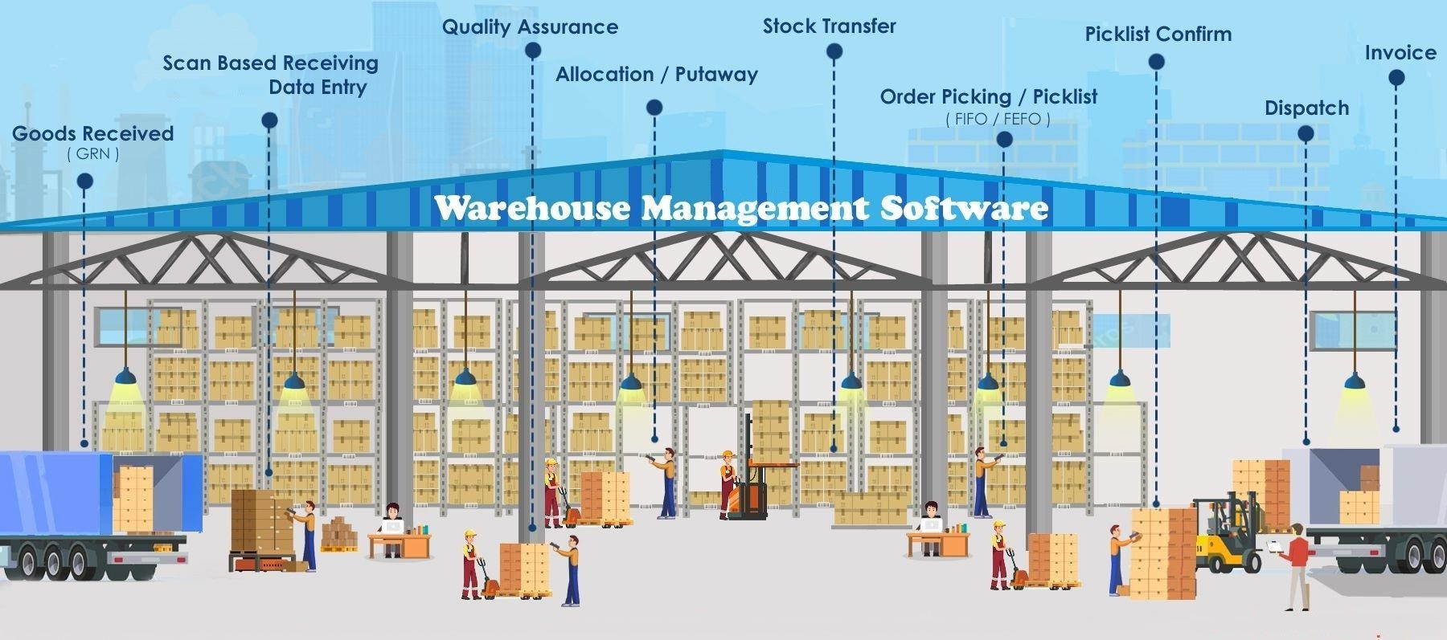

In sum a Warehouse Management System (WMS) plays a pivotal role in modern warehouse operations by optimizing inventory management, order fulfillment, space utilization, and overall efficiency. It helps warehouses run smoothly, reduces errors, and enhances customer satisfaction by ensuring that products are delivered accurately and on time.

* **Data representation and analysis**

The following data is collected during research period taken by me through WMS.

* + **Clints in the warehouse**
  1. Harper Collins Publishers India Ltd.
  2. Next Education India Pvt. Ltd.
  3. Golden time Publishers Pvt. Ltd.
  4. Hachette Book Publishing India Pvt. Ltd.
  5. Relx (Elsevier)

## TAT (Turn Around Time) of Publishers

1. Hachette Book Publishing India Pvt. Ltd.

|  |  |
| --- | --- |
| **No. of Titles** | **Turn Around Time (Hours)** |
| 1-199 | 24 |
| 200- 399 | 48 |
| 400+ | 72 |

1. Harper Collins Publishers India Ltd.

|  |  |
| --- | --- |
| **No. of Titles** | **Turn Around Time (Hours)** |
| 1-50 | 24 |
| 51-199 | 48 |
| 200+ | 72 |
| If quantity is 2500+ | 48 |

1. Next Education India Pvt. Ltd. And Golden time Publishers Pvt. Ltd.



For any order Turn Around time is 24 hours.

1. Relx Publisher

For any order turn around time is 2 hours.

|  |  |  |  |  |  |  |  |  |
| --- | --- | --- | --- | --- | --- | --- | --- | --- |
| **PICKING DEPARTMENT TAT REPORT JANUARY** | | |  |  |  |  |  |  |
| **PUBLISHER** | **Count of Order No** | **Sum of Total Titles** | **Sum of Dispatch Qty** | **Sum of Bulk Cartons** | **Sum of Loose Cartons** | **Count of IN TAT** | **Count of OUT OF TAT** | **PERCENTA GE** |
| Goldentime Publishers Pvt Ltd | 3 | 7 | 405 | 1 | 7 | 3 |  | 100 |
| Hachette Book Publishing India Pvt. Ltd. | 1088 | 9126 | 87997 | 964 | 2220 | 1069 | 19 | 98.25 |
| Harpercollins Publishers India Ltd. | 6920 | 78217 | 756069 | 13786 | 19308 | 6752 | 182 | 97.57 |
| Next Education India Pvt. Ltd. | 44 | 192 | 4954 | 83 | 154 | 44 |  | 100 |
| **Grand Total** | **8055** | **87542** | **849425** | **14834** | **21689** | **7868** | **201** | **98.96** |

**FEBRUAR**Y

|  |  |  |  |  |  |  |  |  |  |  |  |
| --- | --- | --- | --- | --- | --- | --- | --- | --- | --- | --- | --- |
| HarperCollinsPublishersIndia Ltd. | 7224 | 78512 | | 800620 | 15745 | | 20548 | | 7186 | 38 | 99.47 |
| NextEducationIndia Pvt. Ltd. | 52 | 236 | | 5492 | 96 | | 212 | | 52 |  | 100 |
| GoldentimePublishersPvt.Ltd. | 17 | 11 | | 720 | 8 | | 15 | | 17 |  | 100 |
| HachetteBookPublishing India Pvt. Ltd. | 1282 |  | 10456 | 96587 | 993 |  | 2569 |  | 1268 | 14 98.90796 | |
| **GrandTotal** |  | **8575** | **89215** | **903419** |  | **16842** |  | **23344** | **8523** | **52 99.60** | |

#### Warehouse Picking Methods

* Single order picking, also referred to as discrete order picking, involves fulfilling individual customer orders one by one. This method suits businesses with diverse, small- to-medium-sized orders.
* Batch order picking, also known as multi-order picking, entails picking multiple customer orders simultaneously to enhance efficiency and reduce travel time within the warehouse.

#### Warehouse Packing Methods

* Pick verification is crucial in confirming that items picked match those listed on customer orders, ensuring accuracy and satisfaction.
* Packing utility refers to the benefits effective packing provides in various contexts, such as product packaging and logistics.

#### Errors in Picking and Packing Processes

* + Picking inaccuracies arise from selecting items from the wrong location or performing extra picks, leading to inventory errors.
  + Communication gaps between associates and executives delay processes and cause clarity issues in instructions.
  + Packing errors occur due to bypassing standard operating procedures (SOPs), resulting in customer dissatisfaction.
  + Inadequate implementation of 5S (Sort, Set in order, Shine, Standardize, and Sustain) affects picking and packing efficiency.
  + Work management mismatches with employee scale lead to delays in operations.

#### Factors Affecting Warehouse Efficiency

* SOP bypasses in different departments disrupt operations.
* Inventory replenishment issues, caused by a lack of proper methods and machinery, delay deliveries and impact picking and dispatching efficiency.
* Inadequate implementation of 5S hampers efficiency.
* Communication gaps between customer service teams and other departments, as well as between associates and executives, hinder operations.
* Proper warehouse automation requires additional resources for effective implementation.

# CHAPTER -6

**DATA ANALYIS AND INTERPETETION**

During the research phase, data was gathered through a questionnaire administered to 60 associates across three warehouses operated by the company: Sonipat (Kundli-1, Kundli-2), and Greater Noida.

#### Frequency Table

**Table 1: Frequency and Percentage of Associates Confirming the Relationship Between Cost and Efficiency.**

|  |  |  |
| --- | --- | --- |
| **Have relationship b/w Cost & Efficiency** | **Frequency** | **Percentage** |
| **Yes** | **40** | **80** |
| **No** | **10** | **20** |
| **Total** | **50** | **100** |

**Table 2: Frequency and Percentage of Executives Confirming the Relationship Between Cost and Efficiency.**

|  |  |  |
| --- | --- | --- |
| Have relationship b/w Cost & Efficiency | Frequency | Percentage |
| Yes | 15 | 75 |
| No | 5 | 25 |
| Total | 20 | 100 |

**GRAPH**

**COST-EFFICIENCY GRAPH**

**FIG 1: Frequency and Percentage of Associates Confirming the Relationship Between Cost and Efficiency.**

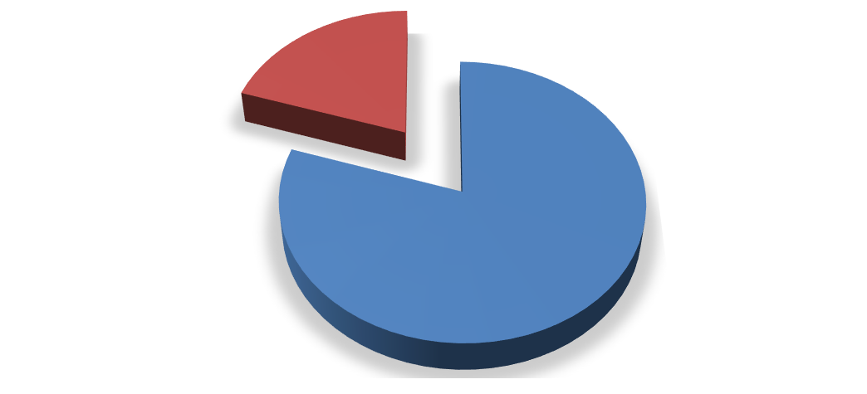

**RESPOSES**

**20%**

**80%**

YES NO

**Interpretation**

The total no. of associates includes in the research is 50. Out of 50 associates, 80% (40) confirmed that there is relationship between cost and efficiency and 20% (10) said that there isn’t any relationship between cost and efficiency.

**FIG 2: Frequency and Percentage of Executives Confirming the Relationship Between Cost and Efficiency.**



**RESPOSE**

**25%**

**75%**

YES

NO

#### Interpretation

The total no. of executives includes in the research is 20. Out of 20 executives, 75%

(15) confirmed that there is relationship between cost and efficiency and 25% (5) said that there isn’t any relationship between cost and efficiency.

# CHAPTER -7 FINDING AND SUGGESTION

After thoroughly analyzing the operations and available data of AAJ Enterprises, the following findings and recommendations have been derived.

#### Location Management:

* It is advisable to institute a robust location management system to mitigate the occurrence of erroneous picking instances by ensuring that each ISBN is associated with a distinct and clearly delineated location.
* Regular audits and updates of location assignments are recommended to forestall any instances of duplication.

#### Inventory Accuracy:

* Regular cycle counts should be conducted, and any inventory discrepancies promptly reconciled to forestall instances of excess picking and inventory discrepancies.
* Implementation of barcode or RFID technology is recommended to enhance the accuracy of inventory tracking.

#### Communication Improvement:

* Establishment of open communication channels between associates and executives is vital to promptly address any delays or issues that may arise.
* Clear delineation of roles, responsibilities, and instructions is imperative to circumvent misunderstandings and errors

.

#### Standard Operating Procedures (SOPs):

* Adherence to SOPs during packing should be strictly enforced to eradicate instances of bypass. Provision of training and incentives for compliance is advised.
* Regular reviews and updates of SOPs are essential to ensure that they embody the most efficient and error-free processes.

#### 5S Implementation:

* Development of a comprehensive plan to instill 5S principles in the warehouse is recommended.
* Regular audits and continuous improvement efforts are imperative to sustain the 5S framework.

#### Work Management Optimization:

* Conducting workload analysis to align work distribution with the workforce's capacity is essential. Adjustment of staffing levels as necessary is advised to preempt delays.
* Implementation of task management software can aid in prioritizing and assigning tasks efficiently.

#### Inventory Replenishment:

* Development of a formal replenishment process utilizing data analytics to determine optimal reorder points and quantities is recommended.
* Investment in automation or technology solutions to streamline and expedite the replenishment process is advisable.

#### Automation Integration:

* Assessment of the warehouse's automation requirements is recommended, followed by investment in technology solutions such as conveyor systems and automated picking and packing robots to enhance efficiency.
* Exploration of the integration of warehouse management software (WMS) and Enterprise Resource Planning (ERP) systems for real-time data synchronization is advised.

#### Cross-Departmental Communication:

* Facilitation of regular meetings and collaboration between the Customer Service (CS) team and other departments is essential to address issues, share insights, and enhance coordination.
* Implementation of a centralized communication platform can augment information flow.

#### Resource Allocation:

* Resource allocation, including human resources and automation equipment, should be based on workload and demand fluctuations.
* Regular reviews of resource optimization are recommended to ensure efficient allocation

.

#### Continuous Improvement Culture:

* Instillation of a culture of continuous improvement within the warehouse team is imperative. Encouragement of employees to identify and report issues and propose solutions is advised.
* Reward and recognition of employees for suggestions leading to increased efficiency are recommended.

#### Training and Development:

* Investment in ongoing training and development programs for warehouse staff to enhance their skills and knowledge is advisable.
* Cross-training of employees to perform various warehouse tasks can enhance versatility and flexibility.

Implementing these recommendations should assist in addressing the identified issues, resulting in increased efficiency, reduced errors, and enhanced customer satisfaction in your warehouse operations.

# CHAPTER -8 CONCLUSION

This thesis has delved into the intricate domain of warehousing and distribution network design from the perspective of a third-party logistics (3PL) company. Through an extensive exploration of various factors and considerations, including cost, efficiency, technology, and customer satisfaction, we have gained valuable insights into the complexities and challenges faced by 3PL providers in optimizing their warehouse and distribution operations.

The analysis of data collected from associates and executives across multiple warehouses has provided a nuanced understanding of the relationship between cost and efficiency within the 3PL context. By examining the frequency and percentage of responses confirming this relationship, we have identified key areas for improvement and optimization within the warehousing and distribution network.

Furthermore, this thesis has underscored the critical role of technology and innovation in enhancing the effectiveness of warehouse operations and streamlining the distribution network. From the integration of advanced warehouse management systems to the adoption of automation and robotics, technological advancements offer promising opportunities for 3PL companies to improve efficiency, accuracy, and overall

customer satisfaction.

As the global logistics landscape continues to evolve rapidly, driven by factors such as e-commerce growth, supply chain digitization, and changing consumer expectations, it is imperative for 3PL providers to remain agile and adaptive in their approach to warehousing and distribution network design. By embracing innovation, fostering strategic partnerships, and leveraging data-driven insights, 3PL companies can position themselves for success in an increasingly competitive market environment.

In conclusion, this thesis serves as a valuable contribution to the understanding of warehousing and distribution network design from a 3PL perspective, offering practical recommendations and insights for industry practitioners and stakeholders. As the industry continues to evolve, it is our hope that this research will inform future strategies and initiatives aimed at driving operational excellence and maximizing value for 3PL companies and their clients

# CHAPTER -9 REFERENCES

* Chopra, S., & Meindl, P. (2020). Supply Chain Management: Strategy, Planning, and Operation. Pearson.
* Fernie, J., & Sparks, L. (2014). Logistics and Retail Management: Emerging Issues and New Challenges in the Retail Supply Chain. Kogan Page Publishers.
* Mentzer, J. T., Stank, T. P., & Esper, T. L. (2008). Supply Chain Management and Its Relationship to Logistics, Marketing, Production, and Operations Management. Journal of Business Logistics, 29(1), 31–46
* Mollenkopf, D. A., Frankel, R., Russo, I., & Daugherty, P. J. (2010). The Supply Chain Triple-A Supply Chain. Harvard Business Review, 88(10), 102–111.
* Wisner, J. D., Tan, K. C., & Leong, G. K. (2020). Principles of Supply Chain Management: A Balanced Approach. Cengage Learning.
* https://[www.aajenterprises.com/blog/](http://www.aajenterprises.com/blog/)
* https://[www.forbes.com/advisor/business/software/what-is-wms/](http://www.forbes.com/advisor/business/software/what-is-wms/)
* https://[www.sciencedirect.com/science/article/pii/S2351978920301967V](http://www.sciencedirect.com/science/article/pii/S2351978920301967V)

# QUESTIONARE

#### Section 1: Demographic Information

What is your role within the third-party logistics (3PL) company?

* Warehouse Associate
* Warehouse Manager
* Distribution Manager
* Operations Manager
* Executive/Management
* Other (please specify)

How many years have you been working in the logistics industry?

* Less than 1 year
* 1-3 years
* 4-6 years
* 7-10 years
* More than 10 years

#### Section 2: Warehousing Operations

How would you rate the current efficiency of your warehousing operations?

* Excellent
* Good
* Fair
* Poor

What factors do you believe contribute most to the efficiency of your warehousing operations? (Select all that apply)

* Warehouse layout and design
* Inventory management systems
* Staff training and performance
* Technology and automation
* Transportation and logistics integration
* Other (please specify)

#### Section 3: Distribution Network Design

How would you describe the current effectiveness of your distribution network design?

* Highly effective
* Moderately effective
* Somewhat effective
* Ineffective

What challenges do you face in optimizing your distribution network design? (Select all that apply)

* High transportation costs
* Inefficient route planning
* Limited visibility and tracking
* Inadequate infrastructure
* Customer demand fluctuations
* Other (please specify)

#### Section 4: Technology and Innovation

To what extent does your company utilize technology and innovation in warehousing and distribution operations?

* Extensively
* Moderately
* Minimally
* Not at all

Which technologies or innovations have been most beneficial for improving your warehousing and distribution operations? (Select all that apply)

* Warehouse management systems (WMS)
* RFID technology
* Automated guided vehicles (AGVs)
* Robotics and automation
* Predictive analytics
* Other (please specify)

#### Section 5: Future Outlook

In your opinion, what are the most important areas for improvement in warehousing and

distribution network design for your company?

* Cost reduction
* Efficiency improvement
* Enhanced customer service
* Adoption of new technologies
* Expansion of distribution network
* Other (please specify)

How do you envision the future of warehousing and distribution network design in the 3PL industry?

* More centralized and automated facilities
* Increased focus on sustainability and green initiatives
* Greater integration of technology and data analytics
* Enhanced collaboration and partnerships within the supply chain