**Research Paper On:**

**“EXPLORING THE PRACTICES AND BENEFITS OF GREEN SUPPLY CHAIN MANAGEMENT”**

***FOR THE PARTIAL FULFILLMENT OF THE REQUIREMENT***

***FOR THE AWARD OF***

***MASTER OF BUSINESS ADMINISTRATION***

**UNDER THE GUIDANCE OF**

**Mr. Vivek Aggarwal**

**Professor**

**SOB,**

**GALGOTIAS UNIVERSITY**

**Submitted By**

**ROHIT SHARMA**

**(22GSOB2010306)**

**MBA 2022-2024**

 **School of Business**

**Galgotias University**

1. **Abstract**

Green Supply Chain Management (GSCM) has emerged as a strategic approach for organizations to integrate environmental sustainability into their supply chain practices. This study aims to explore the practices and benefits associated with GSCM and their impact on environmental sustainability and business performance. Employing a mixed-methods research approach, data will be collected through semi-structured interviews, focus group discussions, surveys, and secondary data analysis. Qualitative data analysis will involve thematic analysis of interview transcripts and focus group discussions, while quantitative analysis will utilize descriptive and inferential statistics. The study will employ purposeful sampling to select organizations representing diverse industries, sizes, and geographical locations. Ethical considerations will be ensured throughout the research process, including obtaining informed consent and maintaining confidentiality. The findings of this study are expected to provide insights into the key drivers, barriers, and outcomes of GSCM adoption, contributing to a better understanding of its role in promoting environmental sustainability & enhancing organizational performance in supply chain management.

1. **Research Objective**
2. To investigate the current practices and trends of Green Supply Chain Management (GSCM) adopted by organizations.
3. To identify the perceived benefits and challenges associated with the implementation of GSCM practices.
4. To explore the impact of GSCM on environmental sustainability metrics, such as carbon emissions reduction, waste reduction, and resource conservation.
5. To assess the influence of GSCM on business performance indicators, including cost reduction, operational efficiency, and customer satisfaction.
6. To examine the drivers and barriers influencing the adoption and implementation of GSCM practices.
7. To provide recommendations for organizations seeking to enhance their GSCM initiatives and maximize their environmental and business benefits
8. To Contribute to the existing body of knowledge on GSCM by offering insights into its practices, benefits, and implications for sustainable supply chain management.
9. To explore the motivations driving organizations to adopt green supply chain management practices, examining factors such as regulatory pressures, consumer preferences, and corporate sustainability goals
10. To evaluate the effectiveness of specific green supply chain management strategies, such as eco-design, green procurement, and reverse logistics, in achieving environmental objectives while maintaining economic viability
11. To quantify the financial and non-financial benefits of implementing green supply chain management practices, including cost savings, risk mitigation, brand reputation, and stakeholder engagement.

**3. Introduction**

In an era marked by heightened environmental consciousness and the imperative for sustainable development, businesses are compelled to reassess their operational strategies. Among these strategies, the concept of Green Supply Chain Management (GSCM) has emerged as a pivotal framework for integrating environmental concerns into supply chain practices. GSCM emphasizes the reduction of environmental impact throughout the entire supply chain lifecycle, from product design and sourcing to manufacturing, distribution, and end-of-life disposal or recycling.

This research paper aims to explore the multifaceted dimensions of Green Supply Chain Management, with a focus on its implications for sustainable business practices. By delving into the theoretical underpinnings of GSCM, examining case studies, and conducting empirical analyses, this research endeavors to provide insights into the challenges, opportunities, and best practices associated with the adoption and implementation of GSCM strategies.

**3.1. Definition of Green supply chain management**

Green Supply Chain Management (GSCM) has emerged as a strategic approach for organizations to integrate environmental sustainability principles into their supply chain operations. It encompasses a range of practices aimed at reducing environmental impact, enhancing resource efficiency, and promoting sustainable development across the entire supply chain. GSCM involves the adoption of environmentally friendly processes, technologies, and policies to minimize waste, conserve resources, and mitigate environmental risks associated with sourcing, production, transportation, and distribution activities.

**3.2 Importance of Green supply chain in operations**

1. Enhanced Efficiency and Productivity
2. Environmental Sustainability
3. Competitive Advantage
4. Data-Driven Decision-Making
5. Business Model Innovation
6. Cost Saving
7. Risk Migration
8. Enhanced Reputation:
9. Regulatory Compliance
10. Long-term Viability

**3.3 The Role Green supply chain in operations**

1. Streamlining Operations
2. Continuous Improvement
3. Improving Decision-Making
4. Reverse Logistics
5. Optimizing Supply Chain Management
6. Product Design and Packaging:
7. Resource Efficiency:
8. Sustainable Sourcing:
9. Transportation and Logistics

**4. Overview of Operations**

An overview of operations entails a concise examination of the processes and activities involved in the production and delivery of goods and services within an organization. It encompasses a wide range of functions, including procurement, manufacturing, distribution, logistics, and customer service. Operations management focuses on optimizing these processes to ensure efficiency, quality, and cost-effectiveness while meeting customer demands and organizational objectives. Effective operations management involves strategic planning, resource allocation, process improvement, and performance measurement to drive organizational success and competitiveness.

**4.1. Overview Of Green practices in supply chain management**

With numerous green practices adopted, companies in their business and supply chain operations improve their productivity with better environmental growth. While, some well-known green practices are as follows:

Green material sourcing: Green sourcing means sourcing or purchasing materials and components which have such enviable ecofriendly characteristics as reusability, recyclability and nonuse of hazardous/dangerous chemicals.  
  
Green marketing: Green marketing practice promotes the products with environmental friendly properties  
  
Green management: Green management practices (GMP) provide a firm with supplementary sources of information that can enhance their business and environmental objectives  
  
Green transportation & reverse logistics: Green transportation and reverser logistics practices provide opportunity to organizations, to improve their image and reduce their costs   
  
Green Manufacturing: Green manufacturing practices are to implement socially and environmentally accountable practices to mitigate harmful effects of manufacturing and increased profitability of firms. Green practices in production improve efficiency of processes.  
  
 **4.2. Best practice and success factors in GSCM**Best practices in GSCM include setting clear environmental goals and targets, engaging with stakeholders to foster collaboration and transparency, integrating sustainability criteria into supplier selection and evaluation processes, investing in green technologies and innovation, and measuring and reporting environmental performance metrics. Success factors for effective GSCM implementation include top management commitment, employee training and empowerment, cross-functional collaboration, supply chain visibility and traceability, and continuous improvement through monitoring and feedback mechanisms.

**5. Research Design and Methodology**

# 5.1. Research Design

i. Cross-Sectional Study: This research may adopt a cross-sectional study design to collect data at a single point in time from a diverse sample of organizations across different industries and geographical regions. A cross-sectional study allows for the examination of GSCM practices, drivers, and outcomes within a specific timeframe, providing insights into the current state of GSCM implementation.

ii. Survey Design: If surveys are used for data collection, the research will involve designing a structured questionnaire to gather information on various aspects of GSCM, such as green procurement practices, eco-design initiatives, reverse logistics processes, and performance metrics. The survey instrument may include closed-ended questions with Likert scales to measure attitudes, perceptions, and behaviors related to GSCM, as well as open-ended questions to capture qualitative feedback and suggestions

# 5.2. Data Analysis

i. Quantitative Analysis: Quantitative data collected through surveys may be analyzed using statistical techniques such as descriptive statistics, regression analysis, correlation analysis, and factor analysis. Descriptive statistics can be used to summarize and present survey responses, while regression analysis can examine the relationship between independent variables (e.g., GSCM practices) and dependent variables (e.g., environmental performance). Correlation analysis can assess the strength and direction of associations between different variables, while factor analysis can identify underlying dimensions or constructs of GSCM.

ii. Qualitative Analysis: Qualitative data obtained from interviews and focus groups may be analyzed using thematic analysis, content analysis, or narrative analysis. Thematic analysis involves identifying patterns, themes, and categories in qualitative data to uncover recurring patterns and insights. Content analysis involves systematically coding and categorizing textual data to identify key concepts and themes. Narrative analysis focuses on interpreting the narrative structure and meaning of qualitative data to understand participants' experiences, perspectives, and stories related to GSCM.

**6. Methodology**

The methodology for Green supply chain in operations involves a qualitative research approach to delve deeply into the multifaceted aspects of this phenomenon within organizational contexts.

At the outset, the research design is carefully crafted, drawing insights from existing literature and theories related to digital transformation, operations management, and organizational change. This ensures a solid foundation for formulating research questions and selecting appropriate data collection methods.

Semi-structured interviews serve as a primary means of data collection, allowing for open-ended discussions with key stakeholders involved in digital transformation initiatives within organizations. Through these interviews, insights are gathered into the motivations, challenges, and outcomes of digital transformation efforts, providing a nuanced understanding of the organizational context.

Complementing interviews, focus groups are conducted to facilitate collective discussions among participants, enabling the exploration of shared perspectives, experiences, and emerging themes related to digital transformation in operations. This interactive format fosters collaboration and the exchange of diverse insights.

Participant observation is employed to immerse the researcher in the organizational environment, providing firsthand insights into the implementation processes, adoption dynamics, and cultural nuances surrounding digital transformation initiatives. This observational approach captures tacit knowledge, informal practices, and unanticipated challenges that may not be evident through interviews alone.

Document analysis complements primary data collection methods by examining organizational documents, reports, and presentations related to digital transformation efforts. This includes strategic plans, progress reports, and communication materials, offering additional context and insights into the strategic priorities, goals, and challenges associated with digital transformation initiatives.

The data collected through these various methods are analyzed using thematic analysis, a qualitative analytical technique that identifies recurring patterns, themes, and insights within the data. Through rigorous analysis and interpretation, the research aims to uncover underlying dynamics, connections, and implications of digital transformation in operations.

Throughout the research process, ethical considerations are paramount, with measures in place to ensure participant confidentiality, informed consent, and ethical conduct in data collection and analysis.

By adopting this qualitative research methodology, the study seeks to provide a comprehensive and nuanced understanding of digital transformation in operations, offering insights that inform theory, practice, and decision-making in this rapidly evolving domain.

# Data Analysis and Interpretation

1.Age group:

2. Organization implementation:

3.Motivation for implementation:  
  
 4.Benefits:  
  
  


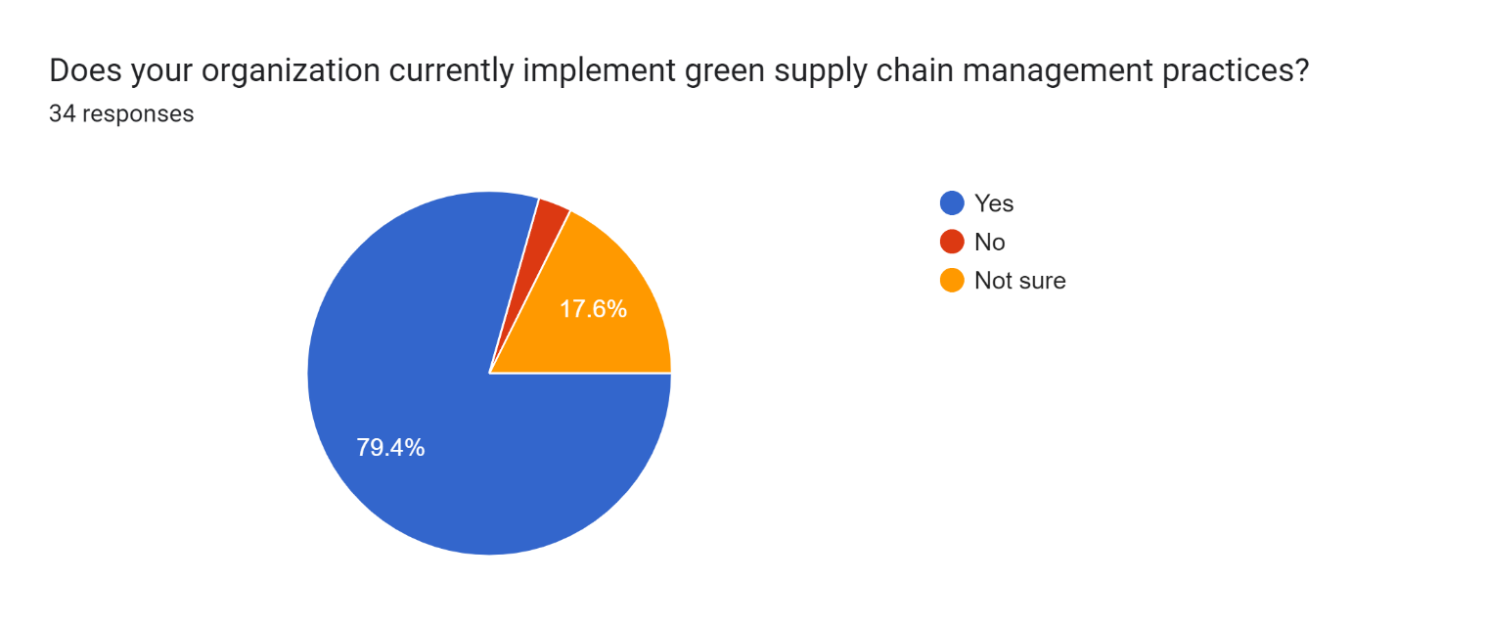

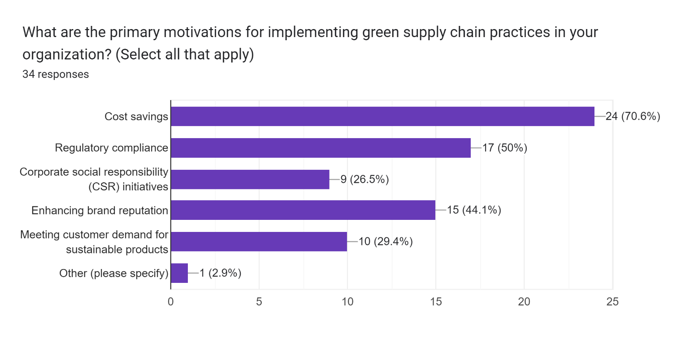

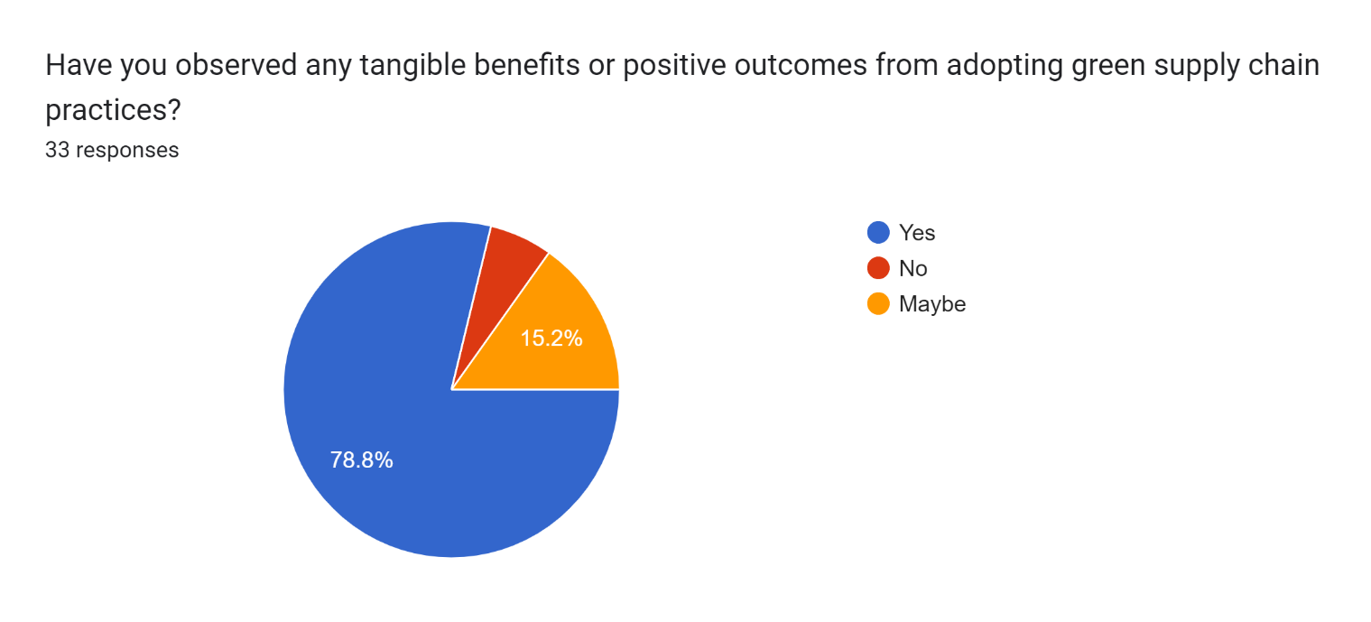

**7. Limitations**

While the research on green supply chain management (GSCM) provides valuable insights, it is important to acknowledge its limitations. These limitations can impact the generalizability and applicability of the findings and should be considered when interpreting the results. Some limitations of this research include:

Sample Size and Representativeness: The study may have a limited sample size or may be focused on specific industries or geographic regions, which could affect the generalizability of the findings. Moreover, the sample may not fully represent the diversity of organizations practicing GSCM globally, leading to potential biases in the results.

Self-Reported Data: The data collected through surveys or interviews rely on self-reported information provided by participants. This may introduce response bias or social desirability bias, where respondents provide answers that they perceive as socially desirable rather than reflecting their actual practices or experiences.

Cross-Sectional Nature: The research may adopt a cross-sectional design, capturing a snapshot of GSCM practices at a particular point in time. As a result, it may not capture the dynamics and evolution of GSCM practices over time, limiting the understanding of long-term trends and impacts.

Limited Scope of Variables: The study may focus on a specific set of variables or practices related to GSCM, potentially overlooking other important factors that influence sustainability performance or outcomes. This narrow scope may restrict the comprehensive assessment of GSCM practices and their implications.

Measurement Challenges: Assessing the effectiveness or impact of GSCM practices can be challenging due to the lack of standardized metrics or performance indicators. Variability in measurement methodologies and data quality may introduce inconsistencies or limitations in comparing results across studies.

Contextual Factors: The effectiveness of GSCM practices can be influenced by various contextual factors, such as industry characteristics, organizational culture, regulatory environments, and market conditions. Failure to account for these contextual factors may limit the applicability of findings across different contexts or settings.

Publication Bias: There may be a tendency for studies reporting positive outcomes or significant findings to be more readily published, leading to publication bias. This bias may skew the overall perception of the effectiveness of GSCM practices if negative or non-significant results are underrepresented.

**8. Conclusion**

This research provides valuable insights into the practices and benefits of GSCM, highlighting its importance in achieving environmental sustainability, operational excellence, and competitive advantage. By understanding the motivations, challenges, and impacts associated with GSCM adoption, organizations can develop more resilient and sustainable supply chains that create value for society, the environment, and the economy. Continued research and collaboration are essential to drive further advancements in green supply chain management and address pressing environmental challenges.

**9. Recommendations**

Following the in-depth analysis conducted in this master's thesis on Green supply chain in operations, several key recommendations emerge for organizations aiming to navigate and capitalize on this transformative journey effectively.

Firstly, Origination should Set Clear Sustainability Goals which help in specific and measurable sustainability goals for your supply chain operations, such as reducing carbon emissions, minimizing waste, or increasing the use of renewable energy. These goals will provide a clear direction and help track progress over time

Moreover, Implement strategies to optimize transportation and logistics operations, such as consolidating shipments, using alternative transportation modes, and optimizing delivery routes to minimize fuel consumption and emissions.

Invest in energy-efficient technologies and practices to reduce energy consumption in manufacturing, warehousing, and transportation operations. This may include upgrading equipment, implementing energy management systems, and investing in renewable energy sources.

Furthermore, Collaborate with industry peers, government agencies, non-governmental organizations (NGOs), and other stakeholders to share best practices, leverage resources, and address common sustainability challenges collectively.

Embrace a mindset of continuous improvement and innovation in green supply chain management practices. Regularly review and refine processes, technologies, and strategies to identify new opportunities for reducing environmental impact and enhancing sustainability performance

Finally,Establish key performance indicators (KPIs) to track environmental performance metrics, such as carbon emissions, energy usage, waste generation, and recycling rates. Regularly monitor and measure performance against these KPIs to identify areas for improvement and track progress towards sustainability goals.

By implementing these recommendations, businesses can effectively integrate green supply chain management practices into their operations, achieve environmental sustainability goals, drive cost savings, mitigate risks, and maintain a competitive edge in the marketplace

**10. References**<https://www.edureka.co/blog/green-supply-chain-management>

<https://www.gep.com/knowledge-bank/glossary/what-is-supply-chain-management>

[Introductory Chapter: Introduction of Green Supply Chain Management | IntechOpen](https://www.intechopen.com/chapters/63678)  
  
  
<https://en.wikipedia.org/wiki/Green_supply_chain_management>  
  
  
<https://www.agility.com/en/blog/what-are-green-supply-chain-practices-your-guide-to-supply-chain-sustainability>