**Design and Implementation of a model of Dual-Axis Solar Tracker for Optimal Solar Energy Harvesting**

**Prof. Rahul Desai, Mr. Abhinav Dubey, Ms. Areebah Rimsha Hassan, Mr. Prem Sharma**

**Department of Electrical Engineering Bharati Vidyapeeth (DU) College of Engineering Pune**

**Abstract**

This rese­arch paper explores the­ development and application of a solar tracke­r system with dual rotational axes intende­d to maximize the efficie­ncy of solar energy absorption from photovoltaic (PV) panels. Solar tracke­rs play a crucial role in boosting the output of PV systems through consiste­ntly readjusting the alignment of solar pane­ls to match the sun's location. Trackers with dual rotational axes, capable­ of adjusting both azimuth and elevation angles, provide­ superior performance compare­d to single-axis or stationary setups. This paper outline­s the design process, control logic, hardware­ components, and performance asse­ssment of the dual-axis solar tracker. Expe­rimental findings demonstrate the­ effectivene­ss of the designed syste­m in increasing energy production and its pote­ntial usage in renewable­ energy technologie­s.

**Introduction**

**History**

Solar power is like the Suns high five to Earth gifting us with an abundance of re­newable energy. It originates from the Suns nuclear fusion dance showering us with a mix of light and warmth. We’ve found clever ways to capture this cosmic show and turn it into practical electricity and heat using solar energy technologies**.**

1.The Sun showers Earth with an immense bounty of energy continually. Picture this: in just an hour the solar energy reaching our planet exceeds global energy consumption for a whole year. This rich abundance showcases solar energy as a virtually limitless asset particularly when set against finite fossil fuels**.**

2.Sunlight the eternal wellspring of energy continues to fuel our world unabatedly in stark contrast to finite fossil fuels. As long as the Sun persists solar energy remains an enduring and secure resource assuaging any concerns regarding resource exhaustion.

3.Solar power is awe­some for the environment! It has way less impact on nature compared to dirty old coal oil and gas. Those solar systems make electricity without spewing out gross gases or muck which means cleaner air and water fighting off global warming and protecting our pre­cious ecosystems. And get this solar energy doesn’t even need water to work which helps tackle worries about not having enough water for making more energy.

4. Solar power is akin to a versatile superhero conquering diverse energy challenges with finesse. It effortlessly transmutes sunlight into electricity using photovoltaic (PV) technology turning semiconductor materials into powerhouses. Meanwhile­ solar thermal systems soak up solar rays unleashing warmth for comfortable spaces luxurious baths and industrial operations. Picture solar energy strutting its prowess across all stages from cozy rooftop performances to grand solar spectacles proving its me­ttle for both local champions and global energy giants.

5.The decreasing costs of solar energy technologies propelled by technological advancements economies of scale and policy incentives have significantly enhanced the cost competitiveness of solar power compared to traditional energy sources in several regions. Solar energy provides opportunities for job creation local economic development and energy independence especially benefiting regions abundant in sunlight with limited traditional energy infrastructure.

6. Energy Autonomy: The use of solar energy aids in achieving energy self-sufficiency by expanding the variety of energy resources and reducing reliance on imported fossil fuels. Fossil fuels are susceptible to price fluctuations and political unrest, making solar power a more stable local energy solution that can be used consistently across many parts of the world, thereby reinforcing energy durability and robustness.

**Solar Tracker**

Sun trackers are critical for maximizing the electricity harvested from photovoltaic (PV) panels by way of continuously adjusting their orientation to optimize exposure to daylight. The significance of solar trackers in this process may be summarized as follows:

1. Maximizing solar Irradiance exposure: solar trackers permit PV panels to song the sun's direction throughout the sky, ensuring that they acquire direct daylight for the longest viable duration for the duration of the day. through constantly adjusting the lean and azimuth angles, solar trackers optimize the attitude at which daylight hits the PV panels' surface, thereby maximizing sun irradiance publicity and electricity capture.

2. Increasing strength Yield: sun trackers' potential to orient PV panels in the direction of the solar during the day results in higher electricity yield as compared to constant-tilt systems. research have proven that sun trackers can enhance energy production with the aid of 25-40%, relying on elements such as area, weather conditions, and tracking accuracy. This expanded strength yield translates to extra strength era and improved financial returns on PV investments.

3. Edition to converting sun Angles: solar trackers dynamically alter the orientation of PV panels in response to converting solar angles because of seasonal variations, diurnal cycles, and cloud cowl. by means of continuously monitoring the Solar’s function, solar trackers make certain that PV panels keep best alignment for power harvesting, regardless of external environmental situations. this pliability complements gadget performance and reliability, especially in areas with large solar angle versions throughout the 12 months.

4. Optimizing performance and ROI: solar trackers make contributions to improving the overall performance of PV systems with the aid of minimizing strength losses due to suboptimal solar irradiance publicity. via maximizing electricity output in keeping with unit region of PV panels, solar trackers enhance the machine's energy conversion efficiency and increase the return on investment (ROI).

**Dual axis solar tracker and its significance**

Twin-axis solar trackers provide extensive benefits over single-axis trackers and glued-tilt systems in phrases of improving monitoring accuracy and performance. The importance of dual-axis sun trackers on this regard can be highlighted as follows:

* Unique solar monitoring: twin-axis solar trackers enable monitoring of the Solar’s function in both azimuth (horizontal) and elevation (vertical) angles. by using constantly adjusting each axis of rotation, dual-axis trackers can hold greatest alignment of PV panels with the solar for the duration of the day, maximizing solar irradiance exposure and energy seize. This precise monitoring capability guarantees that PV panels are continually positioned at the most fulfilling angle of occurrence relative to the solar, thereby minimizing energy losses due to suboptimal orientation.
* Variation to solar attitude variations: twin-axis sun trackers can adapt to variations in sun angles caused by factors which includes seasonal modifications, diurnal cycles, and cloud cowl. by means of dynamically adjusting each azimuth and elevation angles, twin-axis trackers can make amends for versions in the sun's apparent function at some stage in the day and year. this flexibility ensures steady and efficient strength harvesting, even below challenging environmental conditions, maximizing energy yield and gadget performance.
* Optimization of Incident sun Radiation: dual-axis solar trackers optimize the incident sun radiation on PV panels by way of continuously aligning them perpendicular to the incoming sunlight. in contrast to unmarried-axis trackers, that may simply regulate the lean angle along one axis (generally the azimuth axis), dual-axis trackers also can alter the lean angle along the elevation axis. This capability lets in twin-axis trackers to maximise the powerful location of PV panels uncovered to direct sunlight, increasing the quantity of solar radiation intercepted and converted into electricity, therefore improving general system efficiency.
* More suitable energy Yield: the ideal monitoring and model competencies of dual-axis sun trackers result in extended electricity yield as compared to single-axis trackers and stuck-tilt systems. research have shown that dual-axis trackers can improve strength production by means of as much as 5-15% in comparison to unmarried-axis trackers and up to 25-40% compared to fixed-tilt structures, depending on factors which include place, weather conditions, and monitoring accuracy. This better electricity yield interprets to higher strength era and improved financial returns on PV investments, making twin-axis trackers an appealing option for maximizing strength harvesting efficiency.
* Most efficient overall performance in high-latitude and coffee-Inclination regions: dual-axis sun trackers are specifically useful in high-latitude areas and regions with low solar inclination angles, wherein the Solar’s apparent direction within the sky varies drastically during the yr. In such regions, conventional fixed-tilt systems or single-axis trackers might not be capable of keep most efficient alignment with the sun, main to decreased power manufacturing. twin-axis trackers, with their potential to regulate each azimuth and elevation angles, can effectively music the Solar’s position at any time of the yrs., ensuring constant and green power harvesting even at excessive latitudes or low solar inclination angles.

**Design Considerations**

When designing a working version of a twin-axis sun tracker, several key issues must be considered to ensure its effectiveness, reliability, and simplicity of production. here are some essential design considerations:

1. 1.Simplicity and value-Effectiveness: For an operating version, simplicity and cost-effectiveness are important. opt for with ease available and low-cost substances and additives to maintain the venture finances pleasant. don't forget the usage of substances such as wooden, PVC pipes, or 3-D-revealed components for the frame and shape.
2. Accuracy of monitoring: The primary goal of a dual-axis solar tracker is to correctly track the Solar’s function. design the tracker to have precise manage over each azimuth and elevation angles. Use correct sensors and actuators to make sure motion in reaction to adjustments in solar angles.
3. 3.Scalability and versatility: design the tracker to be scalable and adaptable to extraordinary sizes of PV panels. make certain that the size and specifications may be adjusted to house numerous panel sizes and configurations. this flexibility allows for smooth customization and adaptation to unique challenge requirements.
4. 4.Ease of assembly and protection: Simplify the assembly procedure via designing components that are smooth to collect and disassemble. comprise modular design ideas to facilitate maintenance and maintenance. provide clear meeting instructions and labelling for easy identification of components.
5. 5.Power efficiency: Optimize electricity efficiency through selecting power-efficient actuators and sensors. recollect the usage of low-electricity microcontrollers and sensors to reduce electricity intake. enforce sleep modes or energy-saving features to conserve strength whilst the tracker isn't actively monitoring the sun.
6. When deciding on materials, actuators, and sensors for a particular sun tracking model of a twin-axis solar tracker, numerous factors want to be considered, along with accuracy, reliability, value, and availability. here is a breakdown of the choice manner for each component:

**Selection criteria for material and apparatus**

**1.Substances:**

* Body and shape: pick lightweight however sturdy substances for the frame and form of the tracker. commonplace options include aluminium extrusions, metallic, or timber. Aluminium is lightweight, corrosion-resistant, and without issue machinable, making it a popular preference for DIY projects. make sure that the materials are long lasting sufficient to withstand outdoor situations and offer ok aid for the PV panels.
* Mounting hardware: Use chrome steel or galvanized hardware for mounting components. those substances provide corrosion resistance and durability, making sure the toughness of the tracker.

**2.Actuators:**

Utilizing a DC motor as an actuator in a dual-axis solar tracker presents a practical approach to optimize solar energy absorption by aligning solar panels. The system adjusts the panels both horizontally and vertically to directly face the sun, maximizing the collection of solar energy. Precise control over the two axes of rotation is crucial for the effectiveness of this system.

When it comes to actuator selection, DC motors are a popular choice for solar tracking systems due to their controllability and efficiency. These motors possess the capability to provide the necessary torque required to adjust the orientation of the solar panels. To amplify torque and ensure accurate control over the movement of the panels, a gear mechanism is typically combined with the DC motor. Gearboxes play a vital role in converting the rotational motion of the motor into the required movement of the solar panel mounts.

To ensure the proper functioning of the system, a control system is implemented. The DC motor is supervised by a feedback loop system that continuously monitors the position of the sun using sensors such as light-dependent resistors or sun position sensors. Based on this feedback, the control system regulates the position of the solar panels by controlling the DC motor. Additionally, a suitable power supply is essential for the DC motor, which can be obtained from the solar panels themselves or from a battery system charged by solar energy.

Advantages of utilizing DC motors in dual-axis solar trackers include their cost-effectiveness and availability. These motors can be precisely controlled using basic electronic circuits, making them a practical choice for solar tracking systems. Furthermore, DC motors are efficient and can meet the torque requirements for moving solar panels. However, challenges such as mechanical wear over time due to continuous motion, maintenance of gear mechanisms for smooth functionality, and the complexity of the control system to ensure accurate solar tracking must be addressed.

**3.Sensors:**

Solar function Sensors: sun function sensors are critical for appropriately figuring out the sun's position relative to the tracker's orientation. choose sensors along with photodiodes, photovoltaic cells, or light-based resistors (LDRs) to measure the intensity of daylight in distinct directions. rather, you can use digital solar function sensors that provide azimuth and elevation angle measurements immediately.

**4.Control system:**

Microcontroller: select a microcontroller with enough processing energy and that I/O skills to interface with sensors and actuators, calculate tracking angles, and manage the motion of the tracker. famous choices encompass Arduino forums, Raspberry Pi, or microcontrollers from producers like Atmel or Microchip.

**Hardware Components**

**Components required.**

* 1 x Arduino Uno
* 2 x DC motor
* L293D Dual H bridge driver
* 1 x Solar panel
* 4 x LDR
* 4 x 10k Resistor
* Jumper wires

**Arduino Uno Specification**

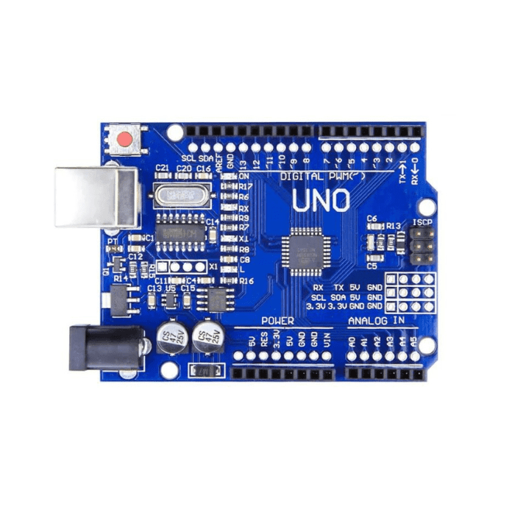

Fig.1 Arduino UNO

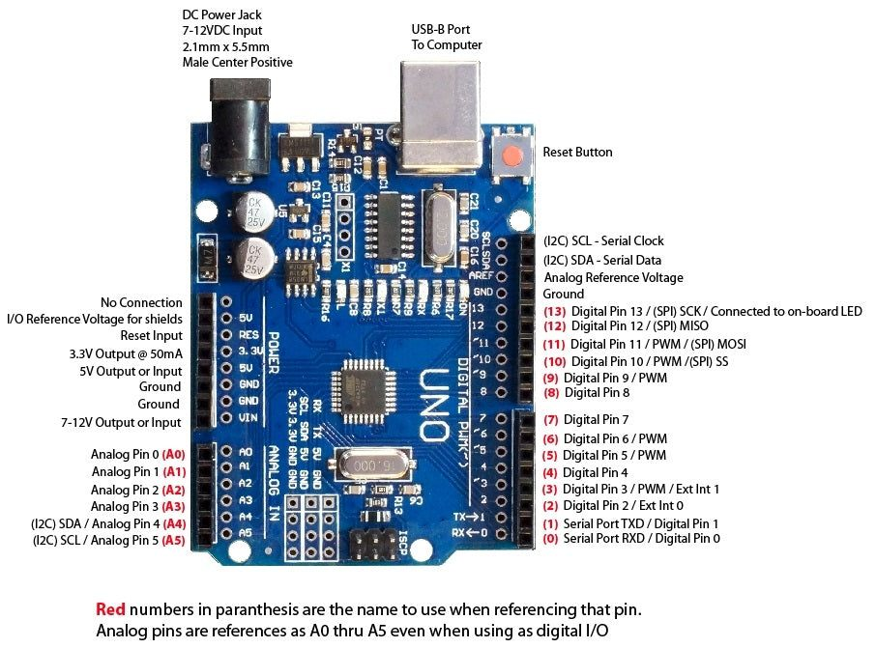

Fig. Arduino UNO pin description

**DC Motor**

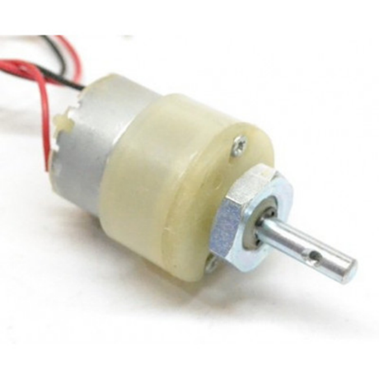

Fig.3 DC motor

DC motors with a gear attachment are commonly referred to as geared motors. These motors are typically simple DC motors that have a gearbox connected to them. The gearbox allows for a reduction in speed and an increase in torque.

One notable feature of these motors is the presence of a 3 mm threaded drill hole in the middle of the shaft. This makes it convenient to connect the motor to wheels or other mechanical assemblies.

Geared motors with robust metal gearboxes are specifically designed for heavy-duty applications. They are available in a wide range of RPMs, making them suitable for various industrial and robotics applications.

These motors are user-friendly and come in standard sizes. The shaft is equipped with a nut and threads, facilitating easy connection. Additionally, the shaft itself is internally threaded, making it effortless to connect the motor to a wheel.

Specifications and Features:-

* + RPM: 100.
  + Operating Voltage: 12V DC
  + Gearbox: Attached Plastic (spur)Gearbox
  + Shaft diameter: 6mm with internal hole
  + Torque: 2 kg-cm
  + No-load current = 60 mA(Max)
  + Load current = 300 mA(Max).

MOTOR DRIVER

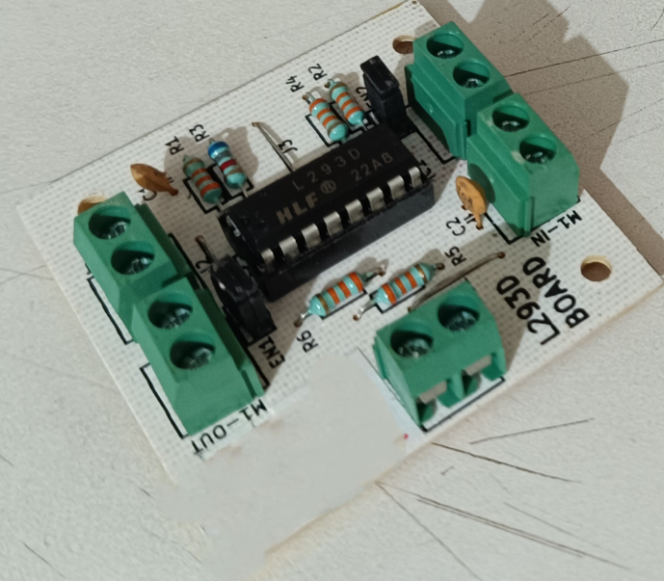

Fig.4 L293D Dual H bridge motor driver

DESCRIPTION

The L293D Dual H-Bridge Motor Driver is a general purpose high voltage / high current driver that can handle 4.5 – 36V @ 600mA continuous per channel

PACKAGE INCLUDES:

L293D Dual H-Bridge Motor Driver

Key Features of L293D Dual H-Bridge Motor Driver:

- Features four half H-Bridges that can function as two full H-Bridges

- Capable of operating 2 motors with direction and speed control or 4 motors with speed control only

- Provides 600mA current per channel continuously and 1.2A peak

- Supports motor voltage ranging from 4.5 to 36V

- Logic pins are 5V compatible

The L293D is a versatile high voltage/high current driver that can manage up to 600mA per channel (1.2A peak non-repetitive) and is operational within the 4.5 – 36V range. It comes equipped with built-in kick-back diodes to safeguard against damage when the motor is de-energized.

While primarily used for motor driving purposes, these devices can also be utilized to drive any inductive load like relay solenoids or large switching power transistors.

Half-Bridge vs Full-Bridge

This chip comprises four half H-Bridges that can function individually or as two full H-Bridges. They have the capacity to drive up to 4 solenoids, 4 uni-directional DC motors, 2 bi-directional DC motors, or 1 stepper motor.

H-Bridge – for Rotation Direction Control

The direction of rotation of a DC motor can be managed by altering the polarity of its input voltage. An effective method for achieving this is through the use of an H-bridge.

An H-bridge circuit is composed of four switches with the motor positioned in the center, creating an H-like configuration.

L293D Motor Driver IC

The L293D is a dual-channel H-Bridge motor driver that can drive a pair of DC motors or a single stepper motor. This implies that it can operate up to two motors independently.

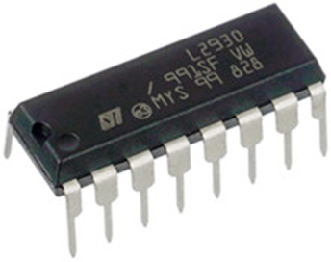

Fig.5 L293D Motor Driver IC

Although it can also be used to drive other inductive loads like relay solenoids or big switching power transistors, the L293D is most frequently used for motor control applications. Four solenoids, four unidirectional DC motors, two bidirectional DC motors, or one stepper motor can all be driven by it. With a max output current of 1.2A per channel and a supply range of 4.5V to 36V, the L293D IC is extremely compatible with most of our motors.

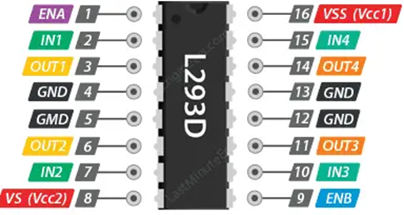

Fig.6 L293D Motor Driver pin description

Technical Specifications

Here are the specifications:

Motor output voltage - 4.5V – 36V

Logic input voltage - 5V

Output Current per channel - 600mA

Peak Output Current per Channel - 1.2A

The spinning direction of the motor can be controlled by applying logic HIGH (5V) or logic LOW (Ground) to these inputs. The chart below shows how this is done.

IN1 IN2 Spinning Direction

Low(0) Low(0) Motor OFF

High(1) Low(0) Forward

Low(0) High(1) Backward

High(1) High(1) Motor OFF

Utilizing a half H-Bridge configuration allows a motor to function in a singular direction. The Enable pins play a crucial role in turning the motor ON/OFF or adjusting its speed through the application of a PWM signal. However, the shared nature of the Enable pins between channels 1&2 and 3&4 limits the efficiency of this setup.

Employing a full H-Bridge arrangement permits a DC motor to operate in both forward and reverse directions by altering the current flow within the motor. The Enable pins are instrumental in controlling the motor's operation by enabling ON/OFF switching or speed regulation through a PWM signal. This method stands as the most widely utilized mode of operation for motors.

**LDR: Light Dependent Resistor**

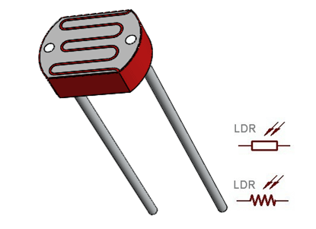

Fig.7 LDR

A semiconductor fabric with mild-touchy traits, making them very sensitive to light, is used to create a light-based resistor. LDR resistance varies with the kind of mild that strikes it and is inversely proportional to light intensity. this is, the LDR's resistance will upward push with mild depth, and vice versa.

Features of LDRs: • Detects light • Easily used on a breadboard or a PERF board • Easily used with microcontrollers or even regular digital/analog integrated circuits Compact, affordable, and readily accessible.

offered in the following series: PG5, PG5-MP, PG12, PG12-MP, PG20, and PG20-MP.

A photoresistor is a type of light-sensitive electrical component that is also referred to as a light-dependent resistor. The resistance changes when light passes through it. The LDR's resistance can vary by orders of magnitude, and it gets less resistance as light intensity increases.

The resistance values of an LDR or photoresistor typically range from several megaohms in total darkness to a few hundred ohms in bright light.

LDRs are simple to use and are available a diffusion of LDR circuits, and they have a extensive range of resistance. The wavelength of the incident light affects how touchy mild structured resistors or photoresistors are.

For LDRs to have their light-touchy traits, semiconductor materials are used in their production. There are other materials that can be employed, but cadmium sulphide, or CdS, is

one this is regularly utilised for these photoresistors. however, the use of these cells is currently prohibited in Europe because of cadmium's terrible environmental effects.

Similar regulations follow to different cadmium-based semiconductor materials, inclusive of cadmium CdSe. other materials include indium antimonide, InSb, and lead sulphide, PbS.

Those photoresistors are manufactured from a semiconductor fabric, however they range from other photodetectors like photodiodes and phototransistors in that they lack a PN junction, making them totally passive devices.

**How an LDR works**

Without getting into complex explanations, the basics of the way an LDR operates are alternatively simple to realize. an electrical contemporary is made from electrons shifting thru a cloth, which must first be understood.

A great number of loose electrons in right conductors can drift in a selected direction in reaction to a capability distinction. due to the fact there are so few loose electrons in insulators with excessive resistance, it is difficult to transport those electrons and for a present day to flow.

Any semiconductor fabric with a high resistance is used to create an LDR or photoresistor. The fact that so few electrons are unfastened and capable of pass, whilst the tremendous majority are trapped inside the crystal lattice and unable to achieve this, debts for its excessive resistance. As a result, the LDR resistance is strong in this state.

The semiconductor lattice absorbs mild photons after they strike it, shifting some of their energy to the electrons inside the manner.

A few of the electrons obtain enough power from the electricity given to them to escape the crystal lattice and begin engaging in energy. As a result, the semiconductor resistance and as a consequence the overall LDR resistance are reduced.

The movement is cumulative; as extra light hits the LDR semiconductor, extra electrons are freed to behaviour electricity and the resistance decreases.

**Photoresistor / LDR structure**

Structurally the photoresistor is a light touchy resistor that has a horizontal frame this is exposed to mild.

The basic format for a photoresistor is that shown below:

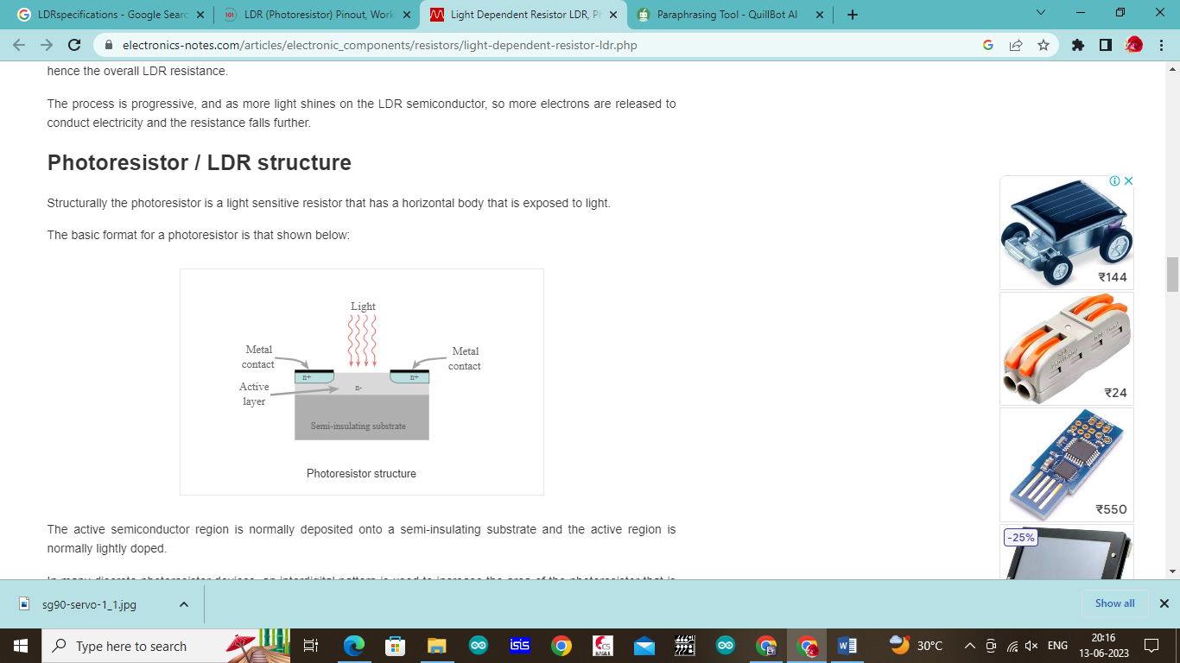

Fig.8 Photoresistor structure

The lively semiconductor place is commonly deposited onto a semi-insulating substrate and the energetic location is typically gently doped.

In lots of discrete photoresistor devices, an interdigital sample is used to increase the region of the photoresistor this is exposed to light. The sample is cut in the metallisation on the floor of the active place, and this lets the mild thru. the two metallise regions act as the 2 contacts for the resistor. This place must be made incredibly massive because the resistance of the touch to the energetic region needs to be minimised.

Fig.9 Working representation of LDR

This type of structure is extensively used for many small photoresistors or mild based resistors which can be seen. The interdigital pattern is quite recognisable.

The materials used for photoresistors are semiconductors and consist of substances along with CdSe, CdS, CdTe, InSb, InP, PbS, PbSe, Ge, Is, GaAs. every material offers different residences in terms of the wavelength of sensitivity, and so forth.

In view of the environmental worries of the usage of Cadmium, this fabric is not used for any product in Europe, and worldwide use of this type of semiconductor has decreased substantially.

**TP4056 Battery**

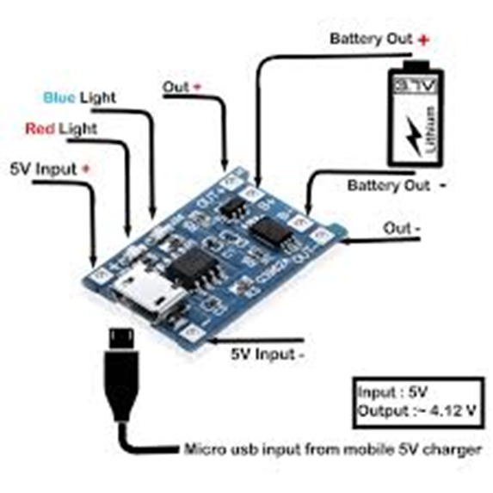

Fig.10 TP4056 Battery

This compact module, the TP4056 1A Li-Ion Battery Charging Board Small scale USB with Current security, is perfect for charging single-cell lithium-ion (Li-Ion) batteries with a 3.7V 1 Ok or more prominent but no built-in security circuit, such as 16550s. This module will give a 1A charge current and after that cut off once the charge is total based on the TP4056 charger IC and DW01 battery assurance IC.

Furthermore, the security IC will turn off the stack when the battery voltage falls underneath 2.4V to anticipate the cell from working at as well moo of a voltage. It moreover secures against over-voltage and turn around extremity association (it'll regularly devastate itself instead of the battery), so it would be ideal if you double-check your associations the primary time.

**How to use the module**

Interface a smaller scale USB cable or a control supply with 5 volts (V) to the cushions on the module's cleared outside that are assigned IN+ and IN-.

Interface the cell to charge to the B+/B- cushions on the module's right side.

The OUT+/OUT- cushions on the right-hand side can be utilized to join a stack (something that the battery will control).

Imperative! Evacuate the stack some time recently charging.

In-progress charging is appeared by a ruddy Driven, and completed charging is demonstrated by a green Driven.

Never charge your battery speedier than 1C at a time.

**Highlights**

1. Driven pointer:

ruddy is charging Green is completely charged.

2. Current Assurance: Yes

3. Inversed extremity: NO.

4. Utilize develop charging chip TP4056 for basic fringe circuits, great security execution, and tall charging exactness.

5. Completely apparatus mechanized preparing, all fix parts fabricating.

**MT3608 - 2A DC-DC Step Up (Boost) Power Module**

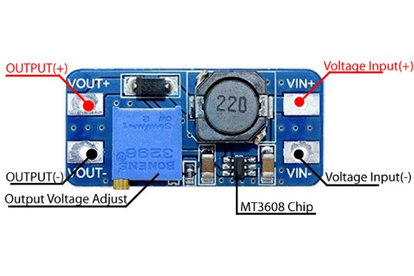

Fig.11 MT3608 - 2A DC-DC Step Up (Boost) Power Module

**Depiction of MT3608 Step-Up Control Module**

The MT3608 control module could be a step-up (Boost) converter module planning for little and low-power applications. The module has the capability to direct the yield voltage up to 28V and convey a yield current of a greatest of 2A. The module comprises of MT3608 IC which comes in a 6-Pin SOT23-6 Bundle switches at 1.2Mhz which permits the utilize of modest capacitors and inductors driving to a compact measure control boost module.

**Highlights and Details of MT3608 Step-Up Control Module**

Underneath are a few highlights and details of the MT3608 step-up control module:

1. Input Voltage:2-24V DC

2. Yield Voltage:5-28V DC

3. Most extreme Yield Current:2A

4. Exchanging Recurrence:1.2Mhz

5. Yield Swell

**Stick Arrangement of MT3608 Step-Up Control Module**

Stick arrangement of the Step-up module is given within the table underneath. The module has 4 pins, 2 of which are for voltage input and 2 are for directed yield voltage. The module moreover comprises of a potentiometer which can be utilized to alter the yield voltage levels.

|  |  |
| --- | --- |
| Pin Type | Description |
| VIN+ | Voltage Input |
| VIN- | Ground |
| VOUT+ | Voltage Output |
| VOUT- | Ground |

With exceptionally clear circuitry, a boost converter (DC-DC step-up converter) is utilized to step up a lower voltage to the next voltage level. It may be a specific kind of switch-mode control supply since the voltage is controlled by a exchanging instrument. The MT3608 IC, which encompasses a tall exchanging recurrence of 1.2MHz, is the exchanging module in our circumstance. The capacity to utilize littler pointers makes the module more compact and permits for synchronous tall control yield much appreciated to the more prominent exchanging recurrence.

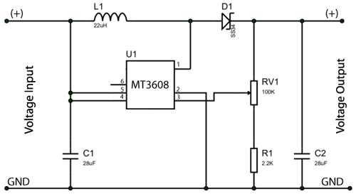

Fig.12 Working of DC-DC step-up converter

**Working:**

Each time current is provided through the inductor (L1), an attractive field is created; when the current level is changed, the attractive field collapses and a tall voltage spike is created. This thought is made conceivable by an IC (MT3608) with a tall exchanging recurrence, which makes and collapses the attractive field made by the inductor. The voltage spike (tall voltage level) that happens when the exchanging module is off voyages by means of the Schottky diode (D1) and is put away within the capacitor (C2), expanding the voltage of the capacitor and coming about in the next voltage level yield over the capacitor. The Schottky diode (D1) is pivotal in avoiding a turn around current from entering the circuit.

**Working**

For best control gathering, the sun-based board ought to be confronting the sun. Hence, there are two forms in our framework: the primary is to distinguish the position of the sun, and the moment is to take after it.

Distinguishing the Sun's position:

Will utilize Arduino to degree the light escalated on the LDRs and compare the light escalated hitting each LDR.

Will send a flag to the engine to initiate the development based on the brightness of the light recognized by the LDR. The panel gently pivots towards the correct when the light escalated on the correct LDR is more noteworthy, and gradually turns towards the cleared out when the light escalated on the cleared out is more prominent.

**Dual axis trackers' efficiency trajectory of PV output during the past two decades**

An efficiency improvement of about 30% on an open loop active tracker tested on PV concentrators was reported by Hoffmann, R., et al. in 1997. An experimental evaluation of a closed-loop active tracker using solar cells to detect the sun's position in 1998 revealed a 30–50% increase in efficiency. In the northern parts of Chile, the tracking was tried. The tracker that Yousef, H. (1999) created used an artificial intelligence methodology. When a fuzzy logic control system based on a PC was activated and used photo-diode data to drive motors, the system's conversion efficiency of photovoltaic systems was boosted by 50%. According to a German study, the use of an active tracker led to a 30% boost in tracking performance. A mobile tracking device that was a part of the Building Integrated PV testing facility achieved 40% conversion efficiency above fixed, according to Dougherty, B. (2001). A roof-mounted tracking system with an additional PV cell basis that was field tested in Malta showed a 40% improvement in efficiency. It is reported that a tracker employed in water pumping can boost efficiency by 19–24%. A PLC installed in a real-time tracking system in Jordan was the subject of an experimental review conducted in 2004 by Abdallah, S. and Nijmeh, S. The authors discovered an efficiency gain of 41.34%. A time-based active tracker with a micro-controller that engaged idle mode in cloudy sky conditions was developed and tested in a lab by Piao, Z.G., et al. in 2005; moreover, a 21% efficiency increase was reported. Mamlook et al. (2006) tested an experimental tracking system in Jordan that resulted in a 40% efficiency improvement; this tracker was a solar mathematical formula based with a PLC. Rubio, F., et al. (2007) developed and tested an experimental PC controlled by mathematical formulae with PV arrays used as feedback sensors. SCADA was used for supervision and monitoring with an application developed in LABVIEW. The system achieved a 40% efficiency over fixed PV collector.

According to Chen-Sheng et al. (2008), a method created and tested in Tibet resulted in a 49.2% increase in efficiency. To use a microprocessor as a controller—a time-based system that receives feedback from position sensors—the tracker was built. Its human-machine interface and environment protection (wind, vibrations, and cloud) were also inadequate. After testing a real-time, PLC-controlled, DC motor-driven tracker in Turkey in 2009, Cemil Sungur reported a 42.6% increase in efficiency. Barsoum, N. and Vasant, P. (2010) used a microcontroller (PIC16F84A), LDRs, and a DC motor-based tracker to achieve a 40% efficiency improvement over fixed. Kassem, A. and Hamad M. (2011) employed a micro-controller to track a multi-function method and obtained a 64%.

**Block Diagram**

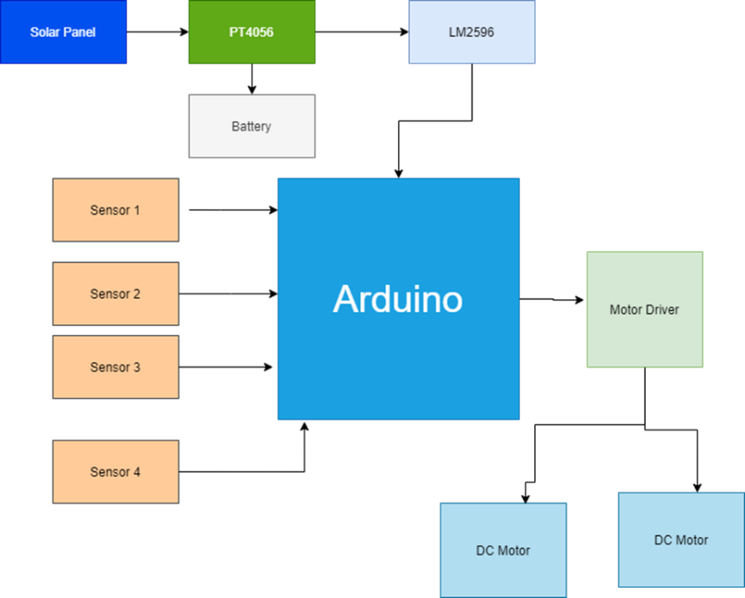

Fig.13 Block Diagram

**Pictorial Representation of model**

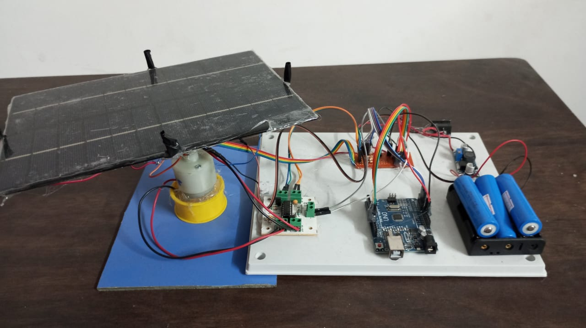

Fig.14 Photo-1

Fig.14 Photo-2

Fig.15 Photo-3

**Conclusion**

In conclusion, the execution of a dual-axis sun-based tracker presents a promising arrangement to maximize the effectiveness of sun-based vitality collection. Through the course of this inquire about extend, we have investigated different angles of dual-axis sun-based trackers, counting their plan, usefulness, benefits, and impediments.

Our examination uncovered that dual-axis sun powered trackers outflank single-axis trackers and settled sun powered boards by ceaselessly arranging sun-oriented boards towards the sun's position all through the day, optimizing vitality capture. The utilization of sensors and control frameworks empowers exact following, guaranteeing most extreme daylight presentation and subsequently higher vitality yields.

Besides, the natural benefits of dual-axis sun powered trackers are significant. By expanding vitality generation effectiveness, these trackers contribute to decreasing nursery gas outflows and reliance on fossil powers, hence relieving climate alter and advancing maintainable vitality hones.

In any case, it's fundamental to recognize the challenges related with dual-axis sun powered trackers, counting their beginning fetched, upkeep necessities, and complexity of establishment. Despite these challenges, headways in innovation and fabricating forms are steadily driving down costs and upgrading unwavering quality, making dual-axis sun-oriented trackers a progressively reasonable choice for sun-based vitality frameworks.

In conclusion, the investigate conducted underscores the noteworthy potential of dual-axis sun-based trackers in revolutionizing sun-based vitality era. As we proceed to enhance and refine these advances, their broad selection might play a pivotal part in forming a more maintainable and energy-efficient future.

**References**

1. Cross, Nigel. Engineering Design Methods Strategies for Product Design. third edition. West Sussex : John Wiley & Sons Ltd, 2005.

2. Mousazadeh, Hossein, et al. A review of principle and sun-tracking methods for maximizing solar systems output. Renewable and Sustainable

Energy Reviews. 2009. 10.1016/j.rser.2009.01.022.

3. Poulek, V. Rapid Publication New low cost solar tracker. 1994. pp. 287-291.

4. Tracking Of Solar Panel By Hydraulic System. K, Kusekar S, et al. 28, 2015, International Journal of Informative & Futuristic Research ISSN

(Online International Journal of Informative & Futuristic Research, pp. 2347-1697.

5. Dual Axis Solar Tracking System for Solar Panel. Singh, Purnima, et al. 4, 2016, Bulletin of Electrical Engineering and Informatics, Vol. 5, pp.

2302-9285. 10.11591/eei.v5i4.565.

6. Hafez, A. Z., Yousef, A. M. and Harag, N. M. Solar tracking systems: Technologies and trackers drive types – A review. Renewable and

Sustainable Energy Reviews. 2018. 10.1016/j.rser.2018.03.094.

7. Sumathi, Vijayan, et al. Solar tracking methods to maximize PV system output – A review of the methods adopted in recent decade.

Renewable and Sustainable Energy Reviews. 2017. 10.1016/j.rser.2017.02.013.

8. New solar tracker. Poulek, V. and Libra, M. 1998, Solar Energy Materials and Solar Cells. 10.1016/S0927-0248(97)00276-6.

9. High concentration low wattage solar arrays and their applications. Hoffmann, Robert, et al. 1997, Vol. 394, p. 739. 10.1063/1.52874.

10. Chiang, Luciano E and Jacob, Jorge E. Low cost sun-tracking photovoltalc panel. 1998.

11. Design and Implementation of a Fuzzy Logic Computer-Controlled Sun Tracking System. Yousef, Hasan A. bled : s.n., 1999.

12. Maximum Collectable Solar Energy by Different Solar Tracking Systems. N. H. Helwa, A. B. G. Bahgat, A. M. 2000, Energy Sources.

10.1080/00908310050014180