**TITLE OF THE RESEARCH PAPER**

**“The Role of Hr in promoting diversity and inclusion in non-government organization”**

**BY – MANSI GUPTA**

**Executive Summary**

The study conducted on “The Role of Hr in promoting diversity and inclusion in non-government organization” aims at understanding the significance of Human Resource Management in Non-Government organizations (NGOs) besides learning about the functioning of non-government welfare organizations, assessing the effectiveness of Training and Development programs in NGOs and identifying the career opportunity and growth for Human Resource Management professionals in NGO sector. For an understanding of Human Resource functioning and its significance in the Non-Government Organization, four NGOs: namely *Action-Aid India*; *Help-Age India*”, *Deepalaya* and *Child Relief and You (CRY) are taken for study*. Detailed research was carried out with the help of the well-structured questionnaire to assess the effectiveness of the Training and Development programs and to identify the career opportunity and growth for Human Resource Management professionals in these respective NGOs.

The findings show that people today have more opportunities than before to do something for humanity, as the NGO sector has become more professional and is now an option for doing good work. The NGO sector has attracted some of the best and brightest professionals in India today. With Human-Resource playing a vibrant and significant role in developing employees by conducting various Training and development programs and by a large Society.

**Introduction**

In today's globalized and interconnected world, the importance of diversity and inclusion in organizations cannot be overstated. Non-governmental organizations whose mission is to respond to social challenges and promote social justice are central entities for promoting diverse and inclusive workplaces. At the core of this endeavor is the function of human resources (HR) as a catalyst for organizational change and progress. This study aims to delve into the multifaceted role of HR in promoting diversity and inclusion within NGOs. By understanding the challenges, strategies, and best practices that HR professionals use in these organizations, we can enlighten you about truly inclusive environments where people from diverse backgrounds thrive and contribute meaningfully. The difference includes many differences like, but no. limited by race, ethnicity, gender, sexual orientation, age, disability, socio-economic status and cultural background. In contrast, inclusion means active, deliberate and ongoing efforts to ensure that all people feel valued and appreciated and have the opportunity to fully participate in organizational processes and decision-making. The rationale for promoting diversity and inclusion in NGOs. not only based on ethical requirements but also on pragmatic considerations.

**Characteristics of NGO**

The advantage of NGOs, especially those working in the field, is their **ability to connect with local communities**, and to encourage community ownership and participation in development.

NGOs often can **respond quickly to new circumstances** and can experiment with innovative approaches.

NGOs can **identify emerging issues** and, through their dialogue and participation, identify and express the views of otherwise unheard beneficiaries.

NGOs are often successful intermediaries between actors, **building bridges between people and communities,** on the one hand, and governments, development organizations, donors and development organizations, among others.

In an advocacy role, NGOs frequently **represent issues** and views important in the **dynamics of the development process**.

**Forms of NGOs:**

**Advocacy -** These NGOs basically work on advocacy or campaigning on issues or causes. As a

focus, they do not implement programmers.

**Consultancy / Research Organizations**

These NGOs are dedicated to social research, development and consultancy

**Training / Capacity Building Organizations**

Training in the NGO sector is often referred to as capacity building. Some NGOs only work on Capacity Building of the other NGOs

**Networking Organizations**

These NGOs provide vital network opportunities for NGOs in a specific field e.g. **Association of Voluntary Agencies for Rural Development** (AVARD) works on networking of NGOs working in the field of Rural Development

**Mother NGOs**

These NGOs are both givers and receivers, e.g. large NGOs like **CRY**, Concern India receive funds as well as disburse funds. They have a work focus, but instead of implementing projects, they identify projects and monitor, evaluate and build capacities of participating NGOs

**Grassroot Organizations**

These NGOs work directly with the community **e.g. Apnalaya** works directly with the disadvantaged groups in the Govandi slum area. Traditionally all Mahila Mandals fall under this category.

**City Based Organizations**

These NGOs restrict their focus to cities e.g. **AGNI** focuses its work in Mumbai City

**National Organizations**

These NGOs have national presence. In India, very few NGOs are national level. e.g. **CRY, Pratham, Concern India**

**International Organizations**

These are part of International NGOs e.g. CARE India is an integral part of CARE's global operations. Like mother NGOs, these NGOs receive and disburse grants

**Self Help Groups**

They are not typically terms as NGOs. These are formed by beneficiary communities, typically women who come together in a group of 10 plus. India is currently witnessing a very successful SHGs movement and these women are making a difference in Andra Pradesh and rural Tamil Nadu.

**Methods and tools of collecting Data**

1. Data Analysis
2. Survey Design
3. Google Forms Implementation
4. Data Collection

**Research Design:**

Exploratory research design has been used in this project, which required systematic data analysis , Utilizing Google Forms, as the Data Collection to acquire new knowledge about the career growth opportunity and effectiveness of training & development programs in non-government organization.

The research approach involves the development of a structured questionnaire tailored to investigate various dimensions of The Role of Hr in promoting diversity and inclusion in non-government organization encompassing demographic information. The questionnaire will be designed meticulously to ensure alignment with the research objectives and theoretical frameworks in promoting diversity and inclusion in non -government organization. Utilizing Google Forms as the data collection tool offers several advantages, including ease of administration, accessibility to a wide range of respondents, and streamlined data aggregation and analysis processes.

**Methodology**

**Analysis In Quantitative Terms**

Quantitative data gleaned from surveys will be analysed by use of statistical software In order to provide a concise summary of the most important findings, descriptive statistics such as mean, median, and standard deviation will be computed.

**Analysis of Qualitative Data**

Thematic analysis is going to be used on a variety of different types of qualitative data, including open-ended survey responses and user comments. In order to gain a more in-depth understanding of customer behaviour, themes and patterns in qualitative data will be uncovered and recognized.

**Data Collection Methods:**

1. Google Forms Survey
2. ii. Convenience Sampling Approach

**DATA ANALYSIS & INTERPRETATION**

**Data Preparation and Processing**

data planning and processing process for anThe Role of Hr in promoting diversity and inclusion in non-government ORGANIZATION include the following steps:

**Data Cleaning:** This includes reviewing the collected data for errors, inconsistencies, missing values. and inconsistencies. Value, all inconsistencies at this stage are resolved or removed.

**Data entry:** Coded inputs are entered into computer software such as Microsoft Excel.

**Descriptive Statistics:** This step involves calculating the frequency, mean, and standard deviation for each variable in the data.

**Interpreting the results:** Interpreting the results of the statistical analysis and draw conclusions based on the research objectives and questions.

**8. Data Analysis**

**1.** (Period for which employees are working with the N.G.O)

**2.** (Satisfaction regarding the Recruitment policy of the company)

**3.** (Type of test conducted during selection)

**4.** (Qualification)

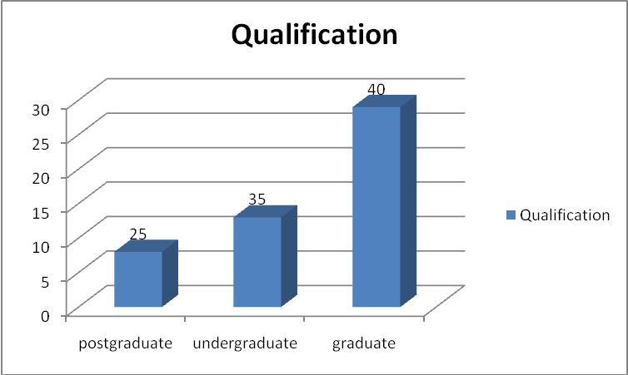

**5.** (Are you Satisfied with “ Promotional measure?)

**6.** (employees satisfied to the job)

**7.** (Working environment of the company)

**Limitation of the research:**

Questionnaires are being considered as a very important means of collection Primary Data, but several times it has been found that it does not result into fruitful results. This due to the following reasons:

1. Busy-bee employees
2. Individual perception
3. Conscious response
4. Unwillingness of respondent’s

**Conclusion:**

Based on the findings and interactive, responses from the respondents. Finally, I would like to conclude that Non-Government Organizations have fostered a culture of participation and modernism for employee growth and contribution. A high slandered of social ethics and religious dedication in there day to day activities have made these organization grow more professionally. There is an atmosphere of complete harmony and support in these organizations. There unique work culture is based on trust, openness and a commitment to creativity and consultation. A section of Training and development programs handles all training activities on a predetermined basis. Various kind of training methods are being followed which enrich employees with better social skills and empower them for future development. Employees show high motivation and are dedicated to their jobs and responsibilities.

It may be pertinent to note that a substantial number of executives in non-government organization find training directly, indirectly, or in some way relevant. They also feel that training has helped them in changing their attitude, brought in greater self-confidence and improved their performance.

The recruitment patterns of the voluntary sector have seen a perceptible change in its workforce profile, with more engineering and management graduates opting to work in this sector. It is worth noticing that voluntary work has changed into a pulsating profession with exciting growth possibilities, especially those that are technology-driven, the role of the professionals in this sector has taken a canter-stage and they are the key-drivers of high performance and integrity.

**It has happened in spurts in the past. It has happened elsewhere in the world. But the trend is now strengthening in India.**

**Recommendation:**

Based on the results of the findings carried out in the organization following recommendations are made:

The Training programs should be planned so that it relates to the trainee’s previous experience/ background and present job requirement. This background should be used as a foundation for development & new behavior. the Training programs should be made more interesting & the employee’s intelligence & motivational level should be checked throughout the programs.

Attract and encourage zealous professionals as well as fresh management graduates with competitive pay benefits, and by building awareness using different media across the country. Make improvement and streamline selection process to ensure that eminence professional join the organization.

**References:**

**Non-governmental organizations**: Performance and Accountability beyond the Magic: **by Michael Edwards, David Hulme**

Kamat, Sangeeta. Development hegemony: NGOs and the State in India, Delhi, New York; Oxford University Press, 2002

The State and NGOs: Perspective from Asia: by Shinoichi Shigetomi.

Strategic management: NGO management- by R.K Gupta.

Guidelines for NGOs Management in India: Snehlata Chandra. New Delhi, Kanishka, 2003

Human Resource Management: by Gary Dessler

World Bank Policy Research Working Paper No. 3525: by William A. Blomquist , Ken Calbick and Ariel Dinar

Proceedings of the 7th International Conference, Enterprise Information Systems (ICEIS), Miami, USA, May 24-28, 2005: José Vasconcelos, Paulo Castro Seixas , Paulo Gens Lemos and Chris Kimble

World Bank Policy Research Working Paper No. 2530: Shanti Jagannathan

Ross School of Business Paper No. 1055: Thomas P. Lyon and John W. Maxwell

Community-Based Scheme Working Paper No. 3: International Labour Office and Saliya Kanathigoda

***Internet References:***

<http://www.cry.org/intro.html>

<http://www.actionaidindia.org/>

<http://www.deepalaya.org/>

<http://www.helpageindia.org/>

# 