##### Master’s Thesis On

**A Study on analysis of financial statement of ICICI Bank**

***FOR THE PARTIAL FULFILLMENT OF THE REQUIREMENT FOR THE AWARD OF***

***MASTER OF BUSINESS ADMINISTRATION***

###### (2022-2024)

**UNDER THE GUIDANCE OF**

##### Dr. Rashi Mittal

###### Submitted By Twinkle Kumari

**Enrolment Number: 22042010036 Admission id: 22gsob2010043**

###### MBA 2022-2024



**School of Business Galgotias University**

**May, 2024**

## CERTIFICATE

This is to certify that the Master’s Thesis **“A Study on analysis of financial statement of ICICI Bank”** of the Master’s Thesis” has been prepared by Mr./Ms. Twinkle Kumari under my supervision and guidance. The project report is submitted towards the partial fulfillment of 2 year, Full time Master of Business Administration.

Name : Dr. Rashi Mittal

Signature of Faculty Date

## DECLARATION

I, Twinkle Kumari GU I’d 22GSOB2010043, student of School of Business, Galgotias University, Greater Noida, hereby declare that the Master’s Thesis on **“A Study on analysis of financial statement of ICICI Bank”** is an original and authenticated work done by me.

I further declare that it has not been submitted elsewhere by any other person in any of the institutes for the award of any degree or diploma.

Name: Twinkle Kumari

Signature of the Student Date

## ACKNOWLEDGEMENT

I offer my sincere thanks and humble regards to Galgotias University for imparting me the valuable professional guidance during the Master thesis in MBA Dual Specialization degree.

I pay my gratitude and sincere regards to Dr. Rashi Mittal, my master thesis mentor, for giving me the cream of their knowledge. I am thankful to her as she has been a constant source of advice, motivation and inspiration throughout the project work. I take the opportunity to express my gratitude and thanks to our computer Lab staff and library staff for providing me an opportunity to utilize their resources for the completion of the project. I am also thankful to my family and friends for constantly motivating me to complete the project and providing me an environment, which enhanced my knowledge.

Date:

Name: Twinkle Kumari Enroll. No.22042010036

Course: MBA Dual Specialization

## ABSTRACT

Financial Statement Analysis is a method of reviewing and analyzing a company’s accounting reports (financial statements) in order to gauge its past, present or projected future performance. This process of reviewing the financial statements allows for better economic decision making.

There are different users of financial statement analysis. These can be classified into internal and external users. Internal users refer to the management of the company who analyses financial statements in order to make decisions related to the operations of the company. On the other hand, external users do not necessarily belong to the company but still hold some sort of financial interest. These include owners, investors, creditors, government, employees, customers, and the general public. These users are elaborated on below:

The managers of the company use their financial statement analysis to make intelligent decisions about their performance. For instance, they may gauge cost per distribution channel, or how much cash they have left, from their accounting reports and make decisions from these analysis results.

Small business owners need financial information from their operations to determine whether the business is profitable. It helps in making decisions like whether to continue operating the business, whether to improve business strategies or whether to give up on the business altogether. Horizontal analysis is the comparison of financial information of a company with historical financial information of the same company over a number of reporting periods. It could also be based on the ratios derived from the financial information over the same time span.

Vertical analysis is conducted on financial statements for a single time period only. Each item in the statement is shown as a base figure of another item in the statement, for a given time period, usually for year.

**TABLE OF CONTENTS**

|  |  |  |
| --- | --- | --- |
| **S. No.** | **Subject** | **Page No.** |
| 1. | Introduction | 1-3 |
| 2. | Literature Review | 4-6 |
| 3. | Research Methodology | 7-12 |
| 4. | Data Analysis | 13-21 |
| 5. | Conclusion, Suggestion and Recommendation | 22-24 |
| 6. | Annexures | 25-30 |

# Introduction

ICICI Bank is India's second-largest bank with total assets of about Rs.1,67,659 crore at March 31, 2005 and profit after tax of Rs. 2,005 crores for the year ended March 31, 2005 (Rs. 1,637crore in fiscal 2004). ICICI Bank has a network of about 560 branches and extension counters Andover 1,900 ATMs. ICICI Bank offers a wide range of banking products and financial services to corporate and retail customers through a variety of delivery channels and through its specialized subsidiaries and affiliates in the areas of investment banking, life and non-life insurance, venture capital and asset management. ICICI Bank set up its international banking group in fiscal 2002 to cater to the cross-border needs of clients and leverage on its domestic banking strengths to offer products internationally. ICICI Bank currently has subsidiaries in the United Kingdom, Canada and Russia, branches in Singapore and Bahrain and representative offices in the United States, China, United Arab Emirates, Bangladesh and South Africanises Bank's equity shares are listed in India on the Stock Exchange, Mumbai and the National Stock Exchange of India Limited and its American Depositary Receipts (ADRs) are listed on the New York Stock Exchange (NYSE).As required by the stock exchanges, ICICI Bank has formulated a Code of Business Conduct and Ethics for its directors and employees.

At April 4, 2005, ICICI Bank, with

free float market capitalization of about Rs. 308.00billion (US$ 7.00 billion) ranked third amongst all the companies listed on the Indian stock exchanges. ICICI Bank was originally promoted in 1994 by ICICI Limited, an Indian financial institution, and was its wholly-owned subsidiary. ICICI's shareholding in ICICI Bank was reduced to46% through a public offering of shares in India in fiscal 1998, an equity offering in the form of ADRs listed on the NYSE in fiscal 2000, ICICI Bank's acquisition of Bank of Madura Limited in an all-stock amalgamation in fiscal 2001, and secondary market sales by ICICI to institutional investors in fiscal 2001 and fiscal 2002. ICICI was formed in 1955 at the initiative of the World Bank, the Government of India and representatives of Indian industry. The principal objective was to create a development financial institution for providing medium-term and long-term project financing to Indian businesses. In the 1990s, ICICI transformed its business from a development financial institution offering only project finance to a diversified financial services group offering a wide variety of products and services, both directly and through a number of subsidiaries and affiliates like ICICI Bank. In 1999, ICICI become the first Indian company and the first bank or financial institution from non-Japan Asia to be listed on the NYSE. After consideration of various corporate structuring alternatives in the context of the emerging competitive scenario in the Indian banking industry, and the move towards universal banking, the managements of ICICI and ICICI Bank formed the view that the merger of ICICI with ICICI Bank would be the optimal strategic alternative for both entities, and would create the optimal legal structure for the ICICI group's universal banking strategy. The merger would enhance value for ICICI shareholders through the merged entity's access to low-cost deposits, greater opportunities for earning fee-based income and the ability to participate in the payments system and provide transaction-banking services. The merger would enhance value for ICICI Bank shareholders through large capital base and scale of operations, seamless access to ICICI's strong corporate relationships built up over five decades, entry into new business segments, higher market share in various business segments, particularly fee-based services, and access to the vast talent pool of ICICI and its subsidiaries. In October 2001, the Boards of Directors of ICICI and ICICI

Bank approved the merger of ICICI and two of its wholly-owned retail finance subsidiaries, ICICI Personal Financial Services Limited and ICICI Capital Services Limited, with ICICI Bank. The merger was approved by shareholders of ICICI and ICICI Bank in January 2002, by the High Court of Gujarat at Ahmadabad in March 2002, and by the High Court of Judicature at Mumbai and the Reserve Bank of India in April 2002. Consequent to the merger, the ICICI group's financing and banking operations, both wholesale and retail, have been integrated in a single entity.

#### History

ICICI Bank was originally promoted in 1994 by ICICI Limited, an Indian financial institution, and was its wholly-owned subsidiary. ICICI's shareholding in ICICI Bank was reduced to46% through a public offering of shares in India in fiscal 1998, an equity offering in the form of ADRs listed on the NYSE in fiscal 2000, ICICI Bank's acquisition of Bank of Madura Limited in an all-stock amalgamation in fiscal 2001, and secondary market sales by ICICI to institutional investors in fiscal 2001 and fiscal 2002. ICICI was formed in 1955 at the initiative of the World Bank, the Government of India and representatives of Indian industry. The principal objective was to create a development financial institution for providing medium- term and long-term project financing to Indian businesses. In the 1990s, ICICI transformed its business from a development financial institution offering only project finance to a diversified financial services group offering a wide variety of products and services, both directly and through a number of subsidiaries and affiliates like ICICI Bank. In 1999, ICICI become the first Indian company and the first bank or financial institution from on-Japan Asia to be listed on the NYSE.After consideration of various corporate structuring alternatives in the context of the emerging competitive scenario in the Indian banking industry, and the move towards universal banking, the managements of ICICI and ICICI Bank formed the view that the merger of ICICI with ICICI Bank would be the optimal strategic alternative for both entities, and would create the optimal legal structure for the ICICI group's universal banking strategy. The merger would enhance value for ICICI shareholders through the merged entity's access to low- cost deposits, greater opportunities for earning fee-based income and the ability to participate in the payments system and provide transaction-banking services. The merger would enhance value for ICICI Bank shareholders through a large capital base and scale of operations, seamless access to ICICI's strong corporate relationships built up over five decades, entry into new business segments, higher market share in various business segments, particularly fee- based services, and access to the vast talent pool of ICICI and its subsidiaries.

In October 2001, the Boards of Directors of ICICI and ICICI Bank approved the merger of ICICI and two of its wholly-owned retail finance subsidiaries, ICICI Personal Financial Services Limited and ICICI Capital Services Limited, with ICICI Bank. The merger was

approved by shareholders of ICICI and ICICI Bank in January 2002, by the High Court of Gujarat at Ahmadabad in March 2002, and by the High Court of Judicature at Mumbai and the Reserve Bank of India in April 2002. Consequent to the merger, the ICICI group's financing and banking operations, both wholesale and retail, have been integrated in a single entity.

#### Organizational Structure

ICICI Bank’s organization structure is designed to be flexible and customer focused, while seeking while seeking to ensure effective control and supervision and consistency in standards across the organization and align all areas of operations to overall organizational objectives. The organization structure is divided into six principal groups Retail Banking, Wholesale Banking, International Banking, Rural (Micro-Banking) and Agriculture Banking, Government Banking and Corporate Centre.

###### RETAIL BANKING:

The Retail Banking Group is responsible for products and services for retail customers and small enterprises including various credit products, liability products, Distribution of third- party investment and insurance products and transaction banking services.

###### WHOLESALE BANKING:

The Wholesale Banking Group is responsible for products and services for large and medium- sized corporate clients, including credit and treasury products, investment banking, project finance, structured finance and transaction banking services.

###### INTERNATIONAL BANKING:

The International Banking Group is responsible for its international operations, including operations in various overseas markets as well as its products and services for non-resident Indians and its international trade finance and correspondent banking relationships.

###### RURAL AND AGRICULTURAL BANKING:

The Rural, Micro-Banking & Agri Business Group is responsible for envisioning and implementing rural banking strategy, including agricultural banking and micro-finance.

###### GOVERNMENT BANKING:

The Government Banking Group is responsible for government banking initiatives.

###### CORPORATE BANKING:

Its corporate banking strategy is based on providing comprehensive and customized financial solutions to its corporate customers. It offers a complete range of corporate banking products including rupee and foreign currency debt, working capital credit, structured financing, syndication and transaction banking products and services. Fiscal 2008 saw continued demand for credit from the corporate sector, with growth and additional investment demand across all sectors. We were able to leave rage our international presence and deep corporate relationships to work on overseas acquisitions made by Indian companies and infrastructure projects in India. During fiscal 2008 we were involved in 75% of outbound mergers and acquisitions deals from India. We are now a preferred partner for Indian companies for syndication of external commercial borrowings and other fundraising in international markets and have been ranked number one in off shore loan syndications of Indian corporate in calendar year 2007.

###### PRODUCTS AND SERVICES OF ICICI

ICICI Bank offers a wide range of banking accounts such as Current, Saving, Life Plus Senior, Recurring Deposit, Young Stars, Salary Account etc. tailor made for every customer segment, from children to senior citizens, Convenience and ease to access are the benefits of ICICI Bank accounts.

###### YOUNG STARS ACCOUNT:

A special portal for children to learn banking basics, manage personal finances and have a lot of fun.

###### BANK CAMPUS:

This student banking services gives students access to their account details at the click of amuse. Plus, the student gets a cheque book, debit card and annual statements.

###### SAVINGS ACCOUNTS:

Convenience is the name of the game with ICICI bank’s savings account.

Whether it is an ATM/debit card, easy withdrawal, easy loan options or internet banking, ICICI bank’s saving

account always keep you in touch of money.

###### FIXED DEPOSITS:

ICICI Bank offers a range of deposit solutions to meet varying needs at every stage of life. It offers a range of tenures and other features to suit all requirements.

###### INSURANCE:

The ICICI group offers a range of insurance products to cover varying needs ranging from life, pensions and health, to home, motor and travel insurance. The products are made accessible to customers through a wide network of advisors, banking partners, corporate agents and brokers with the added convenience of being able to buy online.

###### LIFE INSURANCE:

The ICICI group provides the many life insurance products through ICICI Prudential Life Insurance Company

###### GENERAL INSURANCE:

The ICICI group provides the many general insurance products like motor, travel and home insurance through ICICI Lombard General Insurance Company.

###### LOANS:

ICICI bank offers a range of deposits solutions to meet varying needs at every stage of life. It offers a range of tenures and other features to suit all requirements.

###### HOME LOAN:

The No. 1 Home Loans Provider in the country, ICICI Bank Home Loans offers some unbeatable benefits to its customers Doorstep Service, Simplified Documentation and Guidance throughout the Process. It's really easy!

###### PERSONAL LOAN:

ICICI Bank Personal Loans are easy to get and absolutely hassle free. With minimum documentation you can now secure a loan for an amount up to Rs. 15 lakhs.

###### VEHICLE LOANS:

The No. 1 financier for **Car loan** in the country. Network of more than2500 channel partners in over 1000 locations. Tie-ups with all leading automobile manufacturers to ensure the best deals. Flexible schemes & quick processing are the main advantages are here. Avail attractive schemes at competitive interest rates from the No 1 Financier for **two wheelers loan** in the country. Finance facility up to 90% of the On Road Cost of the vehicle, repayable in convenient repayment options and comfortable tenors from 6 months to 36months.

###### CARDS:

ICICI Bank offers a variety of cards to suit different transactional needs. Its range includes Credit Cards, Debit Cards and Prepaid cards. These cards offer you convenience for financial transactions like cash Withdrawal, shopping and travel. These cards are widely accepted both in India and abroad.

###### CREDIT CARD:

ICICI Bank Credit Cards give you the facility of cash, convenience and a range of benefits, anywhere in the world. These benefits range from lifetime free cards, Insurance benefits, global emergency assistance service, discounts, utility payments, travel discounts and much more.

###### DEBIT CARD:

The ICICI Bank Debit Card is a revolutionary form of cash that allows customers to access their bank account around the clock, around the world. The ICICI Bank Debit Card can be used for shopping at more than 3.5 Lakh merchants in India and 24 million merchants worldwide.

###### TRAVEL CARD:

ICICI Bank Travel Card. The Hassle-Free way to Travel the world. Traveling with US Dollar, Euro, Pound Sterling or Swiss Francs; Looking for security and convenience; take ICICI Bank

Travel Card. Issued in duplicate. Offers the Pin based security. Has the convenience of usage of Credit or Debit card.

###### MOBILE BANKING:

Bank on the move with ICICI Bank Mobile Banking. With ICICI Bank, Banking is no longer what it used to be. ICICI Bank offers Mobile Banking facility to all its Bank, Credit Card, Demat and Loan customers. ICICI Bank Mobile Banking can be divided into two broad categories of facilities:

###### Alert facility:

ICICI Bank Mobile Banking Alerts facility keeps you informed about the significant transactions in its Accounts. It keeps you updated wherever you go.

###### INVESTMENT PRODUCTS:

Along with Deposit products and Loan offerings, ICICI Bank assists you to manage its finances by providing various investment options ranging from ICICI Bank Tax Saving Bonds to Equity Investments through Initial Public Offers and Investment in Pure Gold. ICICI Bank facilitates following investment products:

* ICICI Bank Tax Saving Bonds
* Government of India Bonds
* Investment in Mutual Funds
* Initial Public Offers by Corporate
* Investment in "Pure Gold"
* Foreign Exchange Services
* Senior Citizens Savings Scheme,

###### BANKING:

Internet banking is available to all ICICI bank savings and deposit account holders, credit card, demat and loan customers. Internet banking service offers customers a world of convenience

with services such as balance enquiry, transaction history, account statement, bill payments, and fund transfers and accounts related service requests.

###### ATMs:

With more than 2500 ATMs across the country, ICICI Bank has one of the largest ATM networks in India.

###### PHONE BANKING:

Phone banking offers 24*7 service across liability, asset and investment products to both retail and corporate customers.

# LITERATURE REVIEW

###### Internet banking feature InPrivate sector banks, Mookerjee

* + Internet Banking is fast becoming popular in India. However, it is still in its evolutionary stag, by the year2018, highly competitive internet banking markets will develop. Almost all the banks operating in India and having their websites but only a few banks provide transactional Internet banking and ICICI bank is one of them.

###### Performance of the new Indian private banks” -A Comparative Study. Sanjay J. Bhavani

* + In his study analyzed the product and services of new private sector banks with the help of reports, The study covered 3 leading private sector banks-ICICI, HDFC, & IDBI for a period of 5 years from 2000-2004.
  + It is revealed that the products and services of ICICI bank is the best among all the banks followed by UTI.

###### Reddy K. Sri Harsha (2012) analyzed relative performance of banks in India using CAMEL approach.

* + It is found that public sector banks have appreciably improved indicating positive impact of the reforms in liberalizing interest rates, rationalizing directed credit and Investments and increasing competition.

1. **Joseph Jelsy and Vetrivel, (2012)** have studied the financial performance in connection with Activity Based Costing, and concluded that better cost predictions, loss making products are identified. The ABC can be used for cost reduction, DSS (Decision Support System) budgeting and better performance measurement in order to improve the financial performance of the companies
2. **Singh A.B., Tandon P. (2012)** examined the financial performance of SBI and ICICI Bank, public-sector and private sector respectively. The study found that SBI is performing well and financially sound than ICICI Bank but in context of deposits and expenditure ICICI bank has better managing efficiency than SBI. IITM Journal of Business Studies (JBS) Vol. 1, Issue 1, 20144. Srinivas K., Saroja L. (2013) compared and analyzed the Financial Performance of HDFC and ICICI Bank. For the purpose of analysis of comparative financial performance of the selected banks using CAMELS model with t-test. The result showed that there is no significance difference between

the ICICI and HDFC bank’s financial performance but the ICICI bank performance is slightly less compared with HDFC.

1. **Sanjay J. Bhayani (2006)** in his study, “Performance of the New Indian Private Banks: A Comparative study”. The study covered 4 leading private sector banks-ICICI, HDFC Bank, UTI and IDBI. The result showed that the aggregate performance of IDBI Bank is the best among all the bank.6. A Comparative Study of Financial Performance of Banking Sector in Bangladesh- an application of CAMELS Rating System” by Nimalathasan (2008), focused on the 6,562 branches of 48 banks in Bangladesh. The banks studied under this research were nationalized commercial banks, Government owned development financial institution, Private commercial banks, and foreign commercial banks. He concluded that out of 48 banks only 3 banks were rated “strong” using CAMELS rating system and as many as 31 banks were rated “satisfactory”, 7 banks were rated fair and 5 banks were rated as marginal and 2 banks were unsatisfactory.
2. **Prof. Dr. Mohi-ud-Din Sangmi & Dr. Tabassum Nazir (2010)** in their article titled, “Analyzing Financial Performance of commercial Banks in India: Application of CAMEL Model” instituted that,

Punjab national bank and Jammu and Kashmir Bank, had been able to maintain capital adequacy ratio well above the minimum ratio prescribed by RBI. They also observed that J & K bank was more efficient in maintaining its net NPA to net advances. The spread management showed that PNB had received more interest income in comparison to J & K Bank, while the liquidity position of J & K bank was better than the PNB.

# Research Methodology

The procedure adopted for conducting the research requires a lot of attention as it has direct bearing on accuracy, reliability and adequacy of results obtained. It is due to this reason that research methodology, which we used at the time of conducting the research, needs to be elaborated upon. It may be understood as a science of studying how research is done scientifically. So, the research methodology not only talks about the research methods but also considers the logic behind the method used in the context of the research study. Research Methodology is a way to systematically study and solve the research problems. If a researcher wants to claim his study as a good study, he must clearly state the methodology adapted in conducting the research the research so that it may be judged by the reader whether the methodology of work done is sound or not.

**OBJECTIVE OF THE STUDY**

Objectives are the ends that states specifically how goal be achieved. Every study must have an objective for which all the efforts have been done. Without objective no research can be conducted and no result can be obtained. On the basis of objective all the research process is followed. Objectives are the main aspect of every study. The objective of the study

gives direction to go through the research problem. It guides the researcher and keeps him on track. I have two objectives regarding my research project. These are shown below: -

###### objective: -

* To analyses the financial statements of the corporation to assess its financial position by the use of ratios.

###### Data Collection Method

**PRIMARY DATA:**

Primary data provides new and original information that is not available from other sources. This data can be used to make informed decisions, develop new products, or design new programs. To tailor research methods: Primary data collection methods can be customized to fit the research question or problem.

Responses collected from the survey conducted through a questionnaire on the study of ICICI Financial Services:

https://docs.google.com/spreadsheets/d/1rXjyWYvL4AYxuQkhpdALepHpqfe7liN6J0bUzrbp9Og/ed it?usp=sharing

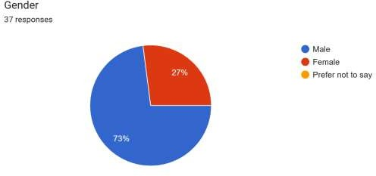

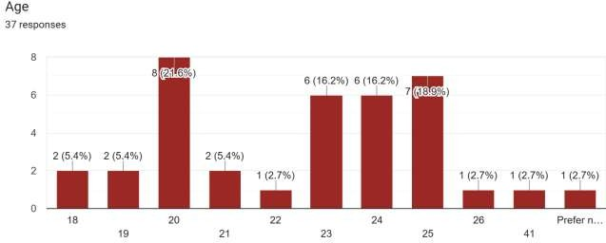

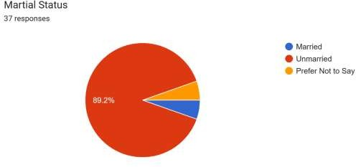

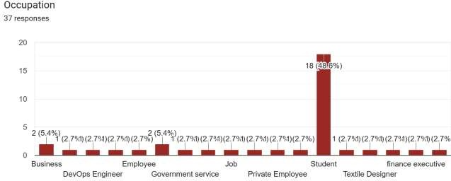



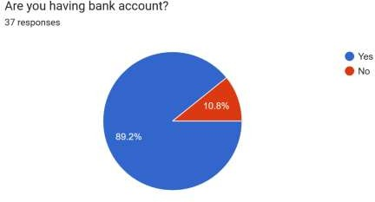

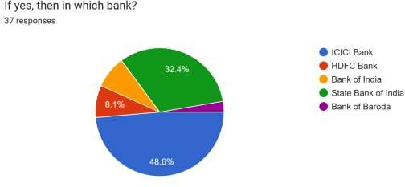

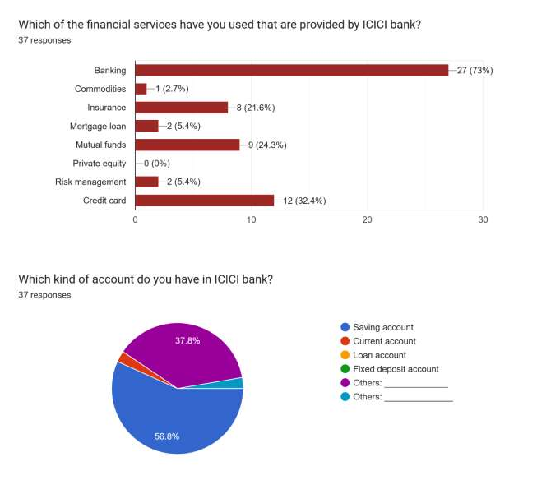

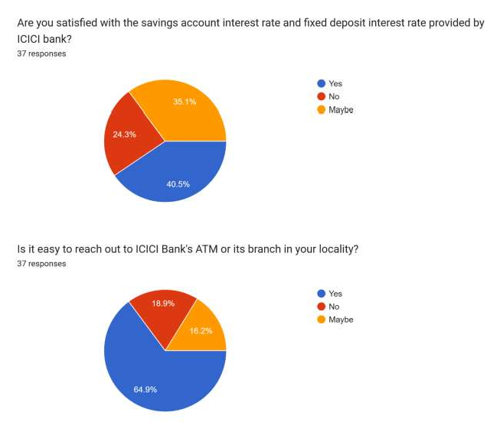

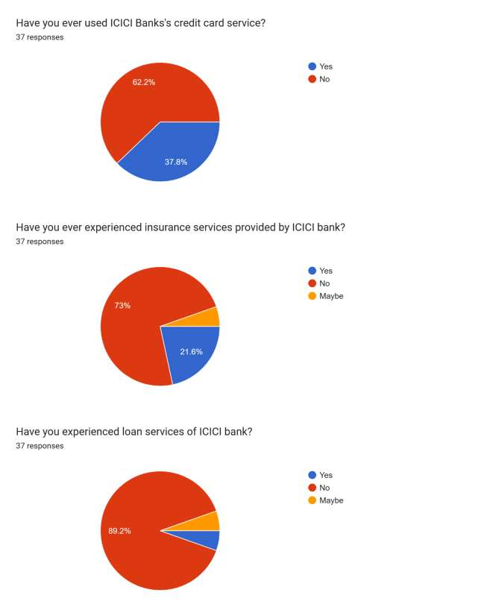

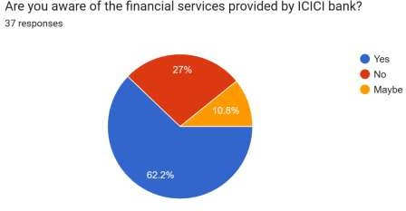

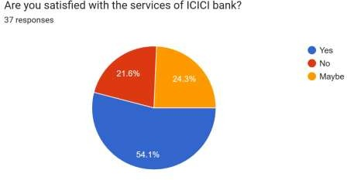

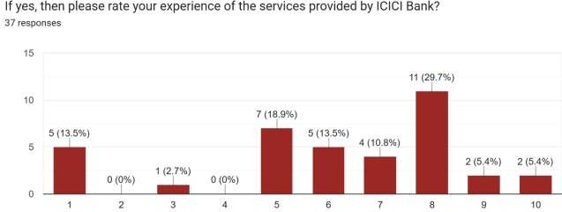

**SECONDARY DATA** - it is the data which is already collected by someone else. Researcher has to analyze the data and interprets the results. It has always been important for the completion of any report. It provides reliable, suitable, adequate and specific knowledge.

**TYPE OF DATA USED IN THE STUDY**

The required data for the study are basically secondary in nature and the data are collected from ♣ The audited reports of the company.

* INTERNET – which includes required financial data collected form ICICI Bank’s official website i.e. [www.icici.com](http://www.icici.com/) and some other websites on the internet for the purpose of getting all the required financial data of the bank and to get detailed knowledge about ICICI Bank for the convenience of study.
* Broachers of ICICI Bank.
* The valuable cooperation extended by staff members and the branch manager of ICICI bank, dharmshala contributed a lot to fulfil the requirements in the collection of data in order to complete the project

###### ANALYTICAL TOOLS APPLIED:

1. Ratio Analysis.
2. Trend Percentage.

**Financial Statements**

|  |  |  |  |  |  |
| --- | --- | --- | --- | --- | --- |
| **PROFIT & LOSS ACCOUNT OF ICICI BANK (in Rs. Cr.)** | **MAR 22** | **MAR 21** | **MAR 20** | **MAR 19** | **MAR 18** |
|  | **12 mths** | **12 mths** | **12 mths** | **12 mths** | **12 mths** |
| **INCOME** |  | | | | |
| **Interest / Discount on Advances / Bills** | **63,833.56** | **57,288.81** | **57,551.11** | **47,942.62** | **40,866.21** |
| **Income from Investments** | **16,409.27** | **16,539.78** | **14,673.21** | **12,796.88** | **11,568.17** |
| **Interest on Balance with RBI and Other Inter- Bank funds** | **1,560.83** | **1,631.91** | **682.15** | **736.09** | **663.38** |
| **Others** | **4,570.89** | **3,657.77** | **1,891.85** | **1,925.60** | **1,868.14** |
| **TOTAL INTEREST EARNED** | **86,374.55** | **79,118.27** | **74,798.32** | **63,401.19** | **54,965.89** |
| **Other Income** | **18,517.53** | **18,968.53** | **16,448.62** | **14,512.16** | **17,419.63** |
| **TOTAL INCOME** | **104,892.08** | **98,086.80** | **91,246.94** | **77,913.36** | **72,385.52** |
| **EXPENDITURE** |  | | | | |
| **Interest Expended** | **38,908.45** | **40,128.84** | **41,531.25** | **36,386.40** | **31,940.05** |
| **Payments to and Provisions for Employees** | **9,672.75** | **8,091.78** | **8,271.24** | **6,808.24** | **5,913.95** |

|  |  |  |  |  |  |
| --- | --- | --- | --- | --- | --- |
| **Depreciation** | **1,152.31** | **1,058.40** | **947.12** | **776.91** | **780.74** |
| **Operating Expenses (excludes Employee Cost & Depreciation)** | **15,889.47** | **12,397.26** | **12,394.63** | **10,503.91** | **9,009.25** |
| **TOTAL OPERATING EXPENSES** | **26,733.32** | **21,560.83** | **21,614.41** | **18,089.06** | **15,703.94** |
| **Provision Towards Income Tax** | **6,297.68** | **4,665.66** | **3,746.03** | **3,360.60** | **2,661.85** |
| **Provision Towards Deferred Tax** | **971.72** | **-675.62** | **2,371.20** | **-2,947.14** | **-2,004.72** |
| **Other Provisions and Contingencies** | **8,641.42** | **16,214.40** | **14,053.23** | **19,661.14** | **17,306.98** |
| **TOTAL PROVISIONS AND CONTINGENCIES** | **15,910.82** | **20,204.44** | **20,170.46** | **20,074.60** | **17,964.11** |
| **TOTAL EXPENDITURE** | **81,552.58** | **81,894.11** | **83,316.13** | **74,550.05** | **65,608.10** |
| **NET PROFIT / LOSS FOR THE YEAR** | **23,339.49** | **16,192.68** | **7,930.81** | **3,363.30** | **6,777.42** |
| **NET PROFIT / LOSS AFTER EI & PRIOR YEAR ITEMS** | **23,339.49** | **16,192.68** | **7,930.81** | **3,363.30** | **6,777.42** |
| **Profit / Loss Brought Forward** | **31,009.07** | **21,327.47** | **17,879.57** | **18,495.26** | **18,744.94** |

|  |  |  |  |  |  |
| --- | --- | --- | --- | --- | --- |
| **TOTAL PROFIT / LOSS AVAILABLE** | **54,348.56** | **37,520.15** | **25,810.38** | **21,858.56** | **25,522.36** |

|  |  |  |  |  |  |
| --- | --- | --- | --- | --- | --- |
|  | | | | | |
| **FOR APPROPRIATIONS** |  | | | | |
| **APPROPRIATIONS** |  | | | | |
| **Transfer To / From Statutory Reserve** | **5,834.90** | **4,048.20** | **1,982.80** | **840.90** | **1,694.40** |
| **Transfer To / From Capital Reserve** | **1,574.20** | **130.23** | **395.44** | **28.00** | **2,565.46** |
| **Transfer To / From Revenue and Other Reserves** | **0.00** | **1,500.00** | **0.00** | **350.00** | **700.00** |
| **Dividend and Dividend Tax for The Previous Year** | **0.00** | **0.00** | **645.31** | **0.00** | **0.00** |
| **Equity Share Dividend** | **1,385.23** | **0.00** | **0.00** | **965.13** | **1,457.46** |
| **Tax On Dividend** | **0.00** | **0.00** | **0.00** | **0.00** | **8.73** |
| **Balance Carried Over to Balance Sheet** | **43,671.34** | **31,009.07** | **21,327.47** | **17,879.57** | **18,495.26** |
| **TOTAL APPROPRIATIONS** | **54,348.56** | **37,520.15** | **25,810.38** | **21,858.56** | **25,522.36** |
| **OTHER INFORMATION** |  | | | | |

|  |  |  |  |  |  |
| --- | --- | --- | --- | --- | --- |
| **EARNINGS PER SHARE** |  | | | | |
| **Basic EPS (Rs.)** | **33.66** | **24.01** | **12.28** | **5.23** | **10.56** |

###### Diluted EPS (Rs.) 32.98 23.67 12.08 5.17 10.46

|  |  |  |  |  |  |
| --- | --- | --- | --- | --- | --- |
| **DIVIDEND PERCENTAGE** |  | | | | |
| **Equity Dividend Rate (%)** | **250.00** | **100.00** | **0.00** | **50.00** | **75.00** |

**Source: Dion Global Solutions Limited**

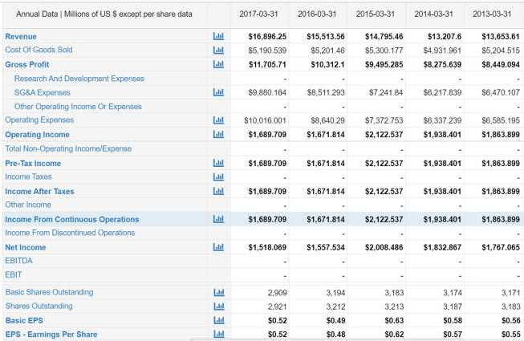

**Balance Sheet**

|  |  |  |  |  |  |
| --- | --- | --- | --- | --- | --- |
| **BALANCE SHEET OF ICICI BANK**  **(in Rs. Cr.)** | **MAR 22** | **MAR 21** | **MAR 20** | **MAR 19** | **MAR 18** |
|  | 12 mths | 12 mths | 12 mths | 12 mths | 12 mths |
| **EQUITIES AND LIABILITIES**  **SHAREHOLDE R'S FUNDS** |  | | | | |
| Equity Share Capital | 1,389.97 | 1,383.41 | 1,294.76 | 1,289.46 | 1,285.81 |
| **TOTAL SHARE CAPITAL** | **1,389.97** | **1,383.41** | **1,294.76** | **1,289.46** | **1,285.81** |
| Revaluation Reserve | 3,195.66 | 3,093.59 | 3,114.87 | 3,044.51 | 3,003.19 |
| Reserves and Surplus | 165,659.93 | 143,029.08 | 112,091.29 | 104,029.40 | 100,864.37 |
| Total Reserves and Surplus | 168,855.59 | 146,122.67 | 115,206.16 | 107,073.91 | 103,867.56 |
| **TOTAL SHAREHOLDE RS FUNDS** | **170,511.97** | **147,509.19** | **116,504.41** | **108,368.04** | **105,158.94** |

Deposits

1,064,571.

61

932,522.16 770,968.99 652,919.67 560,975.21

|  |  |  |  |  |  |
| --- | --- | --- | --- | --- | --- |
| Borrowings | 107,231.36 | 91,630.96 | 162,896.76 | 165,319.97 | 182,858.62 |
| Other Liabilities and Provisions | 68,982.79 | 58,770.37 | 47,994.99 | 37,851.46 | 30,196.40 |
| **TOTAL CAPITAL AND LIABILITIES** | **1,411,297.**  **74** | **1,230,432.**  **68** | **1,098,365.**  **15** | **964,459.15** | **879,189.16** |
| **ASSETS** |  | | | | |
| Cash and Balances with Reserve Bank of India | 60,120.82 | 46,031.19 | 35,283.96 | 37,858.01 | 33,102.38 |
| Balances with Banks Money at Call and Short Notice | 107,701.54 | 87,097.06 | 83,871.78 | 42,438.27 | 51,067.00 |
| Investments | 310,241.00 | 281,286.54 | 249,531.48 | 207,732.68 | 202,994.18 |
| Advances | 859,020.44 | 733,729.09 | 645,289.97 | 586,646.58 | 512,395.29 |
| Fixed Assets | 9,373.82 | 8,877.58 | 8,410.29 | 7,931.43 | 7,903.51 |
| Other Assets | 64,840.12 | 73,411.21 | 75,977.67 | 81,852.17 | 71,726.80 |
| **TOTAL ASSETS** | **1,411,297.**  **74** | **1,230,432.**  **68** | **1,098,365.**  **15** | **964,459.15** | **879,189.16** |

**OTHER ADDITIONAL INFORMATION**

|  |  |  |  |  |  |
| --- | --- | --- | --- | --- | --- |
| Number of Branches | 5,418.00 | 5,266.00 | 5,324.00 | 4,874.00 | 4,867.00 |
| Number of Employees | 105,844.00 | 98,750.00 | 99,319.00 | 86,763.00 | 82,724.00 |
| Capital Adequacy Ratios (%) | 19.16 | 19.12 | 16.11 | 16.89 | 18.42 |
| **KEY PERFORMANC E INDICATORS** |  | | | | |
| Tier 1 (%) | 18.35 | 18.06 | 14.72 | 15.09 | 15.92 |
| Tier 2 (%) | 0.81 | 1.06 | 1.39 | 1.80 | 2.50 |
| **ASSETS QUALITY** |  | | | | |
| Gross NPA | 33,294.92 | 40,841.42 | 40,829.09 | 45,676.04 | 53,240.18 |
| Gross NPA (%) | 4.00 | 8.00 | 6.00 | 7.00 | 0.00 |
| Net NPA | 6,931.04 | 9,117.66 | 9,923.24 | 13,449.72 | 27,823.56 |
| Net NPA (%) | 0.81 | 2.10 | 1.54 | 2.29 | 5.43 |
| Net NPA To Advances (%) | 1.00 | 2.00 | 2.00 | 2.00 | 5.00 |

|  |  |  |  |  |  |
| --- | --- | --- | --- | --- | --- |
| **CONTINGENT LIABILITIES, COMMITMENT S** |  | | | | |
| Bills for Collection | 75,150.83 | 54,643.42 | 48,216.24 | 49,391.99 | 28,588.36 |

|  |  |  |  |  |  |
| --- | --- | --- | --- | --- | --- |
| Contingent | 3,867,675. | 2,648,640. | 2,523,825. | 1,922,038. | 1,289,244. |
| Liabilities | 87 | 67 | 80 | 29 | 00 |

Source: Dion Global Solutions Limited

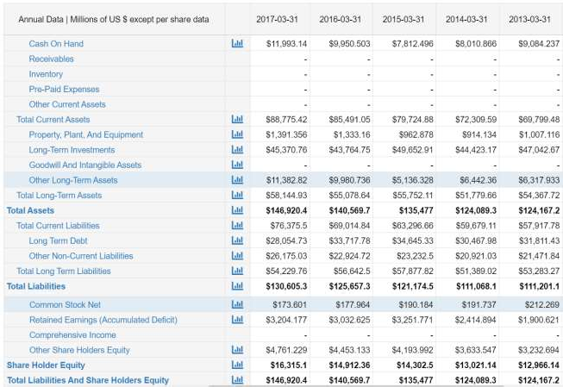

#### Cash Flow

|  |  |  |  |  |  |
| --- | --- | --- | --- | --- | --- |
| **CASH FLOW OF ICICI BANK (in Rs.**  **Cr.)** | **MAR 22** | **MAR 21** | **MAR 20** | **MAR 19** | **MAR 18** |
|  | 12 mths | 12 mths | 12 mths | 12 mths | 12 mths |
| **NET PROFIT/LOSS BEFORE EXTRAORDINARY ITEMS AND TAX** | **30,608.89** | **20,182.72** | **14,048.04** | **3,776.76** | **7,434.56** |
| Net Cashflow from Operating Activities | 55,046.93 | 124,093.36 | 78,449.44 | 38,418.79 | 13,303.65 |
| Net Cash Used in Investing Activities | -35,035.45 | -53,491.40 | -37,107.40 | - 23,875.31 | - 38,968.80 |
| Net Cash Used from Financing Activities | 14,868.04 | -55,935.32 | -2,644.55 | - 18,251.09 | 34,118.30 |
| Foreign Exchange Gains / Losses | -185.40 | -694.13 | 161.97 | -165.48 | 3.17 |
| **NET INC/DEC IN CASH AND CASH EQUIVALENTS** | **34,694.11** | **13,972.51** | **38,859.45** | **-3,873.09** | **8,456.32** |
| Cash And Cash Equivalents Begin of Year | 133,128.25 | 119,155.74 | 80,296.29 | 84,169.38 | 75,713.06 |
| Cash And Cash Equivalents End of Year | 167,822.36 | 133,128.25 | 119,155.74 | 80,296.29 | 84,169.38 |

Source: Dion Global Solutions Limited

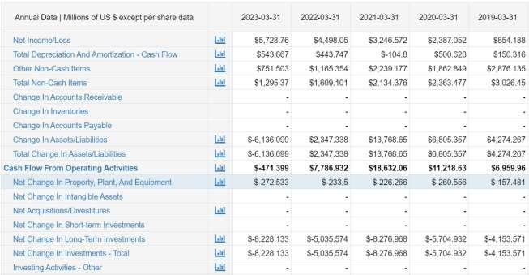

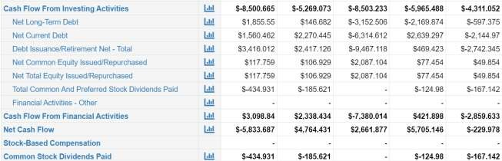

**Analytics**

#### CASA %

###### =CASA Deposits / Total Deposits

|  |  |  |  |  |
| --- | --- | --- | --- | --- |
| **2022** | **2021** | **2020** | **2019** | **2018** |
| **48.69** | **46.28** | **45.11** | **49.61** | **51.68** |

**Interpretation**

###### In this Chart You can see

In 2022 the CASA% is 48.69.

In 2021 the CASA% is 46.28

In 2020 the CASA% is 45.11

In 2019 the CASA% is 49.61

In 2018 the CASA% is 51.68

#### ROCE (%)

###### =EBIT / Total Assets – Total current liabilities

|  |  |  |  |  |
| --- | --- | --- | --- | --- |
| **2022** | **2021** | **2020** | **2019** | **2017** |
| **2.92** | **3.10** | **2.67** | **2.52** | **2.92** |

**Interpretation**

###### In this Chart You can see

ROCE% of 2022 is 3.92

ROCE% of 2021 is 3.10

ROCE% of 2020 is 2.67

ROCE% of 2019 is 2.52

ROCE% of 2018 is 2.92

1. **Net Profit Margin (%)**

**= Net Income / Revenue**

|  |  |  |  |  |
| --- | --- | --- | --- | --- |
| **2022** | **2021** | **2020** | **2019** | **2018** |
| **27.02** | **20.46** | **10.60** | **5.30** | **12.33** |

###### Interpretation

**In this Chart You can see**

Net profit margin of 2022 is 27.02 Net profit margin of 2021 is 20.46 Net profit margin of 2020 is 10.60 Net profit margin of 2019 is 5.30 Net profit margin of 2018 is 12.33

1. **Return on Assets (%)**

**=Net Income / Total Assets**

|  |  |  |  |  |
| --- | --- | --- | --- | --- |
| **2022** | **2021** | **2020** | **2019** | **2018** |
| **1.65** | **1.31** | **0.72** | **0.34** | **0.77** |

###### Interpretation

**In this Chart You can see**

The return on assets of 2022 is 1.65 The return on assets of 2021 is 1.31 The return on assets of 2020 is 0.72 The return on assets of 2019 is 0.34 The return on assets of 2018 is 0.77

1. **Return on Equity**

###### =Net Income / Shareholder’s Equity

|  |  |  |  |  |
| --- | --- | --- | --- | --- |
| **2022** | **2021** | **2020** | **2019** | **2018** |
| **13.94** | **11.21** | **6.99** | **3.18** | **6.63** |

**Interpretation**

###### In this Chart You can see

The Return on Equity of 2022 is 13.94 The Return on Equity of 2021 is 11.21 The Return on Equity of 2020 is 6.99 The Return on Equity of 2019 is 3.18 The Return on Equity of 2018 is 6.63

1. **Cost to Income (%)**

#### =Non interest Expenditure / net total income

|  |  |  |  |  |
| --- | --- | --- | --- | --- |
| **2022** | **2021** | **2020** | **2019** | **2018** |

|  |  |  |  |  |
| --- | --- | --- | --- | --- |
| **40.65** | **42.57** | **45.79** | **48.98** | **46.51** |

###### Interpretation

**In this Chart You can see**

The cost of Income of 2022 is 40.65 The cost of Income of 2021 is 42.57 The cost of Income of 2020 is 45.79 The cost of Income of 2019 is 48.98 The cost of Income of 2018 is 46.51

1. **Earning Yield ratio**

### =Earning / Price

|  |  |  |  |  |
| --- | --- | --- | --- | --- |
| **2022** | **2021** | **2020** | **2019** | **2018** |
| **0.5** | **0.4** | **0.4** | **0.1** | **0.4** |

###### Interpretation

**In this Chart You can see**

The earning yield ratio of 2022 is 0.5 The earning yield ratio of 2021 is 0.4 The earning yield ratio of 2020 is 0.4 The earning yield ratio of 2019 is 0.1 The earning yield ratio of 2018 is 0.4

1. **Current Ratio**

= **current assets / current liabilities**

|  |  |  |  |  |
| --- | --- | --- | --- | --- |
| **2022** | **2021** | **2020** | **2019** | **2018** |
| **0.76** | **0.65** | **0.56** | **0.62** | **0.59** |

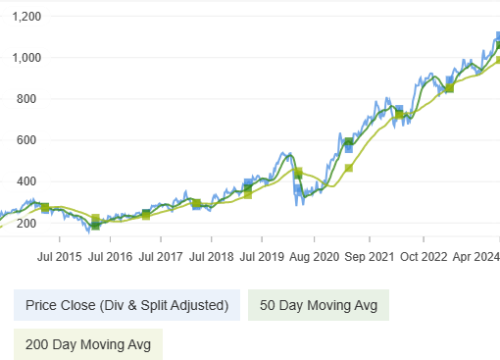

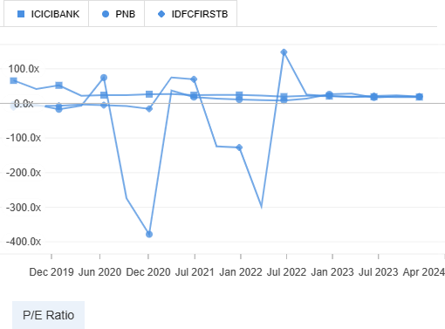

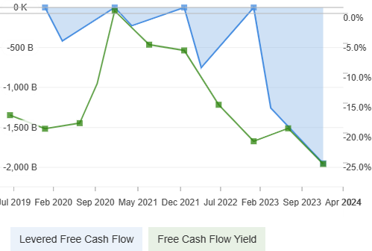

#### Interpretation

**In this Chart You can see**

current ratio of 2022 is 0.76

current ratio of 2021 is 0.65

##### current ratio of 2020 is 0.56

current ratio of 2019 is 0.62 current ratio of2018 is 0.59

#### P|E ratio

=**Share price \ Earning per Share**

|  |  |  |  |  |
| --- | --- | --- | --- | --- |
| **2022** | **2021** | **2020** | **2019** | **2018** |
| **20.17** | **21.35** | **21.86** | **60.59** | **23.16** |

###### Interpretation

In this table you clearly seen that 2022 P|E is 20.17

2021 P|E is 21.35

2020 P|E is 21.56

2019 P|E is 60.59

2018 P|E is 23.16

#### Findings

* 1. In this Chart you clearly seen that Current account Saving Account percentage of 2022 is **48.69%** which means **48.69%** of total deposits are contributed by low-cost CASA deposits.

**Interpretation** The CASA Ratio of ICICI bank from last five years is increasing it means that the company has a good **net interest margin** which means good operation efficiency of the bank. ICICI are more focus to increase their funds.

* 1. Capital Employed percentage of 2022 is lesser than 2021 that is from **3.10 to 2.92** it means that there could be spending funds Unproductively.

**Interpretation** In financial Statements it is clearly seen that the company are not generating a **positive financial return** in comparison of year 2021.

* 1. Net profit Margin Percentage of 2022 is increasing to **27.02**% in comparison of Year 2021

**Interpretation** The net profit margin of ICICI bank is increasing from last five year it means that company are able to manage our **operational efficiency**.

* 1. Return on assets percentage increasing consistently from year **2019** that means company are able to make profit from their assets.

**Interpretation** It means that the company is so much efficient in generating profit from their total assets on their **balance sheet.**

* 1. Return on Equity percentage is also increasing Consistently from year 2019.

**Interpretation** It means the ICICI are able to manage the capital that shareholders have invested in it. The higher the ROE the more efficient a company’s management is at generating income and growth from its equity financing.

* 1. Cost to Income Percentage is decreasing in 2022 to 40.65 it means company is more efficiently a bank operates which results in increased profitability.

**Interpretation** The cost to income is decreasing from past five years it means that the ICICI is more efficient which result in increased profitability.

* 1. earning yield ratio is increasing in 2022 in comparison of year 2020 which means low yield bond is better for investor who wants virtually risk-free debt.

**Interpretation** The earning yield ratio is increasing from the past five years it means that Shares might be undervalued and worth looking into in more details for consideration as a new investment.

* 1. Current ratio is increasing to 0.76 in year 2022.

**Interpretation** The current ratio is increasing from the last five years that measures a company ability to pay short term obligations or those due within one year.

* 1. P|E ratio less than 20 P|E ratio is good for some investment above 20 it can be risky.

**Interpretation The** P|E Ratio of ICICI bank is quite good from the past five years it is approximately 20-24 it means that the investors may invest because near 20 P|E will be the best P|E to invest in any company.

# Conclusion

**Conclusion**

On the basis of various techniques applied for the financial analysis of ICICI Bank we can arrive at a conclusion that the financial position and overall performance of the bank is satisfactory.

The return on Capital employed of ICICI bank is reducing to 2.92 from the year 2020 it means that the potential signal that the company could be spending funds more unproductivity.

The bank has succeeded in increasing its Net profit margin also which has increased around in the last 5 years. The major achievement of the bank has been a tremendous increase in its deposits, which has always been its main objective. Fixed and current deposits have also shown an increasing trend. The CASA Ratio of ICICI bank from last five years is increasing it means that the company has a good **net interest margin** which means good operation efficiency of the bank. ICICI are more focus to increase their funds.

Equity shareholders are also enjoying an increasing trend in the return on their capital. Though current assets and liabilities (current liquidity) of the bank is not so satisfactory but bank has succeeded in maintaining a stable solvency position over the years. As far as the ratio of external and internal equity is concerned, it is clear that bank has been using more amount of external equity in the form of loans and borrowings than owner’s equity. Bank’s investments are also showing an increasing trend. Due to increase in advances, the interest received by the bank from such advances is proving to be the major source of income for the bank.

# ANNEXURES

#### Bibliography:

###### Books Referred:

* Accountancy. R.K. Mittal, A.K. Jain.
* Financial Management- Theory and Practice. Shashi.K. Gupta, R.K. Sharma.
  + Essentials of Corporate Finance 2nd edition, Irwin

/McGraw-Hill. Ross, S.A., R.W. Westerfield and

B.D. Jordan.

* + Basic Financial Management ,8th edition

,Prentice -Hall,Inc. Scott, D.F., J.DMartin,

J.W. Petty and A.Keown.

#### Internet websites:

* [Www.Icicibank.Com](http://www.icicibank.com/)
* [Www.Moneycontrol.Com](http://www.moneycontrol.com/)
* [WWW.Money.Rediff.Com](http://www.money.rediff.com/)
* [Www.Wikipedia.Org](http://www.wikipedia.org/)
* [Www.Google.Com](http://www.google.com/)
* [Www.Scribd.Com](http://www.scribd.com/)
* [Www.Managementparadise.Com](http://www.managementparadise.com/)

Thank You