**Master’s Thesis On**

# **Store Operation on V2 Retail Limited**

**FOR THE PARTIAL FULFILLMENT OF THE REQUIREMENT**

**FOR THE AWARD OF**

**MASTER OF BUSINESS ADMINISTRATION**

**UNDER THE GUIDANCE OF**

**Asst.Prof. Reji John**

**Submitted By**

**Bineesha Jaisawal**

**22042010521**

**MBA 2022-2024**



**School of Business**

**Galgotias University**

**May, 2024**

**Abstract:**

This research paper explores the retail marketing strategy adopted by V2 Retail Limited, a major player in the Indian retail industry. The aim of this study is to understand the relationship between store performance and customer satisfaction in the context of V2 Retail Limited's operations. Quantitative analysis of indicators. Primary data was collected through interviews with store managers and employees and surveys of V2 Merchants. Secondary data was obtained from company records, industry publications, and academic records. These ideas are evaluated according to their impact on the market and customer satisfaction. By relating these metrics to various store operations, the study aims to identify patterns and relationships that contribute to overall customer satisfaction. Positive impact on the store's customer satisfaction. In particular, factors such as product availability, employee performance, and store cleanliness are important determinants of customer satisfaction. From a theoretical perspective, this research contributes to the understanding of the relationship between marketing and customer satisfaction. In fact, the findings provide V2 Retail Limited with an insight to optimize its store and improve customer experience to be competitive in the retail environment.

**Introduction**

V2 Retail is a publicly listed company.

The focus of V2 Retail is to sell apparel although it does have other range of products such as Lifestyle, General Merchandise, and Mix, etc.

V2 Retail works under Value format i.e. in low price segment the focus of V2 is more. The focus is more on opening stores in Tier 3, and Tier 4 cities.

The target customers are from the Lower, Lower Middle to Middle Classes.

V2 Retail currently operates in 4 Zones in India - North, South, North East, and East.

V2 Retail has a good & strong presence in North East and Eastern regions of India.

V2 Retail purchases from multiple vendors while also producing apparel of their own. The in-house Manufacturing is handled by the Production dept. Buying and Merchandising engages in buying from vendors and they also coordinate with the Production dept.

The Production of apparel takes in 3 broad formats. Look wise, Set Wise, and Mix in Value format.

Set-wise production is done in-house.

The focus of V2 Retail is generating money from sales in stores (retail outlet focus) and that money is re-invested to boost sales in stores while also focusing on opening new stores. Recently the company has also started its E-commerce outlet named v2kart.com. The company also wants to focus on B2B sales and there are plans to boost that part as well.

Currently, the revenue is generated mostly from the Eastern region due to its strong presence

On average 30% Gross Margin is maintained by the company.

Retail stores under V2 Retail have divisions. These are men, Ladies, Kids, Household items, etc.

Each store model is based on layout which is decided by the company beforehand based on the area available. Generally, the store area ranges from 7000-15000 sq feet.

The company has 4 Segments of products based on price band. These 4 segments have been created under every Division for monitoring sales, purchases, planning, etc at the article level. The 4 Segments are listed below

1) Economy: Rs 150 max (Crowd Puller category) Based on this affordable category customers visit the store.

2) Value: Rs 500 max (Crowd Enhancement category) The company has trained the store staff to persuade customers to purchase goods in higher segments as they have more margin.

3) Premium: Rs 999 max. This is also used for crowd enhancement however the customers who are already looking at products from the Value category will be interested to purchase in this category.

4) Super-Premium: Rs 1000 starting with no upper cap in a few categories (Could even go to Rs 5000 for occasion wear products). These products are used for customer gradation where a customer is pushed to purchase products that give high margins to the company.

**Review of literature**

**Financial Reports and Statements:** Review the company's annual reports, quarterly reports, and financial statements. These documents provide insights into the financial health, performance, and strategy of the company.

**News Articles and Business Publications:** Look for news articles, business magazines, and publications that feature information about V2 Retail Limited. These sources can provide recent developments, market analysis, and expert opinions.

**Company Websites and Investor Relations:** Visit the official website of V2 Retail Limited and explore the investor relations section. Companies often provide detailed information, presentations, and updates for investors.

**Social Media and Online Discussions:** Check social media platforms and online forums for discussions related to V2 Retail Limited. While not scholarly, these sources can provide insights into public opinions and sentiments.

**The objective of v2 retail**

**Focus on Efficiency and Performance:**

* Analyze V2 Retail's current store operations to identify areas for improvement in efficiency, inventory management, and customer service.
* Evaluate the impact of V2 Retail's omnichannel strategy (including online and physical stores) on store performance and profitability.
* Benchmark V2 Retail's store operations against industry best practices and identify potential areas for adaptation.

**Strategic Growth and Expansion:**

* Examine V2 Retail's recent store expansion plans and assess the company's strategy for reaching new markets and customer segments.
* Analyze the effectiveness of V2 Retail's current store location strategy and suggest potential improvements for future expansion.
* Investigate the impact of technology on V2 Retail's store operations and explore how the company can leverage technology to enhance the customer experience.

**Sustainability and Social Impact:**

* Evaluate V2 Retail's current store operations in terms of environmental sustainability and social responsibility.
* Explore how V2 Retail can improve the sustainability of its supply chain and in-store operations.
* Investigate the impact of V2 Retail's store operations on local communities and suggest strategies for positive social impact.

**Customer Experience and Satisfaction:**

* Analyze customer satisfaction with V2 Retail's store operations, including factors like store layout, product availability, and staff interaction.
* Investigate emerging trends in retail customer experience and propose ways for V2 Retail to adapt and improve.
* Evaluate the effectiveness of V2 Retail's loyalty programs and in-store promotions in driving customer engagement and sales.

**Research Methodology**

There are many ways to get information. The methods used are:

* Research Design
* Data Collection
* Primary Research
* Questionnaire Surveys
* Talking with people
* Personal interviews
* Telephone surveys
* Secondary Research
* Literature Searches
* Through the Internet and Periodicals
* Sampling Procedure
* Analysis of Data.
* Conclusion

# Process adopted:

Gaining information about the store operations: Perusing the store operations was the to begin with step embraced. This gave not as it were in-depth information approximately what is been advertised by the stores but moreover demonstrated valuable whereas creating the questionnaire.

**Research Design**

We carried out the explore utilizing a combination of basic and assistant data. In this way the ask almost is arranged with a combination of:

Exploratory Examine Pla

Graphic Ask around Design

**Exploratory Investigate**

As I was ignorant of the store operations, exploratory ask approximately made a contrast me to amass information from the assistant resources. I implied to distinctive magazines, the Internet, industry connection reports, etc., and was able to collect information on merchandising.

**Descriptive Plan**

After conducting the exploratory examine, for development concrete inconspicuous components with regard to distinctive store players, I turn to the Realistic Arrange of grandstand examine. Underneath this, I have analyzed the patient's behavior on particular parameters. The Expressive arrange has given me a superior understanding into the exhibit within the Retail Industry by bringing to the fore various scaled down unpretentious components with regard to customer slants. It has empowered a distinction in a cautious examination of the assistant data and refined the needed data by making the objective clearer.

**Descriptive Arrange utilizing the taking after strategies:**

Qualitative Strategies:

* Survey Survey
* Talking to the customers

**Quantitative Methods:**

Information Collection

The whole request is based on fundamental data as well as assistant information.

Primary Information:

Primary data was collected through the overview from the diverse stores.

**Secondary Information:**

Secondary data was collected through magazines,

Secondary Information: Auxiliary information was collected through magazines, daily papers, store catalogs, and notices.

**Data Analysis**

**Survey for Consumers**

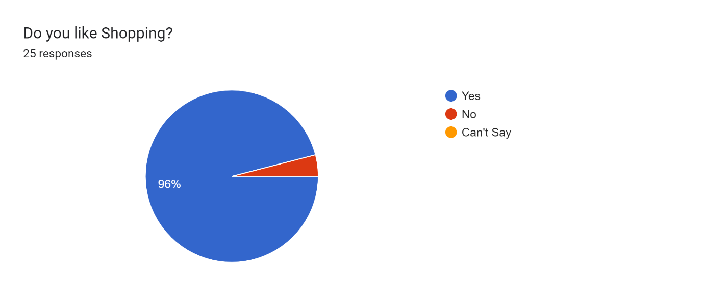

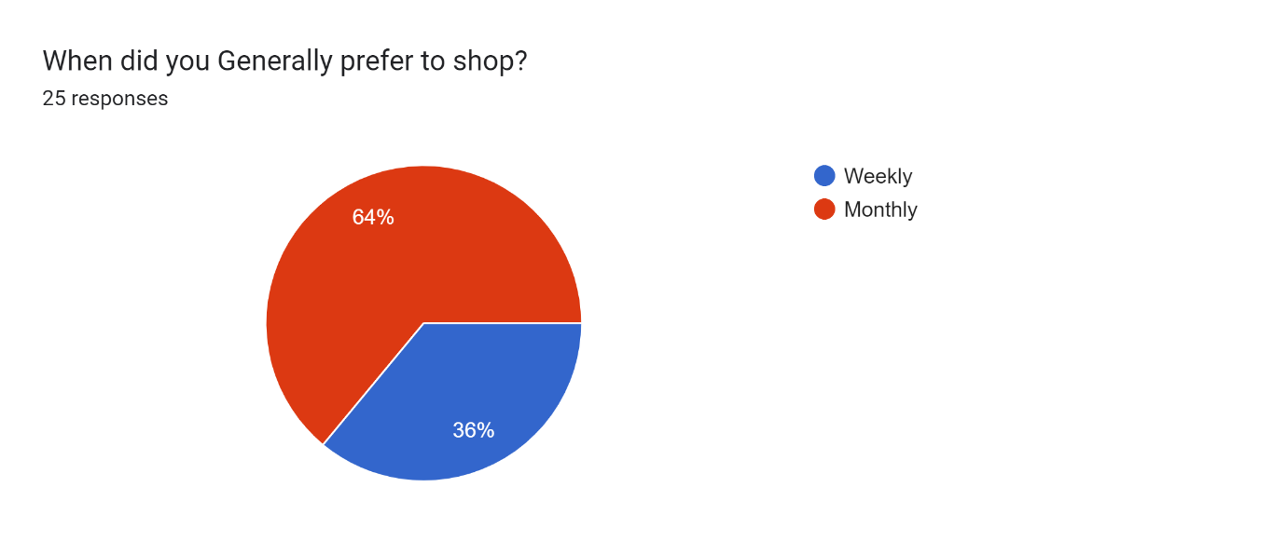

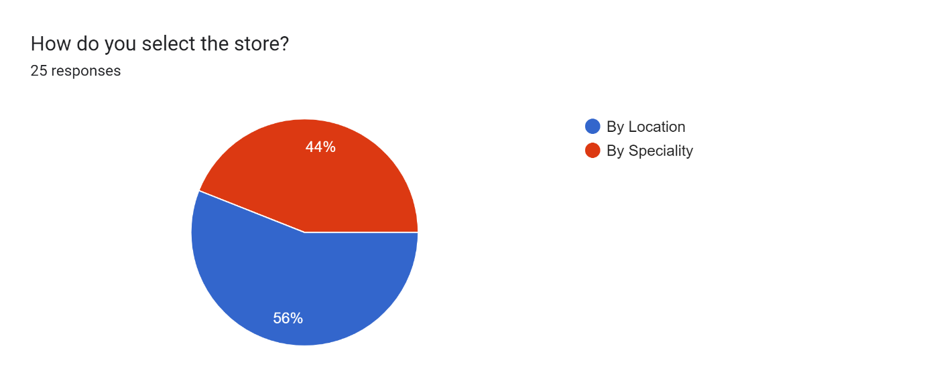

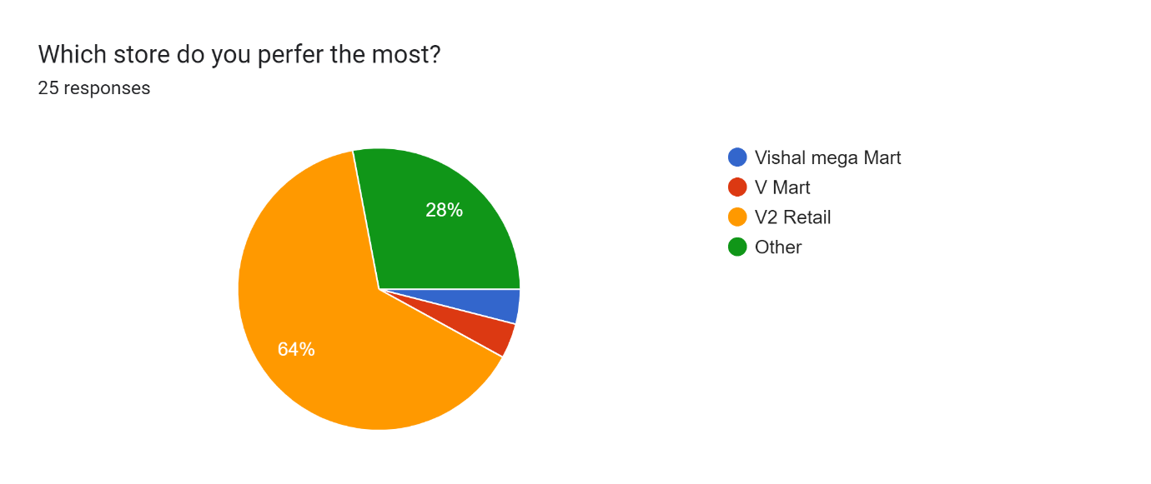

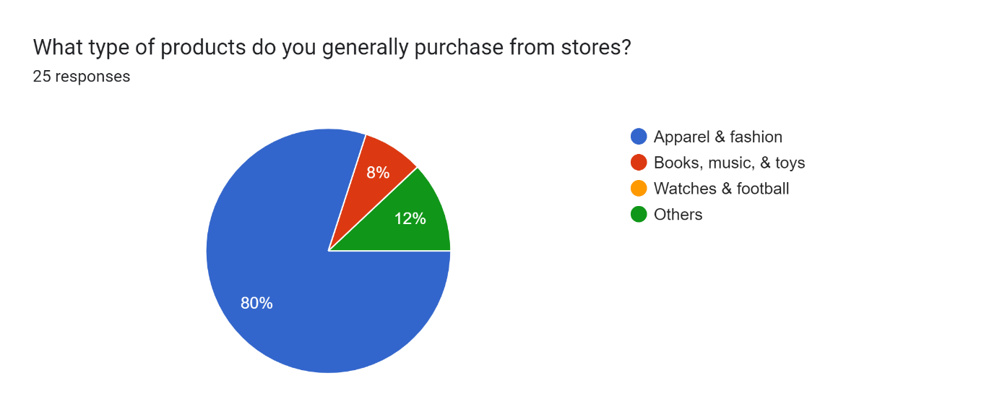

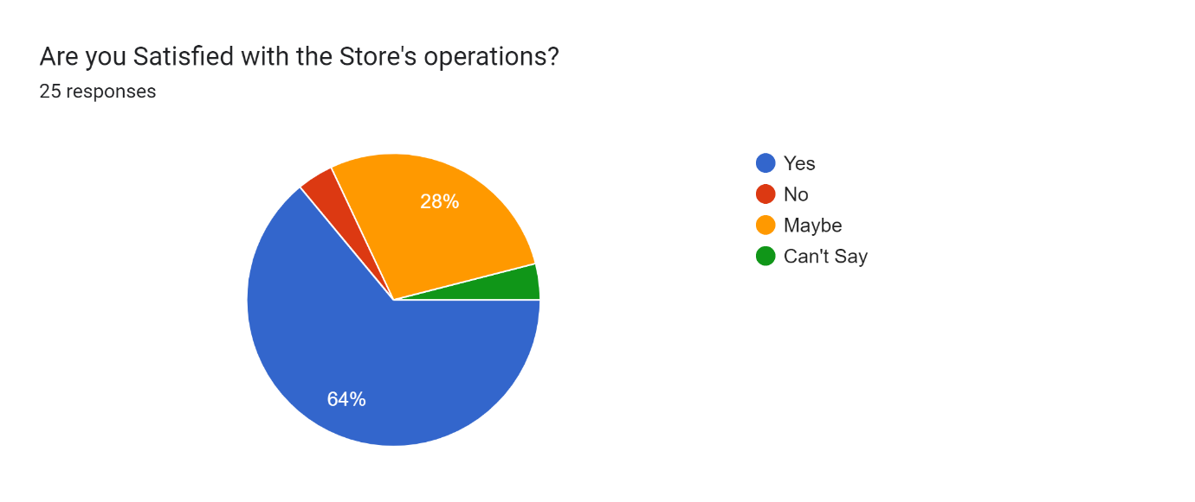

**Recommendations**

Promotional exercises are one of the essential things that are required inside the company. Amid my visits to distinctive companies, I came across the fact that there is no mindfulness of the company in the shape of blurbs, stands, and other related things. One thing that I would like to prescribe would be the presentation of more special exercises to produce more income for the company. The company can present more--

Schemes

Get together for channel partners

Brand acknowledgment in the market

To Keep more inventories

Advertisements in a mechanical region

**Focus more on “b” and “c” category Companies -** This is moreover one of the prime things that are required. With around 80% of the incomes coming from less than 20% of the Companies, more center ought to be given to 'b' and 'c' category companies.' A' category specialists are said to be the specialists who contribute more than Rs.50000 of incomes per month. Companies ought to center more on 'b' and 'c' category clients so that more of these clients can be changed over to the 'a

category.

**Coordination among diverse channels-** With the organization office in a diverse building and no coordinated control over the area operations, straightforwardness between diverse channels is missing. With the arrangement for administrators that I have proposed over, there seems to be more straightforwardness that can come in the general operations of the NCR region.

**Different commission pieces for diverse channels-** With commissions being one of the prime thought processes for the Deals Official to do commerce with distinctive companies, more and more accentuation ought to be given to the commissions that are rendered to the agents.

Very constrained corporate tie This ought to be one of the most imperative things that ought to be the motivation for the travel category. A corporate tie-up can effectively provide a trade of more than 50000 per month. Other than that, the contract is on a long-term premise. This hence makes a difference in getting an simple commerce for the company. Hence, from my point of see, more accentuation ought to be given to this category of trade as well**.**

**SWOT Analysis of V2 Retail Limited**

**Strengths:**

• **Strong Brand Portfolio:** V2 Retail claims a collection of set up brands like Godspeed, Herrlich, and Glamora, each **catering to particular client segments.**

**• Distribution Organize:** They have a well-developed arrange of departmental stores and claim to fame stores over India, coming to a wide audience.

• **Established Connections:** V2 Retail likely has solid connections with producers and providers due to their bulk buying practices.

**• E-commerce Nearness: Their** online stage, [invalid URL expelled], permits them to grow their reach past physical stores.

**Weaknesses:**

**• Limited Item Extend:** V2 Retail centers on attire and adornments, which might limit their advertise share compared to retailers advertising a more extensive assortment of products.

**• Dependence on Physical Stores:** Whereas they have an online nearness, their dependence on physical stores might make them defenseless to changing buyer propensities towards e-commerce.

**• Competition:** The Indian retail showcase is exceedingly competitive, with built up players like Aditya Birla Mold and Retail and Max Mold competing for showcase share.

**Opportunities:**

**• Growing Retail Advertise:** The Indian retail showcase is anticipated to involvement noteworthy development in the coming a long time. V2 Retail can capitalize on this by growing its item offerings or topographical reach.

**• Omnichannel Methodology:** A more grounded center on joining online and offline shopping encounters can give more comfort to customers.

• **Private Name Improvement:** Creating their private name brands might move forward benefit edges and brand recognition.

**Threats:**

• **Economic Downturn:** An financial lull may lead to diminished buyer investing, affecting V2 Retail's sales.

• **Rising Costs:** Vacillations in crude fabric costs or purport obligations seem increment V2 Retail's working costs.

• **Changing Customer Inclinations:** Advancing mold patterns and buyer inclinations towards economical or morally sourced clothing may require adjustment for V2 Retail.

**Conclusion**

Given the brand awareness created recently, V2 Retail Constrained has been accepted and continues to be used and is associated with customers recommending the same products to their colleagues. It can also be seen that customers will not use the limited products of V2 stores, but this is almost a consensus. The purpose of V2 stores is not to make sales, it is a store that the seller uses in the customer's mind, affects him by creating conflict between V2 stores, limits the product, and is affected by all kinds of images of the product. Therefore, the visual type is equalized with the visual type, and the tags contribute to the creation of the visual type. Their closeness to their customers, the benefits they offer and the relationships they maintain with their customers have helped V2 Retail Limited companies create and recreate the image they share with their customers. Promotion and management, which refers to the development of the business through the execution of quality and effort, can make any business combination successful if correct. Progress and entrepreneurship are often seen in the fields of innovation, medicine, manufacturing, conservation and finance. Promotions and assets that make it visible and marketable include: . Reputation often depends on quality and performance. Generally speaking, as long as these two criteria are met, automatic devices can also produce verbal messages. Professionals, company leaders, and celebrities make the best word of mouth. In addition, social merchants have created a vast marketplace for direct and successful marketing of products and brands to consumers and other retailers. V2 for retail limited companies. He said there is no doubt that V2 Retail Restricted India will probably grow at a doubledigit rate, but V2 Retail Restricted has a long way to go in convincing consumers to learn more about them, which is perfect for potential buyers. . Basically, the customer has a positive perspective and since it is not clear how good the image is, it is not clear whether it will turn into a business. Clothes are more beautiful and decorated to match one's fashion and personality, and in the future, all products will become products. The key to presenting well and exceeding expectations depends on the person who knows how to get customers to agree and sell. The product because the final product survives and is sold.