**INTEGRATED FAULT DETECTION SYSTEM FOR UNDERGROUND LINES USING ESP32 AND LORA COMMUNICATION**

Arulkumar D[1],Kanojesh T [2], Moghith M [3], Yuvaraj R[4]

1,2,3,4 Department of ECE, IV year, Panimalar Institute Of Technology, Chennai, Tamil Nadu

**Abstract**

The ESP32 microcontroller, which functions as a central processing unit in charge of coordinating numerous functionalities, is the primary component of the system. Six toggle switches, each designated to monitor a certain geographical segment, are positioned strategically along the subterranean lines to form the detection mechanism.When a malfunction occurs, the associated toggle switch is activated. The GPS location data is smoothly coordinated by the system to be transmitted to the LoRa communication device. An LED indicator is also used to provide instantaneous visual feedback. Real-time updates on the system's operational status are provided by an LCD display unit. Utilizing IOT technology, the LORA communication device on the receiving end safely accepts the transmitted data and sends it to cloud infrastructure.

**Keywords**

**Fault detection, Realtime updates, LoRa communication, location via GPS, LED indicator, Visual feedback, Cloud infrastructure, IOT technology.**

**I.INTRODUCTION**

Because of the subsurface environment, deterioration, rodents, etc., underground cables are vulnerable to a wide range of problems. It is also challenging to identify the cause of a defect, and digging the entire line is necessary to inspect and correct faults. Thus, we present a cable failure detection over IoT solution that precisely locates the defect and facilitates easy repair operations. Repairmen know precisely which section is broken, and only that region needs to be excavated. In order to find the root of the problem. This enables quicker maintenance of subterranean cables while also saving a great deal of time, money, and effort. We employ IoT technology, which enables online defect monitoring and checking by the authorities. Six toggle switches, each designated to monitor a particular location segment along the subterranean lines, are strategically positioned to aid the system in fault detection. When a defect occurs, the associated toggle switch is activated, which quickly starts the fault detection procedure. The microcontroller detects this and updates the user. Through LoRa Communication

technology, the data is transmitted to the station, which is situated at a certain distance. This data transmission system makes sure that crucial information about the exact location of the defect is transmitted to the control station. Furthermore, an LED indication is used to give instantaneous visual input, making it possible to quickly identify fault occurrences. The microcontroller receives the fault line data and sends it over the internet for online display in addition to displaying it on an LCD display.

**II.RELATED WORKS**

Several studies have explored driver impairment detection using various approaches.

Title 1: Cable Fault Detection -Optical Fiber Current Sensor Cable Link Noise Reduction

In fiber optic current sensors, two main parts, the sensor head unit and the drive/control/chassis unit, are connected by optical fiber cable links. The fiber link carries measurement information from the sensor to an electronics chassis faraway. The optical cable can be wrapped around the main high voltage/current conductors to reduce cost. However, a fiber wrapped around the conductor will have an induced Faraday effect due to the power conductor magnetic field. This creates an unwanted current signal pickup. Also, vibrational pickup due to the macro and micro bend loss of this fiber cable is present as well. These unwanted signals interfere with electric current measurement in a very problematic and erratic way. We have demonstrated by employing optical depolarizers in the sensor fiber link a method of reducing unwanted vibrational and current pickup in the sensor.

Title 2: Underground Cable Fault Location via Random Forest Algorithm.

In recent years, Metropolitan Electricity Authority (MEA) has increasingly replaced the overhead lines with underground cables in Bangkok Metropolitan Area. This is to improve the efficiency and reliability of the distribution system, and also the esthetic quality of the landscape. However, the processes of locating and repairing underground cable faults are generally more difficult and time-consuming than those for overhead lines. This article proposed the use of Random Forest algorithm to locate faults for medium voltage underground cables. When tested on the MEA’s open-loop underground cable system, this algorithm was capable of finding the fault locations with high accuracy, and can serve system operators and crew staff as a guideline for an efficient system service restoration.

Title 3: Fault Location in Underground Cable System Using Optimization Technique

This paper presents a way for endeavoring cable fault distance location by using an optimizing technique. The proposed scheme aims to model and test the two popular cable fault location methods i.e. Murray and Varley loop. The modelling of the bridge circuits of Murray and Varley loop are implemented in MATLAB environment. Using optimization algorithms, both implemented platforms of Murray and Varley loop test, locate the earth faults and short circuit fault in underground cables accurately. The proposed platforms are useful to study the concept of optimization techniques in combination with the conventional cable fault location methods. Here Box’s evolutionary multivariable optimization technique is used for calculating two resistance variable function of the Murray Loop and Bisection Method which converges to a single optimum root is used for calculating single resistance variable of the Varley Loop for balancing the bridge circuit. The simulation results confirm that the proposed scheme assess the fault location with minimum error and is unaffected to variation in fault distance, fault resistance, and fault inception angle.

Title 4: Fault Identification of High-voltage Cable Sheath Grounding System Based on Ground Current Analysis

In order to reduce the induced voltage of the metal sheath of the high-voltage cable, the metal sheath of the high-voltage cable is usually cross-connected in the transposition box of the cable cross-interconnection. In the process of reconnecting the cable line, the transposition is easy to be connected backwards, or even wrong. In addition, there will be many situations such as moisture, water intrusion, external force damage, resulting in cross-interconnection failures in the metal sheath of the high-voltage cable. Cross connect faults need to be dealt with in time. The paper analyzes the cross-connect faults of 110kV XLPE high-voltage cables, and uses PSCAD electromagnetic transient software to model and simulate. Simulation results summarize the characteristics of grounding current changes under different sheath faults. The results can provide a theoretical basis for the fault detection of the cable cross transposition system.

Title 5: Cross-Point Resistive RAM Based on Field-Assisted Super linear Threshold Selector.

We report a 3-D-stackable 1S1R passive cross-point resistive random access memory (RRAM). The sneak (leakage) current challenge in the cross-point RRAM integration has been overcome utilizing a field-assisted super linear threshold selector. The selector offers high selectivity of >107, sharp switching slope of 1011. Furthermore, we demonstrate 1S1R integration in which the selector subthreshold current is 102 memory ON/OFF ratio and >106 selectivity during cycling. Combined with self-current-controlled RRAM, the 1S1R enables high-density and high-performance memory applications.

**III.METHODOLOGY**

**Diagram**

**ESP32**

**POWER SUPPLY**

**TOGGLE SWITCH (6)**

**I2C**

**GPS**

**LCD**

**LORA TX**

**RED LED (2)**

**Fig 1.Block diagram for cable fault detection transmitter section**

**ESP32**

**POWER SUPPLY**

**LORA RX**

**IOT**

**Fig 2. Block diagram for cable fault detection receiver section**

**FAULT DETECTION:** In this module, we utilize the ESP32 microcontroller as the central processing unit, serving as the brain of our system. The underground fault detection is initiated manually through toggle switches strategically placed along the lines. If any toggle switch is triggered (turned off), it automatically detects the occurrence of an underground line fault. An LED serves as an indicator for streetlight fault detection, providing immediate visual feedback. Additionally, an LCD display presents the current system status, enabling easy monitoring and management.

**ESP32**

**POWER SUPPLY**

**TOGGLE SWITCH (6)**

**I2C**

**LCD**

**RED LED (2)**

**Fig 3. Block diagram for fault detection**

**RECEIVING SECTION:** In this receiving section, we employ the ESP32 microcontroller as the central processing unit, functioning as the core of our system. Within this module, we integrate an IoT controller, specifically the ESP8266 microcontroller. Upon the occurrence of a line fault, the receiving unit receives the fault location data through GPS and promptly updates this information to the cloud.

**ESP32**

**POWER SUPPLY**

**LORA RX**

**IOT**

**Fig 4. Block diagram for the central control unit’s receiving section**

**LORA COMMUNICATION:** In this module, the ESP32 microcontroller serves as the central control unit, functioning as the core component of our system. Leveraging LoRa (Long Range) technology for extended communication range, the system automatically transmits fault location data through LoRa upon fault occurrence.

**ESP32**

**POWER SUPPLY**

**GPS**

**LORA TX**

**Fig.5 Block diagram for LoRa communication(transmitting section)**

**ESP32**

**POWER SUPPLY**

**LORA RX**

**Fig 6.Block diagram for LoRa**

**communication(Receiving section)**

**IV. IMPLEMENTATION**

An ESP32 microcontroller serves as the project's central processing unit. The system's primary function is to find subterranean line faults. Six toggle switches are used in the detection method; each is assigned a certain place. When a failure is detected, the system automatically sends the GPS location data to a LoRa communication device and activates the toggle switch corresponding to the affected area.

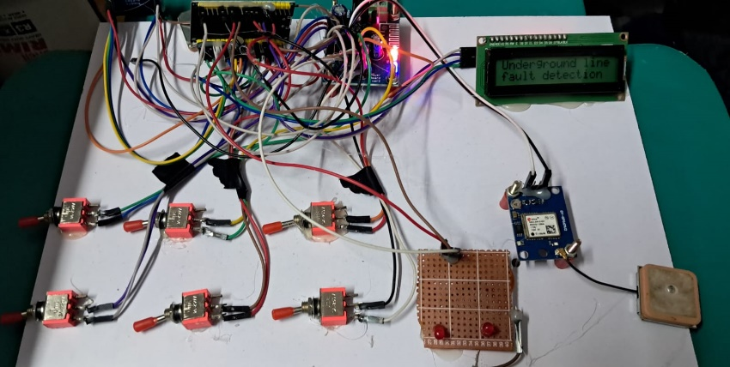

**Fig 7.Hardware setup(Tx section)**

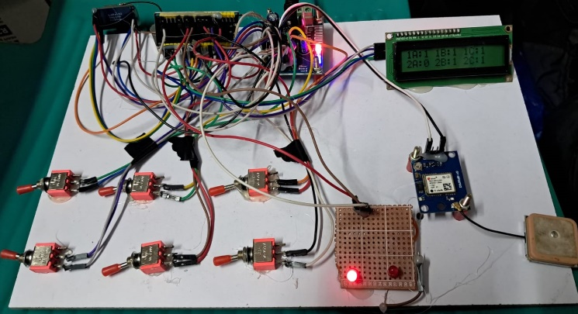

**Fig 8.Fault Generation**

Furthermore, an LED indicator indicates whether or not a fault has been found. Moreover, an LCD monitor offers real-time status updates for the system. After receiving the data transmission, the LoRa device uses Internet of Things technology to pass it to the cloud for additional processing and analysis.The complete configuration facilitates prompt and effective problem detection, protecting the integrity of subterranean cables. Along the subterranean cable route, sensors are put to monitor voltage and current, among other factors. These sensors can use LoRa technology to wirelessly communicate data. Sensor data is wirelessly transmitted to the gateway or central control unit via LoRa transceiver modules. Since typical wireless technologies might not be able to reach underground situations, LoRa's long-range capability is crucial for communication.The central control unit, receive and process the sensor information. To get ready for analysis, the data may need to be filtered, aggregated, and normalized.

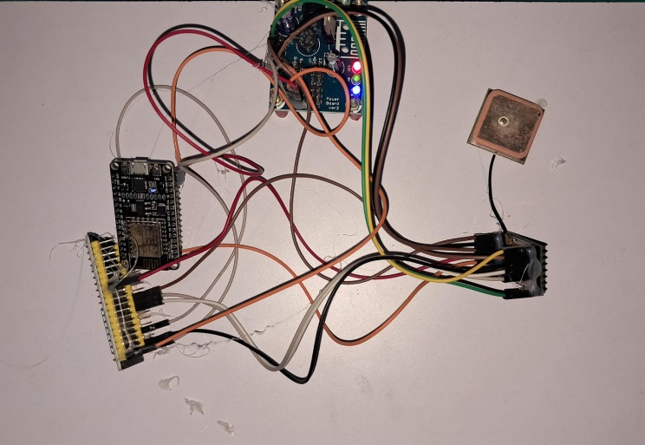

**Fig 9. Hardware Setup(Rx section)**

**V.RESULT**

As a result, the sensors identify the fault-occured area, and the GPS helps to  transfer this information to the central control unit via LoRa connection.The cloud infrastructure makes it simple for the user or employee to keep an eye on the control unit. If any problems arise, we can use the GPS data obtained from the subterranean LoRa transmitter to communicate the precise position of the problems to the technical team.

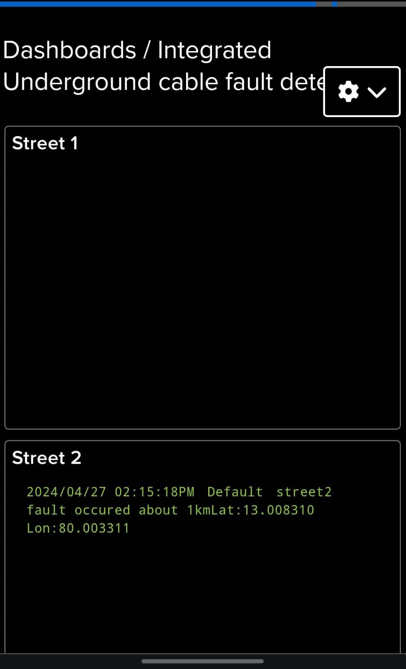

Fig 10.GPS location of fault occurred area fetched via cloud.

**VI.CONCLUSION**

The device can be used in subterranean power distribution networks to precisely identify and locate faults. It helps locate the network's weak points so that targeted fixes may be made with the least amount of downtime. This application is essential for businesses, residences, and other establishments that depend on a steady supply of electricity. The defect information is instantly accessible to maintenance staff according to the system's real-time data transmission capabilities. They are able to efficiently plan and carry out repair tasks, get trouble notifications, and remotely monitor the system. This application increases overall system reliability, speeds up response times, and simplifies maintenance procedures. The ability of the fault detection system to evaluate data patterns and identify any defects before they occur can be improved by incorporating machine learning techniques. The infrastructure of subterranean lines can be made much more reliable and efficient by using this predictive maintenance strategy. Through the use of sophisticated algorithms and toggle switch status monitoring, it is able to precisely locate any defect within the simulated kilometer range. It provides a workable way to find faults in subsurface lines without requiring expensive specialized equipment.

**VII. REFERENCES**

[1] I. U. Khalil et al., “Comparative analysis of photovoltaic faults and performance evaluation of its detection techniques,” IEEE Access, vol. 8, pp. 26676–26700, 2020.

[2] M. K. Alam, F. Khan, J. Johnson, and J. Flicker, “A comprehensive review of catastrophic faults in PV arrays: Types, detection, and mitigation techniques,” IEEE J. Photovolt., vol. 5, no. 3, pp. 982–997, May 2015.

[3] M. Köntges et al., Review of Failures of Photovoltaic Modules. Paris, France:International Energy Agency, 2014.

[4] A. F. Murtaza, M. Bilal, R. Ahmad, and H. A. Sher, “A circuit analysisbased fault finding algorithm for photovoltaic array under L-L/L-G faults,” IEEE J. Emerg. Sel. Topics Power Electron., vol. 8, no. 3, pp. 3067–3076, Sep. 2020.

[5] R. Hariharan, M. Chakkarapani, G. Saravana Ilango, and C. Nagamani, “A method to detect photovoltaic array faults and partial shading in PV systems,” IEEE J. Photovolt., vol. 6, no. 5, pp. 1278–1285, Sep. 2016.

[6] S. Roy, M. K. Alam, F. Khan, J. Johnson, and J. Flicker, “An irradiance independent, robust ground-fault detection scheme for PV arrays based on spread spectrum time-domain reflectometry (SSTDR),” IEEE Trans. Power Electron., vol. 33, no. 8, pp. 7046–7057, Aug. 2018.

[7] M. K. Alam, F. Khan.J.Johnson, and J. Flicker, “PV ground-fault detection using spread spectrum time domain reflectometry (SSTDR),” in Proc. IEEE Energy Convers. Congr. Expo., 2013, pp. 1015–102.

[8] T. Pei, L. Li, J. Zhang, and X. Hao, “Module block fault locating strategy for large-scale photovoltaic arrays,” Energy Convers. Manag., vol. 214, 2020, Art. no. 112898.