**The Evolution of Fintech and its Influence on Traditional Banking**

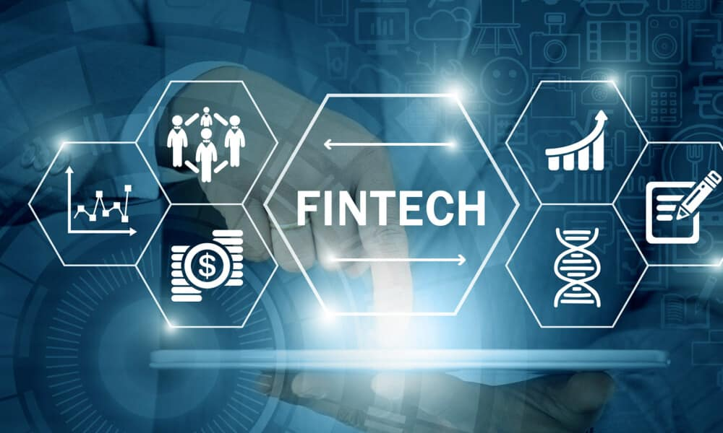

**Mitul Raj**

Student of BBA (Marketing & Automobiles Mgt.)

Galgotias University

**INTRODUCTION**

In recent years, the financial landscape has undergone a profound transformation driven by the emergence of financial technology, or fintech. Fintech encompasses a wide range of innovative technologies and digital solutions that have revolutionized how financial services are delivered, accessed, and utilized. From mobile payments and peer-to-peer lending to robo-advisors and blockchain technology, fintech has reshaped the way individuals and businesses interact with financial institutions and manage their money.

The roots of fintech can be traced back to the early days of electronic trading and the advent of the internet, but its true emergence gained momentum in the aftermath of the global financial crisis of 2008. Faced with increased regulatory scrutiny, changing consumer behaviors, and advances in technology, traditional financial institutions began to seek new ways to streamline operations, improve efficiency, and enhance customer experiences.

In this research paper, we will explore the evolution of fintech and its influence on various aspects of the financial industry, including traditional banking. By examining key trends, developments, challenges, and opportunities, we aim to provide a comprehensive understanding of the impact of fintech on the future of finance.

**TYPES OF FINTECH**

**Payment Processing:** Fintech has revolutionized the way payments are made and processed, offering faster, more convenient, and secure alternatives to traditional methods. Payment processing fintech solutions include mobile wallets, peer-to-peer payment apps, contactless payment systems, and digital payment platforms. These technologies enable individuals and businesses to transfer funds, make purchases, and manage transactions seamlessly, often eliminating the need for physical cash or traditional banking channels.

**Lending Platforms:** Fintech lending platforms leverage technology and data analytics to streamline the borrowing process and provide access to credit for individuals and businesses. These platforms utilize algorithms and alternative data sources to assess creditworthiness, determine loan eligibility, and offer personalized loan products.

**Blockchain Technology:** Blockchain technology, the underlying technology behind cryptocurrencies like Bitcoin and Ethereum, has emerged as a disruptive force in the financial industry. Blockchain is a decentralized, distributed ledger system that enables secure and transparent peer-to-peer transactions without the need for intermediaries.

**Digital Currencies:** Digital currencies, or cryptocurrencies, are digital assets designed to function as a medium of exchange, store of value, or unit of account. Fintech has played a central role in the development and adoption of digital currencies, facilitating their use in everyday transactions and investment opportunities. Examples of digital currencies include Bitcoin, Ethereum, Ripple, and Litecoin. Fintech applications related to digital currencies include cryptocurrency exchanges, digital wallets, decentralized finance (DeFi) platforms, and blockchain-based payment solutions.

These are just a few examples of the diverse range of fintech solutions reshaping the financial industry. As technology continues to evolve and innovate, new types of fintech are likely to emerge, further transforming how individuals and businesses interact with financial services and institutions.

**Impact on Traditional Banking**

Fintech has significantly disrupted traditional banking models and services, reshaping the industry in several ways:

**1.Customer Experience:** Fintech companies have raised the bar for customer experience by offering intuitive, user-friendly digital platforms and services. Traditional banks, in response, have been forced to invest in digital transformation initiatives to remain competitive.

**2.Accessibility:** Fintech has democratized access to financial services, particularly for underserved populations and those with limited access to traditional banking infrastructure.

**3. Cost-effectiveness:** Fintech companies often operate with lower overhead costs and greater efficiency compared to traditional banks, allowing them to offer competitive pricing and innovative products. As a result, traditional banks are facing margin pressure and increased competition in key areas such as lending, payments, and wealth management.

**Challenges and Opportunities**

**1. Regulatory Compliance:** One of the primary challenges facing traditional banks in adapting to the rise of fintech is navigating complex regulatory requirements and compliance obligations. Fintech innovations such as digital identity verification, blockchain technology, and cryptocurrencies present new regulatory challenges related to data privacy, cybersecurity, anti-money laundering (AML), and know-your-customer (KYC) requirements.

**2. Technological Integration:** Traditional banks often grapple with legacy IT systems, infrastructure limitations, and organizational silos that hinder their ability to integrate fintech solutions seamlessly.

**3. Collaboration and Innovation:** Despite the challenges posed by fintech disruption, traditional banks have opportunities to collaborate with fintech companies and leverage their expertise and technology to drive innovation.

**REGULATORY ENVIRONMENT**

The regulatory environment surrounding fintech and traditional banking is complex and continually evolving to address emerging risks and opportunities. Regulatory bodies worldwide are tasked with balancing innovation and consumer protection while maintaining financial stability. Fintech startups often face regulatory hurdles related to licensing, data privacy, cybersecurity, and compliance with anti-money laundering (AML) and know-your-customer (KYC) requirements. Traditional banks, on the other hand, must navigate regulations that govern their core banking activities, including lending, deposit-taking, and risk management, while also adapting to the digital transformation driven by fintech. Issues such as cross-border regulation, regulatory sandboxes, and the harmonization of standards pose challenges for both fintech and traditional banking sectors. Striking the right balance between fostering innovation and safeguarding consumers and financial systems remains a key priority for regulators and industry stakeholders alike.

**Case Study: Goldman Sachs and Marcus**

Marcus by Goldman Sachs is the consumer banking division of Goldman Sachs, offering online savings accounts, personal loans, and other financial products. Launched in 2016, Marcus aims to provide consumers with transparent and accessible banking services through digital channels.

**Partnership with Traditional Banks:** While Goldman Sachs is primarily known as an investment bank, it has successfully entered the retail banking market through the Marcus brand. Marcus leverages Goldman Sachs' institutional expertise and financial resources while operating as a separate entity focused on consumer banking. Through partnerships with traditional banks and fintech companies, Marcus has expanded its product offerings and distribution channels, reaching a broader audience of consumers seeking competitive interest rates and straightforward banking solutions.

**Strategies for Integration and Growth:** Marcus' success lies in its ability to combine the trust and credibility of a well-established financial institution with the agility and innovation of a fintech startup. By prioritizing customer experience and offering competitive interest rates, Marcus has attracted millions of customers and built a strong brand reputation in a relatively short period. Furthermore, Marcus continues to invest in digital technology and strategic partnerships to enhance its product portfolio and reach new customer segments. Overall, Marcus' hybrid approach to banking, blending traditional banking principles with fintech innovation, has enabled it to differentiate itself in the competitive retail banking market.

These case studies illustrate how successful fintech companies and partnerships with traditional banks can drive integration and growth by leveraging technology, innovation, and strategic collaboration. By adopting a customer-centric approach and embracing digital transformation, fintech companies and traditional banks can create value for consumers and remain competitive in an increasingly digital and interconnected financial ecosystem.

In the future, fintech and traditional banking will undergo further digital transformation, driven by advancements in technology, changing consumer preferences, and regulatory developments. We can expect increased collaboration and interoperability through open banking and API integration, leading to a more diverse and interconnected financial ecosystem. Personalization and AI-driven insights will enhance customer experiences, while the rise of embedded finance will integrate financial services into non-financial platforms and industries. Regulatory evolution will play a crucial role in fostering innovation while protecting consumers and addressing concerns related to data privacy, cybersecurity, and financial stability.

**CONCLUSION**

In summary, fintech has revolutionized the financial industry, reshaping traditional banking models and services through innovative technologies. From payment processing and lending platforms to robo-advisors and blockchain, fintech has enhanced accessibility, efficiency, and customer experiences. Despite regulatory and technological challenges, collaboration between fintech and traditional banks presents opportunities for innovation and growth. As fintech continues to evolve, its impact on the financial industry will persist, driving digital transformation and shaping the future of finance for consumers and businesses worldwide.