VIBRATION MONITORING SYSTEM WITH SMART CANTILEVER BEAM USING DSPACE

Dr. M Shanmugavalli M.Tech , Ph.D

Professor,

Department of Instrumentation and Control Engineering,

Saranathan College of Engineering,

Tiruchirappalli-12, India.

shanmugavalli-ice@saranathan.ac.in

Yokeswaran.T

Instrumentation and control engineering

Saranathan college of engineering

Tiruchirappalli, India

yokesptk1212@gmail.com

Mukesh.P

Instrumentation and control engineering

Saranathan college of engineering

Tiruchirappalli, India

[mukeshpadmanaban129@gmail.com](mailto:mukeshpadmanaban129@gmail.com)

Sudharsan.S

Instrumentation and control engineering

Saranathan college of engineering

Tiruchirappalli, India

sudharsansannasi@gmail.com

**Abstract** - It is possible to control the smart beam's vibration. Actuators and sensors positioned at the base of a cantilever beam make up this smart beam configuration. Vibrations can be caused by a variety of things, such as nearby motorized machinery and human activity. In this case, the disturbance is produced by the actuator signal. The vibration is detected by the piezoelectric sensors. In order to lessen vibration, the PID(s) controller simultaneously sends a control signal to the actuator via dSPACE. To optimize results, a PID controller is devised for vibration suppression of flexible beam structures using Ziegler-Nichols. Using an online system identification technique, the system model is generated, which comprises the dynamics of the structure and the sensor/actuator dynamics. Using a dSPACE controller board, the PID(s) controller's performance is tested experimentally.

Keywords— Vibration Control, dSPACE, Cantilever Beam, Piezoelectric, PID(s) Controller (simulink).

1. **INTRODUCTION**

The feasibility and potential of this technology have been demonstrated by more than thirty years of research in the field of smart structures. Many uses have been proposed, many of which have been imagined experimentally. Controlling the vibrations of plates and beams, buckling and shape control, and the commercial realization of smart skis are a few examples. Actuators and sensors that are integrated into the main structure of a smart structure are managed by a computer.

One kind of adaptive material that can be integrated with smart structures is piezoelectric materials, which have a wide range of applications. Over the past 20 years, there has been a notable increase in the use of piezo ceramics as actuators and sensors due to their high quality and efficiency. Piezo ceramics has many advantages, such as low cost, no moving components, fast response time, portability, and ease of usage. Piezo ceramics make it easier to handle issues with signal conditioning, location, and bonding than other smart materials.

In the last ten years, a lot of research has been done on the vibration control of flexible structures using dispersed sensors and actuators, and additional dimensions are being added to enhance structural behavior management. The utilization of PID(s) controllers is the primary design methodology for systems form. In order to obtain an acceptable dynamic response, one tunes the controller and creates the control signal for the closed-loop system that matches the dynamic response. Since the states are typically not measurable, one must develop a controller for them. In order to use the states for control, this controller provides the necessary information about them. One of the most used control instruments is the PID controller.

However, there are several disadvantages connected to challenges with actual application in the early going after its debut. The control signal that actuates the beam is computed using the tuned values in the PID(s).

Although prior research has amply demonstrated PID's enormous potential, there haven't been many applications of PID for piezoelectric bonded structure vibration management. Thus, the current experimental work's goal is to regulate smart buildings using a PID controller. The first of its type, according to the authors, is the real-time application of PID for smart structure vibration control via dSPACE.

# Experimental Setup

# 

**Figure.1.** Schematic diagram of the experimental setup

# 3.Hardware Description

* 1. **dSPACE**

In real-time implementation, the MATLAB Simulink tools rely on the dSPACE controller board, a widely used platform in academic research. The well-known controller board dSPACE has several benefits for automating, monitoring, and controlling experiments as well as improving the efficiency of controller development.

In this investigation, the DS1104 controller board that responded the best in terms of a large memory space and a quicker implementation process was taken into account. Fig. 2 describes the characteristics of the DS1104 controller board.

The general connections between the controller board, the PC, and the hardware converter are depicted in this picture. Figure 3 displays a picture of the DS1104 controller board, and Figure 4 shows the dSPACE-based converter system's implementation flow. The real-time adoption software for the dSPACE scheme is called Real-Time Interface (RTI). It improves the automation of real-time C-code, flawlessly affects the hardware structure of the dSPACE system and input/output, and automatically generates, accumulates, connects, and executes real-time C-code from the Simulink structure. Additionally, ControlDesk will communicate with the variable file that RTI generates in relation to the signals and parameters, updating the parameters.

You may just run the function models on the DS1104 controller board using RTI. By removing RTI blocks, it graphically configures each I/O and cuts down on implementation time. With a robust improvement system, the DS1104 improves personal computers (PCs) to enable speedier control implementation. For the graphical representation of an analog-to-digital converter (ADC), a digital-to-analog converter (DAC), I/O lines, and PWM, RTI creates Simulink blocks. Generally speaking, any PC with a free 5-V peripheral component interface (PCI) slot can have the board installed.

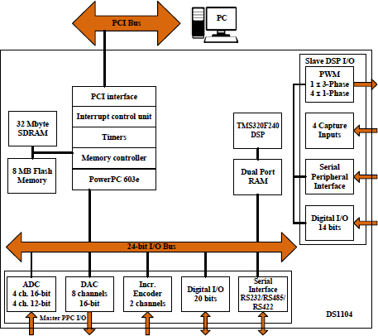

**Figure. 2.** Block diagram of the DS1104 controller board

It is necessary for the dSPACE controller board to process the signal conditioning circuits before the signal is fed. This criterion makes sure that the levels of the voltage and current signals are defined to match the controller's ADC input range. The signal is subjected to either reduction, amplification, or current-to-voltage conversion, contingent upon the input level state. As shown in Fig. 5, the signal conditioning is composed of circuits for conditioning AC voltage and current as well as DC voltage conditioning. The ControlDesk (dSPACE 2008) program and the DS1104 controller board are the pieces of dSPACE-related hardware that need to be installed on the computer.

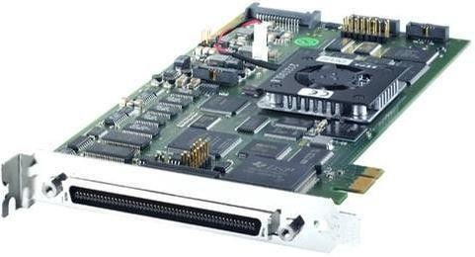

**Figure.3**. Photo of the DS1104 controller board.

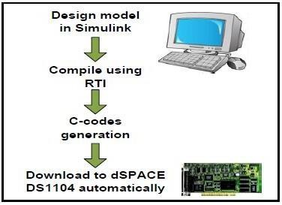

**Figure. 4.** Flow of the implementation of the dSPACE-based converter system

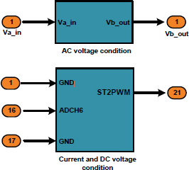

**Figure. 5**. Signal conditioning

Using the dSPACE DS1104 RTI, the MATLAB/Simulink converter control approach is implemented with proficiency and simulated in real time. In doing so, the control approach makes use of the necessary dSPACE input-output library blocks. This is the dSPACE 1104 card in Fig. 6.

# 20220504_103444.jpg

**Figure.6.** dSPACE 1104.

# Design of Cantilever Beam

In this project, an aluminum cantilever beam with a piezoelectric sensor attached is used. One end of the cantilever beam is free, and the other end is fastened to a support structure. The following table provides dimensions and material composition information for the cantilever beam utilized in this vibration control experiment.

**Table.1**. Dimensions And Material Properties of Cantilever Beam

|  |  |  |  |
| --- | --- | --- | --- |
| **S. No** | **SYMBOL** | **PARAMETERS (with unit)** | **VALUES** |
| 1  . | L | Length (m) | 0.35 |
| 2  . | B | Width (m) | 0.025 |
| 3  . | H | Thickness (m) | 0.003 |
| 4  . | P | Density (kg/m3) | 2700 |
| 5  . | E | Young’s Modulus (N/m2) | 7.1\*1010 |
| 6  . | V | Poisson’s Ratio (unit less) | 0.34 |

# Piezo-Electric Sensor

A piezoelectric sensor is a tool that converts changes in physical quantities, such force, temperature, and acceleration, into electrical quantities, like charge. In this project, a piezoelectric sensor is fastened to the beam in order to detect vibrations that arise from forced vibration of the beam. This signal is sent to the dSPACE, which stores the data, and MATLAB programming is used to monitor it after that. The piezoelectric sensor's dimensions and material characteristics are listed in the table below.

**Table.2.** Dimensions and material properties of piezoelectric sensor

|  |  |  |  |
| --- | --- | --- | --- |
| **S. No** | **SYMBOL** | **PARAMETERS (with unit)** | **VALUES** |
| 1. | *Lp* | Length (m) | 0.0765 |
| 2. | *B* | Width (m) | 0.0127 |
| 3. | *Ta* | Thickness (m) | 0.0005 |
| 4. | *Ep* | Young’s Modulus (Gpa) | 47.62 |
| 5. | *d 31* | Piezoelectric strain constant (mV-1) | -247x10-12 |
| 6. | *g31* | Piezoelectric stress constant (VmN-1) | -9x10-3 |
| 7. | *Ρ ρ* | Density (kg/m3) | 7500 |

# Software Description

* 1. **Simulink**

A graphical add-on for MATLAB designed for system modeling and simulation is called Simulink. The capacity of Simulink to describe a nonlinear system—something that a transfer function cannot—is one of its primary advantages. Simulink also has the benefit of taking on initial conditions. It is assumed that the beginning conditions are zero when building a transfer function. Systems are represented on the screen as block diagrams in Simulink. There are numerous block diagram components available, including virtual input and output devices like oscilloscopes and function generators, as well as transfer functions, summing junctions, and other components.

Data may be moved between MATLAB and Simulink with ease because of their integration. In these lessons, we will model the systems, construct controllers, and simulate the systems using Simulink on the MATLAB instructional examples. Simulink is included in the student edition of MATLAB for desktop computers and is supported on Unix, Macintosh, and Windows platforms.   
These tutorials are designed to be seen in a window while Simulink is open in another one. You can open system model files in Simulink by downloading them from the tutorials.

As you learn how to utilize Simulink for system modeling, control, and simulation, you will alter and expand these systems. The windows, menus, and icons in the tutorials should not be confused with the windows on your real Simulink system. The majority of the visuals in these tutorials are static; they just show you what your own Simulink windows should look like. Use your Simulink windows for all Simulink tasks.

The dSPACE experiment program for smooth ECU development is called Control Desk. It completes all required procedures and provides you with a single workspace.   
Powerful layout, instrumentation, measurement, and post-processing (ASAM MDF) Integrated ECU calibration, measurement, and diagnostics access (CCP, XCP, ODX) Synchronized data capture across ECUs, RCP and HIL platforms, and bus systems Control Desk combines features that frequently call for multiple specialist tools. In addition to giving users access to linked bus systems and simulation platforms, it can measure, calibrate, and diagnose ECUs via standardized ASAM interfaces, for example. Its highly scalable modular structure allows it to adapt to the needs of different application scenarios. This offers you distinct advantages in handling, training requirements, and processing power needed.

# 

# Figure.7. Simulink of Vibration Control

Control Desk is the dSPACE experiment software for seamless ECU development. It performs all the necessary tasks and gives you a single working environment

* Integrated ECU calibration, measurement and diagnostics access (CCP, XCP, ODX)
* Synchronized data capture across ECUs, RCP and HIL platforms, and bus systems
* Powerful lay outing, instrumentation, measurement and post-processing (ASAM MDF) Control Desk unites functionalities that often require several specialized tools.

It provides access to simulation platforms as well as to connected bus systems and can perform measurement, calibration and diagnostics on ECUs, e.g., via standardized ASAM interfaces.

Its flexible modular structure provides high scalability to meet the requirements of specific application cases. This gives you clear advantages in terms of handling, the amount of training needed, the required computing power, and costs.

# cotrol.PNG

Controller O/P

INPUT

# Figure.8. Control Desk 7.2 Vibration Control

# Modeling Structure

Control design of flexible structures relies on accurate modeling of the system dynamics. The analytical- model-based approaches have been highly doubtful under high precision requirements because of the difficulty in simulating the properties of these complicated systems.

The finite-element model- based methods are usually time consuming and their applications for accurate control are sometimes hindered by factors such as the assumption of perfect bonding at the interface between the structure and transducers. In most cases, these traditional modeling approaches are intractable and even impossible for highly complex structures. Hence, the unknown parameters of the smart structure dynamics are estimated using an online system identification method, which is proven to be more universal and feasible than analytical and numerical models for the present system [3].

The recursive least squares (RLS) method based on the Auto Regression with extra inputs (ARX) model is used here for linear system identification, which is easy to implement and has fast parameter convergence.In this paper, the state space model of the system based on the work in [4] is considered for the design of controller.

𝑿 = 𝑨𝒙 + 𝒃 𝒖 + 𝒆 𝒓 ; 𝒚 = 𝒄 𝑻 𝒙

where *x* is the state vector, *u* is the control signal, *y* is the sensor output, A, B, C are respectively the state, the input, the output matrices.

The controller design to suppress the vibration at resonance involves five steps. First is the design of state estimator, the state feedback gain calculation[6], transfer function obtaining, root locus plot and PID tuning using Ziegler-Nichols method.

# Design of information filter

The information filter is designed to estimate the unknown states of the structure. For the design of estimatorthe continuous system model given in equation is discretized at a sampling interval of 0.01 sec. The initial values are chosen to be R=1,Q=1xI4 and zero initial states.

# State feedback gain calculation

The state feedback controller is designed using pole placement to reduce the amplitude of vibration of a cantilever beam at resonance. Let (𝜱, 𝐹, ) be the discrete time system obtained by sampling the system inequation at a sampling interval of 0.01 seconds.

A stabilizing state feedback gain is obtained such that the eigen values of (**Φ+ ΓF**) are not at origin [10].The state feedback gain obtained is

𝐹 = [16.2346 − 7.7462 11.0017 61.2536]

The corresponding closed loop poles of the system (𝜱 + 𝐹𝑭) 𝒂𝒓𝒆 − 𝟎. 𝟑𝟖 ± 𝒋𝟎. 𝟖𝟖, 𝟎. 𝟖𝟖𝟕 ±

𝒋𝟎. 𝟐𝟗.

# Obtaining transfer function

The transfer function was obtained by matlab coding using the formula “tf=C∗ [𝑆𝐼 −

𝐴]−1 ∗B” giving the matrices as input.

transferFunction =

0.2046 s^3 + 48.02 s^2 + 9124 s - 1.322e05

s^4 + 0.9625 s^3 + 4.271e04 s^2 + 2.038e04 s + 4.242e07

Continuous-time transfer function. Simplified transferFunction =

0.2046 s^3 + 48.02 s^2 + 9124 s - 132200

s^4 + 0.9625 s^3 + 42710 s^2 + 20380 s + 424200000

# Root locus plot

Root locus of the obtained transfer function was plotted using matlab coding and the gain and frequency

value was obatined.

Gain(Ku)= 1.03𝑒+03 or 1030 Frequency(ὠ)= 125 rad/secs

# Tuning of PID

Tuning of the PID has done using the Ziegler-Nichols method.

**Calculations:**

𝑃𝑢=2𝜋/𝜔=2𝜋/125=0.05024

𝐾𝑢=1030 𝑃𝑢=0.05024

**Table.3**. PID tuned values by Ziegler-Nichols method

|  |  |  |  |  |  |  |  |  |  |  |
| --- | --- | --- | --- | --- | --- | --- | --- | --- | --- | --- |
| **Type of**  **Control** | **KP** | | **TI** | | **KI** | | **TD** | | **KD** | |
| **PID** | 0.6\*Ku | 618 | Pu/2 | 0.02512 | KP/TI | 24601.911 | Pu/8 | 0.00628 | KP\*KD | 3.88104 |

# Natural Frequency of a Beam

1. Natural Frequency (fn) = 1 √(𝐾 ) Hz

2𝜋 𝑚

m->model mass of the beam(kg)

1. Moment Of Inertia (I) = 𝑏ℎ3 𝑚4

Where,

* 1. b->Breadth(m)
  2. h->Height(m) (iii)l->Length(m)

1. Beam Stiffness (K) =3𝐸𝐼 (N/𝑚2)

𝑙3

* 1. E->Young’s modulus

**Calculations:**

* Moment of Inertia (I)= 𝑏ℎ3

12

* Moment of Inertia (I)= 5.625×10−10 𝑚4
* Beam Stiffness (K)= 3𝐸𝐼

𝑙3

* Beam Stiffness (K)= 279.446041 (𝑁/𝑚2)
* Natural Frequency(fn) = 1 √(𝐾 )

2𝜋 𝑚

* Natural Frequency(fn)=51.228008 𝐻z

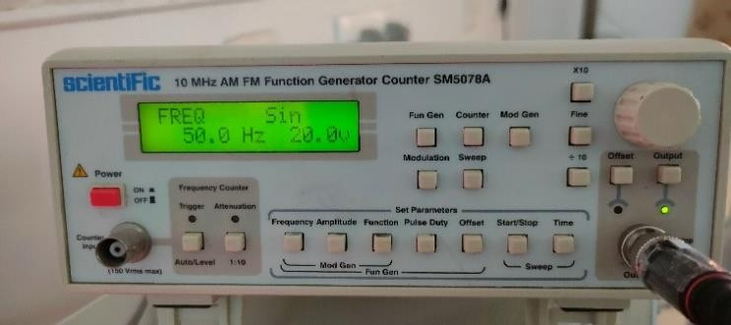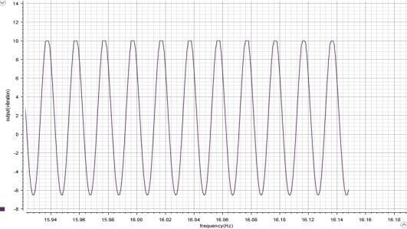

**Figure.9**. AFO Input **Figure.10.** O/P in dSPACE

# Experimental Setup/Hardware Prototype

The below figure depicts the hardware prototype that has been developed to realize the

proposedmethodology. The tests were conducted using the below experimental setup.

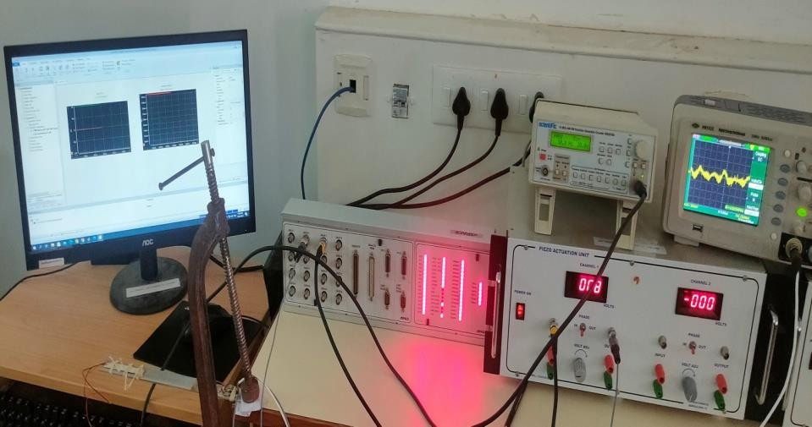

**Figure.11.** Experimental Setup

# Operation

A flexible aluminum beam with fixed clamped end as shown in figure 2.1 is considered in this paper. Two piezo ceramic patches are surface bonded at a distance of 5mm from the fixed end of the beam. The patchbonded on the bottom surface acts as a sensor and the one on the top surface acts as an actuator. To apply anexcitation to the structure another piezo ceramic patch is bonded on the tip of the beam. The piezo ceramicsare electrode with fixed-on adherent silver of solderable quality.

Electrical contacts to the electrodes are made by soldering. This makes fragile piezo ceramics much easier to work with and easier to integrate into the structure. The sensor output is given to the piezo sensing system which consists of high quality charge to voltage converting signal conditioning amplifier with variable gain.

The conditioned piezo sensor signal is given as analog input to dSPACE1104 controller board. The control algorithm is developed using simulink software and implemented in real time on

dSPACE 1104 system using RTW and dSPACE real control block diagrams and real time workshop is used to generate C code from the simulink model. The C code is then converted to target specific code by real time interface and target language compiler supported by dSPACE1104. This code is then deployed on to the rapid prototype hardware system to run hardware in-the-loop simulation. The control signal generated from simulink is interfaced to piezo actuation system through configurable analog input/output unit of dSPACE 1104 system. The piezo actuation system drives the actuator and the excitation signal is applied from simulink environment through a DAC port of dSPACE system.

# Result

The PID(s) controller designed using zigler-Nichols in section IV to suppress the vibration. The sensor output is sampled at 0.01 sec through ADC port of dSPACE and MATLAB/simulink to generate a control signal. The output of the controller is compared with the plant constant.

The control signal, comparison between the plant ADC signal and constant. One can see that the output almost matches with the plant output and showing the better performance and ease of implementation with PID(s) using dSPACE. The control signal is generated by multiplying with gain and is applied to the control actuator through DAC port of dSPACE controller board.

The controller is implemented by developing a real time simulink model using MATLAB RTW in simulink.To show the performance of the controller , the beam is continuously vibrating using AFO with natural frequency of 50Hz. Constant (0) given as setpoint. ADC converts the analog input into digital which will be given by function generator to piezo which is paste on the beam. Analog signal 20V,50Hz given through ADC channel 5 in dSPACE . Constant and ADC signals are compared by comparator. PID(s) continuous controller, which was tuned by Ziegler-Nichols method. PID(s) controller generates a control signal which was multiplied by a gain(10) to amplify a signal. Saturation point is given as ±5. Digital signals are converted into analog using D/A converter. Analog signal are taken from the DAC channel 1 to suppress a beam.

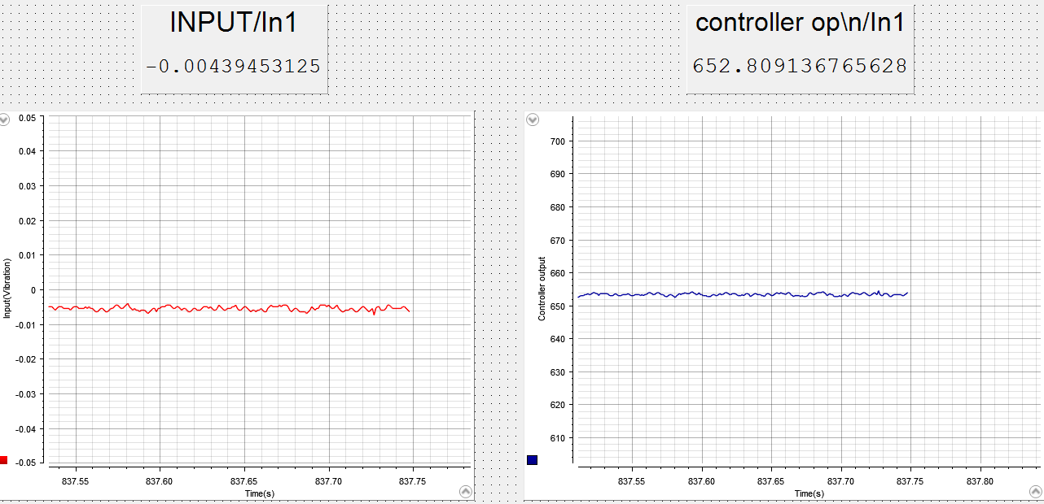**Figure.12.** Before Input to the beam

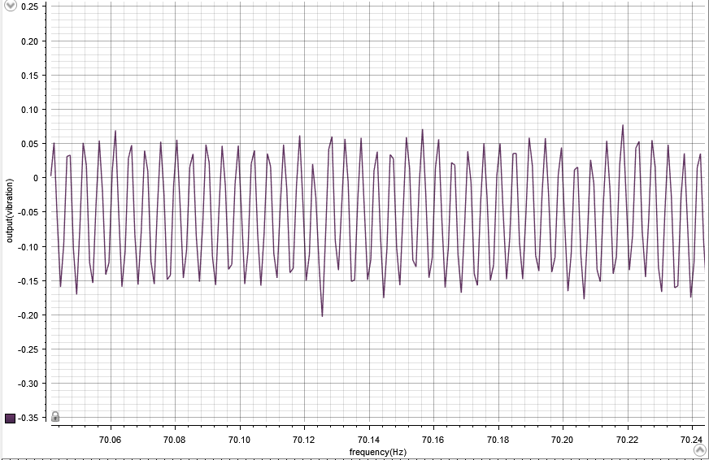

**Figure.13.** Beam response before control

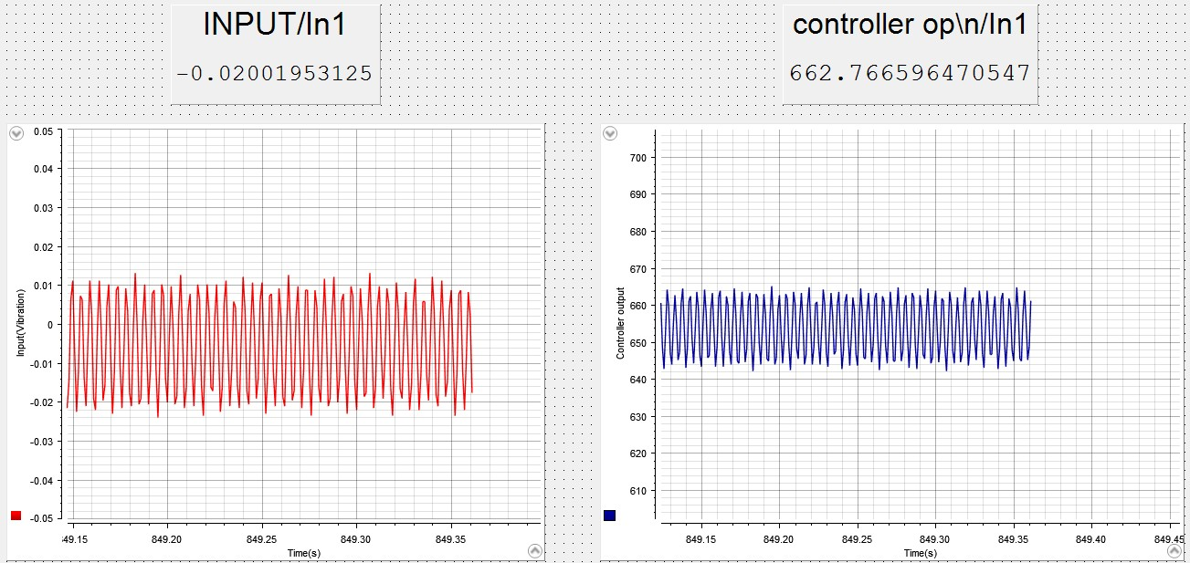

Beam response after control, a controlled

**Figure.14.** Experimental results with PID controller

# Conclusion

This paper presents an experimental evaluation of PID controller for vibration suppression of smart cantilever beam using the tuned values obtained from Ziegler-Nichols method. From the experimental results it is observed that vibration reduction is 66.7%(approx.). The experimental results demonstrate very good closed loop performance and simplicity of the PID(s)

**REFERENCES**

[1]. Mark A. Kamel, Khalil Ibrahim,Abo El-Makarem Ahmed,” Vibration control of smart cantilever beam using finite element method”, Alexandria Engineering Journal (2019) 58, 591–601.

[2]. D.Ezhilarasi, M.Umapathy, B.Bandyopadhyay,“Design and experimental evaluation of simulaneous fast output sampling Haigen Yang,”Vibration Control for a Cantilever Beam with an Eccentric Tip Mass Using a Piezoelectric Actuator and Sensor” ,International Journal of Acoustics and Vibration, Vol. 22, No. 1, 2017.

[3]. Huang, Z.; Huang, F.;Wang, X.; Chu, F. Active ,“Vibration Control of Composite Cantilever Beams”. Materials 2023, 16, 95.

[4]. Shanmugavalli M , Pranav Kumar S , Suriya Prakaash D , Kabileshwaran R and Sathish Kumar M,” Vibration Monitoring and analysis using dSPACE Card “,International Journal of Multidisciplinary Research Transactions (A Peer Reviewed Journal) Issue 6, 2022 ISSN (Print)

: 2663-2381 ISSN(Online) : 2663-4007.

[5]. Khalil Ibrahim, Abdel Badie Sharkawy, “A hybrid PID control scheme for flexible joint manipulators and a comparison with sliding mode control”, Ain Shams Eng. J. 9 (2018) 3451– 3457.

[6]. S. Khot, N.P. Yelve, R. Tomar, S. Desai and S. Vittal, “Active vibration control of cantilever beam by using PID based output feedback controller”, J. Vib. Control 18 (2012) 366–372.

[7]. A. Ebrahimi-Tirtashi, S. Mohajerin, M. R. Zakerzadeh & M. A. Nojoomian,” Vibration control of a piezoelectric cantilever smart beam by L1 adaptive control system” , systems science & control engineering: an open access journal,2021, vol. 9, no. 1, 542–555.

[8]. Junqiang Lou, Jiangjiang Liao, Yanding Wei, Yiling Yang and Guoping Li,” Experimental identification and vibration control of a piezoelectric flexible manipulator using optimal multi- poles placement control”, Appl. Sci. 7–309 (March 2017)

[9]. K. B. Waghulde et al. /International Journal of Engineering and Technology, “Vibration Control of Cantilever Smart Beam by using Piezoelectric Actuators and Sensors “, Vol.2(4), 2010, 259- 262.

[10]. Fevzi Cakmak Bolat and Selim Sivrioğlu,”Control of Elastic Beam Vibrations Using Piezoelectric Actuator”,International Journal of Applied Mathematics, Electronics and Computers Advanced Technology and Science ISSN:2147-82282147-6.

[11]. Xu, S., Sun, G., & Li, Z. (2018),”Finite frequency vibration suppression for space flexible structures in tip position control”,International Journal of Control, Automation and Systems, 16(3),1021–1029.

[12]. Aleksandar M. Simonovic, Miroslav M. Jovanovic, Nebojsa S Lukic, Nemanja D Zoric, Slobodan N Stupar and Slobodan S. Ilic ,́ ”Experimental studies on active vibration control of smart plate using a modified PID controller with optimal orientation of piezoelectric actuator”,

J. Vib.Control (2014)