# Master’s Thesis Research Paper

**INNOVATION IN RECRUITMENT IN**

**TALENT ACQUISITION: A STUDY ON**

**TECHNOLOGIES AND STRATEGIES**

**ADOPTED FOR TALENT MANAGEMENT**

**IN IT SECTOR**

***FOR THE PARTIAL FULFILLMENT OF THE REQUIREMENT***

***FOR THE AWARD OF***

***MASTER OF BUSINESS ADMINISTRATION***

**Submitted By**

**(Shalini Rai)**

**Enrolment No. 22042010477**

**MBA 2022-2024**



**School of Business**

**Galgotias University**

**May, 2024**

**Abstract**

In today's competitive job market, companies are constantly seeking new and innovative ways to attract and hire top talent. Traditional recruitment methods, such as posting job ads and conducting interviews, are being enhanced and complemented by technological advancements.

The introduction of innovative recruitment strategies involves leveraging technology, data analytics, and social media platforms to reach a wider pool of candidates. By utilizing AI-powered tools, companies can automate and streamline various aspects of the hiring process, such as resume screening and candidate assessment.

Furthermore, virtual reality and gamification are being incorporated into recruitment processes to create immersive and engaging experiences for candidates. Virtual reality simulations can be used to assess a candidate's skills and abilities, while gamification adds an element of fun and competition to the hiring process.

Overall, innovation in recruitment aims to make the process more efficient, effective, and engaging for both employers and candidates. By embracing new technologies and creative approaches, companies can stay ahead in the talent acquisition game and attract the best candidates for their organizations.

Inovation in recruitment and talent acquisition refers to the use of new and creative methods to attract and hire the best candidates for a job. It involves thinking outside the box and leveraging technology and data to streamline the hiring process. With the rapid advancements in technology, there are various innovative approaches being used in recruitment.

Another innovative method is the use of gamified assessments. These are interactive and engaging assessments that simulate real-life scenarios and test candidates' skills, knowledge, and problem-solving abilities. By incorporating elements of gamification, recruiters can make the assessment process more enjoyable and immersive for candidates.

Additionally, social media recruiting has become a powerful tool in talent acquisition. Platforms like LinkedIn, Twitter, and even Facebook can be used to connect with potential candidates, build employer branding, and engage with passive job seekers. Social media provides a wider reach and enables recruiters to tap into a diverse pool of talent

**INTRODUCTION**

Inovation in recruitment and talent acquisition refers to the use of new and creative methods to attract and hire the best candidates for a job. It involves thinking outside the box and leveraging technology and data to streamline the hiring process. With the rapid advancements in technology, there are various innovative approaches being used in recruitment.

Another innovative method is the use of gamified assessments. These are interactive and engaging assessments that simulate real-life scenarios and test candidates' skills, knowledge, and problem-solving abilities. By incorporating elements of gamification, recruiters can make the assessment process more enjoyable and immersive for candidates.

Additionally, social media recruiting has become a powerful tool in talent acquisition. Platforms like LinkedIn, Twitter, and even Facebook can be used to connect with potential candidates, build employer branding, and engage with passive job seekers. Social media provides a wider reach and enables recruiters to tap into a diverse pool of talent.

These are just a few examples of how innovation is transforming the recruitment and talent acquisition landscape. By embracing new technologies and creative strategies, companies can attract top talent .

As organizations develop innovative activities, they encounter relatively greater uncertainty and variability in the innovation process when they attempt to develop innovative activities (Atuahene-Gima, 1996). This creates a need for creative employees who are flexible, risk- taking, and tolerant of uncertainty and ambiguity (Madsen & Ulhai, 2005). Thus, HR needs to highlight these characteristics in the recruiting process. When organizations use creative capabilities and innovative characteristics as hiring and selection criteria, their employees are likely to spawn diversity of ideas and commit to more innovation behaviors (Brockbank, 1999, Atuahene-Gima, 1996), Hence, through effective recruitment, employees become essential sources of new ideas in the firm's innovative process. However, little is known about what role HR plays in the recruitment of innovative individuals.

In today's globalized world where organizations face continuously changing and competitive situations, innovation is emerging as a crucial factor for organization's competitive advantage (Cohen & Levinthal, 1990; Damanpour, 1991; Hurley & Hult, 1998, Nooteboom, 1999, Roberts, 1998, Tanner, 1998; Uterback, 1994). Research indicates that sustaining innovation in fast-growing organizations can be challenging (Kotter & Sathe, 1978; Department of Trade and Industry, 2000, Katila & Ahuja, 2002; Kutcher, Nottebohm & Sprague, 2014). Innovation in recruitment and talent acquisition has emerged as a critical component in navigating the complexities of the modern workforce landscape. As organizations strive to remain competitive and agile in a rapidly evolving business environment, they are increasingly recognizing the need to revolutionize traditional hiring practices. This shift towards innovation is driven by various factors, including advancements in technology, changing candidate expectations, and the growing importance of employer branding and candidate experience.

Organizations must be proactive in their approach to talent acquisition and retention if they are to remain competitive in this dynamic climate. The effectiveness and candidate experience of hiring processes can be greatly improved by integrating gamification, AI and machine learning, and video interviews.

**CONCEPT OF RECRUITMENT :**

**Recruitment refers to the process of :**

**Identifying,**

**Attracting,**

**Interviewing,**

**Selecting,**

**Hiring**

**Onboarding employees.**

Put another way, it covers every aspect, from determining the need for personnel to actually filling it. A variety of employees are in charge of recruiting, depending on the size of the company.

**LITERATURE REVIEW**

The literature review in a study on "Innovation in Recruitment and Talent Acquisition in the IT Sector would typically involve an extensive review of existing research, theories, and findings related to:

Recruitment and talent acquisition strategies: This would include examining various approaches such as traditional recruitment methods, online job portals, social media recruiting, employee referrals, etc.

Technological innovations in recruitment: This involves reviewing emerging technologies such as artificial intelligence, machine learning, big data analytics, applicant tracking systems, and virtual reality used in recruitment processes.

Talent management practices: Exploring effective strategies for attracting, developing, and retaining top talent in the IT sector, including employee training. performance management, succession planning, and career development programs.

Challenges and opportunities: Identifying the challenges faced by organizations in the IT sector regarding recruitment and talent acquisition, such as skills shortages, competition for talent, and diversity issues, as well as opportunities presented by technological advancements and innovative approaches.

Best practices and success stories: Examining case studies and examples of organizations within the IT sector that have successfully implemented innovative recruitment and talent acquisition strategies, highlighting key lessons learned and best pratices.

Overall, the literature suggests that innovation in recruitment and talent acquisition can lead to more efficient and effective hiring processes, improved candidate experiences, and better quality hires. However, it's important to note that while these innovative approaches have shown promise, there is still ongoing research to explore their long-term impact and potential limitations.

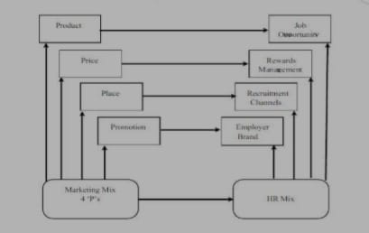IMPACT ON THE RECRUITMENT PROCESS AND ORGANIZATIONAL OUTCOMES

1 **Emerging Technologies in Recruitment**: In the fast-evolving world of recruitment, some groundbreaking innovations are transforming the hiring landscape Artificial intelligence (AI) is expected to play a major role, cutting hiring expenses by an astounding 60% and time-to-fill by an astounding 70%, according to new research from HR Technologist. These figures highlight the efficiency improvements that AI-powered recruiting solutions can provide to enterprises.

2 **Candidate Experience and Employer**: Candidate experience is the sum of all the interactions and impressions that candidates have with your organization throughout the hiring process, from the initial contact to the final outcome. Employer brand is the reputation and image that your organization has as a place to work, both internally and externally.

3 **Diversity and Inclusion Initiatives:**  DEI initiatives are designed to address discrimination, biases, differences of opinion, and marginalization issues and to create a culture of respect and inclusion for employees from all backgroundsThese activities can take many different forms, including as policy changes, employment policies, and training and education campaigns.

4 **Gamification and Social Media recruitment**: Gamification in recruitment can filter out only the best potential hires that would be a good fit for the job position you offer. You can use gamification for sourcing candidates, keeping the employees engaged, and assessing job applicants based on the data collected from the games.

5 **Remote and Virtual Recruitment Practices:** In short, virtual recruiting describes a hiring process that takes place remotely, without meeting the candidates face to face. Rather, recruiters use technology to conduct remote assessments, surveys, virtual events, and video interviews with candidates.

6 **Challenges and Ethical Considerations:** These principles include voluntary participation, informed consent, anonymity, confidentiality, potential for harm, and results communication. Researchers and scientists are required to follow certain guidelines at all times when gathering information from other people.

.

7 **Metrics and Analytics in recruitment innovation**: Recruitment analytics is defined as the application of statistical and predictive analysis to the recruitment process to improve sourcing, selection and hiring. Recruitment analytics, in its most basic form, assists HR directors and recruiters in comprehending the performance potential of their hiring procedures, both now and in the future.

Which three recruitment analytics are the most crucial?

Recruitment Analytics Stages. The three phases of recruitment analytics—operational reporting, advanced reporting, and predictive analytics—should be taken into account by hiring managers, HR departments, and recruiters.

**SAMPLING DESIGN AND PLANNING**

**To study about sampling design and planning of innovation in recruitment in talent acquisition.**

To start, we need to **define the population** we want to study. For example, it could be HR professionals or hiring managers in a specific industry or region.

Next, we determine the **sample size.** This is based on statistical considerations and the level of precision we want. It ensures that our findings are representative while being feasible to gather data from.

Now, a **sampling method**. We can go with random sampling, where participants are selected randomly from the population. Or we can use stratified sampling, where we divide the population into subgroups and select participants from each group.

Once we have our sampling method, it's time to **collect data**. We can use surveys, interviews, or a combination of both. Online platforms or tech tools can make data collection more efficient.

Now, we develop our **survey or interview** questions. These should explore different aspects of innovation in recruitment and talent acquisition. They need to be clear, concise, and aligned with our research objectives.

Before the main study, it's a good idea to **pilot test** our questions with a small sample. This helps us identify any issues or areas for improvement.

With our **data collection** process in place, we can start gathering data from our selected participants. It's important to ensure confidentiality and anonymity if needed.

Once we have the data, it's time to **analyze** it. We can use statistical techniques or qualitative analysis methods to look for patterns, trends, and insights related to innovation in recruitment and talent acquisition.

Finally, we interpret the findings and draw conclusions based on our analysis. We can prepare a report or presentation summarizing the results and providing recommendations for future action.

**When it comes to sampling design and planning for a topic like innovation in recruitment in talent acquisition, here's an example of how it could be done:**

1. Define the Population: Determine the specific population you want to study. For example, it could be HR professionals or hiring managers in a particular industry or region.

2. Determine Sample Size: Calculate the appropriate sample size based on statistical considerations and the level of precision desired. This ensures that the findings are representative of the population while being feasible to gather data from.

3. Sampling Method: Choose a sampling method that suits your research objectives. It could be random sampling, stratified sampling (dividing the population into subgroups), or purposive sampling (selecting participants based on specific criteria).

4. Data Collection: Decide on the data collection method. It could involve surveys, interviews, or a combination of both. Consider using online platforms or technology-driven tools to gather data efficiently.

5. Develop Survey or Interview Questions: Create a set of questions that explore the various aspects of innovation in recruitment and talent acquisition. Ensure they are clear, concise, and aligned with your research objectives.

6. Pilot Testing: Before conducting the main study, pilot test your survey or interview questions with a small sample to identify any potential issues or areas for improvement.

7. Data Collection Process: Implement the data collection process by administering surveys or conducting interviews with the selected participants. Ensure confidentiality and anonymity, if necessary.

8. Data Analysis: Analyze the collected data using appropriate statistical techniques or qualitative analysis methods. Look for patterns, trends, and insights related to innovation in recruitment and talent acquisition.

9. Interpretation and Reporting: Interpret the findings and draw conclusions based on the data analysis. Prepare a report or presentation summarizing the results, highlighting key findings, and providing recommendations for future action.

**RESEARCH DESIGN AND METHODOLOGY**

Define the Research Objectives:

Clearly articulate what you aim to achieve through your research. Are you looking to identify innovative recruitment methods, evaluate their effectiveness, or understand the impact of technology on talent acquisition.

Research design is a **quantitative study**, where researchers collect and analyze numerical data to measure the impact of innovative recruitment practices on various outcomes. This could involve surveying both recruiters and candidates to gather their perceptions and experiences with innovative recruitment methods. Researchers can then use statistical analysis to determine any correlations or relationships between the variables.

Another approach is a **qualitative study,** which focuses on gathering in-depth insights and understanding the experiences of recruiters and candidates in the context of innovative recruitment practices. This could involve conducting interviews or focus groups to gather rich, detailed information about their perspectives, challenges, and successes. Qualitative research helps researchers gain a deeper understanding of the complexities and nuances involved in implementing and utilizing innovative recruitment strategies.

The research design for this paper consists of a case study due to the investigative nature of the research. The focus of case studies can be described as "collecting information about a specific object, event or activity, such as a particular business unit or organization" (Sekaran & Bougie, 2016, p. 98). Adapting the previous description, the studied case helps in furthering knowledge of how HR involves innovation in the recruiting process and point to further research. A case study is considered useful in this research as it enables the authors to examine data at the micro level, more specifically, what role HR plays in the recruitment of innovative individuals. In the scope of this research, a large sample population would prove challenging to obtain, and thus, a case study is more practical. Other advantages of using a case study are the presentation of data of real-life situations and therefore providing better insights into the specific behaviors of the subjects of interest than what other research designs might capture.

**METHODOLODY**

The research methodology used in a study on "Innovation in Recruitment in Talent Acquisition: A Study on Technologies and Strategies Adopted for Talent Management in the IT Sector would likely involve a mix of quantitative and secondary methods. This could includes surveys, articles, questionnaire and possibly data analysis of recruitment and talent management practices within IT companies.

**Literature Review**: Conduct a comprehensive literature review to understand existing theories, models, and studies related to innovation in recruitment and talent acquisition.

Determine the gaps in the literature that your study seeks to fill.

.

**Research Questions**: Develop specific research questions that guide your study. These questions should align with your research objectives and help you investigate the phenomenon of ↓ innovation in recruitment.

**Research Design**: Research design based on your objectives and research questions. Options include qualitative, quantitative, or mixed-methods approaches. A mixed-methods approach might be beneficial, combining both qualitative and quantitative data collection and analysis techniques.

**Data Collection Methods**: Decide on the methods for collecting data. This could involve interviews, surveys, observations, document analysis, or a combination of these approaches. Ensure that your chosen methods are aligned with or research questions and objectives.

**Ethical Considerations**: Address any ethical concerns related to your research, such as confidentiality, informed consent, and potential risks to participants. Obtain any necessary ethical approvals before conducting your study.

**DATA ANALYSIS AND INTERPRETATION**

Data analytics can provide valuable insights into candidates' feedback and preferences during the recruitment processOrganizations can pinpoint areas for improvement and identify pain points by examining data from application drop-off rates, interview comments, and candidate surveys.

The importance of data analytics in talent acquisition cannot be overstated. In today's digital age, companies need to leverage data insights to make better decisions, gain a competitive edge, and ultimately attract top talent. data analytics can help companies understand the recruitment landscape, identify potential candidates, and measure the effectiveness of their recruitment strategies. In this section, we will explore the different ways data analytics can be used in talent acquisition, and how it can help streamline the recruitment process.

Analyzing and interpreting data in the context of innovation in recruitment for talent acquisition involves examining various metrics and trends to understand the effectiveness of new strategies and technologies in attracting, assessing, and retaining top talent. This includes analyzing data on recruitment channels, candidate engagement, time-to-hire, cost-per-hire, candidate experience, and employee performance. Interpretation involves identifying patterns, correlations, and insights that inform decisions on refining recruitment processes, adopting new tools, and optimizing strategies to attract and retain the best candidates in a competitive talent market.

Organizations might find biases in their hiring, promotion, and recruitment procedures by using data analysis. Organisations can detect and mitigate potential biases by identifying and analysing data pertaining to candidate qualifications and selection criteria.

At some occasions during the interviews, interviewees used incomplete sentences or filler words while responding to the posed question. Therefore the authors manually deleted the filler words whenever it was deemed appropriate to make the structure of the sentences more comprehensible in the transcripts. The authors were careful in making sure to maintain the intended meaning behind the interviewees' words. The authors also deleted names and terminologies used by the interviewees that could be used to identify the interviewees or FGIC. For example, some of the interviewees used termologies specific for FGIC, which is easily searchable online and directly links to FGIC Thus, the authors changed the names of the terminologies to protect the company's identity. After these steps, the authors analyzed the content by using grounded theory as it fits the exploratory nature of this study.

A grounded theory analytical approach involves a series of coding stages to analyze the collected data. There are three stages of analyzing open coding, axial coding, and selective’

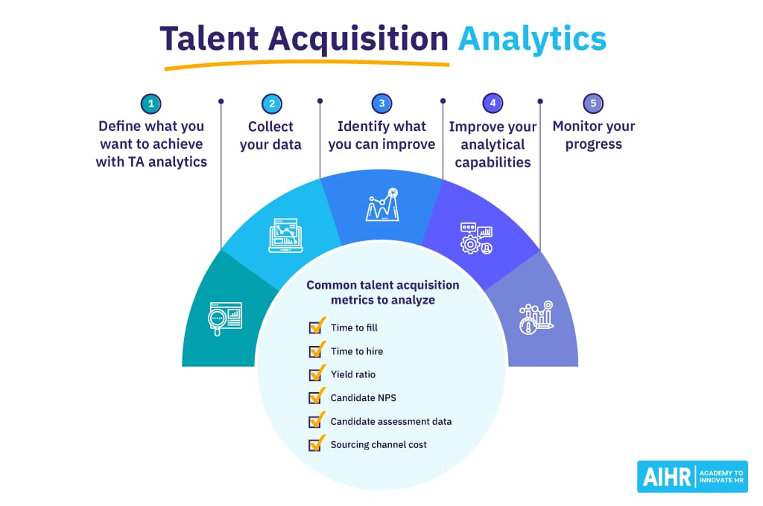

Understanding Data Analytics in Talent Acquisition

Data analytics in talent acquisition refers to the process of collecting, analyzing, and interpreting data related to recruitment and hiring processes.

HR professionals use data from various sources, such as applicant tracking systems, job portals, social media, and employee surveys, to gain insights into the talent

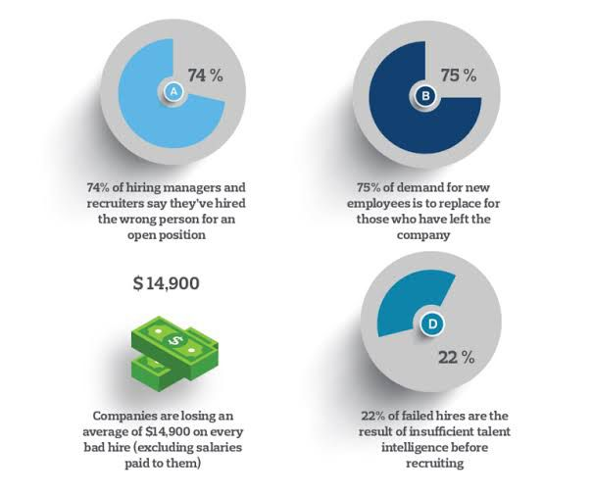

74% of employers admit having hired the wrong person for an opening. . Two-thirds of workers say they accepted a job offer only to realize later that the company was a bad fit; and 75% of the workers say they’re loyal to their employers, but only 54% feel their company is loyal to them

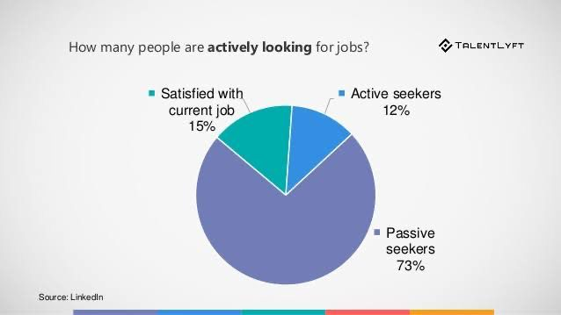

As you see the above diagram, Now a days people or employees are not much satisfied with there job. Out of 100% only 15% of people or employees are satisfied and part from that 12% people are seeking for job who are active and passive seekers 73% out of 100%.

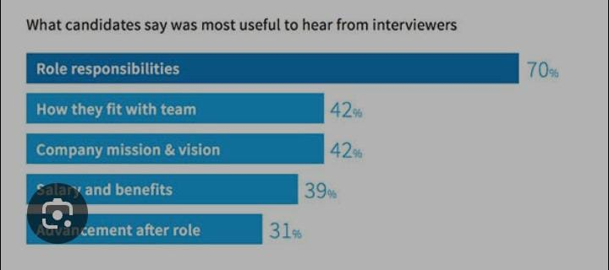

**CONCLUSION AND RECOMMENDATIONS**

**Conclusion:**

1. Innovation in recruitment can bring numerous benefits, such as improved candidate experience, increased candidate quality, and reduced time-to-fill positions.
2. Resistance to change and potential biases in innovative tools are limitations that need to be addressed for successful implementation.
3. Cost and resource considerations should be taken into account when adopting innovative recruitment practices.

4. Staying updated on the latest trends and continuously evaluating and adjusting strategies is crucial due to the rapid pace of technological advancements.

**Recommendations:**

1. Foster a culture of openness to change and provide training and support to employees and hiring managers to embrace innovative recruitment practices.

2. Regularly assess and monitor the algorithms and tools used in the recruitment process to ensure fairness and minimize biases.

3. Conduct a cost-benefit analysis before implementing innovative practices and explore options for cost-effective solutions.

4. Stay informed about industry trends and best practices through conferences, webinars, and networking to ensure your recruitment strategies remain innovation and effectiv

**REFERENCES**

Book:

Bhatnagar. J. Talent management strategy of employee engagement of Indian ITES employees: key to retention. Employee Relations, 2906), 2007, pp. 640-63. Retrieved from: http://www.researchgate.net/publication/235264272_Talent Management Strategy_of_E mployee Engagement in Indian ITES Employees Key to Retention

121 Bosall, P. HR strategy and competitive advantage in the service sector. Human Resource Management Journal, 13(3), 2003, pp 5-20 Retrieved from: https://pdfs.semanticscholar.org/be8f/1753985241c813e4c9931a5b6bcd046f44b3.pdf

Breaugh, J. Talent acquisition: A guide to understanding and managing the recruitment process. Society of Human Resource Management, 2016. Retrieved from: http://www.shrm.org/hr-today/trends-and-forecasting/special-reports-and-expert- views/documents/talent-acquisition-recruitment.pdf.

Hughes, 1, and Rog, E. Talent management: A strategy for improving employee recruitment, retention and engagement within hospitality organizations. International Journal of Contemporary Hospitality Management, 20(7), 2008, pp. 743-757. Retrieved

from: https://www.emeraldinsight.com/doi/abs/10.1108/09596110810899086

151 English, M. 1., and Baker Jr, W. H. (2006). Rapid knowledge transfer. The key to success. Quality Progress, 39(2), 2006, p. 41. Retrieved from: http://asq.org/qic/display- item/index.html?itens-20414 Haas, M. Know Better. HR Monthly, (2), 2008, pp. 40-43

[7] Hubburd. G. Wheel of fortune. HR Monthly, (7), 2007, pp. 30-32. Retrieved from: https://www.academia.edu/4901106/Emergence of the Knowledge Economy_and Kno wledge Management_and_their_Importance_in_the Talent Acquisition Front [8]

Huselid, M.A. Extimatex of the impact of human resource management practices on mrnover and productivity, paper presented at the Annual Meeting of Academy of Management, Atlanta, GA, 1993 Retrieved AMI_HPWS_Paper.pdf from:

http://www.markhuselid.com/pdfs/articles/1995 Jones, R. People don't leave bad organisations, they leave bad managers. Integrated System Models, 2006 Retrieved from