**TRAINING AND DEVELOPMENT IN BANKING SECTOR WITH REFERENCE TO HDFC BANK**

By:

Diya Singh

Topic

# ABSTRACT

Training and Development is the framework for helping bank employees to develop their personal and organizational skills, knowledge and abilities. The focus of all aspects of Human Resource Development is on developing the most superior work force so that the organization and individual employees can accomplish their work goals in service to customer. Transformation in the Indian Banking industry, ever increasing competition, fast moving and complex world of latest technology have compelled banks to think of and to adopt themselves to the changing banking environment. There is need to develop the competencies i.e. Skill, knowledge and attitude among the bank staff to make them more suitable to the changing conditions, through proper Training and Development programs. The present study aimed that to know the opinion on Training and Development at private sector banks employees. All the employees want to be valuable and remain competitive in the labour market at all times. This can only be archived through employee training and development. Employees will always want to develop care-enhancing skills, which will always lead to employee motivation and retention. There is no doubt that a well trained and developed staff will be a valuable asset to the banks and thereby increasing chances of his efficiency in charging his or her duties.

# INTRODUCTION

Every organization needs to have well trained and experienced people to perform the activities that have to be done. This is the most important aspect of Human Resource Management. It is widely known that Human Resource Management helps people to expand their capabilities and offer numerous opportunities. It is also felt that the expanded capabilities and opportunity for people at work will lead directly to improvement in operating effectiveness. The human resources approach means that better people achieve better results. So, if the current or potential job occupant can meet this requirement, training is not important. But when this is not the case, it is necessary to raise the skill levels an increase the versatility and adaptability of employees. Inadequate job performance or a decline in productivity or changes resulting out of job redesigning or a technological break –through require some type of training and development effort. As the jobs become more complex, the importance of employee development through training also increases.

In a rapidly changing society, employees training and development is not only an activity that is desirable but also an activity that an organization must commit resources to if, it is to maintain a viable and knowledgeable work force. In fact, industrial to, if is to maintain a viable and knowledgeable work force. In fact, industrial growth cannot take place properly without trained manpower. The technological advancement is taking place at such a rapid speed that the knowledge and skill required become obsolete at much faster rate. In order to cope up with the fast changes in requirement of skill and knowledge due to advancement of technology the need for systematic training has been felt in almost all organizations. Having selected most suitable persons for various jobs in the organization through the application of scientific techniques, the next function of personnel management is to arrange for their training. All types of jobs in the organization usually require some type of training for their efficient performance. Employees talent are not fully productive without a systematic training program. Moreover, big organization hires a large number of young people every year.

The need for a systematic training has increased because of rapid technological changes, which create new jobs and eliminate old ones. New Jobs require some of special skills which may be developed in old workforce only by giving them necessary training. The employees try to train themselves by trial and error or by observing other if no training program exists in the organization. But it is an established fact that the absence of systematic training program will result in higher training costs. The employee will take much longer time in learning the skills.

## Some more additional benefits ,need and importance:

* To improve organizational climate
* To improve health and safety
* Obsolescence prevention
* Personal growth
* Benefits of Training Program

## The types of training programs

* Technical training is a type of training meant to teach the new employee the technological aspects of the job.
* Quality training refers to familiarizing employees with the means of preventing, detecting, and eliminating non-quality items, usually in an organisation that produces a product. Skills training, the third type of training, includes proficiency needed to actually perform the job.
* The fourth type of training is called soft skills training. Soft skills refer to personality traits, social graces, communication, and personal habits that are used to characterize relationships with other people.
* Professional training is a type of training required to be up to date in one’s own professional field.

# OBJECTIVES

Studying training and development in the banking industry with a focus on HDFC Bank can have a number of purposes, such as:   
  
Comprehending Best Practices: To pinpoint and examine the banking sector's best practices for employee training and development, with a particular emphasis on HDFC Bank as a pioneering organization. This entails looking at the tactics, procedures, and methods that HDFC Bank uses to train its employees.

Evaluating Efficiency: to assess how well HDFC Bank's training and development programs are working. This entails evaluating how these initiatives affect customer happiness, skill development, staff performance, and overall organizational success.

Finding Opportunities and Challenges: to determine the chances and difficulties HDFC Bank faces in staff training and development. This entails looking at things like new trends in the banking industry, regulatory needs, client expectations that are shifting, and technological improvements.

Improving Worker Engagement and Retention: To investigate how training and development can improve work environment, employee engagement, and retention rates at HDFC Bank. This entails being aware of the ways that training initiatives affect worker motivation, professional advancement, and workplace culture in general.

Maintaining Risk Management and Compliance: to evaluate HDFC Bank's efforts in terms of risk mitigation through training & development programs and regulatory compliance. Examining the bank's compliance with regulatory requirements, ethical guidelines, and industry standards is part of this.

The overall goal of this study on training and development in the banking business, with a focus on HDFC Bank, is to learn more about the ways that well-designed training initiatives support employee happiness, organizational success, and competitive advantage in the fast-paced banking sector.

# Literature Review

According to Rani, K., & Garg, D. in the paper titled International Journal of Management and social sciences Research in the year (2014) The process of financial development in India has hinged effectively on the development of banking system. The Indian banking industry is continuously going through a process of transformation since nineties, due to the introduction of Liberalization, Privatization and Globalization (LPG), Information and Communication Technology (ICT). The first objective of present paper is to study existing status of training and development programmes banks for their employees. The second objective is to examine the effectiveness of training and development programmes for employees in fulfillment of their duties. Present research paper is of descriptive type and based on primary data collected through questionnaire filled by the bank employees. The present paper explained some suggestions to enhance training and development strategies, and to cope up with the existing challenges in the wake of severe competition in the training and development. The findings of the study suggest that training and development is inevitable and unavoidable in any sector.

According to Rahman, H. in the paper Central European Business Review in the year 2014.

Every organization needs well-adjusted, trained, and experienced people to perform its activities effectively and efficiently. Today’s business environment has become complex; the training for employees’ education is becoming a diver for adjusting dynamic change in organizational interfaces. This survey reveals that employee training and job satisfactions have a significant positive relationship with organizational effectiveness. The survey also indicates that job dissatisfaction has an insignificant relationship with organizational effectiveness in commercial banks. The study indicates that to chase dynamic business environments, management should focus on building human resources through diverse training for promoting organizational effectiveness.

According to Faridi, A., & Baloch, A. in the paper published Journal of Management Sciences in the year 2019. This study investigates the role of training and development methods in improving the empowerment and professionalism among the banking industry of Pakistan. It also determines the comparison between the modern and traditional methods in private and public banks. Using purposive and convenient sampling techniques, total 380 responses were gathered from professionals working in the banking sector of Pakistan. The results showed in that private banks, professionalism and empowerment significantly get improved under modern methods in contrast with traditional methods at public banks. Moreover, findings also revealed that professionalism and empowerment are positively affected by the modern methods of training whereas there is non-significant impact of traditional training on empowerment and professionalism. Permanent employees showed greater professionalism and empowerment as compared to contractual employees. The study theorizes that modern methods of training leads to empowerment, which further enhances the professionalism among banking industry of Pakistan.

# RESEARCH DESIGN AND METHODOLOGY

## Research Design:

Objective: Clearly state the goals of the study, including determining areas for improvement, assessing the efficacy of HDFC Bank's training initiatives, and investigating best practices.

Research Issues:  
Formulate targeted research inquiries that tackle the goals. As an illustration:   
Which training courses does HDFC Bank offer?   
What impressions do staff members have of these initiatives' efficacy?   
What effect do training initiatives have on job satisfaction and performance?   
What obstacles does HDFC Bank face when putting training programs into place?

Method of Research:   
Depending on the resources that are accessible and the type of research questions, select from mixed-method, quantitative, and qualitative approaches. A mixed-method approach could be useful to obtain thorough understanding.

**Sampling strategy:** specify the sampling technique (e.g., stratified random sampling) and the target population (workers of HDFC Bank). Calculate the sample size taking feasibility and statistical significance into account.

**Surveys:** Self-administered surveys will be distributed to academic staff in various universities and disciplines in India. The survey will consider:

Demographic information (age, gender, religion, race, etc.) . Cultural Identity and Beyond

Perceptions of workplace diversity

Level of employee engagement (belief scale) . Qualitative Summary:

**Semi-structured interviews:** In-depth interviews are conducted with a small number of academic staff representing different families. The interview will require:

Lived experiences of cultural diversity in the workplace How cultures affect sense of belonging and engagement Cross-cultural challenges and opportunities.

Techniques for Gathering Data:   
Make use of a variety of data collection techniques, including document analysis, interviews, and surveys.   
**Surveys:** Provide employees with standardized questionnaires to get quantitative information on training satisfaction, perceived efficacy, and other topics.

**Interviews:** For in-depth qualitative insights, do semi-structured interviews with HR managers, trainers, and chosen employees.

# ANALYSIS AND RESULTS

## Gender of respondents?

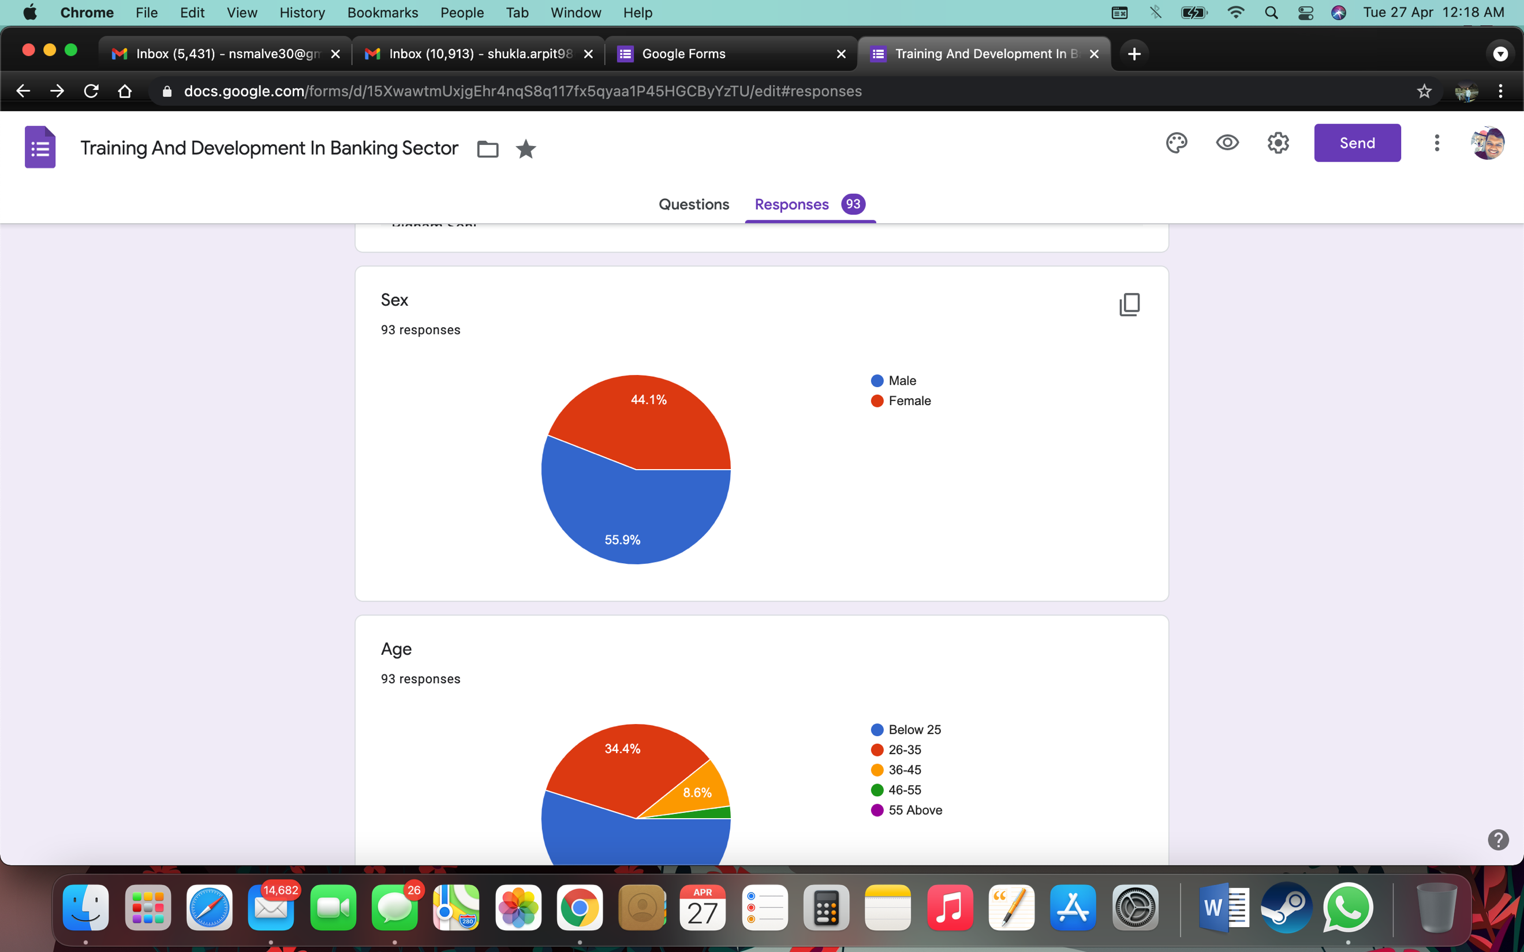

According to the question 55.9% respondents are male and reaining 44.1% respondents are female.

## Age of respondents?

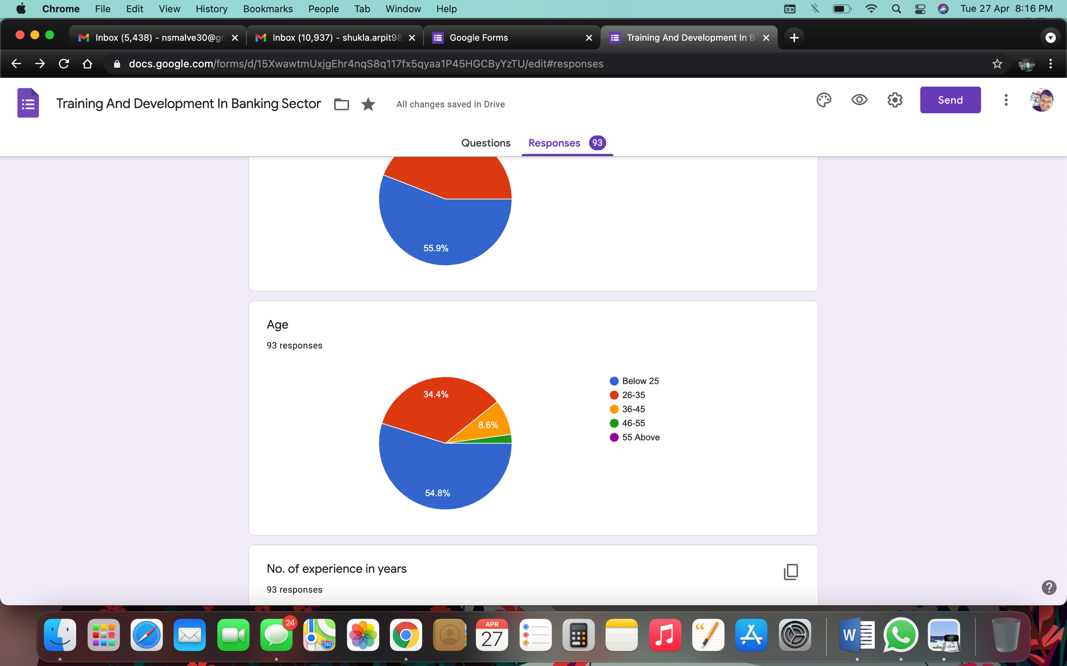

51 respondent’s age is below 25 years, 32 respondents belong to 26-35 years of age, while 08 respondents belong to 36-45 years of age and the remaining 02 respondents belong to 46-55 years of age.

## Has the training provided by the Organisation helped in improvement of your skill/knowledge?

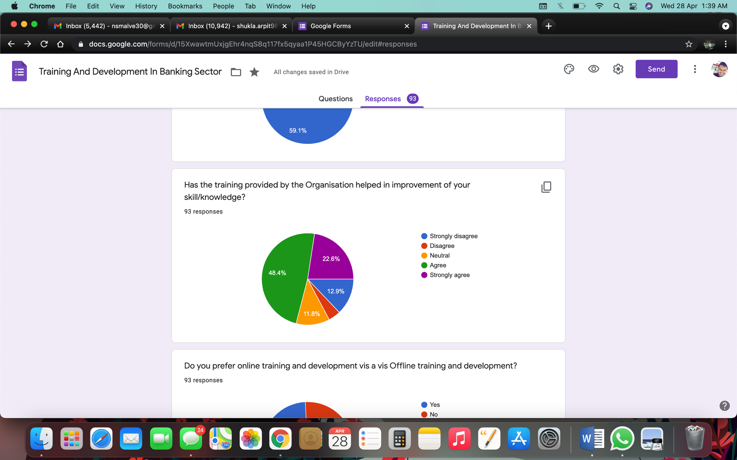

According to the question 12.9% of respondents strongly disagree that training has provided by organization helped in improvement of your skill/knowledge. While 4.3% of respondents disagree that training has provided by the organization has helped in improvement of their skill/knowledge. 11.8% of people are confused that they don’t know wether the the training has provided by the organization helped in improvement of their skill/knowledge. But 44.8% of respondents agree that training provided by the Organisation helped in improvement of your skill/knowledge. The remaining 22.6% of respondents strongly agree that training provided by the Organisation helped in improvement of your skill/knowledge.

## Do you prefer online training and development vis a vis Offline training and development?

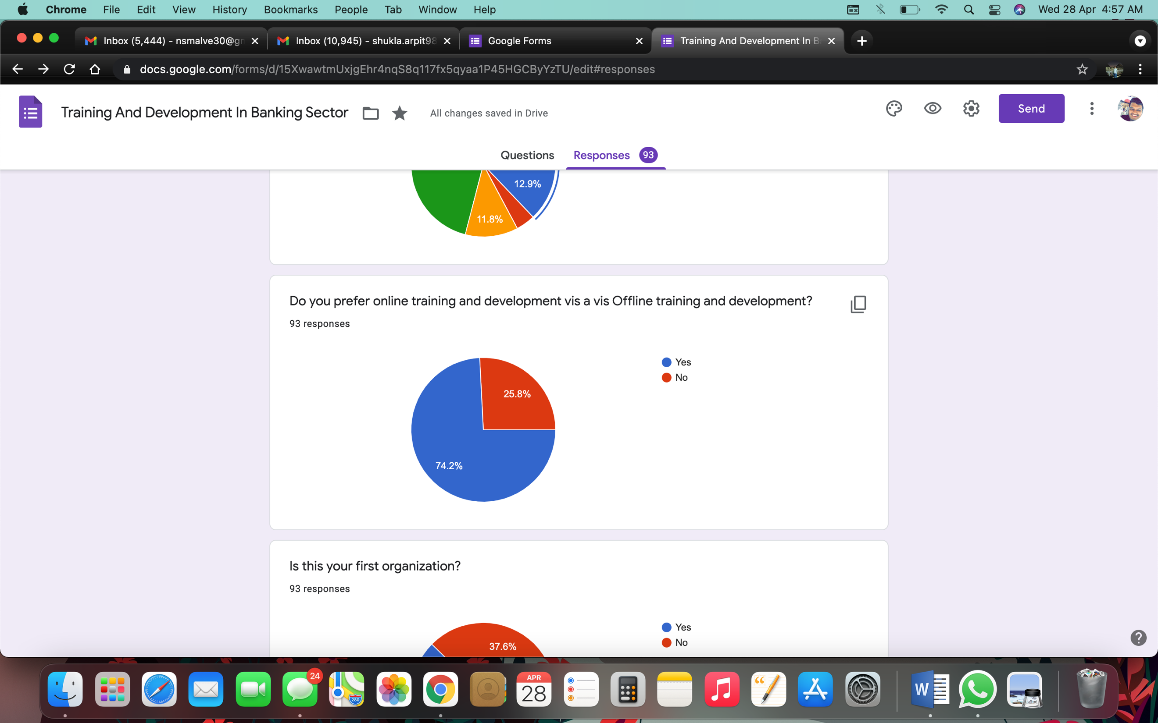

According to the response in this question 69 respondents i.e 74.2% say that they prefer online training and development vis a vis Offline training and development. While the remaining 24 respondents i.e 25.8% say that they do not prefer online training and development vis a vis Offline training and development.

## Does HDFC organises training and development programme for the employees?

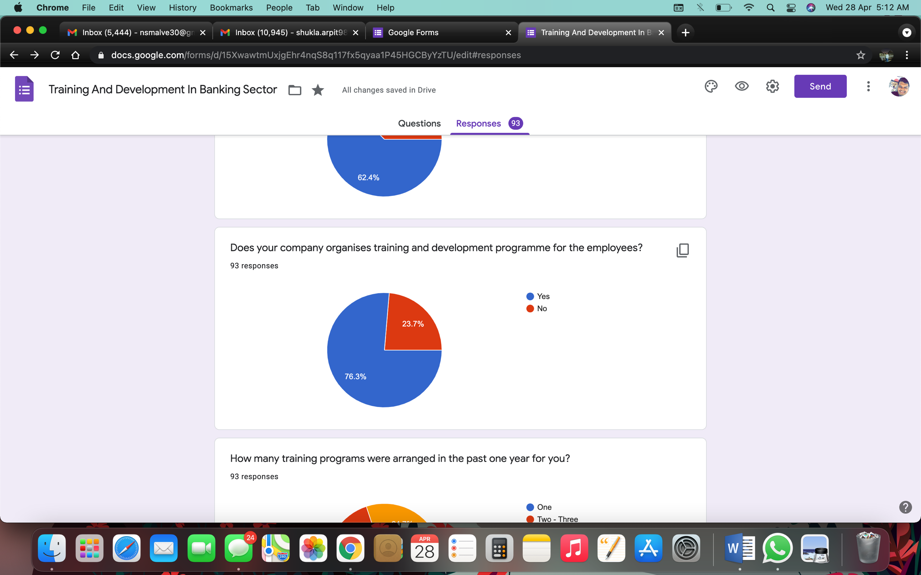

According to the responses received 76.3% of respondents say that yes their company organises training and development programme for the employees. The remaining 22.7% of respondents say that no their company does not organise training and development programme for the employees.

# Discussion and Findings

In most of the banks employees are well aware of the role and importance of the training They are self-motivated to attend such training program as it will result in their skill enhancement & improving their interpersonal skill.

* In various banks seminars are conducted to help out new employees with their difficulties
* Two types of training are provided to the employees of the bank -induction training and soft skill development training.
* Questionnaire is the most popular mean of evaluating the training program in banks.
* Most of the Employees feel that interview is the most appropriate method of evaluating the training program.
* Post training evaluation focus on result rather than on the effort expended in conducting the training and it worth the time, money and effort.
* Most of the participants are benefitted by giving feedback after attended the training. It motivated them to do better, helped them to increase their job performance and is an aid to future planning

In banks, post training evaluation is used to identify the effectiveness and valuation of training program, to identify the ROI (return on investment), to identify the need of retraining and to provide the points to improve the training.

# LIMITATIONS OF STUDY

* The period of the study was limited which may provide a deceptive picture in comparison to the study based on the long run.
* The study is based only on secondary & primary data so lack of keen observations and interactions were also the limiting factors in the proper conclusion of the study.
* It was difficult to collect data regarding the banking industry due to the low level of response from the people working in the banks due to their busy schedules.
* The number of respondents who responded to the data collection methods were less.
* Many of the respondents were not quite well adapted to the new technology and couldn’t reply well to the online survey conducted.
* Many were unaware and ignorant about various functions and aspects of HRM.

# Conclusion

There is enough evidence to show that employees who were trained on a regular basis are the ones who provide a higher quality services to the customers. To develop an integrated and proactive training and development strategy there is requirement of coherent corporate culture rather than ad-hoc programs. In a service-oriented industry such as banking, people are among the most important asset sand a bank must efficiently manage its employees during every phase of employment in this competitive arena. It is concluded that public sector banks undertake training and development programs for their employees to increase their efficiency. Banks provide training programs to enhance their knowledge and skills to satisfy the customers. Growth of banking sector in India is the result of skilled manpower which is the outcome of training and development.

# Recommendation

* The management must commit itself to allocate major resources and adequate time to training.
* Ensure that training contribute to competitive strategies of the firm. Different strategies need different HR skill for implementation. Let training help employees at all levels acquire the needed skill.
* Ensure that a comprehensive and systematic approach to training exists, and training and retraining are done at all levels on a continuous and on-going basis
* Ensure that there is proper linkage among organizational, operational and individual training needs.
* Skill based training (product/process training) should also be provided.
* Besides questionnaire other methods of post training evaluation should also be used like interviews, self-diaries, observation and supplement test.
* The evaluation procedure must be implemented concerning trainer, trainee and subject.

# Reference

* Rani, K., & Garg, D. (2014). A study on training and development in public sector banks. *International Journal of Management and social sciences Research*, *3*(1), 33-36.
* Majumder, M., & Hossain, T. (2012). Human resource management practices and employees’ satisfaction towards private banking sector in Bangladesh. *Human Resource Management Practices and Employees’ Satisfaction Towards Private Banking Sector in Bangladesh (January 2, 2012). International Review of Management and Marketing*, *2*(1), 52-58.
* Falola, H. O., Osibanjo, A. O., & Ojo, I. S. (2014). Effectiveness of training and development on employees' performance and organisation competitiveness in the nigerian banking industry. *Bulletin of the Transilvania University of braşov*, *7*(1), 161.
* Karthikeyan, K., Karthi, R., & Graf, D. S. (2010). Impact of Training in Indian Banking Sector-An Empirical Investigation. *International Journal of Business and Management*, *5*(7), 77.
* Khan, R. A. G., Khan, F. A., & Khan, M. A. (2011). Impact of training and development on organizational performance. *Global journal of management and business research*, *11*(7).
* Rahman, H. (2014). Training and job satisfaction for organizational effectiveness: A case study from the banking sector. *Central European Business Review*, *3*(1), 27-34.