FUTURE HOLDS FOR ONLINE SHOPPING IN INDIA (E-COMMERCE)

Project report submitted

FOR THE PARTIAL FULFILLMENT OF THE AWARD OF:

MASTER OF BUSINESS ADMINISTRATION

UNDER THE GUIDANCE OF

MR. TARA CHAND SAXENA

Submitted By :

SAKSHI PRIYA

ADMISSION NO 22GSOB2010576

MBA 2022-2024

School of Business



ABSTRACT

* E-commerce as anything that involves an online transaction. E-commerce provides multiple benefits to the consumers in form of availability of goods at lower cost, wider choice and saves time. The general category of e -commerce can be broken down into two parts: E-merchandise: E-finance. E commerce involves conducting business using modern communication instruments: telephone, fax, e-payment, money transfer systems, e-data interchange and the Internet. Online businesses like financial services, travel, entertainment, and groceries are all likely to grow. Forces influencing the distribution of global e - commerce and its forms include economic factors, political factors, cultural factors and supranational institutions. It has an impact over the economy of many countries among which India is on the top of that list. It has named as new gold rush in e -commerce. E-commerce has many reasons that why it is very crucial in developing the country . For the study we have taken several parts of the world such as North America , Latin America , Europe , Middle-East , Africa and South Asia ,and Australia. Ecommerce has an intent to bring some transformation in the society and that„s the reason it‟s essential for the B2B and B2C commerce

INTRODUCTION

* The introduction will be explaining the purpose of my research. Their search questions, limitations and a background will be presented.
* The invention of the Internet has created paradigm shift of the traditional way people shop. A consumer is no longer bound to opening times or specific locations; he can become active at virtually any time and place and purchase products or services. The Internet is a relatively new medium for communication and information exchange that has become present in our everyday life. The number of Internet users is constantly increasing which also signifies that online purchasing is increasing(Joineset,Scherer&Scheufele,2003).The rapid increase is explained by the growth in the use of broadband technology combined with a change in consumer behavior(Oppenheim&Ward,2006).
* The Internet is considered a mass medium that provides the consumer with purchase characteristics as no other medium. Certain characteristics are making it more convenient for the consumer, compared to the traditional way of shopping, such as the ability to at any time view and purchase products, visualize their needs with products, and discuss products with other consumers (Joinetal.2003).Oppenheim and Ward (2006) explain that the current primary reason people shop over the Internet is the convenience. They also recognize that the previous primary reason for shopping online was price, which has now changed to convenience.
* Online shopping is the process consumers go through when they decide to shop on the Internet. The Internet has developed into a “new” distribution channel (Hollensen, 2004) and the evolution of this channel, e-commerce, has been

* identified by Smith and Rupp (2003) to be the most significant contribution of the information revolution. Using the Internet to shop online has become one of the primary reasons to use the Internet, combined with searching for products and finding information about them (Joinesetal, 2003).Smith and Rupp (2003) also state that the consumers have never had access to so many suppliers and product/service opinions. Therefore, the Internet has developed to a highly competitive market, where the competition over the consumer is fierce. In order to have an impact on and retain consumers, in a competitive market, Constantin ides (2004) stated that the first step is to identify certain influencing aspects when purchasing online, these can be regarded as factors.



Findings

* E-commerce as anything that involves an online transaction. E-commerce provides multiple benefits to the consumers in form of availability of goods at lower

cost, wider choice and saves time. The general category of e -commerce can be broken down into two parts: E-merchandise: E-finance. E commerce involves conducting business using modern communication instruments: telephone, fax, e-payment, money transfer systems, e-data interchange and the Internet. Online businesses like financial services, travel, entertainment, and groceries are all likely to grow. Forces influencing the distribution of global e - commerce and its forms include economic factors, political factors, cultural factors and supranational institutions. It has an impact over the economy of many countries among which India is on the top of that list. It has named as new gold rush in e -commerce. E-commerce has many reasons that why it is very crucial in developing the country . For the study we have taken several parts of the world such as North America , Latin America , Europe , Middle-East , Africa and South Asia ,and Australia. Ecommerce has an intent to bring some transformation in the society and that„s the reason it‟s essential for the B2B and B2C commerc

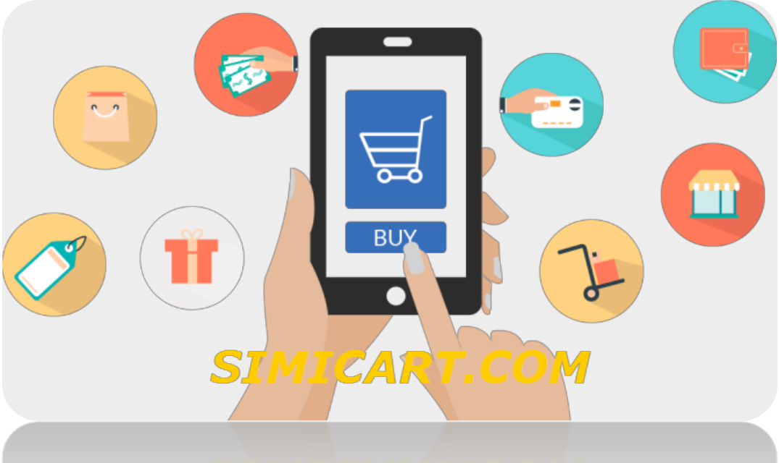

Litreture Review

* E-commerce as anything that involves an online transaction. E-commerce provides multiple benefits to the consumers in form of availability of goods at lower cost, wider choice and saves time. The general category of e -commerce can be broken down into two parts: E-merchandise: E-finance. E commerce involves conducting business using modern communication instruments: telephone, fax, e-payment, money transfer systems, e-data interchange and the Internet. Online businesses like financial services, travel, entertainment, and groceries are all likely to grow. Forces influencing the distribution of global e - commerce and its forms include economic factors, political factors, cultural factors and supranational institutions. It has an impact over the economy of many countries among which India is on the top of that list. It has named as new gold rush in e -commerce. E-commerce has many reasons that why it is very crucial in developing the country . For the study we have taken several parts of the world such as North America , Latin America , Europe , Middle-East , Africa and South Asia ,and Australia. Ecommerce has an intent to bring some transformation in the society and that„s the reason it‟s essential for the B2B and B2C commerc

Research objectives

To study consumer behavior towards online shopping.

To know consumer motivations to engage in online shopping.

To find out the perceived benefits and drawbacks of internet shopping. To know about the satisfaction level of consumer in online shopping.

•

Research Design and methodology

* RESEARCH DESIGN
* The research design used for the study E-Commerce.
* Data collection
* Sampling
* Sample design
* Sample size
* Questionnaire
* Validity and reliability
* Data analysis
* AREA OF STUDY This is done with the primary objective of ascertaining the E-Commerce Sector.

Research methodology

* **ACCORDING TO GREEN AND TULL:**
* A research design is the specification of method and procedures and acquiring the information needed. It is the overall operational pattern or fram3work of the project that stipulate which information is to be collected from which sources by what procedures “.For conducting the study, the researcher has adopted both primary and secondary method of data collection.

|  |  |
| --- | --- |
| **TYPE OF STUDY** | **DESCRIPTIVE** |
| **TYPE OF DATA** | PRIMARY |
| **SAMPLING METHOD** | QUESTIONNAIRE,INTERVIEW |
| **SAMPLING AREA** | GREATER NOIDA |
| **SAMP-LE SIZE** | 100 |

* **TYPE OF RESEARCH:**
* Research refers to search of knowledge. It can be defined as scientific a systematic search for pertinent information on a specific topic. It is careful investigation or inquiry especially through search for new facts of any branch of knowledge.
* Research places an important role in the project work. The result of the project is completely based upon the research of the facts and figures collected through the different ways of research. That is why it is also called the movement from known to unknown. Research is the original contribution to the existing stock of knowledge.
* **Exploratory or formative research:**
  + Exploratory research is conducted to clarify the ambiguous problems.
  + **Descriptive research:**
  + To portray the characteristics of an individual, group, situation, etc.
  + **Diagnostic research**:
  + To determine the frequency of occurrence of an event.
  + **Research Design:**
  + In the data collection method, we have collected both primary and secondary data to meet our objective.
* **Primary data:**
  + The primary data was collected by a survey base on the questionnaire. It was formulated on the bases of information gathered by us with the help of Ms. SMITA BARIK who provide useful guidelines and objective of our study.

•

* **Secondary data:**
  + - The secondary data was collected from books and internet.
    - **Data Source:**
    - The data that is collected from different sources, as the first hand information that is called primary data. The source of primary data in our research is questionnaire an observation method. The secondary data were also used in our report preparation .this is collected from internet.**Research approach:**
    - The required information in the form data is collected through survey method with the help of personnel interview through questionnaire method.
  + **Sampling plan:**
    - There is a stage where the planning is done about the sample unit, sample size, sampling procedure, etc.
  + **Sampling unit:**
    - This means, which is to be surveyed .So as mention earlier that the sample unit is potential peoples.
    - **Sample size:**
    - The sample size means how many people should be surveyed. So that total sample size is 100, which cover from greater Noida.
  + **Sampling procedures:**
    - We choose convenient and judgmental sampling for our research.
  + **Data collection Method:**
    - Personal interview method is used for collection of primary data in the form of questionnaire from respondents.

* **Research instruments:**
* Once the source of the data collection is decided then comes the instrument for data collection or the research instrument. In the survey method a questionnaire was framed .This is Philip by the potential people through personal interviews.

Limitations

* E-commerce as anything that involves an online transaction. E-commerce provides multiple benefits to the

consumers in form of availability of goods at lower cost, wider choice and saves time. The general category of e -

commerce can be broken down into two parts: E-merchandise: E-finance. E commerce involves conducting

business using modern communication instruments: telephone, fax, e-payment, money transfer systems, e-data interchange and the Internet. Online businesses like financial services, travel, entertainment, and groceries are all likely to grow. Forces influencing the distribution of global e - commerce and its forms include economic factors, political factors, cultural factors and supranational institutions. It has an impact over the economy of many countries among which India is on the top of that list. It has named as new gold rush in e -commerce. E-commerce has many reasons that why it is very crucial in developing the country . For the study we have taken several parts of the world such as North America , Latin America , Europe , Middle-East , Africa and South Asia

,and Australia. Ecommerce has an intent to bring some transformation in the society and that’s the reason it’s essential for the B2B and B2C commerce

•

Conclusion

* In the past, consumers had sufficient time to visit shopping centers, searching for various products. Many consumers prefer bargaining and decide the purchases after physical examination of the commodities. The entire process can range from a few hours to weeks depending on the product, quantity, quality and source of purchase. Today there is radical change in the entire scenario. Everything in today’s world is Internet oriented like Electronic Data Interchange, E-Mail, E-Business and E-Commerce.
* E-Commerce is exchange of information using network-based technologies. In the present high cost situation, e-Commerce can be used as a competitive strategy. It successfully includes the entire online process of developing, marketing, selling, delivering, servicing and paying for products and services.
* Online shopping is a vast growing technology. If it is properly utilized with assured safety and security for the transactions, it will thrive into a highly competitive and dynamic environment.

Refrences

* Books Christensen, L., Andersson, N., Carlsson, C. & Haglund, L. (2001).
* Hansen, J. (2005). 100 Sidor: Om at start, drive OchMarknadsfora En Butik pa natet.

Stockholm: Redactional.

* Hutt, M.D. & Speh, T.W. (2004). Business Marketing Management–A Strategic View of Industrial and Organizational Markets. 8th ed. Mason, Ohio: Thomson South-Western.
* Loshin, P. & Murphy, P. (1997). Electronic commerce–On-line Orde ringand Digital Money. 2 nd ed. Rockland, Massachusetts: Charles River Media , Inc.
* Internet E-Business, EEurope. (n.d). Retrieved October 13, 2016, from [http://www.eeuropestandards.org/Docs/E-Business%20to%20press.pdf](http://www.eeuropestandards.org/Docs/E-Business to press.pdf)
* E-Business Research Center. February 01, 2016. The ABCs of E-Commerce. Retrieved October 13, 2006, from <http://www.cio.com/ec/edit/b2cabc.html>
* Internet World Stats – Usage and Population Statistics. September 18, 2016. World Internet Users and Population Stats. Retrieved November 13, 2016,from
* http://www.internetworldstats.com/stats.htm