**Title:** “Impact of Brand Promotion on Market Performance Hindustan Unilever (HUL)”

1. **ABSTRACT**

This study looks at the effects of several components on brand marketing and market performance. The researcher conducted an investigation into the case of Hindustan Unilever (HUL) to examine several types of brand equity elements that impact customer purchase intentions. Hindustan Unilever is the best-known rapidly evolving consumer goods (FMCG) business in the Indian market. Under the Hindustan Unilever the company, this company offers 35 distinct goods throughout 20 categories.

The company's annual earnings is INR 27408 crore. HUL is a Unilever company that sells high-quality consumer items to clients in a variety of countries across the world. As a result, HUL has faced a variety of obstacles. Several advertising issues have harmed the company's image HUL, which led to a drop in client databases. Publicity is one of the oldest and most effective methods for influencing customer purchase intentions.

Keywords: Branding Development, Market Approach, Brand Equity, Purchase Decision, and Market Performance.

1. **INTRODUCTION**

Brand promotion is an important marketing word. Brand marketing may be characterized as an important and effective commercial approach for an organization. Brand promotion is defined by the company's positive perception and standing in an extremely competitive region. According to Khoshtaria et al. (2020), the notion of marketing for brands is based on commitment to the brand or brand expansion. Brand marketing also helps a firm get an unfair edge in a highly competitive market sector.

The goal of this study was to look at the influence of different aspects of brand marketing on market performance. In the words of Halliburton and Bach (2012), a range of factors might influence customers' purchasing decisions. An organization's reputation and reputation as a brand can help it gain positive feedback from customers. A favourable portrayal of the company in the market may help attract more customers. A favourable image and reputation for a company's brand may help improve business practices in an aggressive market area. This research study examined Hindustan the corporation's case study to address his unique research question.

The concept of market is derived from the Latin word markets, which means commerce, ware, traffic trade, or a location where business is performed.

1. The market is made up of people who have money and want to spend it.
2. A socioeconomic market is defined as a place where purchasers and sellers of products and services gather in search of possibilities to adjust their mutual interests and interact in an environment of open and unimpeded competition.
3. **LITERATURE REVIEW**

The American Marketing Association (AMA) defines a brand as a phrase, sign, name, as well as design, or symbol that assists in the identification of particular goods or services within the identical industry sector. Melović et al. (2020) found that a product's brand distinguishes it from rivals in the exact same market segment. A brand refers to the social phenomenon that may be achieved via the services provided. A brand gives personality to a product that is allowing it to stand out from other things of a comparable design and designed for similar purposes.

Al Asheq and Hossain (2019), on the other hand, proposed that the brand of diverse enterprises relates to their individual designs. The value of a brand has an influence on the target users of a company's unique product or service, either directly or indirectly. As a consequence, good brand building is one of the most crucial components of attaining a solid position in an extremely competitive sector. As a consequence, effective branding is necessary for a business organization to achieve the most renowned position in the crowded market sector.

The specific company organization educates clients about the item itself and its worth by providing superb product branding. Customers can make educated judgments about purchasing a company's specialized item of interest when it has a solid reputation (Sugiono et al., 2021). On the other hand, it asserted that in order to deliver successful branding for a good or service, this particular entity should implement a branding strategy.

To provide appropriate details about a particular manufacturer of an item or service, the company must establish effective brand value. The firm can achieve brand management to create a successful brand. As a consequence, Hofmann et al. (2021) stated that important criteria include the product, rates, packaging, and effective advertising techniques.

1. **RESEARCH OBJECTIVE**

The major goal of this project is to determine what efforts Hindustan Unilever Ltd. is taking to become the market leader and distinguish itself from its rivals. What procedures does the organization take to identify current market trends? The majority of HUL's items are in the convenience category, and they provide comparable products to their clients. Customers have gotten knowledgeable, and they have excellent understanding about the market and products.

**Other objectives:**

* **Market structure analysis**: examines the level of competition in the market for products and services. The degree of competition in a given market determines the market structures for both products and services.
* **SWOT Analysis** - SWOT analysis is an organizational planning approach that assists individuals or organizations in identifying their advantages, disadvantages, possibilities, and risks in the context of commercial rivalry or project preparation. Its purpose is to outline the objectives of the business endeavour or project and to identify both the internal and external factors that are both favourable and unfavourable to accomplishing those objectives. Practitioners of a SWOT analysis frequently pose and respond to questions to create relevant information for each area, making the tool more effective and identifying their competitive advantage. Strengths and weaknesses are generally internal in nature, whilst Opportunities and Threats are typically concerned with environmental placement.
* **Competitor Analysis** - Competitor analysis evaluates the strengths and shortcomings of present and future competitors. This study presents an offensive and reactive strategic perspective for identifying opportunities and dangers. Profiling incorporates all important competition analysis sources into a single framework to facilitate efficient and successful strategy design, execution, monitoring, and modification. Rival analysis is an important part of company strategy.

1. **RESEARCH METHODOLOGY**
   1. **Data Designing:**

**Basic research**

This study is undertaken only for the advancement of knowledge and has no immediate economic prospects. The study conducted for the wellbeing of humans, animals, and the plant kingdom. It is known as basic, pure, and fundamental research. The primary objective here is to extend human understanding, not to construct or invent something.

**Applied research**

Applied research is intended to solve actual issues in the current world rather than acquiring information for its own sake. Applied research aims to better the human situation. It focuses on analyzing and addressing social and real-world problems. This study is often undertaken on a huge scale and is costly. As a result, it is frequently carried out with the assistance of a finance body such as the national government, government company, world bank, unicef, ugc, etc.

**Quantitative research**

The study is based on numerical data. Quantitative research aims to measure a number or amount, compare it to previous data, and forecast for the future. In the humanities and social sciences, "quantitative research alludes to the systematic examination of quantitative features and events and their relationships".

**Qualitative research**

Qualitative research presents non-quantitative type of analysis. Qualitative research is collecting, analyzing and interpreting data by observing what people do and say. Qualitative research refers to the meanings, definitions, characteristics, symbols, metaphors, and description of things. Qualitative research is much more subjective and uses very different methods of collecting information, mainly individual, in-depth interviews and focus groups.

* 1. **Data Collection:**

Hindustan Unilever, a large consumer products corporation in India, uses a variety of data collecting tools to get insight into customer tastes, market trends, and its operational effectiveness. Hindustan Unilever commonly collects data using the following methods and forms:

* **Surveys and Questionnaires:** Hindustan Unilever frequently runs questionnaires and surveys to acquire customer input on their product choices, habits of use, level of satisfaction, and brand impressions. These surveys may be done using a variety of media, including internet platforms, mobile apps, and in-person interviews.
* **Consumer Panels:** Hindustan Unilever may form consumer panels, which are groups of people who agree to offer frequent feedback on goods and engage in market research operations. This strategy enables the organization to collect precise data over time and monitor changes in how customers behave.
* **Qualitative Research:** Hindustan Unilever undertakes qualitative research using methodologies like as focus groups, extensive interviews, and ethnographic investigation to acquire a better understanding of customer behaviour, attitudes, and cultural influences.

1. **DATA ANALYSIS**

The table shows that out of 450 household respondents, 389 (86.44%) are male and 61 (13.56%) are female.

**Gender of Respondents**

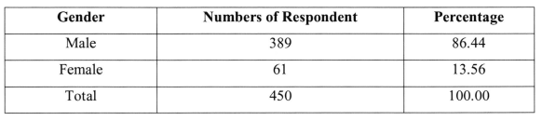

The info gathered is also categorized based on education. All 450 respondents are classified into seven groups: illiterate, from SSC, HSC, Graduate, Postgraduate, above postgraduate, and others. The numbers of respondents in each group are 43, 92, 709, 123, 45, I 6, and 22. This data is shown in the table below.

**Education of Respondents**

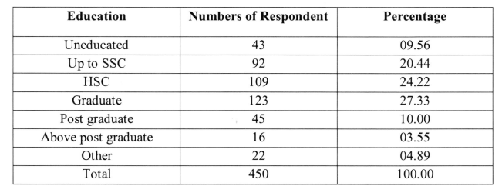

**Purchaser of daily needs goods**

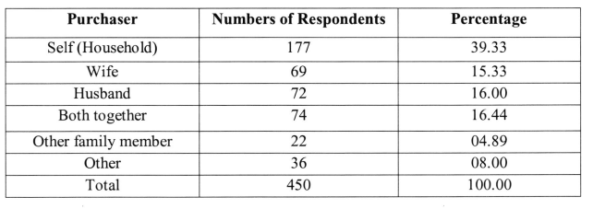

According to the data above, 177 households out of 450 purchase daily necessities. Purchaser Number of Respondents Percentage Self (household) 177 39.33 Wife 69 15.33 Husband 72 16.00 Combined 74 16.44 other relatives 22 04.89 other 36 08.00 Total 450 100.00 180 l4o/n 2t% t5% 25% 20% responders. In 69 homes, the females of the family buy everyday necessities.

In the other 72 families, men make it. In 74 homes, the husband and wife acquire daily necessities jointly. In 22 families, other family members acquire everyday necessities. The remaining 36 families obtain daily necessities with the assistance of other members

**Factors influencing buyer's behavior**

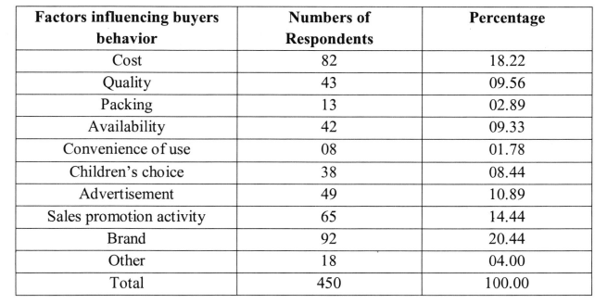

The chart above demonstrates that cost is the primary source of demand among 82 respondents. 43 respondents' desire is influenced by quality. Packing is the third aspect that influences demand among 13 respondents. Due to availability, 42 respondents impact their desire.

Another element that influenced 8 respondents' demands was convenience of usage. Children's preferences are another consideration, since 38 respondents expressed their desires. 49 of all respondents made their demands based on the advertising. 65 percent of all respondents make their demands through sales promotion activities. The brand is the reason why 92 percent of respondents make a demand. The remaining 18 respondents base their desire on other factors.

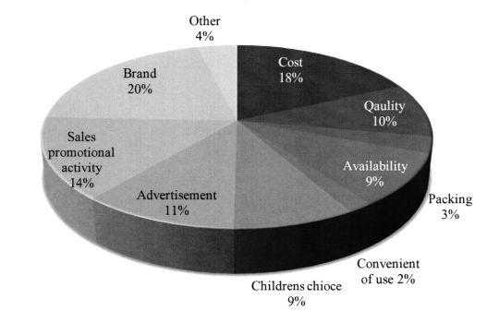

98 percent of respondents consult with their store before choosing on a brand. They buy the manufacturer recommended to them by their store. 88 respondents choose their brand based on their previous experience. 98 respondents chose their brand based on recommendations from their family and friends. 126 of all respondents chose their brand through ads. The remaining 40 respondents chose their brand from other sources.

**Brand selection**

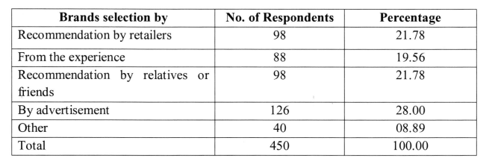

1. **LIMITATION**

A study of Hindustan Unlived Limited's marketing strategy and its impact on consumers in Amravati district, the following limitations occurred: lack of respondents' understanding, variety of products and their use, the subject matter of study, time frame for study, respondent's age and income, etc., and the study has the following limitations as well.

1. The current study was confined to Hindustan Unilever confiner’s goods in the market. Competitor firms' products, such as Proctor and Gamble (P&G), Dabur, Godreg, Nirma, and others, were included for comparison.
2. To reach some normative conclusions on a suitable marketing approach for manufacturers of home care, personal care, and food and beverage products in the organized sectors.
3. The data is trustworthy based on the consumer's loyalty and honesty.
4. Because the study covered personal products, the respondents were hesitant to provide information about how they used them.
5. Some research respondents did not share their preferences and dislikes.
6. Data on little respondents (youngsters) were not collected due to their inclinations.
7. The wholesalers were not prepared to provide their distribution channel.
8. Because retailers ran their businesses solely by themselves, data could not be collected from them.
9. Because some customers solely eat Swadeshi products, data could not be collected.
10. Due to the high cost of some HUL products, low-income consumers are unable to utilize them, resulting in incomplete data collection.
11. **FINDINGS**

The researcher linked this purpose to appropriate literature to discover the various elements of brand promotion. These are one of the most important factors of developing brand marketing. These aspects are additionally referred to as branding assets since they impact the purchase decisions of those who patronize a business.

Brand loyalty refers to the attachment that customers have to a certain brand. Brand allegiance may be measured by a customer's predisposition for frequent purchases and referral marketing about products from the same company. Awareness of a company, on the opposite end of the spectrum, may be described as the ability to recognize one brand from others in an environment of competition.

The study also looked at many factors that impacted customers' purchasing decisions. The study revealed, using secondary sources, that a variety of cultural, psychological and economic factors have affected customers' purchasing inclinations. On the other hand, the researcher has established that the good or service's characteristics influence customer purchasing intentions. Advertising, presentation, price, and retail identity are all examples of extrinsic product or service features.

1. **RECOMMENDATION**

* Creating an integrated plan for marketing communications that ensures continuity and harmony across all channels is referred to as integrated marketing communication, or IMC. This includes arranging promotions, messaging, and visuals for usage in conventional media, internet, and in-store environments.
* Digital Transformation: Given the rising popularity of online venues, it is critical to devote more resources to marketing via digital channels in order to effectively engage and interact with customers. This comprises increasing HUL's online presence, employing social network influencers, and implementing targeted digital advertising strategies.
* Data-Driven Insights: When deciding on advertising strategies, use customer data acquired through fieldwork. Analyze geographic and behavioural data to target specific customer categories, tailor advancements, and maximize marketing ROI.
* Brand Differentiation: To distinguish HUL from the competition, emphasize its distinct value proposition and distinctive identity in promotional efforts. Emphasizing creativity, environmental consciousness, and high-quality products may attract discriminating customers and boost brand loyalty.
* Engagement and Interaction: Encourage deeper customer participation with interactive marketing strategies. This might include user-generated content attempts, gamification, or tournaments designed to increase engagement and create memorable brand experiences.

1. **CONCLUSION**

Hindustan Unilever Private Limited is India's most admired FMCG Company, competing against numerous other industry players such as ITC, Nestle, and P&G.

The examination of HUL's strategic approach reveals that despite its size and breadth of brands, the company has given similar significance to all of its offerings. Furthermore, as is evident across all of its segments, which are frequently employed by Indian and international customers, HUL is not only concentrating on major brands however additionally on those that are ineffective, as well as new products are introduced into the market while keeping the importance of technological advancement in mind in the constantly evolving marketplace.

Hindustan Unilever, also known as Unilever, is a major firm with many brands and products; hence its promotional programs are diverse and wide. It has used ads to raise awareness about its products, disseminating product information through print media such as journals and newspapers.

Sales promotion may also be seen in the form of contests, free samples, cheaper prices for introductory items, and celebrity endorsements. Sakshi Talwar is connected with Vim, Yami Gautam with Kwality Walls, Kareena Kapoor with Lakme, Kajol with Knorr soups, Varun Dhawan with Ponds men's collection, and Anushka Sharma with Bru. To pique consumers' curiosity, various staff members are engaged to conduct live product demonstrations through booths in certain public settings. Its awareness of the client and ability to interact with them through technology and innovation sets it apart.

1. **REFERENCES**

* Al Asheq, A. and Hossain, M.U., 2019. SME performance: impact of market, customer and brand orientation. Academy of Marketing Studies Journal, 23(1), pp.1-9.
* Alić, A., Činjarević, M. and Agić, E., 2020. The role of brand image in consumer-brand relationships: similarities and differences between national and private label brands. Management & Marketing, 15(1), pp.1-16.
* Cowan, K. and Guzman, F., 2020. How CSR reputation, sustainability signals, and countryof-origin sustainability reputation contribute to corporate brand performance: An exploratory study. Journal of business research, 117, pp.683-693.
* Das, S., 2020. Innovations in digital banking service brand equity and millennial consumerism. In Digital transformation and innovative services for business and learning (pp. 62-79). IGI Global.
* Gupta, S., Gallear, D., Rudd, J. and Foroudi, P., 2020. The impact of brand value on brand competitiveness. Journal of Business Research, 112, pp.210-222.
* Gaurav Joshi, Deepti Pathak, Kirti Agarwal and Samant Shant Priya, "Consequence of personality attributes on brand loyalty in the automobile industry", International Journal of Indian Culture and Business Management , Vol. 24, No. 4, pp 503-522.
* Hofmann, J., Schnittka, O., Johnen, M. and Kottemann, P., 2021. Talent or popularity: What drives market value and brand image for human brands?. Journal of Business Research, 124, pp.748-758.