Intelligent Bus Tracking System

Amistrack

Abstract

The Intelligent Bus Tracking System is a cutting-edge solution that integrates machine learning tools and face detection technology to revolutionize transportation services within academic institutions. Leveraging the power of artificial intelligence, this system enhances the accuracy, efficiency, and security of bus tracking while introducing innovative features such as facial recognition for identification to Student Attendance.(Saad et al., 2018)

The bus tracking system is a comprehensive solution designed to enhance the efficiency and safety of transportation services within academic institutions. This system leverages modern technologies, including GPS and mobile communication to provide real time tracking and monitoring of buses operating within the academic campus. The primary goal is to optimize the transportation experience for students, faculties and staff while also improving overall operational management.(Sharif et al., 2018)

Introduction

In this fast life everyone is in hurry to reach their destination in this case waiting for the buses is not reliable people who rely on the college bus transport their major concern ins to know the real time location of the bus for which they are waiting and the time it will take to reach their bus stop. This information helps people to make better travelling decisions. This paper gives the major challenges in the transport system and discuss various approaches to intelligently manage it current position of the bus is acquired by the GPS device on the bus.(Chan et al., 2020) GPS coordinate of the bus when send to the centralized server where various arrival time estimation algorithms are applied using historical speed pattern. This prompted us to alternate bus, along with the shortest route from the bus and informing the student, faculty & parents when the bus is missed.(Kumbhar et al., 2016)

Our project is presenting an application for intelligent mobile devices, mainly GPS several methods are proposed to reduce the wastage of time of students waiting for a bus to arrive, we proposed. GPS based bus tracking and monitoring system in which the tracking is done by implanting. Maps with GPS facility.(Xu & Ying, 2017) The android application is designed for students where they can access/view the daily timetable of bus, bus route, location of bus, and bus arrival and delay timing information. Our main focus is to provide the student with all necessary details regarding the arrival time of the bus, its exact location and expected waiting time.(Minu & Deepak Adithya, 2018)

What is a bus tracking system?

There are so many variables that can affect when and where a bus shows up: the route, traffic, passenger load, mechanical issues, and more. To make the process easier for both passengers and operators, many transport systems are turning to bus tracking or GPS-based vehicle management systems.(Patel et al., 2017)

The bus tracking system uses GPS technology and software applications to track the location of buses and provide real-time updates to operators and passengers. These systems allow passengers to track buses in real-time, making sure they know exactly when the next bus will arrive. They also help operators plan routes and manage resources more efficiently.(Kumari et al., 2020)

This solution is especially useful in the context of academic’s buses. A bus tracking system helps administrators and parents keep track of their children's school buses. This is accomplished through integration with bus fleet management software, providing real-time updates on the location of each bus.(Monica, 2019) This allows parents to know exactly when their child's bus will arrive at home, while administrators can more easily manage their transportation resources. A good system also provides notification of any delays or changes in the schedule.(Ahmed et al., 2017)

A school bus gps tracking tells you where your buses are, when they will arrive at various locations. School bus tracking software reports lets you verify routes and schedules, change routes to accommodate a new housing development avoid traffic congestion and track driver behavior, analyzing the children’s safety and security is vital. You can set parameters to monitor arrival times, excessive speed, and aggression driving.(Premkumar et al., 2020) School bus tracking alerts you when something out of the ordinary happens to delay the bus’s arrivals, so you can allay the fears of parents and school administrators:

* Confirm that your operator is driving safely and cautiously.
* Save fuel by reducing idling time.
* Accurately map bus routes and change inefficient ones to increase on time performance.
* Reposition bus stops as necessary to increase efficiency.(Deebika Shree et al., 2019)

How this solution works?

* The GPS tracker present in the bus will be replaying information about its real time location. The telematics device installed on the bus collects and transmitted critical vehicle and driver data in real time.(Sriram & Sudhakar, 2021)
* The data is sent to central servers via cellular networks and GPS state lights network which will perform all computations and store each bus position in the database.
* This information stored on the cloud will be retrieved by users through fleet management software or android applications. These software and apps will display the real time location of buses based on the user’s destination graphically on the map.(Vidyavathi, 2018)

How can we consider the technique?

There are several factors to consider our technique:

1. Accuracy

One of the most important factors to consider when choosing a tracking system accuracy. The system must be able to accurately track and monitor the moments of student in real time behavior.

1. Scalability

It should be scalable and able to handle large volumes of students details during peak periods without compromising accuracy or system performance.(Shah & Singh, 2016)

1. Data security and privacy

The system should be designed with data security and privacy in mind, including compliance with relevant regulations and standards.

1. Cost

The cost of the project should be reasonable and provide value for money, while also considering long term maintenance and upgrade costs.

1. User friendliness

The system should be user friendly and easy to use for students, parents.(Douglas & Sutton, 2010)

1. Reliability

The system should be reliable and have a high level of uptime to ensure that the student’s safety and operational efficiency.

1. Real time reporting and analytics

The system should provide real time reporting and analytics to enable operators to make informed decisions and improve operational efficiency.

1. Compatibility

it should be compatible with mobile devices to enable students & their parents to access information on the web/application.(K, 2017)

**START**

**Bus Information**

**Select Routes**

**Track Location**

**Administrator**

**Bus Information**

**Student Details & Tracking**

**Updates**

**Short overview of Project**:

Key words/ Key Points

* AI-Based Bus Tracking System
* Machine Learning for Transportation
* Facial Recognition in Bus Transportation
* Smart Boarding Assistance
* Real-Time Monitoring with AI
* Smart Transportation Solutions
* Artificial Intelligence in Student Transportation(Sinha et al., 2017)

**Literature Review**

Android Application

The proposed mobile application is used for solving many problems starting from the students waiting for the bus. The mobile application will be useful to know next stops and student can monitor the location of the bus on the map. The application is very helpful to find the bus by student will be reduced. This application will save the time and iterations of bus will definitely-lessen by this app.(Cholilalah, Rois Arifin, 1967) GIS and GPS technologies introduced this application Amity University Chhattisgarh is going to use this application for their students and providing them best transport services. This system stores all operations done in a day and helps the student and management of transport service. University using this app for better management and quick transport services for students.(Mulla et al., 2020)

Notification System

In the application, a notification system is applied which is more convenient between the server and driver and passengers. As the application is a mobile application then sending notification is a very practical way. This system architecture which describes the structure and overall design of a system is presented.(Ahmed et al., 2017)

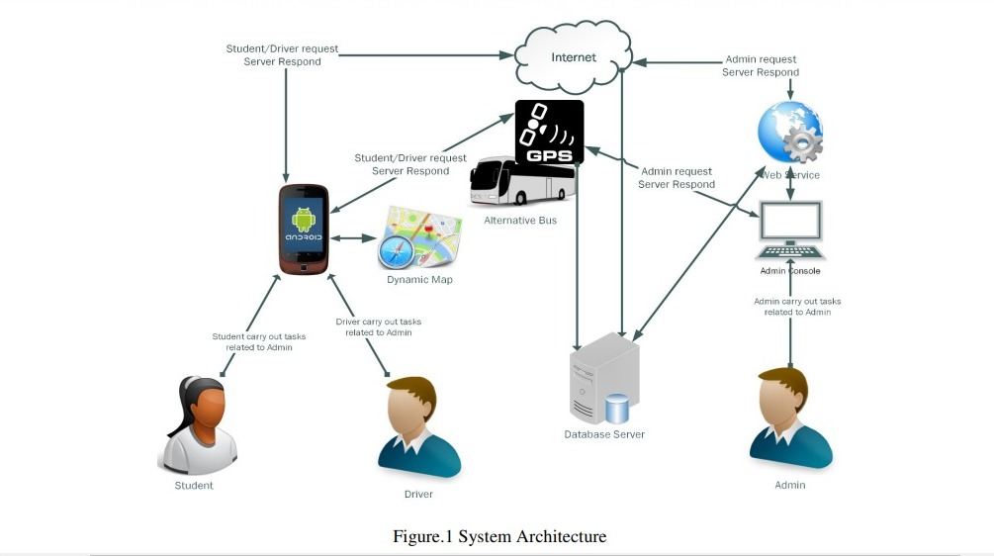

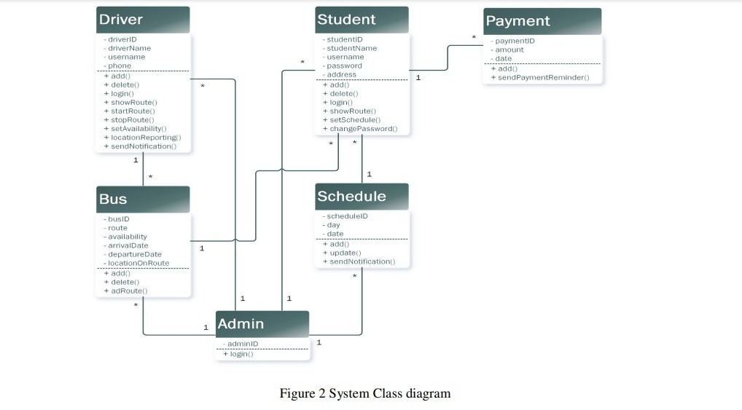

in figure 1. A class diagram of the system is presented in figure 2. The admin has a login. Username and password to log to the web portal to carry out his tasks. The admin can control all the tasks from his screen. The driver can set the availability of the bus weather the bus is available or not, if the bus is not available a notification will be sent to the concerned students.(Krishna et al., 2022)

The timetable of each student will be entered, a notification will be sent, and route will be updated. Accordingly, if there are any changes in the presented schedule.(Priyanka et al., 2021)

**The proposed system consists of three vital modules: -**

1. Bus Unit

2. Central Control Unit

3. Client-Side Application

In the bus unit, a bus has a GPS device attached to it that sends its coordinates i.e. longitude and altitude after every fixed interval of time to the main server. To use GPS there are no subscription fees or setup charges. To calculate the position, GPS receiver can receive signals from at least three satellites.(Kumbhar et al., 2016) Depending on the kind of application the GPS transceivers may be data Loggers, data Pullers or Data Pushers. This device receives the GPS information and sends the data at regular intervals to the server. On receiving, the server analyses the data. To receive signals in the appropriate place, the GPS antenna is connected to the right jack and fixes the antennas. One slot is allocated for SIM card, and it receives the signals from the GSM towers to respond to the users.(Anbalagan & Sudhakar, 2019) The positive and negative wire is connected to 12V or 24V vehicle power system. Then to receive the signals from the satellite the tracker device is turned on. Now the device can receive the latitude and longitude values of the location of the bus. At any point of time, the GPS receiver gives the location values. Now the bus unit has the coordinates with a timestamp which is then compared with the previous coordinates and if there is any distinction then the coordinates are updated and sent to a server over GPRS network (internet).(Miss. Kute Sushma Vijay et al., 2022)

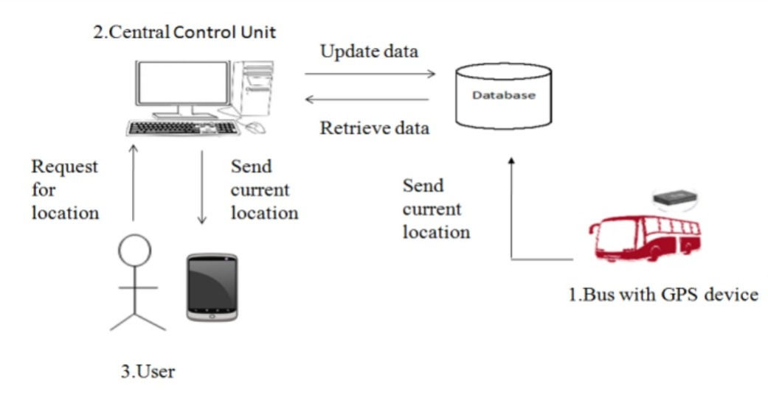

**Bus Tracking-**

**SOFTWARE REQUIREMENT SPECIFICATION FUNCTIONAL REQUIREMENTS**

Functional requirements refer to the functionalities that must apply to a system. The functional requirements of bus tracking system are stated below. The system must be able to show information to user in real time. The system must be able to process the position data received from the bus positioning module, calculate the estimated time to user and display the position on maps. The system must be able to show the estimated arrival time for every bus in every bus stop. The system must be able to allow the user retrieve information from mobile device and computer. The system must be able to show the traffic information on maps. NON-FUNCTIONAL REQUIREMENTS The system should provide the accurate estimated bus arrival time to us(Jiang & Zhen, 2019)er. The system should reduce the paperwork done by bus management team. The system should be able to increase the efficiency and performance of bus service. The system should reduce work done by bus management team by automated calculation of estimated bus arrival time and showing real time bus position to user.(Xie et al., 2014) The system should allow user to access information in anywhere with anytime USER REQUIREMENTS There are two main target users for the proposed system, bus user (student/staff) and bus management team. The requirement from different user is stated below.(Nandhini et al., 2019)

**Bus user:**

Student/Staff is the main user of the proposed system because the main objective of bus tracking system is to provide estimated bus arrival time for student. The student/staff must able to retrieve real time estimated bus arrival time for every bus stop. While waiting in bus stop, student able to access bus tracking system with mobile device instead of using computer to access.(Wang et al., 2014) This is the main purpose of bus tracking system in mobile application is developed. The system is provided real time bus tracking system with mapping feature, which mean student/staff able to view the bus position with a map. With this mapping technique, student able to know where is a bus position based on the map in real time. (Ahmed et al., 2017)

**Bus Driver:**

Bus driver is the second important user of this system. Bus driver is able to update bus status accordingly in order to inform bus users about immediate situation.

**Actor:**

* Parents
* Student
* Faculty
* Driver

**Bus application Use-case:**

* Get the bus location
* Get the bus information
* Get current location
* Send location
* Update location

**WORKFLOW OF THE SYSYTEM**

The workflow of this system proceeds as follows. First, the GPS module which is fixated in the bus starts sending data in the form of latitude and longitude which is stored in the computer system. At the same time, a user can enter the source and destination of the bus number of which it seeks the location. This search will result in the all the bus routes through which the bus will travel. Alongside, the computer system will update the longitude and latitude of the required bus. This search will then look up for the range of bus from the user to its current location.(Wang et al., 2014) If the bus is in range, the search also looks up for the in-between bus stops and the active buses in that range. After this, it matches the bus location with the passenger’s source location and calculates the time required for the active bus to reach the passenger location as shown in Fig. 2. The GUI will display the bus location and the estimated time of arrival to the user. This process follows a repetitive cycle for every search performed by the user.(Mulla et al., 2020)

The location details are stored on a server in the format such as ID, longitude, latitude, timestamp, etc. To identify every bus among the varied buses here ID is taken. Each bus has given one distinctive identification number. The server is the most significant module during this system which acts as a central repository of the system. In this system, the whole information is stored and maintained by the server. The server is the intermediate between bus module and user module. These databases consist of real-time information regarding bus it includes bus routes, actual arrival/departure time and real time location of the bus. (Sinha et al., 2017)

The user side module is nothing but an interactive web-based application that services the various function of the system to remote users. The user side module takes two inputs i.e. one is the source that indicates wherever the remote user is now and second is the destination user wants to travel. When a user sends a request the appliance fires a query to the server for accessing the data stored within the server database and provides the list of obtainable buses in keeping with remote users supply and destination(Ahmed et al., 2017)

**Face Recognition with attendance –**

Face recognition (FR) has received considerable attention in the field of security, especially in the use of closed-circuit television (CCTV) cameras in security monitoring. Although significant advances in the field of computer vision are made, advanced face recognition systems provide satisfactory performance only in controlled conditions. They deteriorate significantly in the face of real-world scenarios such as lighting conditions, motion blur, camera resolution, etc. This article shows how we design, implement, and conduct the empirical comparisons of machine learning open libraries in building attendance taking (AT) support systems using indoor security cameras called ATSS. Our trial system was deployed to record the appearances of 120 students in five classes who study on the third floor of FPT Polytechnic College building. Our design allows for flexible system scaling, and it is not only usable for a school but a generic attendance system with CCTV. The measurement results show that the accuracy is suitable for many different environments.(K, 2017)

There are several benefits from attendance considering using the existing camera system, such as save time and effort, provide striking evidence for quality assurance and human resource management tasks, avoid intermediary of infectious diseases. The existing attendance taking system that uses fingerprint recognition is facing several challenges due to large intra-class variability and substantial inter-class similarity mentioned by Dyre and Sumathi. Ngo et al. combined the data from the academic portal with different FR techniques for the task of taking attendance in the classroom. The result shows that their system works smoothly. However, the investment costs for procurement, camera installation at the school, and many video processing are expensive.(Sharif et al., 2018)

The system can automatically detect and recognize faces from the images, and then gets its detailed information on attendance from the database. The process works by capturing digital images of faces and comparing them against a database of previously collected data. In some cases, the user may need to provide their name and ID card details directly, but if they don’t, the system should still allow the correct person to be identified based on their face. The conventional methods of attendance taking, such as manual roll calls or card-based systems, are not only time-consuming but also susceptible to errors, leading to inaccurate attendance records. The Face Recognition Attendance System aims to address these challenges by providing a more efficient and secure alternative. Facial recognition systems are designed to work with people who attend events, stores, banks, offices, schools, venues, and other public locations. DNN is used for face detection. For SVM and MLP based approach, the features are extracted using PCA and LDA feature extraction algorithms. High-resolution cameras capture facial images during designated time slots, ensuring clarity and precision. The captured facial data is securely stored and processed within the college's database, maintaining the privacy and confidentiality of student information. The system seamlessly integrates with the college's student database, linking facial data to individual student profiles. Real-time synchronization ensures that the attendance records are updated promptly.(Patel et al., 2017)

#### Related Works

Recently, deep learning techniques have made many significant achievements in FR, such as deep convolutional neural networks use a cascade of multiple layers of processing units for feature extraction. They learn various levels of representations that correspond to different levels of abstraction. These techniques are called deep FR. The evolution of the FR is around network architectures and loss functions. Deep face model trained on the large dataset. We often lack resources to learn a complex model with minimal training samples for a specific face recognition task. Therefore, using the pre-trained model as transfer learning is usually applied. Wang and Deng reviewed many model techniques such as Arc Face proposed a new loss function, additive angular margin to learn highly discriminative features for robust face recognition. SphereFace used Resents 64 architecture and angular SoftMax loss to learn discriminative face features with the angular margin. Another face embedding is Face Net that uses a new triplet loss function and a large private dataset to train a Google Net. Cos face introduced their loss function based on a cosine margin term to maximize the decision margin in the angular space. They are some of the famous representatives along with other Deep FR works that are recently published. The surveys show that most of the review models gain high achievements, with more than 98% to almost 100% accuracy on the tested datasets.(Mulla et al., 2020)

#### Problems of Face Recognition in Attendance Taking System Using CCTV

The picture seems simple when we think that we only need to use FR to determine if students are present. However, when we carried out our investigation, we faced some problems:

(1) Required almost 100% accuracy: attendance usually affects students directly. Many schools also require attendance as part of the assessment process. See an example of the course syllabus for EBIO 6300 of the University of Colorado in semester fall-2013. At FPT polytechnic, the minimum attendance required is 80% (over 30 slots of studying). There are several strategies to solve the problem apart from the special technical efforts such as additional policy, system support, etc.

(2) Constrained because of the environment: installed equipment is mainly used for security purposes instead of attendance taking. The cameras are hung at the intersection in the corridor, such as the elevator hall, corridor corner. The AT must not generate any effects on the existing CCTV system.

(3) Performance of the current methods in a real environment: even if the accuracy of Arc Face, the highest archive algorithm mentioned in is up to 99.83% on MS-Celeb-1M test set. Algorithms almost work well in an ideal environment, which may not be satisfied in the real settings because of the effect of motion, camera resolution, light conditions. The attendance taking task may not require responding in runtime; however, the delay should be as short as possible, or it is feasible to do this by increasing the processing capacity of the system. Meanwhile, most of the high accuracy libraries implement the state-of-the-art in FR asked for high processing time.

(4) Ability to integrate with existing systems: attendance taking system has a significant influence on the way the performance of attendees is measured. System integration relates to user habits and operating experience. Therefore, they need to be able to leverage the available resources of existing information systems. Besides, these systems also bring other benefits to the attendance system. (Premkumar et al., 2020)

**The key feature Face Recognition Attendance System: -**

* Precise and Reliable Attendance Tracking

The Face Recognition System offers a high level of accuracy in identifying individuals based on their facial features. By using advanced algorithms, the system ensures reliable attendance tracking, minimizing errors and unauthorized access.

* Touchless Attendance Management

In today's health-conscious environment, the touchless functionality of the Face Recognition System is precious. Employees or students can simply present their faces to the camera, reducing physical contact and the risk of cross-contamination.

* Real-time Monitoring and Reporting

Face Recognition Attendance System provides real-time monitoring of attendance data. Administrators can access attendance reports and analytics instantly, enabling them to make data-driven decisions and streamline attendance management.

* Gesture control

Face Recognition Attendance System comes equipped with cutting-edge gesture control features that elevate the user experience to new heights. With the power of gesture recognition technology, users can interact with the system effortlessly and intuitively.

* Secure and Complaint Data Storage

Data security and privacy are paramount, especially when dealing with sensitive information like biometric data. The highest level of security with encrypted storage, adhering to industry standards and data protection regulations.

* Easy Implementation and user-friendly Interface

With a user-friendly interface, the Face Recognition System is easy to implement, and minimal training is required for administrators and users. This smooth adoption process ensures a hassle-free transition to the new attendance tracking system.(Saad et al., 2018)

**The Future of Face Recognition Technology:-**

* **AI Integration :**

Face recognition technology will be integrated with advanced AI algorithms to enhance its accuracy and efficiency. As of my last knowledge update in January 2022, face recognition technology has been rapidly advancing, and its integration with artificial intelligence (AI) has been a significant trend. Advancements in deep learning algorithms, particularly convolutional neural networks (CNNs), contribute to better accuracy in face recognition. Continued research and development will likely result in even more robust models capable of accurately identifying individuals in various conditions, such as low light or partial occlusion. Efforts are being made to enhance the real-time processing capabilities of face recognition systems. Faster and more efficient algorithms, coupled with improvements in hardware, will contribute to reducing processing times, making face recognition applications more responsive. The future may see the integration of multiple biometric modalities, such as combining face recognition with voice recognition or fingerprint scanning. This multimodal approach enhances overall security and reliability by combining the strengths of different biometric technologies. Integration with AR applications may become more prevalent. This could include real-time face recognition in AR glasses or other devices, enhancing user experiences in various contexts.(Kumari et al., 2020)

* **Holographic Displays:**

Face recognition technology will be used to create lifelike holograms that can interact with users in real-time. Face recognition in holographic displays could lead to more immersive and interactive user experiences. Users may be able to control holographic interfaces or manipulate virtual objects using facial expressions, gestures, or other biometric data. Holographic displays combined with face recognition may enable personalized content delivery. Devices could recognize users and adjust holographic interfaces, content, or advertisements based on individual preferences. As with any technology involving biometric data, there will be ethical considerations surrounding the use of face recognition in holographic displays. Regulations and guidelines may need to be established to ensure responsible and fair deployment. Face recognition in holographic displays could be integrated with other emerging technologies, such as augmented reality (AR) and virtual reality (VR), creating even more dynamic and engaging user experiences. Continued research and development will be essential for pushing the boundaries of what is possible with face recognition in holographic displays. Collaboration between researchers, engineers, and designers will drive innovation in this field.(Kumbhar et al., 2016)

* **Augmented Reality :-**

Face recognition technology will enrich AR experiences and enable seamless interactions between the virtual and physical worlds. The future of face recognition technology in augmented reality (AR) holds significant potential and raises various considerations. As technology continues to advance, Face recognition in AR can lead to highly personalized experiences. AR devices can identify users and tailor content or applications based on individual preferences and characteristics. Advanced facial analysis algorithms can be integrated to detect and respond to users' emotions, allowing for more immersive and emotionally intelligent AR experiences. Face recognition can be utilized for secure authentication in AR applications, enhancing security measures. This can be particularly relevant for access control and secure data handling in various industries. Face recognition can facilitate more natural and interactive social experiences in AR. Users may be able to identify and interact with others seamlessly in virtual or augmented environments, enhancing communication and collaboration. AR devices equipped with face recognition can enable targeted advertising by analyzing user demographics and preferences in real-time. This can enhance the effectiveness of marketing strategies in physical spaces.(Patel et al., 2017)

Methodology (feature, tools, and output)

Here are some of the major tools which are followed with their workflow:

* OpenCV (Open-Source Computer Vision)

It is a machine learning library, it provides various tools and functions for image processing, including face detection. It can be used for face detection in image or videos streams.

* Deep learning frameworks. (TensorFlow etc.)

Deep learning frameworks provide the tools and libraries to build train, and deploy neural network, including those of face detection.

* Face Recognition Libraries (python)

That project in python provider a high-level interface for face detection, recognition, and manipulation.

* Cameras & embedded systems

Cameras are used to capture image or video streams containing the face of individuals within the vehicle. The embed system are used for on boarding processing and analysis of facial data.

* Gateways

It is used to aggregate and transmit data from on boarding devices a central or cloud platform.

* Cloud platform

The central server or cloud platform is responsible for receiving, storing and processing facial data from buses.

* Communication models.

That modules facilitate the transfer of data between on board and devices as the central server.(Minu & Deepak Adithya, 2018)

Reference (via Mendeley apk)

Ahmed, A., Nada, E., & Al-Mutiri, W. (2017). University Buses Routing and Tracking System. *International Journal of Computer Science and Information Technology*, *9*(1), 95–104. https://doi.org/10.5121/ijcsit.2017.9108

Anbalagan, S., & Sudhakar, T. D. (2019). Protection of Power Transmission Lines Using Intelligent Hot Spot Detection. *5th International Conference on Electrical Energy Systems, ICEES 2019*, 1–6. https://doi.org/10.1109/ICEES.2019.8719290

Chan, W. C., Ibrahim, W. H. W., Lo, M. C., Suaidi, M. K., & Ha, S. T. (2020). Sustainability of public transportation: An examination of user behavior to real-time gps tracking application. *Sustainability (Switzerland)*, *12*(22), 1–20. https://doi.org/10.3390/su12229541

Cholilalah, Rois Arifin, A. I. H. (1967). 済無No Title No Title No Title. *Angewandte Chemie International Edition, 6(11), 951–952.*, 82–95.

Deebika Shree, A., Anusuya, J., & Malathy, S. (2019). Real Time Bus Tracking and Location Updation System. *2019 5th International Conference on Advanced Computing and Communication Systems, ICACCS 2019*, 242–245. https://doi.org/10.1109/ICACCS.2019.8728353

Douglas, K. M., & Sutton, R. M. (2010). Kent Academic Repository. *European Journal of Social Psychology*, *40*(2), 366–374.

Jiang, W., & Zhen, Y. (2019). A Real-Time EV Charging Scheduling for Parking Lots with PV System and Energy Store System. *IEEE Access*, *7*, 86184–86193. https://doi.org/10.1109/ACCESS.2019.2925559

K, S. (2017). Smart Bus Tracking and Management System using Iot. *International Journal for Research in Applied Science and Engineering Technology*, *V*(III), 372–374. https://doi.org/10.22214/ijraset.2017.3067

Krishna, R. V., Lokesh, V. A., Sai, N., Reddy, K., & Rao, B. S. (2022). *IOT BASED BUS LOCATION TRACKING SYSTEM Figure 1 : Block Diagram Of Iot Based Bus Location Tracking System*. *06*, 4475–4480.

Kumari, M., Kumar, A., & Khan, A. (2020). IoT Based Intelligent Real-Time System for Bus Tracking and Monitoring. *2020 International Conference on Power Electronics and IoT Applications in Renewable Energy and Its Control, PARC 2020*, 226–230. https://doi.org/10.1109/PARC49193.2020.246240

Kumbhar, M., Survase, M., Mastud, P., & Salunke, A. (2016). Real Time Web Based Bus Tracking System. *International Research Journal of Engineering and Technology*, *3*(2), 632–635. https://pdfs.semanticscholar.org/06df/12eaa6ede3ecb13f77c3bdf92d85051c81e0.pdf?_ga=2.123533326.425985727.1520207232-958697846.1520207232

Minu, M. S., & Deepak Adithya, K. N. (2018). Real time college bus monitoring and notification system. *International Journal of Recent Technology and Engineering*, *7*(4), 14–16.

Miss. Kute Sushma Vijay, Miss. Chothave Reshma Vishnu, Miss. Khandre Krutika Sanjay, Miss. Gorde Priyanka Goraksha, & Prof. Umakant D. Butkar. (2022). Bus Tracking System Using Mobile Application.  *Ijariie-Issn(O)-2395-4396*, *08*(03), 330–346.

Monica, K. I. (2019). Bus Tracking System using GPS on Smartphones. *International Journal of Engineering Research & Technology (IJERT)*, *7*(11), 1–4.

Mulla, R., Mujawar, T., Sutar, S., Shelke, R., & Hippargi, S. (2020). Smart College Bus Transport System: a Review. *International Journal of Engineering Applied Sciences and Technology*, *5*(1), 304–308. https://doi.org/10.33564/ijeast.2020.v05i01.046

Nandhini, R., Duraimurugan, N., & Chokkalingam, S. P. (2019). Face recognition based attendance system. *International Journal of Engineering and Advanced Technology*, *8*(3 Special Issue), 574–577. https://doi.org/10.48175/ijarsct-9225

Patel, D., Seth, R., & Mishra, V. (2017). Real-Time Bus Tracking System Professor. Rucha Pathari 4. *International Research Journal of Engineering and Technology (IRJET) e-Survey*, *146*, 401202. www.irjet.net

Premkumar, K., Pavithra, K., Presiela, J., Priyadarshini, D., & Priyanga, P. (2020). College Bus Tracking and Notification System. *2020 International Conference on System, Computation, Automation and Networking, ICSCAN 2020*, 21–24. https://doi.org/10.1109/ICSCAN49426.2020.9262303

Priyanka, K., Abirami, S., Kalivani, S., Kavitha, A., & Meena, A. (2021). Smart Attendence Monitoring System in College Bus using RFID. *International Journal of Scientific Research & Engineering Trends*, *7*(3), 2395–2566. http://pewinternet.org/~/media/File/Rep

Saad, S. A., Hisham, A. A. B., Ishak, M. H. I., Fauzi, M. H. M., Baharudin, M. A., & Idris, N. H. (2018). Real-time on-campus public transportation monitoring system. *Proceedings - 2018 IEEE 14th International Colloquium on Signal Processing and Its Application, CSPA 2018*, *October 2020*, 215–220. https://doi.org/10.1109/CSPA.2018.8368715

Shah, S., & Singh, B. (2016). RFID based school bus tracking and security system. *International Conference on Communication and Signal Processing, ICCSP 2016*, 1481–1485. https://doi.org/10.1109/ICCSP.2016.7754404

Sharif, S. A., Suhaimi, M. S., Jamal, N. N., Riadz, I. K., Amran, I. F., & Jawawi, D. N. A. (2018). Real-Time campus university bus tracking mobile application. *Proceeding of 2018 7th ICT International Student Project Conference, ICT-ISPC 2018*, *July*, 1–6. https://doi.org/10.1109/ICT-ISPC.2018.8523915

Sinha, S., Sahu, P., Zade, M., Jambhulkar, R., & Sonekar, S. V. (2017). Real Time College Bus Tracking Application for Android Smartphone. *International Journal Of Engineering And Computer Science*, *6*(2), 2319–7242. https://doi.org/10.18535/ijecs/v6i2.22

Sriram, A., & Sudhakar, T. D. (2021). Technology revolution in the inspection of power transmission lines - A literature review. *Proceedings of the 7th International Conference on Electrical Energy Systems, ICEES 2021*, 256–262. https://doi.org/10.1109/ICEES51510.2021.9383707

Vidyavathi, D. B. . (2018). College Bus Tracking System (Traveline). *International Journal of Advanced Research in Computer Science*, *9*(3), 90–93. https://doi.org/10.26483/ijarcs.v9i3.6085

Wang, L., Zuo, Z., & Fu, J. (2014). Bus Arrival Time Prediction Using RBF Neural Networks Adjusted by Online Data. *Procedia - Social and Behavioral Sciences*, *138*(0), 67–75. https://doi.org/10.1016/j.sbspro.2014.07.182

Xie, L., Li, P., & Zhu, Q. (2014). An adaptive model of bus arrival time prediction. *ICAART 2014 - Proceedings of the 6th International Conference on Agents and Artificial Intelligence*, *1*, 387–394.

Xu, H., & Ying, J. (2017). Bus arrival time prediction with real-time and historic data. *Cluster Computing*, *20*(4), 3099–3106. https://doi.org/10.1007/s10586-017-1006-1