**ABSTRACT**

This analysis delves into the evolving landscape of artificial intelligence (AI) adoption within the financial services industry, juxtaposed against broader market trends. Drawing insights from industry experts and research findings, it examines key challenges and opportunities faced by financial institutions in leveraging AI technologies to drive innovation and competitive advantage.

The study highlights the critical importance of data management strategies, cultural transformation, and talent development in facilitating successful AI implementation. It underscores the significance of striking a balance between centralization and federation in data management approaches, alongside the imperative of strengthening ethics and bias management practices.

Furthermore, the analysis delves into the pivotal role of multidisciplinary AI teams, emphasizing the necessity of integrating diverse skill sets, including data scientists, business experts, and senior executives, to maximize the efficacy of AI initiatives. It also sheds light on regulatory developments, such as the Canadian government's Algorithmic Impact Assessment (AIA), aimed at fostering transparency and accountability in automated decision-making systems.

Overall, this study provides valuable insights into the challenges and opportunities inherent in AI adoption within the financial services sector, offering recommendations to guide firms towards sustainable AI-driven growth and innovation.

**INVESTMENTS INTO AI ON THE RISE**

"Artificial intelligence (AI) stands as a revolutionary and transformative technology. The sentiments echoed by Jamie Dimon, CEO of JPMorgan Chase, reverberate across the industry, underlining the pivotal role of AI and its fuel, data, in shaping the future success of our company. The integration of AI and data lies at the core of our firm's technology strategy. Despite this acknowledgment, our research indicates a sluggish uptake of AI within the financial services sector.

Projections from IDC suggest a remarkable surge in global AI expenditure, expected to surpass $300 billion by 2026, with a significant portion allocated to the financial services domain. Dennis Gada, EVP and global head of Banking and Financial Services at Infosys, emphasizes the rapid growth in AI investment within financial services, foreseeing its permeation across all business facets to enhance customer experience, fortify resilience, and drive innovation. This shift unfolds amidst stiff competition with tech giants for top AI talent.

Recent advancements in generative AI, exemplified by innovations like ChatGPT, unveil novel prospects for consumers and enterprises alike. Jane Fraser, CEO of Citi, reveals the firm's multi-year endeavors in harnessing generative models powering ChatGPT, heralding a transformative era in productivity enhancement. Generative AI holds promise in revolutionizing various operational dimensions, from code generation to customer service, fraud detection, market research, and regulatory compliance.

Despite these advancements, financial services entities trail behind other sectors in AI adoption. While a fifth of industries embarked on AI deployment over half a decade ago, only 8% of financial services firms followed suit. Initial forays into AI predominantly catered to rudimentary needs, diverging from the sophisticated use cases prevalent in other sectors, likely attributed to regulatory constraints and skepticism surrounding technology outcomes.

However, a paradigm shift is underway. Financial services institutions are now accelerating AI investments, poised to surpass other sectors by 2023, according to Bal Shukla, AVP and group manager at Infosys. The industry's ascent is underpinned by a newfound resolve to confront legacy challenges and embrace AI's transformative potential.

The Data+AI Radar 2022 survey, encompassing 2,500 AI practitioners across 12 industries, highlights persistent hurdles faced by financial services firms, including legacy system encumbrances and biases within AI frameworks. Despite these challenges, the industry excels in data collection, verification, and deep learning, indicative of its long-term commitment to leveraging AI for positive business outcomes. Notably, financial services firms report the highest satisfaction levels with their AI implementations.

To consolidate its leadership position, the industry must enhance its capacity to identify AI-applicable problems, invest in robust AI infrastructure, and retire legacy systems. These measures are pivotal for financial services to harness AI's full potential and chart a course towards sustained innovation and competitiveness."

**FINANCIAL SERVICES LAG OTHER INDUSTRIES IN AI DEPLOYMENT**

While artificial intelligence (AI) is not a novel concept, its integration into businesses has reached unprecedented levels in recent years. A decade ago, digital behemoths such as Amazon, Google, and Microsoft dominated the landscape of data and AI initiatives. At the turn of the millennium, these companies held distinct advantages over most enterprises: vast reservoirs of data and immense computing power measured in zettabytes and petahertz, respectively. Fast forward to today, and virtually every company mirrors the position Amazon held in 2001: inundated with copious amounts of data and equipped with easily scalable computing resources. Consequently, AI proliferation has become ubiquitous, akin to wildfire spreading across varied ecosystems.

However, despite the widespread adoption of AI, many firms are novices in their endeavors to harness advanced AI capabilities. Our research indicates that while two out of every ten companies deployed their inaugural AI system five years ago, only one out of every ten financial services firms achieved a similar feat (see Figure 1). The majority of companies have embarked on their AI journey within the past two years. Yet, to achieve more sophisticated AI functionalities, these firms will likely necessitate substantially more experience in navigating the intricacies of AI implementation.

**Figure 1: AI deployment time frame**

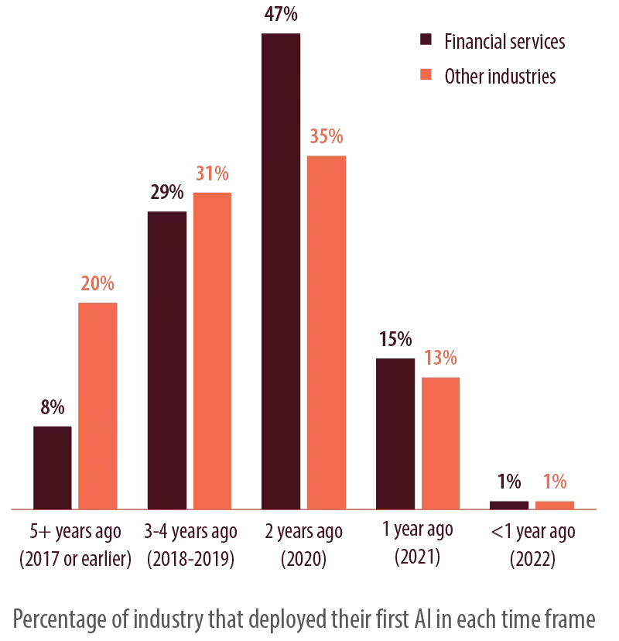

**AI USE CASES ARE LESS MATURE THAN OTHER INDUSTRIES**

We asked respondents what capabilities AI systems deliver and scored answers across our Sense, Understand, Respond, Evolve (SURE) taxonomy (Figure 2). We found that financial services firms are laggards when it comes to achieving greater AI capabilities.

**Figure 2: SURE taxonomy: Only 15% achieve top AI capabilities**

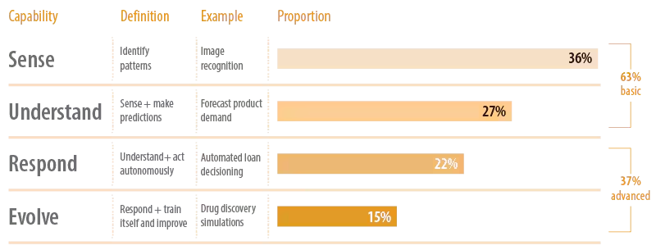

In terms of capabilities, our analysis reveals that the intermediate tiers (Understanding and Responding) exhibit a positive correlation with profit growth, whereas the fundamental tier (Sensing) and the most advanced tier (Evolving) currently lack discernible business value. However, compared to counterparts in other sectors, financial services firms exhibit a lower proportion (64%) of use cases positioned within the Understanding and Responding stages (see Figure 3). These stages entail AI's capacity to identify patterns, sense, and make predictions, albeit requiring human intervention. Given that financial services firms embarked on AI deployment merely two years ago, their emphasis leans heavily towards simpler AI applications, resulting in a lower maturity level.

The prevalent use cases primarily revolve around fraud detection and investment advisory services. For instance, MorningStar's Mo, an investment research assistant fueled by generative AI, has fielded over 25,000 inquiries at an average cost of only $0.002 per question—merely two-tenths of a cent. Mo is engineered to distill Morningstar's impartial insights, catering to investors and investment professionals alike.

**Figure 3: SURE taxonomy: Only 15% financial services firms achieve top AI capabilities**

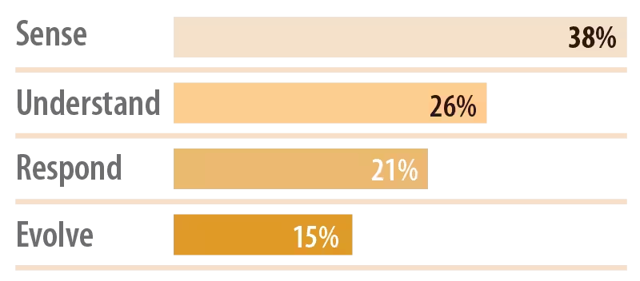

There's a gradual shift underway in this trajectory. Take JPMorgan, for instance, which boasts a portfolio of over 300 AI applications spanning risk management, prospecting, marketing, customer engagement, and fraud detection. AI implementations at JPMorgan have proven instrumental in risk mitigation by curbing fraudulent activities, optimizing trading strategies, and refining portfolio construction through enhanced execution tactics, automated forecasting, analytics, and enriched client insights. The institution anticipates reaping $1.5 billion in business value driven by AI by the close of 2023.

Another noteworthy example is Borealis AI, an innovation hub established by the Royal Bank of Canada (RBC) in 2016. Within this ecosystem, RBC Capital Market traders have developed Aiden, an AI-powered platform designed to elevate trading outcomes and furnish clients with actionable insights in a quantifiable and comprehensible manner.

**LEGACY TECH REMAINS A MAJOR CHALLENGE TO SCALING AI**

In discussing their foremost obstacles, financial services sector underscored the formidable hurdle posed by their entrenched legacy infrastructure, with nearly one-fifth of these firms grappling with this challenge despite having AI systems operational for over five years—a notable contrast to the 7% figure reported in other sectors. Additionally, one in six financial services entities pinpointed inadequate subject matter expertise as a pressing challenge (refer to Figure 4). These hurdles underscore the disparity between financial services and other industries in terms of AI adoption and implementation.

**Figure 4: Top challenges faced by financial services respondents**

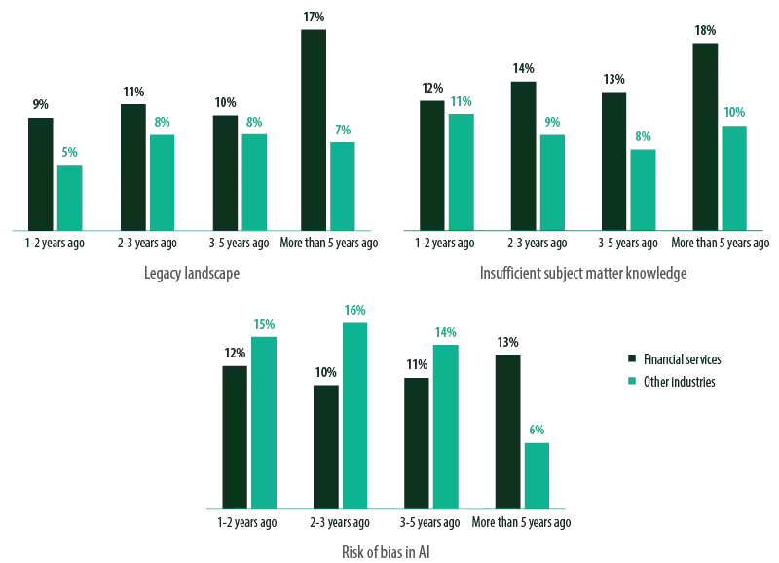

AI professionals in industries where AI has been integrated for more than five years perceive bias risk as a diminished concern, whereas in the financial services sector, the scenario is reversed. Specifically, financial services firms that initiated AI deployment within the past two to five years regard bias as a less prominent challenge compared to their counterparts in other sectors. This discrepancy may be attributed to the robust data practices observed in financial services, particularly concerning data collection and verification (see Figure 5), which potentially contributes to their higher satisfaction levels. However, a disconcerting trend emerges: unlike industries outside of financial services, these firms are not demonstrating improvement in bias management over time, likely due to its persistent significance as a critical issue. This sustained apprehension is likely influenced by the stringent regulatory landscape that characterizes the financial services industry relative to other sectors.

**Figure 5: Challenges faced by financial services respondents that wane over time**

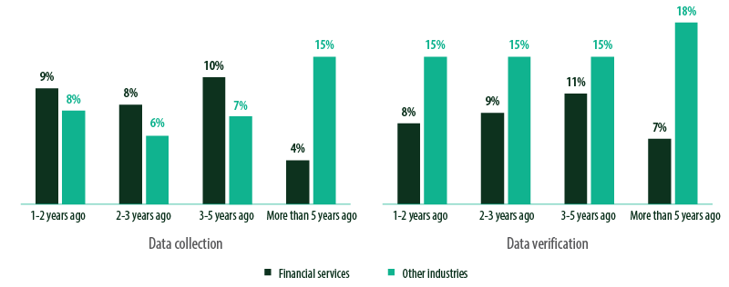

Financial services firms consistently register markedly higher proportions of the aforementioned challenges compared to their counterparts in other sectors. A significant majority of financial institutions have ventured into AI implementation for a mere two-year span. What's concerning is that even among those with over five years of AI experience, these challenges are perceived as escalating.

This trend suggests that these challenges are not diminishing with time; rather, they are increasingly recognized as pressing issues.

The obstacle of data verification remains persistent across all experience levels. However, it's not all bleak for financial services firms. These entities exhibit considerable prowess in data verification and collection compared to industries outside their domain (refer to Figure 5). While other surveyed industries that have operated AI systems for over five years often cite data verification as a primary challenge, financial services firms in this category encounter this issue to a lesser degree. Their structured approach to data and infrastructure management positions them favorably for sustained success and contentment.

Regarding challenges such as scaling AI and analytics and the scarcity of proficient AI practitioners, financial services firms perceive these issues as less formidable as their experience grows.

The Infosys Knowledge Institute study also evaluated use cases based on satisfaction levels, usage frequency, and adoption rates. Out of 63 identified use cases, only 18 (29%) attained elevated satisfaction scores. Notably, the financial services sector, represented by five distinct use cases, reported the highest satisfaction levels across all industries, with all five falling into the high satisfaction category. These use cases predominantly center around core functionalities such as automated compliance and customer service tools within the financial services realm.

**Figure 6: Industries ranked as per satisfaction rates**

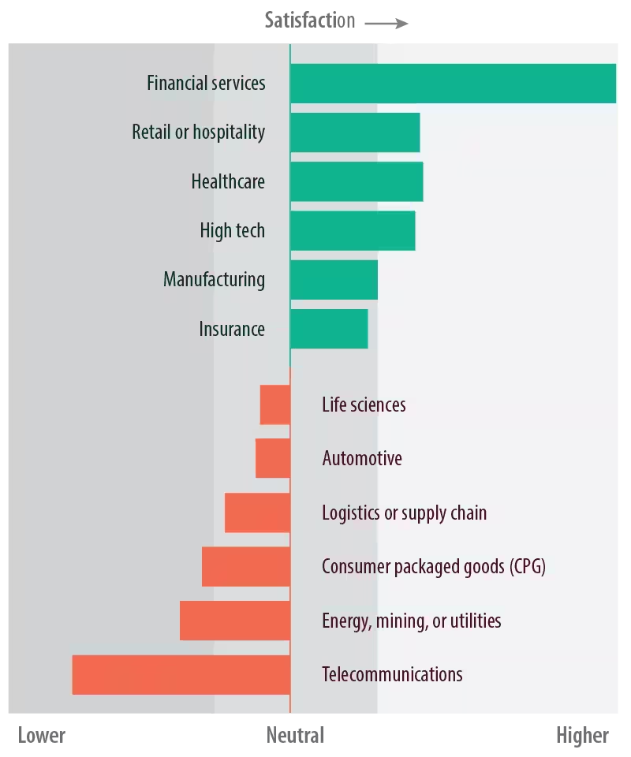

In the sphere of data management, a notable transition is taking place. The majority of companies spanning various industries intend to consolidate their data architecture within the next couple of years. However, those already centralized are transitioning towards a federated system. Interestingly, within the financial services sector, there's a discernible shift from mixed or federated setups towards centralized systems, mirroring broader market trends but on a larger scale (see Figure 7).

For instance, JPMorgan implements a centralized yet federated approach to data strategy, placing emphasis on the significance of interoperability among different data platforms.

**Figure 7: How financial services firms manage data now and in the future**

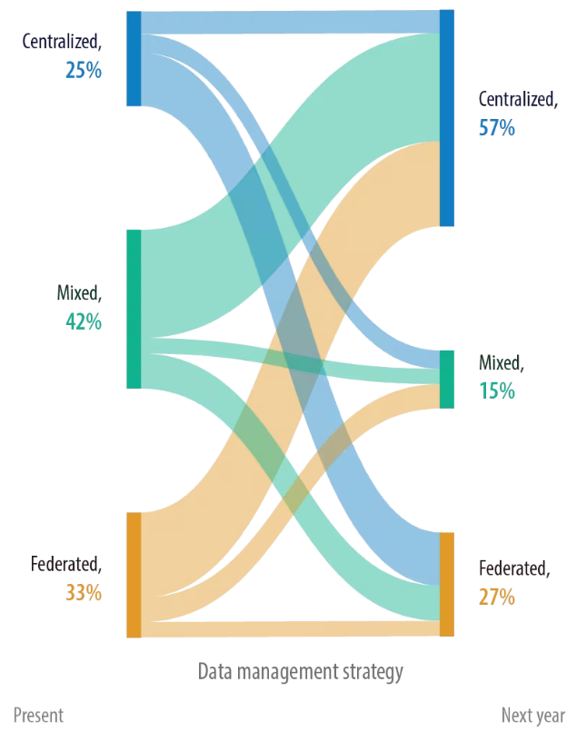

**HOW FINANCIAL SERVICES FIRMS CAN SUCCEED**

The Infosys study underscores that effective data management coupled with AI initiatives can drive improved financial outcomes and foster business growth. To optimize the value derived from data, companies must adhere to specific best practices:

1. **Cultural Transformation and Talent Development to phase out outdated systems**

Jacqueline De Rojas, president-emeritus of techUK, emphasizes that the presence of low-quality data originating from legacy systems poses a significant yet concealed challenge in advancing AI adoption. "The efficacy of algorithms hinges on clean data," she asserts.

According to the Infosys Modernization Radar 2022, approximately 65% of discretionary budgets are allocated towards modernization endeavors. Financial services institutions are leveraging cloud technologies to propel digital transformation, crafting novel customer experiences, and enhancing business agility. The focus is shifting towards adopting hybrid multicloud environments securely, with some entities prioritizing cloud-neutral and multicloud portability. However, apprehension among executives persists, largely stemming from concerns about potential failure despite a desire for change.

Traditional financial institutions prioritize safety and stability, characteristics that diverge from the risk-taking and agile nature typical of digital-native companies. While cloud vendors like Google and Microsoft offer robust security expertise and are compliant with global data governance standards, cultural barriers within organizations hinder technology teams' progress.

Microchange management represents one approach to overcome resistance, enabling firms to incrementally modify employee behaviors rather than attempting sweeping transformations all at once. This method becomes particularly pertinent when organizational culture lags behind technological advancements.

The retirement of legacy assets isn't a uniform endeavor; it requires diverse skill sets tailored to each firm's unique context. Consequently, firms must focus on upskilling their workforce and exploring partnership opportunities to facilitate successful modernization efforts. Many core applications rely on aging developer teams with specialized skills that are increasingly challenging to find.

For instance, at Citizens Bank, CIO Michael Ruttledge spearheads a multiyear next-generation technology (NGT) strategy, which includes upskilling initiatives focused on APIs and modern microservices-based cloud-native architecture. Ruttledge emphasizes aggressive investments in in-house talent development, utilizing hands-on engineering academies, technology immersion sessions, and certification programs, mirroring approaches adopted by Infosys through online web-based learning solutions.

Financial services firms must overhaul their legacy infrastructure to realize the full potential of AI. Research indicates that as financial firms gain more experience with AI, the challenge posed by legacy systems diminishes, suggesting a decreasing reliance on outdated technologies. However, infrastructure modernization remains critical for effectively scaling AI and analytics.

1. **Prioritize Foundational Capabilities over Advanced Solutions**

Financial services organizations must accurately identify the problem-solving potential of AI. Beginning with simpler deployments before progressing to more complex solutions can guide investments in the appropriate AI infrastructure and resources.

1. **Adopt a Holistic Data Management Approach**

Companies must formulate a well-defined data strategy to facilitate effective data management and seamless data integration. However, many organizations lack this fundamental element. Centralized data management is associated with better profit and revenue growth, but transitioning to a fully federated model also correlates with increased profit growth. Striking a balance between centralization and federation is essential, tailoring the approach to each company's unique circumstances. For instance, while centralizing data governance rules, ownership of data across the business should be federated, allowing various stakeholders to update, derive value from, and utilize the data.

1. **Embrace Extensive Data Sharing to Foster Deep Learning**

Sameli Mäenpää, Chief Data Officer of OP Financial in Finland, underscores the importance of unlocking the value inherent in data through comprehensive data sharing practices. Establishing a data-sharing ecosystem with partners and peers yields greater benefits than maintaining solitary data repositories. Inbound and outbound data sharing practices enable companies to provide relevant data to data scientists and AI models. Importing data from third parties and engaging in extensive data sharing practices are shown to enhance corporate profitability significantly. Financial services firms exhibit moderate levels of data imported from and shared with third parties compared to other industries such as insurance and high tech. While these figures are promising, they underscore the potential for financial services firms to further enhance profitability through increased collaboration and higher data-sharing goals.

**Figure 8: Financial services firms are above average in data sharing to and importing from third parties**

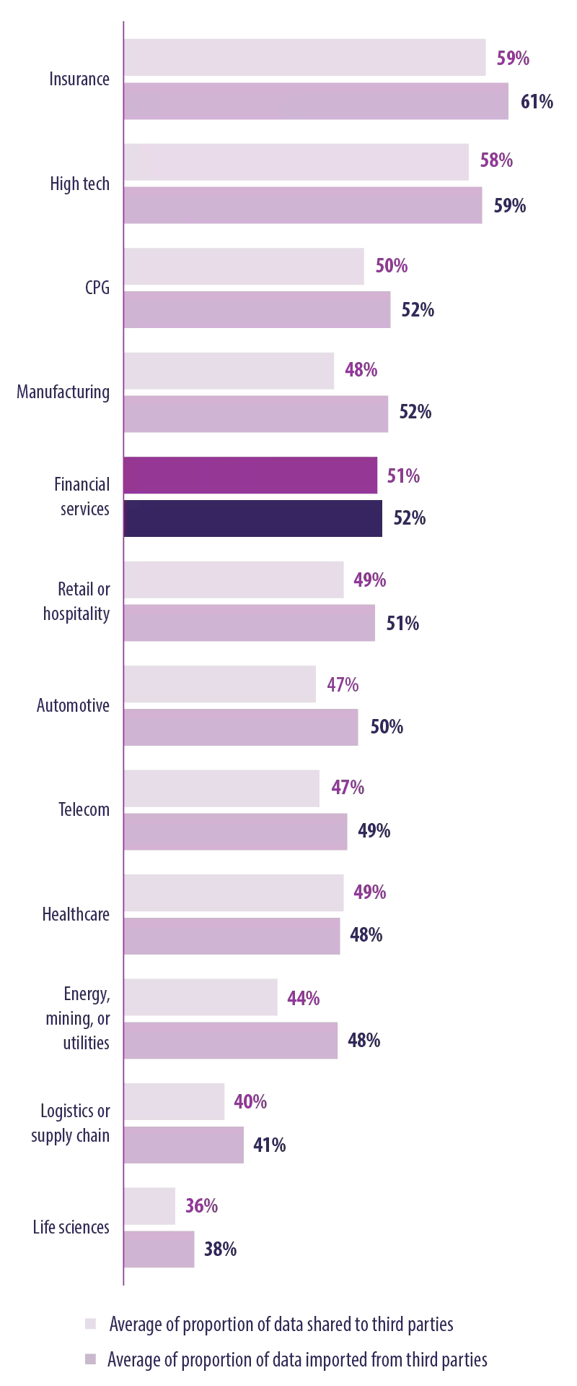

According to Suresh Renganathan, Chief Technology Officer at Teachers Federal Credit Union, business leaders recognize the wide array of opportunities presented by AI-informed data utilization. "All leaders aspire to establish a data-driven business model. Data serves as the fuel propelling business growth at present," he articulated. "Our objectives encompass achieving personalized experiences, facilitating rapid investment decisions, predicting and mitigating delinquencies, and assessing branch performances against predefined objectives. The array of potential applications is vast."

Engaging in data sharing, both in importing and exporting data, enables companies to expand their data reservoirs. Advanced AI capabilities coupled with robust data sharing practices collectively stimulate advanced AI development and facilitate deep learning. The Infosys report underscores that expanding deep learning initiatives and promoting data sharing endeavors contribute to enhanced corporate profitability. Encouragingly, a higher proportion of financial services firms (92%) are actively investing in deep learning and engaging in extensive data sharing practices (refer to Figure 9). Additionally, it is noteworthy that 69% of these firms are incorporating deep learning into over 30% of their AI systems (refer to Figure 10).

**Figure 9: Deep learning correlates with extensive data sharing**

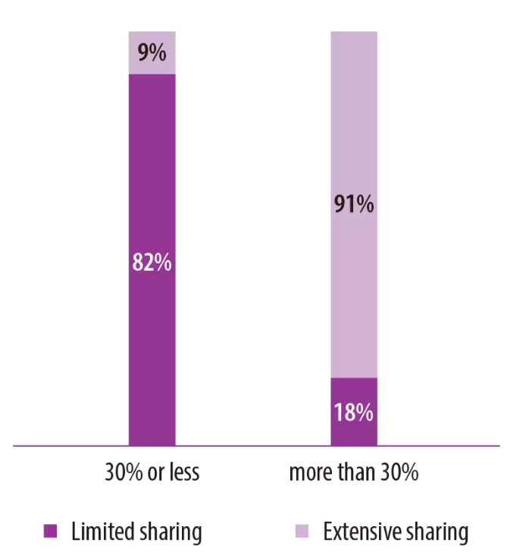

**Figure 10: More financial services firms are doing deep learning**

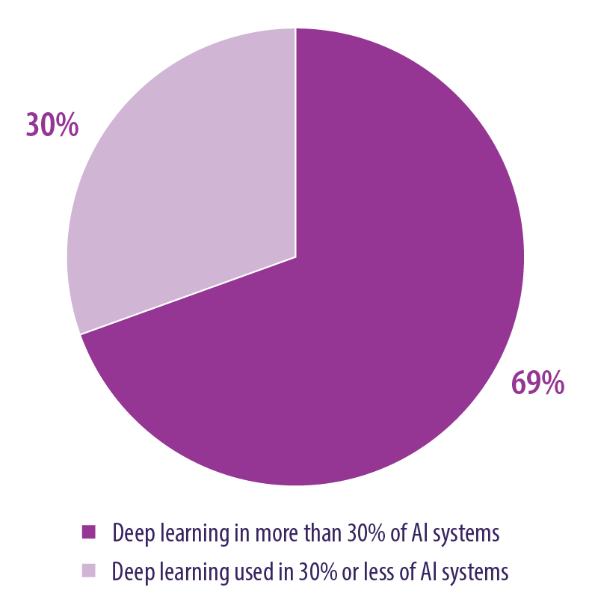

Financial services firms demonstrate proficiency in data verification and deep learning, and they have successfully integrated senior executives and end users into their AI teams. Additionally, their data management strategies are evolving. However, to maximize their potential, they should consider augmenting their AI teams with more business experts and exploring a middle ground between centralization and federation tailored to their specific circumstances.

1. **Enhance Ethics and Bias Management with Accountability and Transparency**

The quest for AI explainability remains an ongoing endeavor. According to experts, employees are more inclined to engage with AI outputs when they have confidence in the responsible operation of AI systems. "Firms must develop AI solutions that are transparent and foster trust among human users," emphasized Shukla. Therefore, ensuring quick and comprehensible understanding of AI outputs is imperative for optimal performance.

Robust ethics and bias management practices instill trust and satisfaction in data and AI utilization. The report highlights a positive correlation between confidence in bias management and ethics and satisfaction with AI outcomes (see Figure 11). Financial services firms venturing into advanced AI systems must prioritize ethics and bias management to bolster trust in AI. This approach could help alleviate challenges related to data sharing and pave the way for the adoption of higher-order AI capabilities.

Governments worldwide are taking steps to regulate AI systems responsibly. For instance, in June 2022, the Canadian government introduced the Artificial Intelligence and Data Act (AIDA), aimed at implementing a risk-based regulatory framework for AI systems. AIDA aims to cultivate trust among citizens in the digital technologies they engage with on a daily basis.

**Figure 11: Strong ethics and bias management correlate with greater trust in AI**

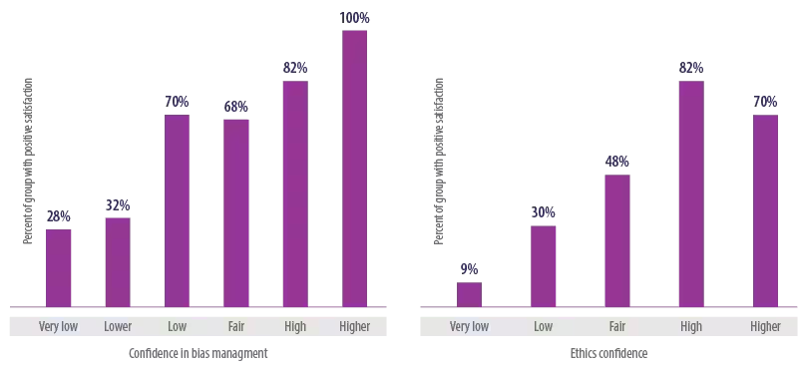

The Canadian government has mandated transparent AI support for administrative decisions, with a particular emphasis on implementing automated decision-making systems that minimize potential risks to clients. In April 2020, it introduced the Algorithmic Impact Assessment (AIA), a questionnaire tool designed to assess the impact of automated decision-making systems.

1. **Establishing a Diverse AI Team**

To fully harness the effectiveness of AI technology, companies must adapt their business processes and team structures accordingly. Effective AI implementation necessitates the formation of a proficient, multidisciplinary team comprising data scientists, business domain experts, and senior executives, each bringing specific expertise to the table. While data scientists play a pivotal role in AI initiatives, the inclusion of business experts who comprehend how to address business challenges and leaders who ensure alignment with organizational strategies for growth is equally vital.

Although the financial services sector actively involves senior executives and solicits input from end users within AI teams, there is a greater emphasis on recruiting data scientists compared to other industries, with a proportion of 18% versus 16% (see Figure 12). However, there is room for improvement within financial services regarding the consistent inclusion of business experts, with a figure of 29% compared to 44% for other industries. Striking the right balance within AI teams can effectively mitigate challenges stemming from a lack of experience.

**Figure 12: AI teams – financial services vs. other industries**

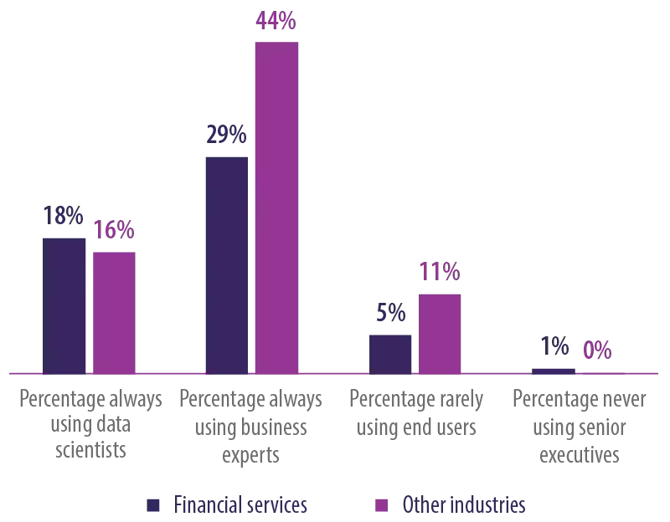

**APPENDIX: RESEARCH APPROACH**

Infosys Knowledge Institute commissioned an independent third-party survey of 2,500 AI practitioners. In addition to questions about data, AI, and technology practices and capabilities, we asked survey respondents for financial details, including revenue range and yearly revenue and profit growth rates. The survey was conducted from May to July 2022. It included respondents from companies with more than $500 million in annual revenue in the US, UK, Germany, France, Australia, and New Zealand We identified and analyzed a large set of actions that could affect profit and revenue change related to data and AI. We then set base cases and found 23 actions (of 69 analyzed) via linear regression that showed evidence of a statistically significant impact on profit or revenue growth. The $467 billion in potential profit growth derives from a ~10% increase in profit growth achievable through 13 actions with statistically significant uplifts

**FINDINGS**

The findings of this report can be summarized as follows:

**1. Slow AI Adoption in Financial Services:** Despite the growing prominence of AI technologies, financial services firms have been slower to adopt AI compared to other industries.

**2. Shift in AI Spending:** Global AI spending is projected to double by 2026, with the financial services sector expected to hold a significant share of this investment.

**3. Increasing AI Investments:** Financial services firms are progressively increasing their investments in AI technologies, recognizing its potential to enhance customer experience, improve operational efficiency, and drive innovation.

**4. Challenges in AI Adoption:** Legacy systems, regulatory constraints, and skepticism about AI outcomes have been significant barriers to AI adoption in the financial services industry.

**5. Evolution of Data Management:** Financial institutions are transitioning towards centralized data management strategies, leveraging cloud technologies, and prioritizing data quality and verification to support AI initiatives.

**6. Importance of Multidisciplinary AI Teams:** Effective AI implementation requires diverse teams comprising data scientists, business experts, and senior executives to address complex business challenges and align AI initiatives with organizational goals.

**7. Emphasis on Ethics and Bias Management:** To build trust and enhance satisfaction in AI systems, financial services firms must prioritize ethics and bias management, ensuring transparency and accountability in AI-driven decision-making processes.

**8. Regulatory Landscape:** Regulatory bodies are increasingly focusing on transparency and accountability in AI systems, with initiatives such as the Canadian government's Algorithmic Impact Assessment (AIA) aimed at ensuring responsible AI deployment.

Overall, the findings underscore the critical need for financial services firms to adapt to the evolving AI landscape, overcome challenges, and capitalize on the opportunities presented by AI technologies to drive growth and innovation in the industry.

**CONCLUSION**

In conclusion, the financial services industry stands at a pivotal juncture in its adoption of artificial intelligence (AI) technologies. While progress has been made, there remain significant challenges and opportunities that require careful consideration and strategic action.

The findings of this report highlight the importance of accelerating AI adoption within financial institutions to remain competitive in an increasingly digital landscape. Despite initial hesitance, financial services firms are gradually increasing their investments in AI, recognizing its transformative potential to enhance customer experiences, streamline operations, and drive innovation.

To effectively harness the power of AI, financial institutions must address key challenges such as legacy systems, regulatory constraints, and data quality issues. This necessitates a concerted effort to modernize infrastructure, cultivate a culture of innovation, and prioritize ethics and bias management to build trust in AI-driven decision-making processes.

Furthermore, the evolution of data management strategies, the formation of multidisciplinary AI teams, and collaboration with regulatory bodies are crucial steps towards achieving responsible and effective AI adoption.

In light of these insights, financial services firms must embrace a forward-thinking approach, leveraging AI technologies to unlock new opportunities, drive sustainable growth, and deliver value to customers in an increasingly digital world. By embracing AI as a strategic imperative and navigating the challenges with agility and foresight, financial institutions can position themselves for success in the AI-driven future.