**“CRETICAL ANALYSIS OF OPERATIONAL STRATEGIES USE BY AMAZON IN INDIA”**

**ASHISH KUMAR (21GSOB1010040)**

**UNDER THE GUIDANCE OF**

**DR. VIDYA DAYINEE SHARAN**

# ABSTRACT

This article takes a close look at the strategies that Amazon employed to launch and expand its online store in India. The rapid growth of India's e-commerce industry has made the nation an avid observer of Amazon's entry and subsequent progress. Among the several facets of Amazon's business included in the research are market penetration, localization efforts, technological innovation, seller empowerment, logistical optimization, regulatory impediments, rivalry, and market dominance. Amazon has invested much in understanding and satisfying the unique needs of Indian consumers as part of its plan to enter the Indian market. Services like Amazon Pantry and the ability to pay upon delivery are available, as is support for the Hindi language. These efforts have helped Amazon gain traction, which has allowed them to compete well with local rivals. Amazon has also invested much in building a robust e-commerce infrastructure in India. The organization's infrastructure, which comprises of warehouses, fulfilment centres, and last-mile delivery networks, allows it to provide reliable and fast delivery services throughout the country. Thanks to innovative digital solutions, such machine learning algorithms that provide personalised recommendations, Indian consumers now enjoy an even better shopping experience. Amazon uses its marketplace concept, which allows third-party sellers to showcase and sell their things on the site, as one of its main approaches in India. Thousands of Indian businesses have joined Amazon's customer base and product offers thanks to this strategy. However, this has also caused others to question the fairness of Amazon's product promotion and the nature of competition more generally.

**Keywords:** Amazon, operational strategies, e-commerce, India, localization, technology, logistics, regulatory challenges, competition, market share.

# 

# INTRODUCTION

The American e-commerce behemoth Amazon is a global powerhouse. It all started in 1994 when Jeffrey P. Bozos started it. Moreover, it debuted in the Indian market in June 2013.Even though Amazon didn't have much of a presence in the Indian market three years ago, it now controls the industry. Early on, investors thought that Amazon's move into the Indian market wouldn't be as lucrative as its 2004 move into China, where Alibaba, another Chinese business, dominated the e-commerce sector. The bozos are shifting their attention from China to India. Amazon chose to set up shop in India in part because of the country's enormous population (1.25 billion people, or four times the size of the United States). Research shows that every month, about six million individuals join the internet in India, making it the country with the highest yearly growth rate of internet users. By 2016, the e-commerce industry in India is expected to reach $15 billion, up from $35 million in 2014. According to Parker and Van Alstyne (2005), a large percentage of marketplace activity is comprised of platform-based markets, which are seeing growth. To complete a transaction, all parties involved—including vendors and consumers—need to be able to use the same platform. Founded in 1994 with the goal of being "Earth's most customer-centric company, where customers can find and discover anything they might want to buy online, and endeavours to offer its customers the lowest possible prices," Amazon has been in operation ever since. Market competition was bound to be a problem for the young entrepreneur, but he found some cheap stuff that could be sold online very easily.

Bezos used $245,573 in startup funding from his parents to start Amazon in his garage. They made $30 billion (or twelve million percent) back from their investment. Three years after its founding and after its first public offering (IPO), Amazon was valued at $438 million in 1997. The company evolved into a global powerhouse with an astounding present worth of $1.6 trillion. The online retail giant became the second US firm to reach a trillion dollars in valuation on September 4, 2018, when its stock price reached a record high of $2050.50, behind Apple. Amazon is the most innovative company of our time due to its business model, marketing strategy, and technological breakthroughs; nevertheless, the growth of the Internet also played a major influence. A multi-trillion dollar powerhouse in e-commerce, consumer electronics, cloud computing, and, more lately, the media and entertainment sectors, Amazon grew from its modest origins as an online bookshop. In this business strategy study, we combine all the ideas, innovations, technological research, collaborations, and tactics that have contributed to Amazon's incredible success. You may also see a brief summary of each division's stock value over the previous many years and sales numbers for that division. Detailed here are some of Amazon's most fruitful strategies throughout the years. But this information would have been gold for Amazon's competitors a few years ago. In fact, they could have anticipated Amazon's moves.

# NEED FOR THE STUDY

Amazon has had phenomenal success in implementing its stated goals and objectives. As a result of relentlessly pursuing these claims, Amazon has achieved extraordinary success. We at Amazon work hard to provide our consumers with what they need and desire by providing "the utmost convenience, the best selection, and the lowest possible prices." We serve these clients on our worldwide job board in all of our target regions. As may be observed from a high-level summary of the purpose statement, Amazon offers a diverse selection of things at affordable prices with a focus on convenience. Both the organization's fundamental goals and the foundation for Amazon's future strategic direction are addressed by this. Consumers want the most time-and money-efficient options in every industry. Does Amazon fall under the category of technology companies? If so, what exactly do they sell? No such thing is made clear in the mission statement. "We strive to offer our customers the lowest possible prices, the best available selection, and the utmost convenience for all your online purchases" is a mission statement that more accurately describes our current state of affairs and provides more information than the current one.

Amazon has a strong mission statement, but its vision statement is even more impressive. Our ultimate goal is to become the world's most customer-focused business. No matter their team or location, all Amazonians have a common goal: to provide our consumers with innovative items, services, and ideas that improve their lives.where Amazon posts job openings worldwide By articulating its goal of being the most customer-centric company on the planet in its vision statement, Amazon is communicating its ambitions to its most valuable stakeholder—its consumers. Using the term "Amazonians" to describe their customers helps create a feeling of connection and belonging. Becoming the leading online retailer is one of Amazon's stated aims in their mission statement. Its primary objectives include serving five distinct clientele, offering an extensive catalogue, and penetrating foreign markets extensively. A focus on the future and a commitment to providing outstanding customer service are common themes in the mission and vision statements.

Per Amazon's 10-K Form for 2018 (p. 57) and 2019 (pg. 59), no vendor accounted for 10% or more of the company's purchases.Form 10-k 1-75, Annual Report According to Amazon, long-term contracts and agreements with its merchants do not frequently ensure product availability, certain payment intervals, or the renewal of credit limits. In November 2019, Amazon released a 51-page document detailing its suppliers for Amazon-branded merchandise, but it did not reveal who the major suppliers were. So, what exactly does each vendor make for Amazon? This list also does not include that data. Numerous Amazon-owned private label products are available for purchase on the website. The relevant document is linked to in the reference section, which can be found at the bottom of this page. Amazon lays out the dangers it confronts due to its ties with its suppliers in their 10-K filing. When it comes to procurement, services, manufacturing, and any related ongoing maintenance of things and content, we depend on a few of key suppliers. Content and technology licensors are examples of such providers; in other cases, there may be limited or even a single source of supply. Most of the time, we don't have long-term partnerships with our suppliers, so we can't guarantee the delivery of goods, components, or services, set certain payment terms, or increase our credit limits. If our present suppliers opt not to sell or licence goods, content, components, or services to us on favourable terms, or if deliveries are postponed for any cause (e.g., supplier bankruptcies due to poor economic conditions, natural disasters, or other circumstances), we may encounter delays in acquiring alternatives from other sources.

# LITERATURE REVIEW

Research by Sharma and Mittal (2009) titled "Prospects of web-based business in India" claims that the web-based business industry in India is seeing rapid expansion. With such a massive population, internet shopping in India is certain to be a huge success. Online shopping has become a popular phrase and an essential component of modern life in India. A diverse array of products and services are offered by sites. Additionally, there are businesses that sell a particular product alongside the services provided by their associates. Internet shop offering a wide range of goods These Indian internet marketplaces provide products and services across a wide range of sectors. Examples include, but are not limited to, human clothing and accessories. Cosmetics and personal care items, Electronic gadgets, computer networks, printed materials, Domestic appliances, automobiles, computer programmes, and hardware for consumers Jewels, news, shows, and products Durable material,

Government agencies and property. "Considerable portions of our daily lives have been transformed by the Internet," remarks Ramírez Nicolas (2010). Everything from our contacts with one another and banks to our news consumption and TV viewing falls under this category. No aspect is too little, including our purchasing and selling practices. These advancements are a direct outcome of the persistent rise of companies offering fresh approaches and groundbreaking solutions. An innovative marketing technique that has always been there is the coupon with the rebate. They increased consumer loyalty at ISSN 2348-8891 by drawing in new customers and being accessible at checkout to promote repeat purchases, regardless of how they got there (in print or by mail). A publication of the Board and Trade channels, it is the Altius Disgraceful Journal. Groups of consumers were granted extraordinary restrictions by certain businesses so that they may take part in the "high number game." So, in 2008, Andrew Artisan created "The Point," a website where users could discover the best sales on collecting materials. In November of that year, the well-known "Groupon" was merged. Groupon has expanded from its 2010 start to 45 countries throughout the globe, and since then, it has attracted multi-million dollar proposals from companies including.

What a thrilling prospect! Oh, and Google itself. With all these advantages, rebate coupons are selling like hotcakes and the customer growth rate is over the roof. Trump Rogan elucidates the connection between advertising strategy and customer behaviour (2007). According to him, the procedure is associated with raising the likelihood and frequency of customer activity. If you want to succeed in this venture, you need to know your consumer and what they want. But post-purchase activity is central to the desire affirmation concept (Oliver 1980). For the purpose of understanding customer happiness and loyalty, this model is often employed in buyer behaviour analysis. Oliver (1980) posits that the key principle of this approach is that satisfaction is shaped by the gap between wish and saw execution. The wish affirmation hypothesis states that customers are happy when they perceive that the product or service meets their needs. Bhattacharjee argues that in order for IS to be sustainable, it is essential that consumers be satisfied (2001). If we can pull this off, we may prove that two of the guiding and intervening elements between appropriation and continuation are fulfilment and trust.

According to Venkatesh (2000), the perceived ease provided by online merchants has a positive effect on customers' perception of the internet as a medium that makes their buying experiences better in a straightforward way. This, in turn, improves their attitude towards shopping on the web. Online shopping provides enormous opportunities for ads aimed at youth. Hristopoulos et al. (2001) found that young individuals make up the bulk of internet buyers. Dholakia found that younger customers reported greater online clothes purchases when she looked at the association between age and online shopping. They also found that younger customers were more inclined to purchase online often and to think that shopping online was better.

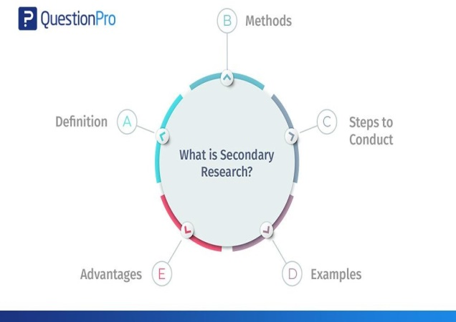

Although factors like usability, ease of use, and enjoyment do influence attitudes and intentions towards online shopping, Benedict et al. (2001) discovered that other external factors like customer attributes, situational factors, product attributes, past online shopping experiences, and trust in online shopping also play a part.

# RESEARCH METHODOLOGY

Secondary research involves the summary, collation and/or synthesis of existing research. Secondary research is contrasted with primary research in that primary research involves the generation of data, whereas secondary research uses primary research sources as a source of data for analysis.

Secondary or desk research refers to the process of using pre-existing data sources. We gather and summarise existing data to make research more productive overall.

"Secondary research" is using the results of other studies and their publications in your own work. These documents can be found in public libraries, on websites, in data obtained from surveys that have already been filled out, etc. Public and commercial sector data repositories are both accessible and used for scholarly research.In primary research, companies or groups can collect the data themselves or pay someone else to do it. Secondary research, in contrast, is far more economical as it takes use of pre-existing data.

The goal of secondary research is to include already collected data from other sources, or to make use of preexisting research materials instead of collecting fresh data from scratch using primary research methods. Common sources for secondary research resources include the internet, academic institutions, archival collections, libraries, and company reports.

In this context, "online data" means any information gathered from an online source. Due of the plethora of easily accessible, high-quality research materials (both free and paid) online, this technique has lately gained favour.

Researchers should nevertheless use caution to only access trustworthy websites, despite the fact that this strategy simplifies data gathering. The internet is like a giant aggregator for all the various places you may get secondary research materials.

**ANALYSIS**

Data analysis was done mainly from the data collected through the customers. The data Collected from secondary sources is also used to analyse on one particular parameter. Qualitative analysis was done on the data collected from the primary as well as secondary Sources.

**SECONDARY SOURCES**

Secondary research is a means to reprocess and reuse collected information as an indication for betterments of the service or product.

* Newspapers
* Magazines
* Internet sites

Both primary and secondary data are useful for businesses but both may differ from each other in various aspects.

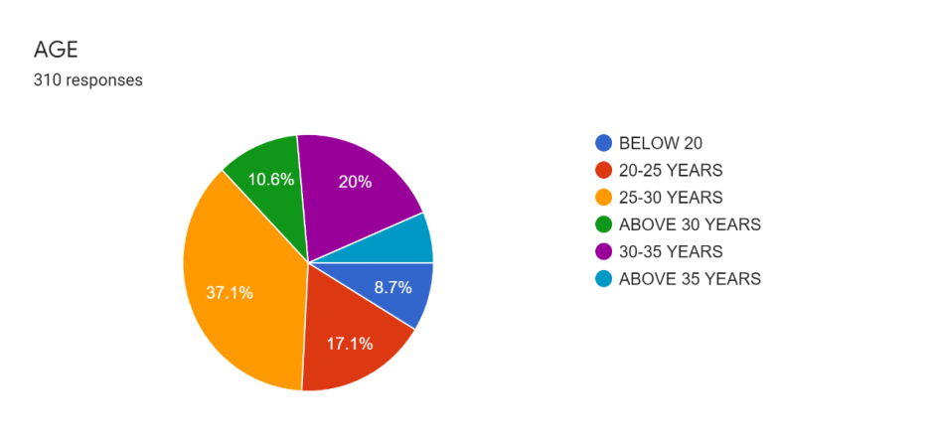

The following is a breakdown of the respondents' ages: 37% fall within the 25–30 age bracket, 20% in the 30–35 bracket, 17% in the 20–25 bracket, 10% above 30 and 8% below 20. The figure gives a visual representation of the demographic breakdown.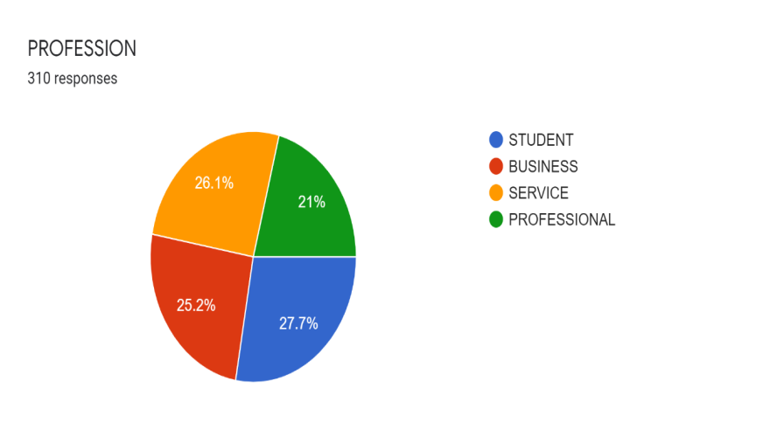

According to the results of the respondents' occupations, 27% are students, 26% are in the service industry, 25% are in business, and 21% are professionals.

CONCLUSION

Data quality was enhanced by eliminating individuals who failed the instructional manipulation exam, according to Oppenheimer et al. Participants routinely outperformed the control group on a Need for Cognition assessment, and the effects were more noticeable in two more traditional models of decision-making and judgement. Oppenheimer and colleagues also found that having test takers read the instructions carefully again in case they answered the answer wrong was an effective strategy. Data quality was improved without data loss or selection bias following the use of such a prompt, according to Oppenheimer et al. (2009). This is because there was a complete erasure of difference between the answer behaviours of participants who passed and those who failed the check. However, this novel method is only applicable to research in which the accuracy of the results relies on the participants' complete understanding of the protocols. According to the question wording, there are several situations when the conventional response format doesn't matter. Unless the instructions in question contain crucial information, omitting them does not inevitably lead to lower-quality solutions. Participants may act maliciously against the study if they feel offended, distrusted, or humiliated when an instructional manipulation check fails. With each succeeding test, we introduced a new type I error probability of 0.05. Among the 3,490 people who were qualified to take part in the survey, 3,384 reported giving an honest answer and 121 said they didn't. Liberals and Conservatives are seen as more moderate by German voters, according to previous study (Pappi, 2009), whilst the Social Democrats, the Left, and the Greens are seen as more radical left-wing. Conversely, conservatives and liberals are seen as belonging to the far right. Before we could even consider using the participants' self-reported political leanings on a left-right scale to determine which of the five main parties or two possible coalitions would form the majority in the future government, we had to make sure the data was reliable. Although MTurk samples can address a number of significant validity issues, researchers should also consider additional constraints associated with their study objectives. Using the many criteria we outline in this analysis, researchers should assess the suitability and quality of MTurk samples with great care.

# REFERENCES

1. Kharif, O. (2019). Amazon's Bet on India: Scale, Speed, and Low Prices. Bloomberg. Retrieved from https://www.bloomberg.com/news/articles/2019-09-09/amazon-s-bet-on-india-scale-speed-and-low-prices
2. Sengupta, A. (2019). Amazon is investing heavily in India, but it's losing ground to local rival Flipkart. CNBC. Retrieved from https://www.cnbc.com/2019/05/09/amazon-losing-ground-to-flipkart-in-india.html
3. Dash, A. (2020). Inside Amazon's Rapid Growth in India: DealBook Briefing. The New York Times. Retrieved from https://www.nytimes.com/2020/02/28/business/dealbook/amazon-india.html
4. Reuters. (2020). Amazon steps up Indian grocery push with more investment. Reuters. Retrieved from https://www.reuters.com/article/us-amazon-com-india-idUSKBN27W0MC
5. Ghosh, S. (2021). How Amazon is winning over India. BBC News. Retrieved from https://www.bbc.com/news/business-56332818
6. Varshney, R. K. (2020). Amazon's India Bet. Harvard Business Review. Retrieved from https://hbr.org/2020/05/amazons-india-bet
7. Arora, A. (2019). Amazon and Walmart's Flipkart are lobbying against India's e-commerce rules. CNN Business. Retrieved from https://www.cnn.com/2019/12/16/tech/india-ecommerce-amazon-flipkart/index.html
8. Kumar, A. (2021). Amazon is ready to do more business in India. But China's tech crackdown is causing concern. CNN Business. Retrieved from https://www.cnn.com/2021/11/11/tech/amazon-india-earnings-china-tech-intl-hnk/index.html
9. Chowdhury, A. (2021). Flipkart Beats Amazon in India's Festive Sale. BloombergQuint. Retrieved from https://www.bloombergquint.com/business/flipkart-beats-amazon-in-indias-festive-sale-marking-return-to-form
10. Reuters. (2021). India court allows antitrust probe against Amazon, deals blow to US firm. Reuters. Retrieved from https://www.reuters.com/business/retail-consumer/india-court-allows-antitrust-probe-against-amazon-deals-blow-us-firm-2021-11-12/
11. Sachdev, R. (2021). India's small businesses push back against Amazon. Nikkei Asia. Retrieved from https://asia.nikkei.com/Business/Retail/India-s-small-businesses-push-back-against-Amazon