**A Glass of Trust : Real Time Detection of Milk Adultration**

**Hari Prasad B P, Deepika S, Bhavyashree B S, GundeBoina Nagalingeswar Rao**

1 Computer Science Engineering, Sambhram Institute of Technology, Bengaluru, Karnataka, India

2 Computer Science Engineering, Sambhram Institute of Technology, Bengaluru, Karnataka, India

3 Computer Science Engineering, Sambhram Institute of Technology, Bengaluru, Karnataka, India

4 Computer Science Engineering, Sambhram Institute of Technology, Bengaluru, Karnataka, India

**ABSTRACT**

Ensuring food security in both rural and urban areas is of paramount importance, directly impacting the health and well-being of citizens. Recent research highlights the presence of pathogenic organisms in raw milk, posing significant risks of contamination if consumed, thereby increasing the incidence of diseases and diminishing overall quality of life. Thus, the development of tools for continuous and intelligent monitoring is imperative for quality assessment and timely decision-making.This study aims to address various aspects concerning the estimation of milk quality and quantity. Leveraging Internet of Things (IoT) technology, the proposed system enables real-time monitoring of gas concentrations in raw milk. Over time, the proliferation of bacteria in stored milk leads to undesirable odors, flavors, and potentially harmful substances. Therefore, a monitoring system is essential to detect and mitigate milk spoilage, ensuring the production of safe and healthy dairy products.The proposed system employs a gas sensor to assess microbial activity, a salinity sensor to measure salt content, and a level sensor to monitor milk levels. Additionally, customers are provided with personalized access cards for dairy transactions, enhancing security and accountability throughout the supply chain.By identifying potential contaminants early on, this system helps prevent complications and ensures the production of high-quality milk products. Through continuous monitoring and data-driven decision-making, stakeholders can maintain product integrity and safeguard public health effectively.

**Keywords:** Monitoring, Identifying.

1. **INTRODUCTION**

The Internet of Things (IoT) refers to a network of physical devices, vehicles, and other items embedded with electronics, software, sensors, actuators, and connectivity, enabling them to collect and exchange data. This interconnectedness allows for intelligent control and remote operation of these devices, facilitating greater integration of the physical world into computer-based systems. This results in improved efficiency, accuracy, and economic benefits, reducing the need for human intervention.Milk, being a perishable product, requires careful handling, typically within hours of collection. In the United States alone, there are hundreds of thousands of dairy farms and processing plants. Dairy cows are milked twice daily using mechanical vacuum milking machines, with the raw milk then transported through stainless steel or glass pipes to refrigerated bulk tanks, where it is promptly cooled to around 40°F (4.4°C).Of particular concern is the vulnerability of certain demographics, such as children and pregnant women, to the potential hazards present in milk. To mitigate this risk, there is an urgent need for a real-time monitoring system that can continuously assess milk quality. While existing systems primarily focus on monitoring microbial activity, there is a growing recognition of the need to monitor additional aspects such as adulteration and overall quality.This ongoing research endeavors to develop a comprehensive monitoring system capable of detecting various indicators of milk quality, including microbial activity and adulterants. By identifying potential contaminants early on, this system aims to prevent complications and ensure the production of safe and high-quality dairy products.

1. **METHODOLOGY**

Within this Internet of Things (IoT) framework, our objective was to explore various facets concerning the estimation of milk quality and quantity. In our proposed system, each customer is assigned a unique access card for entry into the milk diaries, ensuring accountability and traceability.To ascertain the authenticity of milk, a salinity sensor is deployed to detect any presence of salinity, a key indicator of milk adulteration. Additionally, a level sensor is utilized to measure the volume of milk, providing insights into its quantity.Over time, prolonged storage of milk can lead to microbial proliferation, resulting in a characteristic foul odor. To address this, a gas sensor is employed to detect early signs of microbial activity, ensuring timely intervention to maintain milk freshness.In contrast to existing systems that solely rely on gas sensors for early microbial detection, our proposed system offers a comprehensive approach. By integrating sensors for both adulteration detection and early microbial activity, our system enhances the overall quality assurance process for milk.

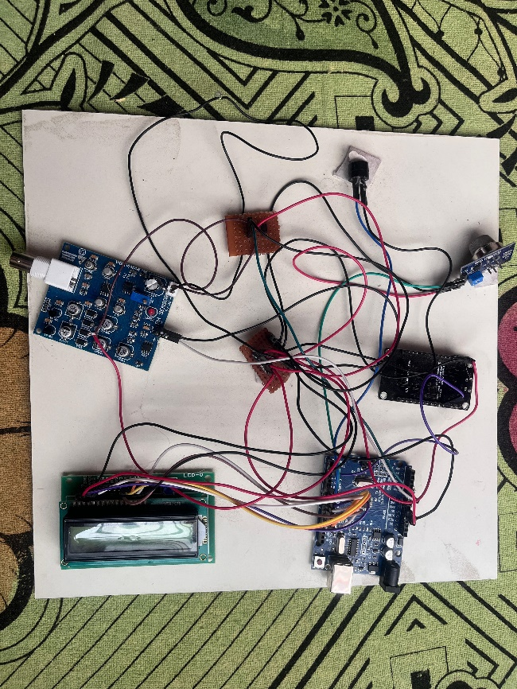

* 1. **Working Principle:**
* In this innovative system, an IoT-based Arduino Microcontroller serves as the central hub, powered by a 5V DC supply. The maintenance of milk quality is facilitated through the utilization of smart sensors, each playing a crucial role in ensuring optimal conditions.
* A temperature sensor diligently monitors the milk's temperature, while a viscosity sensor gauges the consistency of the milk, ensuring it meets the desired standards. Meanwhile, a gas sensor is tasked with detecting any undesirable odors emanating from the milk, indicative of spoilage.
* The milk level sensor provides accurate measurements of the milk quantity, allowing for precise monitoring of supply levels. Additionally, a salinity sensor is employed to identify any deviations in milk purity, safeguarding against adulteration.
* To streamline customer transactions, an RFID reader reads unique RFID cards containing customer and payment details. Upon successful payment verification, the motor is activated, signifying the commencement of milk dispensation. However, in the event of an unrecognized entry or insufficient payment, a buzzer alerts stakeholders, ensuring security and accountability.
* Real-time status updates are prominently displayed on an LCD screen, providing users with clear and concise feedback on the system's operations. Through this sophisticated integration of technology and sensors, the system ensures the consistent delivery of high-quality milk while prioritizing user convenience and safety

2.2 **Components Used:**

* **Hardware:**
* 1. Atmega328: A versatile microcontroller commonly used in Arduino boards, capable of processing and controlling various functions in electronic devices.
* 2. Temperature Sensor: Utilized to measure the temperature of the milk, providing crucial data for monitoring and maintaining optimal storage conditions.
* 3. pH Sensor: Measures the acidity or alkalinity of the milk, essential for assessing its freshness and quality.
* 4. Buzzer: An audible alarm device that produces sound alerts or notifications, serving as a warning mechanism in case of anomalies or emergencies.
* 5. Wi-Fi Module: Enables wireless communication capabilities, allowing the system to connect to a network for remote monitoring and control.
* 6. Gas Sensor (MQ): Detects gases present in the environment, including those indicative of milk spoilage, aiding in early detection and prevention of contamination.
* 7. LCD: A liquid crystal display used for visual output, providing real-time information and system status to users.
* 8. RFID Reader: Reads RFID tags or cards containing unique identification information, facilitating user authentication and access control.
* **Software:**
* Arduino IDE: An integrated development environment used for writing, compiling, and uploading code to the Atmega328 microcontroller, simplifying the programming process.
* Embedded C Program: Software written in the C programming language specifically for embedded systems like microcontrollers, enabling efficient control and operation of hardware components.
* Express PCB: Software for designing printed circuit boards (PCBs), allowing engineers to create custom layouts for integrating hardware components, ensuring efficient and reliable performance in the system.

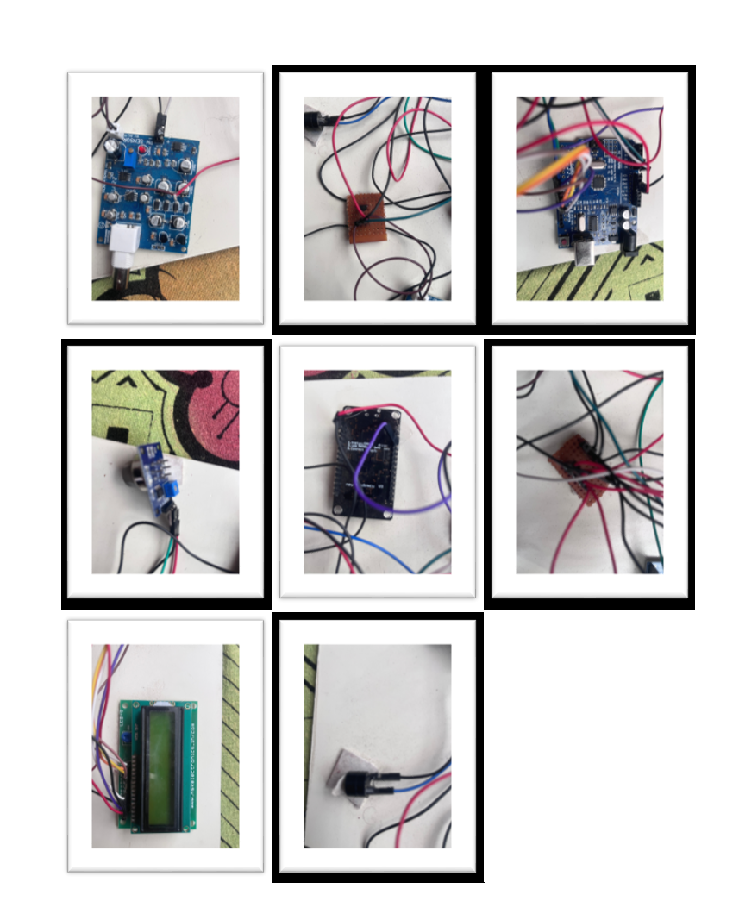

1. **LITERATURE SURVEY**

Authors M. Guetouache, B. Guessas, and S. Medjekal investigated the composition and nutritional significance of raw milk in their paper titled "Composition and Nutritional Value of Raw Milk," published in Biological in 2022. Their methodology focused on examining five common adulterants found in milk and their correlation with fat percentage.Raw milk was found to be rich in essential amino acids, proteins, and phosphorus, crucial for maintaining bone health. However, it also possesses drawbacks, being high in cholesterol and sugar content. Moreover, improper storage conditions can lead to bacterial contamination, posing risks to consumer health.In the paper titled "Measurement Systems: Application and Design," authored by O. D. Ernest in 2019, the methodology centered on the application of an electronic nose system (e-nose). This system comprises an array of sensors designed to detect various food spoilage indicators, aiming to enhance food safety and human health. The electronic nose system (e-nose) offers several advantages, including simplicity, portability, lack of solvent requirements, rapid operation, and relatively low cost. It serves as an effective tool for assessing the authenticity of "Pasture milk."However, despite its benefits, the e-nose system has limitations that affect its full potential. These include a loss of sensitivity in the presence of water vapor or high concentrations of a single component, such as alcohol.In the paper titled "Thermal Conductivity of Some Irons and Steels over the Temperature Range 100 to 500°C," authored by Shelton in 2022, the methodology revolves around the application of an electronic nose system (e-nose). This system comprises an array of sensors designed to detect various indicators of food spoilage, with the overarching goal of enhancing food safety and human health.One of the notable merits of this study is its ability to enhance the rate of heat transfer to the heat transfer fluid, which is significant in thermal conductivity research. However, it's important to note a key limitation identified in the study: as temperature rises, both the number of free electrons and lattice vibrations in the metal increase. Consequently, it's expected that the thermal conductivity of the metal will also increase.Lucas de Souza Ribeiro et. al.states that using a cryoscope, detection of water adulteration in milk can be performed. The GaAsSb sensors, which show quick reactionand great affectability to the NIR range, were utilized to distinguish diffusely reﬂected light. The proposed instrument was tried on milk tests corrupted with water. The outcomes displayed high coefﬁcients of assurance, higher than 0.99.In this manner, the created framework might be utilized for identification of milk debasement. Carla Margarida Duarte et. al.developed a attractive counter that identiﬁes the nearness of Streptococcus agalactiae (a Group B Streptococci) in crude milk. This gadget permits the investigation of crude milk without crossing over the microﬂuidic channels, making this incorporated stage exceptionally appealing for quick bacteriological pollution screening. Wesley Becari et.al.developed a methodology for the detection of bovine milk adulteration by applying electrical impedance measurements. The classiﬁcation\ of the results is proposed through ak- nearest neighbors algorithm that allows to quantitatively qualify the samples of pure and adulterated milk. Pallavi Gupta et. al displayed another framework, which is utilized for the location and estimation of corruption of clariﬁed butterfat, a classiﬁcation of anhydrous milk fat. Identification of defilement by at least 20% of creature musclem versus fat's in clariﬁed margarine is effectively and monetarily done. Dari de O. Toginho Filho and Vanerli Beloti proposed a model of a computerized photometer, microcontrolled, versatile gadget, which utilizes three LEDs with discharge in the NIR area and was created without the utilization of focal points, ﬁlters or moving parts. The outcomes demonstrate that the model reaction resembles the one of a business cryoscope,yet quicker.

1. **PROBLEM STATEMENT**

Milk, a timeless dietary staple cherished across cultures and continents, is celebrated for its unparalleled nutritional richness. Bursting with essential vitamins, minerals, proteins, and fats, milk stands as a beacon of sustenance, offering a complete package of nutrients crucial for the body's growth, development, and overall well-being.

In its purest form, milk represents nature's perfect concoction, providing a nourishing elixir that fuels the body with energy and vitality. From infancy through adulthood, milk remains a cornerstone of dietary intake, serving as a foundational source of calcium for strong bones and teeth, protein for muscle growth and repair, and a host of other vital nutrients essential for optimal health.

However, amidst its wholesome reputation lies a looming threat: the insidious practice of milk adulteration. Adulteration, a devious tactic employed by unscrupulous individuals in the food industry, involves the surreptitious addition of harmful and substandard substances to milk with the aim of deceiving consumers and maximizing profits.

This nefarious practice knows no bounds, with adulterants ranging from innocuous fillers like water and starch to more insidious additives such as urea, formalin, and detergents. These adulterants not only compromise the nutritional integrity of milk but also pose grave health risks to unsuspecting consumers.

The consequences of consuming adulterated milk are dire and far-reaching. Beyond the immediate threat of gastrointestinal distress and allergic reactions, adulterated milk has been linked to long-term health complications, including kidney and liver damage, hormonal imbalances, and even cancer.

Moreover, the adulteration of milk represents a betrayal of trust between producers and consumers, eroding the fundamental principles of food safety and integrity. It undermines the sanctity of the food supply chain, jeopardizing the health and well-being of millions who rely on milk as a staple part of their diet.In response to this growing crisis, regulatory bodies and food safety authorities have intensified efforts to combat milk adulteration through stringent quality control measures, enhanced testing protocols, and public awareness campaigns. However, the battle against adulteration remains an ongoing struggle, requiring vigilance, cooperation, and concerted action from all stakeholders involved.

Ultimately, safeguarding the purity and integrity of milk is not just a matter of food safety; it is a moral imperative that transcends borders and boundaries. It is a commitment to upholding the basic human right to safe, nutritious food and ensuring that future generations can continue to enjoy the countless benefits of nature's most perfect elixir - milk.

**5. Future Scope**

In this endeavor, we introduce a cutting-edge IoT model powered by LabVIEW software, promising meticulous and expedited results. Executed through an Arduino kit, our IoT-based system aims to assess milk adulteration levels across three distinct categories: low, moderate, and high. Leveraging advanced sensors capable of detecting pH value, viscosity, and temperature, our approach ensures user-friendly operation and swift outcome delivery.

Furthermore, we envision augmenting our work by incorporating Machine Learning Technology and IoT-based frameworks, thereby rendering our model market-ready for discerning clients. With the integration of Artificial Intelligence, we aim to develop an intuitive interface, fostering enhanced user engagement and comprehension in the marketplace.

Moreover, we foresee the development of a sophisticated data processing method, facilitating the aggregation of a comprehensive food database. This holistic approach promises to revolutionize food quality assessment and management, laying the groundwork for a more secure and transparent food supply chain.